BMIH6002
Managing Food and Beverage Operations
Module Leader: Jessica Newport
Student name: Gabriela Iuliana Giurgiu
Student ID: 2240417
Table of Contents
Introduction 3
Main Body 3
Conclusion 5
References 7
Appendices 9
Appendix 1: Three learning Objectives 9
Appendix 2: Delta Hotels by Newcastle Gateshead Certification 10

Introduction
The placement organisation was the Delta Hotels Newcastle Gateshead, which is a 4-star hotel located in Newcastle, operated under Marriott. The hotel offers an extensive stay experience catering to both leisure and business travellers. As part of their operations, they also offer food and beverages to guests along with a fine dining experience. Their food & beverage (F&B) operations encompass the Cast Iron Grill Newcastle restaurant, which acts as an incorporated part of the hotel and serves guests in a family-friendly setting. It has separate timings for regular meals and breakfast in the morning (Delta Hotels Newcastle Gateshead, 2025). Alongside, there is also the Cast Iron Bar & Lounge that serves guests looking for a relaxing, friendly and comfortable ambience to enjoy alcoholic drinks and light snacks. However, both the restaurant and bar are integrated well to ensure that consumers can have access to food made of fresh, quality local ingredients along with cocktails (Delta Hotels Newcastle Gateshead, 2025). Moreover, this also shows that their F&B operations are full-service type in terms of family-friendly setting, casual and fine dining experience, and mainstream dishes and alcoholic drinks (Johnston et al., 2012).

Main Body
Reflecting back on my placement period at the Delta Hotels, I could learn and experience new things, which made me appreciate this opportunity even more. My main job description was working in the leisure club, but I got to work in the restaurant more this time, especially while shadowing my supervisor, Lauren Simpson, who was also the leisure club manager.
During my placement, I got to closely see and understand the sustainability approaches and issues in the hotel's F&B operations. In this context, Mohsin (2023) noted that hotels are usually the most resource-intensive areas, but within this, F&B operations add to waste generation significantly. So, it negatively affects the environment and increases the hotel's carbon footprint through GHG emissions. The modules also covered food waste and complex supply chain practices in the hospitality sector.
While working here, I got to see how the team applies different tactics for decreasing food waste. Marriott hotels already apply Winnow AI systems for tracking and minimising waste generation. Hence, it was expected that Delta, being a part of Marriott, would also apply this (ESG News, 2024). However, I have observed them using adjusting portions and menus to reduce food waste per person. I also saw that some of the items for breakfast are served in smaller portions, but guests are encouraged to ask for more if they want. This way, the hotel reduces wastage. As part of the module, I have learnt about the sustainability hierarchy comprising reduce, reuse, and recycle, which aligns with this practice. In this context, the Lean Management principles also become relevant because they prompt organisations to improve quality and reduce waste generation (Mahmud, 2024). So, by having firsthand experience with the hotel’s tactics, especially the ones applied by the F&B staff, I had a greater clarification of the reality.
The Cast Iron Bar & Grill and restaurant provides fresh and quality food cooked. They source the ingredients locally from regional suppliers nearby. This keeps the food fresh and of high quality, which appeals to Delta's guests. In this context, Kaur et al. (2025) stated that when organisations source the supplies locally, it enables them to reduce food miles and support the local economic development. Therefore, it can be stated that it constitutes Delta's sustainability measures. This can be further supported by the fact that The PLEDGE on Food Waste rated Delta with 94% scores in this aspect, which gave them the Gold Level sustainability certification [refer to Appendix 2]. This ultimately reinforces that the Cast Iron Bar & Grill, Delta's F&B operations, align with sustainability practices in the hospitality sector (The PLEDGE on Food Waste Instagram, 2024).
Since I was allocated to work with the kitchen staff on the leisure club members' orders, I had to be there and follow up on the ingredients. I observed their food inventory practice and how they maintain the order based on food allergies. They also maintain an allergen food menu list for highlighting all potential ingredients that can trigger someone's allergies and potential cross-contamination (Dominguez et al., 2022). This added to my knowledge about how complex these tasks can be. Moreover, the staff informed me that there are different items that can cause food allergies in adults and children. For instance, children were more prone to milk, peanut and egg allergies, whereas adults could also develop them from shellfish or other fish (Tedner et al., 2022).
The staff also track information on allergens that could potentially come from cross-contamination. Since I was in charge of obtaining health questionnaires and managing their orders, my supervisor had me update the allergen matrix on their orders. So, I had to liaise and work closely with the kitchen staff and track source specifications. Due to this, I recognised the importance of traceability when it comes to sourcing food ingredients and complexities within supply chain management.
However, I also realised that the sustainability practices are not being fully communicated to the guests. In this scenario, Lin et al. (2025) talked about the significance of communicating sustainability efforts with guests as it can positively influence their behaviour, enhance satisfaction and loyalty. As a result, it can improve the brand image. So, showing the guests how the hotel reduces food waste generation and other measures can raise their awareness and loyalty (Ioannidis et al., 2021). They can address this drawback by making small changes, which would solidify their position among consumers.
As part of the module, we also learnt about leadership and employee management. I was appointed to my job, where I worked under the leadership of Lauren Simpson. She was the manager at the leisure club, where I worked. The club was not directly part of the F&B operations, but part of my job description involved taking care of clients' orders. Moreover, during any wellness event, our team worked closely with the F&B team to ensure that the meals being given to guests complied with their health and well-being needs and matched their health questionnaire. During this period, I got to experience and understand the significance of cross-functional team collaboration.
Lauren encouraged us and established clear objectives every day through regular brief meetings. This helped us to have clear goals and tasks to do for the day, which also helped us to stay on track. Moreover, under her leadership, we also learnt to adopt and use the digital systems for regular tasks. This specifically helped me to learn the Transcendent system, which is a hotel management software solution. I used it for reporting maintenance needs. This helped us to streamline operations with the help of technologies. During our cross-functional collaboration, I observed Lauren leading us, which helped pass feedback and concerns from guests and share them with the F&B team. This helped F&B staff to make changes in their healthy menu offerings, focus on allergen lists and improve them, which satisfies client needs.

Conclusion
Hereby, I conclude my report on the F&B operations at the Delta Hotels Newcastle Gateshead, reflecting back on my experience and observation during my placement there. Even though I was not directly appointed to work in this area, my job still crossed certain parts, where I had to work with the F&B team. This clarified my understanding of the complexities and management of this operation. I got to see the sustainability measures taken by the team to reduce food waste generation. Alongside, as I had to work with them for leisure club guests, I learnt firsthand about food inventory, allergen matrix and menu adjustments in practice. This gives me more confidence to work in F&B in the future.
They need to inform the guests or communicate about their measures to the guests, which may influence the guests to practice the same. For instance, the staff should put up a sign or card on the table informing them that the portion is smaller to reduce waste, but they can ask for more if needed. The card should also request them to be mindful of wastage that would reduce Delta’s carbon footprint and improve brand image.

References
Delta Hotels Newcastle Gateshead. (2025) Restaurants in Gateshead: Delta Hotels Newcastle Gateshead, Marriott Bonvoy. Available at: https://www.marriott.com/en-us/hotels/nclmd-delta-hotels-newcastle-gateshead/dining/ (Accessed: 08 November 2025).
Dominguez, S., Théolier, J., Povolo, B., Gerdts, J. and Godefroy, S.B. (2022) Allergen management under a voluntary PAL regulatory framework–A survey of Canadian food processors. Heliyon, 8(11).
ESG News. (2024) Marriott Hotels UK implements winnow AI to cut food waste by 50% by 2025, ESG News. Available at: https://esgnews.com/marriott-hotels-uk-implements-winnow-ai-to-cut-food-waste-by-50-by-2025/#:~:text=Sustainable%20Travel-,Marriott%20Hotels%20UK%20Implements%20Winnow%20AI%20to,Waste%20by%2050%25%20by%202025&text=Key%20Impact%20Points:,awareness%2C%20and%20surplus%20ingredient%20repurposing. (Accessed: 08 November 2025).
Ioannidis, A., Chalvatzis, K.J., Leonidou, L.C. and Feng, Z. (2021) Applying the reduce, reuse, and recycle principle in the hospitality sector: Its antecedents and performance implications. Business Strategy and the Environment, 30(7), pp.3394-3410.
Johnston, R., Clark, G. and Shulver, M. (2012) Service Operations Management: Improving Service Delivery. 5th Ed. London: Pearson.
Kaur, J., Dutt, A., Nagina, R. and Bhalla, P. (2025) Gastronomic Tourism and Sustainability Strategies: Challenges and Future Directions. In Global Sustainable Practices in Gastronomic Tourism (pp. 1-24). IGI Global Scientific Publishing.
Lin, C.C., Nugraha, K.S. and Hsu, Y.J. (2025) The Effect of Sustainable Development Goals on Customer Satisfaction, Customer Loyalty and the Role of Brand Image in Green Hotels. Advances in Management and Applied Economics, 15(1), pp.1-7.
Mahmud, K.T. (2024) Reducing Food Waste through Efficient Logistics: A Case Study.
Mohsin, K. (2023) WASTE MANAGEMENT IN FOOD AND BEVERAGE OPERATIONS: SUSTAINABLE PRACTICES AND REGULATORY COMPLIANCE. FOOD AND BEVERAGE MANAGEMENT, p.79.
Tedner, S.G., Asarnoj, A., Thulin, H., Westman, M., Konradsen, J.R. and Nilsson, C. (2022) Food allergy and hypersensitivity reactions in children and adults—A review. Journal of Internal Medicine, 291(3), pp.283-302.
The PLEDGE on Food Waste Instagram. (2024) The pledge on food waste on Instagram: ‘we're proud to announce that @deltanewcastle Delta Hotels by Marriott Newcastle Gateshead has been certified at the gold level of the pledge on food waste certification, scoring an impressive 94%! under the leadership of the hotel manager and the Executive Chef, the Cast Iron Bar & Grill is setting a new benchmark for sustainability in the hospitality landscape by proving that culinary craft and sustainability can go hand in hand. Ready to tackle food waste? Register for the Webinar Now and join the movement towards a more sustainable culinary future! #sustainability #zerofoodwaste #excellencedeservesrecognition #Marriott #sustainability #foodwaste #hospitalityindustry #thepledgeonfoodwaste #freewebinar #sustainabledining #recognitiondeservesexcellence’, Instagram. Available at: https://www.instagram.com/p/DC8hmcVpcOP/?hl=en (Accessed: 08 November 2025).

Appendices

Appendix 1: Three learning Objectives
Three Learning Objectives from My Placement:
- To implement food safety practices in restaurant and bar operations
- To understand sustainability practices that can be implemented in F&B operations for reducing food waste generation
- To understand the role of leadership in maintaining cross-functional team collaboration for food service preparation

Appendix 2: Delta Hotels by Newcastle Gateshead Certification
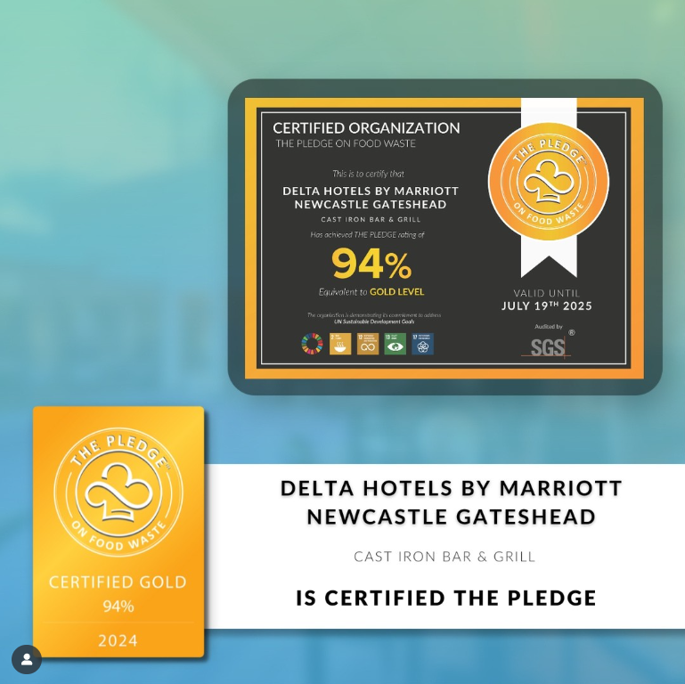
Source: (The PLEDGE on Food Waste Instagram, 2024)

AI declaration
I have used for this presentation AI powered search engines such as Google Schoolar, Google and Yahoo.

