

Module Name: Academic Skills in the Digital Era
Module Code: BMSW4013
Assignment Name: Time-Management: An Essential Skill for Student Success in Higher Education
Student Name: Adelina Georgiana Cozma
Student Number:2431275
Lecturer: Ffion Cumberpatch
Deadline: Friday 6th June 23.59

Wordcount:713
AI Acknowledgement
I confirm that I have not presented any AI generated materials as my own work.

“Time-Management”: An Essential Skill for Student Success in Higher Education
Introduction
Time management is becoming an increasingly difficult challenge. (Zoloth S, 2023) With various distractions such as video games, social media, and the pressure to complete assignments on time, it can become difficult for students to manage their time effectively. Time management is extremely important, especially for students. As academic demands continue to grow, the way we organise our time to meet these demands, while also making room for personal time, is difficult. In this report, I will discuss the difficulties our generation faces with time organisation, the importance of knowing how to manage time, and how artificial intelligence can help make time organisation easier.
The Importance of Time Management in Higher Education
Responsibly managing time allows students to prioritise academic tasks while also maintaining a personal life, which helps avoid procrastination and supports student well-being, making them more relaxed and focused. Students who apply time management strategies achieve better academic results and experience lower levels of stress. (Zoloth S, 2023)
The benefits of time organisation are various, but one of the most important is its contribution to emotional and mental health. Students who plan and learn to efficiently prioritise their workload are less likely to suffer from anxiety, overwhelm, and burnout. Effective time management is essential not only for academic success but also for maintaining a more balanced lifestyle. (Zoloth S, 2023)
Effective Tools and Strategies for Time Management
With the help of digital tools such as Google Calendar, Notion, Trello, and others, time management can become much easier. These digital tools make it simpler to organise and efficiently plan time by allowing users to schedule personal activities and manage academic plans while tracking deadlines, so students are always aware of what needs to be prioritised.

Beyond digital tools that assist with time organisation, there are also study methods that help students work efficiently without feeling exhausted. Francesco Cirillo developed The Pomodoro Technique, which is a method commonly used by students. This technique involves working for 25 minutes followed by a 5-minute break, to maintain concentration and prevent burnout. (Sheldon, R., 2022)
(Pinterest)
Another equally effective method is Time Blocking. This involves allocating a specific time slot for one task, such as reading, writing, or reviewing material. Other effective methods include SMART goals (Specific, Measurable, Relevant) and task lists, which help break down large tasks into smaller, which will be more manageable for students who struggle more with prioritisation.
(Capterra.com)
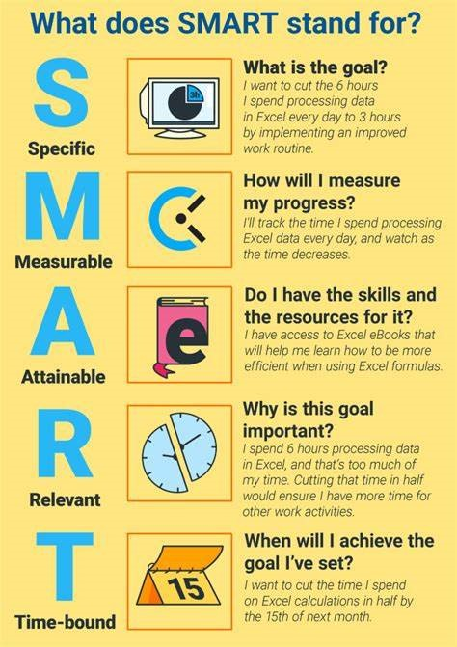(careercliff.com)

Challenges Faced by Students in the Digital Era
Even though there are more digital tools available to help students with time management, young people still face challenges in the digital age. One of the most common issues is digital distraction. Because of platforms like TikTok, Instagram, or YouTube, students tend to spend a significant amount of time on these, due to their dependence on this platform, which leads to lower academic productivity. (Koessmeier, C; Buttner, O.B. 2021). Another major challenge students face is procrastination, due to fear of failure, perfectionism, or lack of motivation. These facts are often caused by the flexibility of online learning, which, although beneficial, can lead to delaying tasks. Likewise, students who combine studies with part-time jobs tend to encounter various difficulties in managing their time. (Koessmeier, C; Buttner, O.B. 2021)
Evidence-Based Solutions for Improving Time Management
When it comes to solutions that have had a positive effect, students can choose from a wide range of methods to meet their individual needs. One of the most used strategies by students that has shown results is creating a weekly schedule. Alongside the digital tools mentioned above, students often create a weekly plan that helps them academically and personally, making it much easier to prioritise and complete tasks. This method helps students stay consistent in their success by turning task completion into motivation. Again, using the Eisenhower Matrix is a major help because it identifies the highest priority tasks, reducing the time spent on low-priority activities and helping students focus on more essential academic work. (Holt, P. 2023)
(Productivity Patrol) 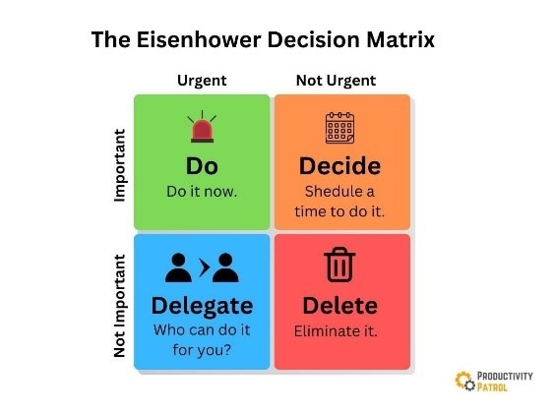

Conclusion
In conclusion, time organisation is essential for students. With suitable time management, they can study efficiently, complete all their tasks, and maintain a balance between personal and academic life. Digital intelligence tools are extremely helpful if used effectively. They help improve academic performance and support better mental health.

REFERENCES
Darcy, N. (2023) ‘7 Time Management Tips for Students.’ Prospects Available at: https://www.prospects.ac.uk/applying-for-university/university-life/7-time-management-tips-for-students#:~:text=7%20time%20management,September%2C%202023
Holt, P. (2023) Task Prioritization with the Eisenhower Matrix: A Step-by-Step Guide. E-student.org. Available at: https://e-student.org/eisenhower-matrix/
Koessmeier, C; Buttner, O.B. (2021) ‘Why Are We Distracted by social media? Distraction Situations and Strategies, Reasons for Distraction, and Individual Differences.’ Psychol., 02 December 2021 Sec. Human-Media Interaction Volume 12 - 2021 | https://doi.org/10.3389/fpsyg.2021.711416
Sheldon, R., (2022) Pomodoro Technique. Tech Target. [online] Available at: https://www.techtarget.com/whatis/definition/pomodoro-technique
Zoloth, S (2023) Time Management: What Is It and Why Is It Important?Available at: What Is Time Management And Why Is It Important? | NSHSS | National Society of High School Scholars

