

Quality & Business Improvement
ACMA4004
Prioritised Improvement Plan
Enrico Miggiano
2312273
11/03/24

Contents Page:
Introduction: page 2
Date Collection: page 3 – 4
Date Analysis: page 4 – 6
Action Plan: page 6 - 8

1. Introduction:
The goal of this report is to develop an improvement plan to help a particular process, application, or operation; the issue must have originated at our place of employment. Since it generates all of the company's revenue, manufacturing is the most crucial component of FSG. This study will focus on the machining procedure for the liners that FSG produces for Xtrutech, one of the firms that FSG manufactures for. FSG produces a variety of parts for Xtrutech. These parts are being produced continuously at FSG and will stay that way because the customer requires large quantities of them frequently. Clamax is an extremely hard material, which causes a lot of issues with tool wear and machine time. However, the real issue with the process is how long it takes to finish. This report will be organised as follows: an identification of the issue, data gathering (including graphs and charts), data analysis, and a plan of action.
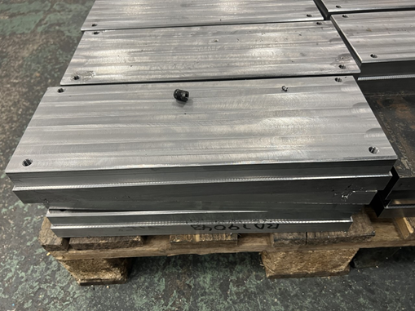
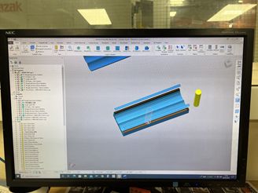
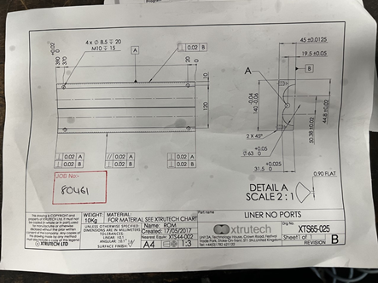
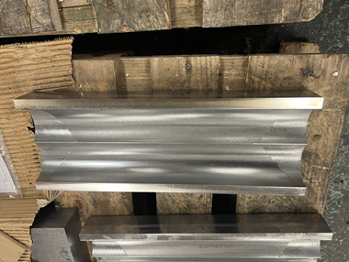

2. Date Collection:
2.1

The graph compares the number of parts produced in a 24-hour period using the old and updated methods. As you can see, the updated approach produces much more parts since it takes less time to complete the operation and uses modern cutters.
2.2 Tally charts displaying the duration of the instruments for the previous and current processes:
Tool Before | How many parts it produced before breaking
32mm AJX | 1
VPX cutter | 3
20mm Moldino | 3
10mm Moldino | 2
16mm Ball nose | 3

Tool After | How many parts it completed before breaking
32mm AJX | 3
VPX cutter | 5
20mm Moldino | 4
10mm Moldino | 4
16mm Ball nose | 3
63 WSX cutter | 5

3. Data Analysis
The main reason for this is that The tools were taking far too large of a cut at the incorrect speeds and feeds, and they were being put on toolpaths they weren't designed for. Because of the requirement to verify the part and replace and re-set several tools, the amount of time the machine was stopped nearly doubled as a result. since of this issue, the process has had to be reevaluated since it was taking too long to manufacture the components and the equipment could not finish many pieces before breaking down. The graph illustrates how long the last procedure took to complete, including the time needed to check and load the next component, was around 2.5 hours. Then, you can observe that the new procedure nearly cuts in half the amount of time needed to mill the item. Naturally, the setup and measurement times cannot be lowered, but the machining cycles have been modified. Another piece of information I gathered for my data collection was the number of parts that each tool could produce before breaking down. I demonstrated this in two separate tally charts, one labelled "before" and the other "after," which displayed the number of parts produced by each tool. This allowed us to identify which tools were being overworked and modify the CAM programme to produce a more effective method of machining.
3.1 Root cause analysis
What is a root cause analysis: By determining the origin of an issue, a root cause analysis enables us to address and ultimately fix the problem. The five whys are some of the techniques we employ to address these issues. This means that you should never stop questioning why something occurred until you identify the root cause. Only then can you take steps to prevent similar issues from occurring in the future. The 5 M's approach is another way to approach this, which entails examining each of the machine, method, material, labour, and measurement components that are utilised. Just to make sure that both of these approaches identify the true root cause of the issue, I will incorporate both of these into my root cause analysis.
3.2 5 m’s analysis
3.2.1 The machine-cause of this issue is that the cutter tips were wearing out far too rapidly, requiring the firm to pay for new tips to be brought in, which resulted in a significant tip expenditure.
Cause: The incorrect tool path was being used by the tools, which increased pressure on the cutter and damaged the tips, making them unusable for subsequent components.
3.2.2 Method-Cause: The components' incorrect programming caused a cutter meant for face milling cutting to cut the job's outer profile, shattering the tips in the process.
Cause: The person who had coded it was accustomed to finishing operations throughout the hardening of these components, so when they noticed one tool roughing much of it, they didn't consider it a problem. This is why the programming issue happened.
Cause: The programmer had also configured the speeds and feeds incorrectly, which led to the destruction of the tips and more money lost.
3.2.3 Material: Although the material in this instance was quite hard, it didn't present any problems for the process; instead, the problem was that the feeds and speeds weren't adjusted correctly, which caused the material to wear out the tips more quickly and render them useless.
3.2.4 Manpower-Cause: Because this method was started during an afternoon shift, when the machines were set up and just run off, the operators didn't want to have them operating at maximum efficiency; instead, they just wanted to get the machines going for the shift. As a result, more tips were wasted because the programme wasn't right and no one on the shift could fix it because all the shift managers were on days and the parts were being run off in the afternoons.
3.2.5 Measurement and medium : There wasn't a measurement issue for these components throughout this procedure; rather, the issue stemmed more from the manner the item was machined, therefore it wasn't anything that needed to be fixed.
3.2.6 Analysis: This has demonstrated to me that the programmer's error in programming during the completion of the job is the root of all problems, as all issues are directly related to their actions. For instance, the tips were worn because of incorrect speed settings, which the programmer should have repeated for the tooling, tool paths, and depth of cuts.

3.3 5 Y’s Analysis
The issue I have chosen to focus on in this report is the amount of time wasted during the machining process when creating the liners for Xtrutech, a firm that FSG Tool and Die produces components for. The issue was that the parts were taking too long to machine, and the tools that were being used were getting damaged—one had melted, and the tips of the others were all deemed unusable. When problems like these arise, the company is alerted because, if the parts are machined in this way going forward, the company will lose money on each part because so much tooling was used to make each one. Someone's programming error, which resulted in incorrect speeds and feeds being entered and expensive tools being used to finish tool paths for which they were not intended, was the cause of the repeated damage to the tools.
3.3.1 Why did this problem occur?
It happened as a result of the programmer not using the proper tools, step-downs, speeds, and feeds, or considering the type of material they were milling.
3.3.2 Why did they do that?
They chose the incorrect tool because they had not read the tooling handbook, which describes the precise functions of the tool and indicates the appropriate step-downs for the material being machined. They did this because they were unsure of the material they were cutting because they had not examined the drawing.
3.3.3 Why did they do this?
They took this action since they are skilled machinists with years of expertise, but regrettably, this caused them to do the task inefficiently, damaging tools and requiring an hourly extension of the part-time labour.

4. Improvement Plan
Speaking with our team leader was the initial step in this procedure, he had told us the tips were breaking and the method was ineffective. The chance to alter the programming to make it shorter was then offered to us. We spoke with our tool specialist about this and he suggested that we replace the tools with ones designed to perform the tasks we were asking them to perform. It took a lot of time and effort from several people, including our Mitsubishi tooling specialist, to develop the action plan that we came up with to fix this process. I took pictures of the setup sheets beforehand and on one of the tools that was the incorrect tool for the job; it was cutting for twenty minutes, effectively damaging the tips due to once more incorrect feeds and speeds. The primary improvement we made was adding a 63 WPX, which eased one of the cutters that was working much too hard on this process. We ran one part off simply to get the speeds and feeds perfect, and we ran another part with only depth of cut. We were able to reduce the duration from two hours to one hour after several trial runs and alternative tool paths, which makes a significant difference when producing big batches of parts; more than forty parts in this case.
4.1 Old Set up
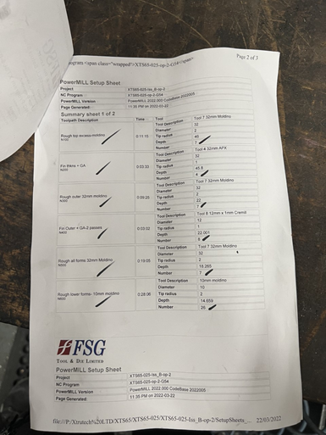
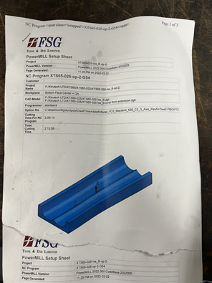

These sheets demonstrate every procedure that was included in the previous programme, as you can see. However, upon closer inspection, it becomes evident that the 10 moldinos were handling a significant portion of the job, which is why the tips were depleting so fast. This was another important issue that needed to be altered.

4.2 New Set Up
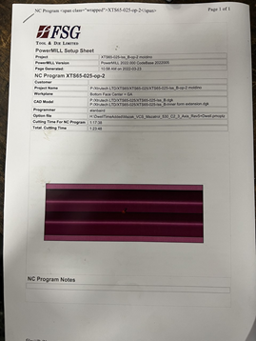
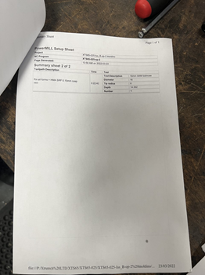
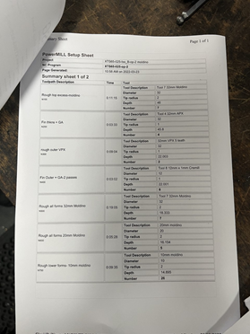

Because there are multiple tools performing different tasks during the roughing process, the processes appear more efficient when compared to the set up sheets. The semi-finishing process is the last one, which accounts for its longer duration than the other processes. However, because the feeds and speeds were changed, the tool's lifespan was extended.

5.Monitor and measure
A complete methodology is required to monitor and measure the action plan provided in an effective manner. First and foremost, in order to monitor advancement and resolve any new problems, frequent check-ins with the tool specialist and team leader are required. It is important to keep track of documentation, including setup sheets and photos, in order to offer concrete proof of the modifications done and their effects. To gauge how well the changes are working, key performance indicators (KPIs) including productivity, part quality, and process length should be set up and routinely checked. Feedback from team members engaged in the process should also be requested in order to find any unexpected difficulties or chances for more optimisation. Through Thorough progress monitoring, performance metrics analysis, and feedback-driven iteration, the effectiveness of the action plan can be precisely assessed, allowing for the necessary action of additional improvements.

6. Barriers and challenges
The action plan's implementation is set by a number of noteworthy obstacles and difficulties. First of all, getting the team leader to acknowledge the issue from the outset needed open communication and may have encountered resistance if there were conflicting views on the root of the problems. Furthermore, it takes a lot of time, energy, and sometimes money to suggest modifications to code and replace tools. Effective collaboration is necessary to manage the coordinated activities of several stakeholders, such as the tool specialist and Mitsubishi tooling specialist, which might be difficult. Though time-consuming and prone to error, setup papers and photos are crucial for documenting the process. Furthermore, technical know-how and painstaking attention to detail are required when selecting the appropriate tools and modifying feeds and speeds to maximise performance. Finally, patience is needed to incorporate trial runs and alternate tool pathways to perfect the process; setbacks may occur before the intended result is achieved. These obstacles must be overcome with tenacity, cooperation, and a dedication to ongoing development.

