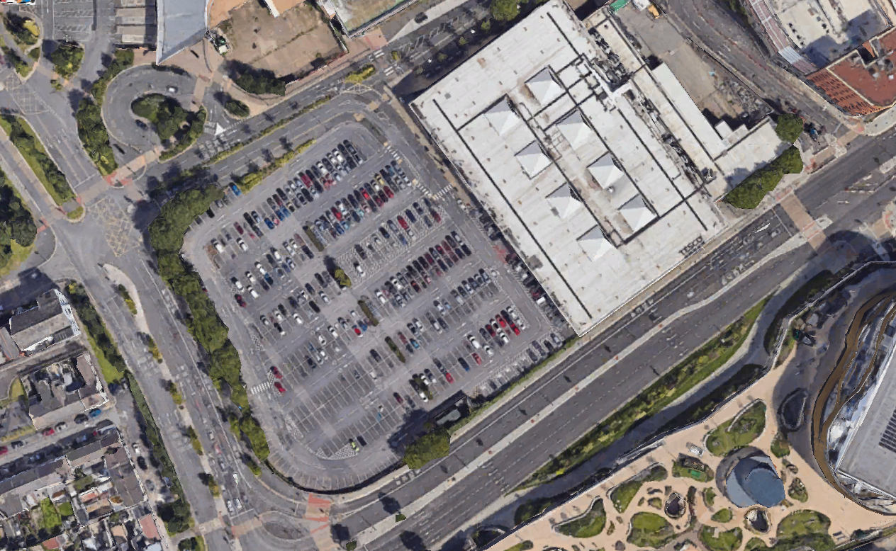
(Google Maps, 2019).

Phase One-Desk Study
  - five storey hotel to replace tesco superstore
Callum Griffiths | ACBA4022 | 09/01/2025

Contents
1.Site Details 2
2.History Of Swansea 7
3.Geological Information 14
4.Environmental Information 16
5.Archaeological Findings 18
6.Considerate Contractors Scheme 18
7.Recommended Foundations 20
8.Reference List 22

1.Site Details
This desk study has been commissioned by Swansea Council and Jarvis Hotels.
The subject of the report is the proposed five storey hotel situated at the current Tesco site on Oystermouth road in Swansea. The current Tesco store will be demolished and relocated to the old Debenhams store making way for the hotel. The proposed site is located opposite the LC2 entertainment complex and the new Swansea Arena.
The surrounding area features a bustling road that connects to key destinations in Swansea, including the scenic Gower Peninsula. Additionally, pathways lead directly to the heart of Swansea Town Centre and the vibrant nightlife hub of Wind Street.

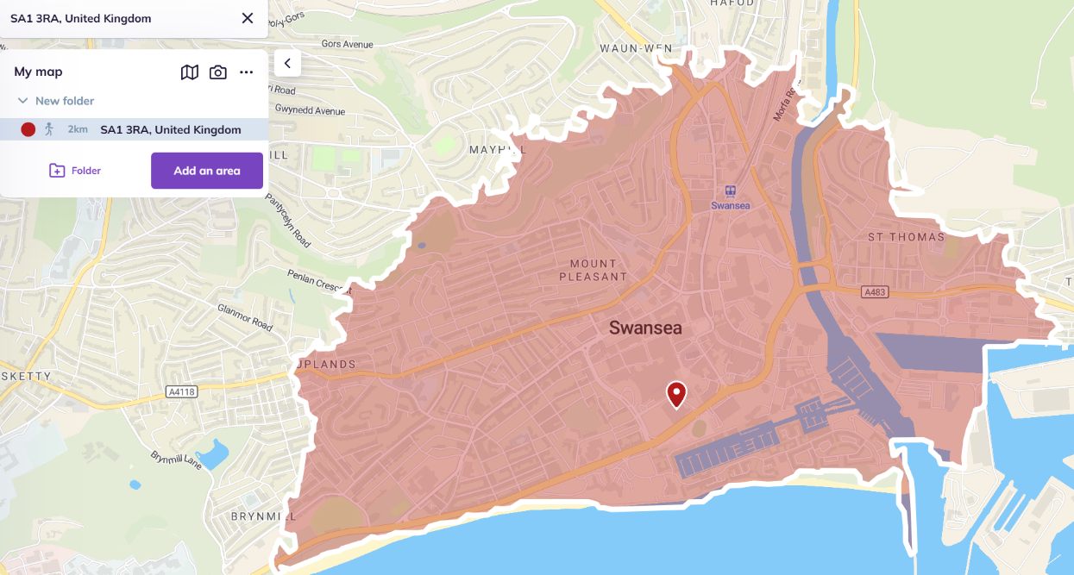
(Calc Maps, 2025).
The postcode of the site is SA1 3RA. The coordinates of the site are 51.6168° N, 3.9439° W. The desk study will review existing information for the surrounding area up to 2km. The above map highlights the surrounding 2km area of the current site.
According to Swansea council, existing buildings within the city centre tend to be 3-5 storeys (Swansea Council, 2016). The proposed hotel falls into this category. Anything 6 storeys or above will fall into the tall buildings category and will need to be treated differently.

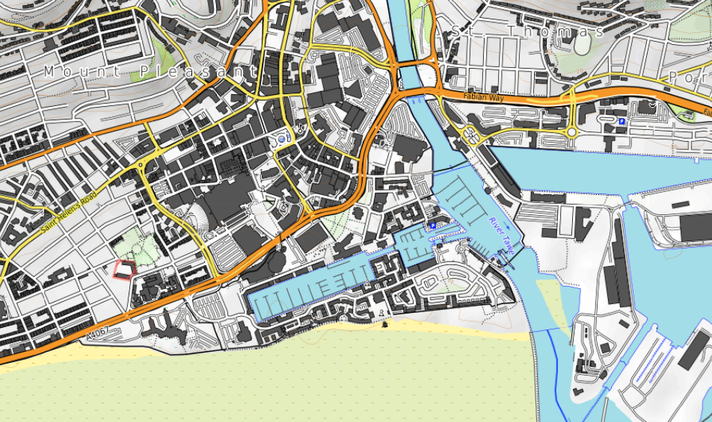
(Calc Maps, 2025).
Above is a topography map showing the site in question and the surrounding area.

Protected land (SSSI)
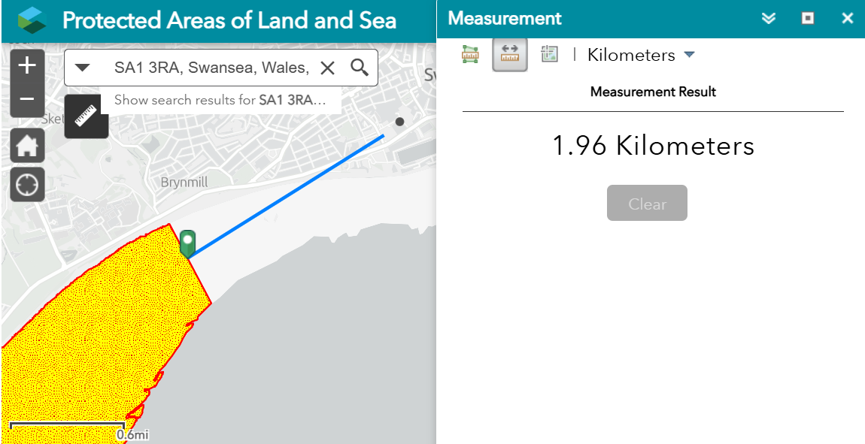
(National Resource Wales, n.d.)
As shown in the map above, within 2km of the site sits Blackpill Beach. In 1986, Blackpill Beach was designated as a Site of Special Scientific Interest (SSSI) due to its importance for local and migratory birds who during the winter, stop off to refuel for their journeys from Africa to Greenland and the Russian Steppe. The mud and sand create an ideal environment for numerous marine invertebrates, which serve as a rich food source for the approximately 150 species of birds recorded in the area (Swansea Council, n.d.).
The Crymyln Burrows is located nearby which is another SSSI. Crymlyn Bog, the largest lowland fen in Wales, features extensive reed and sedge beds that support a wide range of wetland plants, birds, and insects. Regarded as one of the most wetland sites in Europe, the bog has remained intact which is remarkable considering the nearby industrialisation of Swansea (Swansea University, n.d.).
The SSSI’s will need to be considered when planning work as these can provide limitations in the scope of the works allowed to be carried out.

Supplies
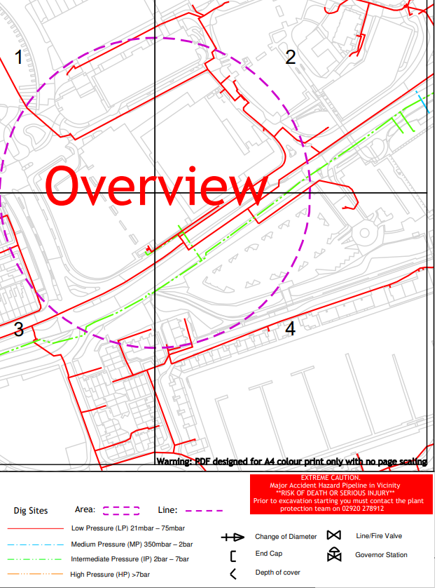
(Wales & West, 2025)
Above is an overview of the gas pipes at the site and surrounding areas supplied by Wales & West.
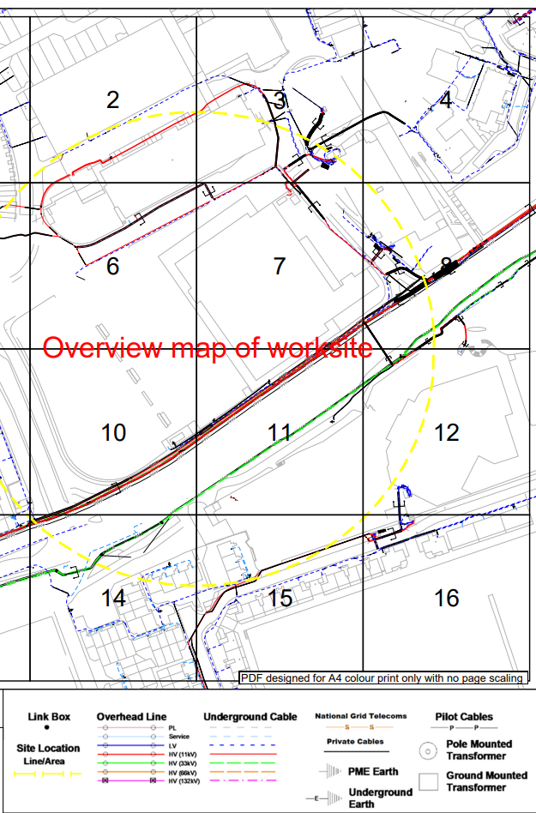
(National Grid, 2025)
Above is an overview of the cables and lines at the site and the surrounding area supplied by National Grid.
Water and sewerage of the site is maintained by Dwr Cymru- Welsh Water (Water UK, 2020).
Additional water supplies will need to be considered such as drinking water for workers and fire control, as well as additional gas and electricity supply.

2.History Of Swansea
Copper History

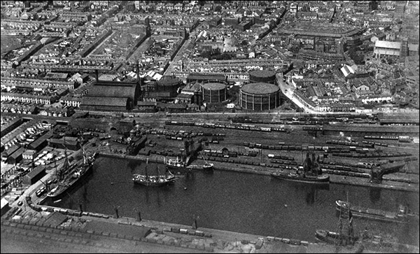
(Britain From Above, 1923)
The site is based near the marina of Swansea which is situated by the old Swansea Docks. Swansea is a city with a rich history of coal mining and copper smelting which contributed to an economic and industrial boom during the 18th and early 19th century. From 1770 to the 1840s, Swansea rose to prominence as a leading smelting hub, producing around one-third of the world’s copper. This remarkable output exceeded the capabilities of traditional smelting centres in Central Europe and Scandinavia, establishing Swansea as a centre of global importance in copper production earning the nickname Copperopolis (Evans and Miskell, 2020). During this period, environmental factors will have contributed to the site during the current period. Due to the previous coal mining activity, the likelihood of subsidence will have increased as well as the contamination of the land.

Oystermouth Road Gas Works
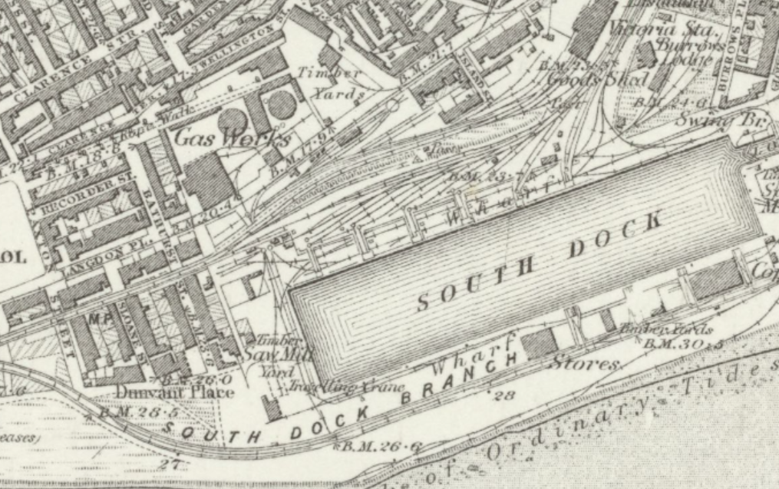
(National Library of Scotland, 1884)
The site is situated on the old Oystermouth Road gas works. As shown in the images above, several gasometers sat on the grounds and were used to store gas before it was supplied to customers. Once Britain discovered natural gas in the North Sea during the 1960’s, the use of town gas dwindled and slowly the use of gasometers was no longer needed (Ram, 2015). The gasometers were eventually sold to make way for the Tesco store that currently sits there. The gasometers and the implications of their use will need to be taken into consideration when carrying out the site investigation. Gas storage is highly likely to make the land contaminated. When carrying out any excavation on the site, plans will need to put in place to handle the contamination as well as remediation of any issues found when excavating.

Mumbles Railway

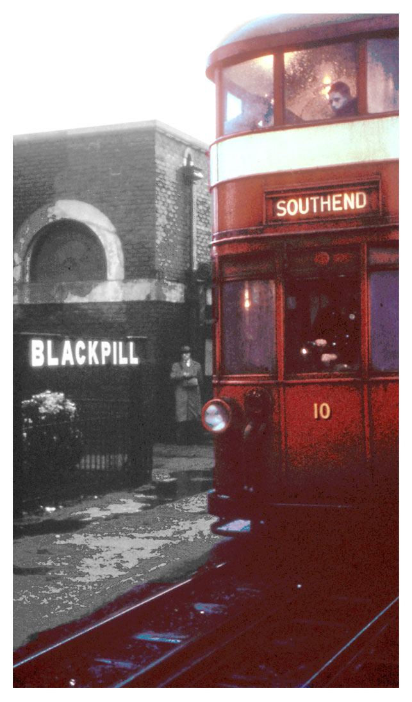
(Swansea Museum, n.d.).
Previously, along the road leading to Mumbles, there was a railway as pictured above. Initially this was an industrial horse drawn tramway until steam locos came into use in 1877. In 1929 the use of electric tramcars took over until the closure of the line in 1960. The original line ran from Swansea to Oystermouth (Swansea Museum, n.d.). This will need to be taken into consideration when carrying out the site investigation. Parts of the infrastructure may still be left behind. This may interfere with the sampling. Railway transport is also a source for soil contamination. The materials that were being carried are also a source of contamination and this will have to be considered when carrying out the site investigation.

Civic Centre
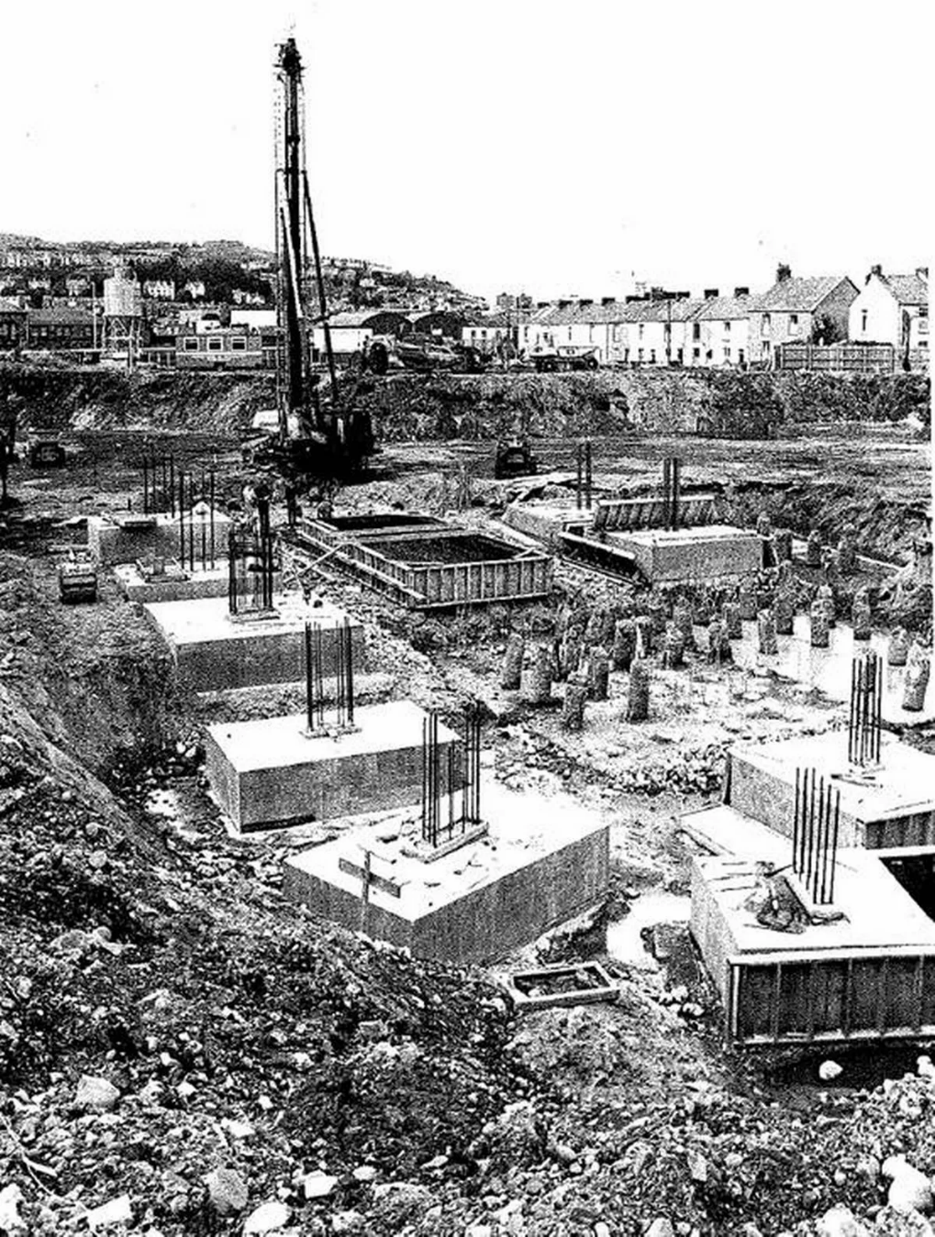
(Wales Online, 2019)
In 1982, County Hall opened in Swansea. What is now known as the Civic Centre is based on Paxton Street which is within 2km of the site in question. Several streets were knocked down to make way for the building. The above image shows the foundations being laid for the centre and shows the use of piles (Dalling, 2019). This information will help later when deciding what foundations to use.

Swansea Blitz
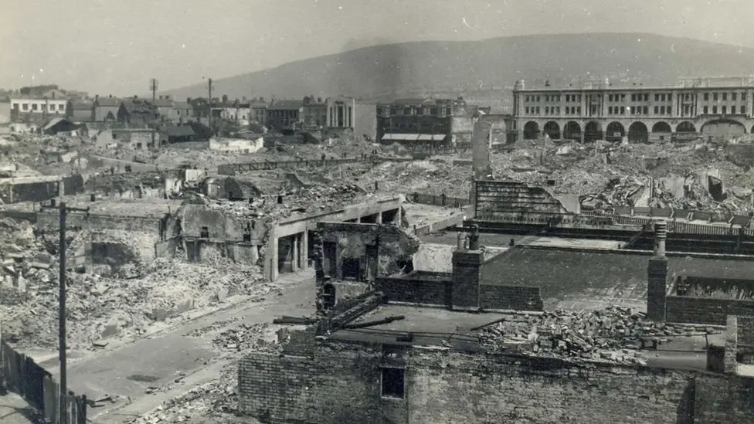
(BBC News, 2021).
During the second World War, Swansea was bombed more than 40 times. In 1941 however, Swansea was subject to a 3-night raid which left the city in ruin. 230 people were killed, almost 400 injured and the city destroyed. This became known as the Swansea Blitz. The Luftwaffe unleashed 1273 high explosive bombs and 56,000 incendiary devices to devastate an area of 41 acres using target maps based on aerial reconnaissance photographs (BBC News, 2021). The docks and ports made Swansea an obvious target. When carrying out the site investigation, special measures will need to be put in place regarding the bombings.

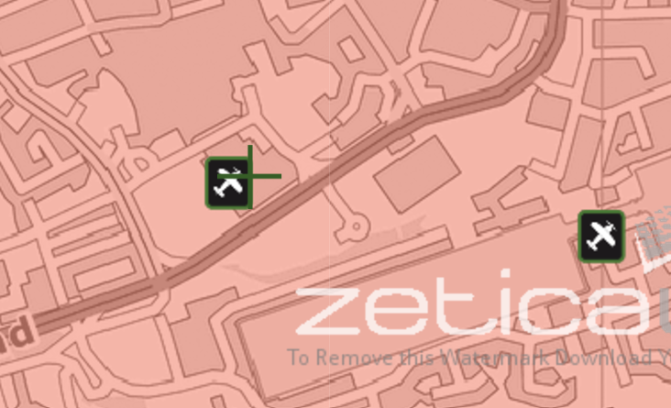
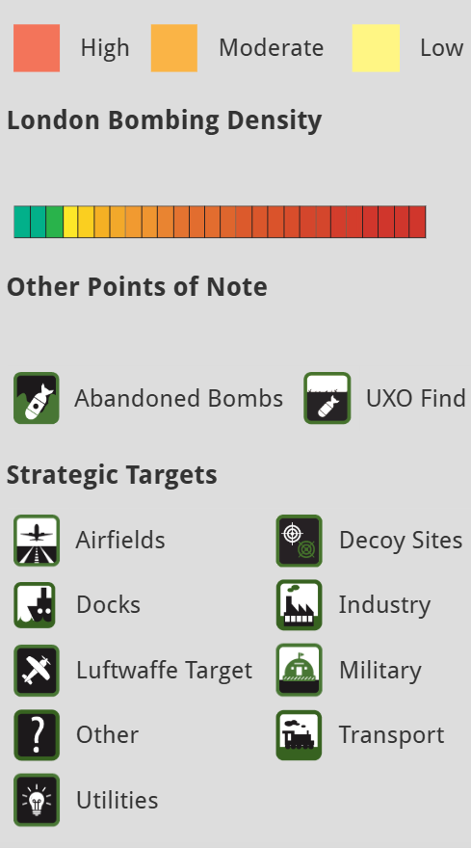
(UXO, 2024)
A detailed UXO report will need to be considered to potentially rule out unexploded bombs or landmines on site. The images above are taken from the Zetica website showing the risk assessment of the site (UXO, 2024). Ground contamination from the bombs will also need to be assessed. The frequent bombing of the site will have released dangerous substances which contaminate the soil and land.

Swansea Canal
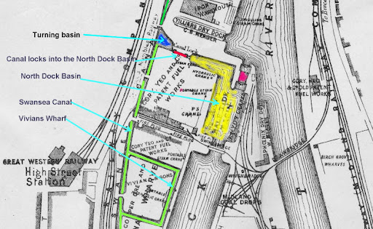
(Gareth Mills, N.D)
During 1794 to 1798, a series of canals were built in Swansea to provide valuable transport links for industry and trade. During the peak of the trade years, the canals ran for 16 miles. Although no longer functioning as working canals, part of the canals are still seen around Swansea today. The canals ran from the North dock which is within the vicinity of the site (Swansea Council, 2025). This will need to be considered when carrying out the site investigation.

3.Geological Information
Borehole Log
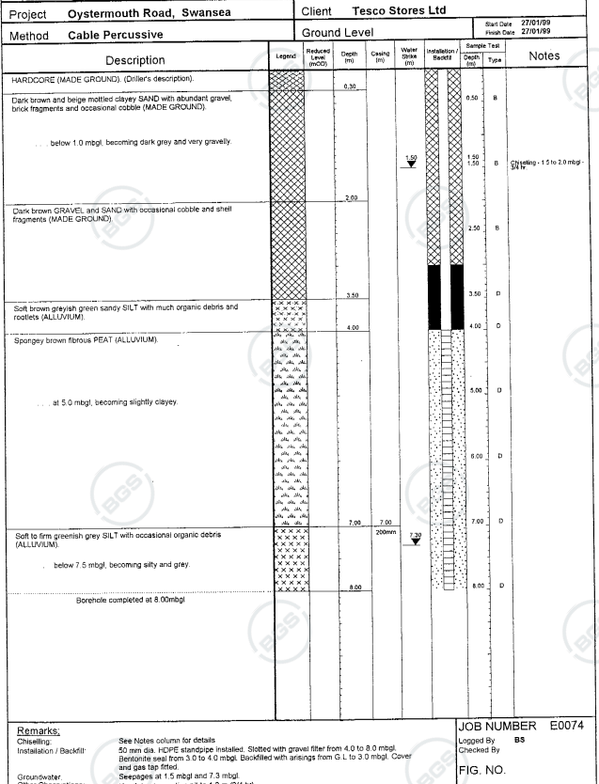
(BGS, 2023)
The borehole log above is taken from 1999 before the construction of the Tesco store on the site in question. This data provides accurate geological and hydrogeological information about the ground underneath the structure and surrounding area.
The first piece of data from the borehole log is 0.30m deep and it indicates that the soil consists of made ground. Made ground refers to soil or materials that have been modified or placed by human activity, typically without engineering oversight. This includes any land altered through human actions such as construction, excavation, or the deposition of materials (Rosenbaum et al., 2003).
As the borehole goes deeper into the ground, the data highlights brick and cobble within the ground. The presence of brick and cobble may potentially be from previous construction works on the ground for example, the gas works demolition. This as well as the initial made ground result would indicate that the soil is contaminated.
The borehole data shows gravel and sand until it gets to 4.0 meters where the presence of sandy silt is detected along with organic debris and rootlets. Silt retains water for a long period of time so has poor drainage capabilities and can expend when wet which may hinder the structure. The presence of silt continues until the end of the borehole data at 8.0 meters. After 4 meters, peat is present within the data.
The borehole data information points towards the soil being contaminated. The presence of made ground will need to be considered when planning the foundation of the building and when excavating the soil for sampling.
The borehole log also indicates a first water strike at 1.5 meters. Like the soil, the water is likely to be polluted.
According to data from BGS, the bedrock geology was formed between 309.5 million years ago and 318 million years ago during the Carboniferous period. The data also tells us the sedimentary superficial deposits formed between 2.588 million years ago and the present during the Quaternary period (British Geological Survey, 2019).

4.Environmental Information
Land Contamination
The land that the proposed site is to be built on is highly likely to be contaminated. The data from the borehole log shows made ground contaminated with brick and cobble. The gas works previously on the site will add support to this as it increases the chance of oil spills. As mentioned previously, the bombing of Swansea during World War 2 will have also increased the likelihood.
According to G Holt’s initial report featured in the Bromley and Humphrys 1979 book ‘Dealing with dereliction: The redevelopment of the Lower Swansea Valley’, over 400 acres of the lower Swansea valley project was covered by waste tips containing 5 million tonnes of industrial waste. The air pollution from these waste tips spread sulphur and heavy metals eventually effecting the vegetation of the area (Bromley and Humphrys,1979).
Contaminated land contains harmful chemicals that can be a danger to human life and the environment. During the site investigation, the rules set out in BS10175 and BS8576 must be followed to ensure the safety of people on the site and the local population. This includes carrying out sampling, transporting the samples and the eventual construction of the hotel.
Following the granting of planning permission, it is advisable to conduct a ground investigation to verify ground conditions and soil properties. The purpose of the investigation is to confirm the conclusions of the contaminated land risk assessments.

Historical Flood Risk
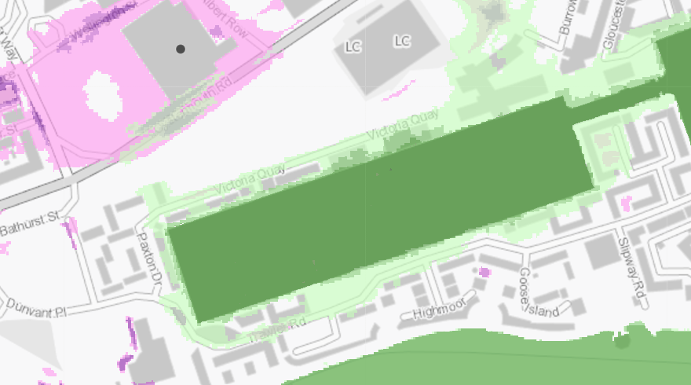
(National Resource Wales, 2025).
Another historical aspect to consider is the site flood risk. The above image is taken from the natural resource Wales map highlighting potential flood risks from sea, rivers and small surface waters. According to the map, the site itself has a low risk of flooding from the sea and rivers but a medium risk of flooding from surface water. The site adjacent however, has a high risk of flooding from the sea as shown in the dark green above (National Resource Wales, 2025).
Radon Level
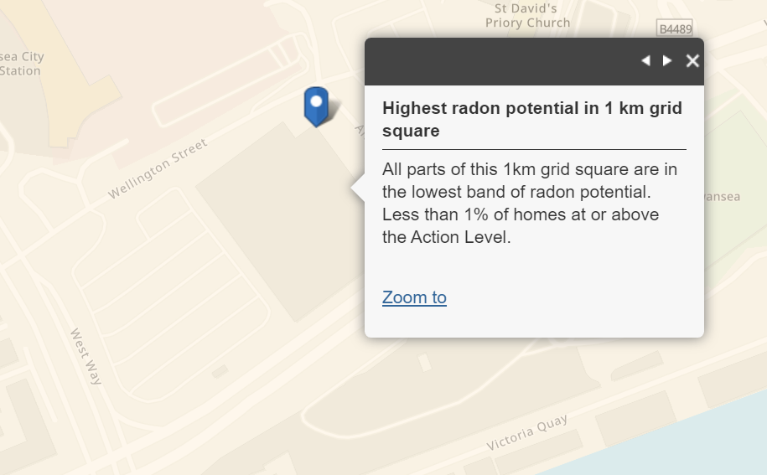
(Public Health England, 2022)
According to Public Health England, the site location is in the lowest band for radon potential.

5.Archaeological Findings
The archaeologic history of the site should be considered when carrying out the site investigation. The area of Swansea contains some of the earliest evidence in history of human occupation with the discovery of the Paviland Cave and the burial of the misnamed ‘Red Lady’ (The Royal Commission on the Ancient and Historical Monuments, 2018). Although this features outside of the radius of the site, it still shows the need to consider these findings and the impact they can have on the timeline of a project. According to Coflein’s archaeological desk study of a nearby area, there are several sites of archeologic interest within the location of our site (Bowen, 2011). Any archaeological findings will need to be reported. The discovery of archaeological artifacts can have an impact on the timeline of a project as all work may have to stop.

6.Considerate Contractors Scheme
The location of the site is in a prominent part of Swansea. In the surrounding areas there are houses, businesses, bus stations, restaurants, public pathways and several other facilities that is of use to the public. While undertaking the site investigation and construction of the project, these surrounding areas will need to be taken into consideration. The considerate contractors scheme stipulates many guidelines that will need to be followed to ensure disturbance to the public will be minimal. Making sure work is only carried out within agreed hours will minimise disruption to the public as well as ensuring dusty or noisy work is carried out in a controlled environment. There are multiple guidelines which ensure the environment is also cared for, for example turning unused plant and equipment is turned off to minimise emissions and using materials carefully to avoid wastage. (Considerate Contractors Scheme, 2024).
A framework for safe working should also be developed. Procedures will need to be put in place to minimize risks from contamination when carrying out, removing and transporting samples. Physical hazards on site will need to be carefully managed when heavy equipment and tools are being used. The land itself is highly likely to be uneven and have shards of glass or metal within it. Personal Protection Equipment and cleaning facilities will need to be supplied and used to minimize risk to workers and visitors visiting the site. Site access should be closely controlled and site boundaries clearly indicated. Signage and care plans should be well known and visible in case of an accident or emergency (Considerate Contractors Scheme, 2024).
As well as taking into consideration the site boundaries, potential road closures will need to be considered. Oystermouth Road is a busy road in Swansea and can frequently be closed for various events throughout the year potentially conflicting site access. These road closures will need to be carefully monitored.

7.Recommended Foundations
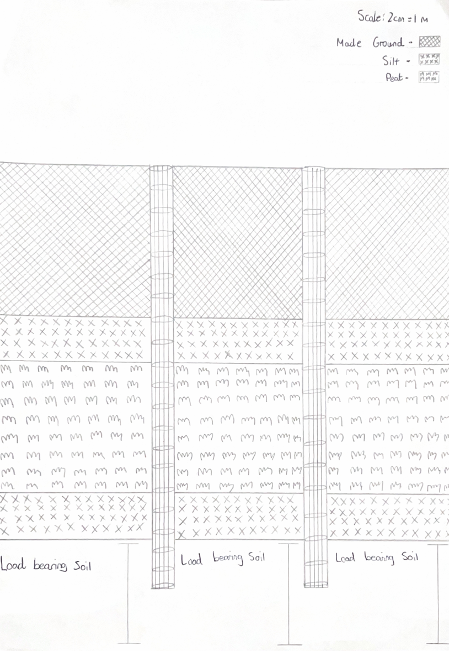
Given the existing information outlined above, the recommended foundation type for the building is piling using a Continuous Flight Auger (CFA) method. Steel or reinforced concrete will be the most suitable material to use. This is based on archival and geotechnical data as well as the size and nature of the building. As mentioned previously, we also have the Civic Centre foundations to provide additional evidence to support the use of piles.
The benefit of using continuous flight auger compared to driven is that driven requires soil with quicker drainage capabilities which the sandy silt soil present on our site does not have. The continuous flight auger piles can transfer loads to deeper, stronger soils which removes the problem of the weaker surface level made ground soil being unable to hold the weight (Lees, 2021).
The hotel will feature heavy footfall from guests internally, while externally some harsh weather conditions and wind loading when you consider the location of the hotel close to the beach.
Another benefit of using CFA piling is the timeline process. CFA piling can often be completed quicker which allows the project to be completed on time or ahead of schedule. This shortens the impact on the surrounding area and the environment (Lees, 2021).
A further benefit of CFA piling is that by extending through the weak made ground and silt layer and instead anchoring into more stable, deeper strata, bored piles will help mitigate the risk of settlement; a common issue associated with silt soils (Lees, 2021).
In conclusion, piles provide substantial benefits in construction, particularly in areas with poor soil conditions, high load requirements, or environmental sensitivities. They offer a reliable, long-lasting, and efficient method for transferring loads to deeper, more stable layers of the earth, ensuring the safety of the structure especially in taller buildings.

8.Reference List
BBC News (2021). Swansea blitz: Childhood memories of ‘bombing horror’, 80 years on. BBC News. [online] 19 Feb. Available at: https://www.bbc.co.uk/news/uk-wales-56115198 [Accessed 16 Dec. 2024].
BGS (2023). GeoIndex - British Geological Survey. [online] Bgs.ac.uk. Available at: https://mapapps2.bgs.ac.uk/geoindex/home.html?_ga=2.12883442.417173455.1736515352-551578714.1736515352 [Accessed 10 Dec. 2024].
Bowen, F. (2011). Canolfan Glandwr, Prince of Wales Dock- Desk Based Assessment . [online] Coflein. Available at: https://coflein.gov.uk/media/314/712/665374.pdf [Accessed 22 Dec. 2024].
Britain From Above (2025). WPW008832 WALES (1923). View of Swansea. [online] Britainfromabove.org.uk. Available at: https://www.britainfromabove.org.uk/cy/image/WPW008832 [Accessed 10 Jan. 2025].
British Geological Survey (2019). British Geological Survey (BGS). [online] Bgs.ac.uk. Available at: https://www.bgs.ac.uk/ [Accessed 20 Dec. 2024].
Bromley, R.D.F. and Humphrys , G. eds., (1979). Dealing with Dereliction the Lower Swansea Valley. University College of Swansea .
Calc Maps (2015). Topography Map of SA1 3RA. Available at: https://www.calcmaps.com/map-area/ [Accessed 19 Dec. 2024].
Considerate Contractors Scheme (2024a). For Contractors and Suppliers. [online] Considerate Constructors Scheme. Available at: https://www.considerateconstructors.com/for-contractors-and-suppliers/ [Accessed 4 Jan. 2025].
Considerate Contractors Scheme (2024b). For the Public. [online] Considerate Constructors Scheme. Available at: https://www.considerateconstructors.com/for-the-public/ [Accessed 5 Jan. 2025].
Dalling, R. (2019). Forgotten houses and the birth of one of Swansea’s best known buildings. [online] WalesOnline. Available at: https://www.walesonline.co.uk/news/wales-news/forgotten-houses-birth-one-swanseas-15905059 [Accessed 19 Dec. 2024].
Evans, C. and Miskell, L. (2020). Swansea Copper : A Global History. [online] Baltimore, Maryland: Johns Hopkins University Press. Available at: https://www.google.co.uk/books/edition/_/4b4CEAAAQBAJ?hl=en&sa=X&ved=2ahUKEwjtn6vqhOuKAxV8TkEAHbovAaYQ7_IDegQIDBAC [Accessed 17 Dec. 2024].
Google Maps (2019). SA1 3RA · Swansea, UK. [online] SA1 3RA · Swansea, UK. Available at: https://www.google.co.uk/maps/place/Swansea+SA1+3RA/@51.6165582 [Accessed 4 Jan. 2025].
https://www.calcmaps.com/map-radius/ (2024). 2km Map of SA1 3RA. Available at: https://www.calcmaps.com/map-radius/ [Accessed 20 Dec. 2024].
Lees, A. (2021). What Are the Types of Piles and Their Construction methods? [online] www.tensar.co.uk. Available at: https://www.tensar.co.uk/resources/articles/what-are-the-types-of-piles-and-their-construction-methods [Accessed 21 Dec. 2024].
National Library of Scotland (1884). Ordinance Survey Showing Gas Works. Available at: https://maps.nls.uk/view/102342508 [Accessed 20 Dec. 2024].
National Resource Wales (n.d.). Natural Resources Wales. [online] naturalresources.wales. Available at: https://naturalresources.wales/guidance-and-advice/environmental-topics/wildlife-and-biodiversity/protected-areas-of-land-and-seas/find-protected-areas-of-land-and-sea/?lang=en [Accessed 19 Dec. 2024].
National Resource Wales (2025). Story Map Series. [online] flood-risk-maps.naturalresources.wales. Available at: https://flood-risk-maps.naturalresources.wales/?locale=en [Accessed 17 Dec. 2024].
Public Health England (2022). UKradon - UK Maps of Radon. [online] Ukradon.org. Available at: https://www.ukradon.org/information/ukmaps [Accessed 19 Dec. 2024].
Ram, E. (2015). Will the UK’s Gas Holders Be Missed? BBC News. [online] 9 Feb. Available at: https://www.bbc.co.uk/news/magazine-30405066 [Accessed 19 Dec. 2024].
Rosenbaum, M.S., McMillan, A.A., Powell, J.H., Cooper, A.H., Culshaw, M.G. and Northmore, K.J. (2003). Classification of artificial (man-made) ground. Engineering Geology, [online] 69(3-4), pp.399–409. doi:https://doi.org/10.1016/s0013-7952(02)00282-x.
Swansea Council (n.d.). Blackpill SSSI (Site of Special Scientific Interest) and Wildlife Centre. [online] Swansea. Available at: https://www.swansea.gov.uk/article/6771/Blackpill-SSSI-Site-of-Special-Scientific-Interest-and-Wildlife-Centre [Accessed 20 Dec. 2024].
Swansea Council (2016). Swansea Tall Buildings Strategy. [online] Swansea Council. Available at: https://www.swansea.gov.uk/article/9916/Supplementary-planning-guidance-SPG [Accessed 17 Dec. 2024].
Swansea Council (2025). Swansea Canal - Swansea. [online] Swansea. Available at: https://www.swansea.gov.uk/swanseacanal [Accessed 10 Jan. 2025].
Swansea Museum (n.d.). Available at: http://www.swanseamuseum.co.uk/swansea-a-brief-history/mumbles-train?doing_wp_cron=1736511026.2616190910339355468750 [Accessed 18 Dec. 2024].
Swansea Museum (n.d.). Mumbles Train. [online] www.swanseamuseum.co.uk. Available at: http://www.swanseamuseum.co.uk/swansea-a-brief-history/mumbles-train [Accessed 18 Dec. 2024].
Swansea University (n.d.). Our Natural Environment - Swansea University. [online] www.swansea.ac.uk. Available at: https://www.swansea.ac.uk/sustainability/natural-environment/ [Accessed 19 Dec. 2024].
The Royal Commission on the Ancient and Historical Monuments (2018). RCAHMW | Paviland Cave and the Ice Age Hunters. [online] Rcahmw.gov.uk. Available at: https://rcahmw.gov.uk/paviland-cave-and-the-ice-age-hunters/ [Accessed 20 Dec. 2024].
UXO, Z. (2024). Risk Maps. [online] Zetica UXO. Available at: https://zeticauxo.com/guidance/risk-maps/ [Accessed 17 Dec. 2024].
Wales Online (2019). Foundations of County Hall. Available at: https://www.walesonline.co.uk/news/wales-news/forgotten-houses-birth-one-swanseas-15905059 [Accessed 12 Dec. 2024].
Water UK (2020). Find Your Supplier | Water UK. [online] www.water.org.uk. Available at: https://www.water.org.uk/customers/find-your-supplier [Accessed 19 Dec. 2024].

