Name – Declan Thomas

Student Number – 1908075

Course – HND Quantity Surveying

Assignment Title – Lighting Layout and Sound Index Calculation

Module – Material Science and Building Services


Table of Contents

Task A 3
Room Index 3
Utilisation Factor – (From Table) 4
The Number of Lamps Required 5
A suitable layout for the lamp fittings 6
Design for the Luminaire Installation 7
Task B 8
Sound Reduction Index for the wall area 8
Implications of frequency and wavelength in Internal Sound Management 10
Reference List 11

Task A

Calculate
- The Room Index
- The Utilisation Factor (from tables)
- The Number of Lamps Required
- A Suitable Layout (Value of S) for the Lamps.

Key information:
- Factory Area = 60M x 24m x 8m in height.
- Factory benches are 1m above floor level
- Areas reflectance’s are – 0.3 for ceiling and 0.5 for the walls
- Light design lumen output = 18,000 lumens required
- Illumination required = 200 lux
- Light loss factor = 0.75

Room Index

Equation
RI = (LxW)
(Hm(L+W))

L = Length of room
W = Width of room
Hm = Height of luminaire from the work plane

Calculation
RI = (60x24) Hm = 8m – 1m
(7(60+24) Hm = 7m

RI = 1,440
588
RI = 2.45

Utilisation Factor – (From Table)

Reflectance
Ceiling = 0.3
Walls = 0.5

Table
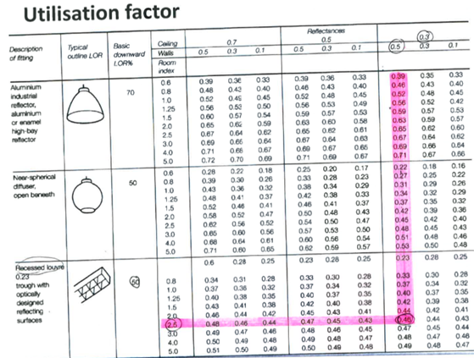

As seen above from the utilisation factor table the value = 0.46

UF Value = 0.46

The Number of Lamps Required

Equation
N = E x A
F x UF x LLF

N = Number of Lamp Required
E = Illuminance level required (lux)
A = Area at plane height (m2)
F = Average luminous flux from each lamp (lm)
UF = Utilisation Factor
Llf = Light Loss Factor

Calculation
N = E x A
F x UF x LLF

N = 200 x 1440
18,000 x 0.46 x 0.75

N = 288,000
6210

N = 46.38

Number of lamps required = 47

Therefore, the best suited number of lamps for the Luminaire installation will be 48Nr of Lamps as a minimum specified is to be at least 70% of the maximum illumination level allowed.

A suitable layout for the lamp fittings

Equation

Smax = 1.5 x Hm

Calculation

Smax = 1.5 x Hm
Smax = 1.5 x 7
Smax = 10.5m metres apart

Design for the Luminaire Installation
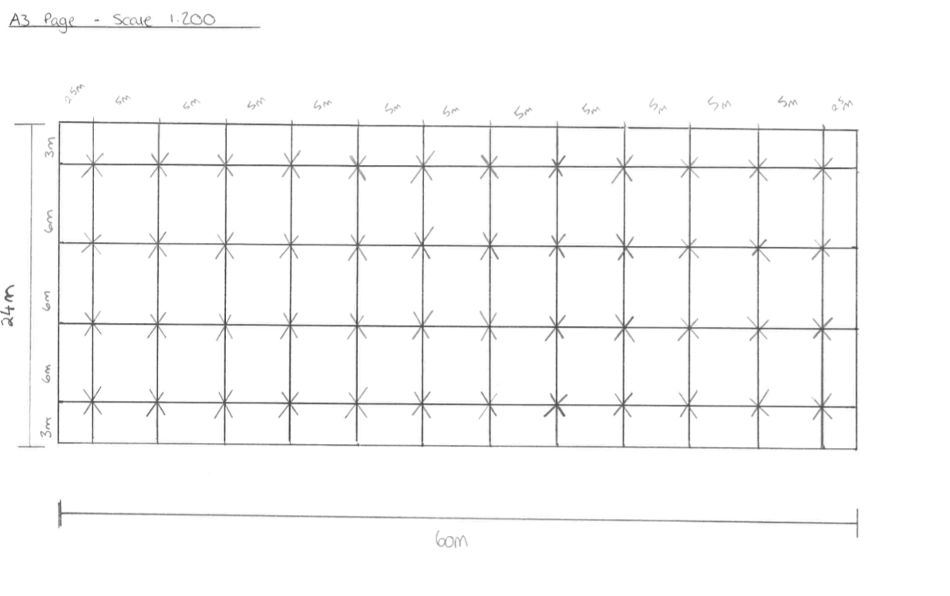

Task B

Sound Reduction Index for the wall area

Question
- A brick wall of area 20m2 contains a window of area 4m2.

Calculate the Overall Sound reduction index for the entire wall.
Values of sound reduction indexes are:
- 50dB for Brick Work
- 10dB for Window

Calculation
Brick work = 20m2 (50dB)
Window = 4m2 (10dB)
Equation
SRI = 10 x (log10(I/T)

Brick work Calculation
SRI = 10 x (log10(I/T)
50 = 10 x (log10(I/T)
5 = log10 (I/T)
I/T = 10⁵
T = 0.000010

Window Calculation
SRI = 10 x (log10(I/T)
10 = 10 x (log10(I/T)
1 = log10(I/T)
T = 10⁻¹
T = 0.10
Equation

T = (T1 X A1) + (T2 X A2)
A1 + A2

T = (0.000010 x 16) + (0.10 x 4)
16+4
T = 0.0016 + 0.4
20
T = 0.40016
20
T = 0.020008

SRI = 10 x (log10(I/T)
SRI = 10 x (log10)I/0.020008)
SRI = 10 X (log10(49.98)
SRI = 10 X 1.6987
SRI = 16.987
SRI = 17dB

Overall Sound index = 17dB

Implications of frequency and wavelength in Internal Sound Management

Frequency of sound is a number of pressure variations passing a given point per second, which is measured in Hertz (Hz) and can be defined as ‘cycles per second’. Frequency is also the speed of vibrations that can determine the pitch of the sound. Wavelengths are calculated in the horizontal length of one cycle wave. Sound transmission is sound of which can be passed through a partition, by converting into mechanical vibrations in the material of the wall. (Partitions such as wall etc).
Following this, the sound transfer will be either classed as airborne or impact sound. Airborne sound is sound which radiates directly from a source that will travel through the air. The sound of passing traffic in the streets or outside of our homes are a prime example of airborne sound. Impact sound or which is also known as structure borne sound is sound that can travel through solid materials usually in direct mechanical contact with the sound source, or from an impact on that material. Prime example of this would be the next-door neighbour knocking on the front door. As we can feel vibrations in the material, this is also structure borne sound but in order for us to hear structure borne sound it must eventually become airborne sound, this will then allow us to hear it. It is very important that the both structure borne sound and airborne sound are both taken into consideration in noise control situations.
Sound insulation is the main method of controlling any sound management in a dwelling. The definition of sound insulation is ‘reduction of sound energy transmitted into an adjoining air space’. Meaning most is transmitted through a partition as either airborne or impact noise. When insulating, it shall depend on which of the two transfer methods will prevail. The airborne sound insulation will be measured by the differences between the two sound levels each side of the wall. This would also depend on the density of the material and the frequency of the sound. Additionally, this will also show the effectiveness of the airborne sound insulation. As an example, if one side of the partition is 100dB and the other side is 50dB, the sound reduction index of the wall would be 50dB. However, partition walls can often include windows and door which will have a reduced sound reduction index than a wall.
Additional to transmitted sound, there are also two other types of sound which are Absorbed sound and Reflected sound. Reflected sound is portion of original sound waves that will stay contained within a room. Absorbed sound is a reduction in the sound energy after reflection from a surface. Meaning there is a loss of sound energy when sound waves meet an absorbent material such as walls, ceiling and floors. Also, we can use material to absorb sound, the thickness on a material will have great impact on sound quality.
There are many types of insulation within the modern construction. The insulation I have chosen to use would be the mineral rock wool insulation. A key benefit of using the rock wool insulation is that is naturally moisture resistant and it shall retain its insulation qualities when wet. The insulation will also act as a good sound barrier. This type of insulation can come in many different shapes and sizes and is very easy to cut, shape and install. Also, the mineral rock wool can be used on many surfaces such as walls, roofs and flooring.

Reference List

https://www.insulationshop.co/top_five_insulation_materials_keeping_you_warm.html
https://www.controlnoise.com/support-tools/about-sound-waves/sound-wave-reflection/
https://www.designingbuildings.co.uk/wiki/Sound_absorption

