TITLE PAGE

Title:
Investigating the Effect of Sodium Chloride on the Mummification and Decomposition of Apple Tissue

Student Name: Alistair Meiring
Student ID: 2306262
Course: Ancient History
Module: Ancient Lives in Death
Institution: University of Wales Trinity Saint David
Date of Submission:

Abstract
Mummification is a preservation process involving the removal of moisture from biological tissues, thereby inhibiting microbial and enzymatic activity. This study aimed to investigate the effect of sodium chloride on the rate of decomposition in apple (Malus domestica) tissue as a model for mummification. A controlled experiment was conducted in which one half of an apple was treated with sodium chloride while the other served as an untreated control. Both samples were stored in airtight conditions and observed over seven days.
The control sample exhibited rapid decomposition, characterised by softening, moisture accumulation, microbial growth, and strong odour. In contrast, the salted sample demonstrated progressive dehydration, reduced microbial activity, and preservation of structural integrity. These findings support the hypothesis that sodium chloride slows decomposition by reducing water availability through osmotic processes.
However, limitations such as the absence of quantitative measurements and small sample size reduce the reliability of the findings. Despite this, the experiment effectively demonstrates the role of water activity in biological decay and supports the use of salt as a preservation agent. The study provides a simplified but valuable model for understanding the principles underlying mummification.

Introduction
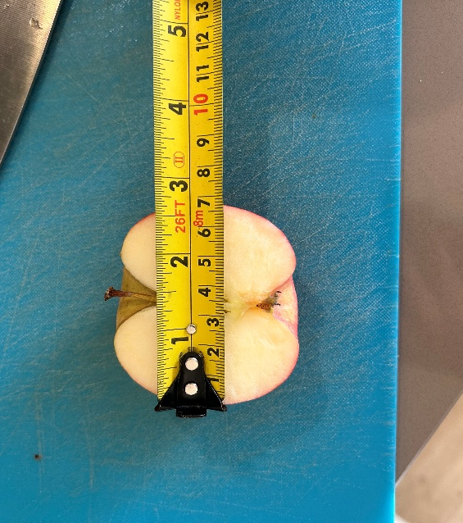
Mummification is a preservation process characterised by the dehydration of biological tissues, which inhibits both microbial growth and enzymatic degradation. Historically, this process is most notably associated with ancient Egyptian burial practices, in which naturally occurring salts such as natron were used to desiccate bodies and prevent decomposition. From a scientific standpoint, mummification can be understood as the reduction of water activity within biological tissues, thereby limiting the biochemical and microbiological processes responsible for decay.
The decomposition of organic matter occurs through two principal mechanisms: autolysis and putrefaction. Autolysis involves the breakdown of cells through the action of endogenous enzymes, while putrefaction is mediated by microorganisms such as bacteria and fungi that metabolise organic substrates (Madigan, 2018). Both processes are highly dependent on water availability, as water acts as a medium for enzymatic reactions, nutrient transport, and microbial metabolism. Consequently, limiting water availability is a key strategy in delaying or preventing decomposition.
Figure 1: A photo showing the width of the tested apple half
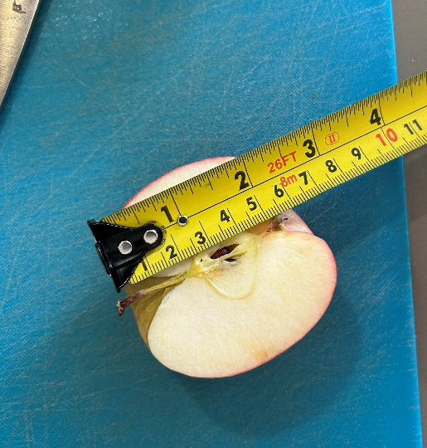
Sodium chloride (NaCl), commonly known as table salt, is widely used as a preservative due to its hygroscopic properties and its ability to reduce water activity. Through osmotic pressure, salt draws water out of cells, creating a hypertonic environment that inhibits microbial growth. In microbial cells, this can lead to plasmolysis, where the cell membrane shrinks away from the cell wall, ultimately impairing cellular function or causing cell death (Jay, 2005). This mechanism underpins traditional food preservation techniques such as curing and salting.
Figure 2: A photo showing the height of the tested apple half
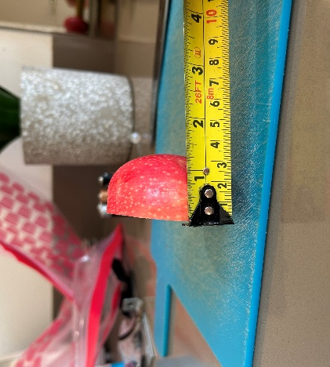
Apples (Malus domestica) provide a suitable model organism for investigating decomposition due to their high-water content, soft tissue structure, and susceptibility to both enzymatic browning and microbial spoilage. When apple tissue is exposed to oxygen, the enzyme polyphenol oxidase catalyses the oxidation of phenolic compounds, resulting in browning (Queiroz, 2008). Over time, microbial colonisation leads to further degradation, including softening of the tissue, discolouration, and the production of odorous compounds associated with decay.
Figure 3: A photo showing the depth of the tested apple half
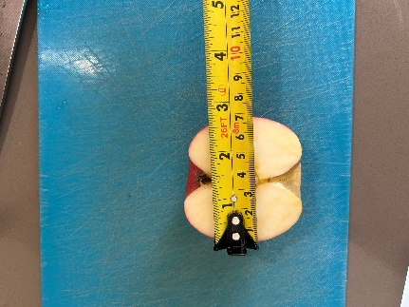
This experiment seeks to investigate the role of sodium chloride in simulating the process of mummification by comparing the rate and characteristics of decomposition in salted and unsalted apple tissue. While the experimental model is highly simplified compared to real-world mummification, it provides a useful framework for exploring the fundamental principles of preservation, particularly the role of water activity in biological decay.

Figure 3: A photo showing the width of the control apple half

Aims and Hypothesis
Aim
The aim of this investigation was to evaluate the effect of sodium chloride on the rate of decomposition of apple tissue and to assess its role in promoting mummification through dehydration.
Hypothesis
It is hypothesised that the apple sample treated with sodium chloride will exhibit a significantly reduced rate of decomposition compared to the untreated control sample. This is because the salt is expected to lower water availability through osmotic processes, thereby inhibiting microbial growth and enzymatic activity, resulting in partial preservation of the tissue.
Method
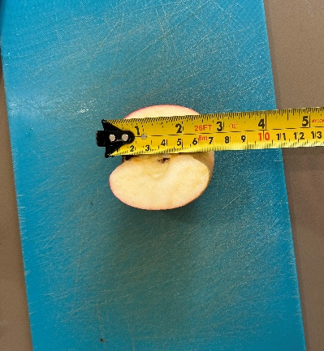
Design
A controlled comparative experimental design was employed. Two samples derived from the same apple were used to minimise biological variability. The independent variable was the presence or absence of sodium chloride, while the dependent variable was the extent and rate of decomposition over time.
Figure 5: A photo showing the height of the control apple half
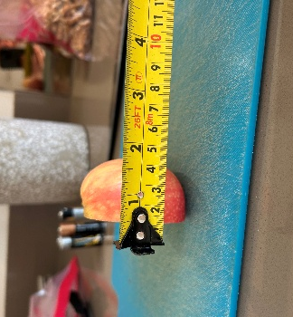
Several variables were controlled to ensure experimental validity. These included the environmental conditions (room temperature and light exposure), the size and origin of the apple samples, and the storage method. Both samples were placed in airtight plastic bags to reduce external contamination and maintain consistent conditions.
Figure 6: A photo showing the depth of the control apple half

Materials
- One fresh apple (Malus domestica)
- Sodium chloride (table salt)
- Knife and cutting board
- Two airtight plastic bags
- Sharpie
- Gloves (optional)
- Procedure

The apple was first washed to remove any surface contaminants. It was then cut into two approximately equal halves using a clean knife. One half was designated as the control sample and left untreated. The second half was thoroughly coated with sodium chloride, ensuring even coverage of the exposed surface.

Each sample was placed into a separate airtight plastic bag, which was then sealed and labelled appropriately. Both samples were stored under identical conditions at room temperature, away from direct sunlight. Observations were conducted daily over a period of three weeks, focusing on visible and sensory indicators of decomposition, including colour changes, texture, moisture content, odour, and the presence of microbial growth.

Results
Over the three-week observation period, clear and progressive differences were observed between the control and salted apple samples. Initially, both samples exhibited enzymatic browning within the first few days, indicating that exposure to oxygen had activated polyphenol oxidase in both cases. However, beyond this point, the patterns of change diverged significantly.
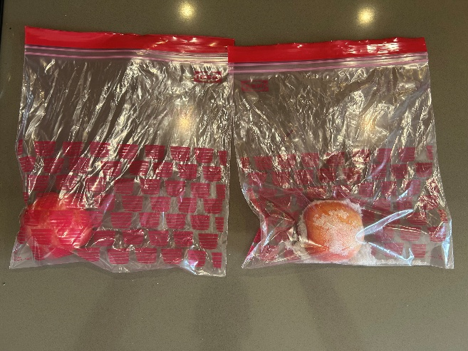
The control sample demonstrated a rapid progression of decomposition. By the end of the first week, the tissue had begun to soften noticeably, accompanied by the accumulation of moisture within the airtight bag. This suggests that cellular breakdown and microbial activity were occurring, releasing water and metabolic by-products. As the experiment progressed, visible mould growth became apparent, indicating the proliferation of fungi. The odour of the control sample became increasingly strong and unpleasant, consistent with the production of volatile compounds associated with microbial metabolism and tissue decay. By the end of the observation period, the control sample had undergone extensive structural degradation, with significant loss of firmness and integrity.
Figure 7: A photo showing the two apple halves in their bags at the start of the experiment
In contrast, the salted sample exhibited a markedly different pattern. Although initial browning occurred, the tissue began to lose moisture rather than accumulate it. Over time, the apple became visibly dehydrated, with the surface developing a shrivelled and leathery appearance. The structure of the tissue remained relatively intact, and there was minimal evidence of microbial growth. Any odour present was considerably less intense than that of the control sample. By the final day, the salted apple displayed characteristics consistent with desiccation and preservation, resembling a mummified state rather than undergoing active decay.
These observations suggest that sodium chloride had a significant impact on the rate and nature of decomposition, promoting dehydration and inhibiting microbial activity.

Discussion of Results
Interpretation
The findings of this experiment strongly support the initial hypothesis, demonstrating that sodium chloride effectively reduces the rate of decomposition in apple tissue. The observed differences between the control and salted samples can be explained through the principles of osmosis and water activity.
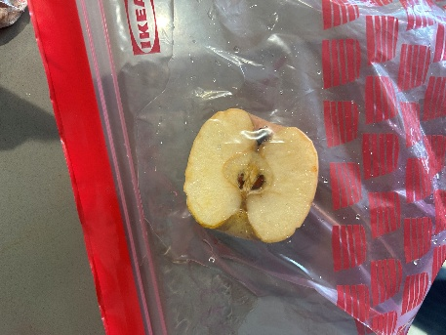
The application of salt created a hypertonic environment around the apple tissue, resulting in the movement of water out of the cells. This process reduced the overall water content of the tissue, leading to dehydration. Since microorganisms require water for metabolic processes, the reduction in water availability would have significantly inhibited their growth (Jay, 2005). This is consistent with the limited mould growth observed in the salted sample.
Figure 8: A photo showing the tested apple at the end of the experiment
Furthermore, the reduced water content would have impaired enzymatic activity within the apple tissue. Enzymes such as polyphenol oxidase require aqueous environments to function effectively. While initial browning occurred in both samples, the progression of enzymatic degradation appeared to slow in the salted sample, suggesting that dehydration limited enzyme function over time.
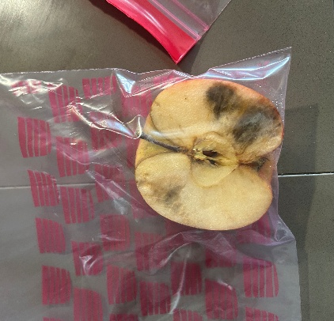
In contrast, the control sample retained its moisture, providing favourable conditions for both autolysis and microbial decomposition. The presence of mould and strong odour indicates active microbial metabolism, which accelerated tissue breakdown. This supports the broader understanding that water availability is a critical factor in the rate of biological decay.
Figure 9: A photo showing the control apple at the end of the experiment
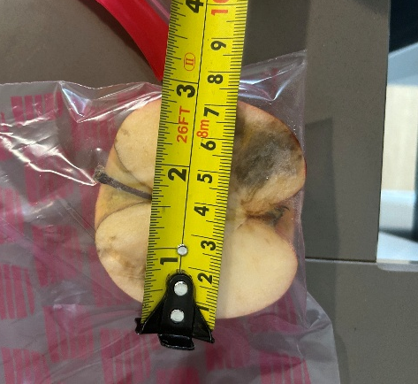
However, while the results are consistent with theoretical expectations, it is important to critically evaluate the extent to which the experiment accurately models mummification. Real-world mummification involves prolonged exposure to desiccating conditions, often in combination with other chemical agents and environmental factors. The simplicity of this experimental model means that it can only approximate these processes.
Figure 10: A photo showing the width of the control apple half at the end of the experiment

Critical Evaluation
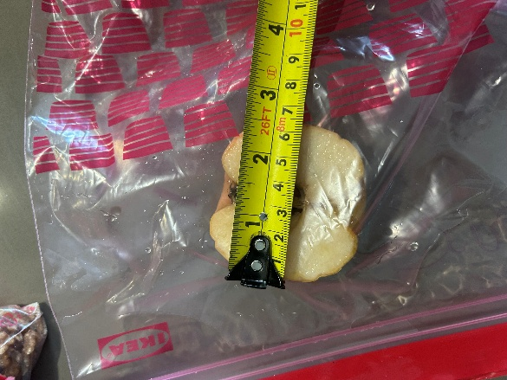
Although the experiment produced clear and interpretable results, several limitations must be considered when evaluating its reliability and validity. One significant limitation is the lack of quantitative data. The observations were primarily qualitative, relying on visual and sensory assessments. While these provide useful insights, they are inherently subjective and may introduce observer bias. For example, assessments of odour intensity or texture are difficult to standardise and may vary between individuals.
Figure 11: A photo showing the width of the tested apple half at the end of the experiment
Additionally, the use of a single apple limits the reliability of the findings. Biological variation between samples could influence the rate of decomposition, and the use of only one replicate per condition reduces the ability to generalise the results. A more robust experimental design would include multiple replicates to allow for statistical analysis and greater confidence in the conclusions.
The use of airtight bags, while intended to control environmental conditions, may also have introduced confounding variables. For instance, the accumulation of moisture within the control sample’s bag may have artificially increased humidity, potentially accelerating microbial growth. Conversely, the sealed environment may have limited evaporation in the salted sample, affecting the rate of dehydration.
Furthermore, the experiment did not control for the exact amount of salt applied, which may affect reproducibility. Variations in salt concentration could influence the degree of osmotic pressure and, consequently, the rate of water loss.
Despite these limitations, the experiment provides a valid demonstration of the general principle that reducing water availability inhibits decomposition. However, the conclusions should be interpreted with caution, and further investigation would be required to produce more definitive results.

Conclusions
In conclusion, the results of this experiment support the hypothesis that sodium chloride reduces the rate of decomposition in apple tissue. The salted sample exhibited clear signs of dehydration and preservation, including reduced microbial growth and maintenance of structural integrity, while the control sample underwent rapid decomposition.
These findings highlight the importance of water activity in biological decay and demonstrate the effectiveness of salt as a preservative agent. While the experimental model is simplified, it provides a useful illustration of the principles underlying mummification and food preservation.
Future research could enhance the validity of these findings by incorporating quantitative measurements, increasing sample size, and exploring additional variables such as salt concentration and environmental conditions.

References
Fellows, P.J., 2009. Food processing technology: principles and practice. 3rd ed. Cambridge: Woodhead Publishing.
Jay, J.M., Loessner, M.J. and Golden, D.A., 2005. Modern food microbiology. 7th ed. New York: Springer.
Madigan, M.T., Bender, K.S., Buckley, D.H., Sattley, W.M. and Stahl, D.A., 2018. Brock biology of microorganisms. 15th ed. Boston: Pearson.
Queiroz, C., Lopes, M.L.M., Fialho, E. and Valente-Mesquita, V.L., 2008. ‘Polyphenol oxidase: characteristics and mechanisms of browning control’, Food Reviews International, 24(4), pp.361–375, available at https://www.tandfonline.com/doi/full/10.1080/87559120802089332, accessed on 26/03/2026
Tortora, G.J., Funke, B.R. and Case, C.L., 2016. Microbiology: an introduction. 12th ed. Boston: Pearson.

Bibliography
Fellows, P.J., 2009. Food processing technology: principles and practice. Cambridge: Woodhead Publishing.
Jay, J.M, 2005. Modern food microbiology. New York: Springer.
Madigan, M.T, 2018. Brock biology of microorganisms. Boston: Pearson.
Queiroz, C, 2008. Polyphenol oxidase and browning. Food Reviews International.
Tortora, G.J, 2016. Microbiology: an introduction. Boston: Pearson.

