

PROGRAMME: MASTER OF BUSINESS ADMINISTRATION

MODULE: MARKETING MANAGEMENT

MODULE CODE: LCMB7024

Assessment Component 2

Student Name: Patel Shivam Vijaykumar

Student ID: 2439811

Table of Contents
1.0 Introduction 3
2.0 Explanation of concept behind the chosen brand 3
3.0 How the brand aligns with current market trends and latest consumer behaviour models 4
4.0 STP Analysis 4
5.0 4Ps of Marketing 6
6.0 Marketing strategy pitch 8
7.0 Reflection 9
References 11
Appendices 14
Appendix 1: NutriFuel Poster 14

1.0 Introduction
The assessment will primarily deal with Nestlé, especially in the form of a strategic brand development plan featuring their latest product, NutriFuel, under their latest beverages section, Nesfusion. Under the Nesfusion brand, a blend of freshness is obtained through early morning tea or coffee, along with workout-specific elements that fitness aficionados seek via protein shakes or other pre-gym related drinks. This portfolio will thus prepare a STP analysis, involving segmentation, targeting, and positioning tactics for identifying potential profiled consumer groups, along with a differentiated reason justifying the brand’s presence among other stalwarts. Moreover, the strategy will also be shaped by a marketing mix approach featuring multiple elements, whereas a pitch will allow the portfolio to propose the brand’s value proposition. This will allow the brand to consider its strategic fitness among Nestlé's different collections.

2.0 Explanation of the concept behind the chosen brand
NutriFuel will exist in the market as a hybrid form of beverage, which will be known in circles as a 'high protein Coffee shake', designed specifically to satisfy fast-moving, conscious users in the UK. The drink will combine Arabica beans in cold-brew form, before blending them naturally with 20g whey or other plant-based protein (Ajibo et al., 2024). That will allow consumers to feel energetic by granting them a slight Caffeine boost, while also looking to repair muscle through synthesis.
The product will also kickstart the new brand ‘Nesfusion', which will create a portfolio of other different category blended drinks together, depending upon the success of 'Nutrifuel’ (Baker et al., 2022).
Moreover, the product and brand were conceptualised by Nestlé, based on the ideology that the UK ready-to-drink market has steadily grown in the last few years. This is characterised by recent trends estimating a $58.3 million revenue business, predicting a compounded annual growth of 16.2% between 2024 and 2030 (Grand View Research, 2023). A YouGov survey also found that among 2106 random adults, nearly two-fifths or 39% Britons consume functional drinks (Fernandes, 2025). While 31% regularly consume ready-to-drink brands like Lucozade, Red Bull, or Monster Energy, ‘NutriFuel’can give a healthy substitute where customers do not have to feel anxious about ingredients, quantity intakes, or even volume to use per glass (Fernandes, 2025). Since instructions will be clarified behind the packs and jars.

3.0 How the brand aligns with current market trends and latest consumer behaviour models
Recent data has also surfaced within the UK, as established by the Nespresso Professional, where consumers of different ages have reported their interests towards functional beverage drinks. This might be through flavouring with intense Coffee beans, while backing its contents with a higher quantity of Protein powder, with reduced amounts of other elements like Carbohydrates, Fat, and Vitamins (Kowalska et al., 2024).
The consumers expressed their mindsets, especially while seeking drinks which support their early morning energy but also accommodate their forgetfully busy schedule. That might prevent them from taking Whey protein post-workout (Baker et al., 2022). Hence, 1 out of 5 (that is, around 21%) millennials aged around 27-40, including male and female consumers, expressed how they wanted a drink which can meet both pre- and post-workout requirements (Cullumbine, 2024). That can save them time by allowing them to pack a single drink worth enough quantity to last both intended meal fulfillments, as they always exercised with friends or a partner in the gym, so it was easier to share with 2 glasses worth of a single functional drink (Dickson et al., 2023). These consumers also wanted the coffee beans ground into drinks to be around 70mg-80mg, while the rest of the energy markup is clinched by another protein-based ingredient (Cullumbine, 2024).
Moreover, the parents of many Generation Z consumers (aged around 18-23), including males and females, have shown their desire to look for trustworthy wellness-focused drinks. That might allow their teenagers or other barely adult-aged consumers to meet the need for Collagen, Protein, or Vitamin components (Cullumbine, 2024).

4.0 STP Analysis
Market Segments for NutriFuel
Demographic segment: The functional drink necessity in the last few years has been driven vigorously by Generation consumers (aged 18-24). They include male and female genders, while a part of their decisions are made by millennial parents (aged 36-45), making decisions for them in a smaller capacity with a disposable income of around £25000-£40000 (Qualityfoodawards.com, 2025). Data shows that 54% have directed an interest towards Collagen fortified drinks, with additional Vitamin and Probiotic requirements, whereby Parents have also pointed out their suspicion on such combined element-based drinks, inquiring about smaller element blended drinks (Qualityfoodawards.com, 2025). This is mainly due to the intake ability of the consumers and their age, which might support this. Hence, Nestlé's ‘Nesfusion’ brand could bring its own version of blended drink offerings using ‘NutriFuel’, which can interest such a market segment (Ajibo et al., 2024).
Psychographic segment: Almost 45% of the UK consumers have the intention of consuming healthy ready-to-drink products, after considering the limitations of excessive Caffeine components which are normally found in Coffee blends (Dickson et al., 2023). Whereas, 55% other consumers engaged in different blends of similar ready-to-drink shakes normally prefer adequate Sugar and Salt quantities (Statista, 2024). However, 17% of the consumers are also of the opinion that consuming drinks separately, which contain energy, Protein, or Carbs, could be avoided by substituting them with a product that contains a fusion of one or two elements (like Protein and Vitamins) (Statista, 2024). Thus, Nestle’s ‘Nesfusion’ brand products in the form of ‘NutriFuel’ could be offered to such consumers to make up their minds.
Target market: ‘NutriFuel’ would initially look to target a demographic market segment in the form of Generation Z masses (averaging between the ages of 19-23), including male and female consumers (Nuss et al., 2021). While these customers will be given the choices of two different types of the products, in the form of Plant-based Protein Coffee or Normal-based Protein Coffee, the consumers can themselves decide their own requirements and even allow their millennial parents to make their decisions for them in terms of choice (Ariffin et al., 2022). However, in the majority of cases, 'NutriFuel' will rely on the personal choices made by the direct Generation users.
Positioning statement: Nestle’s new brand ‘Nesfusion’ will differentiate its products like ‘NutriFuel’ based on good quality, which does not compromise the health of the young consumers and allows them to function properly throughout the day (Sudirjo, 2023). While at the initial phase upon market entry, it will charge low-to-moderate price charges for its products by emphasising a volume-related distribution (Sudirjo, 2023). Hence, the items will be available in lower quantity boxes, smaller sachets, or medium-sized packets. Depending upon the brand's success through 'NutriFuel’, the prices might be premiumised later. Therefore, ‘NutriFuel's’ position in the market could be recognised by viewing the map in Figure 1.
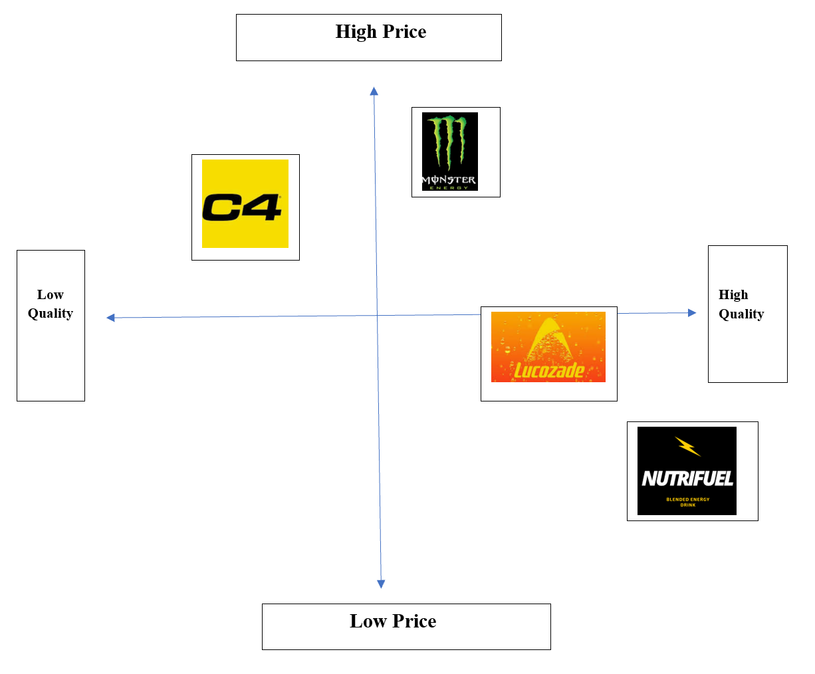
Figure 1: Positioning Map
(Source: Self-created)

5.0 4Ps of Marketing
Product: ‘NutriFuel’ will be distributed within the UK ready-to-drink market as a Coffee-Protein hybrid in two varieties. These varieties will be Coffee with Plant-based Protein or Coffee with Normal Protein. The beans within the drink will be Arabica, which will also be used to serve it in a cold-brew form using an Espresso base, combining up to 20g of Protein (higher-quality). Some of the essential features used within the product are limited sugar essence (which is less than 5g/100 ml and mindfully managed to avoid sugar levy), while natural flavourings will be used to partially neutralise the Protein aftertaste, which can be less accepted among the masses (Beeson, 2024). Such flavours could include the likes of Vanilla, Mocha, or Chocolate.
Meanwhile, the plant-based version of the drink will contain a lower calorific value to capture the interests of the vegan populace or flexitarian masses. The other version of coffee with normal protein will contain relatively higher calorific markup. Each drink will be spread out among 330-350 ml boxes, 25-30 g sachets with single-serving options, and 150-200 ml boxes. The suggestions for use will be as a form of pre-workout, post-workout, for daily communing, and other requirements (Beeson, 2024). Ever since sports nutrition-related interests have grown in the UK, consumers have been seeking hybrid drinks like 'NutriFuel’. This is indicated by a 26.9% growth in overall volume, resulting in a 11% boost in sales (worth £132.4 million) (Beeson, 2024).
Price: As Nescafé's 'Nesfusion’ brand’s ‘NutriFuel’ will look to target the moderate level coffee intakers, it will also look to interest the Sports nutrition catering masses. For instance, the 200-330 ml box variants of ‘NutriFuel' will be priced around £1.60-£2.20 (normal categories or normal protein and coffee blends), and £0.15- £0.30 for low-sugar plant-based protein and coffee blends (The Grocer, 2022). Meanwhile, the sachet versions will cost around £0.75-£1.00, which will try to ensure that consumers can purchase in bulk using multi-card club membership programmes affiliated with different supermarkets (The Grocer, 2022). The price for the product was decided keeping in mind the price-sensitivity of UK consumers, with specific tie-up plans with retailers to ensure loyalty levels can be leveraged for clinching promotional pricing-related schemes. Since Nestle will rely on a promotional push from the retailers, which might initially allow them to disburse large quantities of volume associated with ‘NutriFuel’. Retailers can assist the latter product among Nestle’s brands to take a piece of the £300 million opportunity directly through the UK market (Grocery Trader, 2025).
Promotion: The promotion of ‘NutriFuel' will be brandished by highlighting its dual benefits, which include higher alertness and richer recovery. Moreover, Nestle will take social media platforms like Facebook, Instagram, TikTok, or YouTube to set up campaigns (Sudarman and Lailla, 2023). These will feature pages of the brand ‘Nesfusion', which will lay out different advertisements inspired by global trends and topics to catch the imagination of the users (Sudarman and Lailla, 2023). The TV spots or small commercials will run for 30 seconds, where locally popular or urban professionals and gym owners will promote the brand. Also, Nestle can make their social media page more interactive by allowing 3-4 of its customer relationship managers to directly communicate with interested consumers who follow the page, subscribe to channels, or share and comment on their posts (The Grocer, 2022). Initially, Nestle can also partner up with popular protein brands like Dymatize to release samples. They can decide on the trial period during which the samples will be distributed, before they go on to charge the actual prices. Statistics reveal that the UK has 13 million different buyers who want to enter the ready-to-drink market seeking variety, quality, and good price offers (Grocery Trader, 2025). This allows 50%-60% of the same consumers to clarify their queries using social media, before they go on to try samples of respective energy drink brands (Grocery Trader, 2025). Hence, the social media and sampling strategy as a form of initial promotion could work for ‘NutriFuel’.
Place: A multi-channel distribution plan could be hatched by Nestle for its ‘NutriFuel’ product under the ‘Nesfusion’ brand (Ameyibor et al., 2021). That could allow multiple grocery chains like Tesco plc, Sainsbury’s, and ASDA to possess ‘NutriFuel' in whatever quantity exists within the UK market (in formats between 200 ml and 330 ml) (Carolina and Wirawan, 2021). Whereas, gym vendors like Holland and Barrett or other sports nutrition product sellers like Amazon might also contain the larger quantity version of ‘NutriFuel’ (Ameyibor et al., 2021). The availability of the product will both take advantage of the consumers and their impulsive buying attitudes, which will help create the majority of the demand, centring the market (Carolina and Wirawan, 2021). The sale of the product will also take place all over the UK, especially by focusing more on the urbanised consumers rather than the rural districts. Even if the market remains saturated, Nestle trusts its brand power through ‘Nesfusion’ to drive variable sales and positive revenue surrounding ‘NutriFuel’.

6.0 Marketing strategy pitch
Firstly, ‘NutriFuel’ under Nestle’s ‘Nesfusion' will be a coffee-to-protein hybrid drink designed under two flavours and other blends for the fast-paced, modern lifestyle embracing consumers (Samanta and Arkoudis, 2024). It serves as a go-to option for consumers who want energy and recovery in some gulps. Since the ready-to-drink coffee market is projected to grow by 16.4% by 2030, the time might be conducive for Nestlé to cash in on the minds of consumers by offering them a chance at refreshment and focus with a few small sips. [Referred to Appendix 1]
Secondly, using the STP strategy, it was formulated that ‘NutriFuel’ will target a consumer group aged between 19 and 23, male and female both, with some of these consumers depending on their millennial parents to make their decisions. However, 'NutriFuel’ will try to empower the same consumers with their own personalised choices using their tagline ‘Try Fresh and Recovery Best’. The same brand will be promoted by gym owners, local urbanised stars, and other popular figures. [Referred to Appendix 1]
Thirdly, Nestle has also organised a pricing range for its consumers that considers their pocket worthiness, but also takes into account their ability to pay for quality. This was witnessed through the 4Ps marketing mix strategy, which also emphasised its overall appeal, which will take shape through social media handles of Facebook, Instagram, TikTok, or YouTube.

7.0 Reflection
Description: The task experience allowed me to become familiar with the brand development concept, especially its prerequisites that companies consider while making it suitable before releasing it into the market. Through ‘NutriFuel' by Nescafé's 'Nesfusion' brand, I was able to participate in the methods applied for delivering a linearly working marketing strategy, an inspired pitch, and a persuasive delivery of appeal. This allowed me to combine both analytical thinking and researching real-market data to bring about a strategic coherence for a brand like Nestlé.
Feelings: The assignment brief allowed me ample room to test my creativity borne through innovation. However, I was unsure about the product choice or branding to begin with, before progressing with the strategy. This was mainly due to the commercial viability of the read-to-drink variety products, which creates dubious thinking among researchers. Meanwhile, my confidence grew as I moved forward in the assignment, as market research confirmed my conjectural reasoning. I also felt glad that I learned a lot about the supplement industry for gym goers and regular coffee drinkers, which enabled me to learn about engagement and motivating consumer groups.
Evaluation: A few strengths which I noticed about myself through the work understood genuine consumer requirements. That allowed me to gauge the minds of coffee drinkers and protein shake-seeking buyers. My concept of the STP (segmentation, targeting, and positioning) also improved when I applied the brand strategy for a specific set of consumer groups across the UK.
Analysis: I was able to show the interconnectedness of my ideas courtesy of the academic models. Additionally, my experience reaffirmed the significance of situating creativity within justified evidence. I was able to surface target market contextualisation using logic around the development of the frameworks like STP and Marketing Mix (Kotler and Keller, 2016). My research ability was once again tested by exploring lifestyle trends and sugar levy implications and the total beverages sector. This allowed me to compare both consumer expectations with competitor benchmarks. This helped me refine my pitch to accurately convey the brand's value proposition (Sharp et al., 2024).
Conclusion: The assessment allowed me to learn the successful implementation of creativity, innovation, practicality, and research-centric developments. This allowed me to realise the value of iteration, or evolving my ideas with tested research as obtained from the market in question.
Action Plan: In the case of future projects, I will try to improve my approach towards gathering evidence from the market. That might help me to guide concepts and development of brands, using comparative analysis for refining positioning through product varieties and their blends. This will enhance the quality of the pitch I might be willing to deliver for illustrating ideas.

Appendices
Appendix 1: NutriFuel Poster

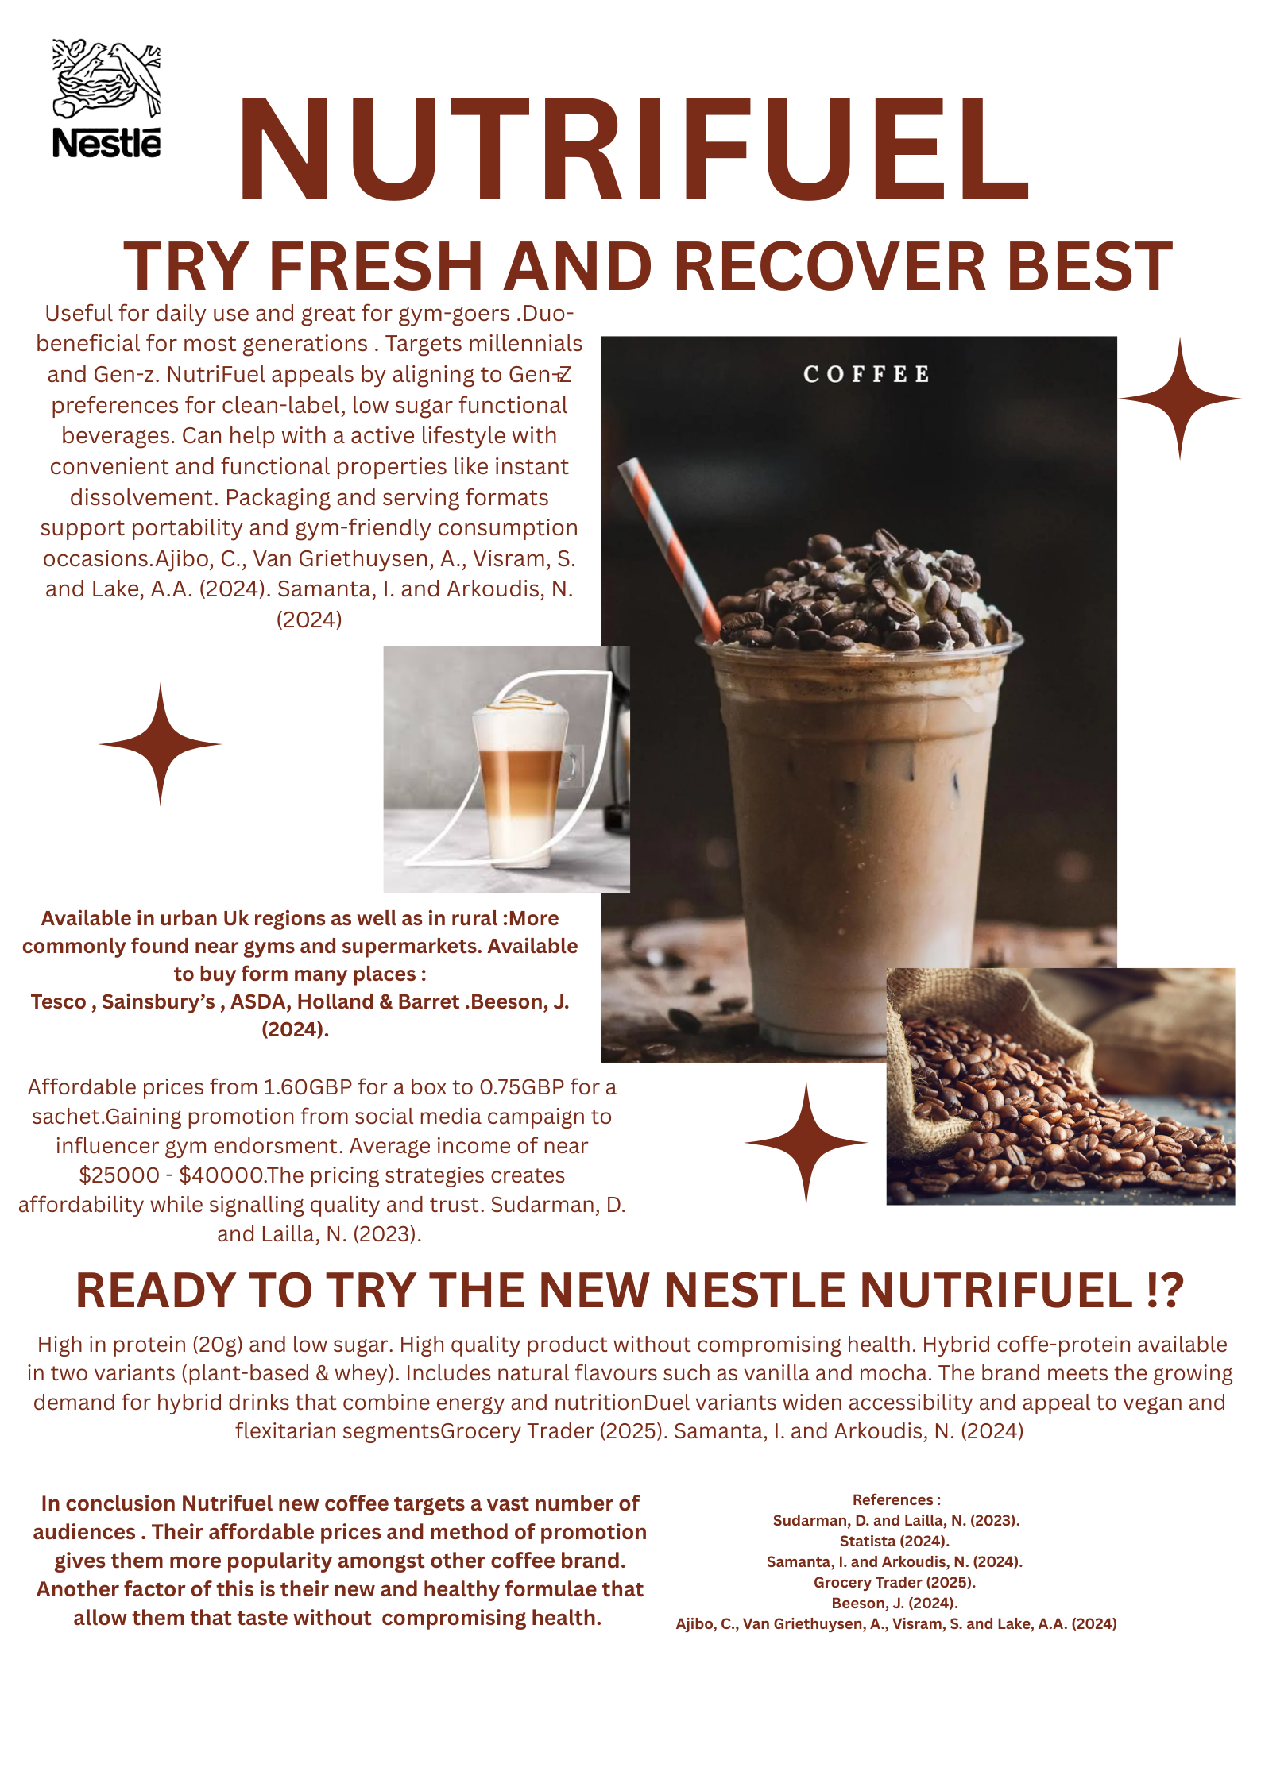

References
Ajibo, C., Van Griethuysen, A., Visram, S. and Lake, A.A. (2024). Consumption of energy drinks by children and young people: A systematic review examining evidence of physical effects and consumer attitudes. Public Health, [online] 227, pp.274–281. Doi: https://doi.org/10.1016/j.puhe.2023.08.024.
Ameyibor, L.E.K., Anabila, P. and Saini, Y.K. (2021). Brand positioning and business performance of alcoholic beverage firms in an emerging market context: the mediation effect of brand equity. International Journal of Wine Business Research, ahead-of-print(ahead-of-print). Doi: https://doi.org/10.1108/ijwbr-11-2020-0056.
Ariffin, H., Chong, X.Q., Chong, P.N. and Okechukwu, P.N. (2022). Is the consumption of energy drinks beneficial or detrimental to health: a comprehensive review? Bulletin of the National Research Centre, 46(1). Doi: https://doi.org/10.1186/s42269-022-00829-6.
Baker, M.T., Lu, P., Parrella, J.A. and Leggette, H.R. (2022). Consumer Acceptance toward Functional Foods: a Scoping Review. International Journal of Environmental Research and Public Health, [online] 19(3), p.1217. Doi: https://doi.org/10.3390/ijerph19031217.
Beeson, J. (2024). Starbucks to launch a range of protein drinks with coffee. [online] The Grocer. Available at: https://www.thegrocer.co.uk/news/starbucks-adds-trio-of-rtd-protein-drinks-with-coffee/692123.article [Accessed 4 Nov. 2025].
Carolina, V. and Wirawan, C. (2021). Marketing Strategy Proposal for Fresh Beverage Product. Journal of Management and Energy Business, 1(1), pp.35–50. Doi: https://doi.org/10.54595/jmeb.v1i1.10.
Cullumbine, L. (2024). Next Generation of Coffee Drinkers Seek Functional Blends to Support Wellbeing - Retail Focus Magazine - Retail Design. [online] Retail Focus Magazine - Retail Design. Available at: https://retail-focus.co.uk/next-generation-of-coffee-drinkers-seek-functional-blends-to-support-wellbeing/ [Accessed 4 Nov. 2025].
Dickson, A., Gehrsitz, M. and Kemp, J. (2023). Does a Spoonful of Sugar Levy Help the Calories Go Down? An Analysis of the UK Soft Drinks Industry Levy. The Review of Economics and Statistics, 15(4), pp.1–29. Doi: https://doi.org/10.1162/rest_a_01345.
Fernandes, J. (2025). How many Brits are consuming energy drinks, protein shakes, and probiotic beverages regularly? [online] Yougov.com. Available at: https://yougov.com/en-gb/articles/51615-how-many-brits-are-consuming-energy-drinks-protein-shakes-and-probiotic-beverages-regularly? [Accessed 4 Nov. 2025].
Grand View Research (2023). UK Ready To Drink Cocktails Market | Industry Report, 2030. [online] www.grandviewresearch.com. Available at: https://www.grandviewresearch.com/industry-analysis/uk-ready-to-drink-cocktails-market-report [Accessed 4 Nov. 2025].
Grocery Trader (2025). Energising sales – Sports & energy products are growing, as consumers seek refreshing and healthy options | Grocery Trader. [online] Grocery Trader | Grocer News from Grocery Trader - Latest news and information for the multiple grocery trade in the UK. Available at: https://grocerytrader.co.uk/energising-sales-sports-energy-products-are-growing-as-consumers-seek-refreshing-and-healthy-options/ [Accessed 4 Nov. 2025].
Kotler, P. and Keller, K.L. (2016). Marketing Management. 15th ed. Harlow: Pearson Education.
Kowalska, A., Leoniak, K. and Sołowiej, B.G. (2024). Consumers’ attitudes and intentions toward functional beverages: a lesson for producers and retailers. Decision, 51(3), pp.321–337. Doi: https://doi.org/10.1007/s40622-024-00395-y.
Nuss, T., Morley, B., Scully, M. and Wakefield, M. (2021). Energy drink consumption among Australian adolescents is associated with a cluster of unhealthy dietary behaviours and short sleep duration. Nutrition Journal, [online] 20(1). Doi: https://doi.org/10.1186/s12937-021-00719-z.
Qualityfoodawards.com (2025). Gen Z drives 54% surge in UK functional drinks as health replaces caffeine and alcohol. [online] Qualityfoodawards.com. Available at: https://uk.qualityfoodawards.com/QFA2025/en/node/newsarticle-gen-z-drives-54-surge-in-uk-functional-drinks-as-health-replaces-caffeine-and-alcohol?type=NewsArticle [Accessed 4 Nov. 2025].
Samanta, I. and Arkoudis, N. (2024). The Impact of Modern Lifestyles on Eating Habits and Food Shopping Behaviours: A Case Study of Omnichannel Retail Consumers Aged 25–40 in Athens. Sustainability, [online] 16(17). doi:https://doi.org/10.3390/su16177521.
Sharp, B., Dawes, J. and Victory, K. (2024). The market-based Assets Theory of Brand Competition. Journal of Retailing and Consumer Services, [online] 76(5). doi:https://doi.org/10.1016/j.jretconser.2023.103566.
Statista (2024). Health and wellness food trends in the UK. [online] Statista. Available at: https://www.statista.com/topics/6843/health-and-wellness-food-trends-in-the-uk/ [Accessed 4 Nov. 2025].
Sudarman, D. and Lailla, N. (2023). The Influence of Marketing Strategy and Marketing Mix on Marketing Performance of Ready-to-Drink Beverages Through Brand Image. International Journal of Professional Business Review: Int. J. Prof.Bus. Rev., [online] 8(9), p.11. Doi: https://dialnet.unirioja.es/descarga/articulo/9070094.pdf.
Sudirjo, F. (2023). Marketing Strategy in Improving Product Competitiveness in the Global Market. Journal of Contemporary Administration and Management (ADMAN), 1(2), pp.63–69. Doi: https://doi.org/10.61100/adman/adman.
The Grocer (2022). How retailers can benefit from the success of the energy drinks sector. [online] The Grocer. Available at: https://www.thegrocer.co.uk/promotional-features/how-retailers-can-benefit-from-the-success-of-the-energy-drinks-sector/668282.article [Accessed 4 Nov. 2025].

