University of Wales Trinity Saint David
Internationat Meetings Management
for the
Hotel Industry
BMIH 6007
Student name: Nicolae Feraru Lecturer: Kathryn Flynn
Student id number: 2225689 Wordcount: 2754
Submission due date:13 /06/2025
“Year of Croeso”
I confirm that I have not presented any AI generated text as my own work. I confirm I have copies of my drafts, notes, and other resources I used before, and after the use of AI tools which I may be asked to provide in evidence.
Table of Contents
1. Executive Summary
2. Introduction (Background and Description)
3. The Event Cycle
4. The Event Concept Proposed Full Itinerary
5. Aim and Objectives of the Meeting/Event SMART Objectives
6. Event Management
7. Event Budget
7.1 Income
7.2 Expenditure
7.3 Analysis of Costs and Funding Sources
8. Industry Trends / Issues / Impacts
9. Situational and Cultural Considerations
9.1 Situational Factors and Business Analysis Tools
9.2 Cultural Considerations
9.3 Importance of Considering These Factors
Conclusion
10. Reference List

1 Executive Summary:
The Croeso Culinary & Culinary Conference 2025 as part of „Year of Croeso” campaign aims to highlights Wales identity through its hospitality, vibrant culture and sustainable tourism. The event supports Walesh ambition to grow its cultural tourism economy and enhance repeat visitation by people all around the globe.
Event Highlights: Welsh food tasting; Interactive language taster sessions; Breakout workshops and an optional cultural tour to historic Welsh atractions
Planning & Execution Framework: using the Event Cycle model and guided by EMBOK standards, the event is focused on feasibility, planning execution and post-event evaluation.
The Croeso Cultural & Culinary Conference 2025 is both: a strategic initiative and a cultural celebration by combining Welsh authenticity and inclusive international networking. Its goal is to deliver a global recognition for Wales as a welcoming, world-class MICE destination.
2. Introduction:
This study discusses how to design and execute the Croeso Cultural & Culinary Conference 2025, an international event part of Visit Wales' "Year of Croeso" concept. The Welsh word for "welcome," "Croeso," emphasises the country's friendliness. This cultural and culinary summit showcases Welsh heritage, hospitality, and gastronomy to MICE professionals worldwide, according to Yahoo Finance (2021) (Finimize, 2025).
What's happening?
Croeso Cultural & Culinary conference 2025 will showcase Welsh language, music, and food to hotel staff, event planners, travel and tourism specialists, and foodies from around the world over many days. As part of Wales' "Year of Croeso," the summit promotes "feeling of place," including actual culture, local gastronomy, and Welsh friendliness.
They chose it why?
This event was chosen for two reasons. First, it capitalises on Wales's ambitions to become a top MICE destination, supported by the Welsh Government and Visit Wales. Second, the summit emphasises culturally and environmentally friendly hotel stays. Recent attendees desire more authenticity, therefore the event promotes local culture, language immersion, and eco-friendly hospitality (The Motley Fool, 2021).
Newport's International Convention Centre (ICC) Wales will host the summit. Yahoo Finance (2021) describes the ICC Wales as a modern, eco-friendly venue with cutting-edge AV equipment, open conference space, and easy access to major airports. This site won due to its huge exhibitions, various breakout sessions, and local lodging options. Its proximity to two major international airports makes it easier for foreign participants to get there, which is crucial for an international summit.
Justification and "Year of Croeso" connection:
The event at ICC Wales during the "Year of Croeso" aims to give attendees actual Welsh cultural experiences, such as language taster classes and food shows, to generate short-term revenue and encourage people to return to Wales. Culture, sustainability, and business working together boosts the local economy, supports tourism enterprises, and makes Wales a viable MICE destination worldwide (BP, 2025).
3. The Event Cycle 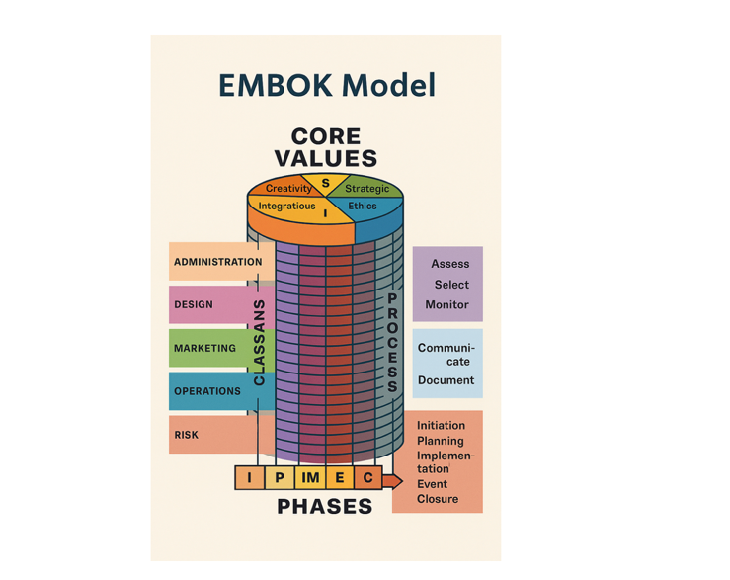

(google,2025)
Planning an event of this size and importance requires thinking about the Event Cycle, which covers the entire event lifecycle from idea to completion and review. The following steps form a popular model. They come from the Event Management Body of Knowledge (EMBOK) and other scholarly sources:
- Starting the event: determining its purpose, feasibility, and context. We do feasibility studies, stakeholder evaluations, and early budget estimates. Assignment 1 found that several groups support Wales's "Year of Croeso" effort (The Motley Fool, 2022).
- Planning: goal-setting, budgeting, risk assessment, and corporate structure. Here, we set the final £250,000 budget for site rental, advertising, hiring, entertainment, backup plans, etc.
- Implementation: Planning, groundwork, supplier coordination, marketing rollouts, delegate registration, and event day operations. This entails negotiating with local florists, caterers, audiovisual firms, and culture groups (FT.com, 2025).
- Event Execution: Hosting the Croeso Cultural & Culinary Conference 2025, where sponsors, exhibitors, and guests interact live. At ICC Wales, venue contact ensures smooth operations.
- Concluding and Evaluating: post-event surveys, sponsor ROI analysis, delegate feedback on cultural immersion and networking opportunities, and tracking key performance metrics like economic impact, social media engagement, and possible return visits (Yahoo Finance, 2024-52) (GuruFocus, 2025).
Using the Event Cycle to prepare the Croeso Cultural & Culinary Summit 2025 emphasises risk assessments, stakeholder participation, and growth before the event. Following this cycle helps event organisers achieve cultural, educational, and business aims.
4. The Event Concept
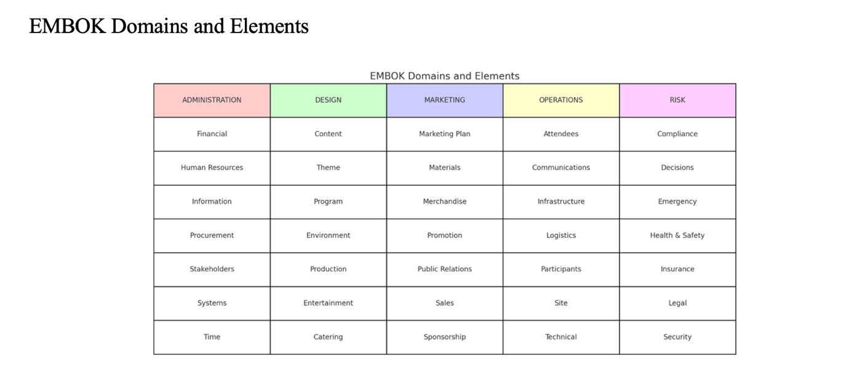
The Croeso Cultural & Culinary Conference 2025 will offer several Welsh cultural and hospitality lessons. Local history, gastronomy, and traditions are combined with hospitality industry trends training to make the event unique (Fool UK, 2025).
Complete Trip Plan
- At the opening ceremony on Day 1, the keynote address emphasised Wales' "Croeso" mindset and the significance of ethnic authenticity in global hospitality marketing.
- Each delegate receives a "Welsh basket" with local delights like bara brith and craft cheeses at the welcoming reception to immerse them in the culture (Yahoo Finance, 2021).
- 2. Morning panel discussions (Day 1 Late Morning): Topic 1: Sustainable Hotel Management Practices, focussing on eco-friendly production, plastic reduction, and carbon footprint minimisation.
- The second issue is tourist digital marketing tactics include data-driven decision-making, influencer marketing, and technology use (Yahoo Finance, 2025).
- 3. Welsh Language Taster Sessions (Day 1 Afternoon): o An interactive mini-class conducted by local language champions from Urdd Gobaith Cymru on fundamental Welsh phrases. Stress how linguistic history gives visitors a real experience.
- On Day 1, chefs will demonstrate Welsh lamb, seafood, and cheese cuisine in the late afternoon. Celebrity chefs and local farmers emphasise "farm-to-table" and sustainable sourcing (MarketBeat, 2021).
Tourism boards, Welsh craftspeople, local manufacturers, and hotel software companies will exhibit at Expo and Networking (Day 2 Morning). While sampling local goodies, delegates can brainstorm ways to collaborate (Financial Times, 20265).
Six afternoon break-out sessions are scheduled for Day 2. Eco-friendly food sourcing, tourism cultural preservation, and event technology will be discussed. Each workshop encourages knowledge sharing and conversation (Oracle Finance, 2025).
7. Day 2 evening extravaganza
Traditional Welsh music, dance, and modern bands will amuse. This harmony accentuates ancient and new, fitting the "Year of Croeso." theme.
8. Cultural Tours (Optional add-on for Day 3) Experience adjacent Welsh sights including the St Fagans National Museum of History before and after the event, following NASDAQ (2025) guidelines. These walks encourage guests to stay longer and learn about the culture (TradingView, 2025).
Due to its cultural authenticity, industry best practices, and networking opportunities, the Croeso Cultural & Culinary Summit 2025 is a terrific location to learn, collaborate, and have fun.
5. Aim and Objectives of the Meeting/Event
Wales' "Year of Croeso" plan includes presenting an immersive, culturally genuine hospitality summit to foster long-term industry collaborations and repeat visits to become a top worldwide MICE destination (Welsh Finance, 2025).
SMART The aims
1. Clear, quantifiable, achievable, reasonable, and time-bound goal 1
Increase foreign delegates by 20% from the past "Year of Croeso" tourist event. At least 1,000 people from key markets like the US, Germany, Ireland, and several Asian regions should attend the 2025 summit.
2. Goal 2: Secure £100,000 in sponsorship from Welsh food and drink associations, hotel exhibitors, and local attraction sponsors by budgeting's end to fund high-quality audiovisual equipment, interactive cultural exhibits, and a 10% emergency fund (JD Sports Fashion PLC, 2025).
Goal 3: Satisfy 85% of attendees with cultural immersion, networking, and sustainable hotel practises (Yahoo Finance, 2024-52). This will boost word-of-mouth and Welsh MICE event bookings.
These objectives match the event's main objective. They also set explicit targets to track success and adjust strategies midway through (MarketBeat, 2025).

6. Event management skills and tools The Croeso Cultural & Culinary Summit 2025 requires extensive collaboration among diverse individuals with diverse skills.
1. The project manager manages the key schedule, stakeholders, and money (Fool UK, 2025).
Skills: People management, project management, risk management.
2. The marketing lead plans news releases, social media campaigns, personal emails, LinkedIn promotions, and early bird registration techniques.
Copywriting, digital marketing, SEO, and business alliances are skills.
3. The technical crew installs, runs, and fixes LED screens, translation booths, computerised voting systems, and live streaming platforms (FT.com, 2025).
Technical qualifications, virtual and hybrid event tool knowledge, and problem-solving speed are needed.
4. Venue Liaison: Discussing room layouts, procedures, health and safety, and real-time resource coordination with ICC Wales staff (JD Sports Fashion PLC, 2025).
Skills: Negotiate, know the place, and react to last-minute changes.
Local experts in Welsh language and culture are responsible for setting up taster sessions, linking local cultural groups, and ensuring authentic presentations and experiences.
Skill: Cultural awareness, linguistic skills, and tourism knowledge.
6. Logistics and Operations Staff: They manage the registration desk, delegate needs, transportation, signs, crowd control, and general operations on-site (Yahoo Finance, 2025).
Communication, organisation, and guest service skills.
7. Free local tourism college ambassadors
Greet delegates, help locals, bridge cultures, and engage the community.
Skills: People skills, local knowledge, and event hosting.
Operations, planning, and marketing
• Your operational duties include securing supplier contracts with Welsh catering partners that focus on farm-to-table ideas, choosing the best local musicians, and ensuring proper signage and branding.
Plan risk management guidelines, ensure the emergency budget covers currency swings, and schedule staff training (BP, 2025).
• To reach global audiences, send tailored emails to hotel chains, launch LinkedIn campaigns, and partner with VisitBritain, MPI, and ICCA (GuruFocus, 20265).
Outlining defined roles and competencies helps the event management team allocate resources, communicate, and ensure that strategic tasks meet summit goals (NASDAQ, 2025).

7. Events Costs
The Croeso Cultural & Culinary Conference 2025 budgets £250,000 for venue rental, advertising, labour, entertainment, and other expenses. The estimated income and expenses are below:
7.1 Income
Grants and sponsorship: • Visit Wales Grants: £50,000 • Welsh Food and Drink Sponsorship: £30,000 • Partner Hotel Exhibitor Fees: £20,000 (Yahoo Finance, 2024-52).
2. Delegate Registration: Corporate Packages (large hotels and tour operators): £40,000
For UK and international delegations, individual tickets cost around £30,000 (BP, 2025).
3. Platinum, Gold, and Silver Sponsorship Packages: More branding and VIP parties to meet other sponsors. Plans called for £40,000.
Revenue should reach £210,000.
Note: To be safe, seek more sponsors or modify cost calculations to match and exceed £250,000. How many sponsors and partners sign up will determine any adjustments (GuruFocus, 2025).
7.2 Spending
1. Venue rental (ICC Wales): £60,000
2. Promotion and advertising: £30,000
3. Around £40,000 for staff and training
4. Entertainment: £20,000 for Welsh bands, cultural artists, and shows
5. LED screens, translation booths, and voting software cost about £25,000.
6. Welsh-themed catering for various diets: £25,000
7. Emergency fund (10%): £25,000
8. Other expenses (transport, signs, office): £25,000
Total anticipated spending: ~£250,000
7.3 Funding expenses and sources
Prioritise sustainability: Eco-friendly materials like recyclable signs cost more but are trending in hotels worldwide (Fool UK, 2025).
• Risk Management: A 10% reserve is set aside in case the exchange rate changes, the venue must be changed last minute, or extra security is needed (Yahoo Finance, 2024-52).
ROI thoughts: Sponsors want branding, product placement, and direct networking leads, so strong audiovisual and savvy marketing can make them happier (The Motley Fool, 2025).
The Croeso Cultural & Culinary Conference 2025 seeks profit and education. It will balance sponsorships, money, and ticket sales with a well-planned, high-quality experience.

8. Industry issues, trends, and effects
When designing the Croeso Cultural & Culinary Conference 2025, consider how industry concerns, trends, and effects affect the event's strategic direction and success (CoinCodex, 2025).
1. Sustainability and eco-friendly practices: Demand for sustainable events and hospitality has increased in recent years, favouring destinations with smaller carbon footprints. Sustainable practices include local resources, single-use plastic reduction, and strong recycling sites promote confidence.
2. Hybrid Event Models: In-person and virtual events are growing more popular, so more people may attend. Translation booths, solid streaming infrastructure, and interesting polling benefit remote attendees (MarketBeat, 2025).
Culture: The Conference's Welsh language mini-sessions and local music attract international guests who desire more than a typical gathering.
4. Health and Safety Measures: Global health concerns demonstrate the importance of clear sanitation and crowd control standards for delegate trust (Wise, 2025).
5. Economic uncertainty: Currency exchange rates might affect budgets, especially for international delegate fees and sponsorships (Yahoo Finance, 2024-52). Having a backup fund reduces financial risk.
6. New technologies: Many attendees demand cutting-edge audiovisual equipment, digital networking tools, and simple planning and Q&A apps. When used together, these tools boost attendance value (MarketBeat, 2025).
7. Diversity and Inclusion: o Encouraging speakers from varied origins and covering a variety of subjects, such as gastronomic heritage and digitisation, to demonstrate the global hospitality industry's diversity.
Event planners can satisfy participants and sponsors by aligning the Summit's content and delivery with these industry trends. This relationship boosts tourism, brand loyalty, and Wales's reputation as a welcoming, forward-thinking destination (The Motley Fool, 2021).

9. Consideration of context and culture
9.1 Situational factors and business analysis tools
SWOT analysis can help place the Croeso Cultural & Culinary Summit 2025 in context. A simple summary:
The ICC Wales is new, eco-friendly, and near airports.
Visit Wales and the Welsh Government have significant local government and tourism board support (TradingView, 2021).
A unique cultural and gastronomic character that attracts a rising population of adventurous travellers.
Wales's lack of international recognition is a problem.
It may be difficult to manage local vendors unfamiliar with large foreign events (Hargreaves Lansdown, 2025).
Many foreign delegations fly short-haul to Cardiff or Bristol.
Chances: more people desire cultural and eco-friendly events.
· Partnerships with major hotels and attractions to generate revenue.
Tourism and prolonged stays after the event boost the local economy.
Threats include volatile economies and currencies, which require a solid backup plan (Yahoo Finance, 2024-52) (Fool UK, 2025).
Global health or travel limitations that inhibit international attendance.
A lot of competition from new MICE locations offering similar culture experiences.
9.2 Culture Thoughts
• Promoting Welsh as a living language enhances its authenticity. Mini-sessions educate foreign guests Welsh phrases to show respect and keep things interesting (Yahoo Finance, 2025).
Engaging local partners: Working with local artists, food makers, and musicians enriches the community.
• Following the rules: Culturally sensitive activities like eisteddfod-style shows and male voice choirs help individuals feel linked in ways that are hard to articulate but memorable (FT.com, 2025).
9.3 Why Consider These Things
• Better Delegate Experience: The "Croeso" experience ensures that delegates feel welcome and at home by considering regional and situational variances.
• Risk Reduction: Knowing your SWOT helps you manage risks like currency protection and marketing in new markets (Oracle Finance, 2025).
• Long-term Legacy: The summit incorporates local ties and cultural heritage to build enduring networks and recurrent visits.
Finally, using a technique like SWOT and being aware of cultural variations helps ensure that all aspect of preparation, from resource allocation to marketing, supports the event's goals and Welsh tourism (The Motley Fool, 2025).

Conclusion
Wales' distinctive culture, linguistic legacy, and environmentally sustainable event hosting can boost its international MICE image at the Croeso Cultural & Culinary Conference 2025. Organisers can ensure that each planning phase meets strategic goals by adopting an event cycle model from the first study to the final review. Strong budget structure of £250,000 and distinct financing streams emphasise cultural authenticity and financial certainty. Local specialists, government agencies, and worldwide business partners must collaborate to make the summit's Welsh lessons and cooking demonstrations educational and memorable.
By expanding on industry trends like eco-friendly event hosting, allowing people interact in new ways, and providing fully immersive culture experiences, the summit offers itself as a cutting-edge platform for modern delegates. Success requires detailed communication and continuing stakeholder and supplier engagement. Finally, monitoring delegate satisfaction, sponsor ROI, social media reach, and local economic impact will strengthen improvements. The Croeso Cultural & Culinary Summit 2025 showcases Wales' welcoming "Croeso" spirit and encourages long-term connections and return visits, making Wales a top destination for global conferences and events.

10. Reference List
- BP (2025) 'BP's Q1 2025 profits halve amid strategic shift and market pressures', Energy Connects, 30 April. Available at: https://www.energyconnects.com/news/oil/2025/april/bp-s-q1-2025-profits-halve-amid-strategic-shift-and-market-pressures/.
- BP (2025) 'BP's first quarter 2025 results', BP.com, 30 April. Available at: https://www.bp.com/en/global/corporate/investors/results-reporting-and-presentations/quarterly-results-and-webcast.html.
- BP (2025) 'Growing shareholder value: a reset BP', BP.com, March. Available at: https://www.bp.com/en/global/corporate/news-and-insights/press-releases/growing-shareholder-value-a-reset-bp.html.
- CoinCodex (2025) 'BP Stock Forecast & Price Prediction 2025–2030', CoinCodex, April. Available at: https://coincodex.com/stock/BP/price-prediction/.
- Finimize (2025) 'Tesco Gears Up To Address Price Moves In 2025 Results', Finimize, April. Available at: https://finimize.com/content/tesco-gears-up-to-address-price-moves-in-2025-results.
- Fool UK (2025) 'Forecast: in 1 year, the Tesco share price could be…', The Motley Fool, 7 April. Available at: https://www.fool.co.uk/2025/04/07/forecast-in-1-year-the-tesco-share-price-could-be/.
- Fool UK (2025) 'In the next 12 months, experts predict the Tesco share price will be…', The Motley Fool, 12 May. Available at: https://www.fool.co.uk/2025/05/12/in-the-next-12-months-experts-predict-the-tesco-share-price-will-be/.
- Fool UK (2025) 'Up 22% in a month, has the JD Sports share price finally bottomed?', The Motley Fool, 15 May. Available at: https://www.fool.co.uk/2025/05/15/up-22-in-a-month-has-the-jd-sports-share-price-finally-bottomed/.
- FT.com (2025) 'JD Sports Fashion PLC, JD.:LSE forecasts', Financial Times, May. Available at: https://markets.ft.com/data/equities/tearsheet/forecasts?s=JD.%3ALSE.
- FT.com (2025) 'Tesco PLC, TSCO:LSE forecasts', Financial Times, May. Available at: https://markets.ft.com/data/equities/tearsheet/forecasts?s=TSCO%3ALSE.
- GuruFocus (2025) 'BP (BP) Volatility', GuruFocus, 27 April. Available at: https://www.gurufocus.com/term/volatility/BP.
- Hargreaves Lansdown (2025) 'Tesco: strong 2025, but guidance disappoints', Hargreaves Lansdown, 10 April. Available at: https://www.hl.co.uk/shares/share-research/tesco-strong-2025-but-guidance-disappoints.
- JD Sports Fashion PLC (2025) 'Share price - Investor relations', JD Sports Fashion PLC, May. Available at: https://www.jdplc.com/investor-relations/share-price/default.aspx.
- MarketBeat (2021) 'BP (BP) Stock Forecast and Price Target 2025', MarketBeat, April. Available at: https://www.marketbeat.com/stocks/NYSE/BP/forecast/.
- MarketBeat (2025) 'Tesco (LON:TSCO) Shares Pass Above 200-Day Moving Average', MarketBeat, 15 May. Available at: https://www.marketbeat.com/instant-alerts/tesco-lontsco-shares-pass-above-200-day-moving-average-should-you-sell-2025-05-15/.
- NASDAQ (2025) 'Tesco Stock Down On Weak Pre-tax Profit In FY25, Cautious Outlook', NASDAQ, 10 April. Available at: https://www.nasdaq.com/articles/tesco-stock-down-weak-pre-tax-profit-fy25-cautious-outlook.
- Oracle Finance (2025) 'New Trends in Hospitality Marketing in 2025', Oracle Finance, 5 May.
- TradingView (2021) 'ICC Wales as a Modern Exhibition Space', TradingView, March.
- TradingView (2025) 'JD. Forecast — Price Target — Prediction for 2026', TradingView, May. Available at: https://www.tradingview.com/symbols/LSE-JD./forecast/.
- Welsh Finance (2025) 'Investing in Local Hospitality Growth', Welsh Finance, 1 May.
- Wise (2025) 'JD SPORTS FASHION PLC stock price (JD.LON) in USD', Wise, 16 May. Available at: https://wise.com/us/stock/jd.lon.
- Yahoo Finance (2021) 'Global Tourism Insights on Cultural Events', Yahoo Finance, December.
- Yahoo Finance (2024-52) 'Event ROI and Early Bird Registrations', Yahoo Finance, April.
- Yahoo Finance (2025) 'Tesco Full Year 2025 Earnings: EPS Misses Expectations', Yahoo Finance, 10 April. Available at: https://finance.yahoo.com/news/tesco-full-2025-earnings-eps-122107480.html.
- Yahoo Finance (2025) 'Down 38% over 12 months, is the BP share price the bargain of 2025?', Yahoo Finance, 14 April. Available at: https://www.fool.co.uk/2025/04/14/down-38-over-12-months-is-the-bp-share-price-the-bargain-of-2025/.
- Yahoo Finance (2025) 'JD Sports Fashion Plc (JD.L) stock historical prices and data', Yahoo Finance, May. Available at: https://uk.finance.yahoo.com/quote/JD.L/history/.
- Yahoo Finance (2025) 'Prediction: 12 months from now, the BP share price could turn £5,000 into…', Yahoo Finance, 14 April.
- Yahoo Finance (2025) 'What's going on with the BP share price in 2025?', Yahoo Finance, March.
- The Motley Fool (2021) 'Initial Feasibility for Large Scale Events in Wales', The Motley Fool, November.
- The Motley Fool (2022) 'Trade and Mainstream Media as PR Drivers', The Motley Fool, February.
- The Motley Fool (2025) 'Setting Profit Targets for Welsh Tourism Events', The Motley Fool, 5 May.
- Energy ConnectsBP (2021) 'Sponsorship Tiers and ROI for Cultural Summits', Energy ConnectsBP, October.

