

1+
+

Assessment Component 1

Case study - Written Report

The Case of a Troubled Family in Stockton-on-Tees

Student name: Emmanuella Destiny Sesay
Student ID:1916051

Module name: Children, Young People and Families
Module code: (BMHP5004_LON)
Lecturer name: Bianca Sanfilippo
Word count: 2,500

Table of content-----------------------------------------------------------------------Page Number
Introduction--------------------------------------------------------------------------------------------------3
Presentation of Case Study------------------------------------------------------------------------------3
The risk factors of Vulnerability-------------------------------------------------------------------------4
Impact of Vulnerability on the child/children health and wellbeing----------------------------4-5
Theoretical Perspective-----------------------------------------------------------------------------------5
The assessment, intervention of multi-agency and results----------------------------------------6
Assessment framework----------------------------------------------------------------------------------7-10
Conclusion------------------------------------------------------------------------------------------------------11
References------------------------------------------------------------------------------------------------------12

Introduction
The report evaluates a case of a troubled family in Stockton-on-Tees, facing adversity. A family facing adversities may experience various issues such as domestic violence, involvement with the criminal justice system, or substance abuse. These complications often make the children being raised in the environment vulnerable. Vulnerability refers to situations that make a group or individual unable to cope with, resist, recover, or anticipate a man-made or natural hazard. It implies that the children are more likely to be exposed to harm, health and safety risk abuse, or neglect. Being a child in Need according to the Children Act 1989, occurs when the child would not been able to have a good quality life without the intervention of the social services ("Children act 1989," 2020, p. 14). Child vulnerability is often an outcome of their interaction with people or environmental factors that compound dynamically over time. The nature and degree of vulnerability often varies depending on how the causative factors evolve and change. For instance, age aids in shaping the needs of children while similarly exposing them to potentially new risks. Consequently, material deprivation and parent’s health can be crucial in influencing the wellbeing of children since they often require predictable and responsive caregiving from their parents. Young children below the age of three are particularly affected by material deprivation and family stress due to their rapid pace of early brain development. On the other hand, the independence of older adolescents can equally make them susceptible to various risks in the community or within their families, thus making the need for supportive adults crucial for their wellbeing.
Presentation of Case Study
The case is about a family in Stockton-on-Tees that comprises of a father, mother and four children, 3 sons and 1 daughter. The family is also caring for a 3-year-old niece. Two of the boys have developed anti-social behavior. The eldest son is well known by the local police since he used to stay out all smoking cannabis at night, thus prompting the local authority to threaten the family with eviction. The children did not seem to receive appropriate care from the parents. The father hardly interacts with the children because he works during the nights and spends most of the day sleeping. He often violent and aggressive towards the children due to their anti-social behavior. Similarly, the mother is also not effective in parenting the children. She is always at home but fails to know the whereabouts of the eldest son. She is addicted to gambling and spends money meant for household bills to gamble. She is also indolent and struggles handling house chores. The children missed their health appointments regularly and were not registered with any dentist. She also had challenges monitoring the school attendance of the children and the boys were not attending school regularly. As a result, the boys’ academic performance had dwindled drastically in the recent past.
The risk factors of Vulnerability
Individual factors contributing to child vulnerability often emanate from emotional, physical, and cognitive capabilities or personal circumstance. For example, a child’s own disposition, disability, age, or mental health difficulties may contribute to various vulnerabilities. Some factors can be invariable such as having an immigrant background or belonging to an ethnic minority. Conversely, other factors contributing to vulnerability can be situational such as being a minor or experiencing maltreatment. In the case, the children’s vulnerability is situational since the children are vulnerable due to the negligence by their parents. They lack access to health services and do not receive appropriate care and attention from their parents. In addition, the children are vulnerable sine they experience maltreatment and abuse from their violent father who constantly harasses them. The vulnerability of the children is influenced by the fact that the children lack supervision and support of caring adults. There is also a poor social network in the family thus depriving the children the social support they require for proper wellbeing. The eldest son is vulnerable since he had disconnected with the family. He rarely interacts with other members of the family. Consequently, the family was facing adversities as the parents were ignorant, neglecting and abusive to the children.
This family is different compared to other average families as these factors make the children vulnerable. Vulnerable children are more likely to experience negative outcomes such as negligence or malnutrition compared to their peers in the population. Most children in average families often interact with their father on a daily basis. However, the children in the case seldom socialized with their father. In the rare occasions he interacted with the eldest son, he was often harassing him for his antisocial behavior. As a result, the other children had developed fear towards him since he was frequently violent. On the other hand, the mothers of most average families are often concerned about the wellbeing of her children. However, the mother in the case was negligent towards the children and they regularly missed meals and health appointments. As a result, the 3-year-old niece had become malnourished and the other children were developing challenges with school attendance. Additionally, most children are often not raised in a family with a mother with a gambling addiction.
Impact of Vulnerability on the child/children health and wellbeing
Child abuse and neglect can attract myriad adverse consequences on the child’s wellbeing and health. Usually, children are often dependent upon their parents to help them in regulating their behavior and physiology. In normal circumstances, the parents serve as “co-regulators” of physiology and behavior and buffer the children from stress (Nadan & Korbin, 2018, p. 13). Consequently, the support by the parents allows the children to gradually assume these regulatory capacities independently. The development is crucial since it aids in enhancing their wellbeing physiologically, behaviorally, and emotionally in order to prepare them for the tasks of reading, writing and interacting with their peers. However, vulnerable children raised by abusive and negligent parents often lack caregivers to buffer them from the stress thus becoming vulnerable to the vicissitudes of a challenging environment. The lack of social support from the parents often makes it difficult for the children to cope effectively with stresses in the environment thus resulting into problematic long-term and short-term consequences.
In the case, the absence and abuse of their father undermines the self-esteem, life satisfaction, and the educational achievement of the children. On the other hand, the mothers gambling addiction also has a damaging impact on the health and wellbeing of the children. Numerous researches suggest that pathological or compulsive gambling can have profound impact on the family, especially children. The children in the case lack emotional validation, parental predictability, stability and attention due to parent’s excessive gambling. Gambling is a hidden form of addiction that is difficult to identify unlike other substances such as drinks or drugs.
Theoretical perspectives
According to attachment theory, children naturally form an attachment to their caregivers in order to enhance their chances of survival (White et al., 2019). The attachment patterns are also reinforced through meaningful relationships between the parent and the child (White et al., 2019).The attachment aids in influencing the behavioral, affective, and cognitive responses of the child. This parent-child relationship forms a blueprint for the future relationships the child will develop with the world and other people (White et al., 2019, p. 67). In the case, the strained and abusive relationship between the father and the children is bound to undermine the ability of the children to communicate with others effectively as they have become accustomed to fear. The absence of the father also makes it difficult for the children to feel safe obtaining assistance from others and feel unsafe to explore the world. The negligent parents fail to provide a conducive environment for the children to develop a secure attachment with them. Research links parental neglect to attachment insecurity and increased psychological problems such as anxiety and depression in adolescents and children. Consequently, the children lack secure attachment in order to attain optimal physiological functioning. The anti-social behavior is a clear indication of the impact of the parent’s neglective behavior. The case also contravenes the provision of the Children Act of 1989, which stipulates that child is ideally cared for within their own families (Sendall, 2018, p. 242). The welfare of the 3-year-old niece is not taken into consideration by the negligent family members since he lacks the emotional, social and medical attention necessary for proper development.
The assessment, intervention of multi-agency and results.
The family intervention worker first met the mother due to a report from the school over the poor school attendance of the eldest son. The police had also arrested him at night severally using cannabis. The mother was also due to be fined because her youngest boy was also not attending school frequently due to her negligence. The intervention worker negotiated a plan with the mother to identify if she was committed to improving the school attendance of the boy. The initial support helped the intervention worker develop trust with the family thus making it easier to address other problems. The intervention worker confronted the mother over her gambling addiction since it was the reason the family was struggling financially. The intervention worker connected her to an addiction support center in order to aid her recover from her gambling problem. She also agreed to tackle the children’s anti-social behavior. The intervention worker informed the parents that it was their responsibility to protect their children from neglect and abuse. The parents made an agreement with the intervention worker to improve their parenting. The intervention worker visited the household regularly to support the family in providing the needed care to the children. The intervention involved a child-centered approach in decision-making in order to ensure the children could attain their fullest potential according to their developmental stage. The Children Act 2004 grants every child the right to be protected from neglect or harm, and to have access to training, education, and recreation in order to enhance their economic and social well-being (Purcell, 2020, p. 68).
In the case, the parents had physically neglected the children since they did not receive timely and appropriate medical care. The children received inadequate affection and nurturance from the parents thus suffered emotional neglect. The children also suffered educational neglect since the boys had developed habitual truancy that averaged at least 5 days a month. However, the intervention also evaluated the developmental history of the parents in order to identify resultant personal psychological resources that might aid in their rehabilitation(See Figure 1).
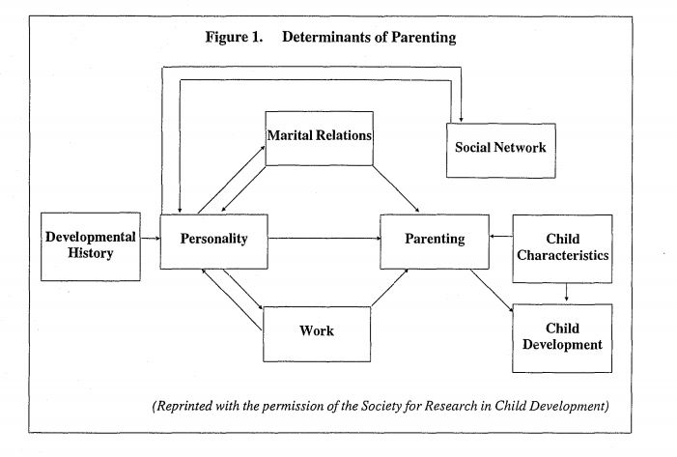Assessment Framework
Effective intervention to remedy and prevents child neglect is dependent on continuous and accurate assessment of the case. The process of assessment of the case begun when the intervention worker made the first contact with the family and continued throughout the life of the case. The assessment took into consideration the various indicators of neglect based on the problems identified by the helper, referral source, and parents. It also involved the provision of support to enhance the parenting skills of the negligent parents. For instance, the intervention provided the mother with enrolling to a rehabilitation center to help her recover from her gambling addiction. The assessment evaluated the causes and barriers to the family system and identified the strengths, resources and coping skills necessary for effective parenting.
The intervention worker developed the plan (See Fig 3. )to support the family with regard to the assessment. The family was kept together in accordance with the Children Act 1989.
OUTCOMES/RESULTS
Referral

PLAN/ACTION
The family

ASSESSMENT

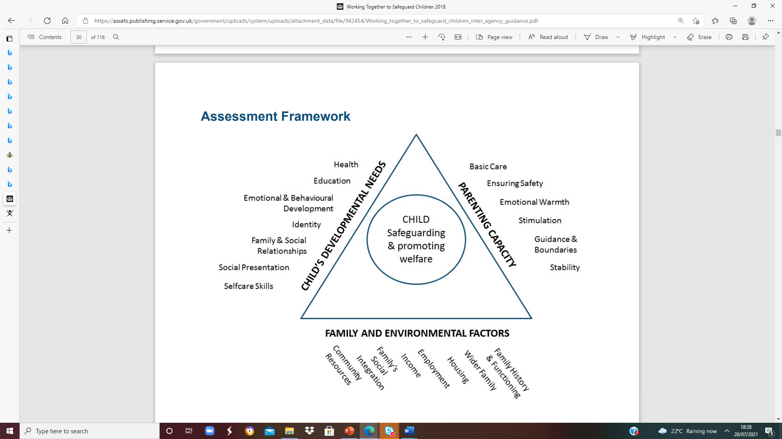
(Figure. 4 Family and Environmental factors)
The intervention in the case study was based on the assessment framework Working Together to Safeguard Children (See figure 4.)A guide to inter-agency working to safeguard and promote the welfare of children (2018). The intervention was implemented in accordance with the Children Act 2004, which mandates the local authorities and other agencies working with children and young people under the age of 18 to protect them from abuse, harm, and neglect. In addition, the UK Government is under obligation to support the health and wellbeing of children due to the United Nations Convention on the Rights of the Child (UNCRC,1991). Article 28 of the UNCRC (1991) grants every child the right to education, thus the intervention was within its mandate to enhance the school attendance of the children ("Children act 1989," 2020, p. 12). The social service intervention supported the family to ensure the children attended school as required.
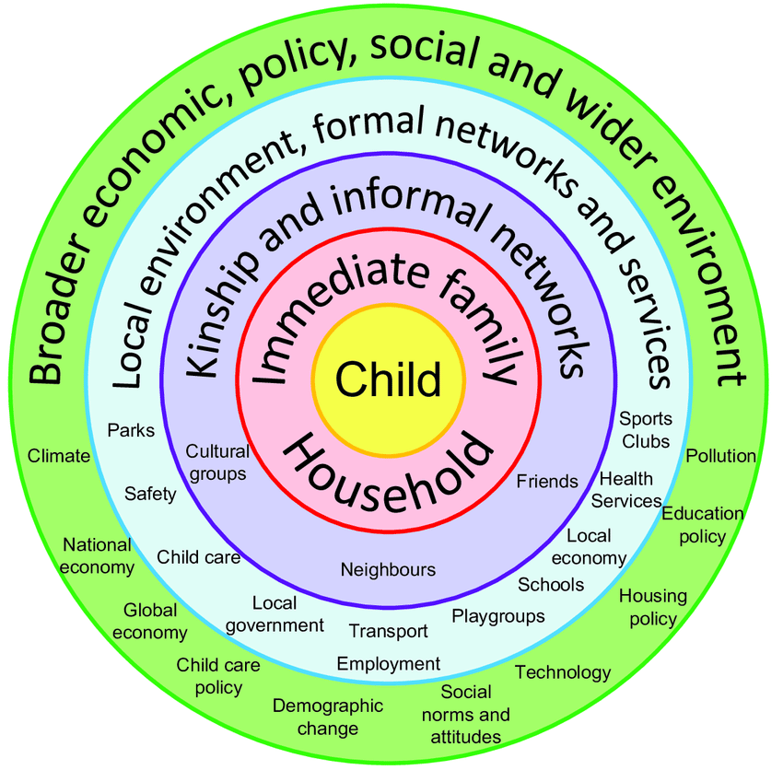
(Figure 5. On social issues on child).

Having considered the specific details of the case as well as current policy and the actions taken by health and social care agencies, provide a critical evaluation based on your perspective of what could have been done differently. Provide recommendations for improvements required, which are appropriate to meet the needs of the children/young people and family involved in the case study. Provide valid reasons for your suggestions and support these with literature and references. The intervention ensured the specific needs of the children were met in order to enhance their development. Maslow’s hierarchy of needs theory (See Fig 2)stipulates those human beings need to satisfy specific needs first in the hierarchical order before they can attain their full potential. Firstly, the parents were required to meet the physiological needs of the children such as water and food. Secondly, the parents were required to provide security for the children. Thirdly, the parents were encouraged to enhance positive relationships between the children and their peers, family members, and friends. Fourthly, the parents would support them in boosting their self-confidence, self-esteem and respect to others. After all the needs are the met then the children would be able to attain self-actualization and meet their full potential (White et al., 2019, p. 80).
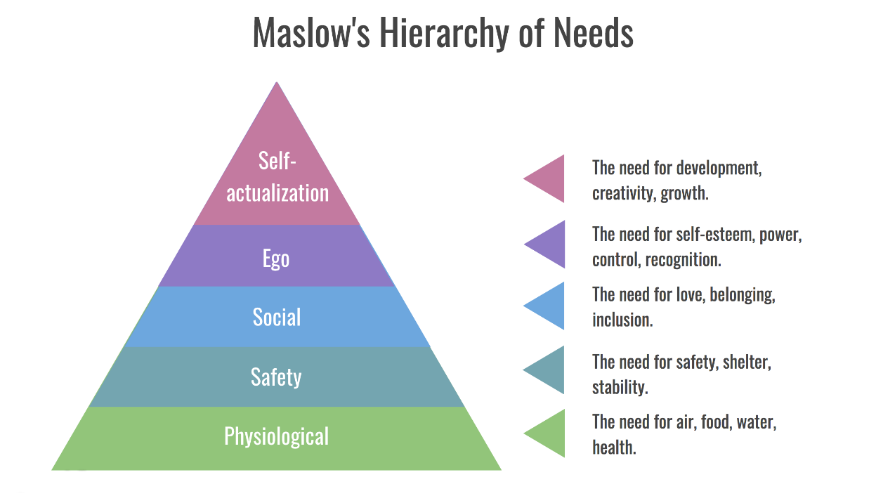

(Fig. 2. Maslow Hierarchy of needs)

Conclusion
To conclude, it is imperative to note that it is imperative to enhance the universal services for children, including more services to prevent difficulties and support families facing adversity. According to Bronfenbrenner theory, the various elements in the environment such as social service institutions and the Government play a crucial role in enhancing a child’s wellbeing (Shelton, 2018, p. 55). The interaction between such institutions in their immediate environment plays an imperative role promoting effective development. Therefore, both the immediate family, learning institutions, churches and other players in the community play a significant role in enhancing the health and wellbeing of children in the society.

References
Children act 1989. (2020). Hershman & McFarlane Children Act Handbook. https://doi.org/10.5040/9781526515032.006
Fenton-Glynn, C. (2019). Introduction. Children's Rights and Sustainable Development, 3-11. https://doi.org/10.1017/9781108140348.001
Nadan, Y., & Korbin, J. (2018). Cultural context, intersectionality, and child vulnerability. Childhood Vulnerability Journal, 1(1-3), 5-14. https://doi.org/10.1007/s41255-019-00003-7
Purcell, C. (2020). Every child matters and the children act 2004. The Politics of Children's Services Reform, 61-74. https://doi.org/10.1332/policypress/9781447348764.003.0005
Sendall, J. (2018). 24. Introduction to the children act 1989. Family Law 2019, 239-247. https://doi.org/10.1093/he/9780198837732.003.0024
Shelton, L. G. (2018). Essentials of systems theory. The Bronfenbrenner Primer, 55-57. https://doi.org/10.4324/9781315136066-11
White, S., Gibson, M., Wastell, D., & Walsh, P. (2019). Practising attachment theory in child welfare. Reassessing Attachment Theory in Child Welfare, 63-82. https://doi.org/10.1332/policypress/9781447336914.003.0004

