Miss Anda-Maria Mircevi

Student Number: 1920426

Programme: BA Business Management

Module: MANAGEMENT ACCOUNTING / LCBB5002

Assignment Title: Assessment 2 Report

Module Lecturer: Riaz Bhatti / Zainab Atta

MANAGEMENT ACCOUNTING
Assessment 2 Report

Table of Contents
Introduction 3
Discussions 3
Section A: “Applied performance evaluation for business Amana Ltd” 3
Part 1: “Identify evaluation regarding original, flexible budget with variance analysis” 3
Part 2: “Evaluating basic performances associated to Amana Ltd considering present performances” 6
Part 3: “Provide recommendation to Amana Ltd depending on present performances” 7
Section B: “Evaluating business operating identification related to Amana Ltd” 7
Conclusions 10
References 11

Introduction
Along with reporting business “financial transactions while the performance of financial accounting is generally completed, management accounting initiated analysis, interpretation, formulation and also communication supportive structure so that general growth including planning, controlling and decision making approach can also be initiated on an efficient basis. Formulation this branch of accounting is also used to bring an optimised approach including operating formulation support also with initiative of which the primary development including basic structural processing can also be managed in a proper order” (HU, 2019).
Maintenance of effective management accounting “concept brings operating development support to individual business with respect to which primary growth including performance maintenance support is also initiated on an efficient basis”. In this report mainly the financial performances including the operating approach for individual business has been initiated with general conceptual approach under “management accounting” mainly.

Discussions

Section A: “Applied performance evaluation for business Amana Ltd”
Under general conceptual framework of “financial management, applied initiatives related to budget are basically initiated to provide a systematic structural processing, with respect of which a general evaluation support related to financial compatibility of a business in associated to the probable situation are identified. In other terms, it is considered as a forecasted or anticipated initiative of business in respect of which the general compatibility including the development formulation of business can be identified. It is used to measure systematic formulation support as well and with the computed results a proper volume of strategic analysis can be initiated on a proper basis. Including the same approach, it also allowed the maintenance initiative related to business formulation processing approach also which is essential for business primary growth initiatives reason” (Rosyidi, 2019). Associated to the same approach for the business of Amana Ltd this type of evaluation has been provided.

Part 1: “Identify evaluation regarding original, flexible budget with variance analysis”
Primary approved associated with “different types of budgeting concept while initiated under financial management, the general processing related to variance analysis which support standard costing are initiated under cost accounting also. The concept of variance analysis is generally provided under standard costing which brings a systematic evaluation related to differentiation approach between the actual performances of the business and the anticipated or four custard analysis with support of business budget processing basically. It is also used to provide compatibility determination support as well in relation of which the primary growth including the formulated feasibility approach of business financial processing can also be realised in a proper order” (Fakilede, 2020).
Respecting the present performance initiative an anticipated financial analysis related to the present production processing of the business has been initiated with response of 100000 units of production basically.
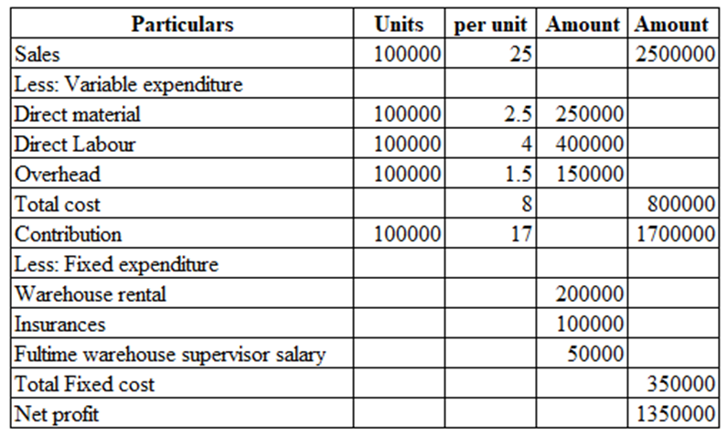
After the determination of business budget approach, a basic presentation related to business actual performances has been initiated in respect to 80000 units basically with support of which the primary compatibility including the financial feasibility approach of the business can also be initiated.
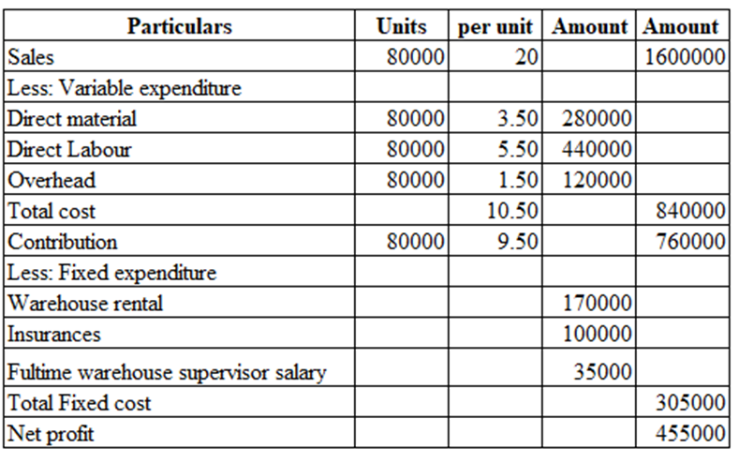
After the determination of both the business budgeted approach and actual performance a systematic evaluation related to business variance analysis has been initiated with support of standard costing concept mainly, which is allowed to maintain comprehensive viewpoints related to the accounting compatibility approach of business in a proper order (Foster, 2017). It is also used to provide a systematic understanding related to business opportunity cost processing also with initiative of which the primary development including the growth initiatives structure of business performance can also be realised. Such presentation has been provided;
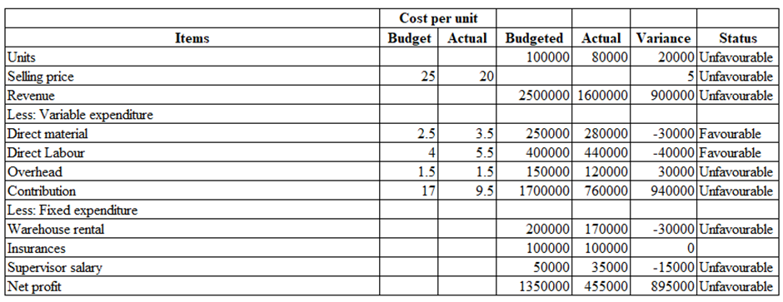
After the analysis of variance computation, a significant amount of differentiation approaches are generally initiated that represent both favourable and unfavourable conditions associated to business performances respectively. Depending on the present situation the volume of business revenue is indicating an unfavourable condition as compared to budgeted approach actual performance is providing comparatively lower support at present situation. Respecting another approach, volume of business variable expenditure regarding the direct material is providing a favourable position as volume of business budgeted expenditure is comparatively lower compared to actual expenses basically, though it required a significant volume of controlling support mainly (Hillen and Lavarda, 2019).
Considering such, present direct labour costs of the business are also providing the same conditions of favourable position basically. However, apart from that the volume of business over it basically provides a favourable condition and as a result the computed results related to contribution is also indicated in an adverse position as well. Depending on the present situation fixed expenditure structure of the business is also providing unfavourable conditions which indicate compared to the budget initiative the overall actual expenditure is providing a comparatively lower structure at the present situation, which is supportive for the business for probable future stability as well as profitability initiative purpose (Rosyidi, 2019).

Part 2: “Evaluating basic performances associated to Amana Ltd considering present performances”
Systematic presentation related to positive costing formulation provides systematic support regarding the presentation of budget in a proper order with respect to which the basic computed analysis of business projects can be identified. Associated with the same approach under the processing of standard costing a systematic evaluation between the budgeted approach and actual performance has been initiated with respect of which the probable opportunity as well as the performance initiatives of business can also be identified on a proper basis. It is used to provide compatible determination support with the maintenance of which the primary structure of growth related to individual productivity processing can also be identified (Rosyidi et al., 2020). Related to the general theoretical approach the presence of variance analysis is also used to provide a systematic analysis processing basically with respect to which the probable opportunity including some of the systematic growth can be realised. In associated to present operating formulation the presentation of basic performance analysis for the business of Amana Ltd has been provided with the maintenance of variance computation support mainly.
Initiated to present computed approach, a significant volume of differentiation is generally noticed that indicates the overall performance structure of the business is different that indicates an unfavourable approach mainly. It is basically considerable that at the present situation the budgeted initiative of business is indicating a comparatively higher approach compared to the actual performance engagement. It is basically indicating that the overall performance related to the business is providing an unsatisfactory approach compared to the expected initiative. Importance to the revenue processing is significant differentiation is noticed related to productivity formulation that indicates the present management of the business need to provide importance over the productivity processing for efficient financial formulation and revenue development approach in future (Aggarwal and Batra, 2018). Including the same approach, it is also considerable that the current volume of expenditure is also indicating an unsatisfactory approach that needs to be managed and formulated with initiatives of operating controlling formulation mainly. Due to basic approach of this kind of differentiation a significant volume of different approaches is noticed related to both the Contribution and net profit initiative of the business that indicates the requisite volume of business performance initiative including optimised formulation approach mainly for future stability and other associated growth formulation purpose.
Though during the present pandemic condition this type of negative approach has occurred as the previous performance structure of the business related to productivity formulation is indicating a comprehensive growth and formulated support with respect of which financial feasibility can be easily recognised (Alamsyah et al., 2020). With considering this approach it is recognisable that at the present situation the management of the business is needed to provide focus cost controlling and revenue development-oriented strategy in a proper basis so that formulated appearances of business performance initiatives can efficiently be initiated in the upcoming period with business furtherance support mainly.

Part 3: “Provide recommendation to Amana Ltd depending on present performances”
With considering the evaluation it is recognisable that, present management of the business is needed to provide focus on some of systematic appearances including formulated approach basically with respect of with the probable opportunity including standardised modifications and financial feasibility can easily be balanced. Depending on such the management of the business needs to provide focus over the;
- Recognising the current marketing approach, the management of the business and the present situation need to increase the productivity volume in a supportive basis with respect of which the probable opportunity including business revenue formulation can also be balanced in a supportive basis.
- The volume of business variable expenditure at the present situation is indicating a favourable approach, however if the production volume is increased therefore, it will be impacted in a negative order. So, depending on such, the management of a business needs to provide importance over the cost controlling formulation for feasibility support of business on a proper basis (Hryhorash et al., 2018).
- The volume of business expenditure also needs to be controlled and formulated in a proper basis so that a proper stability including the sustainability processing can also be balanced in a systematic manner for future growth initiatives.
- Along with initiating both the internal approach, management needs to be concerned about the promotional approach as well with respect to social media processing so that a proper volume of business financial formulation can be easily balanced and monitored.

Section B: “Evaluating business operating identification related to Amana Ltd”
The present performance approach for individual organisations is dependent on the online trading formulation in a systematic basis that provides a proper volume of opportunity related to marketing engagement as well as promotion attributes also. In the present time period while the Technical Advancement has been initiated, the engagement related to online trade approach are providing significant value opportunities including sustainability development also with respect of which the probable formulated approach including the optimised initiative of business can also be balanced in a supported basis. Since the period of pandemic, the overall marketing demand regarding online trade support is rapidly increasing that provides a systematic volume of opportunity related to operating compatibility including operational development support on a proper basis (Aggarwal and Batra, 2018). It is also used to provide a systematic volume of supplies in engagement as well with respect of which the probable opportunity and the positive approach related to performance management can also be initiated. Considering this conceptual approach, this part is basically providing a costing to make-or-buy oriented decision with respect to which the overall systematic formulated approach can be balanced.
Considering the present performance approach, the owner Mr Amana presently has two different business branches related to Birmingham city and Manchester city. And depending on business volume, the owner intended to close down the Birmingham city branch and initiate a 50% selling approach via online processing mainly. Considering the current situation, the management of the business has two options: either initiate their own online platform in order to formulate trading engagement or basically initiate the approach of online processing via Amazon. Depending on this particular scenario in order to recognise the most beneficial approach for the business, basically the conceptual framework related to make or buy decisions has been initiated that provides a positive identification including formulated development.
At the present condition if the management of business uses to initiate its own online platform therefore a significant volume of business costing has to be initiated including formulation support as well as considering which compatibility development of the business can be identified (Aggarwal and Batra, 2018). The present provided approach related to detailed presentation of Costing has been provided;
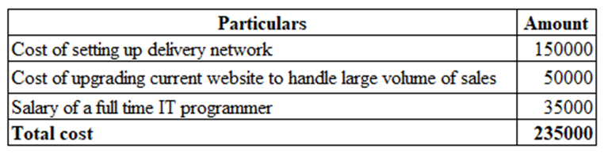
Depending on the computation, it is considerable that if the business is used to initiate own online trading engagement therefore around £235,000 have to be consumed along with a secured production selling approach of 100,000 units mainly. It is basically indicating a comprehensive formulation approach including sustainable development initiatives also with the maintenance of which the primary development including compatibility initiatives of the business can be easily balanced and formulated.
Associated with the same approach and other options related to the engagement of online trading with support of Amazon are also providing a systematic volume of cost contribution as fulfilment fees which will be around £50,000 respectively. Engagement of this type of online trading is providing a guaranteed volume of selling approach related to 65,000 units basically along with sustainable and formulated operating engagement on an effective basis. associated to the same approach it is also recognisable that if the management of the business initiates this particular online processing therefore systematic volume of risk can also be recognised which basically indicates the competitive marketing structure mainly.
With respect to the present computed analysis related both the option for the primary reason of evaluating the most beneficial and influential business investment the processing related to cost per unit analysis has been initiated. Support of this particular initiative related to cost determination per unit base is a positive identification related to most beneficial investment can be identified, and generally lowest costing engagement can be considered as a beneficial one for this particular marketing initiatives (Zhou et al., 2018). Overall volume of Costing differentiation for both the initiative has been provided.
Through own online trading engagement; 235000 / 100000 = 2.35 per unit
Through Amazon engagement; 50,000 / 65000 = 0.76 per unit
Associated with the present computed approach it is recognisable that while the organisation is intended to use their own online trading platform the overall volume of cost associated to per unit is providing the level of 2.35 per unit basically. On the same approach if the business is used to initiate the engagement of Amazon mainly therefore the overall cost will be 0.76 per unit basis. From that initiative, it is generally recognisable that at the present scenario in the management of the business or the owner provides focus over the formulation approach related to Amazon mainly therefore is systematic volume of financial competitive advantages as well as production formulation can be initiated (Soares et al., 2020). Though it represents a comparatively lower guaranteed selling volume, in associated with marketing demand if the business utilises 100% capacity including production quality control processing in a supportive basis therefore a systematic volume of production enhancement approach can be initiated along with guaranteed volume of selling approaches as well. With this scenario, it will be beneficial for the business to initiate engagement related to online trading platforms with the support of Amazon basically so that overall profitability including cost maintenance approach of the business can also be initiated in a proper order. However, if the business is intended to continue their own online trading engagement therefore the volume of production selling approach can be increased however it will have costing issues also in a simultaneous basis which will impact a negative approach over the business profit performances in future (Zhang, 2021).

Conclusions
Essentiality of individual accounting presentation is relevant for business performances with maintenance of which general compatibility including some of the development formulation can also be preceded on a proper basis. It also provides a systematic volume of opportunity also through the considerations of which the fundamental initiative including formulated processing of business can be processed in a systematic order. It also allows the maintenance approach related to business operational growth also with consideration of the probable systematic processing of business performance can also be initiated on a proper basis.

References
Aggarwal, P. and Batra, S., 2018. Business Administration Platform Management through Budget Editor Tool (Doctoral dissertation).
Alamsyah, A., Sudirman, I. and Hakim, W., 2020. The Effect of Business Ethics Principles on Operational Budget Control Policy (Cost Transport). Hasanuddin Journal of Business Strategy, 2(2), pp.1-10.
Fakilede, J., 2020. Strategies Utility Business Organizations Use to Deliver Construction Projects On-Budget and On-Schedule (Doctoral dissertation, Walden University).
Foster, T.A., 2017. Budget planning, budget control, business age, and financial performance in small businesses (Doctoral dissertation, Walden University).
Hillen, C. and Lavarda, C.E.F., 2019. Budget and life cycle in family business in succession process. Revista Contabilidade & Finanças, 31, pp.212-227.
Hryhorash, O., Korneyev, M., Leheza, Y., Zolotukhina, L. and Hryhorash, T., 2018. The development of small business as a source of formation of local budget revenues in Ukraine. Investment management and financial innovations, (15, Iss. 1), pp.132-140.
HU, Y.B., 2019. Study on Budget Management Combined with Business and Finance in China Power Grid Enterprises. DEStech Transactions on Economics, Business and Management, (emba).
Rosyidi, C.N., 2019, August. Make or Buy Decision with Price and Quality Dependent Demand. In Proceedings of the International Manufacturing Engineering Conference & The Asia Pacific Conference on Manufacturing Systems (pp. 272-277). Springer, Singapore.
Rosyidi, C.N., Imamah, N.U.F. and Jauhari, W.A., 2020. An optimization model of make or buy decision and quality improvement of components using rebate. Cogent Engineering, 7(1), p.1767266.
Soares, C.A.P., Magalhães, M.A. and Mendes, J.R., 2020. Investment Capital Budget Method Oriented to Project Management. GSJ, 8(3).
Zhang, W., 2021. Optimization of overall budget management of ABC company under business process management: annotation to master's thesis.
Zhou, F., Zhao, X. and Zhao, B., 2018, August. Promotion of Management Accounting to Cost Management and Management Decision in Small and Medium-sized Enterprises. In 2018 International Conference on Management, Economics, Education and Social Sciences (MEESS 2018) (pp. 307-313). Atlantis Press.

