OPERATING SYSTEM

Student Name: Alison Sherman Vas
Student ID: 2513127
Group no: 1
Module: Computer Architecture and Operating Systems
Course: CertHE Computing Skills for Workplace

Table of Content
Introduction 4
Key Functions of Operating Systems 4
Process Management 5
Memory Management 6
File System Management 7
Device Management 8
Network Management 9
Windows CLI Commands 10
Process Management 10
File Management 11
Network Management 14
User Management 15
Task Scheduling 16
Linux CLI Commands 17
Process Management 17
File Management 18
Network Management 20
User Management 21
Task Scheduling 21
Windows Scripts 22
Script 1: Subtraction 22
Script 2: Folder Checker 23
Linux Scripts 24
Script 1: Subtraction 24
Script 2: File Checker 25
Conclusion 26
References 26

Introduction
Operating systems (OS) hold a critical position in current computing technologies, acting as intermediaries between end-users and hardware components. Operating systems are required to coordinate core computing resources, such as CPU time, memory, storages, and other input/output devices. In doing so, operating systems ensure efficient usage of computer resources and avoid conflicts arising from the simultaneous use of these resources by different users. As a result, operating systems create a stable and reliable working environment that allows applications to run smoothly without any interruptions [1].
Without an operating system, users should manually interact with computer hardware, which implies significant difficulties and inefficiencies in terms of usability. An operating system acts as an interface for user activity and manages low-level interactions with hardware components. Current operating systems, for instance, Windows and Linux, offer two types of interfaces: graphical user interface (GUI) and command-line interface (CLI). Despite CLI being difficult for users, it provides advanced possibilities for executing actions efficiently and quickly.

Key Functions of Operating Systems
The main functions of operating systems create the basis for successful work and proper functioning of modern computers. Operating system is responsible for managing hardware and software resources, allowing for interaction between different components of the system. Process management is one of them. The operating system assigns processor time for multiple tasks' simultaneous execution while controlling processes' statuses. They may be ready, running, and waiting. This ability makes multitasking possible. Memory management is another crucial function that allows assigning the RAM to the processes depending on their needs while avoiding interference between them. Using virtual memory can improve performance as well because it provides an opportunity to use disk space like extra physical memory.

Process Management
Process management represents a core responsibility of an operating system. It refers to managing the way in which programs operate in the computing environment. A process can be understood as a program that is currently executing. An operating system controls how it operates from the moment of creation to completion. A process goes through a set of states depending on the availability of system resources (e.g., new, ready, running, waiting, and terminated) [1].
Synchronization and interprocess communications belong to another important aspect of process management. Processes often need to work simultaneously, sharing certain resources. To manage such interactions, various synchronization algorithms (e.g., semaphores and mutexes) are used by the OS.
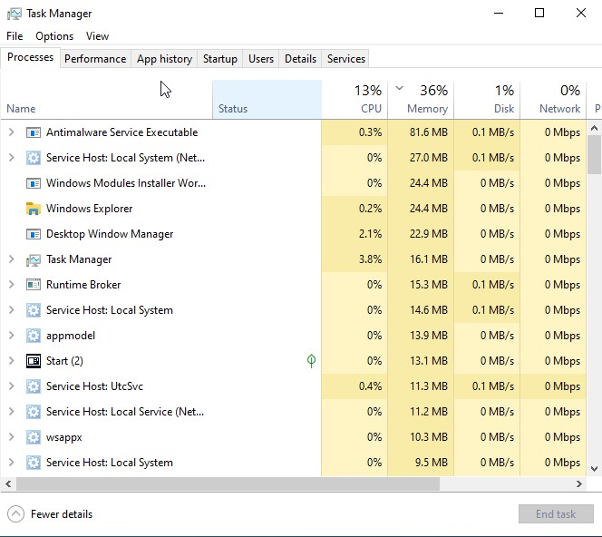
Figure 1: Windows Task Manager displaying active processes

Memory Management
The first role of memory management in computer operating systems is the allocation and control of computer memory, which allows processes to execute efficiently. When processes require memory, the operating system allocates the available memory to them; once the processes are finished executing, the system releases the memory. Dynamic memory allocation reduces memory wastage and makes the system efficient [2]. Another technique used in modern operating systems is that of virtual memory, which utilizes secondary memory as if it were an extension of the RAM of the computer. This technique allows for large programs to be executed regardless of the physical limit of the memory. Examples include paging that divides memory into chunks of predetermined size, making memory management easy.
Memory protection ensures that processes do not access other processes' memory space. This technique provides security in the sense that memory cannot be corrupted by any process and protects the computer system from any threats. Processes can only have access to memory through the system.

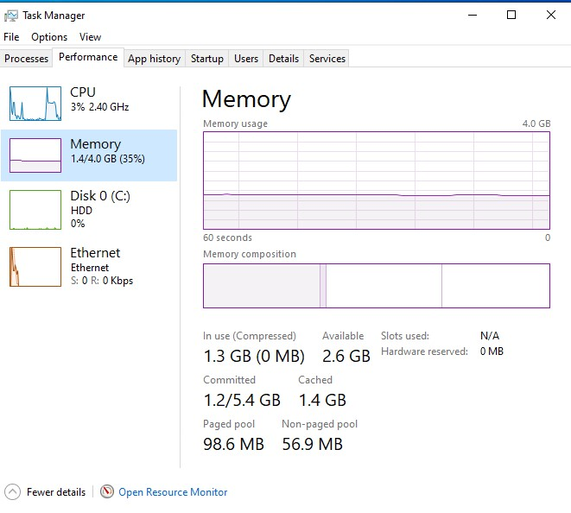
Figure 2: Memory usage monitoring in system performance tab

File System Management
Management of file system involves organizing and managing the data available in storage devices. Operating system organizes the data in files and folders, thus making it possible for users to efficiently store and manage data. This method makes it easy to organize data [2]. Different operating systems use different file systems, for example, NTFS file system for Windows and ext4 for Linux operating system. These file systems determine how data can be stored and accessed and also control access to data, thus ensuring security.
The operating system provides various file management services, including creating, deleting, copying, and moving data from one location to another. The operating system also maintains metadata, such as file size, date created, and access permissions. File management includes error detection and correction techniques. For instance, journaling is used in data recovery in case of any errors in the file system.

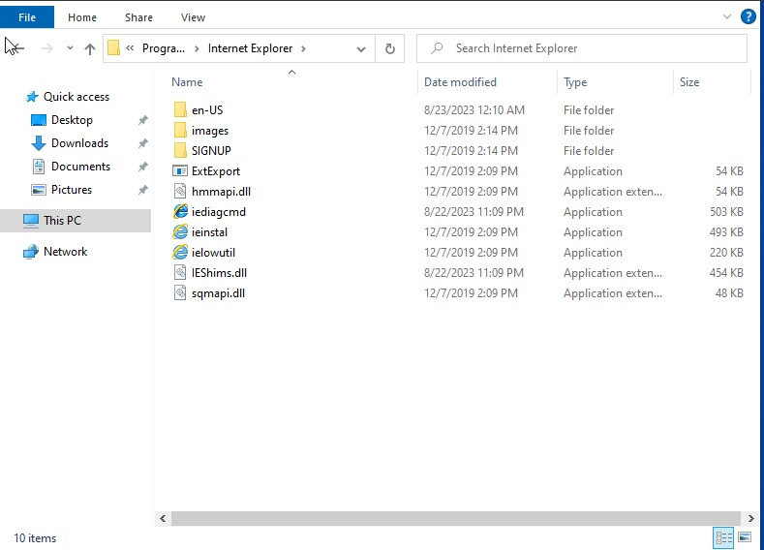
Figure 3: File system structure in Windows File Explorer

Device Management
The ability of the operating system to control and manage hardware devices is referred to as device management. These include printers, keyboards, and other storage devices, among others, and their management can be made possible using device drivers that act as mediators between hardware devices and software applications [3]. Concurrently running of more than one device can be achieved by the operating system, which controls the allocation of resources like ports and memory addresses, and also manages input and output tasks to increase efficiency.
Another crucial feature of the operating system is the ability to detect errors in hardware devices and provide tools to help the user diagnose problems. Windows Device Manager and some Linux utilities such as lsusb can be used by the user to monitor hardware devices and ensure their correct working and configuration.
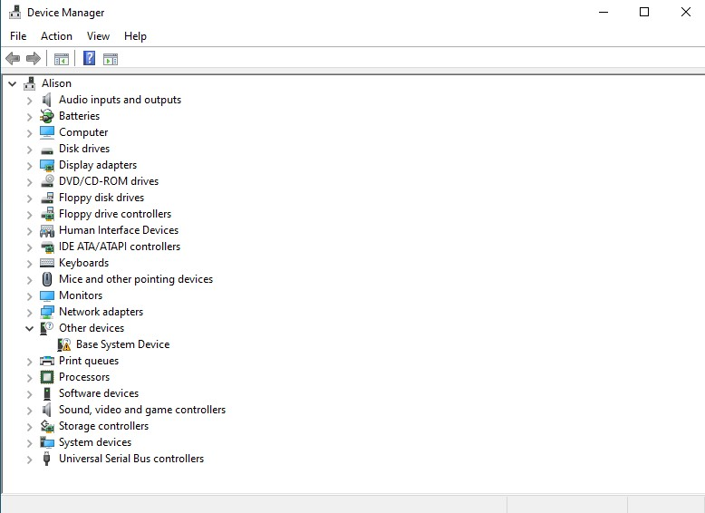
Figure 4: Device Manager displaying system hardware components

Network Management
Network management aids in communication between devices over the Local Area Network and Wide Area Network. This is done by the Operating System, which handles network setup by assigning IP addresses and network interfaces and ensures effective communication [4]. Through communication protocols, including TCP/IP, the operating system communicates data through the network. Communication protocols ensure effective communication between devices by delivering information correctly.
Network management also involves monitoring and resolving network connections. Ipconfig utility in Windows and Ping in Linux can be used to monitor and resolve network problems. Security plays a key role in network management. This involves the use of firewall and encryption techniques to prevent hacking attacks.
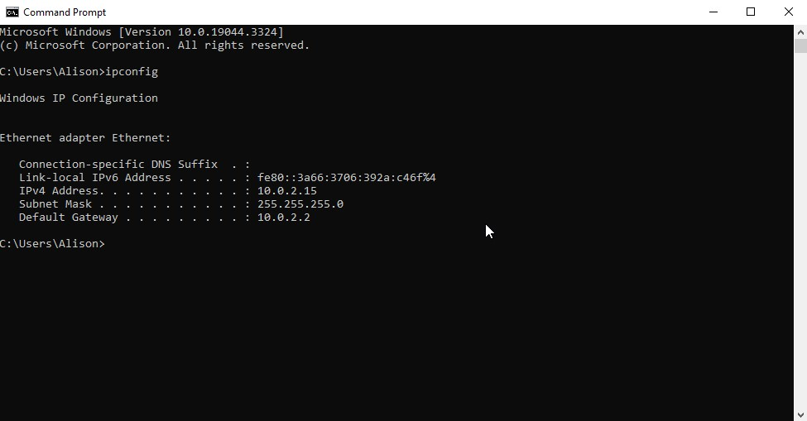
Figure 5: Network configuration output using ipconfig command

Windows CLI Commands
The Windows CLI enables user efficient system control through commands [3].

Process Management

tasklist
The tasklist command is used to display all currently running processes in the system. It provides detailed information such as process ID (PID), memory usage, and session name. This command is particularly useful for identifying resource-intensive applications and monitoring system performance.
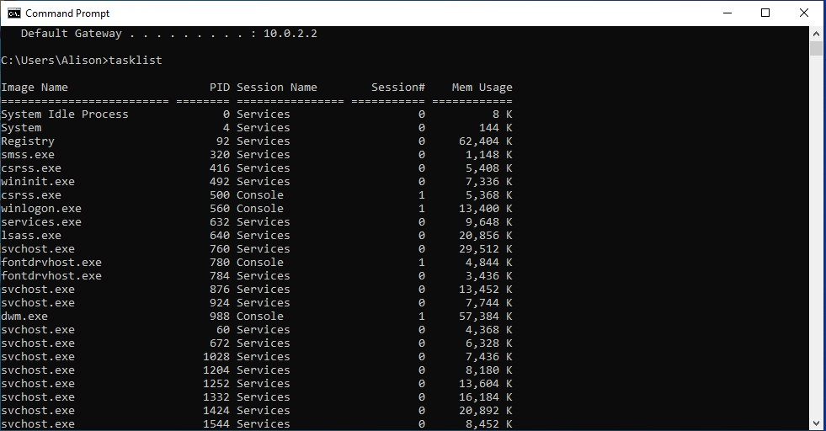
Figure 6: tasklist command running

taskkill
The taskkill command is used to kill/terminate processes using their names or PID. For example, taskkill /PID 6568 /F forcefully stops a process. This is useful when applications become unresponsive or consume excessive resources.
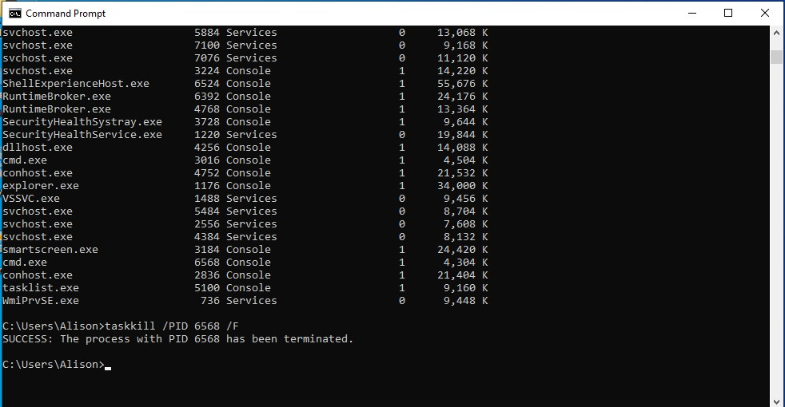
Figure 7: taskkill command running

wmic process list brief
The wmic process list brief command provides a structured list of running processes with additional details. It is useful for advanced system analysis and scripting purposes.
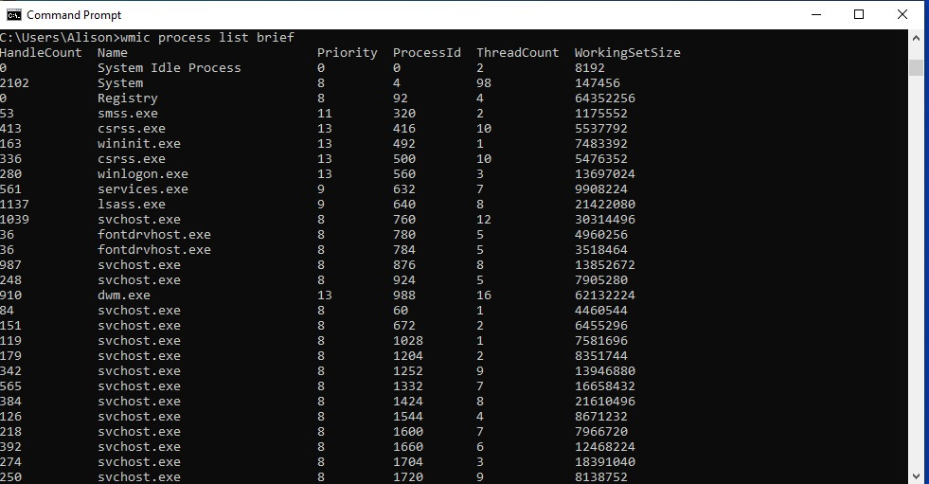
Figure 8: wmic command running

File Management

dir
The dir command displays the contents of a directory, including files and folders. It helps users navigate and understand the file structure.
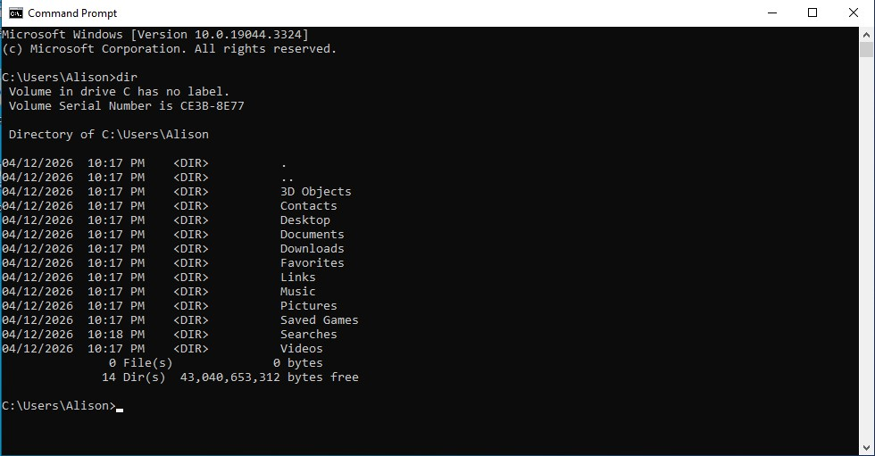
Figure 9: dir command running

mkdir
The mkdir command is used to create a new directory.
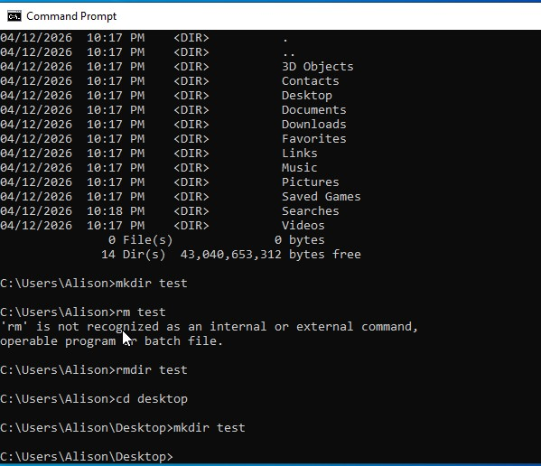
Figure 10: mkdir command running

rmdir
rmdir deletes an existing directory.
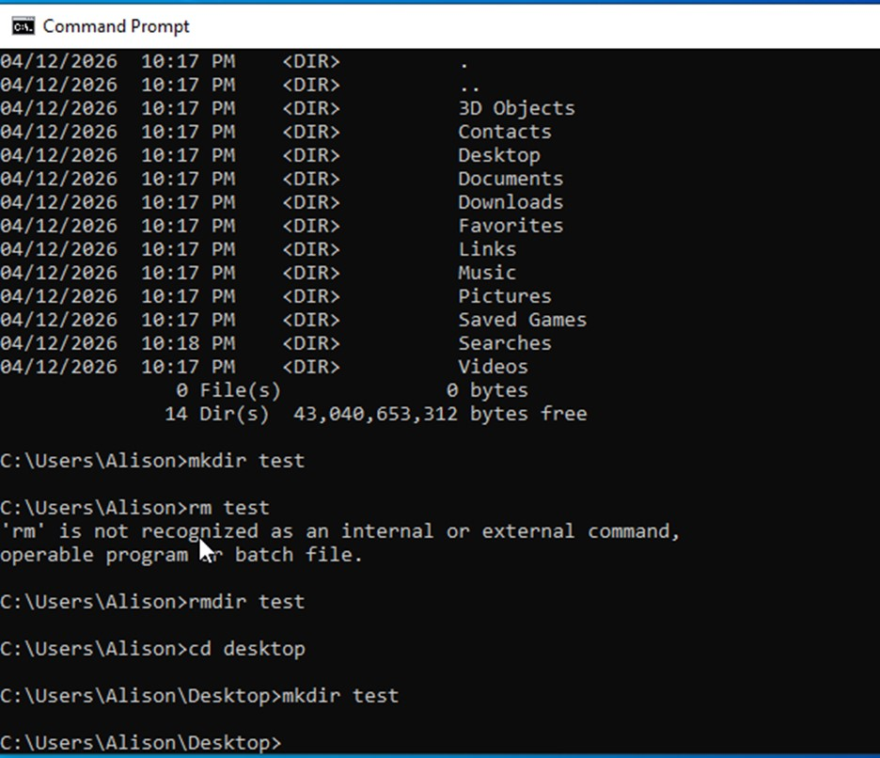
Figure 11: rmdir command running

copy
The copy command allows duplication of files from one location to another.
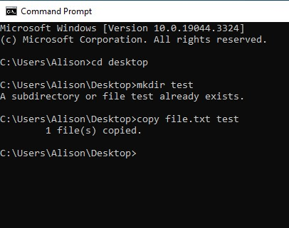
Figure 12: copy command running

move
move is used to relocate files or directories in windows operating system.
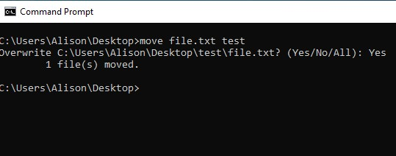
Figure 13: move command running

ren
The ren command is used to rename files or directories efficiently
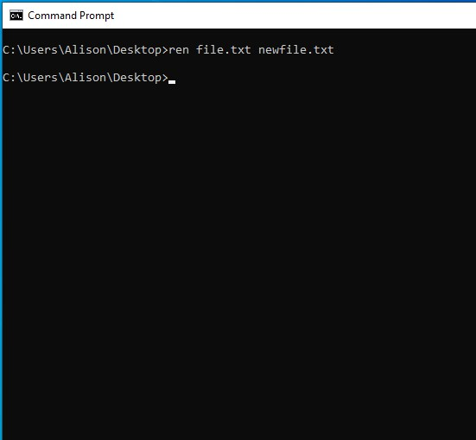
Figure 14: rename command running

Network Management

Ipconfig
The ipconfig command displays detailed network configuration, including IP address, subnet mask, and gateway information. It is commonly used for troubleshooting connectivity issues.
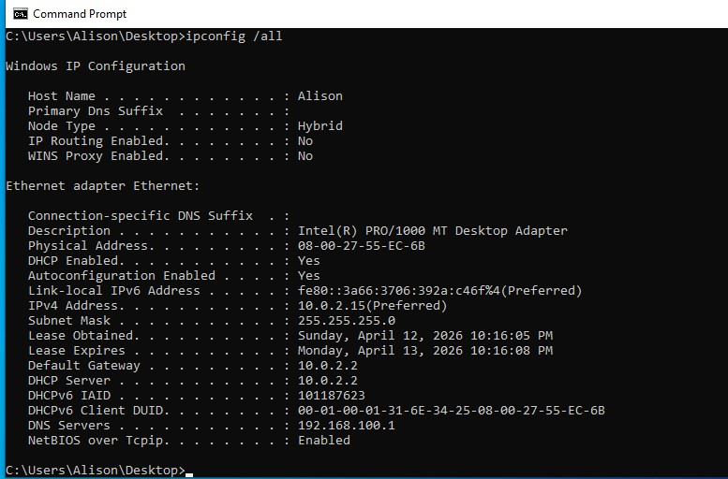
Figure 15: ipconfig command running

ping
The ping command tests network connectivity between devices. For example, ping yahoo.com -n 3 sends three packets to check response time.
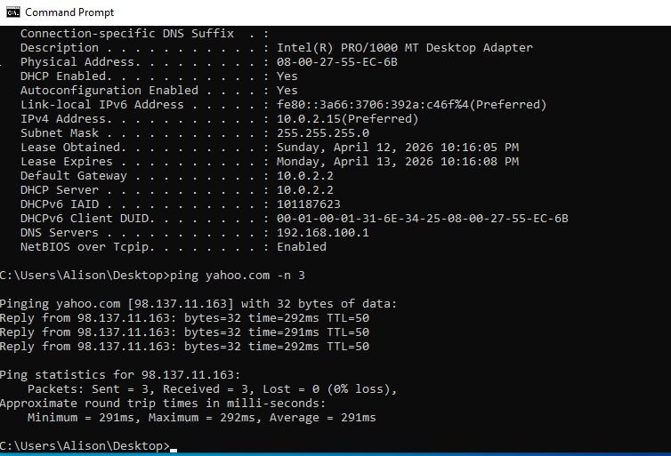
Figure 16: ping command running

netstat
The netstat command shows active network connections and listening ports, which is useful for detecting unauthorized connections or diagnosing network problems.
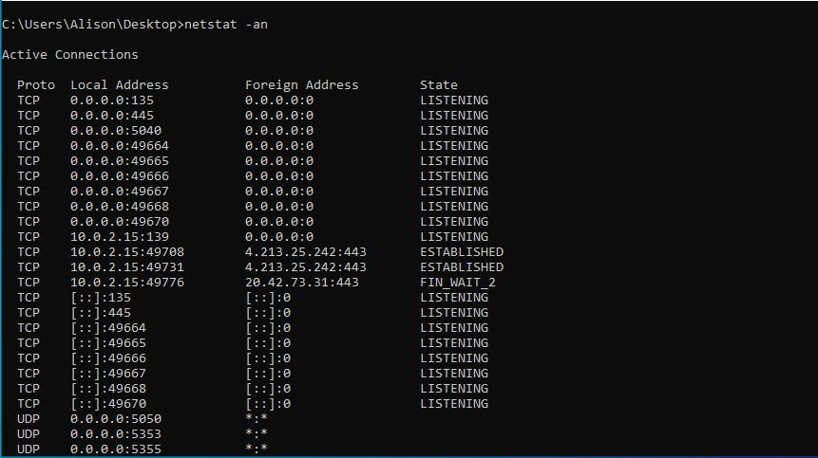
Figure 17: netstat command running

User Management

whoami
The whoami command displays the currently logged-in user, which is useful for verifying user identity in multi-user systems.
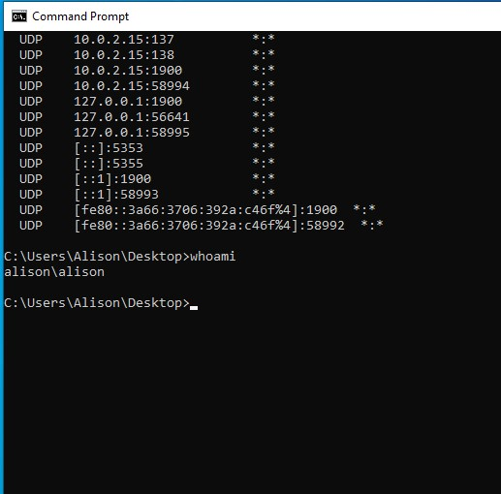
Figure 18: whoami command running

net user
The net user command provides a list of user accounts and can also be used to create, modify, or delete users. This is important for system administration and access control.
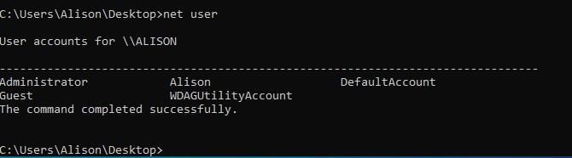
Figure 19: net user command running

Task Scheduling

schtasks
The schtasks command is used to create, manage, and view scheduled tasks. It allows automation of repetitive tasks such as backups or system updates. Task scheduling improves efficiency and reduces the need for manual intervention.
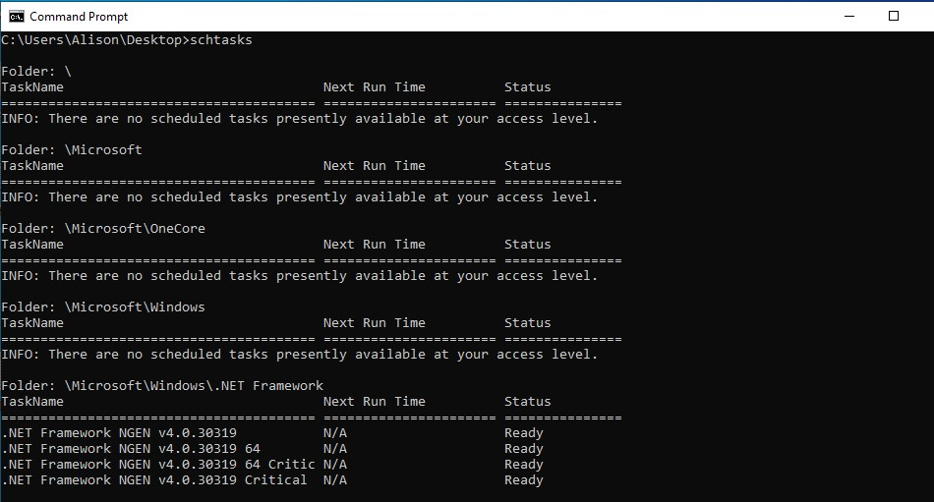
Figure 20: schtasks command running

Linux CLI Commands

Process Management

ps aux
The ps aux command displays detailed information about all running processes, including CPU and memory usage. It is widely used for monitoring system performance.
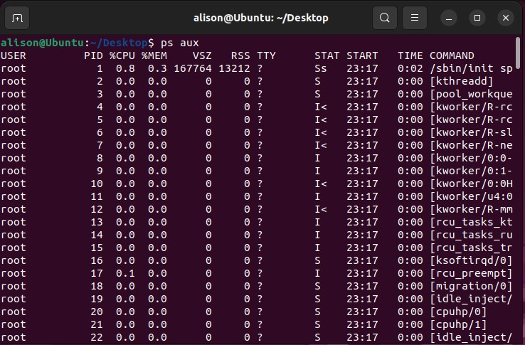
Figure 21: ps aux command running

top
The top command provides a real-time view of active processes, allowing users to identify resource usage dynamically.
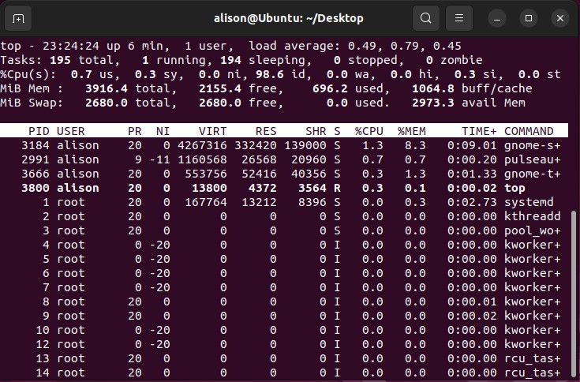
Figure 22: top command running

kill -9
The kill -9 command is used to terminate processes forcefully. It is particularly useful when a process becomes unresponsive.
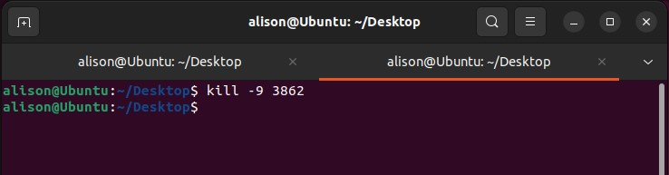
Figure 23: kill command running

File Management

ls –l
The ls -l command lists files and directories with detailed information such as permissions, size, and ownership.
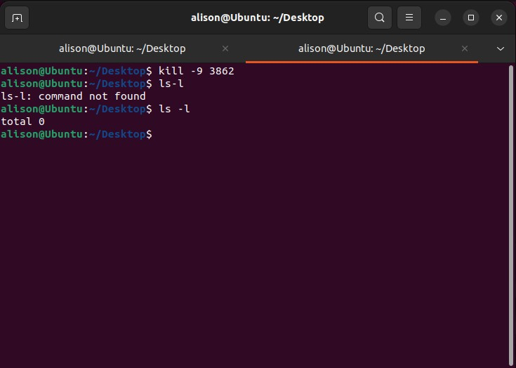
Figure 24: ls -l command running

mkdir
The mkdir command used to creates directory.
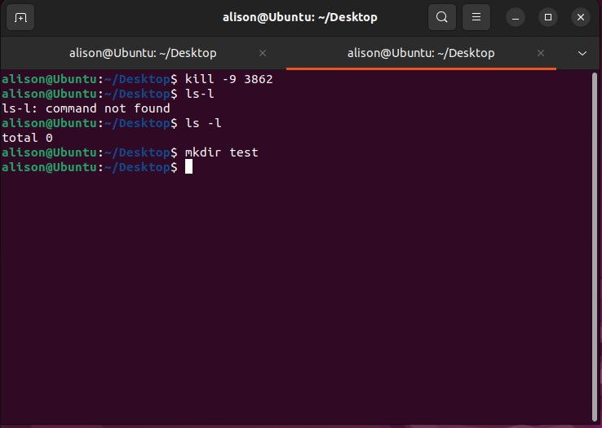
Figure 25: mkdir command running

rm -r
rm -r removes directories and their contents recursively.
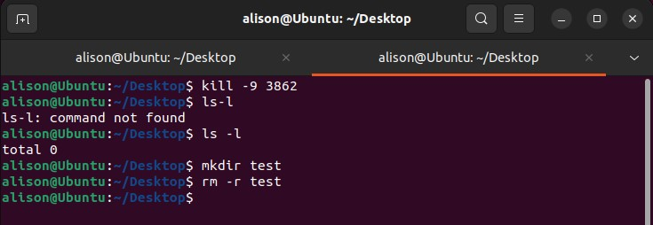
Figure 26: rm -r command running

cp
The cp command allows duplication of files from one location to another.
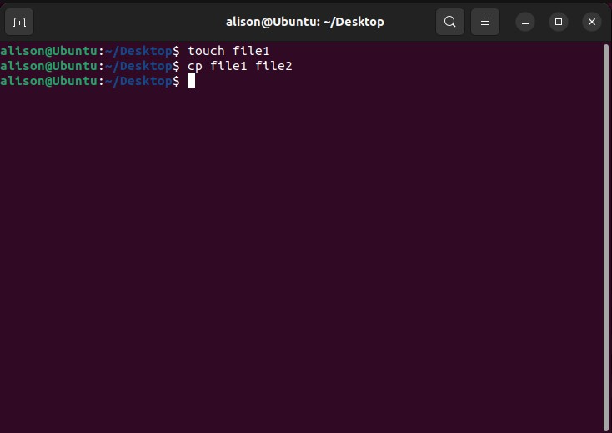
Figure 27: cp command running

mv
mv is used to relocate files or directories.
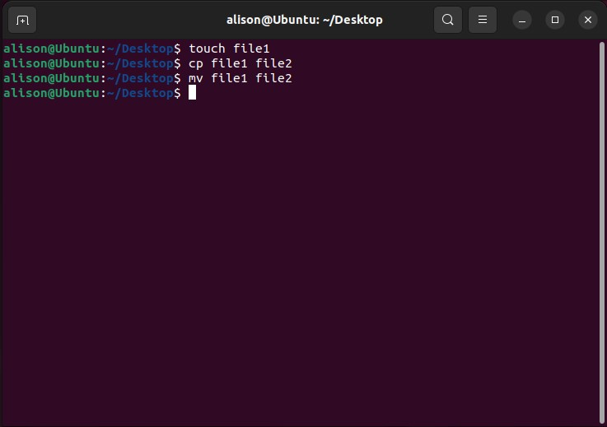
Figure 28: mv command running

Network Management

ip a
The ip a command displays network interfaces and IP configurations in Linux systems.
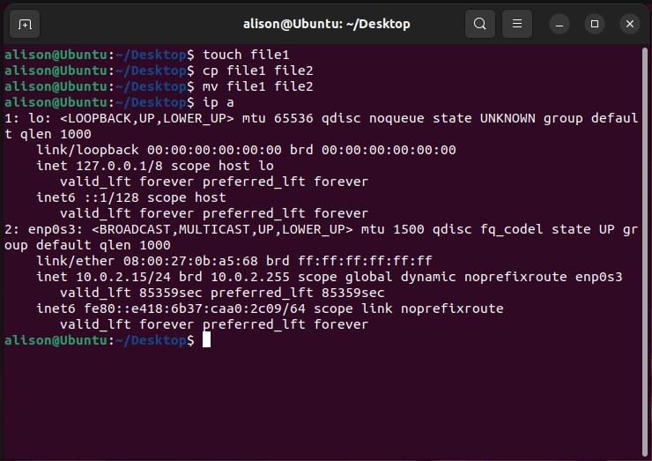
Figure 29: ip a command running

Ping
The ping command tests network connectivity between devices.
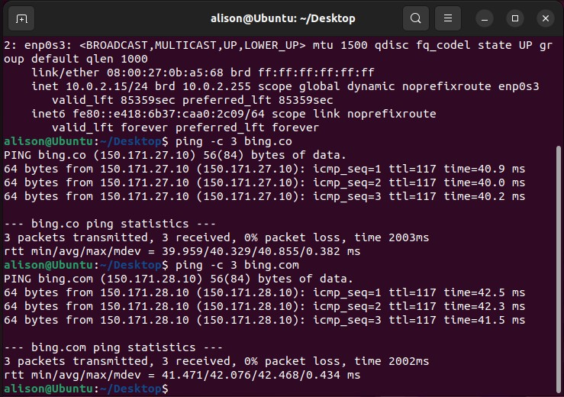
Figure 30: ping command running

ss
The ss command shows active network sockets and listening ports, which is useful for network diagnostics and security monitoring.
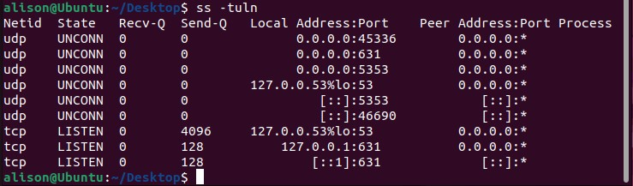
Figure 31: ss-tuln command running

User Management

id
The id command provides detailed information about the user, including user ID and group memberships.
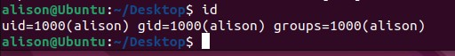
Figure 32: id command running

whoami
The whoami command displays the current user, helping verify permissions.
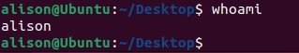
Figure 33: whoami command running

Task Scheduling

crontab
crontab command is used to create, edit and manage tasks that runs automatically at specified time or after regular interval.
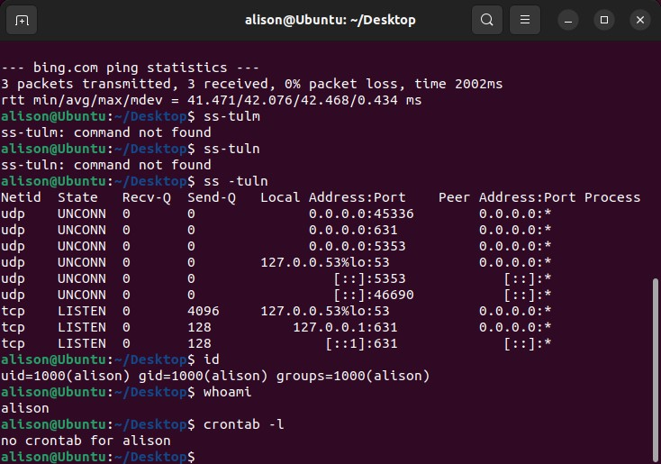
Figure 34: crontab command running

Windows Scripts

Script 1: Subtraction
This batch script performs subtraction between two numbers entered by the user. It uses the SET /P command to take input and stores values in variables. The arithmetic operation is performed using SET /A, which allows mathematical calculations in batch scripts. This script demonstrates how user input and basic logic can be used to automate simple calculations.
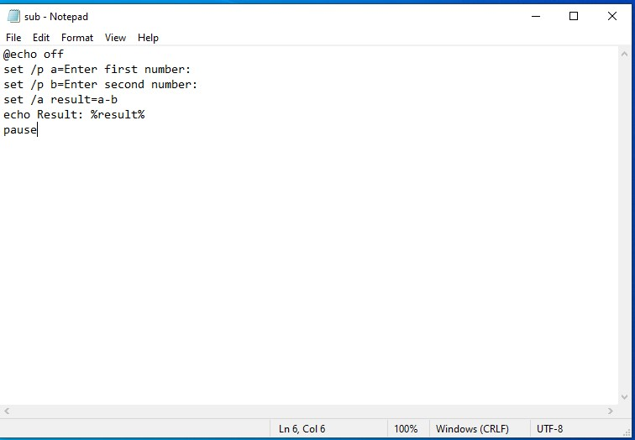
Figure 35: Script code
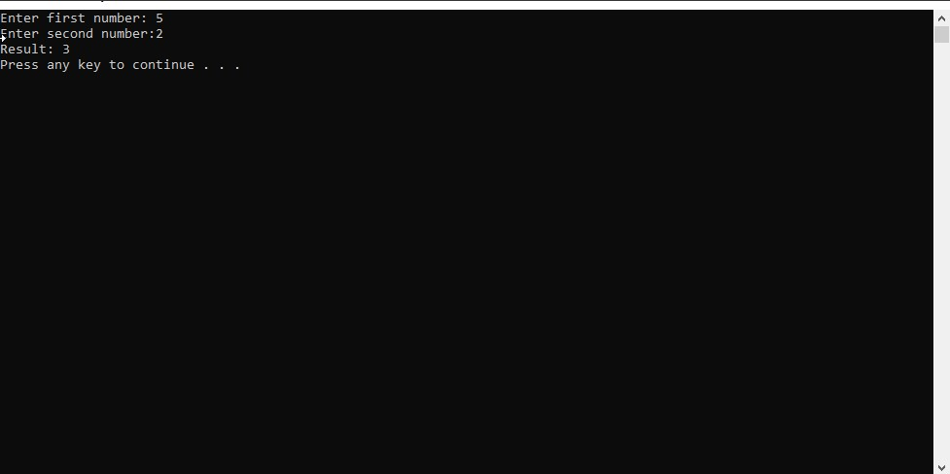
Figure 36: Script running

Script 2: Folder Checker
This script checks whether a folder exists in the system. It uses conditional statements (IF EXIST) to verify the presence of a directory and displays appropriate output. This type of script is useful for automating file system checks and ensuring required resources are available before executing tasks. These scripts highlight the importance of automation in Windows environments, reducing manual effort and improving efficiency.
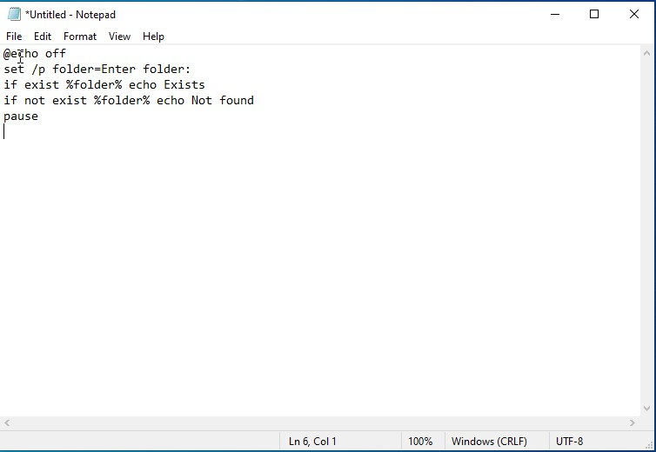
Figure 37: Script code
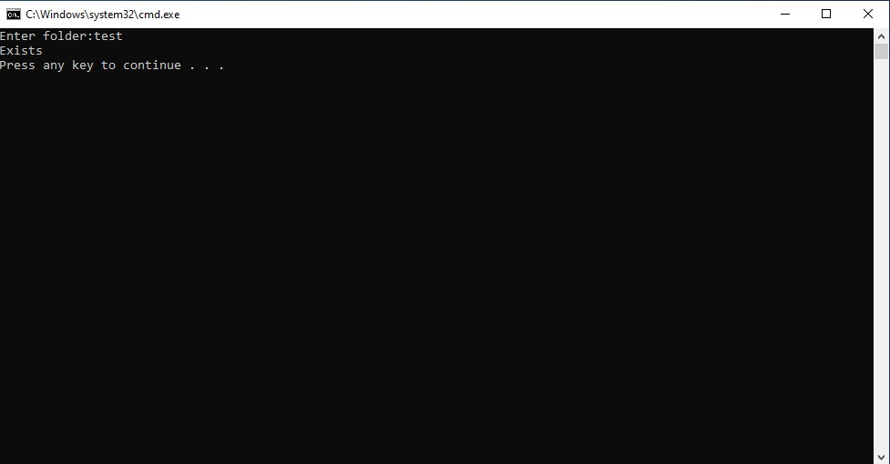
Figure 38: Script running

Linux Scripts

Script 1: Subtraction
This Bash script performs subtraction using user input. It uses the read command to capture input values and performs arithmetic operations using shell expressions. This demonstrates how Linux scripting supports user interaction and calculations.
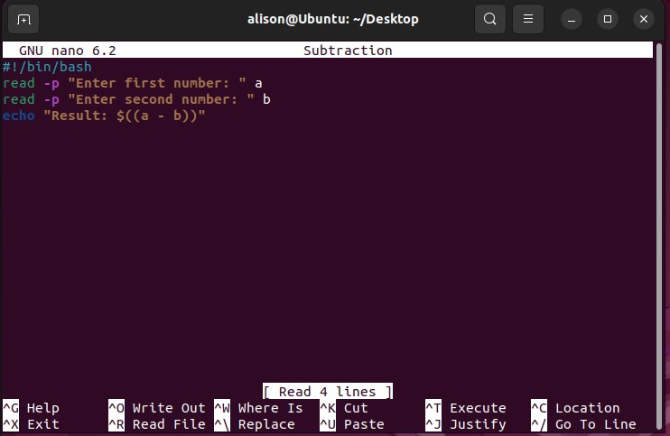
Figure 39: Script code
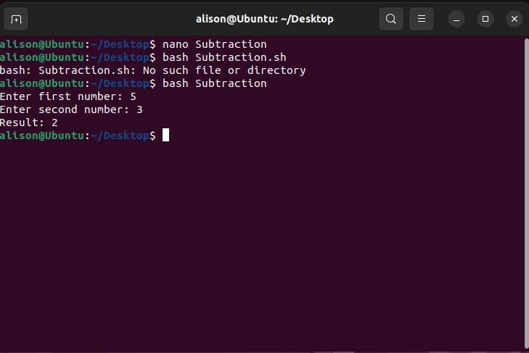
Figure 40: Script Execution

Script 2: File Checker
This script checks whether a file exists using conditional statements (if [ -f filename]). Based on the result, it displays appropriate messages. This is useful in automation tasks such as verifying files before processing them. Bash scripting provides powerful automation capabilities, allowing users to execute multiple commands efficiently and manage system operations with minimal manual intervention.
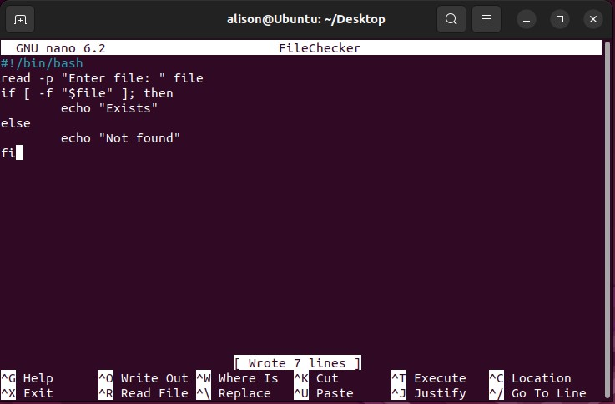
Figure 41: Script Code
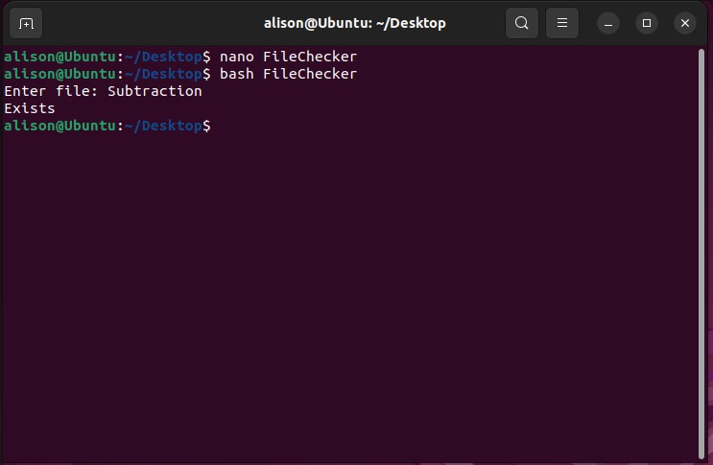
Figure 42: Script Execution

Conclusion
In this report, an analysis of some fundamental functions of operating systems and how they are used in computing practice is performed. The following core functionalities are identified: process management, memory management, file systems, device drivers, and networking, which are considered from a performance perspective. Thus, it becomes clear what each core function does to improve the work of a computer system as a whole.
Moreover, the report highlights some advantages and disadvantages of using command-line interfaces, both in Windows and in Linux. Command-line interface provides powerful tools that can be used for executing different system-related operations like monitoring processes, managing files, troubleshooting network, and administrating users. In comparison with graphical interfaces, command-line utilities offer greater flexibility, higher speed of execution, and more precise results.
The analysis of scripts and scripting languages, such as Batch script and Bash script, reveals the importance of automation for completing repetitive and routine operations with ease. A script allows to execute several actions one after another without any delays and makes a process more reliable and accurate.
Thus, the integration of theoretical knowledge about operating systems together with practical skills related to the command line and scripts is crucial for today's computing. These competencies can be applied by users for improving the efficiency of computer usage, troubleshooting technical problems, and maintaining safe working environment.

References
- A. S. Tanenbaum and H. Bos, Modern Operating Systems, vol. 2. 2014.
- W. Stallings, Operating Systems: Internals and Design Principles, 9th ed. Pearson, 2018.
- P. Yosifovich, Windows Internals. Microsoft Press, 2021.
- B. A. Forouzan, Data Communications and Networking. McGraw-Hill, 2017.

