Designing a control system

Scott ling

Instrumentation and Control.

Wales Institute for Science and Art
University of Wales Trinity Saint David



Abstract

A transfer function of an electronic system is a mathematical function, which theoretically models the devices output for each possible input. Transfer functions for components are used to design and analyse systems assembled from components. This experiment is being carried out due to the need of designing a stable system controller. Using Matlab/Simulink, issues with the system controller can be adjusted to the best of the software prior to instalment in to a process. In this report, a set of 3 numbers were randomly generated and assigned to the author. A task has been set to develop a control system that would be able to control the defined tolerances that have been included within the introduction. From the results gained during the experiment it can be the seen that prior to the tuning, the control system was unstable and by applying selected parameters and tolerances this has now stabilised the control system within the software. A nyquist diagram will be used as another means of comparison within the system controller.

Contents
Abstract 2
1 Introduction 4
1.1 PID theory. 4
1.2 What is a step in a system function? 5
1.3 What is a sum block? 6
1.4 What is a PID? 6
1.5 What is a transfer function? 7
1.6 What is a scope? 8
1.7 Nyquist diagram. 8
2 Equipment 8
3 Method 9
4 Results 18
5 Discussion 24
6 Conclusions 25
7 Table of figures 26

Introduction
For this assignment, a control system will be designed using MATLAB and Simulink software with three randomly selected numbers assigned to the author. Parameters have been set for the controller to be able to work within. By using the control system, the requirement is to be stabilised below two seconds, whilst overshoot is required to be less than 5%. The author was designated the numbers: 5, 1, 1. This will be inputted into the transfer function on Matlab. [1]

PID theory.
A PID controller is executed within a system for the analysis of a sensor, this calculates the requested output. The output will calculate proportional, integral, and derivative responses and then calculating these components to the evaluate the output.
In a control system, the process variable is the system parameter that needs to be controlled. This can include temperature, pressure, or flow rate. The sensor is required to measure the variables and send the information to the control system.

The control systems algorithm, is to determine the required output to move the system.
The closed loop system is an task of reading the sensors in a system and providing constant feedback, as well as calculating the desired actuator output. This is a continuous task and at a fixed loop rate.
Multiple signals have an effect on the system. If anything interferes or interrupts the system this known as disturbance.
Systems are commonly designed to minimise the effect of disturbances. [2]

What is a step in a system function?
A step in Matlab is used to design a system. A reaction to the inputted step is then transferred within a graph removing the calculation for a timed response. A step input can be described as a change in the input from zero to a finite value at time t=0. The step command performs a unit step. The step feedback within the system controller is analysed within the system.
When a step input carried out, the system then begins with the unwanted output period; this is called the transient response. Transient responses occur when the system reaches its final production value.
A continuous state response will occur after transient reaction has ended. Time taken from for the system to reach the desired value is known as the rise time.
The time interval that is taken for the transient response to end and the steady state response to begin is known as the settling time.
In a system the development of stepped response is key, this would require a reduction in the transient, rise, as well as settling times. These need to be shortened whilst the steady state reaches its chosen output. [3]

What is a sum block?
The sum block within Matlab software allows the user to carry out addition and subtraction on the inputs. The add, subtract, sum of the elements and the sum blocks are identical blocks. This block allows the user to be able to add and subtract a scaler, vector, or matrix input. This can also be used to be able to collapse the elements of a signal and carry out the sum.
The user will choose the operations of this block by choosing from the list parameters.
The sum block will convert the input data to the accumulator data type, from this it will then carry out the specified operation. The block will then convert the results to the data output type. This is managed by using the selected overflow and rounding modes. [4]

What is a PID?
A PID or (Proportional integral derivative is a controller that has the potential to be used for the control of various processes or other process variables. The PID controller incorporates the proportional control with additional integral and derivative adjustment, which can assist in compensating for any alterations that have occurred. A requirement for the PID controller is to force feedback to mirror a set point. Controllers are used in systems that what have a small accumulation and of those that can react quickly to any changes within that process.
The principle of a PID controller is the proportional, integral and derivative terms this will need to be modified or adjusted. Depending upon the values that are used, an adjustment factor is evaluated and added to the values.
Percentage overshoot is the amount that the process variable overshoots the final value. Settling time is required for the process variable to settle to under the control system this is normally around 5% of the finished value. [2] [5]

What is a transfer function?
Transfer function shows the connection to the output signal of a control system and input signal, for all possible input values. The block diagram is a image of the system, this uses blocks to show the transfer function, arrows, this then shows the various input and output signals.
The control system has a reference input, this operates using the transfer operation to produce an effect resulting in the controlled output or response.
Transfer function of a control system is the ratio of the Laplace transformation of the output variable. Laplace transformation of the input variable assumes all initial conditions to be zero. [3] [4] [6]

What is a scope?
The scope within the Matlab software shows the input to the simulation time. The scope block has multiple axis’s per port. All axis’s share a familiar interval range with independent y-axis’s. This allows the user to make adjustments to the ranged of stated values.
A scope gives the user the ability to be able to move and resize the window, as well as being able to modify the values whilst carrying out the experiment.
Upon starting a simulation in Matlab, Simulink does not open the scope window, the user will have to do this separately, however it does communicate the data to the connected scopes. When the user opens the scope post experiment, there will be input and output signals displayed.
During this process, the signal that is produced within the scope is continuous, the scope will produce a point-to-point plan. when the produced signal is discrete, a scope will produce a stair step plan.
Once inside a scope window the toolbar allows the user to view the data inputted on to the scope. The potential to preserve the axis settings from one simulation to the next as well as limiting the data that is displayed. [3] [4]

Nyquist diagram.
Nyquist diagram is used for frequency plotting of the response that is used within signal processing and automatic control. Nyquist diagrams are used for evaluating the stability of feedback within a system. The transfer function is plotted on the X-axis. [7]

Equipment
The following equipment is required as follows:
- Matlab/Simulink
- Step
- PID
- Control function
- Scope
- Defined numbers of: 5 1 1
- Overshoot of less than 5%
- Control the system within 2 seconds.
- Nyquist diagram
- Pole plot graph

Method
To be able to carry out this experiment and gain the required results, Matlab and Simulink software is used, a control system is made and the components will be added to the drawing.
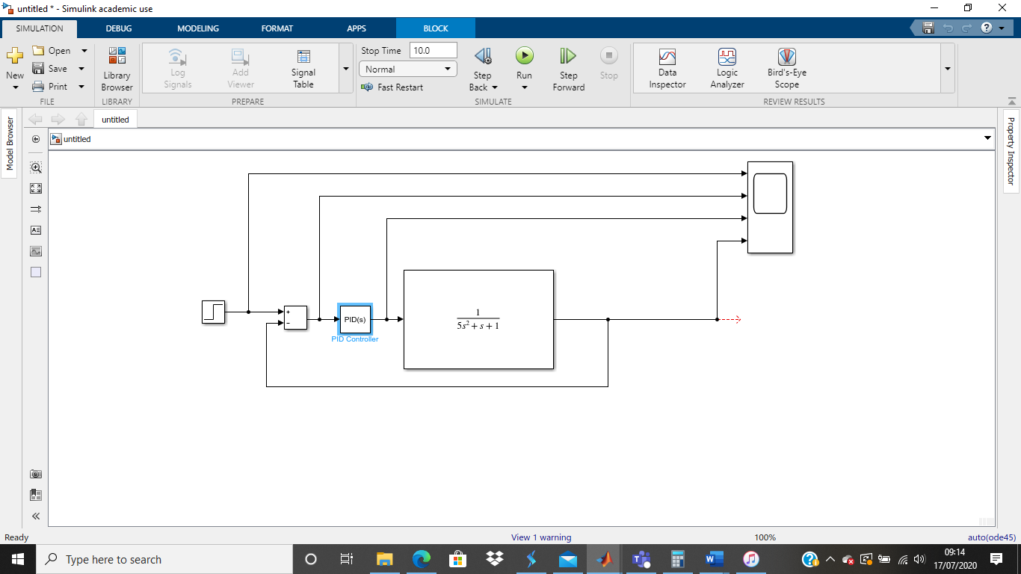
Figure 1 Matlab drawing
The Step, Sum box, PID controller, transfer function and scope are added to the simulation map. The scope has four ports, which takes three feeds from between the step, sum box, PID controller and transfer function; the forth feed will be taken after the transfer function.

Having added in the functions required to run this experiment the predefined values will now be inputted into the transfer function.
Once this has been completed, the user then runs the control system, upon completion of the simulation the user then goes into the scope to be able to retrieve the graph that is produced during the simulation.

Once the graph has been produced, the PID controller block parameters need to be accessed to be able to tune the system controller.

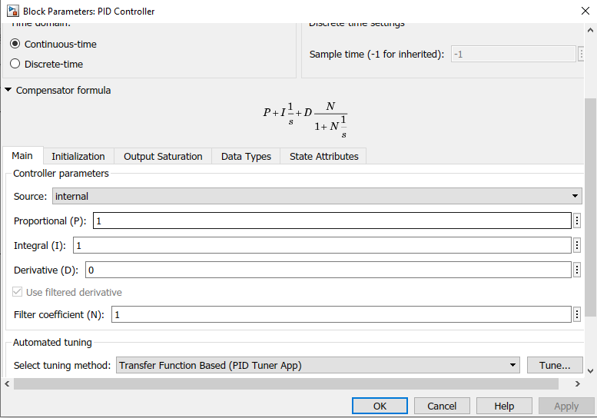
Figure 2 PID controller
From the image above the tuning settings can be selected, this will then open the window that is required to tune the system controller.

The control system is tuned to required tolerences.
To be able to achieve this the response time and transient behaviour sliders were moved across to the right hand side of the bar.
The transient behaviour slider controls how robust the system controller or to give it an aggressive rise in response time, but by doing this the stability of system controller is lowered.

By sliding the bar to the right hand side and meeting the required tolerances, values have been achieved. These will now be used to calculate the forward path transfer function of the system.
The controller’s transfer function is multiplied by the transfer function of the process.

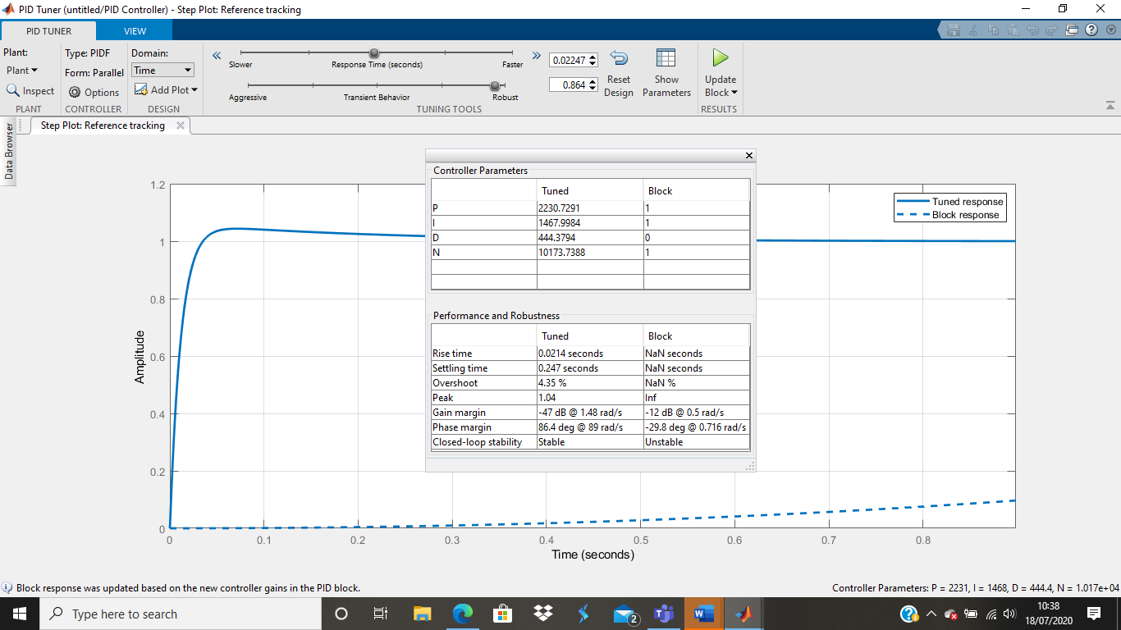
Figure 3 Controller parameters un-tuned/tuned

$$G\left(s\right)=\frac{1}{as^{2}+bs+c}$$

a = 5, b = 1, c = 1 the transfer function now becomes:

$$G\left(s\right)=\frac{1}{5s^{2}+1s+1}$$

The PID tuner in MATLAB, has given the following values:

Kp: 2230.7291
Ki: 1467.9984
Kd: 444.3794
N: 10173.7388

So transfer function for the PID controller is:

$$K_{p}+K_{i}\frac{1}{s}+K_{d}\frac{s}{\frac{1}{N}s+1}$$

$$2230.7291+\frac{1467.9984}{s}+444.3794\frac{s}{\frac{1}{10173.7388}s+1}$$

Calculation of the forward path transfer requires the controllers transfer function to be multiplied by the transfer function of the process.

$$\left(2230.7291+\frac{1467.9984}{s}+444.3794\frac{s}{\frac{s}{10173.7388}+1}\right)×\left(\frac{1}{5s^{2}+1s+1}\right)$$

$$\left(2230.7291+\frac{1467.9984}{s}+444.3794\frac{s}{\frac{s+10173.7388}{10173.7388}}\right)×\left(\frac{1}{5s^{2}+1s+1}\right)$$

$$\left(2230.7291+\frac{1467.9984}{s}+444.3794\left(s÷\frac{s+10173.7388}{10173.7388}\right)\right)×\left(\frac{1}{5s^{2}+1s+1}\right)$$
$$\left(2230.7291+\frac{1467.9984}{s}+444.3794\left(s\left(\frac{10173.7388}{s+10173.7388}\right)\right)\right)×\left(\frac{1}{5s^{2}+1s+1}\right)$$
$$\left(2230.7291+\frac{1467.9984}{s}+444.3794\left(\left(\frac{10173.7388s}{s+10173.7388}\right)\right)\right)×\left(\frac{1}{5s^{2}+1s+1}\right)$$

$$\left(2230.7291+\frac{1467.9984}{s}+\left(\frac{4520999.944s}{s+10173.7388}\right)\right)×\left(\frac{1}{5s^{2}+1s+1}\right)$$

$$\left(\frac{\left((s\left(s+10173.7388\right))×2230.791\right)+\left(s+10173.7388\right)1467.9984+s\left(4520999.944s\right)}{s\left(s+10173.7388\right)}\right)×\left(\frac{1}{5s^{2}+1s+1}\right)$$

$$\left(\frac{2230.7291s^{2}+22694855.2s+1467.9984s+14935032.28+4520999.944s^{2}}{s^{2}+10173.7388s}\right)×\left(\frac{1}{5s^{2}+1s+1}\right)$$
$$\left(\frac{4523230.673s^{2}+22696323.2s+14935032.28}{s^{2}+10173.7388s}\right)×\left(\frac{1}{5s^{2}+1s+1}\right)$$

$$\frac{4523230.673s^{2}+22696323.2s+14935032.28}{\left(s^{2}+10173.7388s\right)\left(5s^{2}+1s+1\right)}$$

$$\frac{4523230.673s^{2}+22696323.2s+141935032.28}{5s^{4}+1s^{3}+1s^{2}+50868.694s^{3}+10173.7388s^{2}+10173.7388s}$$

$$\frac{4523230.673s^{2}+22696323.2s+141935032.28}{5s^{4}+50869.694s^{3}+10174.7388s^{2}+10173.7388s}$$

The block diagram for the control and process will look like this:
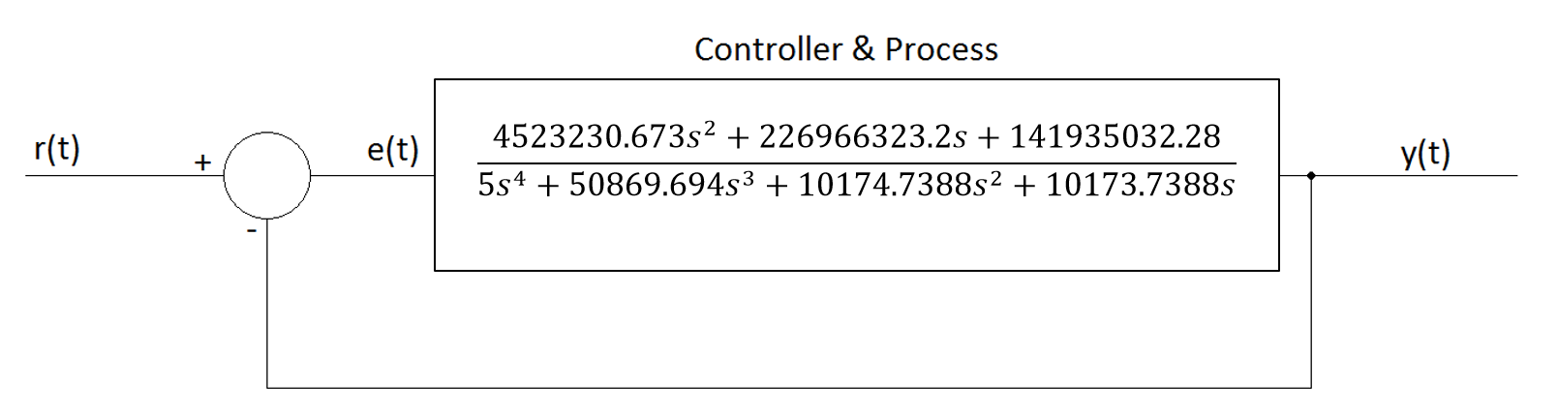

Now there is a new controller & process block diagram the feedback loop has been removed, calculation for the transfer function is carried out.
Using the below formulae:

$$TF=\frac{G}{1+GH}$$

TF is the transfer function of the whole system, G is the forward path transfer function, and H is the transfer function of the feedback loop, in this case $H=1$

$$TF=\frac{\frac{4523230.673s^{2}+226966323.2s+141935032.28}{5s^{4}+50869.694s^{3}+10174.7388s^{2}+10173.7388s}}{1+\left(\frac{4523230.673s^{2}+226966323.2s+141935032.28}{5s^{4}+50869.694s^{3}+10174.7388s^{2}+10173.7388s}\right)×1}$$

$$TF=\frac{\frac{4523230.673s^{2}+22698323.2s+141935032.28}{5s^{4}+50869.694s^{3}+10174.7388s^{2}+10173.7388s}}{\frac{5s^{4}+50869.694s^{3}+10174.7388s^{2}+10173.7388s}{5s^{4}+50869.694s^{3}+10174.7388s^{2}+10173.7388s}+\frac{4523230.673s^{2}+226966323.28s+141935032.28}{5s^{4}+50869.694s^{3}+10174.7388s^{2}+10173.7388s}}$$

$$TF=\frac{\frac{4523230.673s^{2}+226968323.2s+141935032.28}{5s^{4}+50869.694s^{3}+10174.7388s^{2}+10173.7388s}}{\frac{5s^{4}+50869.694s^{3}+10174.7388s^{2}+10173.7388s+4523230.673s^{2}+226968323.2s+141935032.28}{5s^{4}+50869.694s^{3}+10174.7388s^{2}+10173.7388s}}$$

$$TF=\frac{\frac{4523230.673s^{2}+226968323.2s+141935032.28}{5s^{4}+50869.694s^{3}+10174.7388s^{2}+10173.7388s}}{\frac{5s^{4}+50869.694s^{3}+4533405.412s^{2}+226978496.9s+141935032.28}{4s^{4}+138.3836s^{3}+107.5377s^{2}+203.0754s}}$$

$$TF=\frac{4523230.673s^{2}+226968323.2s+141935032.28}{4s^{4}+138.3836s^{3}+107.5377s^{2}+203.0754s}×\frac{5s^{4}+50869.694s^{3}+10174.7388s^{2}+10173.7388s}{5s^{4}+50869.694s^{3}+4533405.412s^{2}+226978496.95s+141935032.28}$$

$$TF=\frac{\left(4523230.673s^{2}+226968323.2s+141935632\right)\left(5s^{4}+50869.694s^{3}+10174.7388s^{2}+10173.7388s\right)}{\left(5s^{4}+50869.694s^{3}+10174.7388s^{2}+10173.7388s\right)\left(5s^{4}+50869.694s^{3}+4533405.412s^{2}+226978496.9s+141935032.28\right)}$$

$$TF=\frac{22,616,153.365s^{6}+{2,288,165,316,441.924062s}^{5}+{46,022,690,629.923212s}^{4}+{46,018,167,399.2502124s}^{2}+{1,134,841,616s}^{5}+{114,816,396,204,877.1008s}^{4}+}{25s^{8}+254,348.47s^{7}+{22,667,027.06s}^{6}+{1,134,892,484.5s}^{5}+{709,675,161.4s}^{4}+{254,348.47s}^{7}+2,587,725,767.653636s^{6}+230,612,946,086.383928s^{5}+{11,546,326,681,882.9486s}^{4}+{7,220,191,659,963.72232s}^{3}+}$$
$$⋯$$
$$\frac{+2,309,343,404,433.9801s^{3}+2,309,116,436,110.78016s+{709,678,160s}^{4}+}{50873.69s^{5}+{517,585,808.590172s}^{4}+{46,126,212,314.882056s}^{3}+{2,309,446,737,591322s}^{2}+1,444,151,766470.54264s+}$$

$$=\frac{{71,800,934,727,536.608s}^{3}+{1,444,157,982,012.9216s}^{2}+1,444,016,046,380.9216s}{{50868.694s}^{4}+{517,534,979.5919272s}^{3}+46,121,682,536.1943856s^{2}+2,309,219,940,677.20972s+1,444,009,944,986.288464s}$$

The next step is to collect all the like terms in the equation.
$$TF=\frac{1,134,841,616s^{6}+2,288,165,316,441.924062s^{5}+114,863,128,573,667.024012s^{4}+74,110,278,131,970.58816s^{3}+}{25s^{8}+508,696.94s^{7}+2,610,392,794.713636s^{6}+{231,747,889,444.573928s}^{5}+{11,547,553,993,721.632772s}^{4}+{7,266,835,407,258.1962152s}^{3}}$$

$$TF=\frac{{1,490,176,149,412.1718124s}^{2}+3,753,132,482,491.70176s}{+{2,355,568,420,127.5065856s}^{2}+5,197,381,652,134.040824s}$$

The block diagram can now be redrawn again as a single block.
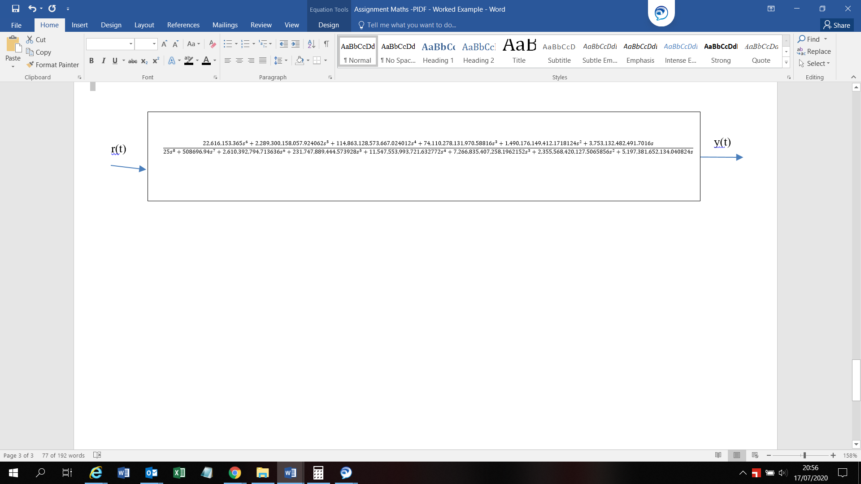
[6]

Results
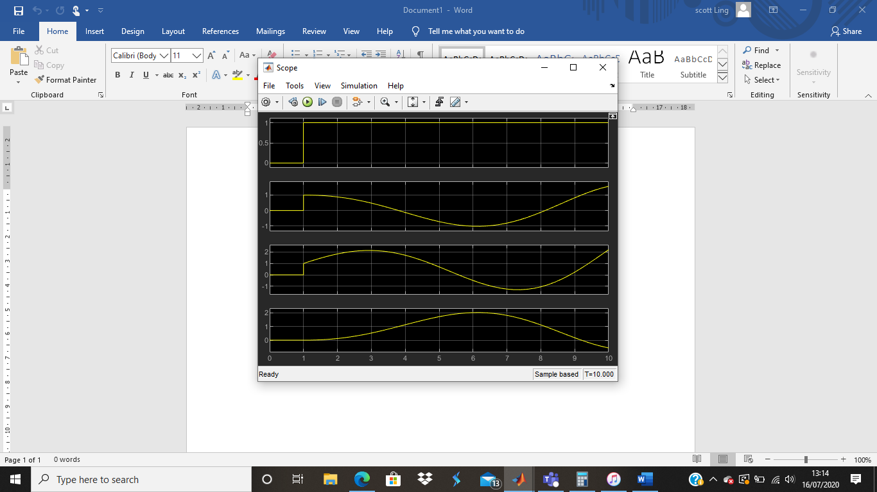
Figure 4 Scope graph un-tuned system controller
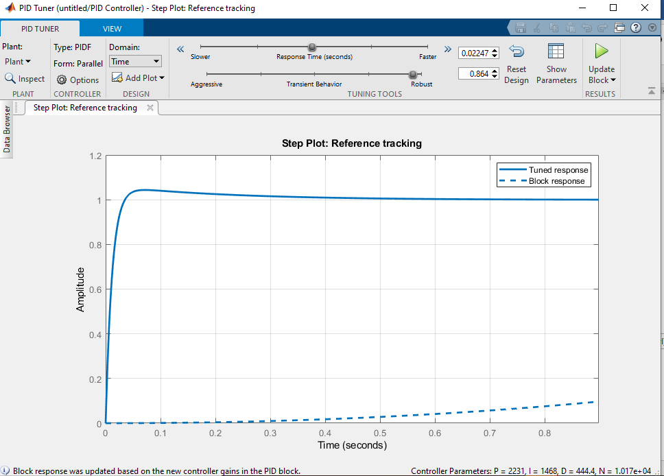
Figure 5 Un-tuned/tuned graph

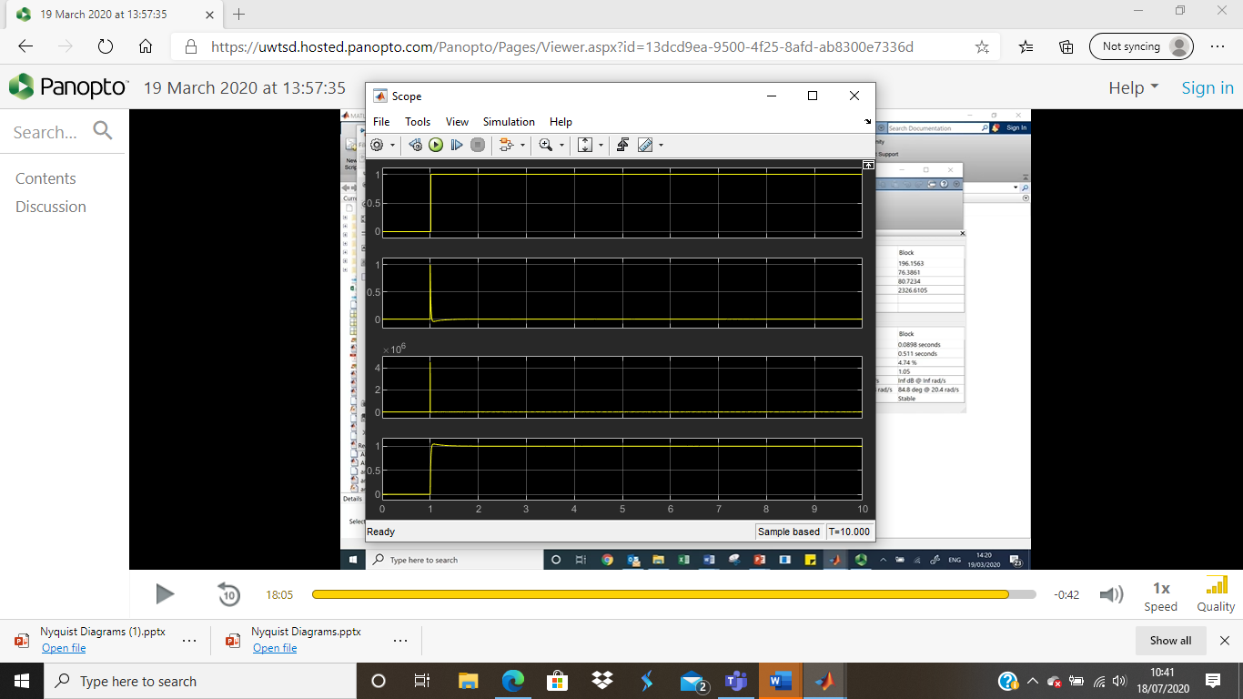
Figure 6 Tuned scope graph
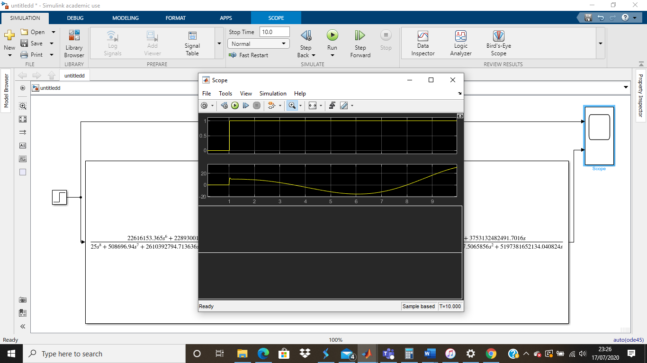
Figure 7 Two port scope graph

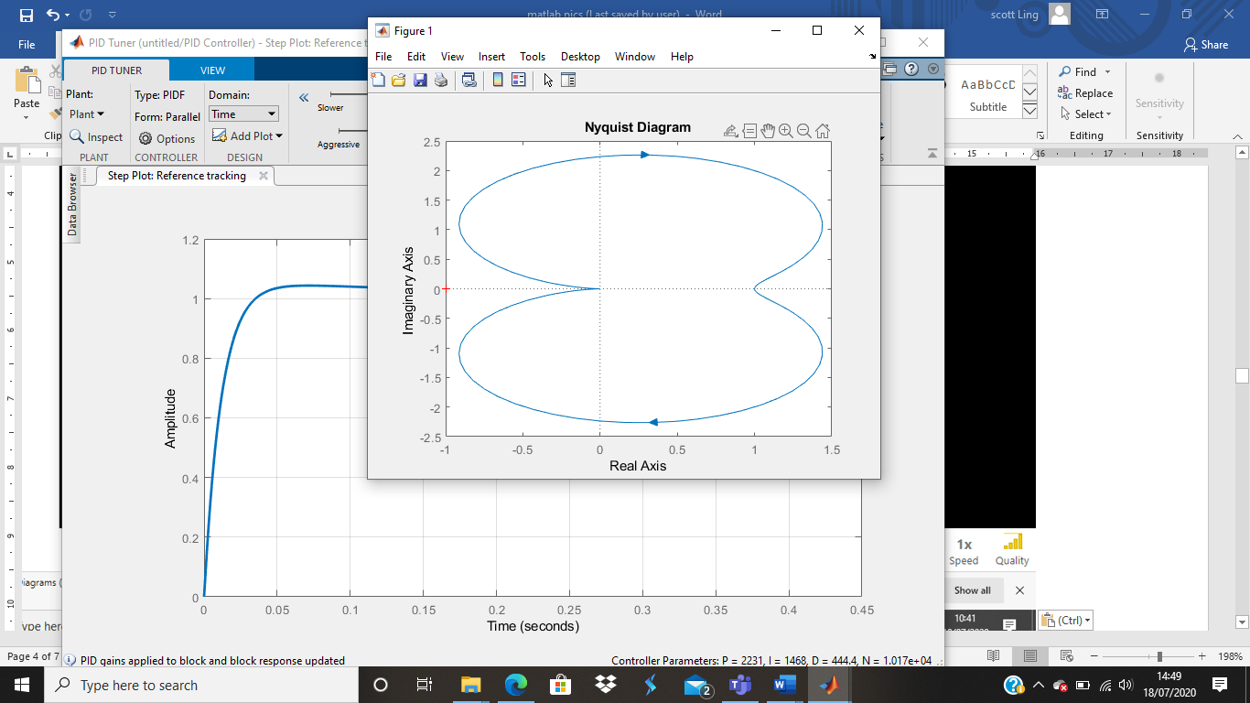
Figure 8 Nyquist pre-tuning

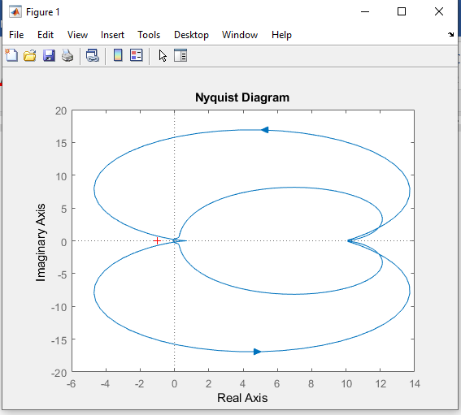
Figure 9 nyquist post tuning
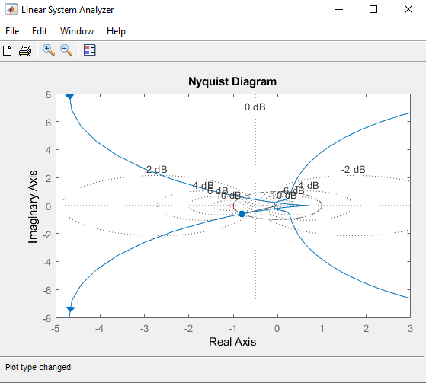
Figure 10 Nyquist including noise
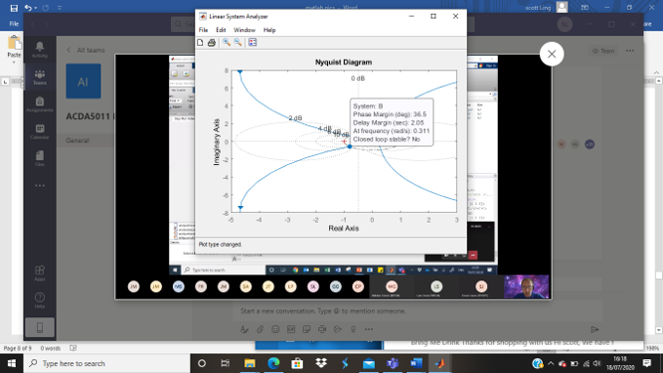
Figure 11 Nyquist including Phase margin
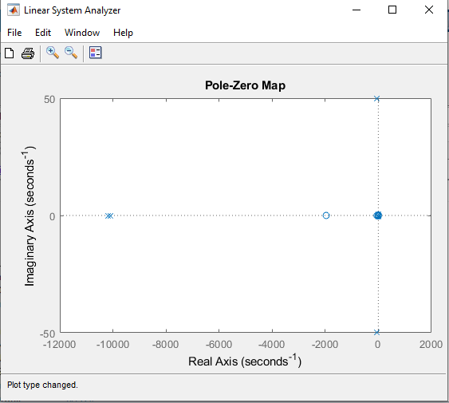
Figure 12 Pole zero graph

Discussion

After carrying the software simulation within Matlab/Simulink, the data for the control system has now been retrieved and a comparison between the un-tuned system controller and tuned system controller can be executed.

From looking at the block response for the un-tuned system, it is noted that the system controller was unstable this can be caused to the mathematical equation, or oscillation within the system controller.

Having tuned the system controller it has now been stabilised as seen in the block parameters.
The threshold tolerances that have been met using a control system have been met by bringing the process under control within 0.247 seconds when the requirement was under 2 seconds, as well as achieving an overshoot value of 4.35 % when the requirement was under 5%. Before the tuning process was carried out the block response within the system controller was unstable by tuning it to the required tolerances this has now made the system controller stable.
A nyquist and pole zero graph have been made for the un-tuned and tuned system.

Conclusions
In conclusion to the simulated system control experiment, data has been obtained and the required tolerances have been met.
Using simulation software tools is important when designing system controllers. This is the first step that can be used to design and understand whether the system controller is stable or unstable before this is inputted into a process. By carrying out this style of experiments and gaining the understanding and data from the experiments, it enables the design of a stable control system before this is installed into a real world process. However, although the software can make the system stable and marginally reduce the overall tuning upon integration with the process, there will need to be modifications upon installation to real world process due to being added into a bigger system as there will be more the one system with the process. The tuning would need to be completed to bring all the system controllers together.
This is due to the software working from algorithms and not being able to take human error factors, power supplies, interference and communications problems. Further investigation will need to be undertaken to fully understand the results from this experiment.

Table of figures
Figure 1 Matlab drawing 10
Figure 2 PID controller 12
Figure 3 Controller parameters un-tuned/tuned 13
Figure 4 Scope graph un-tuned system controller 19
Figure 5 Un-tuned/tuned graph 20
Figure 6 Tuned scope graph 20
Figure 7 Two port scope graph 21
Figure 8 Nyquist pre-tuning 21
Figure 9 nyquist post tuning 22
Figure 10 Nyquist including noise 23
Figure 11 Nyquist including Phase margin 24
Figure 12 Pole zero graph 25

[1]
[2] | NI, “PID theory,” NI, [Online]. Available: https://www.ni.com/en-gb/innovations/white-papers/06/pid-theory-explained.html. [Accessed 11 07 2020].
[3] | Mathwork, “Simulink,” Math work, [Online]. Available: https://www.mathworks.com/help/simulink/slref/add.html. [Accessed 14 07 2020].
[4] | ECE, “Mthlab help,” ECE Northwestern, [Online]. Available: http://www.ece.northwestern.edu/local-apps/matlabhelp/toolbox/simulink/slref/scope.html#:~:text=The%20Scope%20block%20displays%20its,range%20of%20input%20values%20displayed.. [Accessed 12 07 2020].
[5] | O. productions, “how-does-a-pid-controller-work,” omega, [Online]. Available: https://www.omega.co.uk/prodinfo/how-does-a-pid-controller-work.html. [Accessed 10 07 2020].
[6] | https://www.electrical4u.com/transfer-function/, “https://www.electrical4u.com/transfer-function/,” 09 07 2020. [Online]. Available: https://www.electrical4u.com/transfer-function/.
[7] | S. direct, “Nyquist diagram,” science direct, 2020.
[8] | S. mosey, Maths formulae, swansea: s mosey, 2020.
[9] | i. http://ctms.engin.umich.edu/CTMS/index.php?aux=Extras_step#:~:text=A%20step%20input%20can%20be%20described%20as%20a%20change%20in, “http://ctms.engin.umich.edu/CTMS/index.php?aux=Extras_step#:~:text=A%20step%20input%20can%20be%20described%20as%20a%20change%20in,is%20a%20defined%20LTI%20object.,” http://ctms.engin.umich.edu/CTMS/index.php?aux=Extras_step#:~:text=A%20step%20input%20can%20be%20described%20as%20a%20change%20in,is%20a%20defined%20LTI%20object., [Online]. Available: http://ctms.engin.umich.edu/CTMS/index.php?aux=Extras_step#:~:text=A%20step%20input%20can%20be%20described%20as%20a%20change%20in,is%20a%20defined%20LTI%20object.. [Accessed 09 07 2020].
[10] | E. 4. u, “transfer function,” Electrical4u, [Online]. Available: https://www.electrical4u.com/transfer-function/. [Accessed 11 07 2020].

[1] | S. mosey, L5 assignment brief, swansea: s mosey, 2020.
[2] | NI, “PID theory,” NI, [Online]. Available: https://www.ni.com/en-gb/innovations/white-papers/06/pid-theory-explained.html. [Accessed 11 07 2020].
[3] | Mathwork, “Simulink,” Math work, [Online]. Available: https://www.mathworks.com/help/simulink/slref/add.html. [Accessed 14 07 2020].
[4] | ECE, “Mthlab help,” ECE Northwestern, [Online]. Available: http://www.ece.northwestern.edu/local-apps/matlabhelp/toolbox/simulink/slref/scope.html#:~:text=The%20Scope%20block%20displays%20its,range%20of%20input%20values%20displayed.. [Accessed 12 07 2020].
[5] | O. productions, “how-does-a-pid-controller-work,” omega, [Online]. Available: https://www.omega.co.uk/prodinfo/how-does-a-pid-controller-work.html. [Accessed 10 07 2020].
[6] | https://www.electrical4u.com/transfer-function/, “https://www.electrical4u.com/transfer-function/,” 09 07 2020. [Online]. Available: https://www.electrical4u.com/transfer-function/.
[7] | S. direct, “Nyquist diagram,” science direct, 2020.
[8] | S. mosey, Maths formulae, swansea: s mosey, 2020.
[9] | i. http://ctms.engin.umich.edu/CTMS/index.php?aux=Extras_step#:~:text=A%20step%20input%20can%20be%20described%20as%20a%20change%20in, “http://ctms.engin.umich.edu/CTMS/index.php?aux=Extras_step#:~:text=A%20step%20input%20can%20be%20described%20as%20a%20change%20in,is%20a%20defined%20LTI%20object.,” http://ctms.engin.umich.edu/CTMS/index.php?aux=Extras_step#:~:text=A%20step%20input%20can%20be%20described%20as%20a%20change%20in,is%20a%20defined%20LTI%20object., [Online]. Available: http://ctms.engin.umich.edu/CTMS/index.php?aux=Extras_step#:~:text=A%20step%20input%20can%20be%20described%20as%20a%20change%20in,is%20a%20defined%20LTI%20object.. [Accessed 09 07 2020].
[10] | E. 4. u, “transfer function,” Electrical4u, [Online]. Available: https://www.electrical4u.com/transfer-function/. [Accessed 11 07 2020].

