

Module Name: Managing Enterprise
Module Code: BMSW4011

Assignment Name: Business Plan and Reflection

Student Name: Kailash Doolar
Student Number: 2434709
Lecturer: Melanie Squirie
Deadline: 6th March 2026 23:59

Table of Contents
Task One Part 1 3
1. Company Overview and Service Proposition 3
2. Conceptual Inspiration and Motivation 4
3. Legal Structure and Ownership 4
4. Mission, Aim, Objectives, and Unique Selling Proposition 5
5. Physical Location 6
6. Human Resource Strategy 6
7. Marketing and Promotion 6
8. Market Research 7
9. Financial Planning 8
10. Competitor Analysis 8
11. SWOT Analysis 8
12. Conclusion 9
Task One Part 2 9
References 11

Good Karma Care Business Plan

Task One Part 1

1. Company Overview and Service Proposition
Good Karma Care Services Ltd is a private health and social care provider operating across Mauritius. The company specialises in delivering professional, compassionate, and personalised home care services, enabling elderly and vulnerable individuals to promote independent living. According to the recent census, 18.9 per cent of Mauritius citizens are elderly, aged 60 and over. Good Karma Care offers a broad spectrum of services, including personal care such as washing and dressing, dementia and Alzheimer’s support, post-stroke rehabilitation, medication management, physiotherapy at home, and companionship services. The company's value proposition is “Supporting Independence at Home.”
Home-based care services are in growing demand, as traditional residential care facilities may not meet the personalised needs of every client. Evidence suggests that, when effectively coordinated, formal home care services significantly enhance the quality of life for older adults while reducing hospital readmissions (Khatri et al., 2023). Moreover, integrating physiotherapy and dementia-specific support distinguishes Good Karma Care from typical domiciliary services, aligning with international best practices in personalised healthcare (Li and Song, 2022).

2. Conceptual Inspiration and Motivation
The concept for Good Karma Care emerged from observing the difficulties families in Mauritius face in balancing work commitments with caregiving responsibilities. Many elderly individuals prefer the comfort of their own homes, but family members often struggle to provide consistent support. Personally, I have a profound interest in mental health and social care, which has inspired me to create a business that combines professionalism with empathy. This motivation aligns with Walker's (2022) perspective, which highlights that caregiving is often a shared societal responsibility, yet families require external support to maintain quality care.
The business aims not merely to provide basic care but to enhance overall well-being, prevent unnecessary hospitalisation, and reduce caregiver burnout. By offering structured home support, Good Karma Care addresses gaps in Mauritius’ healthcare system and promotes inclusive, person-centred care in line with contemporary healthcare policies (Daly et al., 2022).

3. Legal Structure and Ownership
Good Karma Care is structured as a private limited company (Ltd). This choice provides limited liability protection, safeguarding personal assets while enhancing credibility with healthcare partners, financial institutions, and potential investors. Additionally, a limited company facilitates long-term growth and professionalisation, which is essential given the high standards and risks associated with healthcare delivery.
Despite the benefits, forming a limited company entails higher initial costs, annual reporting requirements, and additional legal formalities. However, these are outweighed by the advantages of business continuity, greater client trustworthiness, and easier access to financing (Joshi et al., 2023). Given the professional nature of healthcare services, the legal structure supports both operational credibility and sustainable expansion.

4. Mission, Aim, Objectives, and Unique Selling Proposition
Mission Statement:
“To provide compassionate, professional and reliable home care services across Mauritius, enabling clients to live safely and independently at home.”
Aim:
To become a trusted home care provider serving all of the nine districts of Mauritius within three years.
SMART Objectives:
1. Recruit and train 10 qualified caregivers within the first 6 months.
2. Secure 25 regular clients within the first year of operation.
3. Achieve monthly revenue of MUR 400,000 by Month 12.
4. Establish partnerships with at least 3 private clinics within 12 months.
Unique Selling Proposition (USP):
• Specialised dementia and post-stroke home care
• Physiotherapy at home
• Multilingual caregivers (English, French, Creole, Hindi, Urdu, and Phojpuri) are well spoken across Mauritius.
• 24/7 responsive support line

5. Physical Location
The administrative office will be located in central Flacq in Mauritius. This location facilitates efficient travel to northern, southern, eastern, and western regions, minimising response time to client requests.

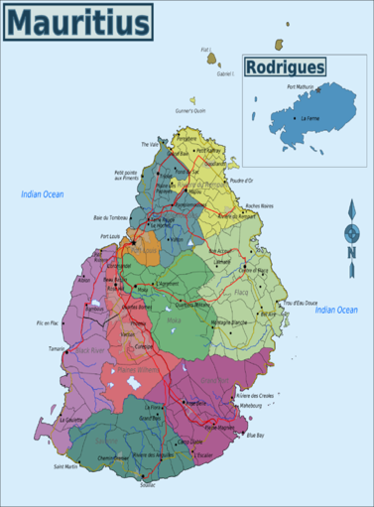

6. Human Resource Strategy
An organisational chart illustrates a hierarchical structure with the managing director at the top, followed by operations coordination, registered nurse oversight, caregivers, and contracted physiotherapists. This approach ensures accountability, clear reporting lines, and effective delivery of specialised services (Giambattista et al., 2023).
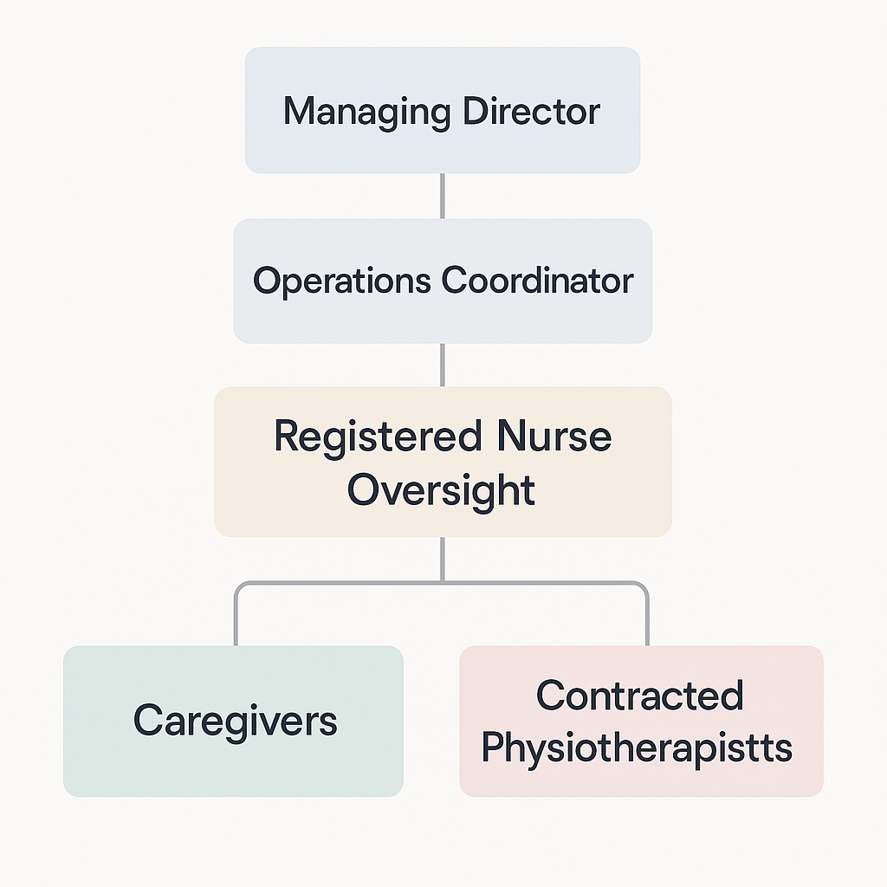

7. Marketing and Promotion
Good Karma Care’s marketing strategy integrates digital and traditional channels. Branding includes a professional logo, uniforms, and a consistent visual identity in blue-and-white medical-themed colours. Offline strategies include distributing flyers in clinics, pharmacies, and community centres; launching a campaign targeting Mauritian adults aged 35–60; creating TikTok awareness videos illustrating the benefits of home care; and hosting community health awareness events. Introductory offers, such as a 10% discount for first-month clients, alongside client testimonials, enhance trust and engagement. This marketing approach aligns with modern healthcare promotion strategies that prioritise visibility, community engagement, and reputation management (Morita et al., 2023).

8. Market Research
Primary research conducted in Mauritius surveyed 50 adults aged 30–65, revealing that 68% expressed concern about elderly parents living alone, 72% preferred home care over nursing facilities, and 60% were willing to pay for professional caregiving. Interviews with five healthcare professionals reinforced the demand for post-discharge home support. Secondary research corroborated these findings, highlighting an ageing population, an increasing prevalence of chronic conditions, and higher female workforce participation, which reduces the availability of family caregiving (Statistics Mauritius, 2023).
The research-informed service design emphasises dementia care, post-stroke rehabilitation, flexible hourly packages, and competitive pricing. By integrating both primary and secondary insights, Good Karma Care ensures that services directly address market needs, optimise resource allocation, and enhance client satisfaction (Khatri et al., 2023).

9. Financial Planning
Estimated startup costs for Good Karma Care total approximately MUR 545,000, covering business registration, office rent, equipment, marketing, insurance, licenses, and initial salary reserves. Pricing strategies include basic care at MUR 250 per hour, specialist care at MUR 350 per hour, and physiotherapy at MUR 800 per session. A 12-month cash flow forecast anticipates initial monthly revenue of MUR 100,000, increasing to MUR 400,000 as client numbers expand, projecting a year-one profit of approximately MUR 700,000.
Funding sources include personal savings, bank loans under the SME Mauritius Scheme, and potential government grants for healthcare SMEs. These projections are grounded in conservative client acquisition estimates, ensuring financial feasibility and operational sustainability (Joshi et al., 2023).

10. Competitor Analysis
Competitor pricing ranges from MUR 200 to 400 per hour. Lessons from the analysis highlight the importance of professional branding, clear pricing, and a robust online presence in attracting clients and establishing credibility (Giambattista et al., 2023).

11. SWOT Analysis
The SWOT analysis concludes that Good Karma Care is viable due to clear market demand, financial planning, and distinctive service offerings (Joshi et al., 2023).
Strength  Specialise services,  Strong branding  Professional structure | Weaknesses  Potential staff turnover  Labour intensive operation  Initial cashflow pressure
Opportunities  Government healthcare collaboration  Expansion into telehealth services | Threats  Regulatory changes  Competition  Economic downturns

12. Conclusion
Good Karma Care Services Ltd demonstrates strong viability in Mauritius’ home care market. Integrating market research, professional staffing, competitive pricing, and specialised services, the business offers sustainable, high-quality home care solutions. With strategic marketing, effective human resource management, and prudent financial planning, Good Karma Care is positioned for long-term growth and positive societal impact.

Task One Part 2
Individual Reflection
The entrepreneurial skills I applied in developing this business plan were both familiar and new to me. The skills in market research, financial forecasting, and competitor analysis were also improved through primary and secondary research specific to Mauritius, organisational structure, and marketing plan. These activities strengthened my ability to translate abstract business ideas into practical action plans. It has also helped me understand how to structure a business concept by considering factors such as target clients, learn skills through our group discussions, and learning how to share ideas and work effectively with others.
Out of these skills, market research and financial planning were the most useful. Surveys and interviews conducted in Mauritius enabled me to gain insights into local consumers’ needs, cultural aspects, and service preferences. Such first-hand experience provided important information for the service proposal, pricing plan, and marketing plan. The financial planning, comprising the cash flow planning and cost analysis, enhanced a sense of realistic business sustainability and risk management. This is essential, as it is a skill set for determining long term viability, where continuity of operations is an important aspect in healthcare.
Critical thinking and evidence-based decision-making were also developed during the process of embedding research findings into the business plan. Through these insights, it ensured that global best practices could be utilised without compromising local context when making strategic decisions.
Good Karma Care promotion also promoted skills of creative problem-solving and strategic communication. It was important to consider service gaps and client expectations when developing a unique selling proposition to differentiate the company from the competition. In the same regard, building a marketing framework that integrates online and community based plans enhanced my ability to sell value to various stakeholders.
The course has helped me develop new entrepreneurial skills such as opportunity recognition and market analysis. On balance, the given evaluation helped pinpoint the necessity of applying both practical research and financial savvy, along with strategic planning, to the practice of entrepreneurship. It also affirmed my ability to come up with a business idea that cannot be easily commercialised, but can also transform society. The practice also highlighted the importance of the constant learning process and change, especially in an industry as dynamic and sensitive as health and social care.
Overall, the enterprise lectures have helped me build a stronger entrepreneurial mindset. It has improved my ability to think creatively, analyse opportunities, and learn about business challenges with greater confidence and strategic thinking.

References
1. Daly, M., León, M., Pfau-Effinger, B., Ranci, C. and Rostgaard, T., 2022. COVID-19 and policies for care homes in the first wave of the pandemic in European welfare states: Too little, too late?. Journal of European social policy, 32(1), pp.48-59.
2. Giambattista, A., L'Angiocola, E., Gironi, C. and Di Lucchio, L., 2023. Designing for better care in nursing homes: improving staff experience through a smart caregiver-oriented wearable system. The International Journal of Design in Society, 17(2), p.71.
3. Joshi, N.K., Joshi, V. and Bajaj, K., 2023. Strengths, weaknesses, opportunities, and threats analysis of the national program for health care of the elderly. Journal of the Indian Academy of Geriatrics, 19(1), pp.54-60.
4. Khatri, R., Endalamaw, A., Erku, D., Wolka, E., Nigatu, F., Zewdie, A. and Assefa, Y., 2023. Continuity and care coordination of primary health care: a scoping review. BMC Health Services Research, 23(1), p.750.
5. Li, J. and Song, Y., 2022. Formal and informal care. In Encyclopedia of gerontology and population aging (pp. 1905-1911). Cham: Springer International Publishing.
6. Morita, P.P., Sahu, K.S. and Oetomo, A., 2023. Health monitoring using smart home technologies: scoping review. JMIR mHealth and uHealth, 11, p.e37347.
7. Nyashanu, M., Pfende, F. and Ekpenyong, M.S., 2022. Triggers of mental health problems among frontline healthcare workers during the COVID‐19 pandemic in private care homes and domiciliary care agencies: Lived experiences of care workers in the Midlands region, UK. Health & social care in the community, 30(2), pp.e370-e376.
8. Walker, A., 2022. Care for elderly people: A conflict between women and the state. In A labour of love (pp. 106-128). Routledge.

