Research Report

Student’s name-Margarita Chaparova
Student number-2123016
Module Code: BMSW4003_BIRM
Module title Digital: Skills and Research Methods
Lecturer’s name :Munodzinesa Zuwirai

Abstract
Digital tools as a means of collaboration have become a norm in most tertiary institutions. This paper examined the most used digital tool for collaboration in UWTSD among Microsoft Teams, Blackboard/student portal, University social media and student email. The study used a sample size of 27 students. The data was collected from the participants using questionnaires, observation and analysis. Questionnaires were the primary form of data collection and each form contained ten questions. The data collected were analyzed and visualized using pie charts and bar graphs. The results showed that students consider Microsoft Teams more effective for collaboration compared to the other digital tools. The study concluded that digital tools are essential for learning in tertiary institutions and more investment should be made on digital tools.(Kanimozi,Janaki,,2018).

- Introduction
With the continuous innovations in technology, schools have also adopted technology as a means of collaboration. Collaboration among university students is essential in their learning since it enhances knowledge sharing and quick access to information and it improves team interaction. The busy schedules among students in universities and colleges have also attributed to the need for digital tools and skills. Institutions use digital tools such as Microsoft teams, university’s social media, blackboard/ student’s portal and student mail. However, the usage of these digital tools differs since some are more effective than others and depend on a student’s preference. Microsoft teams and blackboard prove to be more used than the other tolls.(Kanimozhi,Janaki,2018)
- Research Design
- Research question
Clearly, digital tools are a key component in learning in tertiary institutions. To examine the usage of digital tools, a research will be conducted in UWTSD to determine the most used collaboration tool. This research aims at identifying the most used digital tool for collaboration among UWTSD students by analyzing their frequency pattern in using the four digital tools; Microsoft Teams, Blackboard, University social media and student mail. The research will be answering the question:
Which digital tool is most used for collaboration at UWTSD?
- Research method
The research was conducted among 27 students of UWTSD. The participants were selected using simple random sampling such that the participants were selected randomly. The data was gathered through methods including questionnaires and analysing. Questionnaires were the primary form of data collection while the rest were secondary methods. The questionnaires were distributed across the participants, 27 students, who were supposed to submit them after a few days. The questionnaires contained ten questions, each with the relevant choices for easy analysis and simplicity for the participants. The questions used were easy to relate to and it took approximately few minutes to complete one questionnaire. The questions aimed at understanding the usage frequency of the four digital tolls being examined, students’ preferences, and students’ thoughts about the significance of those tools for collaboration. The questions in the questionnaires were:
- Which is your preferred digital tool for collaboration at university?
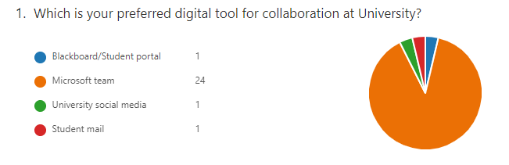

- Do you think digital tools help you to collaborate at university?

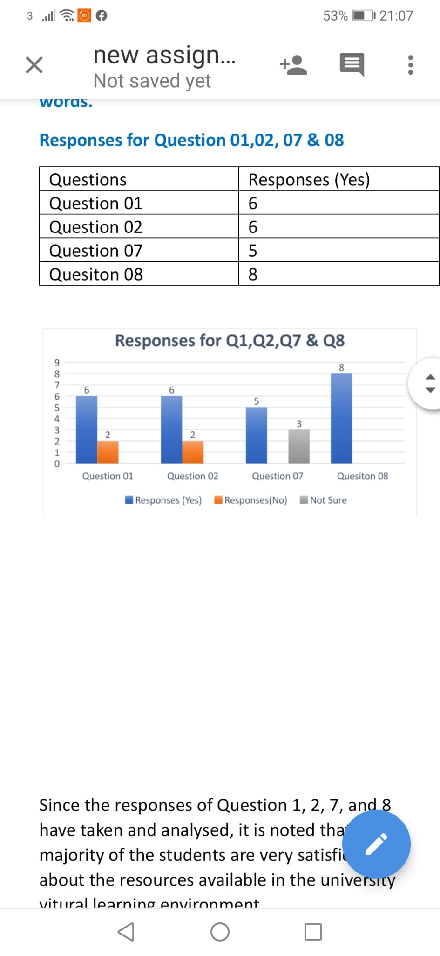

- Do you think using digital tools for collaboration is secure enough at university?
- Do you think using digital tools for collaboration help student to save faculty time?
- How often do you interact with students on the Blackboard/social media?
- How often do you interact with students in Microsoft teams?
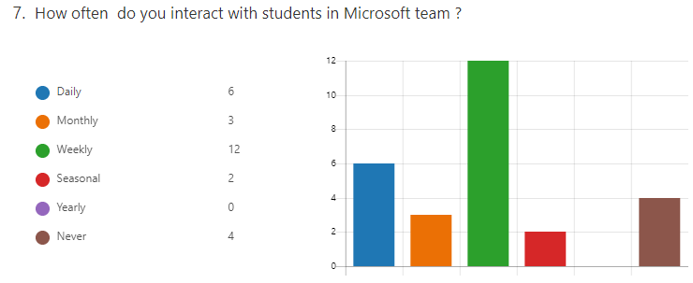

- Do you think using digital tool help students learn easier the subject at university?
- How does using collaboration tools improves your study at university?

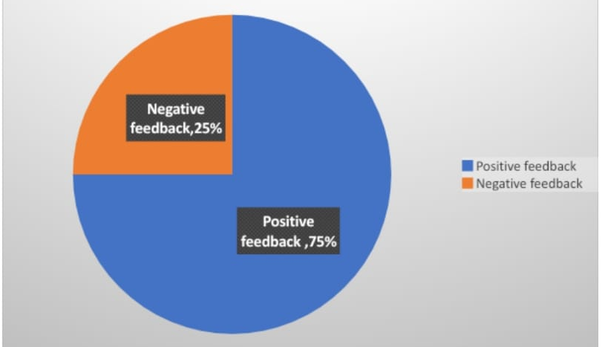

- Do you think UWTSD should invest more in digital tools for collaboration?
There was also a contact where participants would reach out for further information. The questionnaires were filled within seven days after distribution and the data analysis began. The simplicity of the questionnaire contributed to getting responses from all 27 participants. The data from the questionnaires were analyzed through pie charts and bar graphs. The secondary methods of data collection were meant to supplement the information obtained from the questionnaires.
- Ethical considerations
The study observed several ethical considerations including anonymity, confidentiality, voluntary participation and informed consent. Every participant was aware of what the study was about and the primary aim of the study. Details of participants were protected such that their personal information was kept out of the data users. The names and faculties of the participants were also not exposed to ensure their anonymity of the participants. No participant was coerced to fill in the questionnaire; the participants contributed to the study willingly. From the random sampling used to select the sample from the population, individuals who were not willing to participate in the study were excluded and other students were included;
- Results
All the questionnaires were well filled by the 27 participants by week two. All students agreed that digital tools help in collaboration and make collaboration effective at UWTSD. 92% of the students agreed that digital tools help them in saving time because one can share information quickly and share knowledge with others when there are issues. Blackboard and social media were among the rarely used digital tools since 37% of the students had never used them while those using them were doing it at a low frequency. Microsoft teams proved to be the most used digital tool for collaboration at UWTSD with approximately 78%. Only four out of 27 students had never used Microsoft Teams. Most students were certain that the digital tools being used at UWTSD were making learning easier in various subjects. The participants acknowledged the contribution of digital tools to knowledge sharing, quick access to information and improving team interaction. Students showed that improving team interaction is the most beneficial aspect of having digital tools at UWTSD. 85% of the participants showed the need for UWTSD to invest in digital tools for collaboration.

- Discussion
Collaboration is essential among students from tertiary institutions hence the need to implement digital tools that can favour collaboration. There are a variety of digital tools for collaboration but very few are effective. From this research, Microsoft Teams is an effective collaboration tool that most students prefer and are compatible with. It is used at a high frequency by most students ranging from daily to weekly. Blackboard, student emails and university social media are not often used by students for collaboration; most students never use these platforms. Rodríguez-Abitia et al (2021) note that there has been a huge transformation of digital collaboration tools in universities. It then shifted to the blackboard or student’s portal which was considered efficient because students’ information was safe, and it encouraged team interaction. Microsoft Teams is the latest digital tool innovation that allows students to form learning groups and saves academic resources for future reference. From the study, students need this digital tool, and they consider them effective for learning since they help in knowledge sharing, access to information and interaction among teams. Digital tools are also essential in sharing assignments and books among students which makes it difficult for students to collaborate without them. Pacheco et al (2018) state that education experts have questioned the benefits of these digital tools in learning because they have made students’ overdependence on them increase thus affecting the learning process.
For instance, using the student portal, students can organize themselves into learning groups where they can share knowledge. Kryukov, (2017) acknowledges that digital tools also help students in sharing the necessary learning material which ensures every student is updated.
Students showed more interest in wanting to collaborate using digital tools which push institutions to invest more on these platforms. There is a lot to be done in ensuring these platforms become more effective. Institutions should also train students on how to use these tools to ensure students are informed. Some digital tools are not used since students lack the necessary digital skills to use them (Coccoli et al., 2014).
- Conclusion
From the study, digital tools are useful for the collaboration of students in tertiary institutions. Students at UWTSD confirmed that digital tools are quite essential in their learning process. Apart from easing learning, they also help in reinforcing student interactions, knowledge sharing and enhancing quick access to information. Microsoft Teams is considered the ultimate digital tool for collaboration since most students at UWTSD use it to interact with other students. From the above statistics, students use Microsoft Teams every week for collaboration. For effectiveness, institutions should focus more on Microsoft Teams compared to the other digital tools- university social media, student emails and blackboard. With the ongoing advancement in technology, learning institutions should ensure that their digital collaboration systems are updated and make learning easy and collaborative.
References

Coccoli, M., Guercio, A., Maresca, P. and Stanganelli, L., 2014. Smarter universities: A vision for the fast-changing digital era. Journal of Visual Languages & Computing, 25(6), pp.1003-1011.

Doiron, R. and Asselin, M., 2011. Exploring a new learning landscape in tertiary education. New Library World.

Enaohwo, A. and Awotua-Efebo, E., 2018. Students’ interest in the usage of WhatsApp as a digital learning tool in tertiary institutions in the port Harcourt metropolis. African Journal of Educational Research and Development (AJERD), 11(1).

Flintoff, K., Mellow, P. and Clark, K.P., 2014. Digital curation: Opportunities for learning, teaching, research and professional development.

Huddy, A., 2017. Digital technology in the tertiary dance technique studio: expanding student engagement through collaborative and co-creative experiences. Research in Dance Education, 18(2), pp.174-189.
McArthur, David. “Investing in Digital Resources.” New Directions for Higher Education, vol. 2002, no. 119, 2002, pp. 77–86, 10.1002/he.74. Accessed 22 Mar. 2021.
Ali, Alisha, et al. “Hospitality Students’ Perceptions of Digital Tools for Learning and Sustainable Development.” Journal of Hospitality, Leisure, Sport & Tourism Education, vol. 15, July 2014, pp. 1–10, 10.1016/j.jhlste.2014.02.001.
Sousa, Maria José, et al. “DIGITAL LEARNING METHODOLOGIES and TOOLS – a LITERATURE REVIEW.” EDULEARN Proceedings, Mar. 2017, experientiallearning.net/wp-content/uploads/listing-uploads/file-up-to-1-document/2020/04/paper-digital-learning-methodologies-and-tools-EDULEARN17-FV.pdf, 10.21125/edulearn.2017.2158. Accessed 21 Mar. 2022.
Dabbagh, Nada, and Helen Fake. “College Students’ Perceptions of Personal Learning Environments through the Lens of Digital Tools, Processes and Spaces.” Journal of New Approaches in Educational Research (NAER Journal), vol. 6, no. 1, 15 Jan. 2017, pp. 28–36, www.learntechlib.org/p/174398/. Accessed 7 Apr. 2022.
Moreillon, Judi. “Increasing Interactivity in the Online Learning Environment: Using Digital Tools to Support Students in Socially Constructed Meaning-Making.” TechTrends, vol. 59, no. 3, 23 Apr. 2015, pp. 41–47, 10.1007/s11528-015-0851-0.

Kryukov, V. and Gorin, A., 2017. Digital technologies as education innovation at universities. Australian Educational Computing, 32(1), pp.1-16.

Pacheco, R.R., Rochman, A.G., Vega, A.V.D.L., Ornelas, E.L., González, O.M. and Serrano, F.V., 2018, May. Design of a digital collaborative tool to improve mobility in the universities. In Conference on Sustainable Urban Mobility (pp. 591-598). Springer, Cham.

Rodríguez-Abitia, G. and Bribiesca-Correa, G., 2021. Assessing digital transformation in universities. Future Internet, 13(2), p.52

Appendix

Questionnaire

  - Which is your preferred digital tool for collaboration at university?

    - Blackboard/Student’s portal

    - Microsoft Team

    - University Social Media

    - Student mail

  - Do you think digital tools help you for collaboration at university?

    - Yes

    - No

  - Do you think using digital tools makes collaboration more effectively at university?

    - Yes

    - No

  - Do you think using digital tools for collaboration is secured enough at university?

    - Yes

    - No

  - Do you think using of digital tools for collaboration help student to save faculty time?

    - Yes

    - No

  - How often do you interact with students in the Blackboard/social media?

    - Daily

    - Weekly

    - Monthly

    - Seasonal

    - Yearly

    - Never

  - How often do you interact with students in Microsoft teams?

    - Daily

    - Weekly

    - Monthly

    - Seasonal

    - Yearly

    - Never

  - Do you think using digital tool help students learn easier the subject at university?

    - Definitely

    - Probably not

    - Possibly

    - Very probably

    - Probably

    - Yes

    - No

  - How using collaboration tools improves your study at university?

    - Knowledge sharing

    - Quick access to information

    - Improve team interaction

  - Do you think UWTSD should invest more in digital tools for collaboration?

    - Yes

    - No

