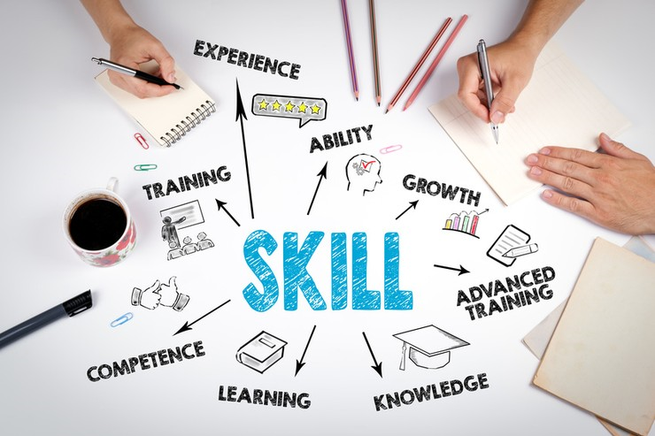

ACADEMIC AND EMPLOYABILITY SKILLS

Table of Contents
Introduction 3
Impact of learning in my academic and employability skills 3
Skills that I have acquired through my past jobs 4
Skills gap 5
Measures for overcoming the gaps 6
Conclusion 10
Reference List 11

Introduction
The competition is getting intense day by day so every individual needs to focus on improving existing skills and attributes so they could become more productive and successful in life. One must also try to focus on learning from their past experience. The study sheds lights on my academic learning and the skills that I have acquired from my past works. The study composes the skills that I have acquired from my past work experience and what I want to attain in future. An individual is responsible for own learning and one must try to learn from their mistakes so that the same mistake does not gets repeated in the future. As an employee, I need to focus on contributing to the firm through my performance and commitment. Every organisation recognizes employees that are committed and provide them the opportunities to grow within the organisations. The study also highlights the skill gaps that I need to overcome in the future.

Impact of learning in my academic and employability skills
Learning is a continuous process and every individual must try to learn from every event that is going around. I have served as a school teacher at Atanazio Gomes back in my country Sao tome and Principe and it was my first job. Through this job I was able to understand the importance of learning. My first job taught me that I need to continue learning and enhance my knowledge. As suggested by Bryan and Clegg (2019), every organisation seeks for employees that are knowledgeable and possess some specific skills. My academic history started from 1993 and is still going on. The reason behind this, I have been continuing to study is learning and knowledge. I have always focused on learning at the workplace and at my university.
As suggested by Tymon and Batistic (2016), learning not only enhances knowledge but it also provides experience that stays for lifetime. The experience could be used to attain a good position in a health sector. Learning process has allowed attaining my first job as a teacher and the experience that I have attained through my first job allowed me to change the job. After changing my first job I felt that my skills have enhanced and I realised that it was a learning process that helped me to enhance the skills. My communication skills have enhanced as I had to interact with parents about their children's progress and development.
Learning and experience are the two aspects that have helped to attain new skills and I performed as a laundry operator in my second job. I learned about staying calm and working under pressure as the job role was hectic and the environment of the workplace was at a fast pace. I learned to stay cool and calm and how to handle workload. I was continuously enhancing my skills and attributes; I had understood that if I want to be successful in life then I should not stop learning.
I performed as a cleaning operative at Xenon Ltd and it was my third job. I enhanced my team working skills from this job and as per my opinion; team working is one of the most important skills that an employee needs to possess. I practiced collaborative working so that I could contribute to my team.
I had participated in several group activities and project works and from these activities I had attained the team working skills. I was able to understand the needs of my team members and tried to guide them in their tasks. The group activities and project that I had participated in school and colleges has provided lots of valuable knowledge and experience. The communication skills that I possess are all due to my academic learning.

Skills that I have acquired through my past jobs
My past jobs have allowed enhancing my existing skills and have also allowed me to acquire new skills. The health organisations always seek for the employees that possess experience, knowledge and skills (Rowe and Zegwaard, 2017). I have always focused on becoming a productive employee wherever I have worked. I also try to gain knowledge and experience from my workplace. As per my opinion, learning is a continuous process and one must not try to stop learning. As suggested by Abas and Imam (2016), one must try to learn from every event that takes place. I think past experience and mistake also plays a major role in a person’s life. I always try to learn from my mistakes and look out for the reason behind the mistake. I have attained some valuable skills through my past jobs and I will continue to attain new skills. The skills that I have attained through my jobs have been closed below.
Public speaking
My first job allowed attaining public speaking skills as I had to make an announcement and conduct small events for students and parents. Lately, I was afraid to speak in public or in front of an audience but I was able to overcome this fear through my first job. I understood that I need to learn new skills for moving forward in life. Now, I could speak in front of anyone without any hesitation. I am glad that I was able to overcome one of the barriers through my work. I had gained lots of valuable knowledge and experience through my jobs and I am going to continue gaining experience from my work.
Communication skills
Communication skills are the most essential skill that every employee needs to possess. As per the view of Griffiths et al. (2018), communication allows to avoid and resolve conflicts and misunderstanding at the workplace or in a group. I had understood the importance of communication so I continuously focus on improving my communication skills. My first job allowed me to interact with parents and this helped to enhance my communication skills. I learned to communicate effectively and understand what could hinder the communication process.
Team player
Team player is another skill that I possess; I always focus on assisting and supporting my team members in their tasks and work. As suggested by Nisbet and Shucksmith (2017), team working leads to collaborative working and collaborative working leads to success. So basically being good team players allows attaining success. I had been practicing this concept and it has turned out to be effective for me until now. I attained these skills during my college time but my skin got enhanced during my third job where I had to work with a team.
Ability to work under pressure
An employee must be able to perform tasks under pressure as there are numerous situations which tests employees’ capability and partitions. I attained this skill during my second job as the working environment was fast paced and the work sometimes become stressful. Slowly I attained this skill and I am thankful that I had attained this skill.

Skills gap
I am going to conduct a Personal SWOT Analysis for understanding the skill gap. The skill gap basically refers to the skills that are polished or lacking. I have to attain new skills so that I could continue learning and to increase my own performance at the workplace.

Strengths  - I have the ability to meet people from varied backgrounds  - I possess strong communication skills  - I am a good team player  - I have the ability to stay calm and work under pressure  - I possess cognitive and professional skills | Weakness  - I lack leadership qualities and skills  - My time management skills are poor and sometimes I am unable to perform my job under deadline  - I ignore small details which is one of my greatest weaknesses  - I am unable to make adequate decisions and this states that I lack decision making skills
Opportunities  - I focus on continuous learning which allows me to enhance my skills and knowledge  - I have a good working environment  - I have good colleagues and friends willing to assist me in enhancing my skills and knowledge | Threats  - In future if I am unable to fit into the company's culture then it could become an issue  - I have the fear of failure
Table 1: Personal SWOT Analysis
(Source: Created by author)

The skill gap is quite large and this states that I need to work hard and continue learning to overcome this skill gap. I am going to develop a personal development plan for overcoming my skill gap. Currently I am going to focus on the skills that I need to attain and enhance.

Measures for overcoming the gaps
In accordance with the views of Collet et al. (2015), it can be stated that, continuous improvement can be entailed as essential for professional development. In compliance to this, it can be stated that, Reflective learning can be extremely essential for personal development. In fact, Both Reflective learning and personal development can be used in amalgamation with each other in order to make the learning process successful. Personal Development plan (PDP) can be used by me in order to overcome deficits with my skills accordingly. The main reason for implementing PDP is that, it would help me to grow more as a professional.
Short Term Goals
Goals | Opportunities | Action Plan | Outcomes | Time Taken
Time management | This would allow me to make more efficient utilization of Time and hence, I would be able to become more productive and enhance my capability to work | Making a time schedule and working on it, would allow me to focus more on productive work | I would be able to make more productive utilization of my free time and work more on improving my skills accordingly | 3 months
Attention to details | Focusing more on these skills would help me in Mastering the art of Perfection. Therefore my teachings would be better | I would have to be patient and make more productive utilization of my time accordingly | It would help me in becoming more productive | 2.5 Months
Table 2: Personal Development Plan
(Source: Created by Author)
Mid Term Goals
Goals | Opportunities | Action Plan | Outcomes | Time Taken
Adaptability | This would help me in working in a more productive environment. I would be able to overcome all difficult work conditions. Moreover, it would also allow me to interact with my teammates and deployed creativity in work | In order to make this possible. I would be able to Respect the concepts associated with Diversity at workplace | I would be able to adapt to various work cultures | 6 Months
Problem Solving | This would allow me to display creativity within my profession and solve critical problems with efficiency | I would have to be interactive with my teammates and consider their viewpoint while solving a specific problem | I would be able to solve creativity within my profession | 7 months
Table 3: Personal Development Plan
(Source: Created by Author)
Long Term Goals
Goals | Opportunities | Action Plan | Outcomes | Time Taken
Leadership | Effective leaders are the key to success for any organization, hence, it would help me in leading a team of professionals with ease | I would have to master the art of interpersonal skills in order to be an effective leader | I would be able to become an effective leader | 10 months
Decision Making | Mastering this art would help me in taking efficient decision that would benefit my professional. | I would have to work on my analytical skills, in order to make efficient decisions | I would be able to make good decisions | 12 months
Table 4: Personal Development Plan
(Source: Created by Author)

Conclusion
Continuous improvement can be entailed as essential for professional development. In compliance to this, it can be stated that, Reflective learning can be extremely essential for personal development. Apart from This, I can mention that, Learning is a continuous process and every individual must try to learn from every event that is going around. I have served as a school teacher at Atanazio Gomes and it was my first job. Through this job I was able to understand the importance of learning. Communication skills are the most essential skill that every employee needs to possess. Good communication would allow me to interact with my teammates and develop problem solving skills. Focusing more on these skills would help me in mastering the art of Perfection. Therefore my teachings would be better.

Reference List
Abas, M.C. and Imam, O.A., (2016). Graduates' Competence on Employability Skills and Job Performance. International Journal of Evaluation and Research in Education, 5(2), pp.119-125.
Bryan, C. and Clegg, K. eds., (2019). Innovative Assessment in Higher Education: A Handbook for Academic Practitioners. Abingdon: Routledge. 4(1). pp. 74-84.
Collet, C., Hine, D. and Du Plessis, K., (2015). Employability skills: perspectives from a knowledge-intensive industry. Education+ Training, 57(5), pp.532-559.
Griffiths, D.A., Inman, M., Rojas, H. and Williams, K., (2018). Transitioning student identity and sense of place: future possibilities for assessment and development of student employability skills. Studies in Higher Education, 43(5), pp.891-913.
Nisbet, J. and Shucksmith, J., (2017). Learning strategies. Abingdon: Routledge. 2(1). pp. 25-84.
Rowe, A.D. and Zegwaard, K.E., (2017). Developing graduate employability skills and attributes: Curriculum enhancement through work-integrated learning. 6(2). pp. 12-40.
Tymon, A. and Batistic, S., (2016). Improved academic performance and enhanced employability? The potential double benefit of proactivity for business graduates. Teaching in Higher Education, 21(8), pp.915-932.

