Student Name: Saiqa Bibi

Student Number: 2020850

Module: Psychology in Health and Social Care

Module Code: BMHP4003_BIRM

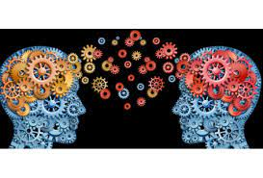

Contents Page

Introduction 3

Social Identity Theory 4

Attribution Theory 5,6

Frustration Aggression Hypothesis Theory 7

Conclusion/Recommendations 8

References 9

Introduction

This report is for the attention of the practice manager of a local counselling centre.
The report will offer support and guidance in how best to deal with the current situation.

The report will be focusing on the theories and apply them to the case study.

The service user’s condition is called Emery-Dreifuss Muscular Dystrophy. A muscle disease causing ‘slowly progressive muscle wasting and a significant weakness in children’s arms, shoulders and calves.’ It can also cause stiff joints which is why he is unable to sit for long periods causing cramps. (Helbling-Leclerc, A., Bonne, et al 2002)

Suicide attempts in the UK have almost doubled in recent years within teenagers and are continuing to rise.’ It is causing a deep concern in the rise in young teenagers’ mental health’. (Mohdin, A 2018)

Therefore, counselling can be beneficial as it can improve a child’s confidence and more so in this case study allows the service user to come to terms with his condition.
Counselling can help with the child being able to express their emotions without being judged and get to the root cause of their experiences with the hope of finding solutions or coping mechanisms. (Wolf, B 2016)

Social Identity Theory

The social identity theory is based on three stages. Social categorization, Social Identification and Social Comparison.
Social identity is what an individual defines themselves as who they are and what groups they belong to.

Tajfel (1979) who introduced the social identity theory suggested that an individual who belongs to certain groups such as a football group or even social class were an important source of pride and self-esteem. It brings a sense of belonging and a sense of social identity in a social society. (McLeod, S 2008)
Social identification is adopting a certain identity, belonging to a certain group and becoming reliant upon that group membership. There will also be a sense of emotional significance towards the group membership.

Social comparison is where people categorize themselves as ‘us’ and ‘them’, This can be done as the group may believe they are better than the other group. For example, one group of a certain religion or sexual orientation may believe they are better than the other and look to point out all the negatives in other groups beliefs or sexuality thus increasing their own self-image and status.

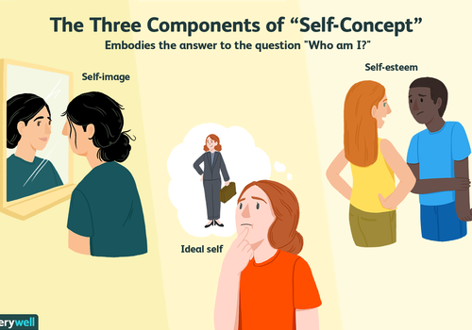

Verywell/Cindy Chung April 18, 2021. Figure 1.

A diagram showing the three components of social identity theory,

This theory can apply to the case study where the service user’s social identity was once a part of a football group. Being part of a thriving football team would’ve contributed towards an increase in the service user’s self-esteem and pride however due to his diagnosis and being forced to give up his place would have been a shock and had a negative impact on the service user’s confidence and self-esteem.
His medical condition could also have affected his social identity. He may compare himself to other groups and no longer have a sense of belonging. He may feel isolated and compare himself to others who may still be in the football group. This would have a knock-on effect on his self-image, and he may feel a sense of low self-worth.
He may feel a sense of social comparison at no longer being a part of the group. The reason for his behaviour could also be the long period of waiting which could have caused him pain and cramps in his muscles, therefore not being able to sit or stand for too long a period could have led to his outburst.

The staff member’s behaviour could also be applied by using the social identity theory as she may feel isolated and lonely and not have a socially active lifestyle where she would feel a sense of belonging. As Turner and Tajfel suggested ‘social identity within a group shapes our norms, attitudes and behaviours’.

Attribution Theory

Attribution theory suggests the process by how an individual makes sense and judgement of the behaviour of others and themselves. On a day-to-day basis we see ourselves and those around us questioning why and how things occur and what are the causes. This can be through thinking in our own minds or discussing in a social group of friends. One of the key questions a person can ask, or think is ‘why did he/she do that?’
This has been labelled as a ‘basic human activity’.

Fritz Heider (1958) introduced the attribution theory as he studied closely how one person explains another’s behaviours. His theory was ‘people are active interpreters of the events that occur in their lives, and they use consistent and logical modes of sense-making in their interpretations. They do this to ‘understand and control the world around them.’ (Manusov, V et al 2008)
Dispositional attribution are ones made by a person’s own behaviours or personal factors such as abilities, feelings, etc. rather than external sources.
‘Heider noted people usually attribute other people’s behaviours either to their internal dispositions or to their external situations. (Myers, G D 2001). This is one of the key principles he based his theories on.

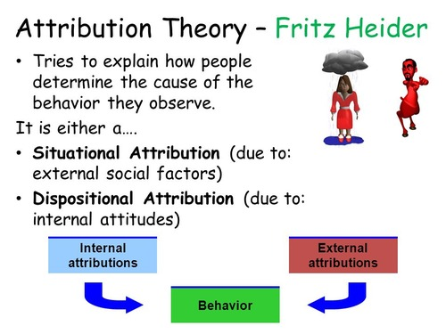

Figure 2. A diagram to illustrate Heider’s theory

By justifying or explaining certain types of behaviours we can often question our own internal attributions such as personality traits, known as the fundamental attribution error.
A person’s behaviour can be due to their beliefs, personality or motives.

Another principle which Heider discussed was how actions and behaviours are not random, they are caused by underlying issues.

This applies to the service user and staff member. By observing Heider’s attribution theory it may be the staff members and service user’s outburst was not random as they both have external situations.

The internal cause of behaviour for the staff member may be a personality characteristic, she may be short tempered and the external cause for her outburst may have been she is going through menopause causing unpredictable mood changes, which may have contributed to her anger and frustration as the service user was not complying.

The service user’s behaviour could be internal as he may question himself ‘why me’ as Heider suggest one of the main ways we make judgement is by questioning ourselves so he may have with his condition and have difficulty coming to terms with his new way of living.

Frustration Aggression Hypothesis (FAH)

Frustration Aggression Hypothesis was originated by Dollard et al (1939), studies carried out looked at aggression in humans and what leads to aggression.
Having feelings of frustration can often lead to aggression and aggression can often be set off by experiencing frustration.
Frustration can be developed when one is unable to meet their goal.
Berkowitz (1993) suggested that being frustrated could be aggression in the waiting as he believes that it will lead to it once a person is frustrated. (Bennett, V M et al 2009).

Berkowitz (1969) followed on with a revised frustration aggression hypothesis suggesting that frustration will not always lead to aggression. He believes aggression will only happen if there are certain cues such as even seeing a gun, or some form of weapon can ignite aggression.

Tajfel (1978) implied aggression can result from certain situations where it can be seen as being acceptable or when an individual is seen as an easy target.

Bandura another key theorist suggests aggression is learnt through observance and copying other’s actions. Over a period, it can be implemented as a learned behaviour from within an individual’s social environment.

‘If Aggression is not directed to the cause of frustration, it can then be displaced on another person or object.’ (Kent, M 2007)

This is how the service user would have reacted as the diagnosis would have caused frustration, another cue would be not being part of the football team any longer causing frustration and increased arousal, therefore this led to aggressive behaviour which he vented out on the staff member as he wasn’t able to direct his aggression to the actual root cause of his frustration.
The staff member was just a means of another way for the service user to ‘let off steam’ therefore he was verbally abusive towards her.

The staff member would have felt frustrated as she wasn’t being listened to therefore, she spoke in a loud tone to the service user, and this ignited aggression.

Conclusion

To conclude, all theories discussed from the social identity theory which identifies how as Tajfel (1979) described how important it is for an individual to fit in socially and be part of a group as it builds their self-esteem and pride.
Attribution theory suggests how an individual judges themselves and others through behaviours, as Fritz Heider suggested this is to make ‘understand and control the world around them.’
The frustration aggression hypothesis theory, which suggests aggression is led from feelings of frustration. Berkowitz suggested it may not always be the case as he developed a revised plan which suggested that frustration will not always lead to aggression, there would have to be certain cues which will determine aggression.

The theory that best describes the staff member’s aggression is the frustration aggression hypothesis, because she was not being listened to and basic rules were not being followed leading to frustration and when the service user was verbally abusive, this was a cue for her frustration to lead to aggression towards the service user.

Recommendations

Having studied the different theories and taking factors into consideration, my recommendation would be to dismiss the complaint made.
This is because the staff member has not had any complaints before, overall, she is a polite person however on this one occasion, due to the service user having gone through a traumatic time recently. This was unknown to her therefore the matter escalated as he was verbally abusive.
However, it was still vital as a professional to show empathy and patience especially when dealing with difficult customers and I would suggest a training course should be booked for the frontline staff to ensure customer service is delivered correctly and robustly.

References

Aggression in the sporting environment. Cue Arousal and Social Learning Theories. 08 May 2012.

An Introduction to health psychology. Author Bennet, Val Morrison And Paul. EAN 9781405899208. Publisher: Pearson Prentice Hall. Published: 26/03/2009. Edition: 2nd ed. Pages 701.

Attribution Theory. ‘Finding Good Cause in the Search for Theory.’ Valerie Manusov and Brian Spitzberg.’ 03-Baxter-45485.qxd 2/13/2008 4:37 PM Page 37.

“Attribution theory.” Merriam-Webster.com Dictionary, Merriam-Webster, https://www.merriam-webster.com/dictionary/attribution%20theory. Accessed 18 Nov. 2021

Emery Dreifuss muscular dystrophy. Helbling-Leclerc, A., Bonne, G. & Schwartz, K. Emery-Dreifuss muscular dystrophy. Eur J Hum Genet 10, 157–161 (2002). https://doi.org/10.1038/sj.ejhg.5200744

Social Identity Theory. Saul McLeod . published 2008. McLeod, S. A. (2008). Social Identity
Theory. Retrieved from www.simplypsychology.org/social-identity-theory.html

Suicide rate rises among young people in England and Wales. The Guardian. By Aamna Mohdin. Tue 4 sep 2018.

Tajfel, H., & Turner, J. C. (1979). An integrative theory of intergroup conflict. The social psychology of intergroup relations?, 33, 47.

The Benefits of Adolescent Counselling. Hopeandhealingforlife.com. By Ben Wolf. May 16, 2016.

The Oxford Dictionary of Sports Science & Medicine. Michael Kent
Publisher: Oxford University Press. Print Publication Date: 2006. Print ISBN-13: 9780198568506. Published online: 2007. Current Online Version: 2007. eISBN: 9780191727788

What is Self Concept? The Psychological Exploration of Who am I? By Kendra Cherry. Updated on April 18, 2021. Verywellmind.com

