

Manufacturing processes and defects

Materials and introduction to Processing ACMA4000

Thomas Evans
2516473

February 2026

1512 Words

Abstract

This report investigates 3 objects and the respective materials. The objects are a golf club head, A bicycle frame and a Phone case. Comparisons will be made on the selection of materials, manufacturing processes, mechanical and thermal properties, and lifespan/cost. A stainless-steel Golf club head using the casting method is selected due to its high strength, corrosion resistance and formability. Bicycle frames made from Carbon fibre using the lay-up process are selected due to their excellent Strength-to-weight ratio and longevity. Phone cases made from Silicone using the injection moulding process are also selected due to their recyclability, Impact resistance and longevity. Alternative materials must also be considered in the report, such as Titanium for golf club heads, Aluminium for bicycle frames, and Polycarbonate for phone cases. This report highlights the absolute importance of selecting appropriate materials and manufacturing methods based on a product's functional, economic, and environmental demands.

Table of Contents
Table of Contents 3
Table of figures 3
Table of tables 4
1 Introduction 4
1.1 Aims 4
1.2 Objectives 4
2 Task-Specific Sections 5
2.1 Selection and description of Objects 5
2.1.1 Stainless Steel Golf Club Head 5
2.1.2 Carbon Fibre Bicycle Frame 6
2.1.3 Silicone Phone Case 7
2.2 Manufacturing Methods Comparison 8
2.2.1 Stainless Steel Golf Club Head 8
2.2.2 Carbon Fibre Bicycle frame 9
2.2.3 Silicone Phone case 10
2.3 Mechanical and Thermal Properties Comparison 11
2.3.1 Mechanical Properties Comparison 11
2.3.2 Thermal Properties 13
2.4 Lifespan and Cost Analysis 14
2.5 Material Selection and Alternative Choices 14
3 Conclusion 15
4 References 16

Table of figures
Figure 1 – Stainless Steel Golf club head (MacDonald, 2024) 5
Figure 2 - Carbon fibre Bicycle frame (Norman, 2024) 6
Figure 3 - Silicone Phone cases (Jewelives.com, 2025) 7
Figure 4 - Investment casting process explained (Process, 2024) 8
Figure 5 - Hand Lay-up process diagram (Sehar et al., 2022) 9
Figure 6 - Injection moulding process (Hallifax, 2021) 10
Figure 7 - Stress-Strain graph for Ceramic, Metal and Polymer (Petrudi, 2024) 12
Figure 8 - Thermal material property chart 13

Table of tables
Table 1 - Mechanical and Thermal Properties of Stainless Steel, Carbon Fibre and Silicone 11

1 Introduction

For this coursework, A task is delegated to select 3 objects and their respective materials. This is a crucial process in engineering design and will impact the object's functionality, cost-effectiveness, sustainability, environmental impact, and durability.

1.1 Aims
Investigate the following objects:
- Stainless Steel Golf club head (Metal)
- Carbon Fibre Bicycle Frame (Composite)
- Silicone Phone case (Polymer)

1.2 Objectives
The requirement for each object is to:
- Select and describe 3 different objects
- Comparison of Manufacturing Methods
- Compare the Mechanical and Thermal Properties
- Analyse the Lifespan and cost of the 3 objects and their respective materials.
- Select the appropriate material and compare it against other alternatives.

2 Task-Specific Sections

2.1 Selection and description of Objects
The following objects have been selected because they are all made from a single material, have key properties that suit their uses, and are produced in very high volumes using a variety of manufacturing processes.

2.1.1 Stainless Steel Golf Club Head
Golf Club heads are predominantly made of metal and manufactured using the investment casting process. Golf club heads transfer energy from the golf club to the golf ball at impact. The head will affect the distance, direction, trajectory, and spin of the golf ball after impact and is used in all weather conditions. This requires the golf club head to have toughness, a high strength-to-weight ratio and corrosion resistance. An estimated 70 million golf clubs are sold annually. (Virtue Market Research,https://virtuemarketresearch.com, 2025)

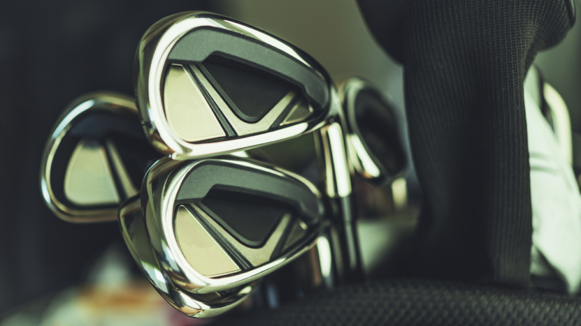
Figure 1 – Stainless Steel Golf club head (MacDonald, 2024)

2.1.2 Carbon Fibre Bicycle Frame

Bicycle Frames are an integral part of the bicycle that keep everything together. This requires the frame to have high tensile strength whilst remaining lightweight. Over the years, Carbon Fibre has become a top choice for high-performance bicycles; this is due to the material's brilliant strength-to-weight ratio and the customisability of stiffness and shape. Carbon fibre bicycle frames are predominantly manufactured using the Lay-up process. Over 100 million bicycles are manufactured worldwide annually. (Lindner, 2025)
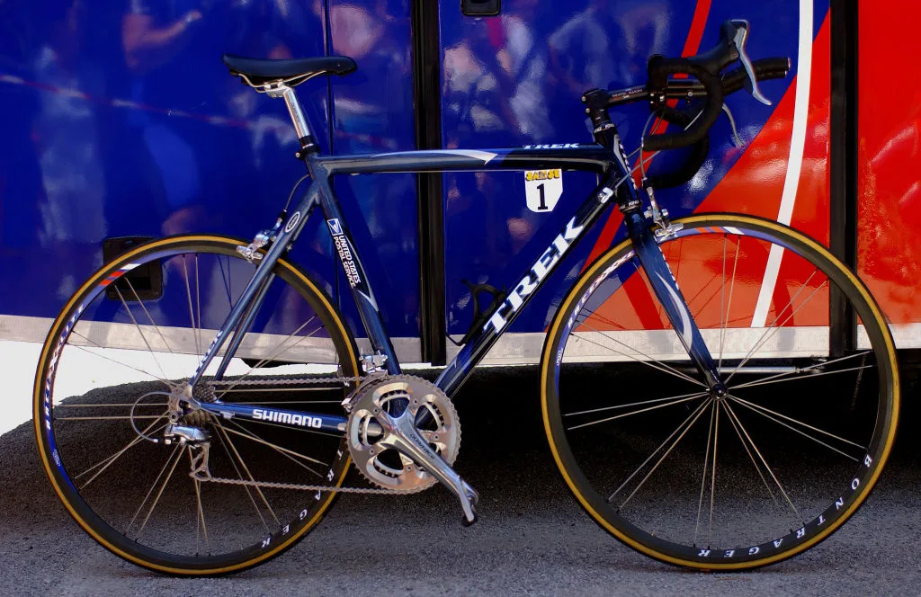
Figure 2 - Carbon fibre Bicycle frame (Norman, 2024)

2.1.3 Silicone Phone Case

Phone Cases are used to protect the technology from scratches and cracks. This requires the case to be impact-resistant and lightweight whilst still looking good on the eye. This is why Silicone has been a preferred material over the years due to its flexibility, shock absorption, and soft touch feel. Silicone can provide excellent protection against damage or scratches that may occur during mobile phone use. Silicone phone cases are predominantly manufactured using injection moulding. Over 1 billion phone cases are sold worldwide annually (Podbase, 2025).

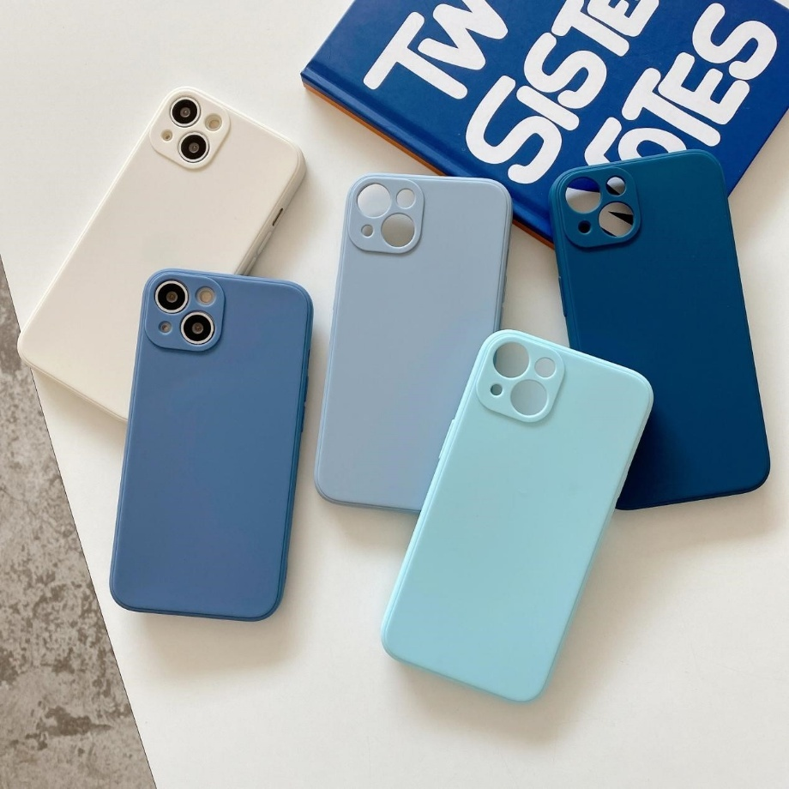
Figure 3 - Silicone Phone cases (Jewelives.com, 2025)

2.2 Manufacturing Methods Comparison

2.2.1 Stainless Steel Golf Club Head

Golf club heads are primarily made using the investment casting process. This is due to its ability to provide complex geometries, high precision, and excellent surface finishes. The process also minimises machining which can help reduce overall costs of production. (Shivansh Sabhadiya, 2024)

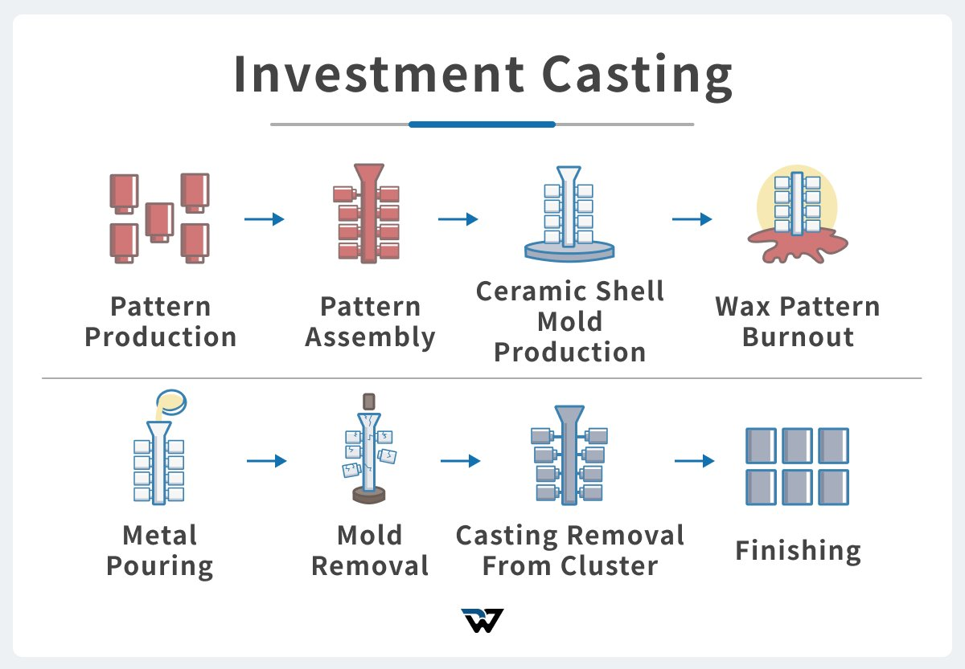
Figure 4 - Investment casting process explained (Process, 2024)

2.2.2 Carbon Fibre Bicycle frame

Carbon Fibre bike frames are manufactured using a lay-up process, which involves arranging sheets of carbon fibre in specific orientation, then curing them under heat and pressure. This produces a product with a high strength-to-weight ratio, stiffness, vibration resistant characteristics and longevity. (Dacheng, 2025)

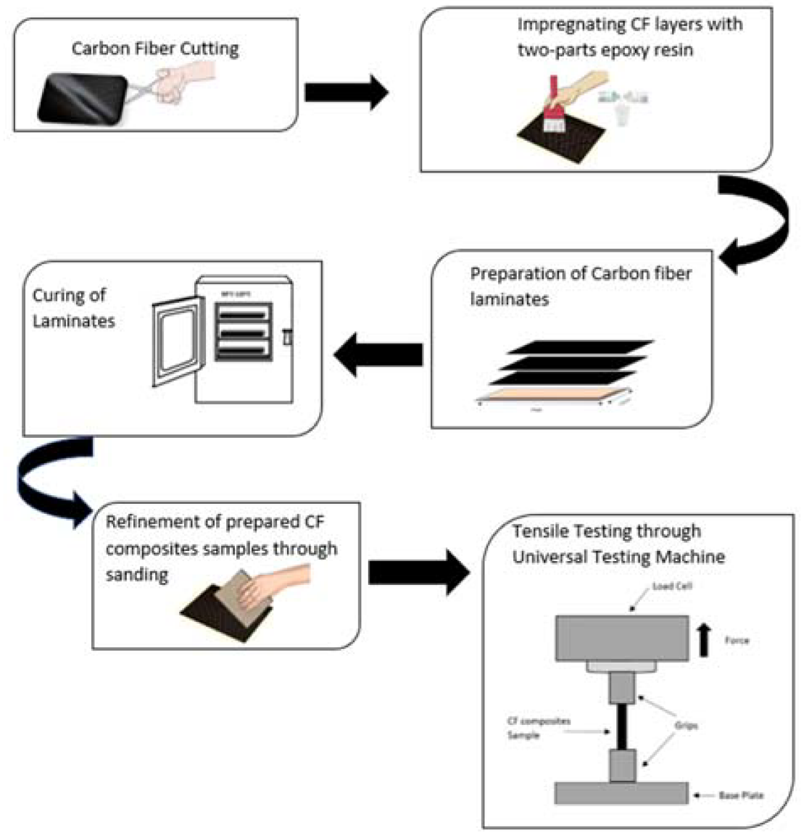
Figure 5 - Hand Lay-up process diagram (Sehar et al., 2022)

2.2.3 Silicone Phone case
Silicone phone cases are made using injection moulding as it offers fast production rate, repeatability and low costs. Injection moulding can also produce complex thin and textured surfaces which is ideal for phone cases. Many industries have widely used this method over the last two decades due to its rapid production of phone cases, high design complexity, and affordability. (Nice Rapid, 2023)
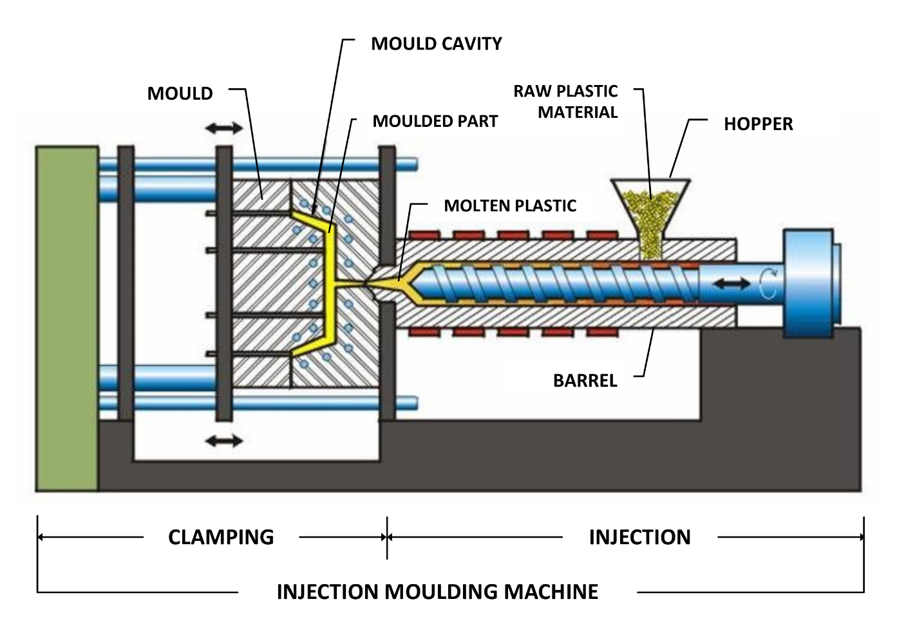
Figure 6 - Injection moulding process (Hallifax, 2021)

2.3 Mechanical and Thermal Properties Comparison

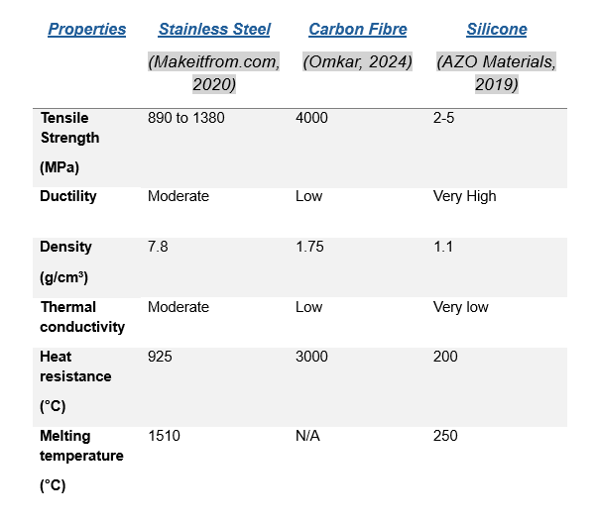

Table 1 - Mechanical and Thermal Properties of Stainless Steel, Carbon Fibre and Silicone

2.3.1 Mechanical Properties Comparison
Stainless steel is the most used material in golf club heads due to its ability to provide better feel and control of the golf ball. This material has a high ultimate tensile strength of 890 to 1380 MPa, which provides good formability during club head production. The material can also achieve significant hardness through heat treatment (248-302 Brinell Hardness), making it beneficial for the repetitive impact of the golf ball on the club face. Stainless steel also has a yield strength of 655 MPa and a density of 7.8g/cm3. (Pearson, 2021)

Carbon fibre has a very low density of 1.6 g/cm³ and a high tensile strength of 3.5-6 GPa, making it ideal for weight-sensitive yet load-bearing applications such as bicycles. (jinsuncarbon, 2024)

Silicone rubber has an ultimate tensile strength of 10.14 Mpa and 531% elongation at break. Silicone is well-suited for situations where some elasticity is needed, and long-term durability is required. (TOGOHK, 2025)

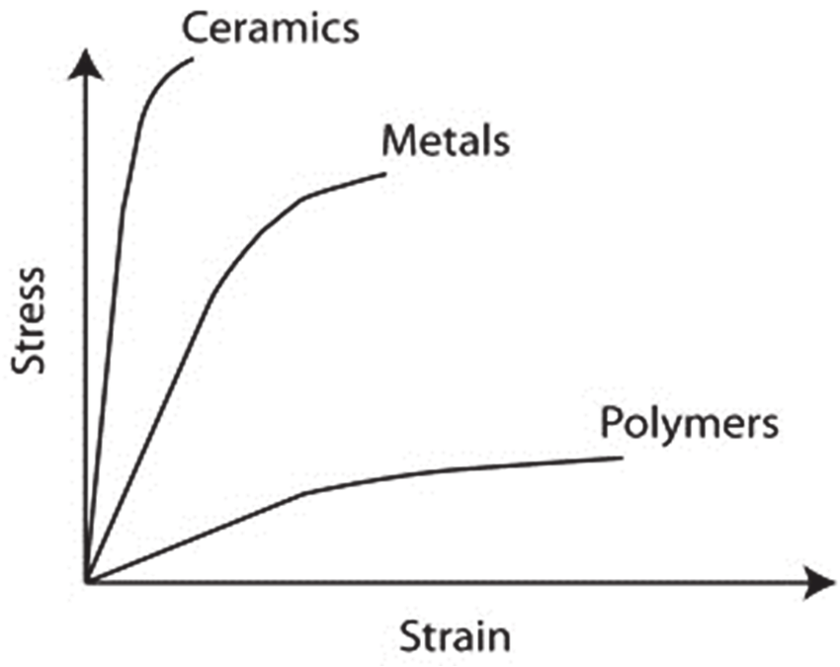
Figure 7 - Stress-Strain graph for Ceramic, Metal and Polymer (Petrudi, 2024)

2.3.2 Thermal Properties
Stainless steel can reach up to 925°C without losing its mechanical properties, with a melting point of 1510°C. This shows that stainless steel retains good heat resistance and can withstand high temperatures while still performing at maximum efficiency (Shane, 2025).

Carbon fibre has no actual melting point, as it breaks down rather than melting. It can withstand an extremely high temperature of 3000°C before it finally breaks down. Carbon fibre is also anisotropic, which means it can conduct heat along the length of the fibres but can also insulate across the fibres. This gives it unique properties that can be adapted to various applications and situations

Silicone can maintain its mechanical properties over a temperature range of -50 to 200, which exceeds that of most other polymers but still falls short of that of metals. However, its flexibility and durability make up for its low temperature resistance and can be used in many applications where low temperatures are required

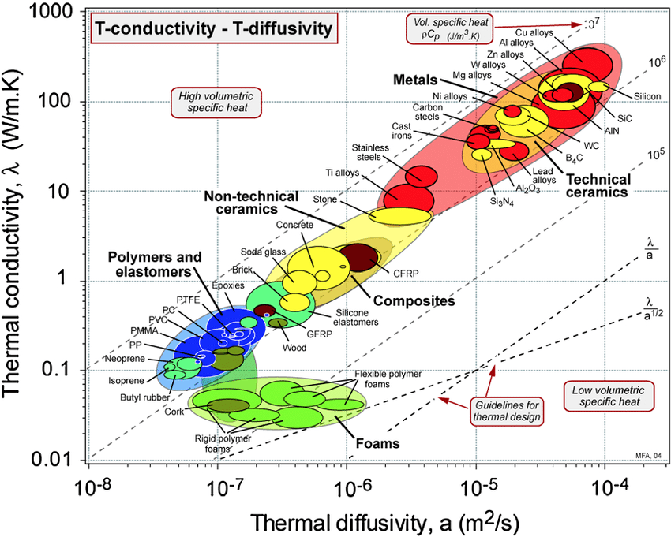

Figure 8 - Thermal material property chart

2.4 Lifespan and Cost Analysis

Golf club heads can last 7-10 years with good maintenance before the club face can corrode, the grooves become dull and rounded, or the head's performance decreases (Joe, 2025). Stainless steel has high resistance to repeated golf-ball impacts and lower manufacturing costs than other metals. Stainless steel is also fully recyclable and can be forged into other applications at the end of its life.

Carbon fibre bike frames can last 10+ years when well-maintained (Ferri, 2022). Due to its resistance to corrosion and high strength, it is a good option for bike frames. However, the manufacturing costs, complexity and difficulty in recycling can make it a challenging process.
Silicone phone cases can last for decades if well-maintained, but due to their nature, wear and tear will occur over time. Silicone is cheap to manufacture and is distinct from many traditional polymers, as it can be recycled and reused several times. However, this material can undergo downcycling, where it becomes a product of lower quality the more it is recycled.

2.5 Material Selection and Alternative Choices

Golf club Heads can also be made from Titanium, which offers a higher strength-to-weight ratio, better corrosion resistance, and high ductility. This could be beneficial for the golf club, as it can withstand repeated impacts while also offering a lighter feel, which can improve performance. However, it can be much more costly in the manufacturing process and is much more challenging to machine than stainless steel. Therefore, stainless steel is the best choice for the Golf club head due to its affordability, ease of casting into complex shapes, and extreme durability under repeated impacts.
Carbon fibre bicycle frames are highly robust and have an excellent strength-to-weight ratio, but the primary concerns are their cost and recyclability. An alternative to carbon fibre is aluminium, as it is cheaper to manufacture and can be easily recycled whilst still maintaining strength and durability. However, the longevity of carbon fibre is unparalleled and can last a lifetime if properly maintained, which is why it is the best material for a bicycle frame.

Phone cases can be made from a variety of materials, each with its own benefits. An alternative to Silicone could be Polycarbonate, as it offers excellent hardness, impact resistance, and formability during manufacturing. However, this material can become brittle over a short period if exposed to high temperatures. This is why Silicone is the chosen material due to it having the same properties, but it has brilliant shock-absorbing and anti-scratching properties, which will last for a more prolonged period

3 Conclusion
In conclusion, this report highlights the absolute importance of selecting appropriate materials and manufacturing methods based on a product's functional, economic, and environmental demands. Despite Titanium having a better strength-to-weight ratio, Stainless steel was the best option due to its low cost and ease of manufacturing. Carbon fibre was chosen as the material for the Bicycle frame due to its extremely high strength and longevity. Silicone remained advantageous due to its brilliant ductility and impact resistance. All serve specific advantages to their respective objects where suited.

4 References
Virtue Market Research,https://virtuemarketresearch.com (2025). Golf Equipment Market | Size, Share, Growth | 2025 - 2030. [online] Virtue Market Research. Available at: https://virtuemarketresearch.com/report/golf-equipment-market.
MacDonald, R. (2024). The Evolution of Golf Clubs: History and Innovation. [online] Tour Quality Golf Tulsa. Available at: https://www.tourqualitygolf.com/2024/05/15/the-evolution-of-golf-clubs-history-and-innovation/.
Lindner, J. (2025). Cycling Industry Statistics. [online] Gitnux.org. Available at: https://gitnux.org/cycling-industry-statistics/ [Accessed 17 Dec. 2025].
Norman, P. (2024). Bike frame materials explained: carbon vs aluminium vs steel vs Titanium. [online] BikeRadar. Available at: https://www.bikeradar.com/advice/buyers-guides/bike-frame-materials.
Podbase (2025). Phone Case Sales Statistics 2025. [online] Podbase.com. Available at: https://www.podbase.com/blogs/phone-case-sales-statistics.
Jewelives.com. (2025). Available at: https://www.jewelives.com/wp-content/uploads/2024/09/Phone-Case.jpg [Accessed 9 Dec. 2025].
Shivansh Sabhadiya (2024). Investment Casting: Definition, Process, Pros and Cons. [online] The Engineering Choice. Available at: https://www.theengineeringchoice.com/investment-casting/.
Process, C. (2024). TEAMSWORLD. [online] TEAMSWORLD. Available at: https://teamsworld.com/news/market-insight/investment-casting.
Dacheng (2025). Carbon Fibre Lay-up Process: Techniques, Applications, and Benefits - MDC Mould- Leading Compression mould maker in China. [online] MDC Mould- Leading Compression mould maker in China - Manufacture-Development-Creation. Available at: https://www.mdcmould.com/2025/04/25/carbon-fiber-layup-process-techniques-applications-and-benefits/.
Sehar, B., Waris, A., Gilani, S.O., Ansari, U., Mushtaq, S., Khan, N.B., Jameel, M., Khan, M.I., Bafakeeh, O.T. and Tag-ElDin, E.S.M. (2022). The Impact of Laminations on the Mechanical Strength of Carbon-Fiber Composites for Prosthetic Foot Fabrication. Crystals, 12(10), p.1429. doi:https://doi.org/10.3390/cryst12101429.
Nice Rapid (2023). How to Make a Phone Case with Injection Molding or Over-Molding Processes? [online] Nice Rapid. Available at: https://www.nicerapid.com/blog/how-to-make-a-phone-case-with-injection-molding-or-over-molding-processes/.
Hallifax, M. (2021). Robotics in Injection Moulding. [online] RNA Automation. Available at: https://www.rnaautomation.com/insight/robotics-in-injection-moulding/.
Makeitfrom.com. (2020). AISI 431 (S43100) Stainless Steel :: MakeItFrom.com. [online] Available at: https://www.makeitfrom.com/material-properties/AISI-431-S43100-Stainless-Steel [Accessed 19 Jan. 2026].
Omkar (2024). Carbon Fiber: Material Properties, Manufacturing, and Performance. [online] Material Science. Available at: https://material-science.ghost.io/carbonfiber/.
AZO Materials (2019). Properties: Silicone Rubber. [online] AZoM.com. Available at: https://www.azom.com/properties.aspx?ArticleID=920.
Anon, (n.d.). How does the Injection Molding Process Work? -. [online] Available at: https://zetarmold.com/injection-molding-process/.
Pearson, J. (2021). Atlas Quality Management Scope: National Doc: Information Notice Stainless Steel 431 Grade Data Sheet. [online] Available at: https://atlassteels.com.au/wp-content/uploads/2021/06/Stainless-Steel-431-Grade-Data-Sheet-28-04-21.pdf.
jinsuncarbon (2024). Graphite Electrode Manufacturer in China - Jinsun Carbon. [online] Jinsun Carbon. Available at: https://jinsuncarbon.com/properties-of-carbon-fiber/#Density.
TOGOHK (2025). Silicone Rubber Elastic Modulus: Properties, Comparisons, and Applications - Silicone Product Manufacturer - TOGOHK. [online] Silicone Product Manufacturer - TOGOHK. Available at: https://www.togohk.com/silicone-rubber-elastic-modulus/.
Petrudi, A.M. (2024). Figure 5: Typical Stress-strain Curve for the three classes of... [online] ResearchGate. Available at: https://www.researchgate.net/figure/Typical-Stress-strain-Curve-for-the-three-classes-of-materials-16_fig4_344130951.
Shane (2025). Stainless Steel 304 vs. 431: What’s the Difference? - MFG Shop. [online] MFG Shop. Available at: https://shop.machinemfg.com/stainless-steel-304-vs-431-whats-the-difference/ [Accessed 11 Dec. 2025].
Joe (2025). How Long Do Golf Clubs Last? – Complete Maintenance Guide. [online] Golf Sidekick. Available at: https://www.golfsidekick.com/articles/golf-clubs-maintenance-guide/.
Ferri, R. (2022). How long do Carbon Bike Frames last? [online] Bike Test Reviews. Available at: https://biketestreviews.com/how-long-do-carbon-bike-frames-last/ [Accessed 11 Dec. 2025].

