Marketing Fundamentals Analysis and Evaluation of Industry Examples

Marketing has been defined by Kotler and Armstrong as “a social and managerial process by which organisations and individuals obtain what they need and want “ (Kotler & Armstrong, 2014, p. 27). There are two types of marketing which consisting of the traditional view of marketing and the contemporary view of marketing. The John Lewis Partnership follows the traditional view of marketing as they advertise their product through television advertisements, articles in magazines and newspapers and through direct mail. The Partnership also follows the contemporary view of marketing as they directly approach their customers and ask for feedback on the customer service they have received. The partnership has also advanced technologically by introducing the John Lewis App, which is available for any device, in order for their customers to shop from the comfort of their home, they also have a variety of pages on numerous social media platforms, for example, Facebook, twitter and a variety of videos of their advertisements are also available on YouTube.
Marketing is vitally important in order to create value for organisations targeted customers. One strategy used by organisations for creating value for customers is customer value – based pricing, which has been defined as a “setting price based on buyers perceptions of value rather than on the sellers cost” (Kotler & Armstrong, 2018, p. 668). The first key factor in order to create value for targeted customers is segmentation, which consists of four major segmentation variables. The first segmentation variable is geographic, which divides the market into groups by nations, regions, and states. The second segmentation group is demographic, which divides the organisations market into alternative groups based on gender, family, size, age, and generation. The third segmentation group is psychographic which divides its customers into social class, lifestyle and personality groups, and the final segmentation group is known as behavioral which divides its consumers into groups based upon occasion, benefits sought and loyalty status. John Lewis can relate towards the majority of the segmentation groups, as they specifically target all age and gender groups, size, and generation but more for customers who are more affluent. The second key factor for creating value for targeted customers is positioning, which shows which products are properly positioned within the market and the organisations that develop them, for example when customers think of smartphones they automatically recognize apple and android. Similarly, in the automobile industry customers would recognize car names such as Ford and Audi. The third key factor for targeted customers is differentiation, which includes adding features to an existing product in order to rival competitors, an example of this would be Anadin, the organisation had originally developed Anadin original, but later introduced multiple versions for example high strength versions and Anadin Extra (Anadin, 2015). The fourth factor for creating value for customers is targeting. John Lewis follows this factor by (selling) high-quality products and avoid making cheaper versions of the products available, while specifically aiming for clients with good financial backgrounds.

All organisations need to actively promote their brand and products and they do this by using the marketing mix model. The Marketing Mix has been defined by Oxford Dictionary as “a combination of factors that can be controlled by a company to influence consumers to purchase its products” (Oxford Dictionary, 2017) . But Kotler and Armstrong have defined it as “the set of tactical marketing tools – product, price, place, and promotion- that the firm blends to produce the response it wants in the target market” (Kotler & Armstrong, 2017, p. 671) .
The marketing mix created by E. Jerome McCarthy who firstly introduced the 4p’s model, which consisted of product, price, promotion, and place. However, in the late 1970’s it was acknowledged that this edition should be updated as consumers demands and target markets had changed and developed. This version was later updated in 1981 by Booms + Bitner to take into account this need for a more relevant marketing mix and included an extra 3 elements known as people, process and physical evidence (Professional Academy, N.D). Another theory of marketing implementation used by organisations is the 3m’s of marketing, which consists of Market, Message and Medium. An example of this theory is the organisation Coca Cola, for example if they promote diet coke they would need to research their target market and consider how they would communicate with their potential customers.
In this assignment, the author will discuss the seven factors of the marketing mix in collaboration with the corporation John Lewis Partnership amongst others.
John Lewis Partnership also uses the experimental marketing strategy as they provide an experience for their customers rather than a distribution point. The partnership’s department stores provide a variety of experiences for their customers, for example, beauty product testing and baby product testing.
The first element of the marketing mix refers to the product/products that the organisation is selling to their target customers, and this forms a crucial base on which all the other elements of the marketing mix are built. Within corporations like John Lewis, the quality of their products is very important, in order to ensure that only high-quality products are sold to their customers at a reasonable price. John Lewis stock thousands of high-quality products designed exclusively by high-quality brands such as satchels for Women by Mulberry Amberley, Shirts for Men by Ralph Lauren and Laurent-Perrier Brut Champagne sets amongst many other high end, high-quality products. Customer service is also very important within any organisation and is also closely tied to the product aspect of the marketing mix, especially as excellent customer service can give the organisation a good reputation. John Lewis has various services available to their customers that include, personally designing furniture, kitchen and bathroom fittings, technological and home appliances fittings, personal styling services (John Lewis , 2017). Excellent customer service is also essential in order for an organisations reputation, as excellent customer service will have a positive impact on the customer’s experience, as they would wish to purchase more from the organisation in the foreseeable future. However, negative customer service would have an adverse impact on the customer and the organisation involved, it would also make the customer question purchases made from the organisation in the future.
The second element included within the marketing mix model is price, which refers to the value of a product. John Lewis also takes the price of their products into consideration in order to ensure they are reasonably within a target customer’s price range. The Partnership guarantee a price promise to their customers known as the “Never Knowingly Undersold Policy”, where customers can make a claim if they find a specific store product being sold at a lower price from another competitor, where they will refund the difference to the customer (John Lewis, 2017).
The third element of the marketing mix is promotion, which consists of the various strategies that the organisation will utilize in order to make a product visible to the consumer and consists of a whole host of various activities ranging from national advertising campaigns to loyalty cards, amongst others.
There are various strategies that John Lewis have used in order to promote their products to their consumer market. For example, John Lewis promotes a variety of seasonal offers during the festive period, which has proven to be very successful for the company and particularly due to the promotion of their Christmas advertisements. The most successful festive advert for John Lewis was “Man on The Moon” in 2015, where Christmas sales for the department store had increased by 21.4% online but in-store sales had decreased by 1.2% (This is Money, 2016), due to the products being featured in the advertisement, in comparison with a comparable store whose sales had decreased by 2.6% in December 2017 (Sky News , 2018). On the other hand, the Partnerships sales figures have decreased for 2017-2018 with £171.44m spent in comparison with £172.52m in 2016-2017 and £171.82m in 2015-2016 (John Lewis, 2017).
Another example of product promotion by John Lewis, is their Boxing Day sales where there are various discounts ranging from 20% – 50% and higher off many high-quality products, for example, handbags and shirts. The weekly sales and boxing day sales are proven to have been very successful to organisations especially John Lewis, but in comparison with the partnership’s previous weekly figures, the organisation’s sales for the week including boxing day have decreased to £137.94m for 2017-2018 in resemblance to their previous year figures of £138.52m in 2016- 2017 and £152.87m in 2015-2016 (John Lewis, 2018).
In order for any organisation’s advertising campaign to be successful, they must also include the benefits that the customer will receive when they use the product. For example within products created by L’Oréal Paris , their adverts include the ingredients used in the products and what benefit they can have on their customers, for instance, the organisations advert for clay shampoo states that the clay used in the product will remove oils, intensely moisturises hair and keep it fresh for 72 hours (L'Oreal, 2017). This advert gives their potential customers the benefits of high-quality hair care products.
The final successful and unusual promotional tactic used by John Lewis is that of the sale match where rather than advertising their own sales, they match the well-publicised sales of their competitors, for example, Debenhams and Marks and Spencer’s.
The fourth element of the marketing mix process, which is how an organisation would deliver their services to their target market. An example of this by John Lewis is that the company give their customers the option to shop online and have their purchases delivered to their homes or local store. An example of a process within another retail organisation is the Nectar Card, which is a process that increases loyalty with their customers, as they would shop at Sainsbury’s to collect nectar points in order to receive money off their next shop or other offers rather than using a rival supermarket.
The fifth element of the marketing mix is people, who are essential for any organisation and their performance within the target market. All members of an organisation are responsible for how the corporation performs, to ensure that the business performs well all members must provide excellent customer service, and appropriate knowledge on the products sold at the establishment and ensure that they have a positive personal presentation to their customers. The staff members employed by John Lewis become part of an employee-owned corporation where they are also stakeholders and have to follow the organisations quality value and service policy, which include being trained to offer advice and appropriate information on all products sold within the department store (John Lewis, 2017).
The sixth element involved in the marketing mix is place, where the products would become accessible to high street stores for the organisation's customers, which can include through retail, wholesalers and the internet. John Lewis has a variety of high street shops based around the UK and Scotland that range from Home Stores to Food Halls, and they have adapted their customer's shopping experience onto the internet, where shoppers can shop from John Lewis’s online website or via their app. There are various distribution channels available in order for products to be dispatched to customers from the distribution point. John Lewis specifically dispatches their items to their customers by using the indirect distribution channel, as the products created for John Lewis are developed by the producer, transferred to wholesale, delivered to John Lewis’s retail store and later dispatched to the consumer.
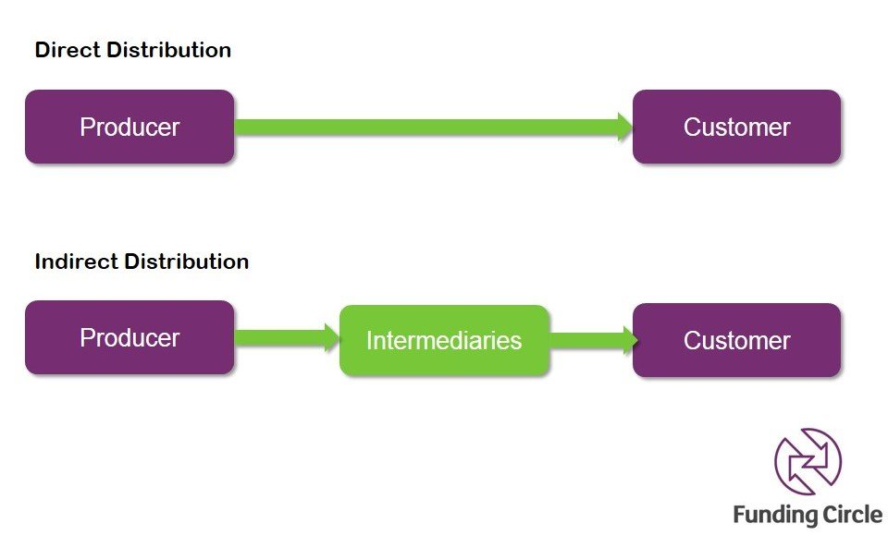

Figure 1 Indirect Distribution Channel (Funding Circle, 2013)

The John Lewis Partnership has a variety of stores located across the UK and Scotland, they are located within large city centers and airports, for example, Heathrow Terminal 2, Glasgow, Cardiff and Oxford (John Lewis, 2018). The shops located in the city centers favor a modern architectural structure with modernized windows, but also within the shop design of the department store, for example, the partnership follows a contemporary clear color scheme with white tiled flooring and white walls, which gives the customer the impression that the store is clean and spacious.
Stakeholders has been defined as “a person who has a legitimate or vested interest in the activities of an organisation” (Oxford University Press, 2008). Stakeholders can be divided into two categories, primary and secondary stakeholders. Primary stakeholders include the managers, investors, employees, and shareholders within any organisation. A secondary stakeholder includes the corporation's suppliers, distributors, and customers (Oxford University Press, 2008), all organisations including John Lewis have primary and secondary stakeholders. The Down To Earth organisation is reliant on secondary stakeholders as their projects cannot be completed without the materials provided by other organisations for example timber wood, and also without trainees who volunteer, the projects cannot be completed.
Stakeholders can affect an organisation's activities in many different ways, for example, customers are important stakeholders within any organisation if the customer's needs aren’t recognized the company will suffer with a loss in sales. In large organisations the shareholders are important stakeholders, in this case, it can affect how the business is performing as they can make the decisions regarding if the business isn’t being run efficiently.
The group have used numerous social media platforms in order to promote the organisation Down To Earth. These platforms include developing a blog in order to promote the sustainable materials used to construct various buildings within the organisations Little Bryn Gwyn and Murton Sites, and also to promote other organisations which are working in collaboration with Down To Earth on specific projects for example, Swansea University had collaborated with Down To Earth in order to create outdoor learning environments. The organisation has developed their own social media platforms ranging from Facebook to Twitter and uploading videos of their work onto these pages and their personal YouTube channel. Down To Earth also have their own blog page that is updated on a regular basis on their projects, videos and on the groups that participate in the training programmes available at their sites.

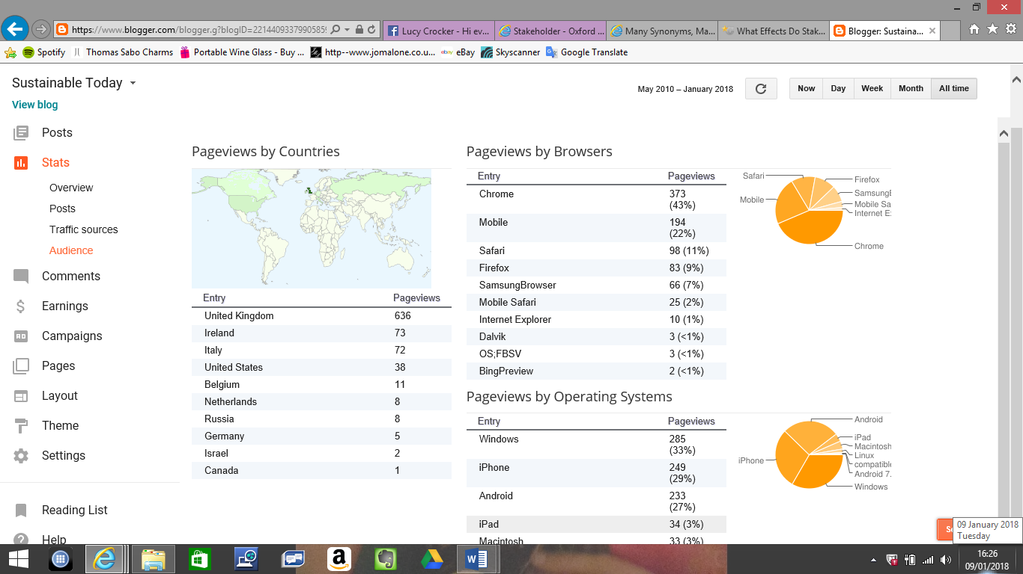
The group had visited the Down To Earth site and from this visit, they gained valuable insight into the organisation and their projects. The group had used numerous academic theories in order to promote and raise awareness of the organisation Down To Earth. Firstly, the group had researched potential sites to use for the blog, before deciding on using the website Blogger.com which was a recommended site for beginners in blogging.
Figure 2 Blog Audience Stats https://www.blogger.com/blogger.g?blogID=2214409337990585953#audiencestats

Once the blog was created, members of the group self-promoted the blog on their Facebook pages, which included the link to the blog site. The blog itself had also promoted Down To Earth by using numerous topics within blog posts based on projects within the organisation to a variety of followers ranging from The United States to Russia. Hypothetically the group could increase awareness and promote Down To Earth further by putting up posters, handing out leaflets but also sharing social media links and blog posts that originated from Down To Earth’s multiple networking sites. The blog was useful for the group promoting Down To Earth as it gained an audience from a variety of continents, which rapidly increased on a daily basis, this also helped raise awareness of the projects like the “Building Our Dreams” project and helped promote Down To Earth’s green agenda.

References
Anadin, 2015. Our Products. [Online]
Available at: http://www.anadin.co.uk/our-products
[Accessed 07 01 2018].
Cleverism, 2018. Marketing Mix/ Place in 4p's. [Online]
Available at: https://www.cleverism.com/place-four-ps-marketing-mix/
[Accessed 08 01 2018].
John Lewis , 2017. Our Services. [Online]
Available at: https://www.johnlewis.com/our-services
[Accessed 01 01 2018].
John Lewis , 2018. Alice Tait London Shortbread Tin. [Online]
Available at: https://www.johnlewis.com/alice-tait-london-shortbread-tin-150g/p3260414
[Accessed 04 01 2018].
John Lewis, 2017. Food Gift Sets. [Online]
Available at: https://www.johnlewis.com/browse/gifts/gift-food-wine-champagne/gift-food-sets/_/N-ame
[Accessed 28 12 2017].
John Lewis, 2017. Handbags, Bags & Purses. [Online]
Available at: https://www.johnlewis.com/browse/women/handbags-bags-purses/_/N-fjg
[Accessed 28 12 2017].
John Lewis, 2017. John Lewis Men's Shirts. [Online]
Available at: https://www.johnlewis.com/browse/men/mens-shirts/_/N-eaf
[Accessed 28 12 2017].
John Lewis, 2017. Never Knowingly Undersold. [Online]
Available at: https://www.johnlewis.com/inspiration-and-advice/never-knowingly-undersold-policy
[Accessed 02 01 2018].
John Lewis, 2017. Quality Service and Value. [Online]
Available at: http://www.johnlewispartnership.co.uk/about/john-lewis.html
[Accessed 03 01 2018].
John Lewis, 2017. Weekly Sales Figures. [Online]
Available at: http://www.johnlewispartnership.co.uk/content/cws/financials/weekly-figures/latest.html#jl
[Accessed 30 12 2017].
John Lewis, 2018. John Lewis Shops. [Online]
Available at: https://www.johnlewis.com/our-shops?rdr=1&s_kwcid=1dx43700024591081843&tmad=c&tmcampid=1&gclid=CNn1ppzVwNgCFQX7GwodlZUCeQ&gclsrc=ds
[Accessed 04 01 2018].
John Lewis, 2018. Weekly Figures. [Online]
Available at: http://www.johnlewispartnership.co.uk/content/cws/financials/weekly-figures/latest.html
[Accessed 03 01 2018].
John Lewis, 2018. Whittard All Butter Shortbread. [Online]
Available at: https://www.johnlewis.com/whittard-all-butter-shortbread-150g/p3097083
[Accessed 04 01 2018].
Kotler, P. T. & Armstrong, G., 2014. Principles of Marketing. 15th ed. Harlow: Pearson.
Kotler, P. T. & Armstrong, G., 2017. Dawson Era - Principles Of Marketing, Global Edition. 17th ed. Harlow: Pearson.
L'Oreal, 2017. L'oreal Play With Clay Advert. [Online]
Available at: https://www.youtube.com/watch?v=gPbeduubLHo
[Accessed 05 01 2018].
Oxford Dictionary, 2017. Marketing Mix. [Online]
Available at: https://en.oxforddictionaries.com/definition/marketing_mix
[Accessed 28 12 2017].
Oxford University Press, 2008. "Stakeholder" A Dictionary of Human Resource Management. 2nd ed. Oxford: Oxford University Press .
Professional Academy, N.D. Marketing Theories - the 4p's and 7p's. [Online]
Available at: http://www.professionalacademy.com/blogs-and-advice/marketing-theories---the-marketing-mix---from-4-p-s-to-7-p-s
[Accessed 05 01 2018].
Sky News , 2018. Jobs threat as Debenhams issues profit warning. [Online]
Available at: https://news.sky.com/story/debenhams-issues-profit-warning-after-christmas-sales-woes-11194913
[Accessed 04 01 2018].
This is Money, 2016. Man On The Moon. [Online]
Available at: http://www.thisismoney.co.uk/money/news/article-3386594/Online-shoppers-save-John-Lewis-Xmas-sales-rise-5-1-nearly-1bn.html
[Accessed 30 12 2017].

