‘Sketches in Sierra Leone’
This essay will comment on a printed page of sketches and text from the Illustrated London News (hereafter ILN), a nineteenth century periodical. Called Sketches in Sierra Leone (Sketches hereafter), it features in the image gallery on the Liberated Africans Database, and was found during research for the previous assignment.
The ILN was a weekly magazine founded in 1842. The first illustrated periodical, it reported on current and world events, sent artists around the world to record other places, people and customs, and ran serialised fiction stories. Improvements in printing technology which reduced cost, as well as a more literate public, drove a ‘second print revolution’ in which ILN achieved large popularity, along with other magazines such as The Penny. ILN was collectable, and it issues bound together in one continuous text; though each issue ran to around thirty pages, the page number for Sketches is given as 434. It utilised the new technique of wood engraving, through which text and illustrations could be easily integrated and printed at scale.
Liberated Africans erroneously dates Sketches to c.1881. This seemed unlikely (though not impossible) because of its implied relevance to the transatlantic Slave Trade. Since the text on the page describes Seirra Leone as a place where liberated captives made new lives, the connection was clearly strong. It was therefore necessary to verify the date. The ILN is fully digitised on the British Newspapers Archive, so it was possible to view every issue. Sure enough, this page did not feature in any of the 1881 issues. A reverse Google Image search found another reference to this image placing it in the issue of 25th October 1856, which the archive confirmed. This date makes it much more relevant, and therefore better explains its inclusion as a resource on Liberated Africans. It is also useful for analysing depictions of Africans and Africa in the post-Slave Trade British view of the world, although the later date would have placed it interestingly within the ‘Scramble for Africa.’ It nonetheless offers a resource for understanding representations of Africa in the decades before that particular chapter in European colonialism and allows us to gain something of a view into the sorts of places in which liberated captives - such as those for whom the Slave Voyages database has biographical data, for example - made their new lives.
Critical Appreciation
The first sketch is an eye-level group view of the ‘Egg-gu-gu,’ an ‘itinerant necromancer,’ with a crowd observing. It must have been a strange and unfamiliar image to the readers, but it could be argued that the crowd of Africans gathered around the necromancer are also mixed in their comprehension or appreciation of it. The addition of musicians transforms what might have once been a relatively normal visit from an important cultural figure into more of an event, perhaps even an example of ‘traditional culture’ performed for urban citizens and tourists in many places in the world even today.
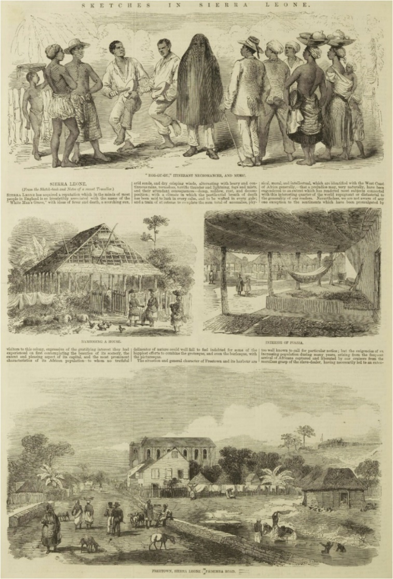
Figure 1: ‘Sketches In Sierra Leone’, Illustrated London News, 25th October 1856
The contrast of black and white in the clothing and skin of the characters is visually interesting, but also creates meaning: note the white clothes of the African man dressed in a more European fashion. The Egg-gu-gu is the only character shown dressed in black, and though its attendant musicians are dressed all in white, the general pattern seems to be that the more white clothing the character is wearing, the further they appear – culturally - from the Egg-gu-gu, and the closer to the European-style man, who is the most ‘white’. Combined with the text immediately below it, which refers to inhospitable weather and landscapes, and the risk of disease, the sketch arguably taps into ideas of the ‘Dark Continent’ and its danger and strangeness.
The second pair of sketches offer something less strange, but still different enough to satisfy curiosity. They show a house being ‘bamboo[ed]’ – that is, under construction - and a ‘piazza;’ both these scenes could be seen as analogues – though technologically inferior ones - to the industrial and the urban of the ‘civilised’ world. But their purpose may well be to settle to reader after the alien-ness of the first image. Indeed, the text below challenges the perceptions of West Africa previously outlined, describing the ‘beauties of its scenery;’ indeed these sketches could be read as idyllic, bucolic even, with the exotic foliage detailed around the house and the almost idealised (and fully clothed, in comparison to the first sketch) figures of women carrying baskets on their head. Such a setting, and the figures within them, could be seen as examples of the ‘modern moral subject’ of the English School of art, which at this time was only just falling out of taste; indeed, the direct observational approach of these sketches is also in keeping with this style, and it compares closely not only with other examples of the English School works, but its deployment in illustrated pages, as evidenced by Fig. 2.
The final sketch, which offers a much wider – and perhaps slightly elevated - perspective, would seem the most familiar to domestic readers, with more robust looking buildings of planks and hard roofs rather than bamboo and straw; though the two types of building cohabit the scene; the more traditional style buildings are shown in an agricultural context while the more European style buildings – including what looks from its arched windows like a church – are shown in a more urban layout. The scene is bordered with roads and fences, implying a world of order and neatness where the jungle is tamed (but still close enough to enjoy aesthetically). The tell-tale detail of a sword and uniform on one of the figures subtly nods to the military character of the overseas colony; indeed it could just as easily be a scene from the Caribbean. The text suggests Freetown was quite well-known and in some ways unremarkable, and draws more attention to its import as a place for liberated captives to settle.
The sketches, taken together, perhaps present a meaning-making journey, from the mysterious and unfamiliar scene of the Egg-gu-gu, through more understandable - but still different - traditional buildings (and their construction), to the far more familiar and comfortable, almost European order of the Freetown vista. This is a narrative of civilising and taming the strange, mysterious and barbaric places of the world by ordered and cultured Britishness. The message is not only presented in the subjects of the sketches but also in the layout: the edges of the page and the internal ordered lines of the colonial settlement act as frames for the scenes, which contain and control them. Collier considers this a means of bounding the peripheries of the Empire so that readers in the core might make sense of them, to ‘…make…vast territory legible by bringing it down to size.’
While this is one reading of the layout, its interactivity must also be acknowledged. It is for the reader to make meaning of it, perhaps informed by the narratives of the day and the suggestion of the editor(s). Collier observes of the ILN that while each image it employs individually holds a ‘classical perspective’ which emphasises foreground or background with its use of high or low angles (as in the eye or even ground level perspective of the central sketches), grouped together they form an ‘enlarged but…fragmented’ view that requires the ‘active construction of the reader in order to convert it into coherent narrative.’ It may, for example, be the case that a reader chooses to contrast the images of liberated Africans living a somewhat traditional and unquestionably freer life with image they may have seen of the slave plantations in the United States at this time, and develop a different narrative (albeit one that complies with larger narratives of Britain’s role in bringing freedom and civilisation).
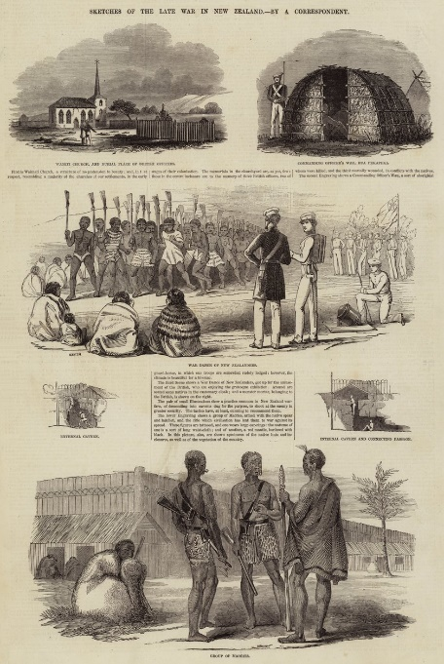
Figure 2: 'Sketches of the Late War in New Zealand' in ‘English School’ style.
Historical and social context, Visual Culture
Weller observes that political stability in the preceding decade to this piece being published, as well as the advances in technology and reading mentioned previously, were necessary for the illustrated periodical to come about. However, despite a general view that wider sections of the public found them accessible due to price, literacy and the prevalence of illustrations, Weller notes there is little evidence for the composition of the audiences of the ILN and publications like it. Events such as the Duke of Wellington’s funeral, and coverage of the Crimean War in the 1850s drove up readership of the ILN; but this period is also characterised by wider access to knowledge-making institutions and artefacts, with the proliferation of encyclopaedias, dictionaries, museums and libraries, so we can have some confidence that readers may have included the working class. Indeed, there is evidence from letters to the editor that ‘working men’ were keen to hold complete collections of the ILN. Collecting these periodicals, argues Weller, would have been driven by goals of social status as well as auto-didacticism. Such self-learning would drive many institutions in the following decades, from libraries to Working Men’s Institutes. This image, therefore, arrives at a crucial moment in knowledge-making.
Sketches should also be contextually understood within both the flourishing of scientific exploration at this time as well as missionary work in the colonies of the Empire, which was expanding. Then, both would have acted as complementary, twin ‘civilising’ forces (the Church of England whole-heartedly backed the ILN) and this is borne out in the naturalist curiosity encouraged by subject and style in Sketches, such as in the contrast between strange and un-Christian and perhaps irrational folk figures and an ordered, European style town with a church.
Since a large part of the readership would not necessarily have been either enrolled in, or even aware of prevailing theories and narratives of meaning negotiated across art by the more elite sections of society, the open-ended and fragmented layouts of ILN’s illustrated pages would have lent themselves to a diverse audience of differing education, allowing them to take part in meaning making and ‘turn[ing] printing from a static into an interactive medium.’ Even as this new polysemic approach widened access, however, a narrative of the superiority of the Christian, Imperial core over the stranger and developing periphery was still arguably reinforced by the treatment of subjects like Sierra Leone in both individual sketches and in the construction of layout and use of space and text in publications like ILN.
This is especially true for representations of the ‘other,’ which Smits argues served to build national identity, an ‘imagined community,’ via its reinforcement of the location of even the lower classes of society in the enlightened and civilised core, and that this was also the case in other European countries.
In summary, Sketches is a useful aid to understanding representations of West Africa, its customs and development under colonialism, as well as that process more broadly. It also offers insight into the stylistic approaches of illustrators and periodical editors of the time. It is equally the case that understanding the wider historical and social context gives greater appreciation of the processes at work in the image. Finally, it is important to note that while it is easy to connect these wider processes with the image in hindsight, during Sketches’ contemporary life these connections and meanings would have been more in flux, negotiated in multiple ways by a diverse audience creating its own understandings of the text. It is therefore advisable to draw conclusions but lightly about the contemporary meaning and impact of historical images.
Additional Notes
Sketches is actually a larger, multi-page spread, and it is worth considering the meaning created - and lost – by Liberated Africans presenting just one. A second page includes more sketches of interiors and exteriors of traditional houses, as well as people dancing in a village. This changes the ratio of ‘traditional’ scenes to modern/European influenced ones, which in turn changes our understanding of the potential central narrative of the piece. Rather than simply showing the civilising effects of British rule, it must be considered that the subject of day to day life in Sierra Leone is being presented for its own interest and value to readers. Liberated Africans also trims the image, removing the issue date and page number, which also reduces our understanding of it, these details only being revealed through further reading. This demonstrates how cross-referencing is required even when dealing with primary sources.
High-quality downloads of individual pages from the British Newspaper Archive were restricted to three, inhibiting comparison of the ILN’s treatment of other topics across other years, which would be interesting and useful to undertake. Moreover, a wider reading of art history would be beneficial in developing a more sophisticated critical appreciation.
Bibliography
Archives/databases
‘The Illustrated London News, (25th October 1856)’, on The British Newspaper Archive. Accessed 22/12/24: https://www.britishnewspaperarchive.co.uk
‘Sketches in Sierra Leone’, image section on Liberated Africans Database. Accessed 21/12/24: https://www.liberatedafricans.org/digital-resources/image-gallery.php#
Secondary Literature
Collier, P., Imperial/Modernist Forms in the Illustrated London News, Modernism/Modernity, Vol 19: No. 3, (Hopkins University Press: 2012), pp. 487–514.
Hultzsch, A., The Crowd and the Building: Flux in the Early Illustrated London News, Architecture and Culture, Volume 6: No. 3 (2018), pp. 371-386.
McKendry, V., The "Illustrated London News" and the Invention of Tradition, Victorian Periodicals Review, Vol. 27: No. 1 (Johns Hopkins University Press, on behalf of the Research Society for Victorian Periodicals: 1994), pp. 1-24.
Smits, T., Looking for The Illustrated London News in Australian Digital Newspapers, Media History, Vol 23: No. 1 (2017), pp. 80-99.
Weller, T., Preserving Knowledge Through Popular Victorian Periodicals: An Examination of The Penny Magazine and the Illustrated London News, 1842–1843, Library History, Vol. 24 No. 3, (2008), pp. 200–207.
Websites
English School, Encyclopedia Britannica Website. Accessed 20/12/24: https://www.britannica.com/art/English-school
Illustrated London News, Encyclopedia Britannica Website. Accessed 20/12/24: https://www.britannica.com/topic/Illustrated-London-News
Sketches of the Late War in New Zealand, Meister Drucke Fine Art Prints. Accessed 28/12/24: https://www.meisterdrucke.ie/fine-art-prints/English-School/1096441/Sketches-of-the-Late-War-in-New-Zealand-%28engraving%29.html
The Scramble for Africa, St John’s College (Cambridge), Online School Resource. Accessed 21/12/24: https://www.joh.cam.ac.uk/library/library_exhibitions/schoolresources/exploration/scramble_for_africa

It ran until the 21st century, though monthly after 1971.
https://www.britannica.com/topic/Illustrated-London-News
Hultzsch, A., The Crowd and the Building: Flux in the Early Illustrated London News, Architecture and Culture, Volume 6: No. 3 (2018), pp. 371-386., p. 371.
The page number is not visible in the version of the image on Liberated Africans.
Hultzsch, The Crowd and the Building, p. 372.
https://www.joh.cam.ac.uk/library/library_exhibitions/schoolresources/exploration/scramble_for_africa
All quotations without footnoted references are taken from the ILN page itself.
https://www.britannica.com/art/English-school
Collier, P., Imperial/Modernist Forms in the Illustrated London News, Modernism/Modernity, Vol 19: No. 3, (Hopkins University Press: 2012), pp. 487–514., p. 492.
Collier, Imperial/Modernist Forms in the Illustrated London News, p. 499.
No date for this image is given by the art seller which features it. It seems likely from the form and style that this, too, is from the ILN. The source is notable in its labelling of the style as English School: https://www.meisterdrucke.ie/fine-art-prints/English-School/1096441/Sketches-of-the-Late-War-in-New-Zealand-%28engraving%29.html
Weller, T., Preserving Knowledge Through Popular Victorian Periodicals: An Examination of The Penny Magazine and the Illustrated London News, 1842–1843, Library History, Vol. 24: No. 3, (2008), pp. 200–207., p. 201.
Weller, Preserving Knowledge Through Popular Victorian Periodicals, pp. 201-202.
Ibid., p. 202.
Ibid., p. 203.
Ibid., pp. 204-205.
https://www.britannica.com/topic/Illustrated-London-News
Hultzsch, The Crowd and the Building, p. 371.
Smits, T., Looking for The Illustrated London News in Australian Digital Newspapers, Media History, Vol 23: No. 1 (2017), pp. 80-99., pp. 81-82.
The other pages of the piece of focus here were unfortunately not available to include as images in this essay.

