3/24/2025
University of Wales Trinity Saint David
London campus
E-Portfolio Link:
Module Name: Learning In the Digital Era
Module Code: ACCA 4025

Student Name: Mohamed Msemar
Student ID: 2527548
Group: 1

Lecturer’s Name: Koushik Modak

LDE Assignment 1
E-Portfolio
Table of Contents
Introduction 2
Main Body 2
Task 1: Essential Academic and Employment Skills for the future career Path 2
Task 1 (a): Report on Essential Academic and Employment Skills 2
Task 1 (b): Evaluation of Task 1 (a) based on Similarity report 3
Task 2: Collaborative Mind Map and Individual Poster 3
Mind Map (Collaborative) 3
Poster (Individual) 3
Task 3: Virtual Collaboration and RefWorks 3
Report on Virtual Collaboration 3
Step-by-step process of using RefWorks with visuals 3
Task 4: E-Portfolio Creation and Evaluation 3
Task 4 (a): E-Portfolio Creation 3
Task 4 (b): Illustrative Review of E-Portfolio tool Selection 3
Conclusion 3
References 3
Task 1 References: 3
Task 3 References: 4

Introduction

Main Body

Task 1: Essential Academic and Employment Skills for the future career Path

Task 1 (a): Report on Essential Academic and Employment Skills
The Essential Academic and Employment Skills are what makes student succeed in education and in the workplace. there are 4 key skills every student should focused on if they want to succeed in education and their career path this are, developing deep learning, critical thinking, independence, and communication skills [1].
Most of your Academic skills will be learned by practice, like everything in life. The more you do it the better you will be at studying and researching. A study shows that taking short breaks help your brain hold on to more information, students that study shorter sessions outperform students that study long sessions because the brain need time to reset. And when it is overloaded, its capacity is limited naturally [2].
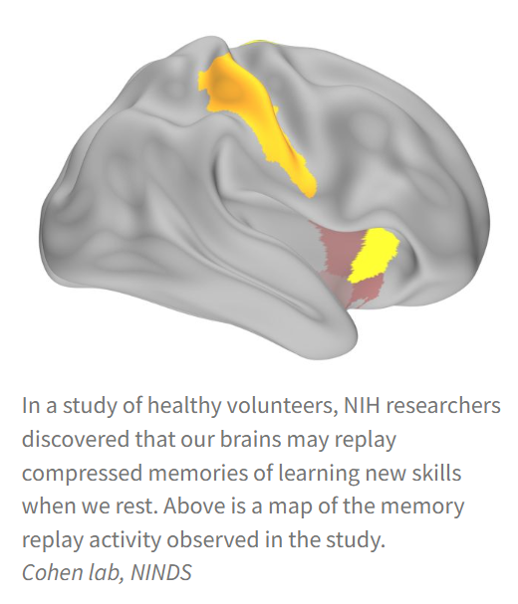
Figure 1: Brain memory activities
One of the most impostant skills in the IT industry is communication skills and team work, in many IT roles having clear communications is an essential skill. This will help you work with other departments and customers to meet your deadlines and goals [3].
Problem solving and analytical skills are another essential skills for education and future employment. In the IT industry professionals are constantly requiered to detect issues , find the cause and find an affective solutions. With a strong analytic and problem solving skills students and employees will be way more productive when it comes to learning and working in the IT industry [4].
Now as we all know Technology changes all the time, New Software, Operating systems Ai tools and much more so Adaptability is a key essential skill both for your education and for your future career Specially in the IT industry we systems are constantly changing and you always will need to adapt to diferent programs devices and much more. Also from this book I have refeerence Employees that are felexible and have a high willingnes to learn are more succesfull in dynamic work environments [5].

Task 1 (b): Evaluation of Task 1 (a) based on Similarity report

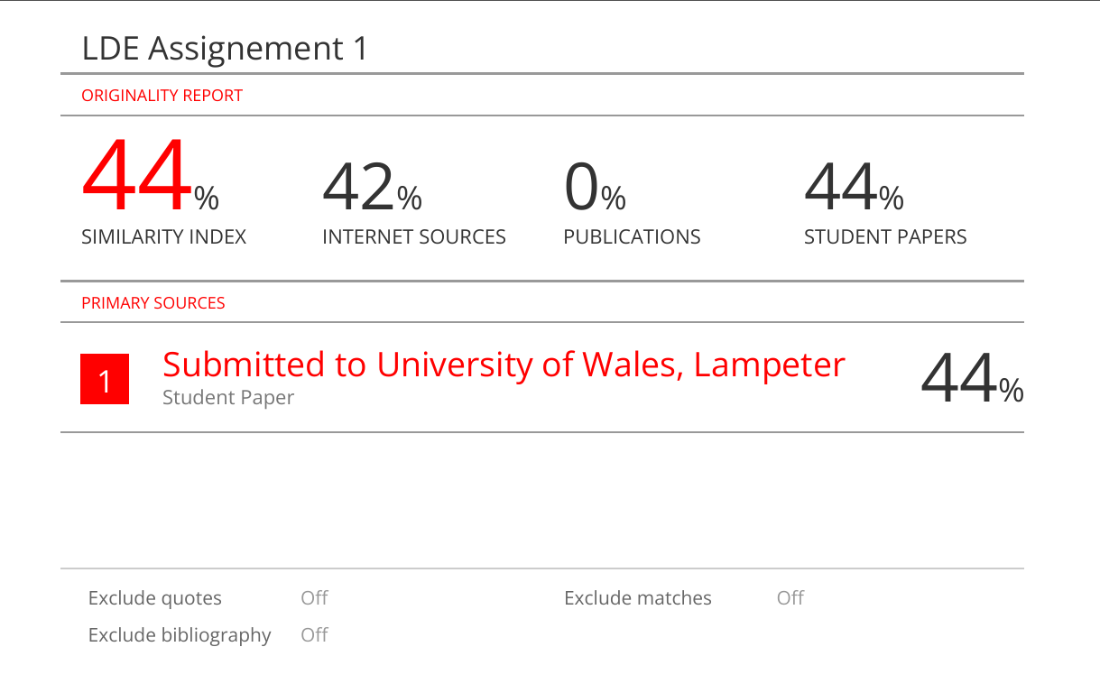
On my final similarity report the system has detected 44% similarity. But it is all from the heading and from the university itself, so it is not relevant. There has been no similarity at all from any other sources. I have done research on the topic and did my work from my understanding of the research I have found so my similarity has not be affected on my work.
My work has been well researched and well explained going straight to the point and using a more casual and friendly language, so it is more natural and easier to understand for everyone. My spelling was perfect and has been double checked. I have also met all the criteria’s such as having at least 5 citations and references and finding a related image for my presentation and making it long enough but also resumed. So, there is not too much irrelevant if not any information in my work. Hence I believe I deserve a minimum of 80 out of 100 for my work

Task 2: Collaborative Mind Map and Individual Poster

Mind Map (Collaborative)
Life is a Team Sport - MindMeister Mind map

Poster (Individual)
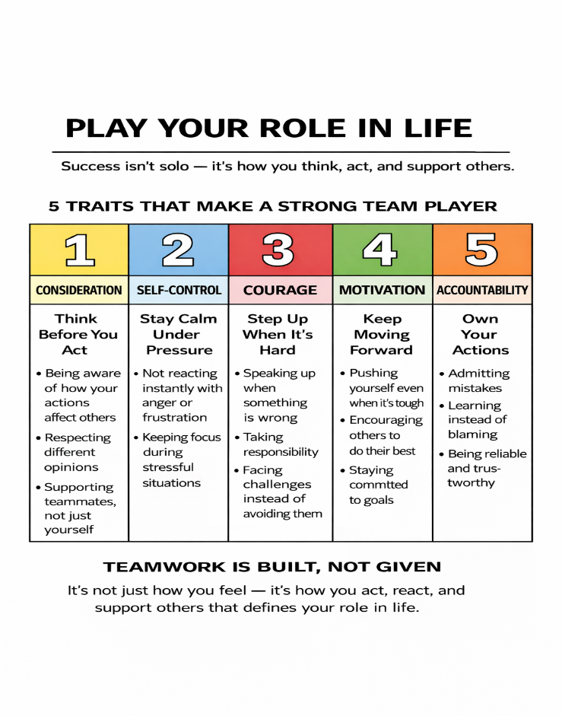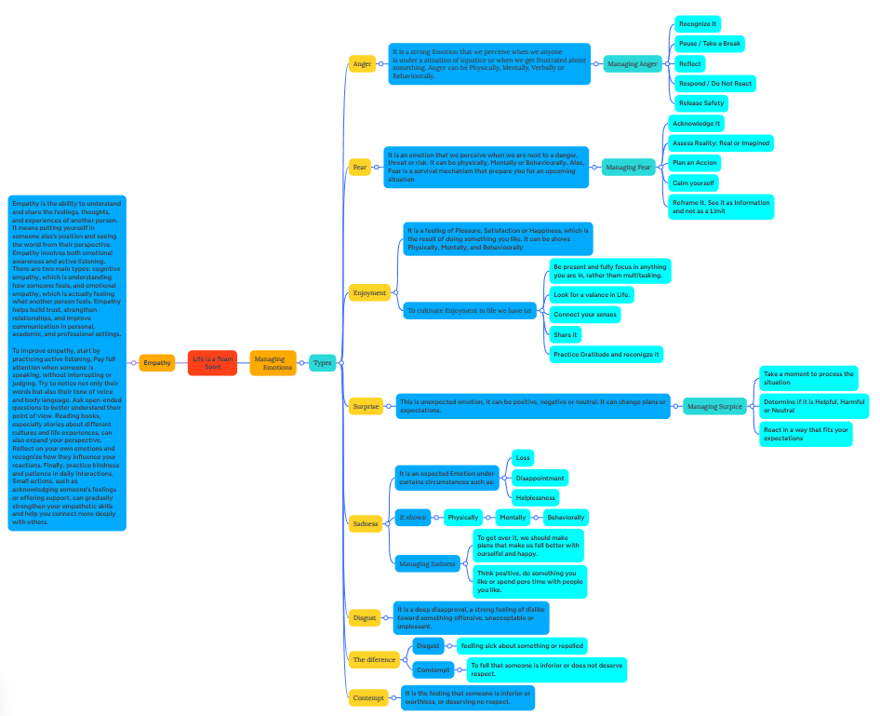

Task 3: Virtual Collaboration and RefWorks

Report on Virtual Collaboration
(Microsoft Teams)
Virtual collaboration is a vital feature that modern businesses and organisations cannot afford to overlook. It enables different employees within a given organisation to collaborate and communicate with one another even when they are not in the same location. This feature has become even more vital due to the adoption of remote work systems. Virtual collaboration tools help organisations to enhance communication, productivity, and teamwork within the enterprise. Among the most popular virtual collaboration tools is Microsoft Teams.

Microsoft Teams is a cloud-based collaboration tool that was created by Microsoft. It enables users to communicate and collaborate with different people within a given enterprise through various channels such as chats and video meetings. This tool was created to enable different communication tools within the workplace to be integrated into a central location. Employees within a given organisation can create different teams to facilitate communication and collaboration. [6]

The fact that Microsoft Teams can be used on a computer, a tablet, and a smartphone means that it can be used virtually from anywhere in the world where an internet connection is available. This allows employees to stay connected to the team even when they are not in the office.

The first reason why Microsoft Teams is widely used for virtual collaboration among team members is that it has many great features. The first feature of Microsoft Teams is that it allows team members to communicate with each other using instant messaging. This means that team members can communicate with each other instantly instead of sending emails. The team members can also set up a group chat to communicate with each other. [7]

The second feature of Microsoft Teams is that it allows team members to have video conferences. This feature allows team members to have virtual meetings where they can communicate with each other face to face. This feature has been very useful for virtual teams and global businesses because it allows team members to communicate with each other even if they are far apart. The feature also allows team members to share screens during meetings. [8]

Another feature that is present in Microsoft Teams is file-sharing capabilities. This allows employees to share files within the application. Employees can collaborate on the same document in real-time. Additionally, it has the capabilities of integrating with other applications such as Microsoft Word, Microsoft Excel, and Microsoft PowerPoint. This allows employees to collaborate on the same document.

There are various benefits that can be derived by an organisation if it uses Microsoft Teams. One of the benefits is that it improves communication. Instead of employees relying on emails to communicate, Microsoft Teams has the capabilities of allowing employees to communicate in real-time. This improves communication within an organisation. [9]

Another benefit is that it improves teamwork. This is because it has the capabilities of allowing various employees within an organisation to collaborate on the same document. This improves teamwork within an organisation.
Despite the benefits associated with Microsoft Teams, there are some challenges associated with the platform. To begin with, some users may find the platform hard to learn at the beginning, considering that the platform has many features and tools that can be utilized. New employees may need training on the use of the tool.

Another disadvantage associated with Microsoft Teams is that virtual collaboration tools require an internet connection. If the connection is slow, the communication may be affected. Also, the overuse of virtual communication may sometimes limit face-to-face interactions, thus affecting the team. [10]

Step-by-step process of using RefWorks with visuals
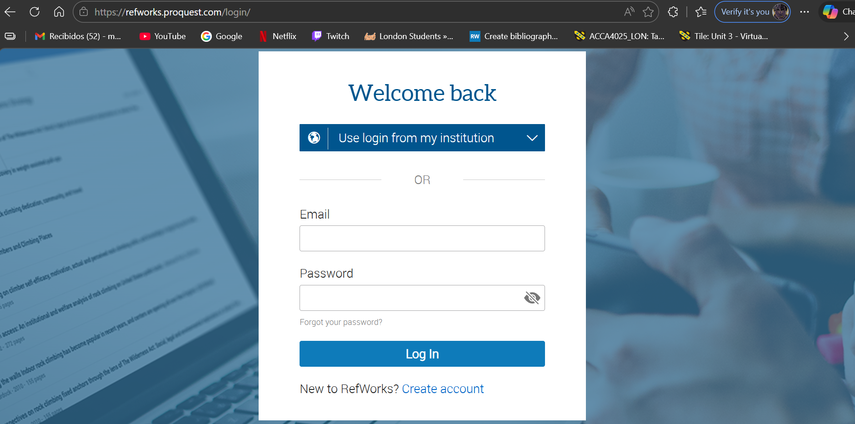
Firstly you have to go to RefWorks website and create your account for free. Once done you will need to verify your email and you will be logged in.
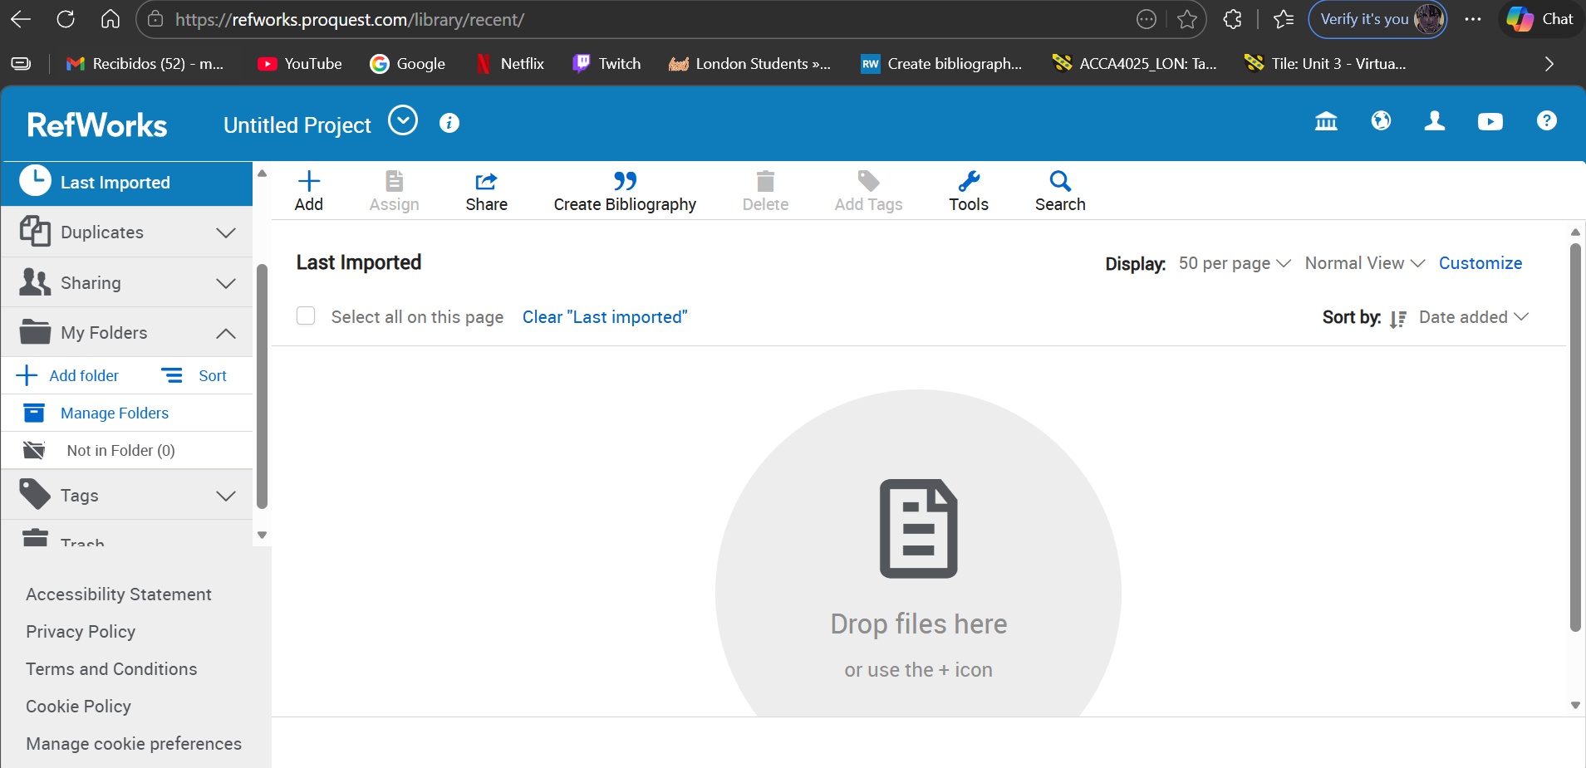
Once you log in your account will be empty, this is because we have not added any citations. So we will first go to the folder icon on the left side and create a new folder were we will store our citations.
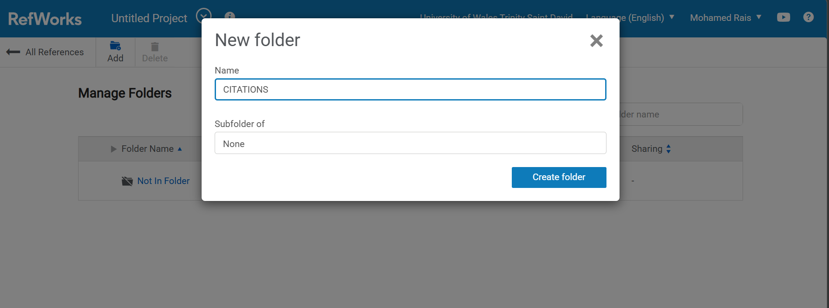
Once here you can name it as you like and press on create and your new empty folder will be created, I will now show you how to create your first citations by using google scholar.
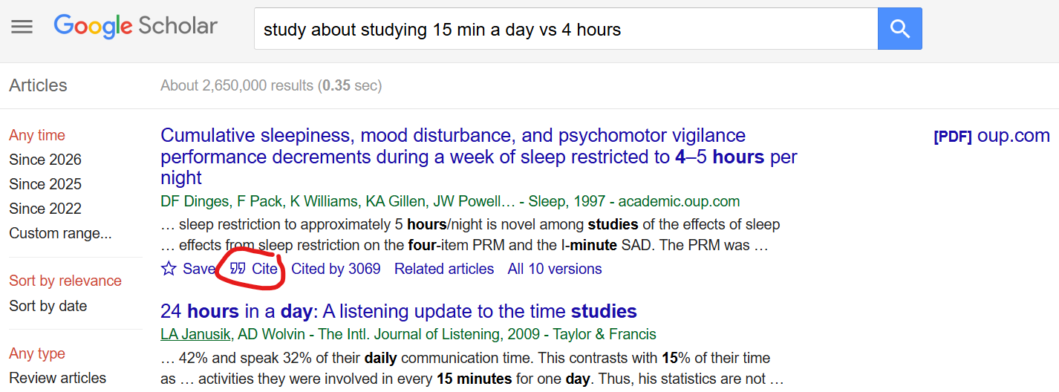
Once on google scholar all we have to do is research and once we find what we are looking for on the bottom of the page it will say cite in small character and blue letter. Once you press that the next screen will come out.
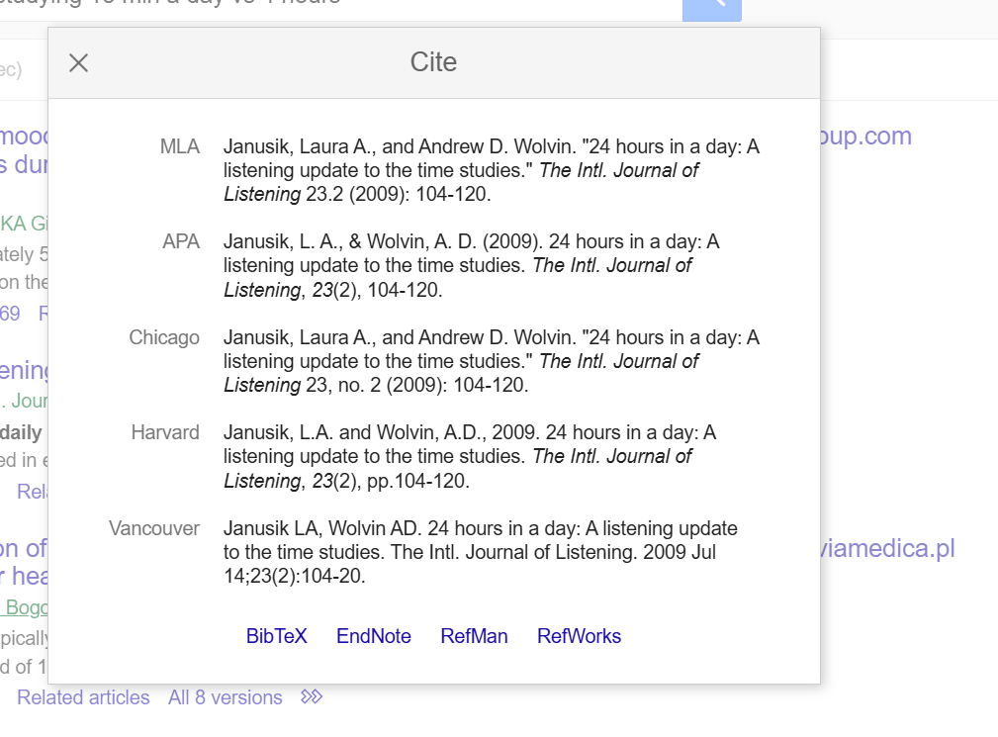
On this screen all the citations will come out to save them to our Ref work all we have to do is press on RefWorks button that is at the bottom right side of the screen.
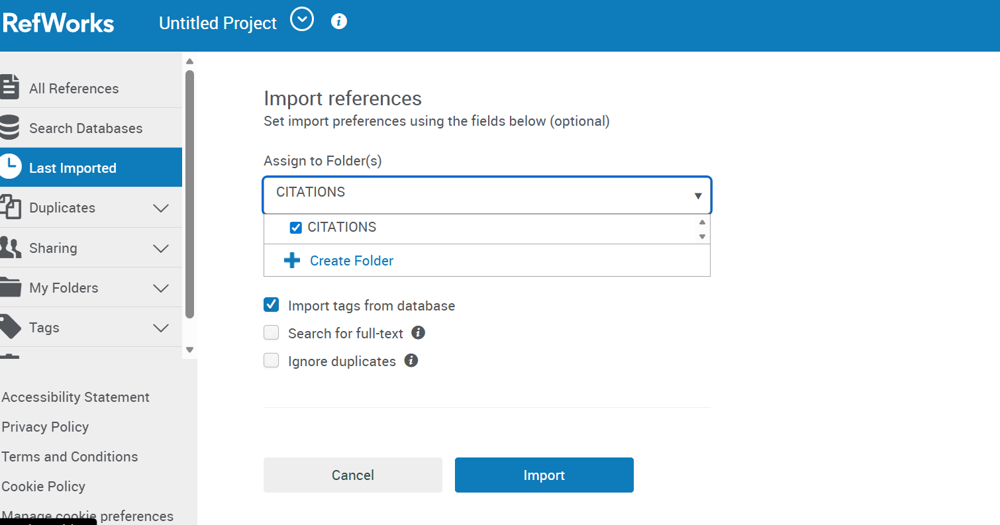
Once you press it, It will then take you back to RefWorks where you will have to select your folder and press on import to save all your citation.
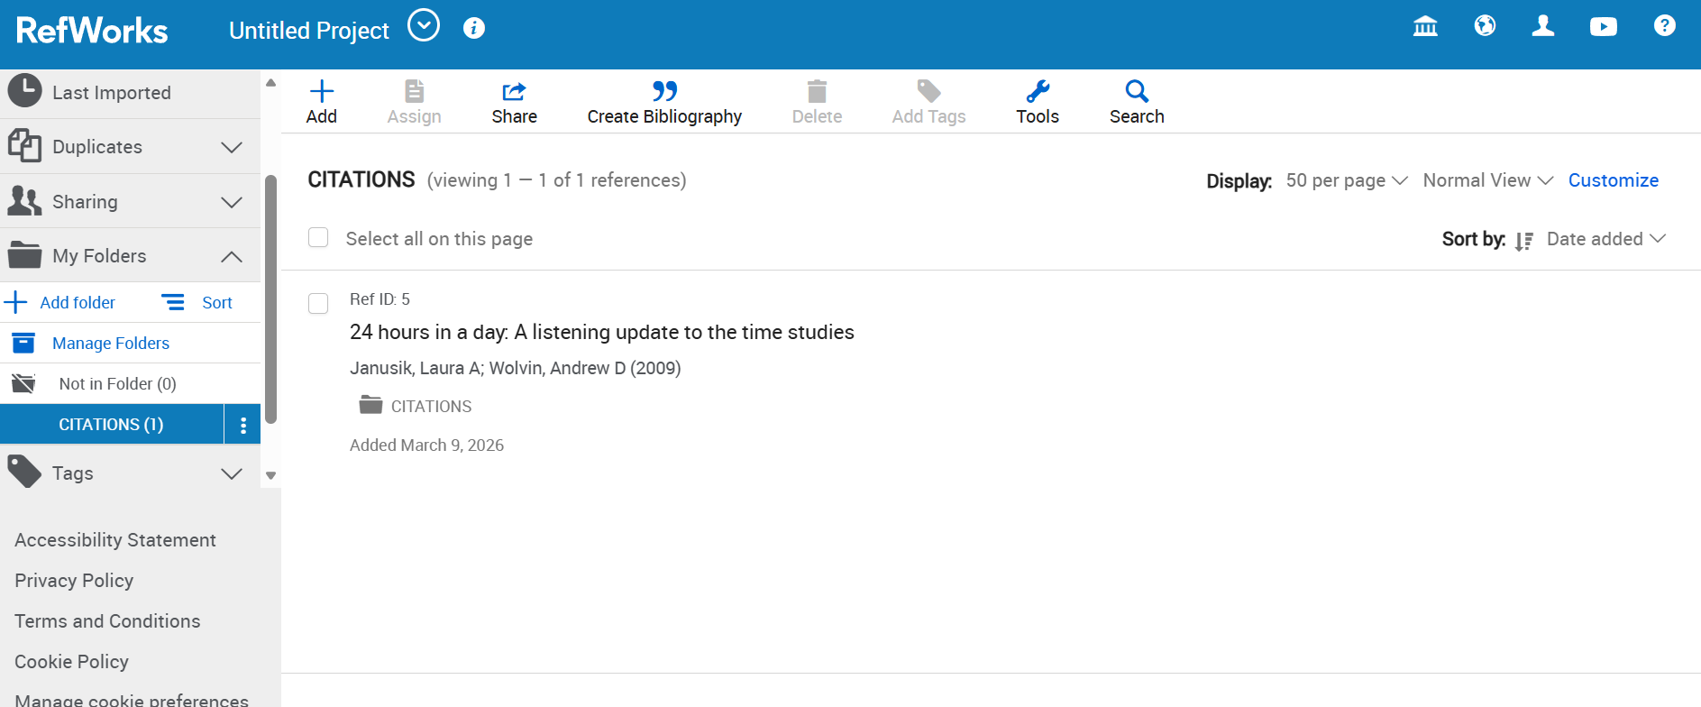
Once you have imported it, you can go back to your folder, and all your citations will be there. Now I will show you how you can access RefWorks from a word document, so it is more convenient to use.
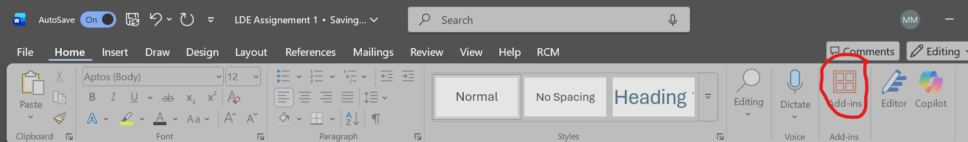
On a work document if you go to home, then look for add-ins on the right side of the screen you will be able to select a wide variety of build in add-ins including RefWorks.
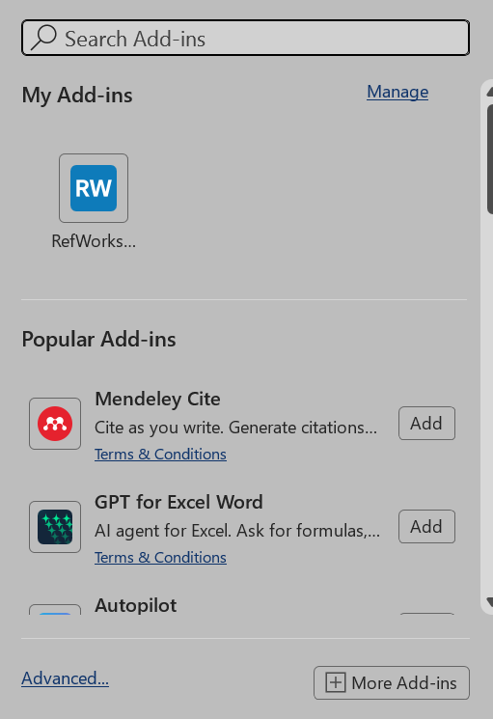
This screen will pop up and if you select or search for RefWorks you should be able to find it easily.
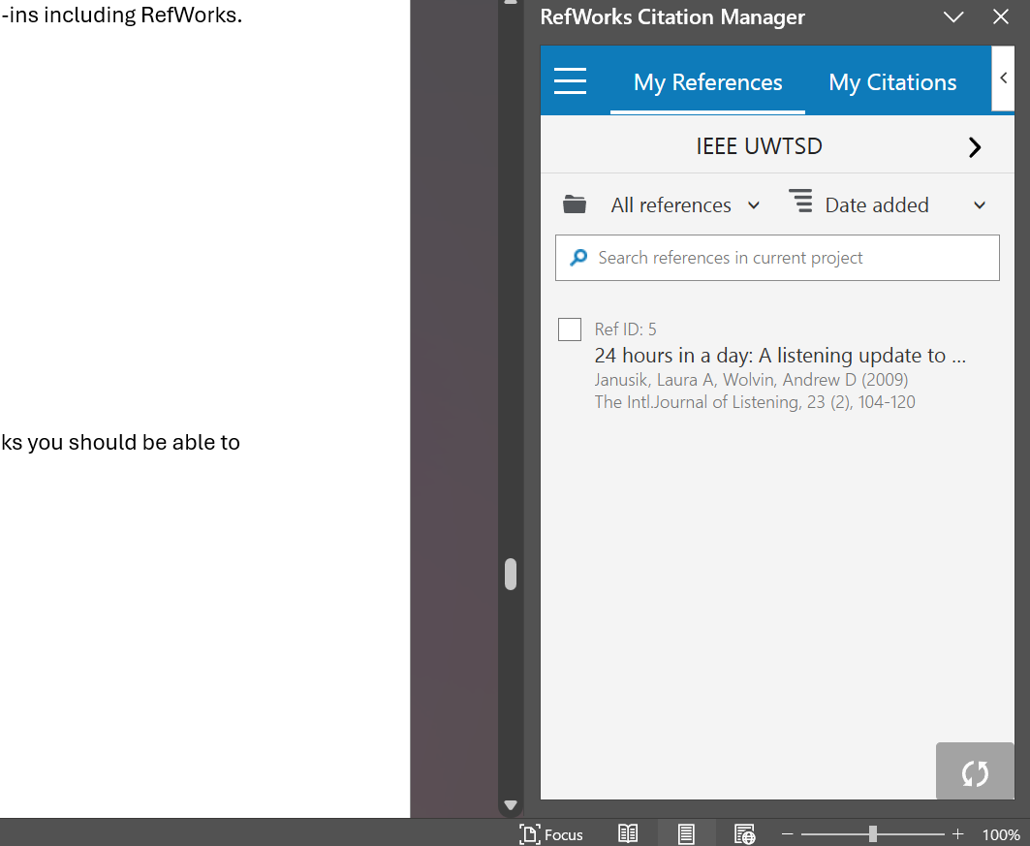
It will ask you to sign in again once you do you will have full access to it from the word document and will be able to take any citations and drop them right in.

Task 4: E-Portfolio Creation and Evaluation

Task 4 (a): E-Portfolio Creation
https://sites.google.com/view/learning-in-the-digital-era-pf/home

Task 4 (b): Illustrative Review of E-Portfolio tool Selection
An e-portfolio is a digital medium used to display an individual’s skills, achievements, and work in an organised and professional manner. E-portfolios are commonly used by students to display their learning achievements and by professionals to aid in their job search or career enhancement. The selection of an e-portfolio is significant because different e-portfolios vary in terms of usability, design, and functionality. E-portfolios vary in terms of simplicity and require technical knowledge.
In this review article, I will discuss Google Sites and WordPress as e-portfolios and highlight my reasons for choosing Google Sites as my e-portfolio.
Google Sites is a simple and easy-to-use website creation tool that is best suited for beginners. One major reason why I selected Google Sites is that it is extremely easy to use. Google Sites is easy to use because it is simple and easy to understand. This means that users do not require any technical knowledge or coding skills to set up a website using Google Sites. This is significant because it is my first e-portfolio, and it is essential that I do not have to worry about how to set up a website but rather focus on creating content.
Another major advantage of Google Sites is that it is very student-friendly. For example, Google Sites is free to use, and this makes it very accessible to all. It is also very compatible with other Google applications like Google Docs, Google Drive, and Google Slides. This makes it very easy to upload assignments, projects, and other forms of evidence into the portfolio. This is especially true for students since most of them are already using Google applications, and this makes the entire process very smooth and efficient.
Another advantage of Google Sites is that it makes it very easy for users to set up a neat and organized portfolio. Although Google Sites has very limited options for its design, it is very beneficial for students. This is because it ensures that the portfolio is very neat and professional without having to be very knowledgeable about its design.
However, Google Sites has some drawbacks. For example, the customization is quite low compared to other sites. This means that users are not able to customize their sites to their own needs. This makes the portfolios quite similar to one another. It is also not the best option for users who are quite advanced and need a very professional and unique website.
On the other hand, WordPress is a very advanced tool for creating an e-portfolio. This is because it has a number of options for personalizing the website. This makes it possible for users to create very professional and unique websites. This makes it one of the best options for users who need to create a website for the long term, especially for business purposes.
Although WordPress has a number of advantages, it is not very easy to use, especially for new users. This is because creating a website using WordPress is quite time-consuming. It also requires some coding knowledge, especially for basic tasks. This makes it quite overwhelming for someone who is creating their first ever e-portfolio.
In addition, while Google Sites is far more accessible, WordPress is far more complex. For a new user, the accessibility of Google Sites is far more important than the advanced functionality of WordPress.

Conclusion
I have chosen Google Sites for my first e-portfolio due to its accessibility, ease of use, and suitability for students. While WordPress is far more advanced, it is also far more complex. For a first e-portfolio, I believe that Google Sites is the best option, especially considering its suitability for students.

References

Task 1 References: [1] [2] [3] [4] [5]
[1] L. A. Janusik and A. D. Wolvin, "24 hours in a day: A listening update to the time studies," vol. 23, no. 2, pp.104–120, 2009,
[2] J. Schulze and S. Krumm, "The “virtual team player” A review and initial model of knowledge, skills, abilities, and other characteristics for virtual collaboration," vol. 7, no. 1, pp.66–95, 2017,
[3] J. Schulze and S. Krumm, "The “virtual team player” A review and initial model of knowledge, skills, abilities, and other characteristics for virtual collaboration," vol. 7, no. 1, pp.66–95, 2017,

