Cyberpunk representations in passive and interactive media.
Research Proposal
Kaan Hanrahan (1904580)
Rich Morgan

Contents

Introduction Page 4

Aims & Objectives Page 4

Background to the Proposed Research Page 5

Reference List Page 8

Bibliography Page 8

Figures

Figure 1 – Graph showing the ideal situation for flow to occur Page 5

Figure 2 – Manifestations of a game paired with elements of flow Page 6

Introduction

“Immersion is the experience of losing oneself in a fictional world. It’s what happens when people are not merely informed or entertained but actually slip into a manufactured reality. J.R.R. Tolkien, who created one of the most immersive tales of all time in his Lord of the Rings trilogy, described it as “the enchanted state,” the frame of mind in which we are so in thrall to a story as to have entered a world of the author’s creation.” [1]

Cyberpunk is a sub-genre of science fiction that shows advanced science and technology in a dystopian future. It is presented in many different forms of media, and it is vital to understand that the methods of portrayal and engrossing a person into a Cyberpunk world differ dependant on the form of media used. The types of media being passive or interactive.
Interactive media gives a user the opportunity to change or manipulate plot elements or the protagonist’s intentions, e.g., Video Games. Interactive media presents a different form of immersion in terms of investment and flow. The user can become an integral and active part of the story, so changes in the content, be it good or bad, is all the user’s doing – however, this comes with the catch of needing to create a much larger world, which almost guarantees that a user will have a different experience to another.
Passive is usually considered to be the ‘traditional’ media type that has no user influence or participation, e.g., Film, TV, Books. Passive media has the benefit of expressing the creator’s true intent of what they would want the user to experience for everyone, at any time. However, the theory of flow does not come into effect with passive media nearly as strong as it does for interactive media.

Aims & Objectives

The main aim of this research is to analyse the differences in Cyberpunk representation in passive and interactive media.
To achieve the aim, this research will identify the contrasts and challenges faced by attempting to immerse users in a Cyberpunk world from both interactive and passive media sources.
This paper will delve into various screenwriting and video game design theories and rules that usually apply in those areas.
It will analyse similar scene/environment comparisons from both forms of Cyberpunk media and draw a comparison as to why those specific scenes were structured and how it relates to the aim of this paper.

Background to the Proposed Research

Flow is a heavily researched topic and is often contributed to experiencing immersion as a user. Mihaly Csikszentmihalyi created the theory of flow in 1975, and alongside Jeanne Nakamura, they identified that there are several factors that make up the experiences of flow:
- “Intense and focused concentration on what one is doing in the present moment
- Merging of action and awareness
- Loss of reflective self-consciousness (i.e., loss of awareness of oneself as a social actor)
- A sense that one can control one’s actions; that is, a sense that one can in principle deal with the situation because one knows how to respond to whatever happens next
- Distortion of temporal experience (typically, a sense that time has passed faster than normal)
- Experience of the activity as intrinsically rewarding, such that often the end goal is just an excuse for the process.” [2]

Otzen further contextualises Csikszentmihalyi’s theory in saying that “Entering into the state of flow requires some sort of activity. The activity presents a given number of possibilities with various outcomes. The person entering into flow, bring some sort of skill required for progressing further in the activity”. [3] Reinforced by Figure 1 below.

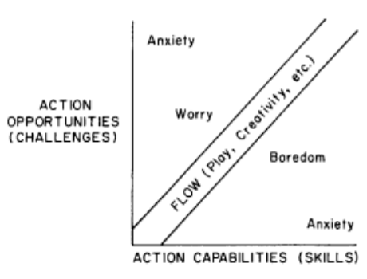

Figure 1 – Graph showing the ideal situation for flow to occur.

Otzen the continues to talk about the theory of flow, except he then relates it to video game design. “Csikszentmihalyi didn’t have computer games in mind, but more traditional games, likes those played by kids or sport exercised by adults. By example he related flow to be experienced by rock-climbers or chess-players.” The figure below is a table in where different manifestations of a game is tied to an element of flow, following the list mentioned prior [2].
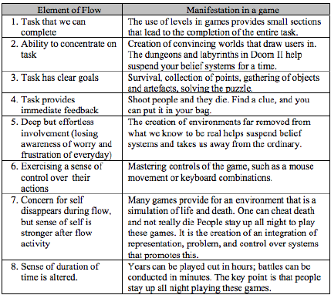
Figure 2 – Manifestations of a game paired with elements of flow.

The right-hand side of the table in Figure 2 above features manifestations involving immersive components.
The research on immersion is further continued by Ernest Adams, he focuses on three main points that target towards video games, movies, and TV.
“Narrative immersion in games is much the same as it is in books or movies. A player gets immersed in a narrative when he or she starts to care about the characters and wants to know how the story is going to end. The player who is immersed in the narrative can tolerate a certain amount of bad strategic and tactical gameplay.
What creates narrative immersion is good storytelling, and what destroys it is bad storytelling: clumsy dialog, stupid characters, unrealistic plots. The skills needed to create narrative immersion are quite different from those needed to create strategic and tactical immersion, which is why smart studios hire professional writers to create their storylines rather than leaving them to the designers.”
“Tactical immersion is immersion in the moment-by-moment act of playing the game and is typically found in fast action games. It's what people call being "in the zone" or "in the groove." It's physical and immediate. When you're tactically immersed in a game, your higher brain functions are largely shut down and you become a pair of eyes directly communicating with your fingers.
Strategic immersion, on the other hand, is a cerebral kind of involvement with the game. It's about seeking a path to victory, or at least to optimize a situation. The highest, most abstract form of strategic immersion is experienced by chess masters, who concentrate on finding the right move among a vast number of possibilities. When you're strategically immersed, you're observing, calculating, deducing.” [4]
Acknowledging these 3 types of immersion, and knowing how they apply to film, TV and video games is vital to understand the differences between them and the challenges.

Reference List

[1] F. Rose, "The Power of Immersive Media", strategy+business, no. 78, p. 3, 2015.
[2] S. Lopez and C. Snyder, Handbook of Positive Psychology. Oxford: Oxford Univ. Press, 2002, p. 90.
[3] T. Otzen, "Immersion and Flow: Ingredients for gameplay", ResearchGate, 2015. [Online]. Available: https://www.researchgate.net/publication/281627226_Immersion_and_Flow_Ingredients_for_gameplay. [Accessed: 17- Oct- 2021].
[4] E. Adams, "Postmodernism and the Three Types of Immersion", Designersnotebook.com, 2004. [Online]. Available: http://designersnotebook.com/Columns/063_Postmodernism/063_postmodernism.htm. [Accessed: 17- Oct- 2021].

Bibliography

[1] F. Rose, "The Power of Immersive Media", strategy+business, no. 78, p. 3, 2015.
[2] S. Lopez and C. Snyder, Handbook of Positive Psychology. Oxford: Oxford Univ. Press, 2002, p. 90.
[3] T. Otzen, "Immersion and Flow: Ingredients for gameplay", ResearchGate, 2015. [Online]. Available: https://www.researchgate.net/publication/281627226_Immersion_and_Flow_Ingredients_for_gameplay. [Accessed: 17- Oct- 2021].
[4] E. Adams, "Postmodernism and the Three Types of Immersion", Designersnotebook.com, 2004. [Online]. Available: http://designersnotebook.com/Columns/063_Postmodernism/063_postmodernism.htm. [Accessed: 17- Oct- 2021].
M. Kreiger, "Passive and Interactive Media", prezi.com, 2012. [Online]. Available: https://prezi.com/3cs53rquerit/passive-and-interactive-media/. [Accessed: 17- Oct- 2021].
S. Axani, "Immersion, Media, and Storytelling", itp.nyu.edu, 2021. [Online]. Available: https://itp.nyu.edu/classes/fnm-sp2015/immersion-media-and-storytelling/. [Accessed: 17- Oct- 2021].
F. Rose, The Art of Immersion, 1st ed. New York: W.W. Norton & Company, 2012.
S. Rawding, "Filmic Immersion: An Analysis of Technique and Perspective in Contemporary Cinema", Msc, University of Malta, 2014.

