

The Importance of Team Working for Academic and Professional Development
  - Academic Skills (LCBB4012)

Professor Name: Roopa Aruvanahalli Nagaraju
Group Presentation
Names: Lupu Florentina-Elena 2420426
Roxana Georgiana Dumitru 2332951

Contents
1. Introduction 3
2. Definition of Team Working 3
3. Tuckman’s Stages of Group Development 3
4. Importance of Team Working 4
4.1 Academic Development 4
4.2 Professional Development 4
4.3 Challenges of Team Working 4
5. Characteristics of Effective Teams 4
6. Conclusion 4
7. Reference 4

1. Introduction
In contemporary higher education and professional environments, teamwork has become a core competency rather than an optional skill. Organisations increasingly rely on collaborative structures to enhance innovation, improve decision-making, and achieve strategic objectives. Universities integrate group assignments into curricula to simulate real-world working conditions and develop students’ transferable skills. Effective team working therefore plays a critical role in both academic success and long-term professional development. This report critically examines the concept of team working, analyses Tuckman’s Stages of Group Development, and evaluates the importance and characteristics of effective teams.
In recent years, higher education institutions in the United Kingdom have increasingly emphasised the development of transferable skills alongside subject knowledge. Employers consistently identify teamwork, communication and adaptability as essential graduate attributes. As a result, collaborative learning has become a central pedagogical strategy within universities. Group assignments are designed not only to assess academic understanding but also to prepare students for the realities of professional working environments.

Furthermore, the modern workplace is characterised by complexity, interdependence and cross-functional collaboration. Few roles operate in isolation. Employees are expected to contribute to shared objectives, participate in problem-solving discussions and adapt to diverse working styles. Therefore, understanding the theoretical foundations of team development and team effectiveness is crucial for both academic progression and long-term career success.

2. Definition of Team Working
Team working refers to a collaborative process in which individuals work interdependently towards a shared goal. Katzenbach and Smith (1993) define a team as a small number of people with complementary skills committed to a common purpose and mutual accountability. This definition highlights shared responsibility as central to team effectiveness.
It is important to distinguish between a group and a team. A group may involve individuals working in parallel without collective responsibility. In contrast, teams generate synergy, where collective output exceeds individual contributions (Robbins and Judge, 2023). Such synergy depends on communication, trust and clearly defined roles.
Effective team working involves both task-oriented and relational components. Task-oriented elements include clearly defined objectives, structured coordination and measurable performance indicators. Relational elements, however, involve trust, psychological safety and mutual respect among members. Edmondson (2018) argues that psychological safety enables individuals to express ideas and concerns without fear of embarrassment or rejection. Without such an environment, teams may struggle to reach high performance despite possessing technical competence.

It can therefore be argued that teamwork is not simply about dividing responsibilities. Rather, it represents a dynamic interaction between individual contributions and collective accountability. The absence of shared responsibility may result in fragmented efforts rather than cohesive performance.

3. Tuckman’s Stages of Group Development
Tuckman (1965) proposed that teams develop through five stages: Forming, Storming, Norming, Performing and Adjourning.
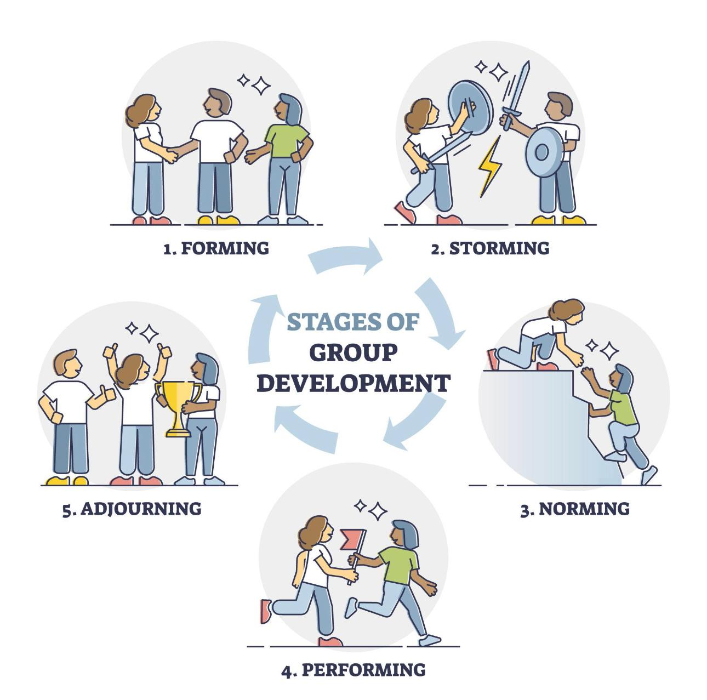
As illustrated in Figure 1, team development progresses through identifiable stages that reflect changes in group dynamics and performance.
Forming involves orientation and clarification of objectives.
Storming includes conflict as members express differing perspectives.
Norming reflects increasing trust and establishment of shared norms.
Performing represents effective collaboration and high productivity.
Adjourning occurs when the team completes its task and disbands.
While the model provides clarity and practical relevance, it assumes a linear progression. Teams may regress to earlier stages when facing new challenges (Tuckman and Jensen, 1977). Despite limitations, the model remains valuable for understanding developmental dynamics and normalising key strength of Tuckman’s model lies in its practical simplicity. The staged structure allows both students and professionals to anticipate potential difficulties within team development. For example, recognising the inevitability of the storming phase may reduce anxiety when conflict arises. Rather than perceiving disagreement as failure, team members may understand it as part of a developmental process.

However, the model has been criticised for its limited attention to contextual factors. Contemporary teams often operate within virtual environments, relying on digital communication tools rather than face-to-face interaction. In such settings, misunderstandings may occur more frequently, potentially prolonging the forming and storming stages. Additionally, cultural diversity within global teams may influence how conflict is expressed and resolved.

Another limitation concerns leadership dynamics. Tuckman’s framework does not explicitly address the role of leadership style in guiding progression between stages. Transformational leadership, for instance, may accelerate movement towards the performing stage by promoting shared vision and motivation. Consequently, while Tuckman’s theory remains highly influential, it should be applied flexibly and adapted to modern organisational contexts.
Tuckman’s framework can be clearly observed in academic group assignments. When students are first allocated into groups, they typically enter the forming stage, characterised by polite interaction and uncertainty regarding expectations. As discussions progress, differences in working styles and standards may emerge, signalling the storming stage. Disagreements about task allocation or quality expectations can create tension, yet this stage is essential for clarifying boundaries.

Following negotiation and agreement, the norming stage develops as trust increases and roles become defined. Communication improves and collaboration becomes more structured. Ultimately, the performing stage is reflected in efficient task completion and shared responsibility for final outcomes. After submission, the team enters the adjourning phase, where reflection and evaluation take place.

4. Importance of Team Working

4.1 Academic Development
Team working enhances communication, leadership, negotiation and time-management skills. Structured collaboration improves analytical thinking and decision-makin from an academic perspective, collaborative assignments enhance critical thinking by exposing students to diverse viewpoints. When individuals challenge each other’s assumptions, deeper analysis is encouraged. This interactive learning process strengthens problem-solving capabilities and promotes intellectual growth. Moreover, team projects require effective time management and negotiation, as members must coordinate schedules and agree on task allocation.

Such experiences simulate workplace expectations, where deadlines and accountability are essential. Students who actively engage in team-based learning are therefore better prepared to transition into professional roles (Salas et al., 2015).

4.2 Professional Development
In professional environments, teamwork increases innovation and organisational performance (West, 2012). Psychological safety supports learning and creativity (Edmondson, 2018).
Highlights that high-performing teams demonstrate stronger innovation and higher levels of productivity. Collaboration facilitates knowledge sharing, allowing organisations to respond more effectively to complex challenges. Furthermore, cross-functional teams integrate diverse expertise, enhancing decision-making quality.

Employability research consistently identifies teamwork as a key competency sought by employers. Technical expertise alone is insufficient; organisations require individuals capable of communicating effectively, managing conflict constructively and contributing to collective goals. Therefore, developing teamwork competence during higher education represents a strategic investment in future career success.

4.3 Challenges of Team Working
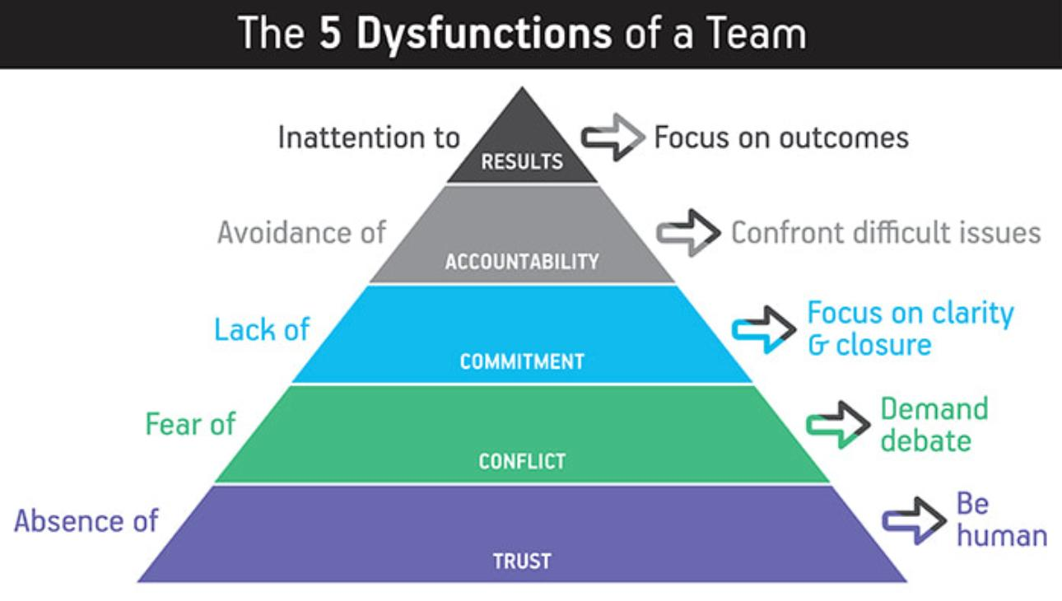
Figure 2: The Five Dysfunctions of a Team (Lencioni, 2002).
As shown in Figure 2, team dysfunctions often originate from an absence of trust, which can escalate into fear of conflict, lack of commitment, avoidance of accountability and ultimately inattention to results.
Teamwork may involve challenges such as social loafing, conflict escalation and role ambiguity. Lencioni (2002) highlights accountability risks, while Hackman (2002) emphasises the need for clear task structures. Effective leadership and communication are therefore essential.

5. Characteristics of Effective Teams
Effective teams share clear objectives, defined roles, trust, accountability and strong communication. Leadership and organisational support further enhance performance (Hackman, 2002).
Accountability represents a critical component of team effectiveness. When individual contributions are transparent, motivation increases and social loafing decreases. Lencioni (2002) emphasises that avoidance of accountability weakens performance and undermines results. Consequently, effective teams balance trust with structured performance monitoring.

Additionally, clarity of purpose ensures alignment between individual efforts and collective objectives. Without shared goals, even skilled teams may struggle to maintain focus. Effective leadership further reinforces direction, providing guidance and maintaining cohesion during periods of uncertainty.
While Tuckman focuses on developmental stages, Belbin (2010) emphasises behavioral roles within teams. According to Belbin’s theory, effective performance depends on the presence of complementary roles such as coordinators, implementers and team workers. This perspective suggests that team effectiveness is influenced not only by developmental progression but also by personality diversity and role balance. Integrating both models provides a more comprehensive understanding of team dynamics.

6. Conclusion
In conclusion, team working represents a critical competency in both academic and professional environments. This report has demonstrated that effective collaboration extends beyond task allocation and requires shared accountability, trust, leadership and structured communication.

Tuckman’s Stages of Group Development provide a valuable framework for understanding how teams evolve over time. Although the model presents certain limitations, particularly in relation to linear progression and modern virtual contexts, it remains highly relevant when applied critically. Furthermore, research on team dysfunctions and effectiveness highlights the importance of psychological safety and accountability in sustaining performance.

From an employability perspective, teamwork competence differentiates graduates within competitive labor markets. Organisations increasingly depend on collaborative structures to address complex challenges. Therefore, students who develop effective team working skills during higher education are better prepared to contribute meaningfully within professional environments.

Ultimately, teamwork should be regarded not merely as an academic requirement, but as a strategic investment in long-term career development.

7. Reference
Belbin, R.M. (2010) Team Roles at Work. 2nd edn. Oxford: Butterworth-Heinemann.
Edmondson, A.C. (2018) The Fearless Organization. Hoboken: Wiley.
Hackman, J.R. (2002) Leading Teams. Boston: Harvard Business School Press.
Johnson, D.W. and Johnson, R.T. (2017) Joining Together. 12th edn. Harlow: Pearson.
Katzenbach, J.R. and Smith, D.K. (1993) The Wisdom of Teams. Boston: Harvard Business School Press.
Lencioni, P. (2002) The Five Dysfunctions of a Team. San Francisco: Jossey-Bass.
Robbins, S.P. and Judge, T.A. (2023) Organizational Behavior. 19th edn. Harlow: Pearson.
Salas, E. et al. (2015) Understanding and improving teamwork in organizations. Human Resource Management, 54(4), pp. 599–622.
Tuckman, B.W. and Jensen, M.A.C. (1977) Stages of small-group development revisited. Group & Organization Studies, 2(4), pp. 419–427.
West, M.A. (2012) Effective Teamwork. 3rd edn. Oxford: Wiley-Blackwell.
Wheelan, S.A. (2020) Creating Effective Teams. 6th edn.

