Task 1: Choose a suitable story to be presented to a group of children noting the rationale behind the choice of story and the main learning objectives that are relevant to the story. You should note the intended audience and the type of language teaching opportunities the story would offer. Prepare one resource based on the story to teach Welsh as a first or second language. (up to 250 words)

The chosen story was Peintio’r drws. Taught to a year 2 class of 19 mixed-ability English-medium learners. The text was chosen after discussions with the class teacher, to ensure the level was suitable for the learners and their linguistic attainment and also the need to ‘hear lively readings from a variety of sources’ (Welsh Gov, p. 38, 2015). The story focuses on the colours of a door, tying into previous lessons when the class had sung the ‘Lliwiau enfys’ song and used coloured ribbons for concrete experiences. I planned to start by introducing Lliw the lion and engage the children by questioning them and promoting prediction skills when they think about what he could be doing. Asking what ‘drws’ means and using a statement and related actions they would have experienced before such as ‘caewch yr drws.’ Linked to cognitive mapping Fisher (2001) as in this way the story activates their prior knowledge and applies it in a new setting so that the children are extending their oral skills through drilling and questioning techniques. I practiced reading the story prior to the lesson to ensure my pronunciation was correct to model correctly to the class. I planned to use the story in multiple ways to engage with all learning styles in my classroom, by using Barbe’s VARK technique (Appendix 1) to help all learners cement their knowledge and give children a deeper understanding of the language.

Task 2: Read a story to a group of children during your PTE and undertake one activity using the resource you have prepared. You will need to film this activity for you to analyse and submit it as part of the assignment. (up to 8 minutes)
https://youtu.be/cdf739YbSJQ

Task 3: A written reflection of task 2 (up to 1500 words)
I planned to keep the focus on the repetition of words from the book, using actions to deliver a more kinaesthetic lesson; this is supported by Lynch (2013) and DERA (2002) who suggest this helps to support EAL pupils and those with a lower ability. Further supported by the theory of a total physical response where children decode actions to formulate language (Asher, 2012). The activity was a way to repeat the colours in Welsh and use AFL to assess pupils’ understanding of the language specific to this lesson. (Jones, 2013) states that the child’s current skills in the target language should be checked and assessed to be used in gaining further understanding. As noted by Chambers (1999) and Pollard & Bourne (1997) it is good practice for the teacher to encourage children to read for pleasure as well as for acquisition of information; if the purposes are explicit then the joy of reading, as well as the information gained will be greatly enhanced. I ensured all children could see the board clearly to start as this can have a huge impact on attention and their ability to follow and understand the story. Asking general questions about reading a story and what we can use in the book to help us make sense of what is happening in the story. As Jones (2013) states, it’s important to use visual aids when teaching language, having considered this I prompted the children to use the pictures to help them understand what the story was about. I probed them for more information to activate their prior knowledge. Questioning was used throughout the story to check for understanding as well as cementing the understanding for the children. I encouraged learners to communicate their ideas about the story and what Lliw might be doing and saying. Getting the children to think about how Lliw the lion is feeling can help the pupils’ connect to the characters in the story, helping to build empathy, a key component in developing the “healthy, confident individuals” Successful Futures is looking for (Donaldson, 2015, p. 31). These questions also opened up further discussion around the topic, making the lesson very individualized as pupils gain ownership by giving their own interpretation of what is happening, a key skill in developing children’s imagination and creativity and an experience looked to be developed through the foundation phase framework (Welsh Gov, 2015). I used gestures to help the class understand what some of the words meant, words such as ‘ty’ and ‘hoffi’r’ where they needed a little reminding of the meaning. I get them to activate their prior knowledge by asking what ‘ty’ means in English, using gestures to make the words more relatable:
Gesture is an explicit, visual memory hook. It acts as a trigger for recording and recalling information. If you get children moving and excited their working memory will be stimulated (Lynch, 2013, p. 9).

Incidental Welsh was used throughout, statements such as ‘dim siarad’ help to surround the children in a Welsh language environment (Welsh Gov, 2017). Using the colours mentioned in the book we tried to spot these around the classroom, this furthered the pupils’ understanding of the topic and the names for the colours in Welsh by stimulating them with a mix of resources (Estyn, 2013). I tried to be animated during the story to make the learning more enjoyable and fun. Getting the children to repeat the actions to join in. I feel it is really important when reading a story to be passionate about the role of storytelling; this enthusiasm rubs off on the children, this is supported by (Grigg, 2015, Pollard & Bourne, 1997 and Corbett & Strong, 2017).

Positive reinforcement was used when one child gave a good answer; I rewarded this behavior by allowing him to move his name up on the ‘learning ladder’ a visual behavior management strategy. Supported by B. F. Skinner’s (1969) work on the theory of operant conditioning, this modelling of good behavior and rewards is intended to have a ripple effect on the children so that they respond by being well behaved and looking to give good responses. Once the action was performed for ‘pawb’ then the class began to understand and tell me what ‘pawb’ meant. As Jones (2013) states it is important to use a range of methods to make sense of new and unknown words. Towards the end of the story I used a drillio technique to get the children to repeat the names of the colours in Welsh. As supported by Gipps, McCallum and Hargreaves (2003) and the teachings of Montessori (Polk Lillard, 2011) this methodology focuses on repetition, further cementing memory of the language, and the ability to recount it when required. The aim is to improve learners’ reading skills and pronunciation by showing the colours and their Welsh names and modelling how to say the words, getting the children to repeat the words to check for pronunciation. As Jones (2013) states, you must probe in order to learn a language, proficiency is gained through repeating, experiencing small failures but also successes.
The activity started off by referring the class back to the book on the interactive white board to think of the colours that were discussed. I set out how I wanted them to behave during the task “no silly running”. I then check for understanding by asking if they think they can do it. Reaffirming the rules of the activity that I want them to place their finger on the colour called out and not to grab at it. I started the activity by first calling out melyn and waiting until all of the children had found the colour – following up to check for understanding I ask in English “What colour is melyn” and get a hearty response of “YELLOW”. I promoted further development in the children’s knowledge during this task by asking them to find porffor, a colour we hadn’t covered in the story but which they quickly remembered. Black (2005), states that we can think of learning as the securing of new knowledge and that the pupil should conceptualise the next step in order to progress their learning. This draws similarities with Jones (2013) and Vygotsky’s Zone of Proximal Development where we construct new knowledge from pre-existing perceptions (Daniels, Cole and Wertsch, 2007). However, when scaffolding learning in this way there must be that basis of understanding for the learner to progress from.
There was some low-level disruption when the story was being read and when the activity was being completed. I’d expect some disruption from pupils this age but felt that it was dealt with sufficiently, either by putting my finger on my lip and waiting for silence or by stating “dim siarad”. Also drawing the attention back to myself with a ‘hocus pocus’ style behavior management strategy worked well with the children as this is a technique I had used in previous lessons. I tried to bring the learning back to the story when I felt the talking was getting out of hand. Some of the ideas were relevant but the learning can get lost in children making comments just for the sake of it. I could have explained more explicitly that pupils need to pay attention as we would use the information in the story for a later activity. This would be particularly helpful to the boys in the class; as they tend to benefit more from practical reading, when they understand there will be a purpose for the information (Barton, 2009). However, as noted by Pollard & Bourne (1997) teachers often provide different interactions to boys and girls as they predict different outcomes from them. It should be noted that girls tend to favour reading simply for pleasure (Barton, 2009); so it is about getting a

balance that suits the majority of pupils, considering time and staffing restrictions it is not always possible to deal with boys and girls separately. This also detracts from our future goal of having more inclusive schools (Welsh Gov, 2016).
Overall I really enjoyed using a story as a hook for a Welsh lesson and follow-up activity. Using the story provided a scaffolding system; this was particularly beneficial to me as a learner of Welsh as I could practice beforehand and had a script to follow. Stories and songs can be a great stimulus for learners, however there has been shown to be a significant drop in attainment levels between foundation phase and key stage 2 (KS2) school. This in part could be down to the fact that previously there was no requirement for schools to track pupils’ progress in Welsh Language Development (Estyn, 2013). However this lack of progress could be addressed with a wider variety of fun and engaging activities for KS2 and older pupils, through stories and songs suitable for the specific age range. A further approach and one with potential longer-term benefits is the upskilling of teachers in their own Welsh Language ability. There are currently government-funded secondment opportunities when practitioners can attend intensive Welsh courses to improve their use of the language. I am looking to attend a five-day intensive Welsh Language course this summer in order to give myself and my future pupils the best chance of learning the language. Once we have well-trained teachers who feel confident and competent to speak Welsh then they can deliver more fluid and engaging lessons to all pupils they teach. This is a longer-term and more costly solution, but one which will benefit the teachers in their professional development, pupils in their future lives and ultimately Wales as a nation.

Reference list

Asher, J. (2012). Learning another language through actions. Los Gatos: Sky Oak Productions.

Barton, A. (2009). Getting the buggers into languages. London: Bloomsbury.

Black, P. (2005). Testing: friend or foe? London: RoutledgeFalmer.

Bourne, J. and Pollard, A. (1997). Teaching and learning in the primary school. London: Routledge in assoc. with the Open University.

Central South Consortium. (2018). “Reading Books - Welsh 2nd Language”
Available at: https://www.cscjes.org.uk/repository/resource/363d38c0-5bbb-4427-9dc7-02e99289fe22/en (Accessed: 07/03/2019)

Chambers, G. (1999). Motivating language learners. Clevedon: Multilingual Matters.

Corbett, P. and Strong, J. (2017). Talk for writing across the curriculum. 2nd ed. London: Open University Press.

Department for Education and Skills. (2002). “Teaching pupils for whom English is an additional language”.
https://dera.ioe.ac.uk/7565/7/6daec76abb550f4aaa9cfb94c4731e95_Redacted.pdf
(Accessed: 27/02/2019)

Donaldson, G. (2015). Successful Futures. Cardiff: Crown.

Estyn. (2013). Welsh Language Development in the Foundation Phase. Cardiff: Crown.

Fisher, R. (2001). Teaching children to learn. Cheltenham: Thornes.

Gipps, C., Hargreaves, E. and MacCallum, B. (2003). What makes a good primary school teacher? London: RoutledgeFalmer.

Grigg, R. (2015). Becoming an outstanding primary school teacher. 1st ed. Oxon: Routledge.

Jones, G. (2013). "My guinea pig died with its legs crossed". Aberystwyth: Atebol Cyfyngedig.

Lynch, S. (2013). “Making the most effective use of gesture in the primary MFL classroom”.
https://www.belleville-school.org.uk/data/dynamic/spaw/documents/S%20Lynch%20-%20Making%20the%20most%20effective%20use%20of%20gesture%20in%20primary%20MFL%20-%20Jan%202013.pdf
(Accessed: 27/02/2019)

Polk Lillard, P. (2011). Montessori: Modern Approach. New York: Schocken Books.

Skinner, B. (1969). Contingencies of Reinforcement. United States of America: Meredith Corporation.

Welsh Assembly Government. (2017). Cymraeg 2050 A million Welsh speakers. Cardiff: Crown.

Welsh Assembly Government. (2015). “Foundation Phase framework”.
Available at: https://learning.gov.wales/docs/learningwales/publications/150803-fp-framework-en.pdf
(Accessed: 07/03/2019)

Welsh Assembly Government. (2016). Inclusion and pupil support. Cardiff: Crown.

Appendix

1.
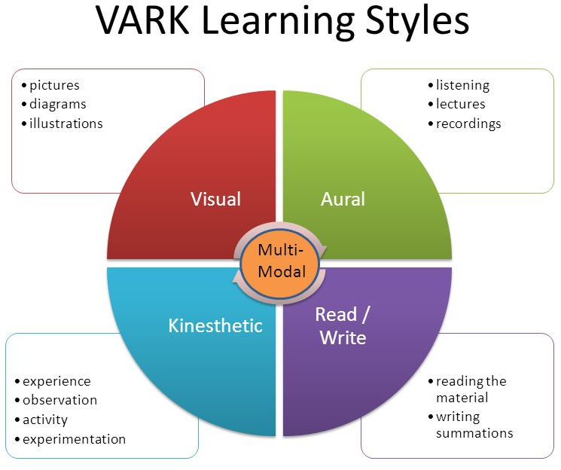
Velpic (2019) “VARK Learning Styles”.
https://www.google.co.uk/search?rlz=1C1GCEB_enGB839&biw=1920&bih=937&tbm=isch&sa=1&ei=rm6CXJP6L5G9UMHMq5AC&q=VARK+model&oq=VARK+model&gs_l=img.3..0i67j0l2j0i5i30l3j0i8i30j0i24l3.3582.3582..3716...0.0..0.52.52.1......0....1..gws-wiz-img.T_kYJBIqWXE#imgrc=a5T2yD73FjS0nM: (Accessed: 08/03/2019)

2.


