

Student name: Elisa Monares
Student ID: 2510396

Module name: Introduction to Health and Social Care
Module code: LCHS4003
Lecturer name : Muhammad Aliyu
Content page

Element 1 …………………………………………………………….. page 3
Element 2 …………………………………………………………….. page 4

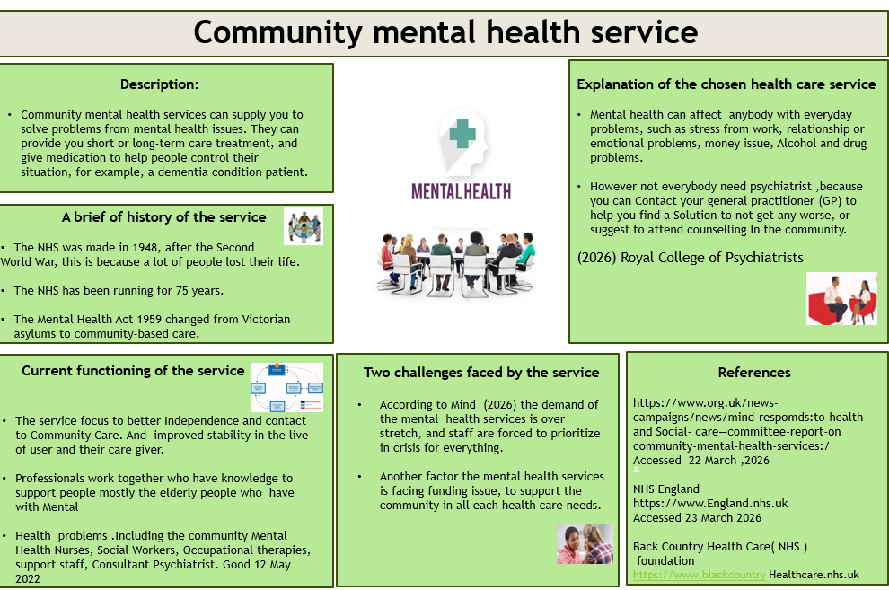
(On PowerPoint)





Current functioning of the service
- The service focus to better Independence and contact to Community Care and improved stability in the lives of user and their care giver.
- Professionals work together who have knowledge to support people mostly the elderly people who have with Mental Health problems. Including the community Mental Health Nurses, Social Workers, Occupational therapies, support staff, Consultant Psychiatrist.

Two challenges faced by the service
- According to Mind (2026) the demand of the mental health services is over stretch, and staff are forced to prioritize in crisis for everything.
- Another factor the mental health services is facing funding issue, to support the community in all each health care needs.

References https://www.org.uk/news-campaigns/news/mind-respomds:to-health-and Social- care-committee-report-on community-mental-health-services:/ - Accessed 22 March ,2026 NHS England
https://www.England.nhs.uk Accessed 23 March 2026
Back Country Health Care (NHS ) foundation https://www.blackcountry Healthcare.nhs.uk
Explanation of the chosen health care service
- Mental health can affect anybody with everyday problems, such as stress from work, relationship or emotional problems, money issue, Alcohol and drug problems.
- However not everybody need psychiatrist, because you can Contact your general practitioner (GP) to help
you find a Solution to not get any worse,
or suggest attending counselling in the community.
(2026) Royal College of Psychiatrists

Description:
- Community mental health services can supply you to solve problems from mental health issues. They can provide you short or long-term care treatment, and give medication to help people control their situation, for example, a dementia condition patient.

Community mental health service
Elisa Monares, Introduction to Health and Social Care, 2510396@student.uwtsd.ac.uk
A brief of history of the service
- The NHS was made in 1948, after the Second World War, this is because a lot of people lost their life. The NHS has been running for 75 years.
- The Mental Health Act 1959 changed from
Victorian asylums to community-based care.

Element 2

The Ambulance Service in the UK: History, Challenges, and Evolution

The ambulance service in the United Kingdom plays a crucial role in providing emergency medical assistance to those in need. Over time, it has evolved from humble beginnings to a sophisticated and complex system that requires careful coordination, advanced technology, and highly trained personnel. This essay explores the history of the UK ambulance service, the challenges it faces, and its current role within the nation’s healthcare system.

History of the UK Ambulance S service
The history of the ambulance service in the UK dates to the early 19 century. The first recorded use of an ambulance in the UK occurred in 1832, when the London Hospital established a horse-drawn ambulance to transport patients ( Murray, 2012 ). However, the concept of a dedicated ambulance service did not become widespread until the 19th century. Prior to this, injured individuals were typically transported by family members or volunteers, which often delayed the provision of essential care.

The establishment of the first organised Ambulance service in the UK is credited to the St John Ambulance Brigade in 1877. This initiative was designed to train people in basic medical techniques and create a network of trained personnel to respond to emergencies (St John Ambulance ,2015). By the early 20th century, the National Health Service ( NHS ) in 1948 played a significant role transforming the ambulance service into a government -funded operation, formalising its integration into the broader healthcare system (NHS ,2016).

Modern Ambulance Service

Today the UK is served by 11 regional ambulance services, all of which are under the umbrella of the NHS, and each is tasked with providing emergency medical services, including responding to 999 calls, offering pre-hospital care, and transporting patients to healthcare facilities. Ambulance services also manage non-emergency transport, particularly for patients who need to attend medical appointments or follow-up treatments (NHS, 2020).

Modern UK ambulance services are equipped with a wide range of vehicles, from basic emergency ambulances to specialized paramedic units, such as air ambulances and rapid response vehicles. Additionally, ambulance staff undergo extensive training to provide advanced life -saving procedures, including administering medication, performing CPR, and managing trauma situation.

Challenges Faced by the Ambulance Service

Despite its importance, the UK ambulance service faces numerous challenges. One of the most significant issues is the growing demand for emergency services. According to a report by the National Audit Office (2018 ) , ambulance services in England have seen a 13 % increase in callouts over the past five years. This rising demand has placed considerable pressure on ambulance staff, who must respond to an increasing number of emergency calls with limited resources.

The pressure is compounded by an increasing number of patients requiring non-emergency medical transport, a trend that often results in demand has placed considerable pressure on ambulance staff, who must respond to an increasing number of emergency calls with limited resources.

The pressure is compounded by an increasing number of patients requiring non-emergency medical transport ,a trend that often results in ambulances being unavailable for true emergencies ( Gonzalez, 2019 ) Furthermore, there is an ongoing challenge related to delays in hospitals handover times, with paramedics sometimes waiting hours to transfer patients to the hospital, which reduces their ability to respond to other emergencies (Department of Health, 2017 ).

Workforce shortages also remain a pressing issue. Ambulance services are struggling with staff retention due to high stress levels, long hours and the physical demands of the job (National Health Service Staff Counsil,2020 ). The shortage of qualified paramedics and other healthcare professionals has led to longer response times and burnout among existing staff.

Finally, the increasing use of technology in healthcare has raised both opportunities and challenges. While innovations such as mobile health applications and telemedicine can enhance patient care, they also require significant investment in training, infrastructure, and support (Murray, 2022 ). Ensuring that ambulance services remain adaptable and responsive to technological changes is a constant challenge.

Conclusion

The UK ambulance service has a long and storied history, evolving from basic transport services to a highly sophisticated component of the nation’s healthcare system. However, it faces significant challenges, including rising demand, workforce shortages, and issues with hospital handovers. Addressing this challenge will require ongoing investment in staff, technology, and infrastructure, as well as improved coordination between different healthcare services. As the demands on the ambulance service continue to grow, it will be essential to ensure that the system remains robust, responsive, and capable of delivering high-quality care when it is needed most.

References

Department of Health,2017. Ambulance services: performance and challenges. London: Department of Health. Gonzalez, L..,2019. Non-emergency medical transport: growing demand and its implications for the ambulance service’. Journal of Healthcare Management, 45(2), pp. 134-142. Murray, S., 2012. History of the UK ambulance services: from the 19th century to modern day. Oxford: Oxford University Press. Murray, S., 2022. ‘The role of technology in modern ambulance services’ .Journal of Emergency Medical Services, 50(3), pp. 56-61 .National Audit Office, 2018. Performance of ambulance service in England .London: National Audit Office.
National Health Service , 2016. The role of the ambulance service in the NHS. London: National Health Service .
National Health Service Staff Council, 2020.
Workforce challenges in ambulance services.
London: NHS Staff Council.
St John Ambulance, 2015.The history of the St
John Ambulance, Brigade. Available at:
https://www.sja.org.uk ( Accessed:21 March 2026 ).

