

- Student Name: Ebrahim Al maisari.
- Student ID: 2502775
- Names of all students in your assignment group: Ebrahim, Connor and Gabriel.

- Link to Individual Blog / Social Media site: https://ty-hafan.blogspot.com/

- I am going to write about the Tŷ Hafan organization, and here I will write about two main aspects of this institution:
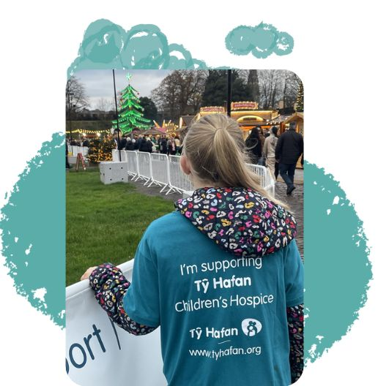
1-The services they provide to the community:

Tŷ Hafan is one of the major charitable organizations and is among the most important institutions that offer exceptional care to children who suffer from serious illnesses and complex medical conditions that shorten their lives. The organization also provides comprehensive care for every one of these children, especially those who have highly complex health problems. Here, we affirm that these children deserve full, compassionate, and specialized medical and psychological care. Tŷ Hafan works with great precision to create a supportive environment that meets all the children’s emotional and physical needs equally, helping them to live with the best possible compassionate quality of life despite the health challenges they face. In all cases, the role of the organization is not limited to providing medical care only; rather, it encompasses all aspects of the child’s social life. The organization offers support and assistance to families who experience feelings of fear, anxiety, and stress while caring for their child who suffers from a life-threatening medical condition. For this reason, the institution provides high-quality, tangible practical and emotional support, delivered with compassion, while considering all aspects of each family’s needs individually according to their different circumstances.
This support has included various services such as psychological counseling, family support sessions, recreational activities for the children and their siblings, and also those practical services that have helped and continue to help these families cope with daily life under such conditions.In addition, the organization provides other services that are no less important than those previously mentioned, as they offer respite care, which gives families a necessary period of rest. They also provide home visits for families who are prevented by certain circumstances from visiting the center, offering advice and guidance on how to manage their children’s medical and psychological conditions, as well as follow-up from the organization’s specialized team.
Moreover, they offer end-of-life care, which is provided with dignity, compassion, and respect, ensuring that the child and their family experience this sensitive stage in a more humane manner, surrounded by mercy and support.
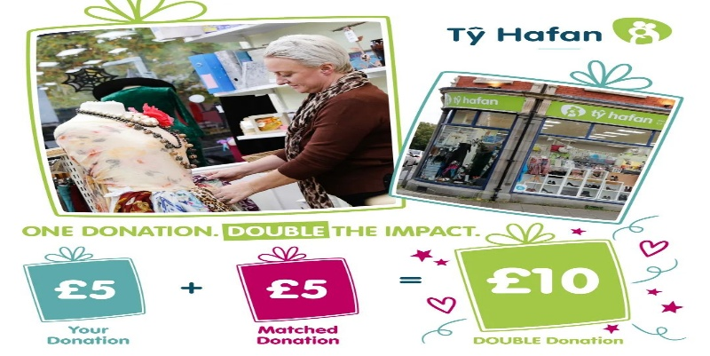
2.Where does the Tŷ Hafan organization receive its support from?

The Tŷ Hafan organization relies heavily on donations and community support in order to meet the financial costs of providing comprehensive care and support for children who suffer from serious, life-shortening illnesses. The organization needs more than £6 million annually to fund the medical, psychological, and social care services offered to the children and their families.The largest portion of this funding comes from individual donations, charity events, and various community activities, making up 85%, which is a significant percentage. On the other hand, government funding is not large, accounting for 12.4% of the annual budget. Thus, financial support reaches the organization’s treasury from many diverse sources across the Wales region, including support from individuals, churches, and schools, as well as open fundraising events, community groups, and many local businesses that collect donations specifically for the benefit of the children. The organization also relies on monthly and annual fundraising, gifts and contributions from donors and generous benefactors, as well as donations from wills. In addition, revenue from the organization’s 19 charity shops across Wales has also contributed significantly and importantly to supporting the care services. Therefore, Tŷ Hafan continues to provide support and specialized services to children and their families without placing any financial burden on them, and all of this is made possible thanks to the supporters and donors. This clearly demonstrates that the continuous support of the community has been a fundamental element in the ongoing work of the organization.

How does your blog/social media help market the charity?
- The primary aim of my publication is to raise the community’s level of awareness about the Tŷ Hafan organization, and it clearly highlights the great services and responsibilities that this organization provides for children and their families. As stated in my publication, this charitable organization has been committed to presenting to the community and the public the services it offers in a simple, easy, and emotionally touching way, so that it becomes easier for everyone to understand the importance of the support provided by charitable institutions, and therefore recognize that such institutions truly deserve the support of donors. I have focused mainly in my publications on explaining to people how this organization helps children who suffer from serious medical conditions, and how it supports their families. This clearly helps the public understand the importance of the charitable work provided by this organization. Moreover, presenting and explaining what families of children with life-shortening illnesses face allows the reader to empathize with this group in society. This approach is intelligent and important for promoting the organization, attracting donors, and ensuring the continuation of support.
- In my second publication, I also wrote clearly about the annual amount the organization spends for this group in society, and I also clarified the sources of funding and support that the charity receives to cover its expenses. This makes it clear how donations are used and why they require continuous support.
This approach of presenting information in a clear and transparent manner earns the public’s trust, their sympathy, and their ongoing support. This is the essential part of intelligent charitable marketing.
- In all cases, and in general, my publications will help promote the organization through the awareness that I aimed to address, the emotional connection with the organization, and the encouragement of the public to donate and give.
Who is the target audience and why were they selected?
- The target audience I focused on is:
- Young adults in Welsh society, because the organization receives and hopes to collect donations from the residents of Wales.
- Parents and families, because this group is the most likely to feel the suffering of children, especially those with this type of illness.
- Local volunteers and donors, since the organization needs 85% of its funding to be covered through donations.
- Students, because they are interested in voluntary work and have the energy to provide support and assistance.
- As I understood, this segment of society is the most capable of empathizing with the children and their families, supporting the organization financially, and
spreading awareness among community members.
What is the objective of each post?
- The first publication:
My aim in the first publication is to raise the level of awareness about what Tŷ Hafan provides for children and their families, and to explain its importance and impact.
- The second publication:
I have tried with full clarity to explain and write about all the sources of support that the organization receives, and the importance of donations for the continuity of providing health services to the children and their families. Overall, the two publications aim to build trust between the public and the organization.
How do your posts engage the target audience?
- Explaining the suffering of the children and their families in an emotional and touching manner.
- Writing the messages in clear language that everyone can understand.
- Including suitable images in the publications to convey the message clearly.
- Focusing on the importance of the community and its role in supporting the organization.
- Presenting real information and factual figures about the sources of support, which enhances trus .
What call to action did you use?
- It is also noted that there is no direct link through which donations can be made. Nevertheless, the publications have indirectly clarified the ways of support, for example:
- The organization’s need for donations and funding.
- Explaining how donations reduce the suffering of the children and their families.
- Highlighting the importance of continuous support in a clear way.
- This will encourage the reader to visit the organization to learn how to provide support in an easy and straightforward manners .

What marketing metrics would you use to evaluate each post?
- To evaluate the success of the publications, the following can be used:
- Comments, likes, and shares.
- The number of views to determine the reach of the publications.
- The total number of clicks on the link to increase traffic to the website.
- The number of followers of the page.
- The rise in the amount of donations the organization receives after the publication.
- With these criteria, we can measure the extent to which the publications have succeeded and achieved the goals we aspire to in these posts.
References:
- Tŷ Hafan (2024) What we do. Available at: https://www.tyhafan.org/ (Accessed: 25 January 2025).
- Tŷ Hafan (2024) How we are funded. Available at: https://www.tyhafan.org/support-us/ (Accessed: 25 January 2025).

