Module Name- Managing Projects in a Workplace
Module code- BMSW5104
Module Tutor- Shehla Khan

Report on Project Management

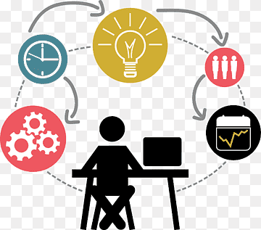

Student Name- Hema Sharma
Student Number- 1812759

Introduction:
Researcher undertook 3000 words report on the Project ‘SAMRA’.
What is a project?
A Project has a specific start date and finish date. It is usually a set of different activities or inputs and outputs that needed to achieve a goal. It can be handled by one person or many, working as a team towards mutual goal. To achieve the success, it should include unique activities, with limitations of cost and time. (Wrik.com, 2020).
Project ‘SAMRA’ (South Asian Muslim Recruitment Agency)
The researcher found that there are not enough Asian Muslim Women are presently working or willing to work in South Wales Police Force. The researcher came up with many barriers which the Asian Muslim women facing, that hinders them to join in. For example, some people from Muslim community think about it as a job that only men can perform, some fears about racism from colleagues and public, fear about wearing hijab, finding hard to get the places to perform prayers etc. (Stone and Tuffin, 2000)

How this project- SAMRA structured?
SAMRA is a recruitment agency which aligns with South Wales Police; thus, the name is South Asian Muslim Recruitment Agency. It was focused to engage with 10 Asian Muslim Women through means and activities, programmes, etc. to encourage and motivate them towards joining in South wales Police job and help to shape their career welfare needs.
Project ‘SAMRA’

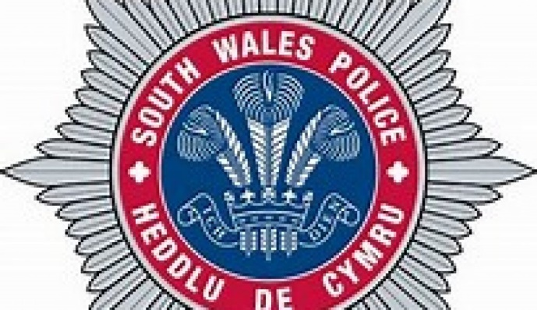

SAMRA’s Goal- Engaging with 10 Muslim Asian Women to recruit in the ‘South Wales Police Force’.
Objectives-
- To assist Asian Muslim Women, towards their welfare needs through recruitment process.
- Enabling a strong support system from recruiting to working, throughout their career development in ‘South Wales Police Force’.
Team- members- Hema, Sofiaya, Rina and Enakshi
Project Duration- 23/10/20-20/11/20
Researcher’s Team-Role- Completer-Finisher
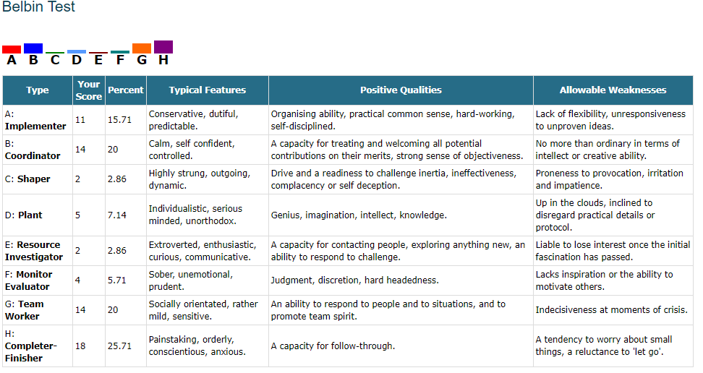
Researcher from the above values assessment test, came up with a weakness, which is- a tendency to worry about small things, a reluctant to let go. This shows a gap and needs to work on it to improve management skills. (Newcastle University, n.d.).

Main Body of the report:
What is a Project Management?
Project Management is the utilisation of skills, tools, techniques, and knowledge to program the activities in such a way to fulfil the project’s required demand. It provides discipline over its four activities, which are- initiating, planning, executing, and controlling to meet the deliverables and achieve its specific goals. (Toolshero.com, 2020)

What is a Project Lifecycle?
It is the sequence of those required activities which are essential for fulfilling the project’s objectives. Every project should go through with the four stages of Project lifecycle, does not matter what the dimensions of the project is- large or small. These phases are:
- Initiation Phase,
- Planning Phase
- Execution Phase
- Monitoring and closing Phase (Guru99.com, 2020)

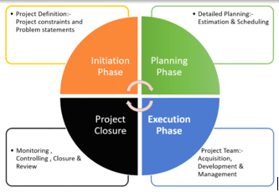
Initiation phase- It represent those procedures that are needed to start a new project. The goal of this phase is to determine what the project should conclude. (Guru99.com, 2020)
This phase mainly contains two main activities- Establish a Project Charter and Identify Stakeholders. These are briefly described down below-

Project Charter-
All the related information should be included in the Project Charter and stakeholder register which includes- Project goals, Stakeholder’s lists, Authorised Project Manager, Project’s pressure and problems, Events, Approvals, Budget, and Agenda. By using this document, manager can fulfil the project by using organisational resources.

Analysing Stakeholders-
It is essential to identify all the stakeholders involved in the project because the project’s success or failure only depends on them. All the stakeholder’s related information should be added in the stakeholders register, for example, description, role, expectation, designation of the stakeholders, type of communications, the influence of the different stakeholders on the project and making sure about projects’ alignment go with the organisation’s objectives.
In relation to SAMRA, the researcher used many tools to explain everything about SAMRA. The first Tool which was used in the project was a Quad Chart.
Quad Chart-
Quad Chart is very effective and simple tool which is mostly a descriptive one-page summary of the Project. It shows all the planning about the project in brief and gives an idea about what you need to do first before you start to work on the project. Basically, it helps to shape the structure of an idea into pieces of work by which it can be easily manageable. It includes four parts- Project Scoping, Stakeholders and stakeholder’s analysis, Desired Outcomes, and measures of Success (Secondary benefits). It provides a brief scenario of a project, across four quadrants in a single PowerPoint slides- thus the name quad. (Chegg.com, 2020)
As per researcher’s view, despite being very useful and enable the stakeholders to simply the summary of the whole information, if the Quad Chart is too long or too detailed then it will be boring and ultimately lose its interest and will be harmful for the success of the project.

What is a Stakeholder?
Researcher suggested that before doing Stakeholders analysis, it is better to understand what is meant by the word- Stakeholder. Stakeholders can be referred as a party who are interested in an organisational activity and have the capability to affect or getting affected by the business. Stakeholders can be divided in Internal and External Stakeholders.

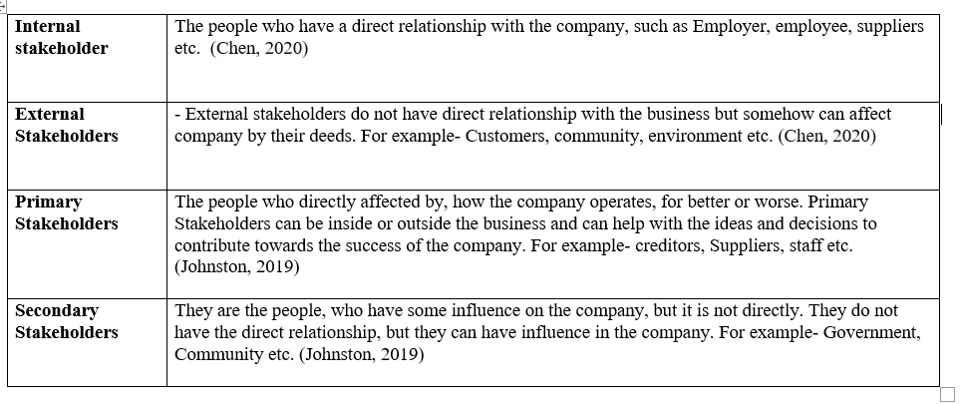

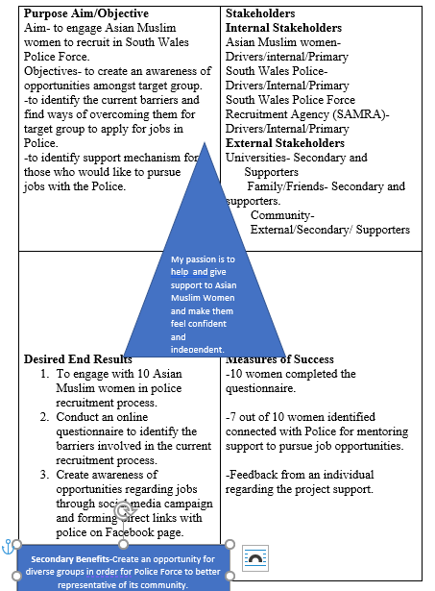
In the above Picture of SAMRA’s Quad Chart, researcher explains about the aim, and objectives of the project SAMRA. The aim is to engage Asian Muslim Women to recruit in South Wales Police Force. The objectives are to know about the barriers they are facing and try to help them to overcome them so that they can join the Police force and also give the support opportunities to those who would like to pursue jobs in the police.
Then researcher explained about the related stakeholders and talked about Internal, external, primary, secondary stakeholders and drives. The researcher explained- Asian Muslim women, South Wales Police and SAMRA as a Drivers/Internal/Primary type of stakeholders and Universities, Family & friends, and Community as Supporters/Secondary/External stakeholders.
In the third box researcher clarifies the desired end results, means the procedures, activities and the research which were undertaken to identify the barriers that stops the Asian Muslim women to join the Police force. The project team delivered an online questionnaires to identify the barriers and to overcome these barriers and performed an awareness program about the police job opportunities through social media campaign and also provide the direct link with police through Facebook page to make it easier.
The fourth box simplifies about the measure of the success of the procedures undertaken, for example, ten women completed survey, 7 women have been connected with the Police to gain mentoring support as an career opportunity and the obtained feedback from the women regarding the support given through project SAMRA.
Researcher talked about the Secondary benefit which will be gained through this project- The project will also create an opportunity for many diverse groups to join the Police force and become better representative for their community and present a good example through that in the future.
The middle Triangle in the Quad Chart represents that the researcher values to provide required help and support to Asian Muslim Women towards their career welfare needs so that they become independent, it seems align with the values of the project, which should be an important necessity for the project delivery.
Why stakeholder’s analysis needed?
It simplifies the interests of the stakeholders towards the problems of the project seeking to address. It shows the conflicts of interests, basically want, and need. It helps to identify the relationship between different stakeholders and provides an overall picture of the project. Hence it is very helpful for building trust, to shape up the project, showing the actions to be taken and helpful to make the project successful, however if not done properly it will ruin all the project strategy as it is the base of the planning phase. (Reqtest.com, 2019)

Priority  H/M/L | Stakeholders | Stakeholders Perspective | Action
High | Asian Muslim Women | They are the main beneficiary from the project towards joining the Police-Force. | Getting help or support from the South Wales Police-Force, through seminars in local Community Hall.  Attending different workshops, before starting to enrol for the Police Force to get an idea about the Police. Getting involved in Communal discussion, advertising in social media, personally contact to increase to increase the knowledge about the Police-Force. A survey was done on 10 women through questionnaire, where it is was noticed that 40% candidate will build the confidence, 10% in need of the job and 20% have barriers about joining in the Police Force.
High | South Wales Police-Force | Recruiting Asian Muslim women in the Police-Force. The Police-Force wants to put an example in front of the local community by changing ideas about the Police. They are committed towards the wellbeing, support of the local community people specially the Asian Muslim women. | Taking part in different seminars and workshops in Universities and Colleges for spreading the supportive ideas of the Police-Force towards the Muslim women. By arranging those in November in Marriot hotel in the town. Giving some leaflet or brochure to give an idea and awareness about the new working culture, changes in the Police-Force. Offering the candidates mentoring support at the recruitment time, so they feel comfortable. Laying total support for the development of the Asian Muslim Women by setting up mentoring support by forming links with Police recruitment advisor and interested participants. Research shows that, for future recruitment drives hijab, as a part of Police uniform will be provided, praying room will also be there as a standard, working hours will also be monitored closely so that child care support can be think of.
Low | University | Can act as the support system to spread the news of recruitment of the Asian Muslim Women in the Police Force. | Advertisement of the recruitment can be done through the student union; representative of the police force can hold seminars to spread the awareness of the recruitment process in the police force in the open days in the university.
Medium | Community | Community can be a great help of creating positive harmony among all the people by spreading the new ideas of the police force for recruiting Asian Muslim Women. | Develop the positive culture through holding regular discussions and workshops, to spread the new changes coming in the Police-Force, holding those seminars in local mosque and Hindu temples. Local communal activities like social gathering, local religious parties, words about the recruitment of the Asian Muslim Women can be spread easily. To provide moral support for the women who wants to join the police as they can be a huge inspiration by spreading the word in the wider community about police Force and how Police can support in the recruitment campaign in different community accessible venues like temple, Mosque etc.
Medium | Friends and families of Asian Muslim Women | Friends and families play an important role in supporting the Muslim women to work in the Police Force. | Families and friends can give them home support so that the Muslim women can do the job with a piece of mind. Families can help the Asian Muslim women to maintain a fine work life balance. Rendering childcare support by the families and friends for the working women can be a great help. Families can contribute by giving inspiration to other members of the family and friend to join in the Police Force.

In the above, shows who are the stakeholders, their priority level and how different stakeholders’ impact on the project which shows through medium, low, or high options. In this analysis it shows, Asian Muslim women and South Wales Police force are on High category, Community and friends are on medium and University is on low category. The last section explains the action, the contributions from different stakeholders, how they are important and what they are going to contribute to fulfil the project, for example South Wales police can contribute through providing mentoring support through contacting the Asian Muslim women through engaging with them through the meetings and scheduled online support program by using Microsoft Teams, Skype. The project team member will keep on contacting the interested women through e mails and messages and will sends direct links of the Police office on their Facebook account. The team members of SAMRA will be forwarding the names of the interested Muslim women who wants to pursue the career at Police Force, through the email address of the Super attendant of the South Wales Police - ‘Ifan Charles’. Email address is: ifan.charles@dyfed-powys.pnn.police.uk

Project Planning Stage-

It is the second phase of Project life cycle, which defines the scope and objectives of the project, derived by the product of the initiation stage. Plan should be always revised in planning phase before entering the next phase which is an execution phase.

Work Breakdown Structure-
In this phase researcher presents WBS which is Work Breakdown Structure. It involves the list of all the activities and their allocated time planned by the project team in a hierarchical way of deliverables and sub deliverables. (Guru99.com, 2020)
It can be simplified by the two types- Deliverable- based and Phase based, but the most common way is Deliverable way.
Down- below the researcher shows SAMRA’s WBS.

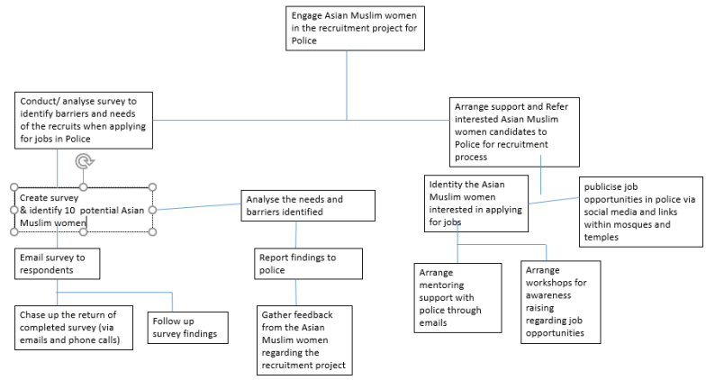
In the above picture researcher broke-down all the activities into deliverables and sub deliverables. For example, first the project team engaged with Asian Muslim Women in the recruitment project for Police, and then divided the tasks in two parts, which is conducting a survey for identifying the barriers to join in the Police force and arranging the support and referring the interested candidates to Police for the further recruitment process. Then the first deliverable divided into further two sub deliverables- create survey and identifying 10 Muslim Women and identifying the barriers and desired needs etc.
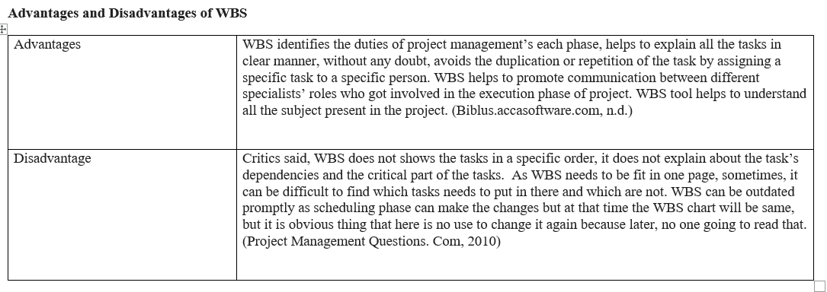

Gantt Chart-
A Gantt Chart is an important graphical tool, showing the activities and tasks executed against time. It helps to understand easily and interpret the activities and tasks. (The Economic Times, 2020).
Gantt Chart is very useful tool for scheduling, planning, and keeping the management aware about the finishing time of a project. By using this tool, we can find out the dependencies and required additional resources. (The Economic Times, 2020).

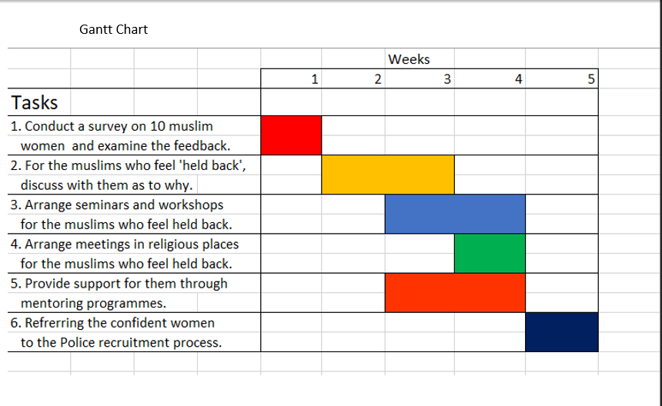

The researcher conducted a Gantt Chart which is showing the activities that needs to be performed on the left side and the assigned time-period for that individual activity on the right side. Some tasks can be seen overlapping, means they took more than a week to complete. Some activities cannot start before finishing of the first one, but some activities can go with other activity.
Advantages and disadvantages of a Gantt Chart
It helps to understand the team members about the objectives, activities, their time, and progress of the project even if they are not directly involved. It helps to set the time for each activity. It is complex to look at but easy to understand. However, due to its complexity sometime its harder to manage for the bigger projects as they having a large number of activities and human resources, and software involved in it and if they don’t hire more than two skilled people than it cannot be successful. Another criticism is that Gantt chart does not show the amount of work, but only shows the time which each activity has undertaken to finish. Sometimes the things changed, and the time of each activity can be changed and if the Gantt Chart does not update regularly it can create a problem for the project. (Project Management.com, 2018).
Another Tool is a Network Diagram
Network diagram-
It is a graphical image of all the activities, tasks and responsibilities for a project showing by the series of boxes and arrows. It shows the work sequence, schedule, progress of each task and completion of the tasks. As it is showing every single task and its outcome, it also displays the scope of a project. A Network diagram shows the dependencies between the tasks and the order in which tasks will be executed. It acquiesces us to transform one of the variables and see what affect it has on the whole project. (Wrike.com, 2020).
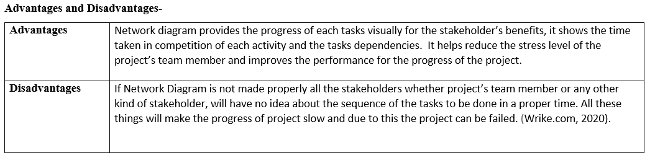
SAMRA’s Network Diagram-

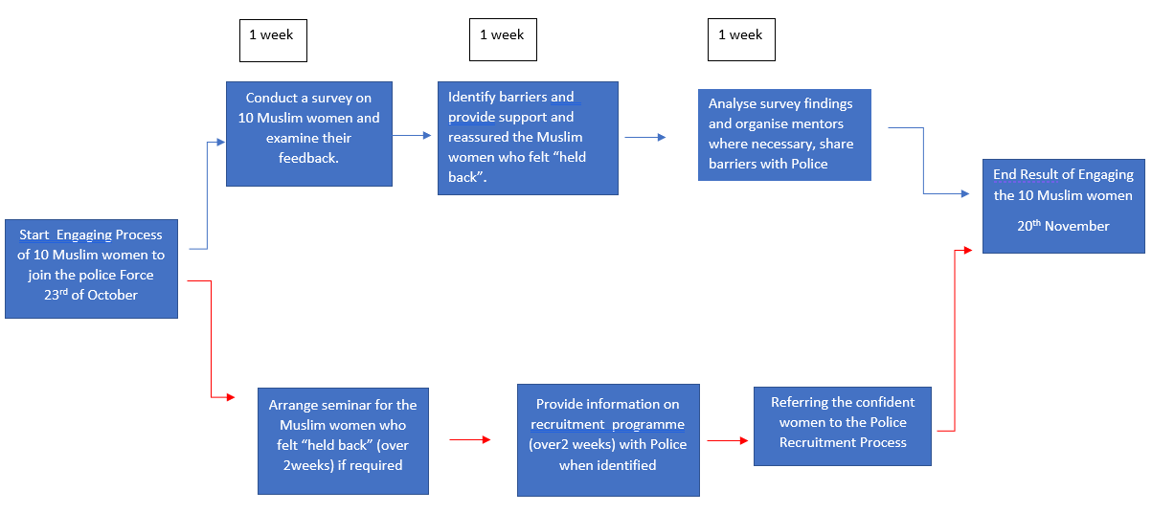

Critical Path of SAMRA’s Network diagram-
All the sequences of activities that took the longest time to finish, can be referred as a critical Path. Those activities that took more than 2 weeks to finish for example, Seminars for the Muslim women took more than 2 weeks. After this, the information on recruitment program in the Police force being provided to the related Muslim women which also took more than 2 weeks hence shows the critical path of SAMRA and can be shown by the red arrows.

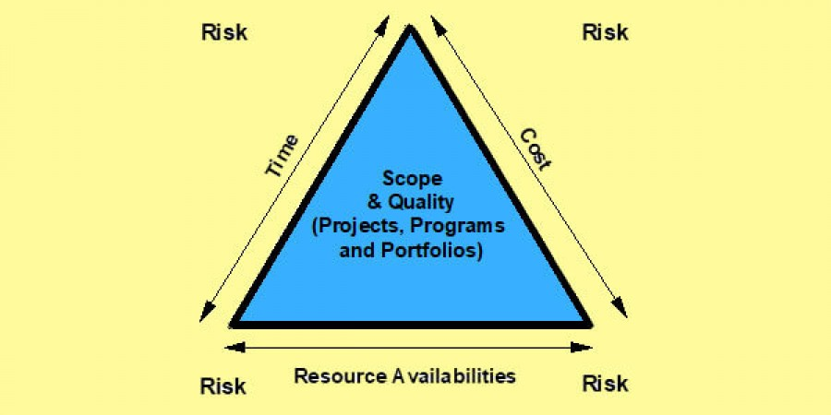
Iron Triangle
The iron triangle explains about the triple necessities of the project management, these are Time, Cost and Quality. (Villanova University, 2019)
In Project SAMRA’s case by looking at the Network diagram some activities took more than 2 weeks to complete, so the scope should be reduced to finish the project in time or cost or budget needs to be increased by including more people. Down below shows Iron Triangle of the Project-SAMRA
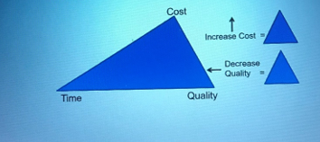

What is a Risk Analysis Grid?
Risk analysis Grid is a tool to identify the factors that could affect negatively on the success of a business or project. By using this tool, the organisations risks can be examined, and organisation can decide whether to take that decision or not. It also helps to makes an organisation to think about how to deal with that risk. (Mindtools.com, n.d.)

SAMRA’s Risk-Analysis Grid-
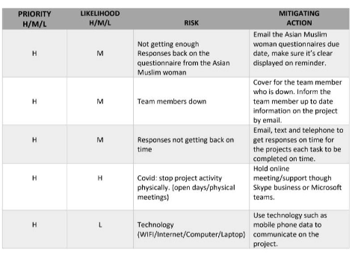
Regarding the Project ‘SAMRA’ the researcher talked through about the four important areas, which are- Risk, their likelihood, the priority level, and actions for mitigate those risks. The researcher here simplifies about the one risk from the above five types of risks, which is not getting enough responses back from the Asian Muslim women, so the likelihood about this is medium and the priority level is high because the Muslim women are the main stakeholder of the project. To mitigate the risk, the reminders is been sent regularly to the Asian Muslim women, about the due date of the feedbacks.
The importance of SWOT and PESTLE Analysis-
SWOT and PESTLE analysis helps to find out the likely threats for project and helps to mitigate them. It helps to know the Pros and cons of the project’s plans. (Woodruff, 2019).

The link between Risk Analysis and the elements of SWOT.
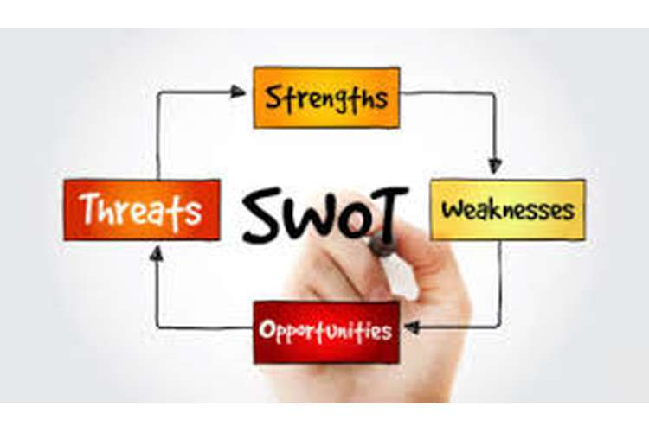
Researcher as a Project Manager, can link the above Risk Analysis with the elements of SWOT through some of the examples, in SAMRA’s context one of the Risk measured is Covid-19 situation which has a great impact on SAMRA’s activities which were decided to do physically to engage and motivate the Muslim women to pursue Police job as a career, through meeting, seminars, programs, workshops etc. Pandemic situation came up as a weakness for SAMRA, as showing the lack of physical contact and discussions but on the other side it turns up as a strength because the project team found a solution by keep in touch with its stakeholders digitally through Microsoft Teams, Skype, emails. The Team member can see as an opportunity to develop their digital skills which will be beneficial for them in present and in future, moreover the Muslim women can attend those meetings and programs while just sitting at home and can look after their family members. In the context of threat, researcher simplified that the weaknesses because of COVID-19 can be turned as a threat if the project related activities cannot be done digitally, in that case the project can face failure.
The link between Risk Analysis and the elements of the PESTLE
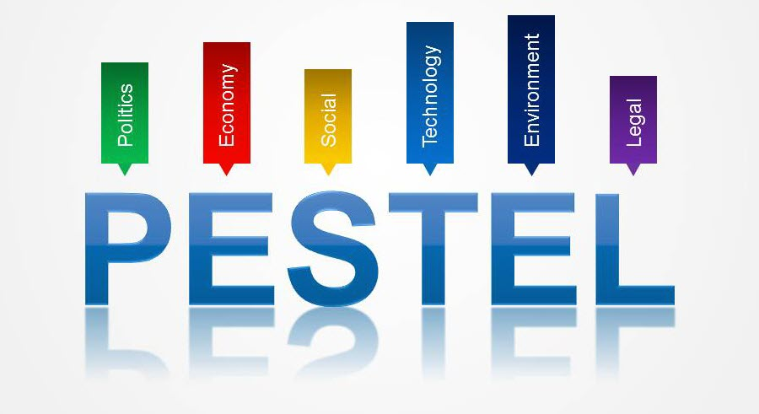
Social- Because of current pandemic Project SAMRA must work through all its activities and engage with its internal and external stakeholders virtually instead of physically. For example, Asian Muslim women could not attend the workshops, meeting physically which ultimately impact the project.
Technology- It is an essential part of the discussion, especially in this current situation of Covid-19, in Project SAMRA’s case the team member couldn’t interact physically with their stakeholders and used technology to meet each other through online, for example- Microsoft teams, skype, mobile phone, email etc.

Iron Triangle
The iron triangle explains about the triple necessities of the project management, these are Time, Cost and Quality. (Villanova University, 2019)
In Project SAMRA’s case by looking at the Network diagram some activities took more than 2 weeks to complete, so the scope should be reduced to finish the project in time or cost or budget needs to be increased by including more people. Down below shows Iron Triangle of the Project-SAMRA

Link with the Iron Triangle-
The researcher further linked some of the risks and linked them with the Iron Triangle. For example, if the project team could not get enough feedback of the questionnaires from the Asian Muslim women, then all the set activities will be delayed. Another example could be if one of team member is affected by the illness then it will be lack of human resources and ultimately need to increase the time of the project to balance the Iron Triangle.
Evaluation Phase
Evaluation phase is the last and important phase of Project Lifecycle, which basically shows the collected data and reveal the efficiency and effectiveness of the project delivered. This process is very important to keep the project in track and it helps to inform the related stakeholders about the progress of the project. (Landau, 2018)
It basically helps to find out what went wrong, what went good, what can we do differently, did we delivered the project in time and many more like, it presents an overview of the whole project and gives an idea how to improve in future by taking valuable experiences which we gain after completion of the project.
Project evaluation helps to perform a rigorous analysis about the projects aims, activities, objectives and helps to find out whether the project is successful to deliver the benefits which were expected, produced planned results and desired changes or outcome after the completion of project. (My Management Guide.com, 2011).
SAMRA’s Mid- Review
Regarding the project SAMRA, which is basically an organisation that alliance with the South Wales & Powys Police and its aims is to engage10 Asian Muslim women to join the Police Force by 2021 and aims to assist and provide the support to these women during their recruitment process, support their religious and welfare needs . Asian Muslim women have many barriers in accordance to join the Police Force which the researcher mentioned above, which tried to overcome through 5 week’s engagement process. Project team members sent 16 questionnaires to the identified Asian Muslim Women, only 10 replied back and only 6 women responded positively towards join in the Police Force and therefore the team got only 7.9% women seems engaging into joining the Police Force. Project SAMRA faced many barriers, for example-lack of face to face interactions due to COVID-19, lack of adequate trainings of the team members, lack of strategic planning, lack of human resources etc. SAMRA used many Tools to achieve the success, for example, Quad Chart, Stakeholders Analysis, WBS, Gant Chart etc. SAMRA didn’t affected by the delays, cost creep or any other factor but the major factor that affected the Project is COVID-19 situation and its restrictions in regard to the performance of tasks deliveries for the health and safety issues.
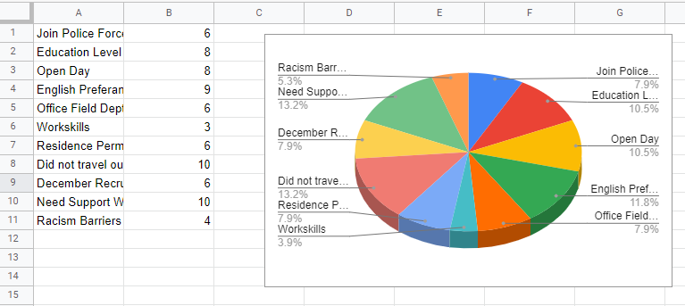
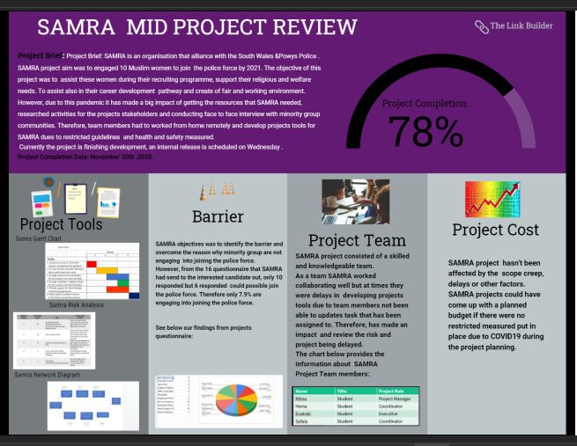

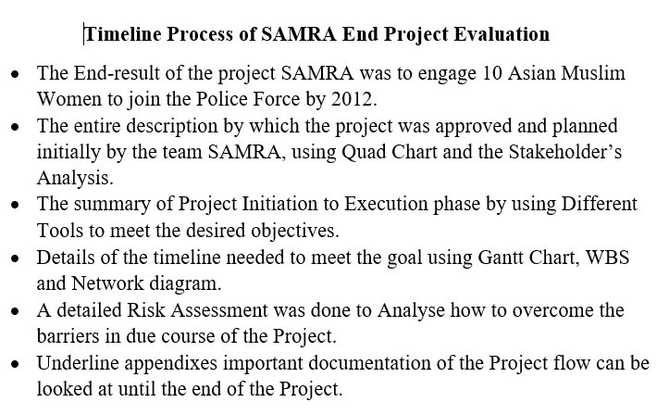

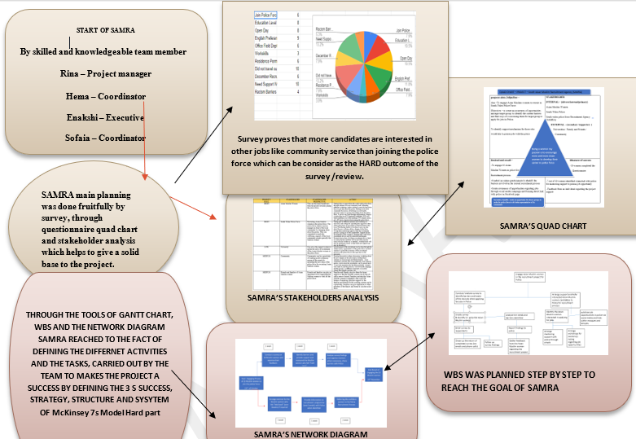
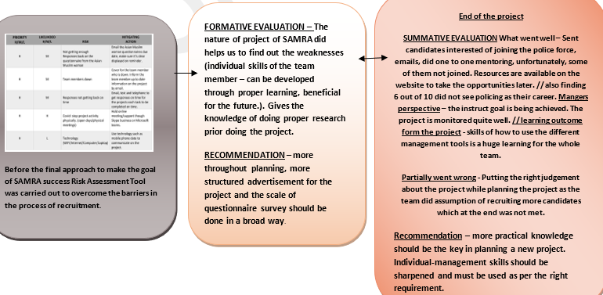
End- Review of the Project- SAMRA
Evaluation Phase provide the list of completed tasks or deliverables, it explains that the objectives and the end- user approval has been done. (USQ, n.d.)
SAMRA’s achieved a success in the main planning about to start a Project, putting skilled team members, doing a survey through questionnaire, create a Quad-Chart and Stakeholder analysis. The result gained proved that most of the candidates preferred community service job rather than the field job in Police field. SAMRA’s team member than executed the Stakeholder analysis to analyse-who are the stakeholders, their priority level and how different stakeholders’ impact on the project’s delivery and success. Quad Chart was done beautifully to explain about the purpose, aims and objectives, who are SAMRA’s internal, external stakeholder, who are drivers, who are primary and secondary stakeholders and what is the desired end result, what is the measures of success, how each team member can relate own values with SAMRA’s values and what are the Secondary benefits of the project. BY using Tools like Gantt Chart, Network diagram and WBS, researcher concluded that each task was defined and executed successfully with a proper time-restrictions and step by step, in which Mckinsey 7s Model’s hard part was used. Risk Analysis Grid was very useful to identify the Risks, their likelihood, the priority level, and required actions for mitigate those risks.
SAMRA’s team played very nicely with collaboration with each other virtually, many communication sources been used, for example- emails, Skype, Microsoft Teams to discuss each activity.

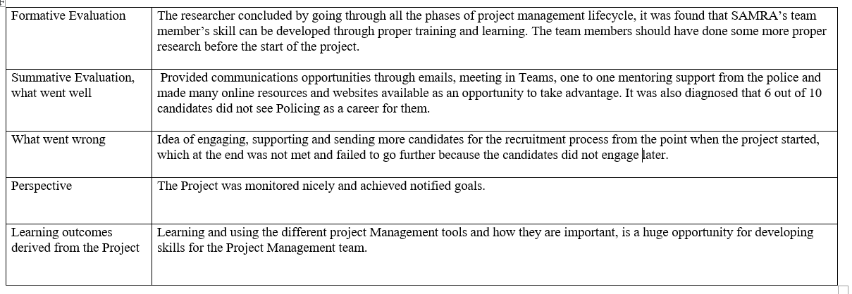

Recommendations- Team member’s Project managements skills should be acuminate with more trainings and should be used accordingly because Project’s success is depending on constantly improving practical knowledge.
It’s always important to recognise and appreciate team’s effort even if the Project takes the time more than expected or produce less favourable results because by doing the evaluation phase brings better outcomes for the future and it’s a great way of learning by knowing the reason for the failure and improve them in future to get best results. (Harvard Business Review, 2016).
Needs to accommodate more human resources as if someone got ill the other one can cover it.
Needs to conduct face to face meeting while having Seminars, Mentoring program as it will improve communication with the candidates, which in SAMRA’s case could not possible because of the COVID-19.
If the project’s tasks taking more time then, scope should be reduced to finish the project in time or cost (budget) needs to be increased by hiring more people.

To make the project successful the project’s 7 values (Strategy, Structure, Staff, Skills, Shared values, Systems and Style) should be aligned to each other and with the team members.
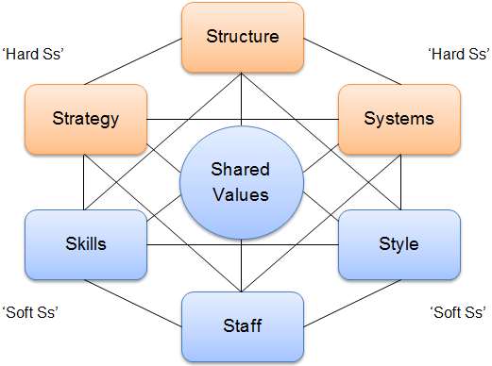
According to Mcnsey 7s Model, for the further improvement in the Project management, every team member needs to identify the area that do not have an alignment and try fill this gap with required changes in the management and in an individual’s skills through trainings etc. (Jurevicius, 2013)

.

References-
Biblus.accasoftware.com (n.d.). Functions and Advantages of Work Breakdown Structure (WBS) [Online] Available at: https://biblus.accasoftware.com/en/functions-and-advantages-of-work-breakdown-structure-wbs/ (Accessed: 2 December 2020)
Chegg.com (2020). What is a Quad chart? [Online] Available: https://www.chegg.com/homework-help/questions-and-answers/quad-chart-quad-chart-one-page-summary-project-visual-well-descriptive-simple-tool-extreme-q25204961 (Accessed: 29 October 2020)
Chen, J. (2020). What is a Stakeholder? [Online] Available: https://www.investopedia.com/terms/s/stakeholder.asp (Accessed: 29 October 2020)
Guru99.com (2020). Phases of Project Management Life Cycle [Online] Available at: https://www.guru99.com/initiation-phase-project-management-life-cycle.html (Accessed: 18 October 2020)
Harvard Business Review (2016). The Four Phases of Project Management [Online] Available at: https://hbr.org/2016/11/the-four-phases-of-project-management (Accessed: 3 December 2020)
Johnston, K. (2019). The Difference Between Primary and Secondary Stakeholders [Online] Available: https://bizfluent.com/facts-7267188-difference-between-primary-secondary-stakeholders.html (Accessed: 29 October 2020)
Jurevicius, O. (2013). Mckinsey 7s Model [Online] Available at: https://strategicmanagementinsight.com/tools/mckinsey-7s-model-framework.html (Accessed: 3 December 2020)
Mindtools.com (n.d.). Risk Analysis and Risk Management: Evaluating and Managing Risks[Online] Available: https://www.mindtools.com/pages/article/newTMC_07.htm (Accessed: 7 November 2020)
Newcastle University (n.d.). Faculty of Science, Agriculture & Engineering [Online] Available at: https://www.ncl.ac.uk/sage.cpd/belbin/index.php (Accessed: 20 October 2020)
Project Management.com (2018). Advantages and Disadvantages of Gantt Charts [Online] Available At: https://project-management.com/advantages-and-disadvantages-of-gantt-charts/ (Accessed: 30 November 2020)
Project Management Questions. Com (2010). Project Management Questions [Online] Available at: https://www.projectmanagementquestions.com/1266/what-are-the-disadvantages-of-wbs (Accessed: 2 December 2020)
Reqtest.com (2019). Why do you need to perform a Stakeholder Analysis? [Online] Available at: https://reqtest.com/requirements-blog/why-you-need-to-perform-stakeholder-analysis/ (Accessed: 30 November 2020)
Stone, V. and Tuffin, R. (2000). Attitudes of People from Minority Ethnic Communities towards a Career in the Police Service [Online] Available at: http://library.college.police.uk/docs/hopolicers/prs136.pdf (Accessed: 19 October 2020).
Taylor, A. (2020). The Quadrant experiment: How Stephen Covey helped organize my day. [Online] Available at: https://www.ruby.com/the-quadrant-experiment-how-stephen-covey-helped-organize-my-day/ (Accessed: 1 December 2020)
The Economic Times (2020). Definition of Gantt Chart [Online] Available: https://economictimes.indiatimes.com/definition/gantt-chart (Accessed: 2 November 2020)
Toolshero.com (2020). Project Management [Online] Available: https://www.toolshero.com/project-management/ (Accessed: 25 November 2020)
USQ (n.d.). Project Management Course [Online] Available at: https://open.usq.edu.au/mod/book/view.php?id=5737&chapterid=417 (Accessed: 3 December)
Villanova University (2019). How to Maximise project Quality with the Iron triangle of Project management [Online] Available at: https://www.villanovau.com/resources/project-management/iron-triangle-project-management/ (Accessed: 30 November 2020)
Wrik.com (2020). What is a Project in Project Management? [Online] Available: https://www.wrike.com/project-management-guide/faq/what-is-a-project-in-project-management/ (Accessed: 23 November 2020)
Wrike.com (2020). What is a Network Diagram in Project Management? [Online] Available: https://www.wrike.com/project-management-guide/faq/what-is-a-network-diagram-in-project-management/ (Accessed: 7 November 2020)

