4/27/2026
Network and Cyber Security Essentials


Lecturer’s Name: Dr Kwame Assa-Agyei
Student Name: Giuseppe Palumbo
Student Number: 2335642
Module: ACCA4024

Table of Contents
Cybersecurity Policy Development for HealthPlus Analytics 1
Abstract 1
Introduction 2
Identification of Modern Threats 3
Modern Security Policies 5
Technical Mitigation Measures 8
Proactive Monitoring and Incident Response 9
Continuous Training and Awareness 13
Conclusion 14
References 15
Appendix A: Screenshot of the Board of Directors PowerPoint presentation 16

Cybersecurity Policy Development for HealthPlus Analytics

Abstract

Cybersecurity is a critical concern for organizations that manage sensitive data, particularly within the healthcare sector. HealthPlus Analytics (HPA), a data-driven healthcare technology company, processes and stores confidential patient information, making it a prime target for cyber threats. The increasing sophistication of cyberattacks, combined with the widespread use of personal devices and hybrid working environments, has significantly increased the organization’s risk exposure. Recent incidents, including ransomware attacks and unauthorized access to cloud-based systems, highlight weaknesses in HPA’s current cybersecurity posture.
This report presents a comprehensive data security and governance framework aimed at strengthening HPA’s defenses. It identifies both internal and external threats, proposes security policies aligned with recognized frameworks such as ISO 27001 and NIST, and outlines practical mitigation strategies. Additionally, the report includes a structured monitoring and incident response plan, along with a continuous training program to improve staff awareness. These measures will help ensure compliance with UK GDPR and NHS Digital Security Standards while protecting the confidentiality, integrity, and availability of sensitive data [3], [4].

Introduction
In today’s digital environment, cybersecurity plays a vital role in protecting organizational systems and sensitive data. HealthPlus Analytics (HPA) operates in the healthcare sector, where the protection of patient data is not only a legal requirement but also an ethical responsibility. Due to the high value of healthcare data, cybercriminals frequently target such organizations using advanced attack techniques.
The recent increase in remote and hybrid working has introduced additional vulnerabilities, particularly through the use of personal devices and unsecured networks. Employees accessing company systems from various locations increases the attack surface, making it more difficult for IT teams to maintain control over data security. Furthermore, regulatory frameworks such as the UK General Data Protection Regulation (GDPR) and NHS Digital Security Standards require organizations to implement strict data protection measures and report any breaches promptly [3], [4].
This report aims to develop a robust cybersecurity framework for HPA by identifying key threats, implementing effective security policies, and proposing practical solutions to mitigate risks. The framework is aligned with industry standards such as ISO/IEC 27001 and the NIST Cybersecurity Framework, ensuring that HPA adopts globally recognized best practices [1], [2].

Identification of Modern Threats

HPA faces a wide range of cybersecurity threats that can compromise the confidentiality, integrity, and availability (CIA Triad) of its data and systems.

External Threats

Ransomware Attacks
Ransomware remains one of the most significant threats to healthcare organizations. Attackers encrypt critical systems and demand payment to restore access. These attacks can halt operations and lead to data loss, significantly impacting availability and business continuity [5]. For example, several NHS organizations have previously been affected by ransomware incidents, demonstrating the severity of such threats.

Phishing and Social Engineering
Phishing attacks involve fraudulent emails designed to trick employees into revealing sensitive information such as login credentials. These attacks exploit human behaviour rather than technical vulnerabilities and are increasingly sophisticated [6].

Cloud Security Breaches
As HPA relies on cloud services for data storage, misconfigurations or weak access controls can lead to unauthorized access. Cloud breaches often result in large-scale data leaks.

Malware and Spyware
Malicious software can infiltrate systems through downloads or email attachments, leading to data theft or system damage.

Distributed Denial of Service (DDoS) Attacks
DDoS attacks overwhelm systems with traffic, making services unavailable to legitimate users.

Internal Threats

Employee Negligence
Employees may unintentionally compromise security through poor password practices or failure to recognize phishing attempts.

Insider Threats
Disgruntled employees or contractors may intentionally misuse their access to steal or leak sensitive information.

BYOD Risks (Bring Your Own Device)
Personal devices often lack adequate security controls, making them vulnerable entry points for attackers.

Poor Access Control
Excessive permissions increase the likelihood of unauthorized access to sensitive data.

CIA Triad Impact
- Confidentiality: Unauthorized disclosure of patient data
- Integrity: Data alteration or corruption
- Availability: System downtime due to cyberattacks

Maintaining the CIA Triad is essential for ensuring data security and compliance with regulations.

Modern Security Policies

To address these threats, HPA must implement robust security policies aligned with ISO 27001 and NIST standards [1], [2].

Access Control Policy
HPA should implement Role-Based Access Control (RBAC) to ensure employees only access data necessary for their roles. The principle of least privilege must be enforced to minimize risk.

Data Protection Policy
All sensitive data must be encrypted both at rest and in transit. This policy ensures compliance with UK GDPR requirements, which mandate the protection of personal data [3]

BYOD Policy
A strict BYOD policy should be implemented, requiring:
- Device registration
- Security check before access
- Installation of Mobile Device Management software

Authentication Policy

Strong password policies combined with Multi-Factor Authentication (MFA) significantly reduce unauthorized access risks.

Incident Response Policy

A formal incident response policy ensures that all security incidents are handled systematically and efficiently.

Backup and Recovery Policy

Regular automated backups must be performed and stored securely. This ensures business continuity in the event of ransomware attacks [5].

Technical Mitigation Measures

Multi-factor Authentication (MFA)
MFA requires users to provide multiple forms of verification, significantly reducing the risk of unauthorized access.

Encryption

Encryption technologies such as AES-256 should be used to protect sensitive data, which is a fundamental concept in modern computer security practices [1], [7]. Secure communication protocols like TLS should be implemented to protect data in transit.

Network Security Controls

Firewalls, intrusion detection systems (IDS), and intrusion prevention systems (IPS) should be deployed to monitor and control network traffic.

Endpoint Security

All endpoints must be secured with antivirus software, regular updates, and patch management systems.

Cloud Security Measures

Cloud systems must be regularly audited to ensure proper configuration and access control.

Backup and Recovery Implementation

Daily backups should be performed and tested regularly to ensure quick recovery in case of incidents [5].

Proactive Monitoring and Incident Response

Monitory Strategy
HPA should implement a Security Information and Event Management (SIEM) system to monitor network activity in real time. SIEM tools collect and analyse logs to detect suspicious behavior.

Incident Response Process

HealthPlus Analytics must follow a structured incident response process to manage cybersecurity incidents effectively. A clear incident response process helps the organization identify, contain, and recover from threats quickly while minimizing damage to systems and sensitive patient data. The flowchart below illustrates the step-by-step process that should be followed when a security incident occurs, aligned with the NIST Cybersecurity Framework [2].

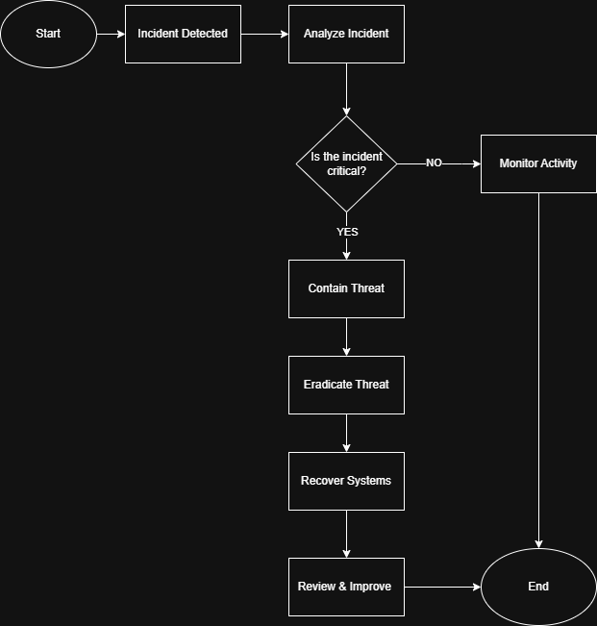
Figure 1: Incident Response Flowchart for HealthPlus Analytics

Flowchart Explanation

Step 1: Incident Detected
The process begins when a security incident is identified through monitoring tools, security alerts, or employee reports. Examples include suspicious login attempts, malware detection, or unauthorized access to patient records.
Step 2: Analize Incident
The IT security team analyses the incident to determine its source, impact, and severity. This helps identify whether sensitive patient data is at risk and what systems are affected.
Step 3: Decision- Is this Incident Critical?
At this stage, the organization decides whether the incident is critical. If the incident poses a serious risk, immediate action is taken. If not, the incident continues to be monitored.
Step 4: Monitor Activity (If Not Critical)
If the incident is not critical, the security team monitors the system for any unusual activity or escalation. This helps ensure that minor incidents do not develop into serious threats.
Step 5: Contain Threat (If Critical)
If the incident is critical, affected systems are isolated to prevent the threat from spreading. This may involve disconnecting systems or restricting access.
Step 6: Eradicate Threat
After containment, the root cause of the incident is removed. This includes deleting malware, closing vulnerabilities, and disabling compromised accounts.
Step 7: Recover Systems
Systems and data are restored using secure backups and tested to ensure they are functioning correctly.
Step 8: Review and Improve
The final stage involves reviewing the incident, documenting lessons learned, and improving security controls to prevent similar incidents in the future.

A structured approach ensures rapid response and minimizes damage [2].
Role and Responsibilities

- IT Security team: Handle technical response
- Management: Decision making and reporting
- Employees: Report suspicious activity

Communication Plan

All incidents must be reported in compliance with GDPR breach notification requirements [3].

Continuous Training and Awareness

Training Programm
HPA should implement a structured training program including:

- Induction training for new employees
- Quarterly workshop
- Phishing simulation exercises

Key Training Areas

- Identifying phishing attacks
- Secure password practices
- Safe use of devices
- Data protection responsibilities

Evaluation of Training

Regular assessments and simulations should be conducted to measure employee awareness and improve training effectiveness.

Benefit of Training

Effective training reduces human error, which is one of the leading causes of data breaches [5], and is supported by fundamental principles of computer security awareness [7].

Conclusion

Cybersecurity is a critical requirement for HealthPlus Analytics due to the sensitive nature of healthcare data. The organization faces numerous internal and external threats that can compromise data security and regulatory compliance.
This report has presented a comprehensive framework that includes threat identification, security policies, mitigation strategies, and incident response planning. By aligning with industry standards such as ISO 27001 and NIST, HPA can ensure a strong security posture [1], [2]. Furthermore, continuous staff training enhances awareness and reduces the likelihood of human error.
By implementing these recommendations, HPA will be better equipped to protect patient data, maintain compliance with UK GDPR, and strengthen its overall cybersecurity resilience [3], [4].

References

[1] S. Watkins, ISO/IEC 27001:2022 - An introduction to information security and the ISMS standard. IT Governance Ltd, 2022.
[2] NIST, “The NIST cybersecurity framework (CSF) 2.0,” The NIST Cybersecurity Framework (CSF) 2.0, vol. 2.0, no. 29, Feb. 2024, doi: Available at: https://doi.org/10.6028/nist.cswp.29
Accessed: 21/4/2026

[3] ICO, “UK GDPR Guidance and Resources,” ico.org.uk, 2023. Available at:
https://ico.org.uk/for-organisations/uk-gdpr-guidance-and-resources/
Accessed: 21/4/2026

[4] NHS England, “Data Security and Protection Toolkit,” Dsptoolkit.nhs.uk, Available at: https://www.dsptoolkit.nhs.uk/
Accessed: 21/4/2026
[5] Verizon, “2025 Data Breach Investigations Report,” Verizon Business, 2025. Available at
https://www.verizon.com/business/resources/reports/dbir/
Accessed: 21/4/2026
[6] ENISA, “ENISA Threat Landscape 2023,” ENISA, Oct. 19, 2023. https://www.enisa.europa.eu/publications/enisa-threat-landscape-2023
Accessed: 27/4/2026

[7] M. Bishop, Computer security: art and science. Boston, Mass.; London: Addison-Wesley, 2003.

Appendix A: Screenshot of the Board of Directors PowerPoint presentation



