Worksheet: Application Gateway Path Routing
In this worksheet, you will create an application gateway using path routing. You will create three backend pools for VMs for the default URL “/*”, “/sales/*” and “/orders/*”. Since this a demo, we will just create one VM for each of these pools all running the Nginx web server.
IMPORTANT: Where you see angle brackets < >, this represents a value that you must provide yourself. For example, <YOUR_RESOURCE_GP> requires you to enter an appropriate resource group name of your choice. Unless otherwise stated, these are the names that should be given to a resource or the name of an existing resource that you have already created.
Values not in brackets represent names of resources that you have already created or you should already know, so use the corresponding name for that resource. For example, YOUR_RESOURCE_GP means that you have already created a resource group and you should provide the name of this resource group here.

Only do this once……
If this if the first time you are using Azure, then setup your subscription details as the default so that you do not need to enter them whenever you wish to execute a command.
az account list -o table
az account set --subscription YOUR_SUBSCRIPTION_ID

Once you have set the default subscription, there is no need to repeat this process ever again!!

Resource Group
Before creating any resources, you must create a resource that can contain those resources. For student Azure accounts your location is “uksouth”. Choose an appropriate resource group name.
# create resource group
az group create --name <YOUR_RESOURCE_GP> --location YOUR_LOCATION

You can list resource groups:
# List all the resource groups
az group list -o table
az group list -o table --query "[?location=='ukwest'].name"

Identify a suitable size VM you can use and a suitable Ubuntu image
You will need a larger VM size for this exercise, as an example “Standard_DS1_v2”. Also look for an Ubuntu image that you can use, starts with “Ubuntu” such as “Ubuntu2204”. Remember these names because we will use them later for UBUNTU_IMAGE and VM_SIZE.
# List available VM sizes at given location
az vm list-sizes --location YOUR_LOCATION --output table|more

# List the available images at the given location
az vm image list --query "[].{Alias:urnAlias,Version:version}" --output table

Create the Virtual Network and a second subnet
The application gateway must be connected to its own subnet separate from that of the VMs. We will use the default subnet that is automatically created for the gateway and create a second subnet ourselves.
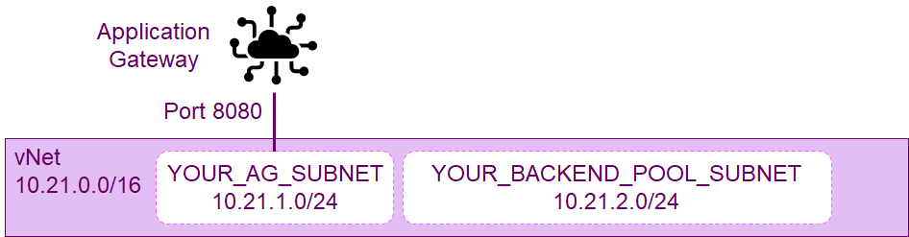
# Create a virtual network with a default subnet
# We will use this subnet for the application gateway
az network vnet create --name <YOUR_VNET> --resource-group YOUR_RESOURCE_GP --location YOUR_LOCATION --address-prefix 10.21.0.0/16 --subnet-name <YOUR_AG_SUBNET> --subnet-prefix 10.21.1.0/24

# Create a second subnet for our backend pool of VMs
az network vnet subnet create --name <YOUR_BACKEND_POOL_SUBNET> --resource-group YUR_RESOURCE_GP --vnet-name YOUR_VNET --address-prefix 10.21.2.0/24

# Display the virtual networks in our resource group
az network vnet list --resource-group YOUR_RESOURCE_GP --output table

I have provided some IP addresses for you in the range 10.21.x.x.

Create three VMs
To demonstrate path routing, we will create three separate VMs one for each pool we will create. In reality, you would setup a VM Scale Set that could scale up and down the number of VMs required as the demand changes.
We will use a VM extension to install the Nginx web server.
Repeat this three times to create three VMs.
az vm create --resource-group YOUR_RESOUCE_GP --name <YOUR_VM> --size VM_SIZE --image UBUNTUiMAGE --admin-username azureuser --generate-ssh-keys --vnet-name YOUR_VNET --subnet YOUR_BACKEND_POOL_SUBNET --public-ip-address ""
az vm extension set --resource-group YOUR_RESOURCE_GP --vm-name YOUR_VM --publisher Microsoft.Azure.Extensions --name CustomScript --version 2.0 --settings '{"fileUris":["https://raw.githubusercontent.com/Azure-Samples/compute-automation-configurations/master/automate_nginx.sh"], "commandToExecute":"./automate_nginx.sh"}'

REPEAT THIS TO CREATE THREE VMs

Create a Public IP Address
To allow our Gateway to be seen over the Internet, we must create a public IP address that acts as the front end for our applications. Interesting, this is a separate entity and we are charged a nominal fee for creating one. We will make it “Static” so that it does not change which make sense otherwise we would have to look it up each time we wanted use it.
The idea is that we can offer multiple different applications that can all be reached through this one gateway, with the same public IP address but using the URL to identify the application to which the traffic should be forwarded.
# Create a public IP address. This actually separate Azure resource and incurs a small cost
az network public-ip create --resource-group YOUR_RESOURCE_GP --name <YOUR_AG_PUBLIC_IP> --allocation-method Static --sku Standard

Create the Application Gateway
We create the application gateway, this also automatically sets:
- the frontend-port, which is the port at which incoming traffic to the gateway will be received
- a HttpSettings object which defines how the traffic should be routed (forwarded) to the backend pool. In our case, the traffic is forwarded to a VM (by IP address) in a backend pool using the Http protocol to port 80. The content of the incoming traffic is forwarded in a new packet using the IP address of the VM with the protocol and port number we configured in these settings.
- a default request routing rule "rule1" which we give a priority 10, that allows us to configure how the traffic is forwarded from the listener to the backend pools.
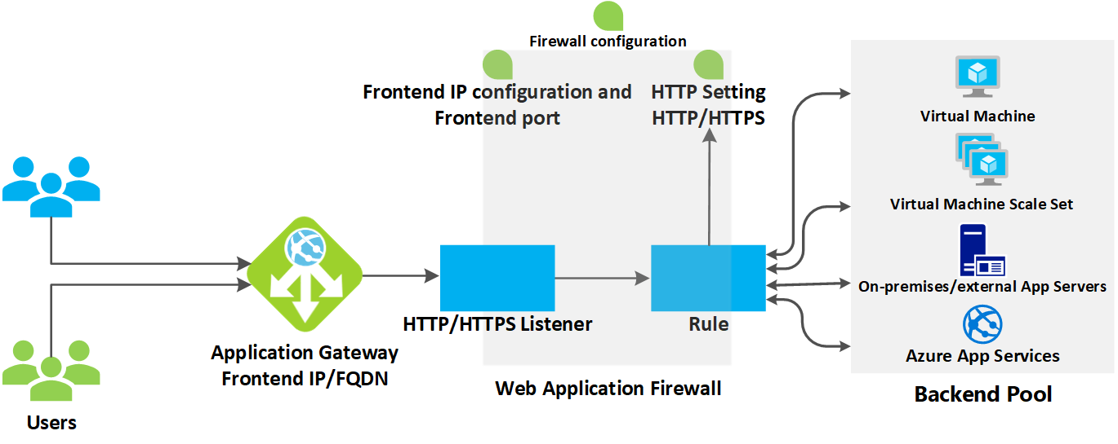

# Create the Application Gateway
az network application-gateway create --name <YOUR_APP_GATEWAY> --location YOUR_LOCATION --resource-group YOUR_RESOURCE_GP --sku Standard_v2 --public-ip-address YOUR_AG_PUBLIC_IP --vnet-name YOUR_VNET --subnet YOUR_AG_SUBNET --frontend-port 80 --http-settings-port 80 --http-settings-protocol Http --http-settings-cookie-based-affinity Disabled --priority 10

Add the VMs to the Pools
Before we can add the VMs to the pools we need to identify the private IP addresses the VMs are using since this is how we will add them to each pool
# List the private IP addresses of the VMs in the backend pool
# They should be 10.21.2.4, 10.21.2.5 and 10.21.2.6
az network nic list --resource-group YOUR_RESOURCE_GP --query [].ipConfigurations[0].privateIPAddress -o table
firstVMIPAddress e.g. 10.21.2.4 Note the IP addresses of the VMs
secondVMIPAddress
thirdVMIPAddress

The first pool was automatically created for us when we create the gateway and we will use this to handle the default URL “/”.
Use one of the IP addresses to add a VM to this pool
# Get the name of the backend pool the Application Gateway created
az network application-gateway address-pool list --resource-group YOUR_RESOURCE_GP --gateway-name YOUR_APP_GATEWAY -o table
appGatewayBackendPool

az network application-gateway address-pool update --resource-group YOUR_RESOURCE_GP --gateway-name YOUR_APP_GATEWAY --name appGatewayBackendPool --servers firstVMIpAddress

Next we need to create two more pools and adding a VM to each using the remaining IP addresses
az network application-gateway address-pool create --resource-group YOUR_RESOURCE_GP --gateway-name myAppGateway --name <YOUR_SALES_BACKEND_POOL> --servers secondVMIPAddress

az network application-gateway address-pool create --resource-group YOUR_RESOURCE_GP --gateway-name YOUR_APP_GATEWAY --name <YOUR_ORDERS_BACKEND_POOL> --servers thirdVMIPAddress

Override the URL for Nginx
We have to override backend path because the Nginx servers in all the VMs only handle the default URL /*. If we sent it /sales/* it will give us 404 not found error. So we ask the gateway to rewrite the URL being passed to the VMs to always be the default /* URL. Using a rewrite rule like this is a flexible approach which makes the backend VM independent of the frontend gateway.
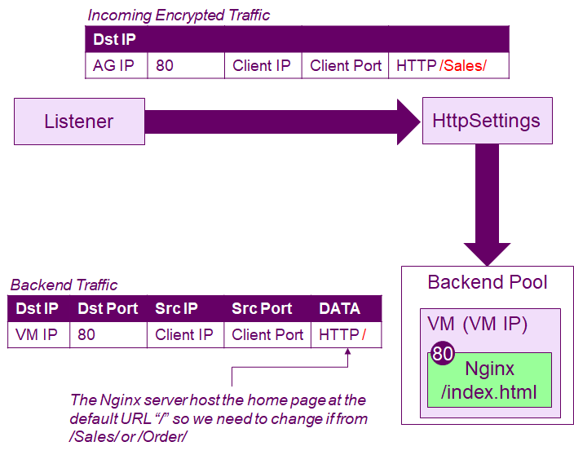
# Get the name of the HttpSettings object
az network application-gateway http-settings list --resource-group myvm-resource-gp --gateway-name myAppGateway -o table
appGatewayBackendHttpSettings

# We change the HTTP settings so that the gateway rewrites the URL in the incoming packet to match a URL that Nginx on our VM recognises.
az network application-gateway http-settings update --resource-group YOUR_RESOURCE_GP --gateway-name YOUR_APP_GATEWAY --name appGatewayBackendHttpSettings --path /

Create the URL paths
We want to route the traffic based on the path (URL) to the three pools that we previously created.
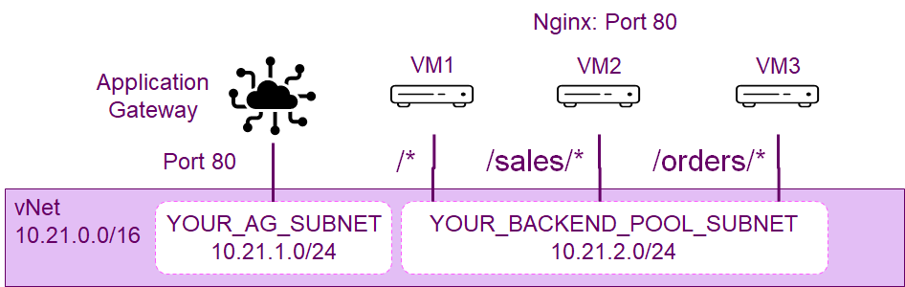
To achieve this we create a URL path map. When we create it we can specify the default-address-pool which is where traffic will be sent for the default path “/*”, which we decided would be the pool automatically created for us when we create the gateway.
Next we add URLs for /sales/* and /orders/*.
Notice: because we are using an Nginx server for all the VMs and hence all the VM pools, we can reuse the same HTTP settings each time.
# Get the name of the backend pool the Application Gateway created
az network application-gateway address-pool list --resource-group YOUR_RESOURCE_GP --gateway-name YOUR_APP_GATEWAY -o table
appGatewayBackendPool

# Get the name of the HttpSettings object
az network application-gateway http-settings list --resource-group myvm-resource-gp --gateway-name myAppGateway -o table
appGatewayBackendHttpSettings

# We set a URL path map that defines the default URL (/*) and
# sets the first path rule for the URL /sales/*
az network application-gateway url-path-map create --resource-group YOUR_RESOURCE_GP --gateway-name YOUR_APP_GATEWAY --name <YOUR_URL_PATH_MAP> --default-address-pool appGatewayBackendPool --default-http-settings appGatewayBackendHttpSettings --rule-name salesPathRule --paths /sales/* --address-pool YOUR_SALES_BACKEND_POOL --http-settings appGatewayBackendHttpSettings

# Add a second path rule for the URL /orders/*
az network application-gateway url-path-map rule create --resource-group YOUR_RESOURCE_CP --gateway-name YOUR_APP_GATEWAY --name <YOUR_ORDERS_PATH_RULE> --path-map-name YOUR_URL_PATH_MAP --paths /orders/* --address-pool YOUR_ORDERS_BACKEND_POOL --http-settings appGatewayBackendHttpSettings

Having created a URL path map we must set the routing rule to use for forwarding incoming traffic from the listener to the pools.
# Get the name of this request routing rule.
# Should be rule1
az network application-gateway rule list --resource-group YOUR_RESOURCE_GP --gateway-name YOUR_APP_GATEWAY -o table
rule1

az network application-gateway rule update --resource-group YOUR_RESOURCE_GP --gateway-name YOUR_APP_GATEWAY --name rule1 --rule-type PathBasedRouting --url-path-map YOUR_URL_PATH_MAP

Connect to and test the Application Gateway
To connect to the Load Balancer we need to find the public IP address that we associated with it. Remember in a previous step we created this public IP resource, but now we want to display the actual IP address so we can connect to it through a web browser.
# Display the public IP address of the load balancer
az network public-ip show --resource-group YOUR_RESOURCE_GP --name YOUR_AG_PUBLIC_IP --query ipAddress -o tsv

CONNECT TO THIS IP ADDRESS IN A WEB BROWSER
RECONNECT TO SEE RESPONDING VM CHANGE

The gateway will choose different VMs to process the traffic depending on the URL you use.
Try the URLs:
- http://<ip-address>
- http://<ip-address>/sales/ <-- IMPORTANT: trailing / is required
- http://<ip-address>/orders/
Replacing <ip-address> with the public IP address of the gateway.

FINISH: Delete Everything
The easy way to stop and delete everything we have created is to just delete the resource group that contains all these resources.
# Clean up
az group delete --name YOUR_RESOURCE_GP --yes

