ALEXANDER GREENSLADE
tATA Steel |
Reflective Project Report
acma5009 – RICHARD SUTTON

Executive Summary
The report discusses an organisational change that occurred in the Raw Materials department at Tata Steel, Port Talbot. The implementation of a project to enhance the handling of coal blends at the Raw Materials lab of the BOS plant in Tata Steel is outlined in the document. This change was safety driven, after a number of near misses occurred regarding certain tasks. This involved the acquisition of a shipping container, cleaning the area surrounding the container, and the establishment of a kanban system to manage coal inventories. Various tools such as A3 planner, DSUM meetings, and process confirmation were utilised to design and maintain the project. As a result of the project's implementation, workplace safety, efficiency, and communication were all enhanced.
Contents
Introduction 3
1) Description of Change 4
a. Change 4
2) Current Practice 4
a. Safety Concerns 4
3) Implementing Change 4
a. Final Solution 4
b. The 5 Whys Methodology 6
c. Lewins Force Field 7
d. Engaging with Teams 8
e. Planning the Change 9
f. External Training 9
g. A3 Planner 10
4) Project Costs 11
5) Project Execution 12
a. Lean Improvements – Kanban 14
b. Safety Considerations 14
c. Implementing Standards 14
d. The Voice of the Operator 15
e. Celebrating Success 16
Conclusion 17
References 18

Introduction
‘Tata Steel is one of Europe's leading steel producers, with steelmaking in the Netherlands and the UK, and manufacturing plants across Europe.’ (Steel, 2022)
The change that occurred took place at Tata Steel, Port Talbot, where there were several safety concerns raised by personnel who performed crucial tasks within the company. Specifically, the task that underwent a change involved the use of coals from Morfa Coke Ovens. The technicians responsible for sampling coals, coke, iron ores, and other by-products and gases in the Raw Materials department performed these tasks frequently throughout the day, with safety being the company's top priority. As a result, the BOS plant's Raw Materials lab at Tata Steel required a project that aimed to improve the handling of coal blends by reducing manual handling, introducing a clear kanban system for managing coal stocks, and improving workplace communication and efficiency. This document outlines the implementation of the project, including the tools used to plan and sustain it.

Description of Change

Change
According to Stobierski (2020), organisational change involves the modification of significant elements within a company or business, such as its culture, underlying technologies or infrastructure, and internal processes. Two critical factors that drive change at Tata Steel are its culture and internal processes.
The day team Lead technician of the area is responsible for addressing any safety concerns or near misses that occur. After observing several of these incidents, the Lead technician held discussions with the technicians working in the area. The technicians proposed various ideas along with their justifications. Subsequently, a plan was formulated and executed to implement the change.

Current Practice
As mentioned in the introduction, the technicians are expected to sample various different coals from Morfa coke ovens. The coals are then kept in wheelie bins for storage. Third-person version: The introduction states that the technicians are expected to sample various coals from Morfa coke ovens and store them in wheelie bins. The coal is utilised in making blends, which involve mixing several coals together. These blends are subsequently charged into the mini-Pilot oven located at the labs, which is intended to replicate the Morfa coke ovens, albeit on a smaller scale.

Safety Concerns
The safety concerns that had been raised were associated with the manual handling of the coals. Before the change, the coals were placed in wheelie bins in the storage room, with each bin weighing approximately 100kg. The storage room was located a considerable distance away from where the technicians had to perform their tasks, and they had to move the bins to the work location before commencing their work. Due to the numerous safety concerns and near misses associated with this job, a change had to be made. A change was made to support the belief from an organisation as a whole, ‘The safety and health of all the people who work in and with the Tata Steel Group is our number one priority’ (Steel, 2022).

Implementing Change

Final Solution
The change that occurred involved the purchase of a shipping container that was closer to the work area, with the aim of reducing the time taken to transport coal by carrying or wheeling it. Another minor change implemented was the bagging of coal before placing it into the wheelie bins. By doing so, the weight of the bags complied with the guidelines set by the HSE.
‘As an employer, you must protect your workers from the risk of injury from hazardous manual handling in the workplace. Manual handling means transporting or supporting a load by hand or bodily force. It includes lifting, putting down, pushing, pulling, carrying or moving loads. A load can be an object, person or animal’ (Health and Safety Executive, 2019).

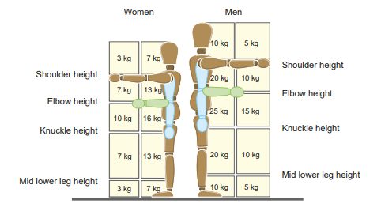
Figure 1 - Manual Handling guidelines

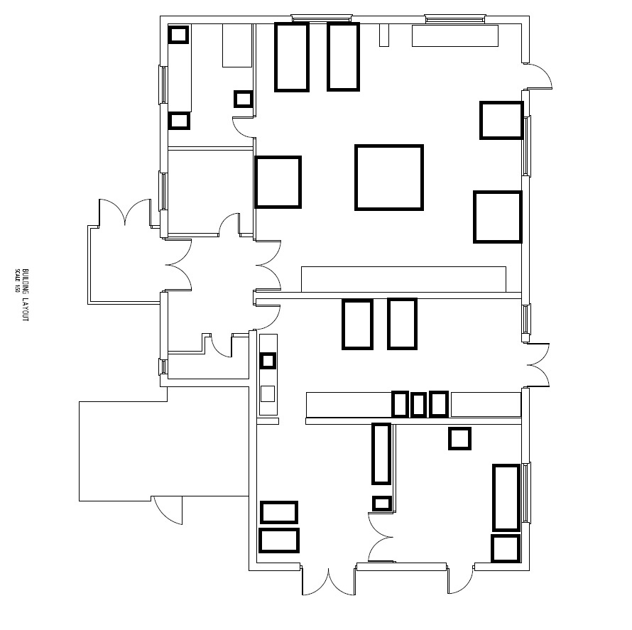
Area where coals are mixed.
Coal Storage Area
Location of shipping container
Figure 2 – Tata Steel Samplers building floor plan

The 5 Whys Methodology
After numerous near misses, and safety concerns raised from the teams it was decided to look at ways to improve the process. As a team, the first objective was to find the root cause of the issues. This was implemented by using a tool called ‘5 whys.
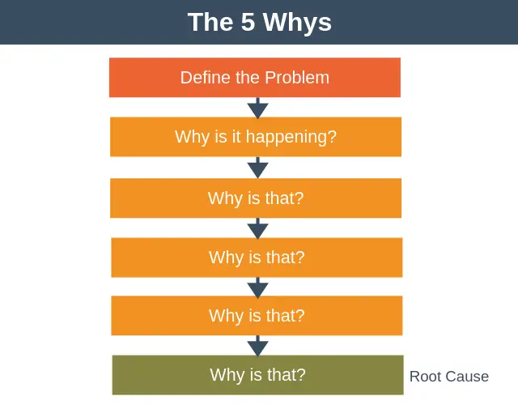
Figure 3 - The 5 Why's

(Denis, 2019)
Figure 3 sets out, the very basic tool of asking 'why?' five times is demonstrated. This tool, known as the 5 whys, is utilised throughout the organisation, not just limited to the Raw Materials lab. It is considered effective in identifying the root cause of problems quickly, without requiring significant planning. The 5 whys can be implemented by creating a blank template on an excel sheet or by using pen and paper in situations where access to a computer is unavailable. Overall, the 5 whys could be an efficient tool and a suitable starting point for addressing any issues that may arise.

Lewins Force Field
Once the root cause had been found for any issue or concern raised, Lewins Force field analysis could be carried out to see what the driving forces are for the change and also the resisting forces.
‘To bring about any change, the balance between the forces which maintain the social self-regulation at a given level has to be upset’ (Connelly, 2020).
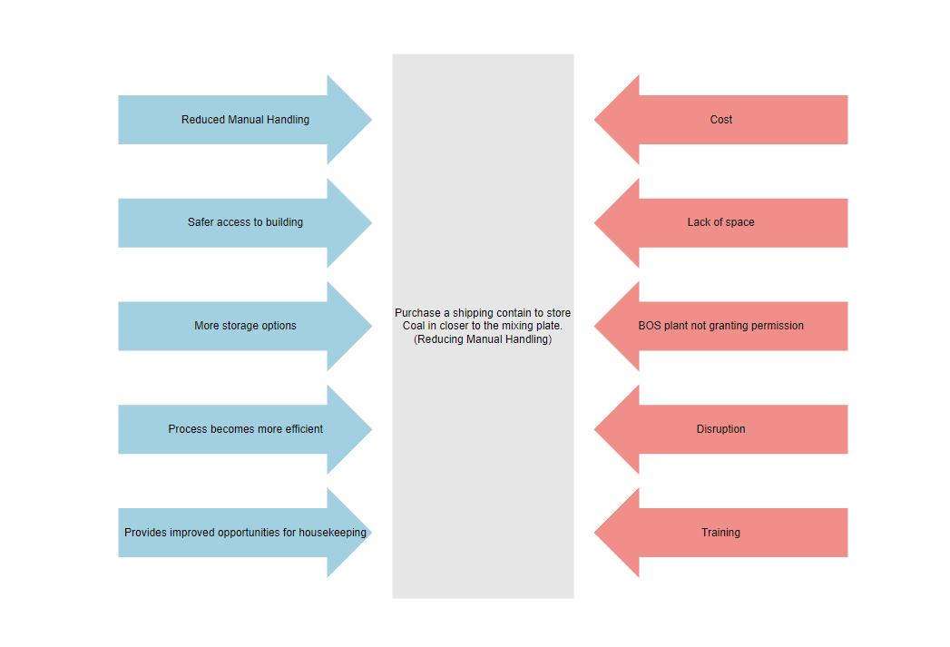
In essence, Lewin's statement suggests that in order for a change to occur, the equilibrium must be disturbed by either increasing the driving forces or reducing the restraining forces. The magnitude of the driving forces can also play a role, as seen in the change implemented at Tata Steel where the driving force was safety, which ultimately became the top priority in the workplace.
Figure 4 - Lewin's Force Field Analysis. Template - (online.visual-paradigm.com)

After the decision was made with all the shareholders, Alex Greenslade and Craig Williams, technologists, conducted Lewin's Force Field analysis. As highlighted in figure 4, the driving forces and restraining forces were in equilibrium. However, due to the change being driven by safety concerns, action was necessary.
Alex believes that Lewin's Force Field analysis is a useful tool to employ when considering changes that may not be strictly necessary. Although it can be applied to various changes, it was not particularly advantageous in the context of the alteration made at Tata Steel's Raw Materials lab because ultimately the change had to be made to ensure safety of staff.

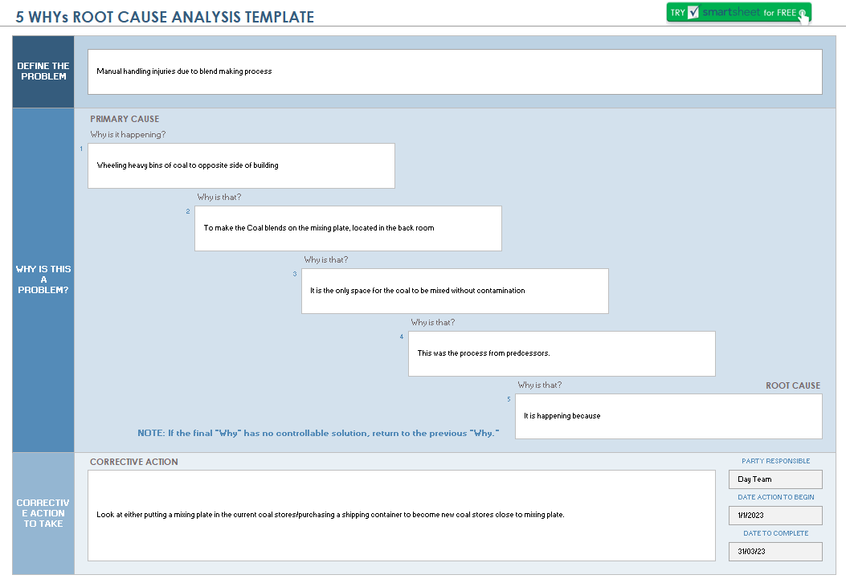
Figure 5 - Tata Steel internal 5 Why's template

Engaging with Teams
‘When possible, include your employees in decision-making and goal-setting. If they can’t be involved in these preliminary processes, be open to hearing their ideas and input. Not only can being receptive to new ideas help empower your employees, it can also open up your organisation to great new ideas’ (Bosworth, 2018).
In line with Bosworth, Tata Steel believes that listening to the personnel who carry out set tasks day in and day out will lead to positive ideas. By engaging with the teams, numerous ideas and suggestions were received on how to improve the process and ultimately make it safer. Meetings were held between Tata Steel representatives, Technologist, and the technicians undertaking the tasks, and a visual list was made of all the ideas that were captured. While the predominant reasoning behind the change was down to safety, there were other driving factors, including the discontent shown by the teams when having to carry out the task of mixing coals.
‘People want guidance, not rhetoric. They need to know what the plan of action is and how it will be implemented. They want to be given responsibility to help solve the problem and the authority to act on it’ (Oyos, 2014).

Planning the Change
Following conversations with the teams, the speaker and Technologist (Line Manager) felt that the teams had solved the issue themselves. By listening to them and providing them with time and information as to why the change needed to take place, the teams were able to create a solution. At Tata Steel, the belief is that if a process or idea is suggested by the technicians it is more likely to stick. These are the people that hold the most experience and will often suggest valuable ideas.
After hosting meetings and discussions with all personnel involved, the speaker and Technologist were then faced with the challenge of planning and implementing the change. Einstein is quoted as having said, “If I had an hour to solve a problem, I'd spend 55 minutes thinking about the problem and five minutes thinking about solutions” (Debevoise, 2021).
At Tata Steel, numerous projects take place every week, with varying durations ranging from a few hours to several days, or even up to 100 days in some cases. The organisation underwent changes at the beginning of the year with the introduction of Sustainable Operational Excellence (SOE). The goal of one particular project was to last for 100 days. The introduction of SOE to the BOS Labs, Port Talbot, meant that they shared the same beliefs as Oyos, 2014 - ‘We believe that people protect what they build; so, we don’t tell people what to do, we help them create lasting change for themselves’ (Oyos, 2014).

External Training
The organisation as a whole underwent a 14-week course led by the outside company 'Unleash & Engage'. During this period, the day staff members were coached and learned various techniques like the 5 whys, A3 planning, 100-day sustainment plan, and visual aids. As part of the coaching received, they decided to make the course their number 1 priority for the next 100 days and used a tool called the A3 Planner to accomplish this. Jim Collins says “If you have more than three priorities, you don’t have any” (Weisul, 2012).

A3 Planner
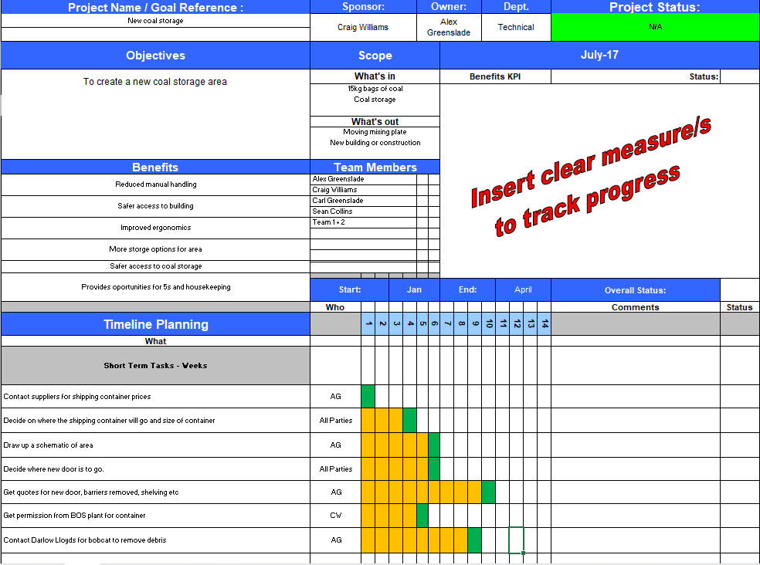
The A3 planner is capable of outlining the objectives, identifying the individuals responsible for completing specific tasks, and setting timeframes for each activity that can be checked off as days go by. The A3 planner is considered a valuable tool that is frequently utilised in daily operations. Additionally, the A3 tracker is made visible to those involved in the blend making process to provide transparency regarding the ongoing improvements being implemented.
Figure 6 - Tata Steel internal A3 planner

Project Costs
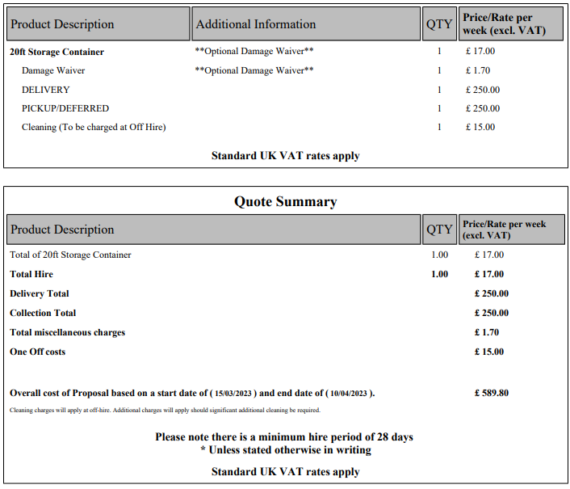
The individual responsible for the first task of the short-term actions was tasked with obtaining information and quotes for shipping containers. Within the first week, they successfully completed this task by contacting various firms that supplied containers. Ultimately, they chose 'Mobile Mini' as the preferred supplier based on the company's reputation and the quality of advice provided. After informing the customer services team of the required container size of 20 ft x 8 ft, a quote was promptly sent to the individual later that week.
Figure 7 - Tata Steel internal quote for shipping container

Project Execution
The decision on where to locate the shipping container took slightly longer than expected due to several reasons. One of the reasons was the need to involve everyone in the decision-making process, including shift workers. Additionally, the decision was dependent on obtaining permission to place the container in a specific area. Since the Raw Materials lab is part of the BOS plant, building owners had to approve the decision before it was finalised.
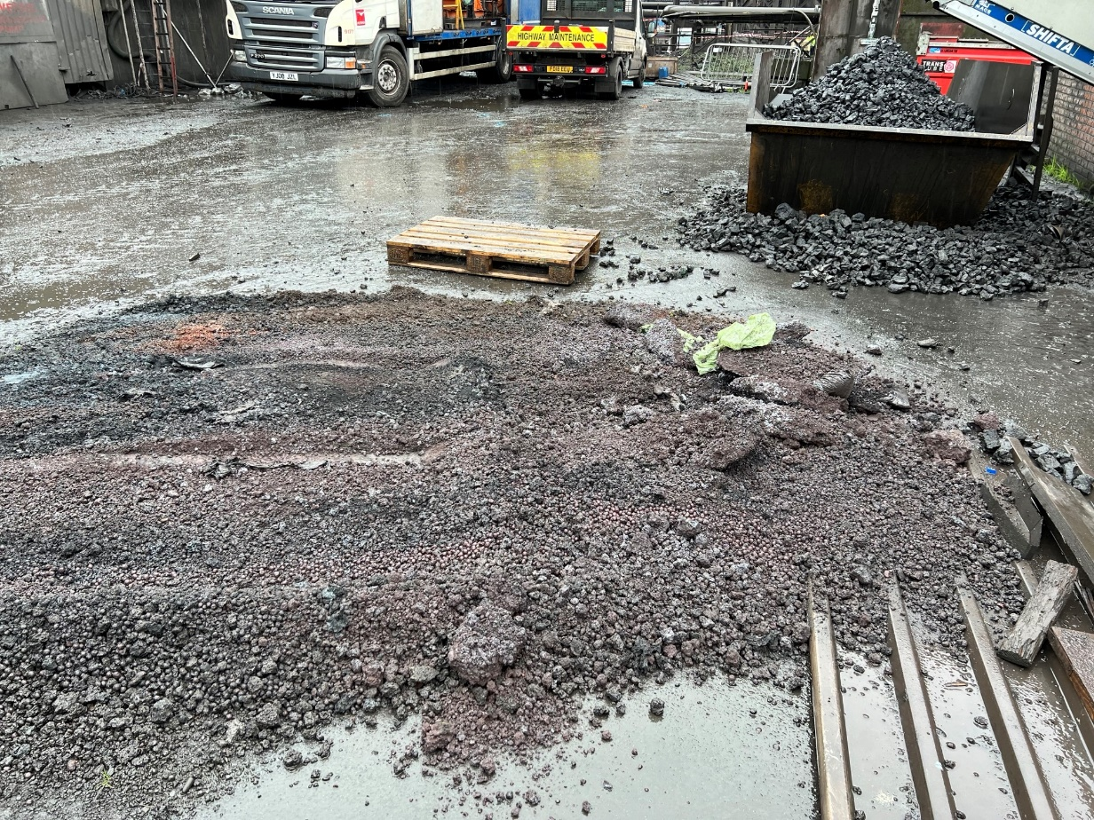
Ultimately, it was decided to place the container behind the samplers building, with a new entrance connected to it. This would reduce the manual handling of coals and bags. However, before the container could be placed, the debris that had accumulated over the years in the area needed to be removed. To accomplish this, a contracting company within Tata Steel, Darlow Lloyds, was contacted to clean the area using a bobcat.
Figure 8 - Condition prior to change at Tata Steel

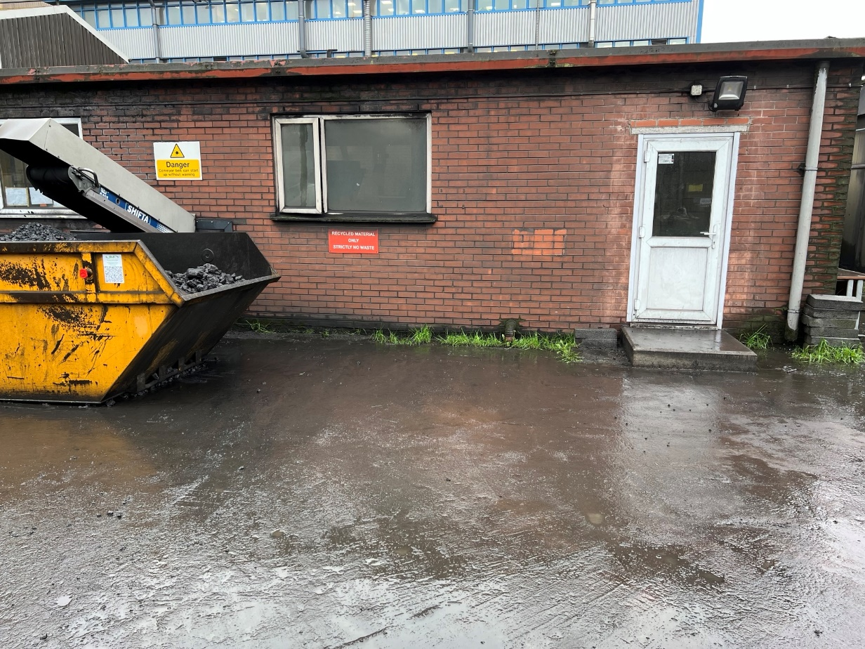
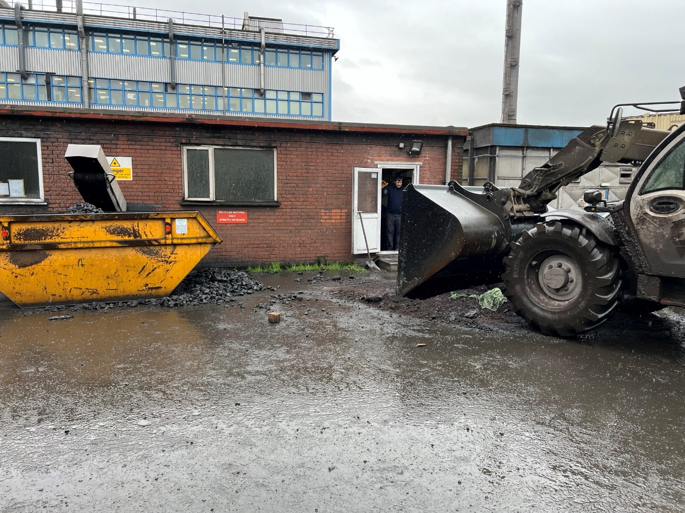
Figure 9 - Area clear of debris at Tata Steel
Figure 10 - Removal of debris at Tata Steel

Lean Improvements – Kanban
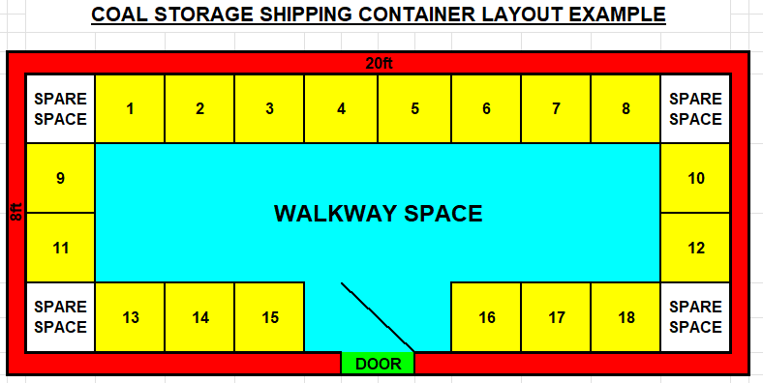
Another task completed was a basic drawing on excel which portrayed what the new Coal stores would eventually look like.
Figure 11 – Future Shipping container floor plan

Figure 11 shows where the entry point is and each yellow square indicates a wheelie bin. This is all part of improving the project as at some point in the near future this would extend to place all current coal stocks on to a kanban board, this way they become easier to control and manage. ‘Planning should occur with minimal waste; it shouldn’t become overhead’ (Benson, 2011)

Safety Considerations
The team made a change with safety as the main reason, but as time passed, they discovered further benefits. They implemented a clear kanban system for each coal, which allowed for the introduction of low stock level limits. These limits were visible on walls and whiteboards throughout the office, which is a form of Visual Management. As a result, the number of Corrective Action Reports (CARs) received from customers decreased. CARs were typically raised when blends were late due to insufficient materials, leading to delays. The upper and lower limits were established by individuals named Craig and the speaker, with a lower limit of 40kg, which is referred to as the 'standard.'

Implementing Standards
After undergoing SOE coaching, the team received a new tool called DSUM (Daily Stand-up meetings), which they learned to utilise effectively. DSUMs are short and direct meetings with team leaders, where necessary information such as ordering critical consumables can be shared. The team found these meetings to be very useful.
As part of the sustainment plan, the team was required to introduce clear standards that work alongside safe working procedures already in place, in a process known as process confirmation. This standardisation process could involve visual management improvements. The DSUM and process confirmation tools are interconnected. Team members, including Craig and the speaker, established coal stock standards on the DSUM boards. This allowed for process confirmation of current stock levels at the start of each shift by the team leaders. For instance, if a coal had a stock of 30kg, this would be highlighted during the morning meeting, and sampled later on the shift, leading to a smoother and more efficient process.
Prior to the implementation of these changes, the team did not have exact information on the weight of the coal. Stock levels were estimated visually by looking at the wheelie bin and recording this as, for example, "1/2 a bin." This approach was deemed a failure as it was open to interpretation, and there was no clear record of the amount of coal in stock.
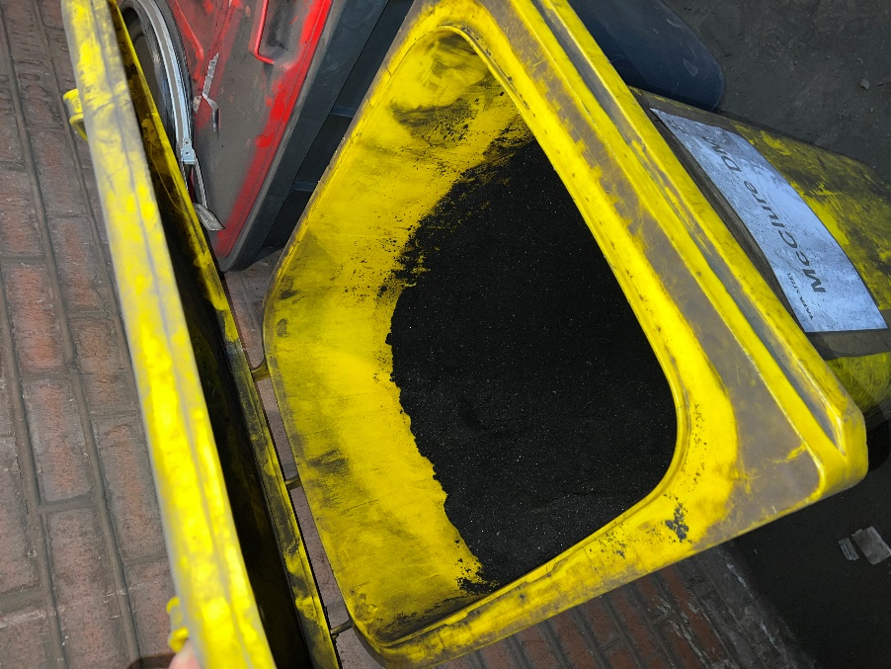
Figure 12 - Loose coal kept in wheelie bins at Tata Steel

While implanting the change, a decision was made to create a clearer standard that could be process confirmed. After considering the change, they decided to start bagging the coals in clear bags. This enabled the bags to be weighed on a balance with the exact weight of total coal recorded on the DSUM board.

The Voice of the Operator
In a workplace, individuals tend to be motivated by different factors. However, when everyone is given a voice and the opportunity to contribute their own ideas, it creates a sense of unity and fosters commitment to the project among all team members.
‘Clear communication leads to positive outcomes. When employees are clear on their roles and what they should be doing they feel motivated’ (Herman, 2022).
By having conversations in the DSUMs, the teams can better understand their expectations and the standard they should be striving for. As stated by Milton Herman, employees tend to feel motivated when they have a clear understanding of their roles and responsibilities. This belief is held by the management at Tata Steel.

Celebrating Success
Another way to motivate people is by celebrating their success. At the start of the year, SOE implemented a new practice where the Raw Materials lab has multiple versions of the DSUM board. Currently, there is a section on the board dedicated to "Celebrating Success." During the meeting, the team leader or the person leading the meeting asks the team if there are any successes to recognise. After receiving great ideas from the technicians, the team highlighted their success and made it visible to everyone. ‘Celebration is one way that we bond with others and feel like we belong to a group or culture’ (Shelton, 2023).

Conclusion
The project aimed at improving the handling of coal blends at the Raw Materials lab of the BOS plant in Tata Steel was implemented successfully, resulting in enhanced safety, efficiency, and communication at the workplace. The project team employed various tools, including A3 planner, DSUM meetings, and process confirmation, to plan and sustain the project. One of the critical outcomes was the introduction of a clear kanban system that improved the accuracy and efficiency of managing coal stocks. The success of the project demonstrated the significance of continuous improvement, effective tools, and communication in achieving workplace success. Despite months of planning and small improvements, the shipping container's delivery from Mobile Mini is pending. All the necessary preparations have been completed, the area has been cleaned and arranged, and the team is now waiting for the delivery.

References
Benson, J. (2011). Personal Kanban Quotes by Jim Benson. [online] www.goodreads.com. Available at: https://www.goodreads.com/work/quotes/15323317-personal-kanban-mapping-work-navigating-life [Accessed 10 Apr. 2023].
Bosworth, P. (2018). 8 Tips to Empower Employees in the Workplace | Leadership Choice. [online] Leadership Choice. Available at: https://leadershipchoice.com/empower-employees-in-the-workplace/ [Accessed 10 Apr. 2023].
Connelly, M. (2020). Lewin’s Force Field Analysis Explained. [online] Change Management Coach. Available at: https://www.change-management-coach.com/force-field-analysis.html [Accessed 10 Apr. 2023].
Debevoise, N.D. (2021). The Third Critical Step In Problem Solving That Einstein Missed. [online] Forbes. Available at: https://www.forbes.com/sites/nelldebevoise/2021/01/26/the-third-critical-step-in-problem-solving-that-einstein-missed/ [Accessed 10 Apr. 2023].
Denis, G. (2019). The 5 Whys. [online] Expert Program Management. Available at: https://expertprogrammanagement.com/2019/05/the-5-whys/ [Accessed 10 Apr. 2023].
Health and Safety Executive (2019). Manual Handling: Health and Safety. [online] Hse.gov.uk. Available at: https://www.hse.gov.uk/toolbox/manual.htm [Accessed 10 Apr. 2023].
Herman, M. (2022). 20 Easy Ways to Motivate Employees. [online] LumApps. Available at: https://www.lumapps.com/employee-engagement/employee-motivation-how-to-motivate-employees/ [Accessed 10 Apr. 2023].
Oyos, R. (2014). 10 Powerful Quotes from Industry Leaders that will Inspire You to Empower Your Employees. [online] transcosmos. Available at: https://transcosmos.co.uk/blog/10-quotes-employee-empowerment/ [Accessed 10 Apr. 2023].
Shelton, S. (2023). Why Should Leaders Celebrate Success? [online] Executive Leadership Consulting. Available at: https://executiveleader.com/leaders-celebrate-success/ [Accessed 10 Apr. 2023].
Steel, T. (2022). Health & Safety. [online] Tata Steel in Europe. Available at: https://www.tatasteeleurope.com/health-and-safety [Accessed 10 Apr. 2023].
Stobierski, T. (2020). What Is Organizational Change Management? | HBS Online. [online] Harvard Business School Online. Available at: https://online.hbs.edu/blog/post/organizational-change-management.
Weisul, K. (2012). Jim Collins: Good to Great in 10 Steps. [online] Available at: https://www.inc.com/kimberly-weisul/jim-collins-good-to-great-in-ten-steps.html [Accessed 10 Apr. 2023].
VisualParadigmOnline. Available at: https://online.visual-paradigm.com/app/diagrams/#diagram:proj=0&type=ForceFieldAnalysis&width=11&height=8.5&unit=inch&gallery=/repository/cbe704bc-30d4-44ee-8f7b-f4ca595150d1.xml

Figures
Figure 1 - Manual Handling guidelines 5
Figure 2 – Tata Steel Samplers building floor plan 5
Figure 3 - The 5 Why's 6
Figure 4 - Lewin's Force Field Analysis. Template - (online.visual-paradigm.com) 7
Figure 5 - Tata Steel internal 5 Why's template 8
Figure 6 - Tata Steel internal A3 planner 10
Figure 7 - Tata Steel internal quote for shipping container 11
Figure 8 - Condition prior to change at Tata Steel 12
Figure 9 - Area clear of debris at Tata Steel 13
Figure 10 - Removal of debris at Tata Steel 13
Figure 11 – Future Shipping container floor plan 14
Figure 12 - Loose coal kept in wheelie bins at Tata Steel 15

