Academic and Employability Skills
Report

By
Zlatka Ciorica
Student ID: 1905836
BCs Cloud Computing Level 4
University of Wales
Trinity Saint David London Campus

Date:29/12/2019

Content:
I. Introduction
1. Who am I?...............................................................page 4
2. Education……………………………………..…...page 4
3. Work Experience………………………………... page 5
3.1. Sales representative…………………………...page 5
3.2. Production Supervisor ………………………..page 5
3.3. Beauty Industry…………………………….…page 6
3.4. Managing small company…………………….page 6
II. Skills Evaluation…………………………………………..page 7
1. Skills required for successful HE learning Employability……………………………………….page 7
2. Self-Evaluation Exercise…………………..…...page 9
III. Action plan……………………………………………....page 12
1.Personal Goals………………………………….….page 12
1.1. Short term goals…………………………….…page 12
1.2. Long term goals…………………………….....page 12
2. Action Plan for the Academic and Personal/Professional Skills …………………………………………………… .page 13
IV. Application………………………………………………page 13
- Looking after your data…………………………..page 13
- Time management and organisation…………..….page 14
V. Conclusion and Evaluation …………………………...page 15
VI. Appendices………………………………………….…page 16

List of figures:
Figure 1(PpPresentation- Introduction and personal skills)..…..page 4
Figure 2(PpPresentation- Introduction and personal skills) …....page 5
Figure 3(PpPresentation- Introduction and personal skills) ..… page 6
Figure 4(APT-S framework)…………………………………....page 8
Figure 5(APT-S framework-work)…………………………...…page 8
Test 1(Test your skills)……………………………………….…page 9
Table 1(Action plan)………………………………………..…page 13
Table 2(PDP)……………………………………………….…page 15
Figure 6(Test your skills questions)…………………...………page 16
Figure 7(PPPresentation-introduction and personal skills)……page 17
References …………………………………...………………..page 19

- Introduction
1.Who am I?
My name is Zlatka Petkova Ciorica. I was born and raised in the small town Parvomay in South part of Bulgaria. The search for opportunities and horizon of successful realization brought me to United Kingdom in 2008.
I worked in different sectors and met new people which challenged me as a person.
2. Education
I graduated English, Information Technologies and Marketing in Bulgaria, Parvomay , SOU’’Dr.Prof..Asen Zlatarov’’.
I also followed my hobbies and turned them to professional qualifications. I studied Hairdressing VTCT Level 2 and 3 in Waltham Forest College, London; Beauty Therapy Level 2 in Elba College, London and Nail technician qualification, Bulgaria.
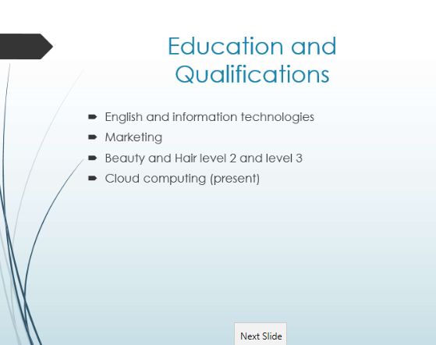
Figure 1

3. Work Experience
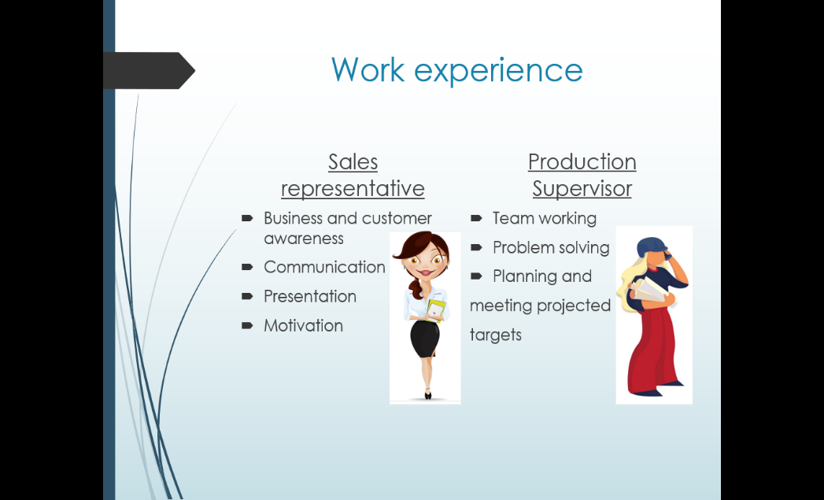
Figure 2
  - Sales Representative - I worked as Sales Representative for 2 years in the culture capital of Bulgaria, Plovdiv. The company I worked for was based in Turkey and just entering the market in my country. The duties which my job included were finding new customers and clients and working with existing ones. Communication was one of the most important part of my job. Keeping in touch and discussing the business, introducing the innovation technologies we were representing and selling on the Bulgarian market. The distribution, negotiating prices and sales, answering all kind of questions for availability, deliveries, warranties and repair services was my responsibility too. I had the chance to meet with members of big companies on the Bulgarian market and do presentations on professional level.
The overall set of skills I exercised and improve in this industry was good customer service and doing a lot of researches so I can be up to date what are the needs of the potential clients and the latest innovations with the products I was representing and selling.
  - Production Supervisor - In 2008 I arrived in England and start working in a farm for soft fruits in Tamworth, Birmingham. After showing good English and good results in the completed tasks I was promoted in Production Supervisor in charge of 30 workers. My responsibilities were planning the jobs for my team. Supervising the work and keeping records for quality and quantity of the production. Analysing the expected soft fruit quantity based on different factors. Making sure that the work prosses is going as planned and ensuring to reach the daily targets expected to satisfy the needs of the customer orders.
The main experience I gained from this job was the teamwork and problem solving.
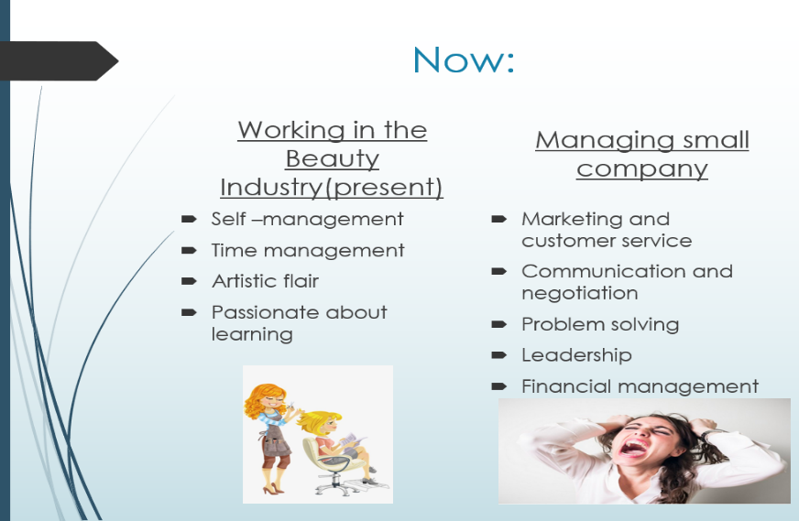
Figure 3
3.3.Beauty Industry-At the present I am working as self-employed in the Beauty Industry. Offering beauty services in a homebased studio. In this job the main skills are self-management, time management and customer service.
3.4.Managing small business - Parallel with it I am managing a small company for Cleaning services, working with 8 subcontractors. My job is to advertise and find new customers and maintain good customer service. Accepting new booking and requests, managing them and doing the schedules for the housekeepers. Very important for this type of business is to focus on the performance of the workers, making sure that a first class service is delivered in terms of standards of cleanliness. This gives us loyal clients and good advertise. I am handling all payments from customers and to workers.
The skills I obtain are leadership, financial management, lots of negotiation for prices and schedules and not in last place problem solving with very short notices.

- Skills Evaluation
1.Skills required for successful HE learning Employability
In the century we are living now the expectation is growing in every economy and the changes are happening every day. This is where is coming the important role of the higher education institutions to prepare the new generation for the upcoming changes and teach them to adapt and develop their skills. Once the graduates are employed in order to keep their job they have to keep on working on their employability. I agree that the learning is not only in education, it’s a process which lasts through out the whole life.
(Bob Smale and Julie Fowlie,2009)
High education institutions and employers expected the students and graduates to develop certain skills during education so they can be prepared for future jobs. Sometimes different skills are named different and this is confusing. Here comes the APT-S framework which organises the skills in 4 categories: Academic, People, Task and Self. This frame simplify the process of managing the learning environment, past experience and the future targets. (Stela Cottrell,2010)

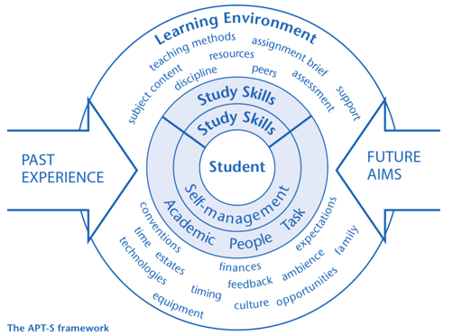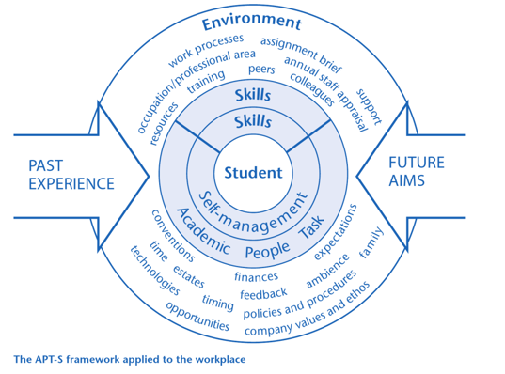
Figure 4 Figure 5
(source:Skills for Success: Personal Development and Employability,2010)
Here are some of the main key skills in explained:
Self-management is all about being very well organised, punctual and meeting the deadlines. The employers are expecting this done in highly manner. Self-managing is a key skill to being employable. If we want to know about ourselves if we are good in self-management we can think of examples from our life. Situations where we demonstrated the ability to be responsible, did planning, preparation and organisation and performed the task good. (Frances Trought, 2017)
Teamworking is essential in today’s globally changing market are many challenges. Collaborations, different opinions and experiences, discussion is strong combination in the path of finding the best solution on a problem. Universities are the place for this skill to be develop, working in teams in projects or working part-time job in life environment. (Frances Trought, 2017)
Problem-solving is analysing and being creative. Employers evaluates the ability to develop solutions in constantly changing markets. There are certain number of steps defined by Bransford and Stein(1984) in their IDEAL problem-solving model:
Identify problem, Define problem, Examine options, Act on plan, Look at consequences (Frances Trought, 2017)
Communication is important and we need to know how to do it effectively. We can learn how to do it and develop it during our academic years. There are different forms and languages. It can be face to face, telephone call, written communication, social media. To make sure that is in the right context academic, professional or social we can use the 7Cs of communication: Clear, Concise, Concrete, Correct, Complete, Courteous. (Frances Trought, 2017)
Emotional intelligence is the ability to manage and respond accordingly. Business needs workforce able to respond to the upcoming challenges. The demanding of emotional intelligent individuals is growing on the job market. The leaders of the future have to be able to analyse the facts and data objectively. According to Daniel Goleman (2014) there are four key components of emotional intelligent individual: self-awareness-knowing how feelings will affect job performance; self-management-self-control and calmness; social awareness-ability to listen; relationship management-ability to inspire, challenge and influence the others(Frances Trought, 2017)

2. Self-Evaluation Exercise
I conducted a Self-Evaluation exercise online to learn more about me like strengths and weaknesses. The total score I have is 56.
The results and advices of the test are as followed:
Test your skills:
(From figure 6)
(18 December 2019)
Leadership and Management
(Questions 5, 7, 12)
My score is 12 out of 15
Good leadership and management are important part of taking any opportunity opens to me. There can be done more jobs with the help of my colleagues. These skills are something that can be trained and learned.
Although there are similarities between leadership and management, they are completely different skill.
Problem Solving and Decision Making
(Questions 2, 10, 14)
My score is 7 out of 15
Problem solving and decision making are skills which need to be well developed and exercised if I want to have successful career. This combined with people skills will make me good in my professional judgment and wise thinking. Same as leadership and management these are closely related.
Identifying and understanding the cause of the problem is the base of these skills. Best tools in this case are Root Cause Analysis, the 5 Whys technique, and CATWOE and other great tools and techniques which I can use. I can only make the right decision if I know and understand the problem and what cases it. This is quite hard job, to make it easier I can use variety of decision-making tools.
One way to learn about my skills is in decision-making quiz. Like this I will see the different stages in decision-making process and choosing the write option. Useful tools for the options are Decision Matrix Analysis and Paired Comparison Analysis and for whether to go ahead the tools are as Impact Analysis, Risk Analysis, and Cost/Benefit Analysis.
Communication Skills
(Questions 9, 11, 13)
My score is 11 out of 15
I strive to be a good communicator, among the skills to achieve this goal are focusing on what the other person is trying to say in order to effectively deal with issues in academic and employability level. This is one of the keys to a successful career.
Other areas I need to work on to be good communicator are conflict resolution and negotiation.
Time Management
(Questions 1, 4, 6, 15)
My score is 20 out of 20
Time management is one of the most important career skills areas. Not only does it help me to be more productive; I'll also be much less stressed!
Time management is very important skill in the career building. It lowers the stress and make plan for the tasks which makes us productive. Self-test and knowing how to prioritize and schedule effectively
It's also important avoiding procrastination - this is when you put off tasks and activities that you should be focusing on right now.
Personal Mastery
(Questions 3, 8)
My score is 8 out of 10
When I know how to "lead yourself" and make good choices for my future, I'll be that much further ahead when it comes to the other skills areas that I've already looked at.
Setting personal goals, using the principles of SMART to accomplish these. No matter how positive I feel now, it's also important to learn how to deal with negative thinking. Self-confidence and self-esteem until I can achieve goals that really matter.
Test 1
(Sourse:www.mindtools.com, 2019

- Action Plans
- Personal Goals
  - Short term goals
My short time goals are:
a) to write down my reports on satisfactory level and finish on time.
b) to do some extra research on the subjects I am the most interested in university
c) to practise what I have learned till now
d) to find the best way to combine successfully work, study and taking care of my family
1.2. Long term goals
My long time goals are:
a) explore careers I am interested in
b) graduate from university with honours
c) continue to Master
d) find a new job

2. Action Plan for the Academic and Personal/Professional Skills

Current skills | Teamwork | Organization | Problem-solving | Academic  Self-efficacy
Skills for improving | Stress management | Meeting university expectation | Confidence  Self-management | Time management
Goals | Managing successfully work and family tasks | Take additional courses | Find a job | Graduate the university
Action plan | -Observation and questioning  -On time for lectures  -Completion of assignments on time | -Writing to-do list  -Using of calendar to plan my university days | -I am confident I will succeed in most of my courses | -I can do well on my tests if I read  -Take time to prepare
Table 1

- Application
- Looking after your data
It is very important to choose the safest, quickest and easiest way to store your data. To do this efficiently have to check where is possible, and to store only what is needed. It is recommended to store the data in more than one safe place. Options are many such as temporary files, back-up copies, files accessible from one person.
Data loss is happening all the time by different factors so the experience teaches us that backup is the way to make sure we won’t lose important information.
There are three practices for backing up data. First is to make more than two copies, second storing in different locations and last using of many different types of storage media, different manufactures.
Data is good to be maintained so can be still used in future as the technologies are changing all the time. The process is called Data Preservation.
What to keep? This is way of prioritizing the importance of data. Selecting and keeping the useful stuff can save money and effort. By limiting the use of storage for holding \managing the stored data. (www.data.cam.ac.uk, 2019)
I do store my important data in few copies as I experienced data loss in the past. I use portable storages and virtual storage. I did change the type of the files years ago , upgraded to more modern as the old one I had are not supported anymore.

- Time management and organization
Time management and organisation are skills which develop with the experience. It became a necessity even in the daily tasks in our lives. Employers expected and appreciated these skills.
There are few key points which can help in managing the time and organising it. On first place is to set the goals. Once the target is determined can be created a plan to prepare a schedule, that includes all commitments and prioritise the tasks, like this can be predicted approximately how long it is going to take every step and on which tasks can be spend more. Here comes the self-motivation which is the running power of the whole process to be successful.
I do keep my calendar with tasks. Which make it easier to follow and less chance to forget. Making lists is another option to keep up with my commitments to my family and work. I do have electronic version and paper one too.

- Conclusion and Evaluation

Personal Development Plan

Which are my big goals | Priority goals | When do I want to achieve this? | What obstacles might get in my way? | How can I improve my chances of meeting my goals? | Where can I go for review? | Review: How am I going?
Completing bachelor degree Bsc Cloud Computing | Studying and Concentrating on the subjects in level 4 | I would like to graduate by the end of 2021 | -Lack of knowledge or out of date  -Lack of motivation  -Handling family task and studying | -keep focused on topic and continue to read  -meeting deadlines | -lecturers  -University staff  -careers advisors
Table 2

Many Skills are necessary to achieve good result in the university. In order to be compatible on the job market every graduate needs to show good set of skills. It is important to develop them during high education and beyond. Things like time management and stress control may affect every aspect of our lives. (Bob Smale and Julie Fowlie, 2010). Balancing personal and academic skills is difficult but not impossible. Following the right steps, advices and exercises plus self-evaluation can give us tips for way to handle future expectation. Know yourself well, determine weaknesses and strengths and work on them. All the tools created like action plans and personal development plan can navigate the process of mastering the skills.

- Appendices
Self-evaluation ‘test your skills’ done online on www.mindtools.com.
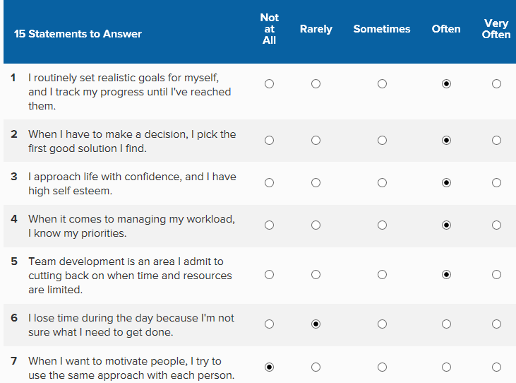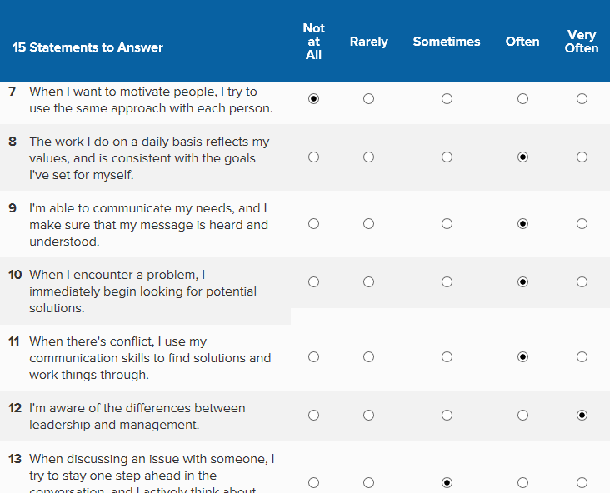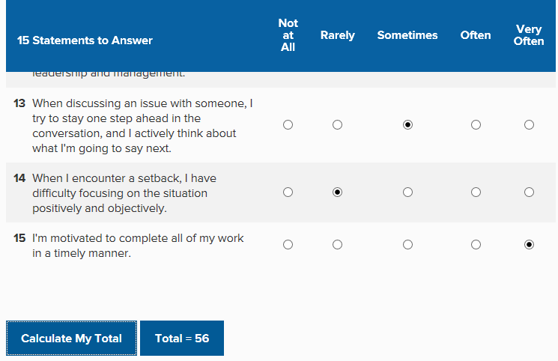

Figure 6

Power point presentation on subject Personal Development Plan
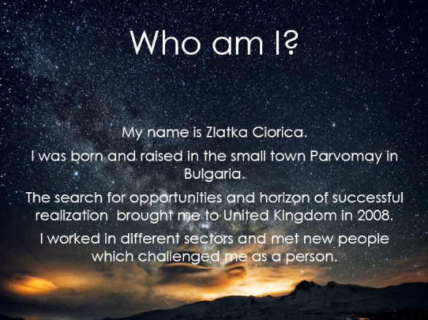
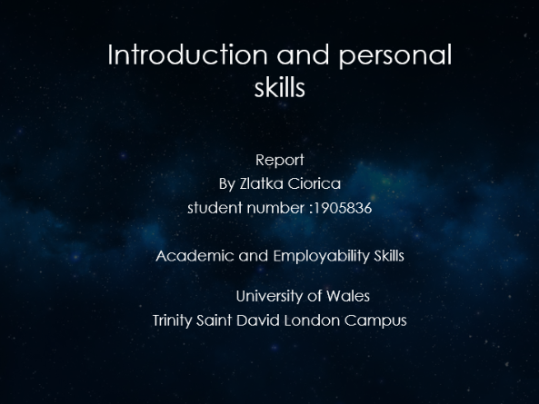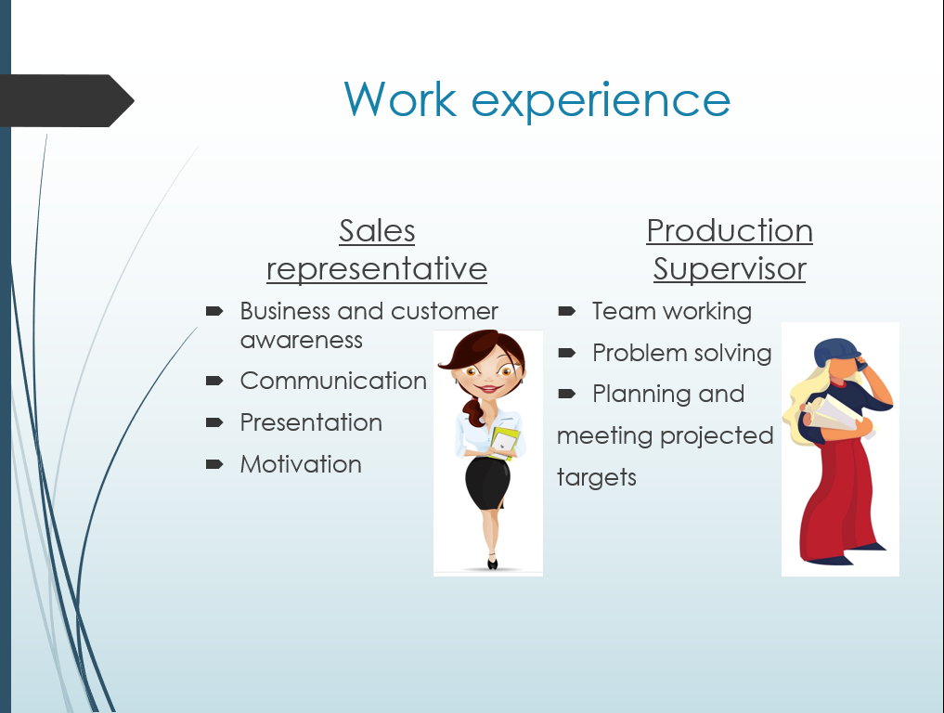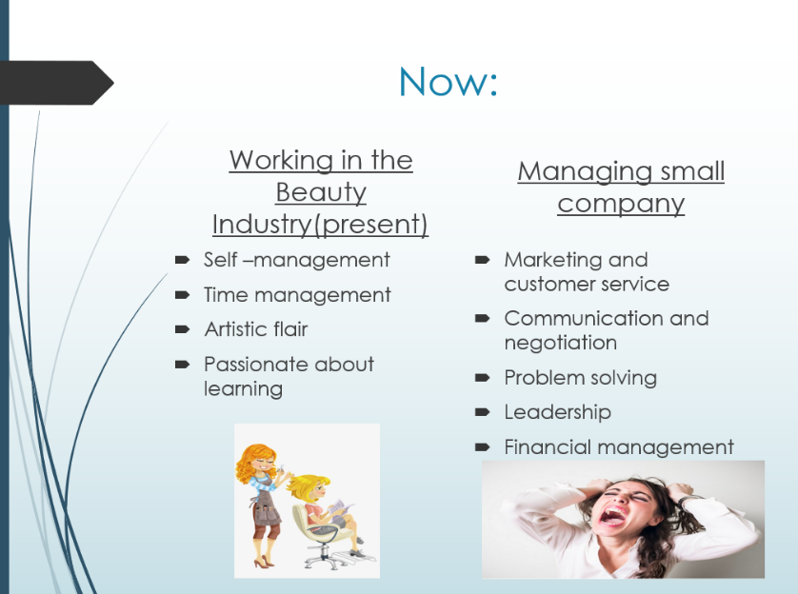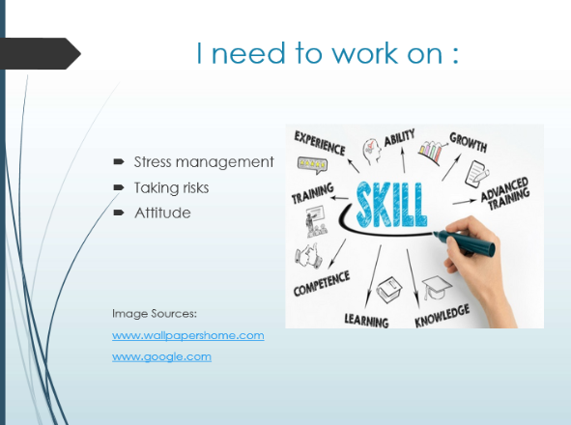
Figure 7

References :
Cottrell, S. (2010) 2nd edition, Skills for Success: Personal Development and Employability, Palgrave Macmillan. [online] Available at: https://books.google.co.uk/books?id=1J67BgAAQBAJ&printsec=frontcover&source=gbs_ViewAPI&redir_esc=y#v=onepage&q&f=false
(Accessed: 26 December 2019)

Smale, B. and Fowlie, J. (2009) How to Succeed at University: An Essential Guide to Academic Skills and Personal Development, Sage Publications Ltd. [online] Available at: https://www-dawsonera-com.ezproxy.uwtsd.ac.uk/readonline/9781446204962 (Accessed:
29 December 2019)

University of Cambridge [online] Available at: https://www.data.cam.ac.uk/data-management-guide/looking-after-and-sharing-your-data
(Assecced: 28 December 2019)

Frances Trought (2017) Brilliant Employability Skills : How to stand out from the crowd in the graduate job market, Pearson Education Limited [online] Available at: https://ebookcentral-proquest-com.ezproxy.uwtsd.ac.uk/lib/trinity/reader.action?docID=5186341&ppg=28 (Accessed :29 December 2019)

Mind tools (2019) [online] available at : https://www.mindtools.com/pages/article/get-started.htm
(Accessed: 18 December 2019)

