

Computer System Fundamentals

Name: Ffion Scourfield

Student No: 2506135

L4 – Computer System Fundamentals

(ACCA4028)

Beng Electrical & Electronic Engineering Degree Apprenticeship

2025-2026

Table of Contents
Table of Figures 4
Table of Tables 4
1.0 Introduction to Task 1 5
2.1 Task 1- Design a custom desktop computer 5
2.2 - Shopping list 5
Images of components 6
Image 1 - GPU 6
Image 2 - Motherboard 6
Image 3 - RAM 7
Image 4 - Storage 7
Image 5 -GPU 8
Image 6 - Power supply 8
Image 7 - Case 9
Image 8 - Monitors 9
Image 9 - Keyboard, mouse and webcam 10
Image 10 - Network connectivity 10
2.3 - Literature review - Specifications 11
2.3.1 – CPU 11
2.3.2 – Motherboard 11
2.3.3 – RAM 11
2.3.4 – Storage 11
2.3.5 – Input and output ports 11
2.3.6 – Graphics card 11
2.3.7 – Power supply 11
2.3.8 – Case 11
2.3.9 – Monitor, webcam, keyboard and mouse 12
2.3.10 – Network connectivity 12
2.3.11 – Software 12
Task 2: 3.0 - Evaluating Cybersecurity Risks 13
Introduction- Task 2 13
3.1 – Identifying and evaluating cybersecurity risks 13
3.1.1 – Outdated firewall 13
3.1.2 – Outdated firmware 13
3.1.3 – International suppliers and weak protection 13
3.1.4 – Limited employee training 13
3.2 – Prioritising Risks 14
3.2.1 – Outdated firewall risks 14
3.2.2 – International suppliers with weak protection 14
3.2.3 – Outdated Firmware Risks 14
3.2.4 – Limited Employee Training Risks 14
3.3 – Cybersecurity Strategy 15
3.3.1 – Outdated Firewall Strategy 15
3.3.2 – Outdated firmware strategy 15
3.3.3 – International Suppliers with a weak detection strategy 15
3.3.4 – Limited Employee Training Strategy 15
3.4 – Incident Response Plan. 16
3.4.1 – Identify 16
3.4.2 – Containment 16
3.4.3 – Eradication and Recovery 16
3.4.4 – Post Incident Activity 16
Conclusion: 16
References 17

Table of Figures
Figure 1 - Intel Core i7-13700KF CPU £330.00 [1] 6
Figure 2 - Tomahawk motherboard £144.99 [2] 6
Figure 3 - Kingston Fury RAM 132.76 [3] 7
Figure 4 – Storage £119.99 [4] 7
Figure 5 – RTX A200 £379.99 [5] 8
Figure 6 - Seasonic Focus GX power supply £123.98 [6] 8
Figure 7 - NZXT H5 Flow £71.99 [7] 9
Figure 8 - MSI PRO MP275 £69.00 [8] 9
Figure 9 - Logitech mk270 £39.98 [8] 10
Figure 10 - Ugreen Ethernet cable 2m £6.99 [9] 10

Table of Tables
Table 1 - SHOPPING LIST OF PC COMPONENTS 4

Introduction to Task 1

Task 1 involves creating a shopping list of components to build a bespoke desktop computer for an electrical engineer, designed to support reliable remote design work. This PC should be able to handle daily use of complex software, online meetings and presentations, with a focus on speed and robust cybersecurity to protect sensitive files.

2.1 Task 1- Design a custom desktop computer

2.2 - Shopping list

Table 1 - SHOPPING LIST OF PC COMPONENTS
Item | Product | Price (£) | Image reference | Total cost (£)
CPU | Intel Core i7-13700 | £330.00 | 1 | £330.00
Motherboard | MSI MAG B760 TOMAHAWK WIFI Motherboard, ATX | £144.99 | 2 | £474.99
RAM | Kingston Fury | £132.76 | 3 | £607.75
Storage | 1TB NVMe SSD (Gen 4) | £119.99 | 4 | £727.74
GPU | NIVIDA RTX A2000 (12GB) | £379.99 | 5 | £1107.73
Power Supply | Sensonic focus GX-750 | £123.98 | 6 | £1231.71
Case | NZXT H5 flow | £71.99 | 7 | £1303.70
Monitor | MSI pro MP275Q | £69.00 | 8 | £1372.70
Keyboard, mouse and webcam | Logitech MK270 with C270 HD Webcam | £38.98 | 9 | £1411.68
Network connectivity | UGREEN Ethernet Cable 2M | £6.99 | 10 | £1418.67
Software | Windows 11 Pro and Microsoft Office 365

Images of components

Image 1 - GPU
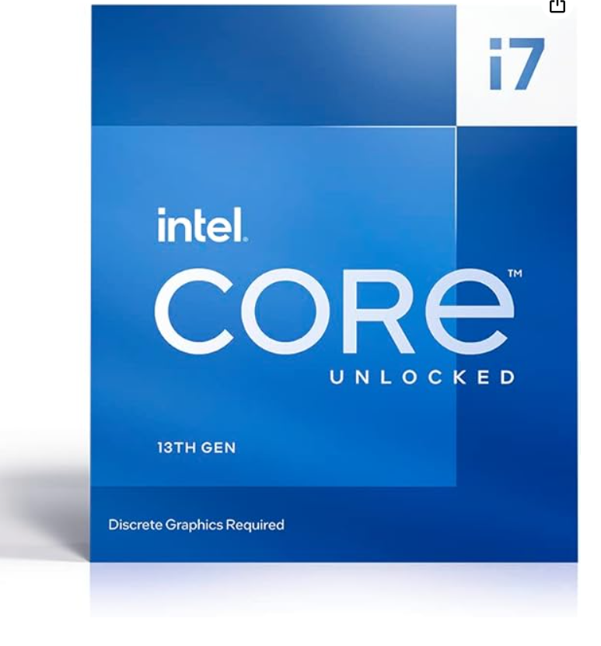
Figure 1 - Intel Core i7-13700KF CPU £330.00 [1]

Image 2 - Motherboard
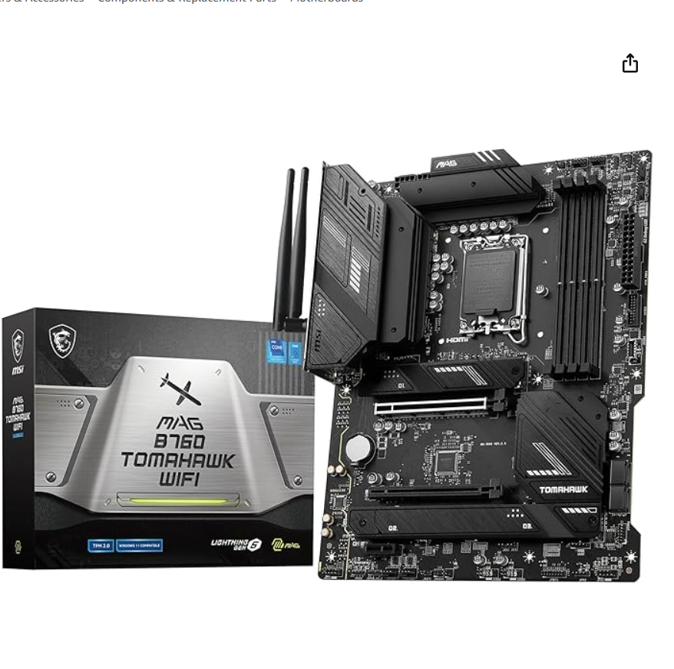
Figure 2 - Tomahawk motherboard £144.99 [2]

Image 3 - RAM
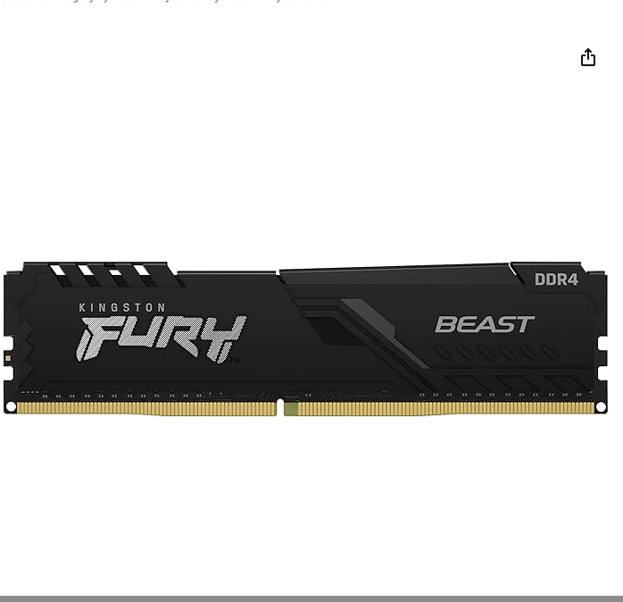
Figure 3 - Kingston Fury RAM 132.76 [3]

Image 4 - Storage
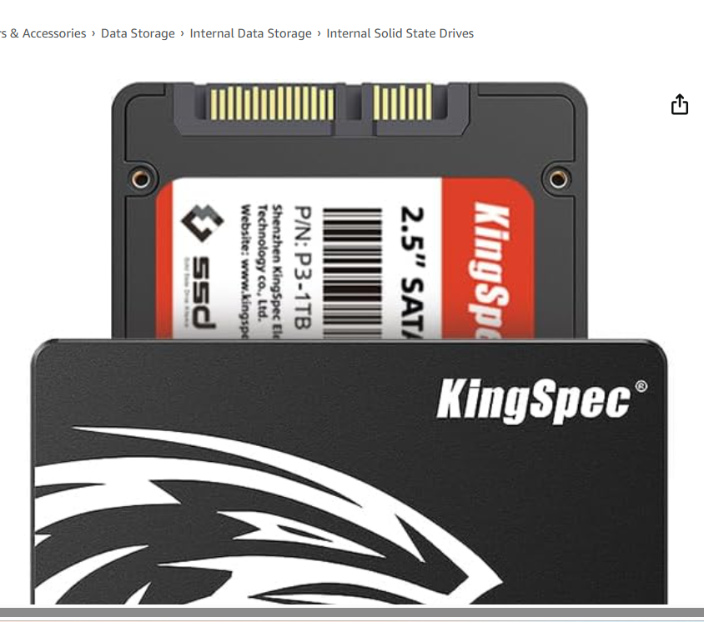
Figure 4 – Storage £119.99 [4]

Image 5 -GPU
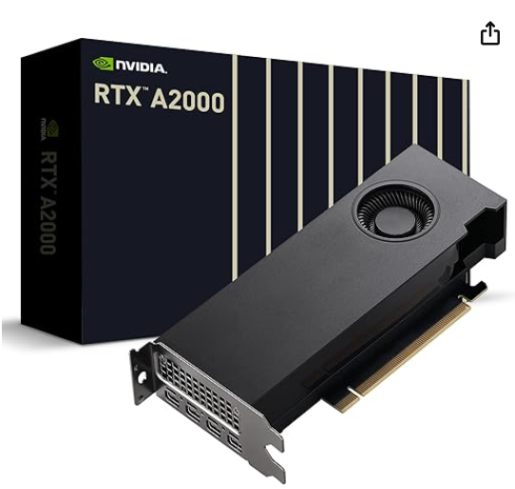
Figure 5 – RTX A200 £379.99 [5]

Image 6 - Power supply
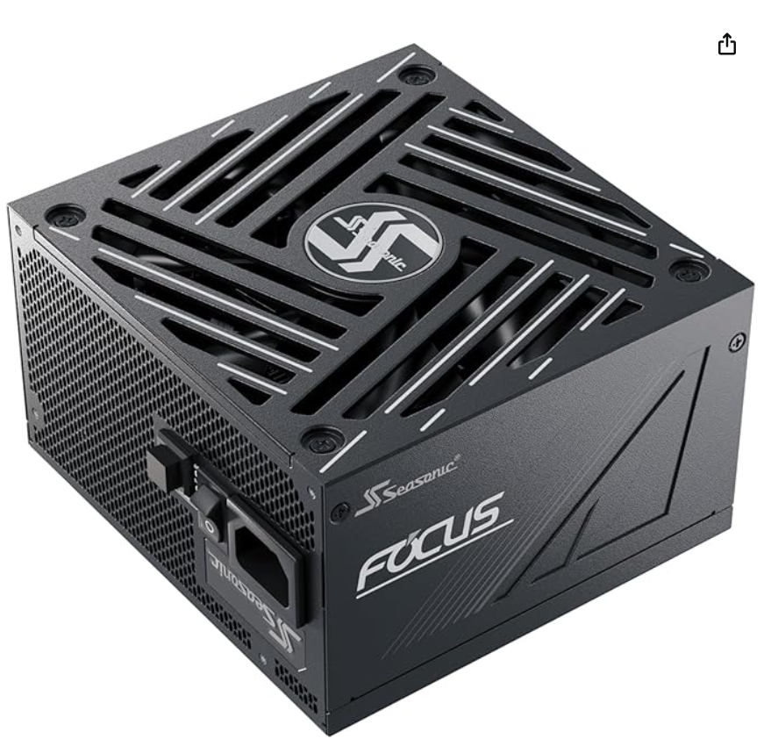
Figure 6 - Seasonic Focus GX power supply £123.98 [6]

Image 7 - Case
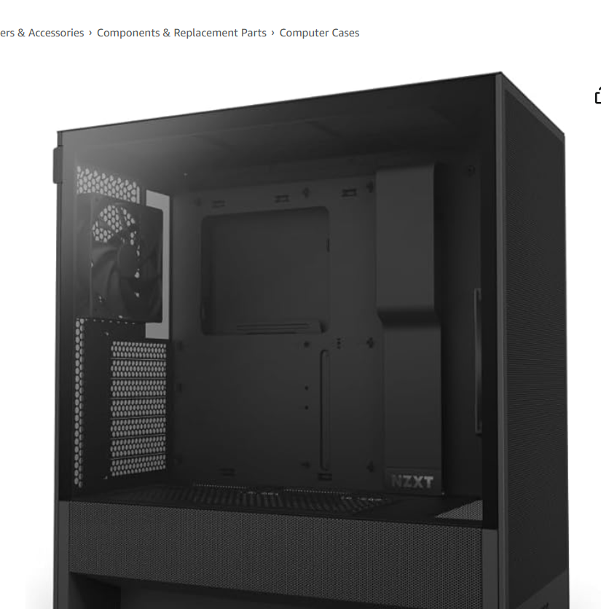
Figure 7 - NZXT H5 Flow £71.99 [7]

Image 8 - Monitors

Figure 8 - MSI PRO MP275 £69.00 [8]

Image 9 - Keyboard, mouse and webcam
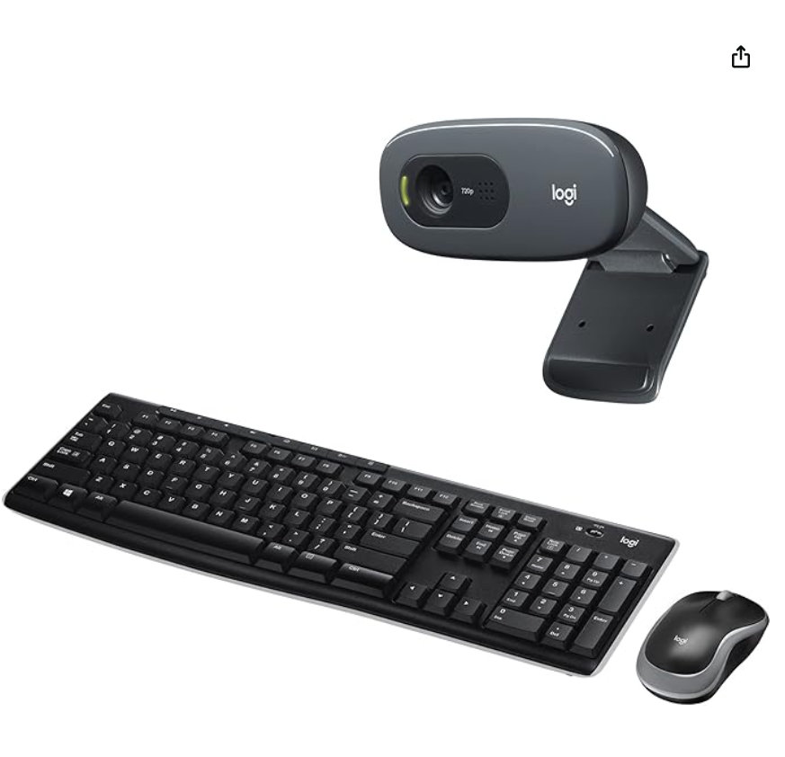
Figure 9 - Logitech mk270 £39.98 [8]

Image 10 - Network connectivity
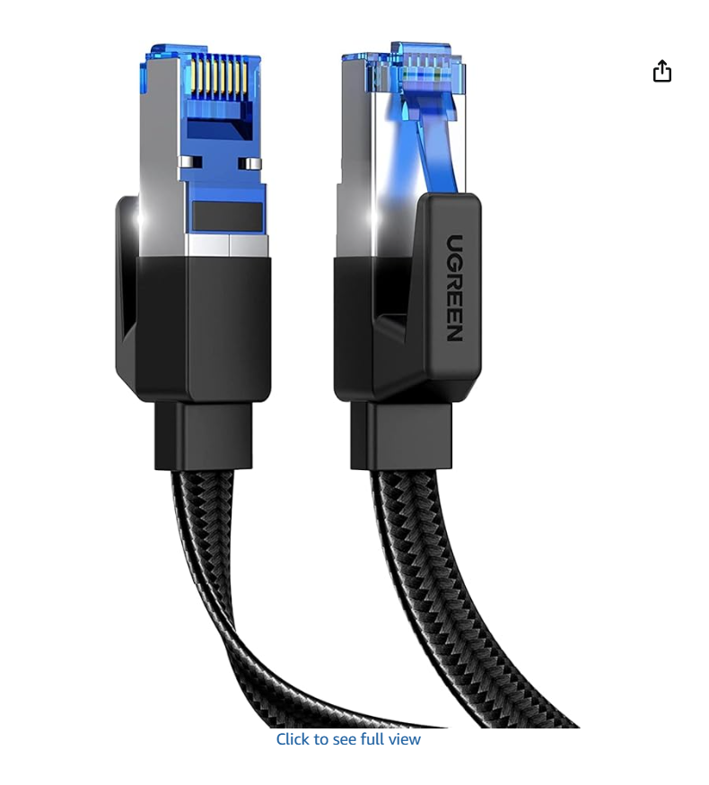
Figure 10 - Ugreen Ethernet cable 2m £6.99 [9]

2.3 - Literature review - Specifications

2.3.1 – CPU
The chosen CPU is the Intel Core i7-13700KF desktop processor, which offers a processing speed of 5.2 GHz. Compared to the Intel Core i7-12700, the number of E-cores has been doubled to 8, meaning that the Intel Core i7-13700 offers up to 24 threads together with its 8 P-cores [10].

2.3.2 – Motherboard
The MSI MAG B760 Tomahawk Wi-Fi was chosen because it supports Intel 12th-, 13th-, and 14th-Gen Core processors. The back panel has various ports, including DisplayPort, USB, HDMI, and HD audio connectors. This motherboard was chosen over the ASRock model for its compact design and comprehensive connectivity support. [11].

2.3.3 – RAM
For RAM, the Kingston Fury Beast 16GB can operate at 3200MHz [12]. One reason this was chosen for this computer design is that it supports Intel systems. This RAM can also provide a powerful performance boost for high-speed requirements, such as design. [13].

2.3.4 – Storage
The King Spec SSD storage offers worry-free storage, low running noise, and vibration resistance. This storage is a good option because of its “enhanced performance, reliability and life span”. This storage performs well under intensive software workloads due to its ability to reduce start-up times [14]. Compared to the HDDs, they are suitable for long-term at-home use.

2.3.5 – Input and output ports
When considering the input and output ports of this desktop computer, the RX 6600 XTs input and output ports are straightforward, with multiple HDMI ports that work effectively with the monitor and the rest of the setup. Making the components selected compatible and efficient when ensuring good working practices [15]

2.3.6 – Graphics card
After researching various graphics cards for this computer design, the Radeon RX 6600 XT MECH 2X 8G OG is the best fit for performance-focused graphics. The graphics card also offers boosted speeds for performance enhancements when running various programs [16]

2.3.7 – Power supply
The Seasonic Focus GX power supply unit features a compact design and is designed for high-power GPUs. This power supply also has a hybrid silent fan control, making this a quiet working system [17] .

2.3.8 – Case
The NZXT H5 Flow Compact Tower Case. The high airflow and black tempered glass design were chosen to support optimal airflow cooling and enhance the computer's aesthetics, with the added benefit of a compact form factor [7]. Other cases did not offer the optimal airflow cooling or the black-tempered glass; this is why the H5 flow case was chosen.

2.3.9 – Monitor, webcam, keyboard and mouse
For easy setup and operation, the Logitech wireless keyboard (for long-range wireless connectivity), Compact mouse (for on-the-go work), and webcam were chosen, and an extended battery life was chosen [8].

2.3.10 – Network connectivity
For connectivity, the UGREEN 2M Ethernet cable was chosen because it is compatible with PCs and laptops. This cable ensures a stable network for data transmission, and due to the compact design of the cable, it allows for easy use and access to the cable [9]. This is an important consideration as applications, online meetings or presentations crashing or buffering are unprofessional when carrying out work. This cable will ensure that the engineer's time is used effectively [18].

2.3.11 – Software
Windows 11 Pro provides a combination of productivity features, remote work capabilities, and security. The SolidWorks Electrical website states that it can run on Windows 11. SolidWorks is the most demanding application among LabVIEW and PSpice, so this PC design will easily handle the load of the other software. The PC will meet the system requirements of the Microsoft Office 365 software [19] and can handle report writing, online meetings and budget preparation.

Task 2: 3.0 - Evaluating Cybersecurity Risks

Introduction- Task 2
Task 2 will focus on evaluating cybersecurity risks and developing strategies to assess and secure systems for a manufacturing company that designs, develops, and produces power distribution equipment for industrial control systems, while prioritising risk within the systems.

3.1 – Identifying and evaluating cybersecurity risks

3.1.1 – Outdated firewall
Having an outdated firewall could allow unauthorised access to sensitive data, and attackers can move more freely across the network once inside. There is also a possibility of exposure of sensitive engineering files, designs and client information. This can then cause knock-on effects, including regulatory and contractual breaches, if the client's data is accessed and leaked. This can cause distrust and a loss of customers and even regulatory fines or lawsuits, which have the potential to destroy a business [19] .

3.1.2 – Outdated firmware
Using outdated firmware can make devices more easily exploited through publicly known vulnerabilities. The use of default passwords allows immediate access, enabling attackers to take control of embedded controllers and physical devices and leading to intellectual property theft. These devices may be used as entry points to attack the wider network [20]. Various firmwares can be affected by this; examples include safety or emergency shutdown alarms, as well as the functioning elements of the operating plant being put in danger.

3.1.3 – International suppliers and weak protection
The second most significant risk to a business is its suppliers, because some international suppliers do not follow secure development or validation practices. Due to remote work, the threat of supply chain attacks increases the risk of malware and tampered components. If the international suppliers did not follow the correct regulations as a business, it could lead to regulatory non-compliance with standards such as ISO 27001 [21]. If this did occur, the impact on client relationships could be catastrophic.

3.1.4 – Limited employee training
Allowing employees to carry out various practices of work without having received adequate cybersecurity training can lead to successful phishing emails, neglecting to conduct security updates and having weak passwords, which can all have a significant impact and allow attackers, if successful, to gain access to sensitive systems [22]. This can become a prevalent issue due to accidental data leaks caused by poor awareness of how to identify unknown emails and suspicious links. This can then have a knock-on effect, increasing the spread of malware across corporate and operational networks.

3.2 – Prioritising Risks

3.2.1 – Outdated firewall risks
A compromised firewall allows attackers to access both corporate and operational systems. In the event of an attack, the severity of the work being compromised is severe and highly likely. Due to the nature of the business and the industry, the work being carried out for various clients, employee data breaches, and ransomware attacks on IT systems. These impacts will harm customer and employee trust and relationships, and the possibility of fines could cause a business to be shut down due to a lack of funds and leaked information.

3.2.2 – International suppliers with weak protection
The second-biggest risk to a business is its suppliers, as they can also affect the integrity of manufacturing processes, including through outdated firmware. Supply chain attacks can compromise hardware and software before they reach the company. However, it poses a greater risk to the supply chain and end-users, leading to unauthorised software modifications and the risk of confidential information leaks.

3.2.3 – Outdated Firmware Risks
Outdated firmware in production has a significant impact; it creates opportunities for vulnerable embedded devices to be hijacked or used as entry points for attacks. Attackers can often scan devices with known vulnerabilities; potential consequences include the manipulation of industrial equipment, such as valves, and the taking of on-site instrumentation and equipment offline. This can cause production downtime as outdated firmware can affect specific devices rather than an entire network.

3.2.4 – Limited Employee Training Risks
The fourth risk a company needs to address is the lack of training provided to its employees. The likelihood of an attack is high given how common phishing emails are for businesses. These are usually easy to detect; however, without training, employees may be unaware of the risks and how these emails can occur, even when the severity of a potential attack using this method is considered low.

3.3 – Cybersecurity Strategy

3.3.1 – Outdated Firewall Strategy
The outdated firewall should be replaced or updated to support modern security features. Another way to mitigate the risk is to ensure that only users within the company have IP access, thereby limiting their exposure. Additionally, a company would benefit from ensuring regular patching. This can help establish a strict schedule for updating firewall software and firmware to patch known vulnerabilities and to repair the flaws [23].

3.3.2 – Outdated firmware strategy
All devices should be updated with new and unique passwords immediately. Additionally, the best way to combat outdated firmware is to maintain an asset inventory to track firmware versions and device status, then isolate vulnerable devices and replace them with new, secure versions.

3.3.3 – International Suppliers with a weak detection strategy
When working with third parties, such as international suppliers, it should be a priority to conduct strict vendor assessments. Additionally, by following development standards such as ISO 27001 [21] can help aid with the assessment. Implementing this assessment will reduce vulnerabilities within the system and ensure that everyone is working to the same standards.

3.3.4 – Limited Employee Training Strategy
To improve the awareness of online safety, continuous cybersecurity awareness and training programs should be implemented to reduce the likelihood of human error and to improve the cybersecurity culture [24]. Implementing the training provides exposure to various types of threats and the different methods hackers use, aiding understanding of the threats and how catastrophic they could be for the business.

3.4 – Incident Response Plan.

3.4.1 – Identify
To produce an incident response plan, the best way to identify an incident is to monitor network traffic for unusual activity. This can include unexpected connections between corporate and OT systems. Checking logs from firewall servers, workstations, and embedded devices for anomalies can help detect and identify a threat, triggering the next phase of containment.

3.4.2 – Containment
To be able to limit the spread of the cyber-attack and prevent further damage to the production systems and the engineering data. The way to contain the threat would be to isolate the affected devices from the network immediately, segment the network to prevent lateral movement between corporate IT and OT systems, following these steps, action should be taken to block malicious IP addresses or domains at the firewall and disable all compromised user accounts and rest passwords to prevent further spread while maintaining essential work and seeking guidance from professionals that can provide support and help report the incident to the relevant communicators.

3.4.3 – Eradication and Recovery
The next stage is to eradicate. It is recommended that the business remove all components affected by the attack, including malware, and address any weaknesses that may have contributed to it. In order to recover, the business should then attempt to restore the system by updating it from a safe backup and by finally performing testing to ensure that there are no threats remaining to the system [25].

3.4.4 – Post Incident Activity
Following the complete defence against the cyber-attack, the business should conduct meetings and reviews in order to be able to highlight how the attack was handled and to be able to develop and progress forward to be able to strengthen the future integrity of the business's cybersecurity [25].

Conclusion:
In conclusion, task 1 offered a detailed approach to the custom desktop computer design developed to meet the electrical engineer's requirements, while taking into consideration the work environment and component selection in terms of performance, cost efficiency, and compatibility.
Task 2 identified the key risks within the organisation, prioritising them based on impact and likelihood, and key vulnerabilities, including outdated systems, weak supply chain security, and limited employee training. A mitigation strategy has been created and supported by an incident response plan, along with the standards that need to be met to ensure that any breaches can be effectively managed and recovered from.

References

[1] | Amazon, “Intel® Core™ i7-13700KF Desktop Processor 16 cores,” 2024. [Online]. Available: https://www.amazon.co.uk/Intel%C2%AE-i7-13700KF-Desktop-Processor-P-cores/dp/B0BG65D6Z2/ref=sr_1_3?crid=2DI82DHSWA5QQ&dib=eyJ2IjoiMSJ9.x6sUSEHhD2RdwF4oXF-0klyEvmGKGa0CFBLs0n1xci3xxeji7Ux_h6ICetc_qpoVRZm5_Oq5jo114YS1RjaVnZ3OCfK1TqdgWncmpZ-ifeMZEIMRaITFr0ZC. [Accessed 13 03 2026].
[2] | Amazon, “MSI MAG B760 TOMAHAWK WIFI Motherboard,” MSI, 14 12 2022. [Online]. Available: https://www.amazon.co.uk/MSI-MAG-B760-TOMAHAWK-WIFI/dp/B0BMM7NZDX/ref=sr_1_5?crid=329QB0KTUCYU6&dib=eyJ2IjoiMSJ9.QIhzZL4-oTy3LvErEKJucYCnJC93zBubaH67AasIIxU1jeGfllZLvmXI_Rha21gWdpukBCQIO6-4jtCl6fkxi4x6PeJQlFea_0AFo8tvSNP4-XOaX7nzhOUiAuFtd77WYDJ7uXGHcwNTKE. [Accessed 13 03 2026].
[3] | Amazon, Kingston, 27 06 2021. [Online]. Available: https://www.amazon.co.uk/Kingston-16-Desktop-Memory-KF432C16BBK2/dp/B097K2MRS3/ref=sr_1_2?crid=CXIU6OGCBH8Y&dib=eyJ2IjoiMSJ9.OUv7W2aNK6jEUfcQYB1mSlvjKOSk_46j6VRAkrd8v0gL0Yr-c8OjzbYbh7iK7JSoPmUtmejecHLnO4PpwJZDZZ2Qup_xpH6AtcKq-JVoEb1M1PFeIC-e7M3slEoZHtgnuh. [Accessed 18 03 2026].
[4] | Amazon, “KingSpec 1TB,” Kingspec, 2026. [Online]. Available: https://www.amazon.co.uk/KingSpec-1TB-SSD-Internal-Computer/dp/B0BKPWQVHV/ref=sr_1_3_sspa?crid=3I3DDS404FOOQ&dib=eyJ2IjoiMSJ9.crPtJ_UFje4ppfJk2uEU_OOzytua2G5uvEUWcCyIM_vBF_8LLgjwtKxzuoodlBJ5Nf0gWriDjOV_dVq89DwtwpoYRowmifIHenUHpdskiat4sUUtvy7suYrMongJrvfci. [Accessed 17 03 2026].
[5] | “Radeon™ RX 6600 XT MECH 2X 8G OC Graphics Card,” Radeon - sold on ebay, 15 03 2026. [Online]. Available: https://www.ebay.co.uk/itm/177942996384?_ul=UK&mkevt=1&mkcid=1&mkrid=710-53481-19255-0&campid=5338353466&toolid=20006&_xiid=177942996384&customid=EAIaIQobChMIt-CTqM2ckwMVw6FQBh1iIBjVEAQYASABEgJBo_D_BwE%7C0AAAAADtppYcdFOuEIJ5eTD_7Pwde3b7on%7CCkEKCQjwyMnNBh. [Accessed 19 03 2026].
[6] | “Amazon,” Seasonic Focus GX power supply unit, 2026. [Online]. Available: https://www.amazon.co.uk/Seasonic-Focus-power-supply-Black/dp/B0DJV6JBPH/ref=sr_1_2?crid=FO3T02LIA4QO&dib=eyJ2IjoiMSJ9.kLB1-bWY_wKOfRfcKQwGNGvnKoCzpIkW7txmujhCvsKp34J1LweBSuHK7HlE83f41cm0uK02yL3CBai8bOnq6CbSLnW4qdsB27GqY8Ab9bL5EZ6VkBa1WkPOCobES_ddcOzyV68y. [Accessed 19 03 2026].
[7] | Amazon, “NZXT H5 Flow,” NZXT, 2024. [Online]. Available: https://www.amazon.co.uk/NZXT-H5-Flow-Mid-Tower-Management/dp/B0D2MK6NML/ref=sr_1_1?crid=1NG64QJ4QG5WM&dib=eyJ2IjoiMSJ9.4UX1GbEeXBLcOxOEDwUui0BbMXQx4CvAcUXNFn0jJwUxTxn1UZNkPuMVty4NfMkKG_l-oq_SbG10DjiIEo0bzfBB_YKFwNK6QUNBg8kzoVbxkBdcH4vRa_wTfYNpL7V1hBLaC0e. [Accessed 19 03 2026].
[8] | Amazon, “Logitech MK270 Wireless Keyboard and Mouse Combo for Window,” Logitech, 2025. [Online]. Available: https://www.amazon.co.uk/Logitech-Wireless-Keyboard-Windows-Webcam/dp/B07YZYCFQZ/ref=sr_1_3?crid=3IE0YZ4IDVOXI&dib=eyJ2IjoiMSJ9.kPlX5QwwDSp642BtkgDqfR7PlPWcP4IJgjLPSM5Naq2a2hLcZabNEZ2tjnG5I2VNB1WOQjT9LYXroy0BXabt-zulOpmxIsyjr0mxcxnJFXEKX_UmwLzsQJZUk5eIP60. [Accessed 19 03 2026].
[9] | Amazon, “UGREEN Ethernet Cable 2M, Cat 8 Internet Cable,” UGREEN, [Online]. Available: https://www.amazon.co.uk/UGREEN-Ethernet-Internet-Compatible-Raspberry/dp/B08W299VLT/ref=sr_1_3_sspa?crid=9VJT59ACK44G&dib=eyJ2IjoiMSJ9.jdSacVHHiRwEhXFHdYaIwB-VR4cTCleevSpmrFRyx47sWDFrTyWd1qdnGIr1jtKAumVVDLI5Li1FSdROX-SPmlrfO0xY0TH6uoGLuvDOcgzsSnQOZG53b7E. [Accessed 19 03 2026].
[10] | notebook check, “Intel Core i7-13700,” 08 01 2026. [Online]. Available: https://www.notebookcheck.net/Intel-Core-i7-13700-Processor-Benchmarks-and-Specs.768846.0.html. [Accessed 11 03 2026].
[11] | MSI, “MAG B760 TOMAHAWK WIFI,” MSI, 2026. [Online]. Available: https://www.msi.com/Motherboard/MAG-B760-TOMAHAWK-WIFI/Specification#:~:text=Chipset%2C%20INTEL%20B760.%20CPU%2C%20Support%20Intel%C2%AE%20Core%E2%84%A2,Intel%C2%AE%20Pentium%C2%AE%20Gold%20and%20Celeron%C2%AE%20Processors%20LGA1700.. [Accessed 17 03 2026].
[12] | Kingston , “Kingston fury memory module specification,” Kingston Technology Corporation, 2022.
[13] | mroecoco, “Kingston memory RAM,” Kingston, 2026. [Online]. Available: https://www.morecoco.co.uk/a?pid=KF432C16BB1%2F16%3E%3EKingston#:~:text=Kingston%20FURY%E2%84%A2%20Beast%20DDR4,Intel%20or%20AMD%2Dbased%20system.. [Accessed 18 03 2026].
[14] | KingSpec, “P3 Series SSD,” KingSpec, 2025. [Online]. Available: https://www.kingspec.com/product/25-inch-sata-ssd-p3-series.html. [Accessed 19 03 2026].
[15] | ASUS, “ASUS Dual Radeon™ RX 6600 XT,” ASUS, 2026. [Online]. Available: https://www.asus.com/motherboards-components/graphics-cards/dual/dual-rx6600xt-o8g/. [Accessed 11 03 2026].
[16] | MSI, “Radeon™ RX 6600 XT MECH 2X 8G OC,” 2026. [Online]. Available: https://www.msi.com/Graphics-Card/Radeon-RX-6600-XT-MECH-2X-8G-OC/Specification#:~:text=Here%20are%20some%20specifications%20for%20the%20MSI,/%20Package)**%20721%20g%20/%201188%20g. [Accessed 19 03 2026].
[17] | Seasonic, “FOCUS GX-750,” 2026. [Online]. Available: https://seasonic.com/focus-gx/. [Accessed 19 03 2026].
[18] | Amazon, “UGREEN Ethernet Cable 2M, Cat 8 Internet Cable,” UGREEN, 2026. [Online]. Available: https://www.amazon.co.uk/UGREEN-Ethernet-Internet-Compatible-Raspberry/dp/B08W299VLT/ref=sr_1_3_sspa?crid=9VJT59ACK44G&dib=eyJ2IjoiMSJ9.jdSacVHHiRwEhXFHdYaIwB-VR4cTCleevSpmrFRyx47sWDFrTyWd1qdnGIr1jtKAumVVDLI5Li1FSdROX-SPmlrfO0xY0TH6uoGLuvDOcgzsSnQOZG53b7E. [Accessed 19 03 2026].
[19] | S. Pagnotta, “5 risks of outdated software and operating systems,” BITSIGHT, 20 09 2024. [Online]. Available: https://www.bitsight.com/blog/outdated-software-issues. [Accessed 07 04 2026].
[20] | EC-Council , “Firmware security risks,” 28 02 2023. [Online]. Available: https://www.eccouncil.org/cybersecurity-exchange/penetration-testing/firmware-security-risks-best-practices/#:~:text=While%20the%20firmware%20in%20most,making%20them%20easier%20to%20exploit.. [Accessed 08 04 2026].
[21] | ISO, “ISO/IEC 27001,” International standards, 2022. [Online]. Available: https://www.iso.org/standard/27001. [Accessed 08 04 2026].
[22] | Techclass, “Cubersecurity training for remote employees,” 07 01 2026. [Online]. Available: https://www.techclass.com/resources/learning-and-development-articles/cybersecurity-training-for-remote-employees-best-practices#:~:text=According%20to%20industry%20research%2C%2064%25%20of%20organizations,outside%20the%20protective%20bubble%20of%20the%20. [Accessed 09 04 2026].
[23] | WYSE travel confederation, “The importance of regular software updates and patch management,” WYSE News , 03 06 2025. [Online]. Available: https://www.wysetc.org/2025/06/the-importance-of-regular-software-updates-and-patch-management/#:~:text=What%20is%20patch%20management%2C%20anyway,the%20breach%20involved%20personal%20data. [Accessed 11 04 2026].
[24] | National Cyber Security Centre , “Help your staff kepp organisation safe online,” NCSC, 19 05 2025. [Online]. Available: https://www.ncsc.gov.uk/information/top-tips-for-staff#:~:text=The%20NCSC's%20*Top%20Tips%20for%20Staff*%20is,training%20platform**%20*%20**Complete%20the%20training%20online**. [Accessed 12 04 2026].
[25] | Fortinet, “How structed cybersecurity incident management improves organizatoinal resilience.,” 2025. [Online]. Available: https://www.fortinet.com/lat/resources/articles/cybersecurity-incident-management#:~:text=The%20Eradication%20Phase%20of%20Cyber,applying%20patches%20to%20fix%20vulnerabilities.. [Accessed 12 04 2026].

