Name: Lachezar Dimitrov
Student ID:1915922
Module Code: LCBB 4003
Module name: Introduction to the Modern Workplace
Assignment 1
Lecturer: Hoang Dang Nguyen

INTRODUCING THE MODERN WORKPLACE

Table of Contents

Introduction 3
Overview of the company 3
The relation between organisational performances with culture and structure to meet the organisational goals 4
Role of management (both functions and process) to develop organisational performance 6
The way different factors can influence individual behaviour in the workplace: 7
Conclusion 8
Recommendations 9
References: 10

Introduction
The development of a modern workplace depends on the organisation's culture and the placement of business goals with the help of a positive work environment. It is the efficiency of the leadership that focuses on managing the organisation's culture as well as the development of new innovative strategies to maintain the goal of future growth of the company effectively. Organisation and performance also depend on the collaboration and innovation of the people who are dedicating their time and efforts to the company. The airline industry specifically depends on hospitality management which requires positive-minded employees to support the goal of the company culture. The aim of this report is to analyse the organisational performance of British Airways to maintain its goal as per the culture and structure of the company. Moreover, the report will also focus on the responsibilities of Management for increasing organisation performance along with the behavioural approach which makes the difference between every member of the company effectively.

Overview of the company
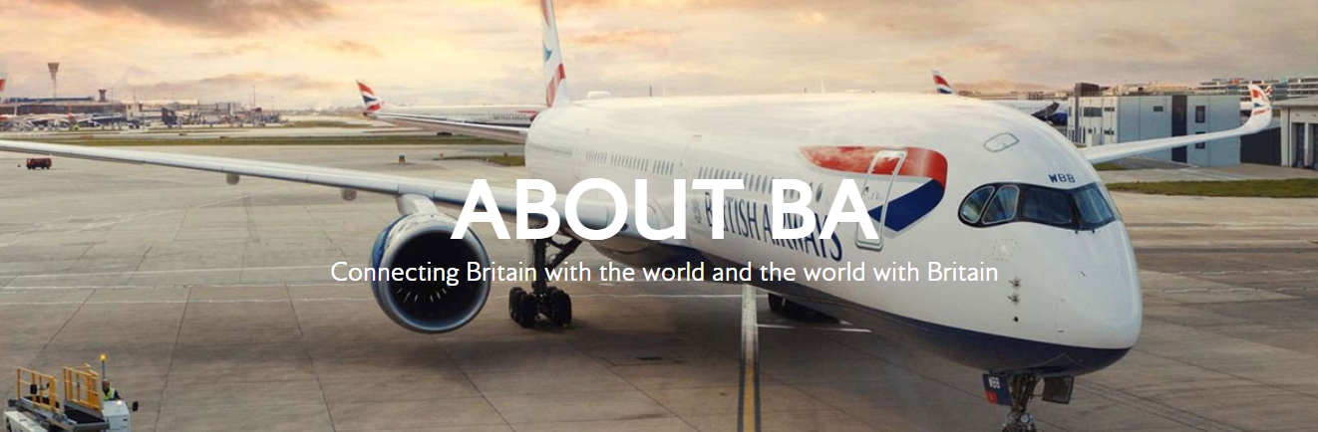
Figure: British Airways Home Page
(Source: About BA, 2022)

British Airways is a global airline company that focuses on enhancing diversity and inclusion with its company culture for more than 100 years. Serving the community and the planet is the main target of British Airways for which the company focuses on sustainability effectively (About BA, 2022). The CEO of British Airway, Sean Doyle believes in the support of the consumers which has made the reputation of British Airways as one of the reputed air service providers in the whole world. The company also focuses on maintaining its Mission by releasing carbon emissions within 2050 (About BA, 2022).
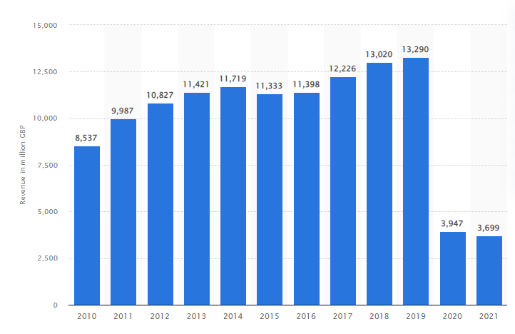
Figure: British Airways Plc's worldwide revenue in 2021
(Source: Statista, 2022)
British Airways generated 3.7 billion British pounds in revenue in 2021 (Statista, 2022). Approximately 30000 people currently working in British Airways always focus on developing the brand reputation by increasing the effective customer experience strategies through positive cultural support (Bloomberg, 2022).

The relation between organisational performances with culture and structure to meet the organisational goals
Organisational culture is one of the important factors in developing the organisation's goal to enhance its position in the competitive market. In this factor, the organisational performance is related to the development of the target of the company to meet the profitability and the product ability effectively. British Airways focuses on a culture that embraces diversity and inclusion in the organisation and culture while developing the goal of managing the efficiency in employee engagement for better customer support.
Hofstede’s cultural dimensions can help in developing the analysis of the organisational culture of British Airways which supports the performance of employees.
- Power Distance Index (high versus low): British Airways has loose hierarchical dimensions which are not as strict as can reduce the efficiency of the employees to work under any pressure. Information sharing is one of the important parts of British Airways for which the employees feel motivated and supported to meet the goal of the company with a collaborative work environment (O’Neill, 2018).
- Individualism Versus Collectivism: individualism versus collectivism shows the preference of different perspectives of approaches which impacts organisational performance. Individualism is one of the top parts of the company for which age and every employee of British Airways have the opportunity to be self-reliant and take the initiative to support the personal goals to meet the target of the company effectively (Ahmed et al. 2020).
- Masculinity Versus Femininity: masculinity versus femininity is also one of the important parts of Hofstede’s cultural analysis which focuses on the preference for any specific gender in any organisation. Masculinity represents personal accomplishment, high efforts and aggressiveness towards developing monetary support while femininity represents modesty, humble attitude and care for society (Quinn and Thakor, 2019). British Airways focuses on masculinity values in the organisation and culture as every employee is very much competitive and focuses on aggressive ambitious achievements to enhance personal accomplishment through work.
- Uncertainty Avoidance Index (high versus low): The uncertainty avoidance index showcases the uneasiness to avoid situations which are unpredictable and ordinary. The uncertainty index is low as British Airways focuses on innovative strategies to enhance the consistency of development for the betterment of the company's growth and customer engagement.
- Long- Versus Short-Term Orientation: British Airways focuses on short-term orientation as it helps in achieving success against the business issues in the external environment (Efthymiou et al. 2018). The rapid changes in the agile business market support the short-term orientation with support to the business performance of the company.
- Indulgence Versus Restraint: indulgent culture is the main priority of British Airways for which employees received benefits of flexible working which supports the growth of quality of work (Lange et al. 2015).
The cultural analysis of British Airways showcases the factor the company has the potential capability to maintain the organisation's performance with an integrated company culture that is more focused and goal-oriented. British Airways also focuses on maintaining a positive work culture for the betterment of high productivity and employee engagement for better performance.
The organisation structure is also one of the important parts of developing the business performance while meeting the goals. British Airways focuses on a tall structure with a responsible management level which is important for managing the customer focus business while engaging the employees for better performance (Coller, Helms Mills, and Mills, 2016). The company has autocratic leadership styles that support centralised decision-making. The company focuses on the segmentation of different organisational functions and maintaining formal employee management relationships that help in achieving the goal in an organised manner.
However, British Airways provides the opportunity to every employee to get the facility of flexibility of working which enhances the management of employee motivation for their work practices. The organisation is more supportive of its organised structure by providing effective resources to the employees and supporting them for enhancing the highest satisfactory level (TAYLOR and WILKINSON, 2022). The goal of the organisation is to maintain the reputation of British Airways as well as provide a based customer support experience for which the company provides all kinds of resources to the people working there to enhance, they are efficient for better customer support.

Role of management (both functions and process) to develop organisational performance
Managers or leaders play a vital role in managing the process and functions of any organisation. It is the efficiency of a leader that develops effective goal setting for the whole team to achieve success through dedication and high productivity. Organisational performance is related to the efficiency of the leaders in managing the tasks and assigning them to the respective employees for better work. The main role of the leaders is to develop the SMART (specific, measurable, attainable, relevant and time-bound) goals to achieve the target and include every team member to work on the target (Ishak, Fong, and Shin, 2019). The goals are developed by effective decision-making and upon the analysis of the current situation and the competitive market. The managers play an important role in motivating the employees to form a better work process. It is the responsibility of the leaders to understand the needs of all the employees and provide them with the best resources so that they can perform their work effectively (Chaudhary, 2020). The management of the work process is maintained by the leaders with their skills and qualities so that the employees Gate the innovative pathway for completing the goal of the task.
Moreover, the management of different basic needs of employees is also the part of the management which helps in maintaining the effective functions of the work. The managers of British Airways focus on analysing the needs of all the employees with the help of Maslow's hierarchy of needs.
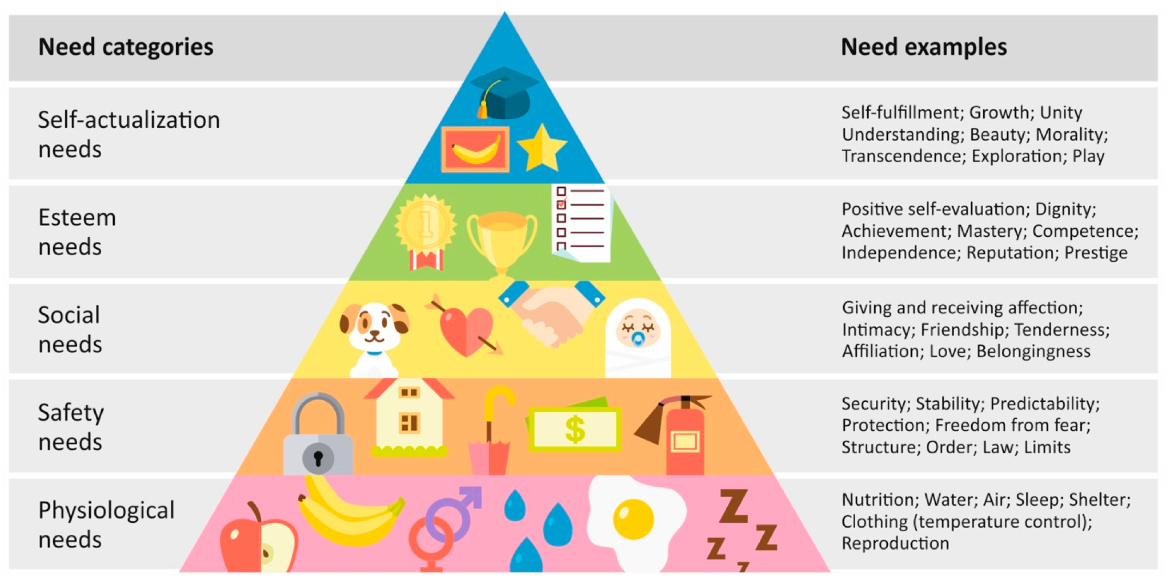
Figure: Maslow's hierarchy of needs
(Source: Desmet and Fokkinga, 2020)
There are five components of the hierarchical pyramid: starting with the basic physiological, safety, love and belonging needs, self-esteem, and self-actualization (Kalawilapathirage, Omisakin, and Zeidan, 2019). Through analysis of the needs of the employees, the managers take effective support to provide them with opportunities while maintaining cultural diversity to sustain the appropriate performance which helps in developing the goal of the company.

The way different factors can influence individual behaviour in the workplace:
The behavioural approach is an important factor to develop the goal of the management practices for performance growth. The behaviour approach is one of the important parts of measuring the performance of employees. There are various methods of behavioural approach which supports the development of span of employee control, satisfaction and turnover rate of the employees. The behaviour approach supports the managers to understand different behaviours of employees and measure the performance as per their efficiencies. In this factor, employee satisfaction and performance appraisals are the important factors which promote the organisation's productivity and profitability effectively. the following factors are relevant for the behavioural approach:

- Reward and recognition: There are different factors which impact the behaviour management of any employee in any workplace. Rewards and recognition are one of the great factors that impact the development of employee performance (Rai et al. 2018). British Airways provides the appropriate scope to every employee to showcase their talents which helps in managing the opportunity to get the appraisals for their performances to motivate the employees for better work.
- Effective communication: The efficiency of the employees is also developed with the communication strategies of leaders (Nwabueze and Mileski, 2018). Positive communication motivates the employees which also helps in maintaining dignity and respect in the positive work culture while supporting performance development effectively.
- Diversity and equality: The maintenance of diversity and inclusion are also important factors to develop the eloquence of performance as it supports the diverse cultures of employees from different societies and communities. British Airways focuses on maintaining the diversity of cultures while respecting all the people in the organisation with equal rights. This is one of the effective factors to enhance the goal of performance management while enhancing positivity in the environment.
- Positive company culture: The development of employee-oriented policies and regulations helps in developing the behaviour and approach of employees which supports the engagement of integrity in the work environment (Cho, Chung, and Young, 2019). Zero discrimination and maintenance of equal opportunity while providing the scope to learn new skills help in changing the positive behavioural approaches of employees of British Airways (British Airways, 2022). It is effective in developing and measuring employee performance management.
- Inclusion in decision making: The inclusion of all the employees is also maintained by the company to enhance performance while boosting the positive behavioural approach (Dos Santos et al. 2019). The inclusion in the decision-making process helps in maintaining positivity among the employees to express their suggestions and ideas for the development of the company. This is one of the innovative ways that is maintained by the management of British Airways which supports the positive dedication of the employees for better performance.

Conclusion
The importance of the modern workplace is an important part of the highly changing business environment. The organisation's culture and the commitment of the managers towards the positive support to the employees help in maintaining the goal of employee engagement as well as performance management effectively. British Airways is a renowned company that focuses on managing the efficiency of the leaders to provide the best support to employee performance management with innovation and appropriate strategies.

Recommendations
British Airways is one of the reported companies that focuses on the development of efficiency in managing performance and the goals of employee engagement. The company also can focus on the following factors to enhance employee performance and maintain a modern workplace in this competitive market
Effective planning: effective planning is important to manage the work pressure and the shifting of different responsibilities among the employees in the airline industry (Parke et al. 2018). Customer management is one of the effective factors for which the company needs to focus on maintaining the goal through analysing the requirements so that employees can be motivated towards achieving those goals for the betterment of productivity as well as profitability.
Skill development: In this highly developing industrial era it is important to keep the skills up to date for meeting the requirements of the customers as well as the market needs (Kalra et al. 2020). The company can focus on continuously checking the skills and qualities of the employees by applying the innovative strategies to provide the best resources for the growth of the performance
Feedback collection: Moreover, feedback collection is also one of the important parts of maintaining the high performance of the employees (Marques-Quinteiro et al. 2019). The regular feedback collection can help in reducing the country of the employees and they will also be motivated by the positives of the company which can reflect in their work activities.

References:
About BA, 2022. About BA. [online] Available at: <https://www.britishairways.com/en-in/information/about-ba?source=BOT_about_ba> [Accessed 1 September 2022].
Ahmed, J.U., Hasan, M.K., Hossain, M.A., Uddin, M.J. and Noor, R.I., 2020. Managing stakeholder emotions and cultural differences during crisis: lessons from four different countries. International Journal of Work Organisation and Emotion, 11(2), pp.120-139.
Bloomberg, 2022. Bloomberg - Are you a robot?. [online] Bloomberg.com. Available at: <https://www.bloomberg.com/news/articles/2021-11-09/british-airways-to-hire-4-000-in-reversal-of-covid-era-cuts#:~:text=BA%20currently%20employs%20about%2030%2C000,would%20boost%20headcount%20almost%2015%25> [Accessed 1 September 2022].
British Airways, 2022. PEOPLE. [online] British Airways. Available at: <https://www.britishairways.com/en-gb/information/about-ba/ba-better-world/people> [Accessed 2 September 2022].
Chaudhary, R., 2020. Green human resource management and employee green behavior: an empirical analysis. Corporate Social Responsibility and Environmental Management, 27(2), pp.630-641.
Cho, S.J., Chung, C.Y. and Young, J., 2019. Study on the Relationship between CSR and Financial Performance. Sustainability, 11(2), p.343.
Coller, K.E., Helms Mills, J. and Mills, A.J., 2016. The British Airways heritage collection: An ethnographic ‘history’. Business History, 58(4), pp.547-570.
Desmet, P. and Fokkinga, S., 2020. Beyond Maslow’s pyramid: introducing a typology of thirteen fundamental needs for human-centered design. Multimodal Technologies and Interaction, 4(3), p.38.
Dos Santos, P.H., Neves, S.M., Sant’Anna, D.O., de Oliveira, C.H. and Carvalho, H.D., 2019. The analytic hierarchy process supporting decision making for sustainable development: An overview of applications. Journal of cleaner production, 212, pp.119-138.
Efthymiou, M., Njoya, E.T., Lo, P.L., Papatheodorou, A. and Randall, D., 2018. The Impact of Delays on Customers' Satisfaction: an Empirical Analysis of the British Airways On-Time Performance at Heathrow Airport. Journal of Aerospace Technology and Management, 11.
Ishak, Z., Fong, S.L. and Shin, S.C., 2019, October. SMART KPI management system framework. In 2019 IEEE 9th International Conference on System Engineering and Technology (ICSET) (pp. 172-177). IEEE.
Kalawilapathirage, H., Omisakin, O. and Zeidan, S., 2019. A Data Analytic Approach of Job Satisfaction: A Case Study on Airline Industry. Journal of Information & Knowledge Management, 18(01), p.1950003.
Kalra, A., Agnihotri, R., Talwar, S., Rostami, A. and Dwivedi, P.K., 2020. Effect of internal competitive work environment on working smart and emotional exhaustion: the moderating role of time management. Journal of Business & Industrial Marketing.
Lange, K., Geppert, M., Saka‐Helmhout, A. and Becker‐Ritterspach, F., 2015. Changing business models and employee representation in the airline industry: A comparison of British Airways and Deutsche Lufthansa. British Journal of Management, 26(3), pp.388-407.
Marques-Quinteiro, P., Vargas, R., Eifler, N. and Curral, L., 2019. Employee adaptive performance and job satisfaction during organizational crisis: the role of self-leadership. European Journal of Work and Organizational Psychology, 28(1), pp.85-100.
Nwabueze, U. and Mileski, J., 2018. Achieving competitive advantage through effective communication in a global environment. Journal of International Studies, 11(1).
O’Neill, B., 2018. Developing future leaders at British Airways. In The Photofit Manager (pp. 72-89). Routledge.
Parke, M.R., Weinhardt, J.M., Brodsky, A., Tangirala, S. and DeVoe, S.E., 2018. When daily planning improves employee performance: The importance of planning type, engagement, and interruptions. Journal of Applied Psychology, 103(3), p.300.
Quinn, R.E. and Thakor, A.V., 2019. The economics of higher purpose: Eight counterintuitive steps for creating a purpose-driven organization. Berrett-Koehler Publishers.
Rai, A., Ghosh, P., Chauhan, R. and Singh, R., 2018. Improving in-role and extra-role performances with rewards and recognition: does engagement mediate the process?. Management Research Review.
Statista, 2022. Worldwide revenue of British Airways 2010-2021 | Statista. [online] Statista. Available at: <https://www.statista.com/statistics/264296/british-airways-worldwide-revenues-since-2006/> [Accessed 1 September 2022].
TAYLOR, S. and WILKINSON, K., 2022. The people management business environment. Studying Human Resource Management: A Guide to the Study, Context and Practice of HR, p.21.

