The Labours of the Months, September
from
The Book of Hours of Louis XII of France

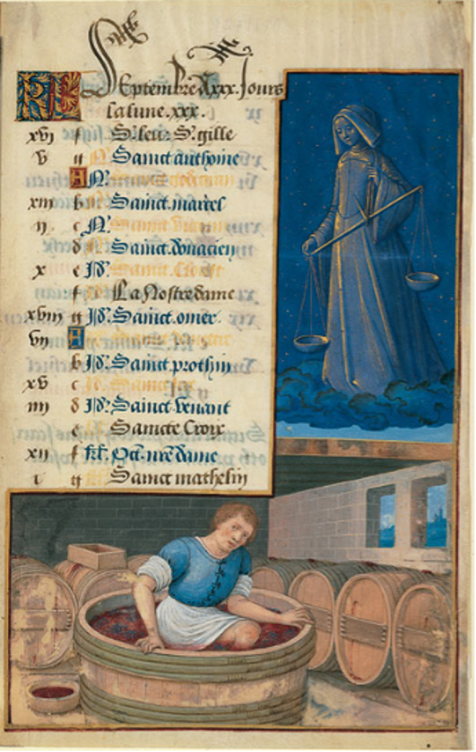

Philadelphia, The Free Library of Philadelphia, Lewis E. M. II 19-22v (September).

The Book of Hours of Louis XII of France was believed to have been produced in 1498 by the court artist Jean Bourdichon. It was patronised by King Louis himself and is believed to be an accompaniment to an almost-identical Hours that was also produced by Bourdichon for Louis’ second wife, Anne of Brittany [see Figure 1]. Often wrongly attributed to King Henry VII of England, the Hours have since been dissembled and are now incomplete. The Hours play a significant role in the visual culture of the time and can tell us much about the function of Books of Hours in Europe during the fifteenth century. As well as its influence on visual culture, I shall also explore its provenance, limitations and authorship in this commentary. In particular, I have chosen to comment upon the month of September for this exercise.
Books of Hours in the Middle Ages were items intended for personal devotion and prayer. They followed the Roman Catholic liturgical year and were principally used to record the feast days of saints, particularly those that patrons may have had some personal devotion to. They may have also been used to record daily prayers in the form of religious services and included devotional texts, although in the case of the Hours of Louis XII these have not survived. We know from other surviving leaves of the Hours that Louis certainly had a personal devotion to the Virgin Mary, as well as saints Louis, Michael and Charlemagne, who were the patron saints of France. This personal devotion is also evident from the list of saints that have been recorded for the month of September. These saints, whose names have been written in gold, blue and black ink appear to be largely of French significance, including St Omer and St Anthoine. The alternating colours of gold, black and blue could potentially represent a hierarchy, with certain colours representing the saints of most importance to the personal piety of King Louis XII. However, it is worth mentioning that the black ink seems to represent place names such as ‘La Notre Dame’ and the monastic community of ‘Sainte Croix’, places that Louis may have been familiar. On the other hand, it may have simply been a stylistic decision by Bourdichon, and indeed the Great Hours of Anne of Brittany have been illuminated in a similar way.
The calendar of saints’ feast days is accompanied by an illumination which depicts a male vintner in the process of pressing grapes underfoot in the manufacturing of wine. This is significant in that it follows the typical medieval convention where the labours of the month of September in Books of Hours would depict a harvest of some form. According to the historian Spagenburg, “the most common image for the labours of the month for September is the grape harvest in warmer climates and sowing seeds and/or plowing in cooler climates”. Certainly, the Great Hours of Anne of Brittany includes a near-identical illumination with a vintner treading grapes, as do many other medieval Books of Hours that similarly depict grape-pressing as the main labour for the month of September. It is probable therefore that Jean Bourdichon was simply following stylistic traditions and medieval precedents in the process of illuminating the Hours.
However, I would argue that the illumination of the vintner is significant for another reason. King Louis XII was credited with the revival of the economy in France following the impact of The Hundred Years War which had sparked an “economic recession and demographic collapse”, particularly affecting agricultural societies. His success in the restoration of the economy came to be deemed as a “golden age for the French peasantry”, which eventually led to Louis adopting the epithet of ‘Le Pere de la People’. This leads me to believe that the Hours of Louis XII had been illuminated with miniatures purposely reflecting the revitalisation of the labouring classes and the economy, and that it had been intended by Jean Bourdichon as a celebration of his achievements as king. Certainly, the fact that the Hours were produced thirty years after Louis had assumed the throne suggests to me that it had been commissioned as a celebratory piece that heralded his achievements.
The Hours appear to be written in Gothic cursive script, and is in French, which is unusual as most medieval Books of Hours were written in Latin, the language of Roman Catholicism. This further supports the idea that Louis XII had patronised the Hours for his personal devotion. However, the foliated initials of ‘KL’ at the top of the page presumably stands for ‘kalends’, the Latin for ‘calendar’, that is traditionally included in medieval Books of Hours. There are other aspects of the Hours which seem to suggest that Louis had some input in the commissioning of its illuminations. The castle and the location in the foreground, for example, represent Western France according to the art historian Janet Backhouse, an area that Louis had a personal connection to. Additionally, the female figure of Libra is dressed in the French fashion, echoing the influences of the French court. This inclusion of Libra, an astrological figure, suggests to me that Louis had a personal interest in astronomy and the lunar calendar, especially since she is the centre point of the page. However, it does appear that many French Books of Hours included similar motifs, so that one could ascertain what month it was by considering this symbolism [see Figures 1 and 2].
The illumination is within a golden frame, which I believe was intended by Bourdichon to present the miniature more like a painting rather than a manuscript illumination. Additionally, Bourdichon’s application of the trompe-l’oiel artistic style gives the miniature an almost three-dimensional quality. Janet Backhouse takes this one step further, arguing that the size of the miniature (which is referred to as a ‘large’ miniature), confirms that the Hours were intended to be displayed and viewed more like a traditional painting. With this in mind, it potentially suggests that the Hours were intended as a form of public art, rather than an item of personal piety, and that it also potentially suggests that the Hours would have been displayed to an audience, and that it was not as personal to King Louis as was originally believed.
In terms of its composition, the devotional texts within the Hours have been destroyed, with only a handful of the liturgical calendars and miniatures remaining. Despite this, the Hours are in good condition and with very minimal damage. The ‘large’ miniatures are painted in oil on parchment, a costly material that would have retained the pigments of the paint better than other materials traditionally used in the composition of medieval Books of Hours. The manuscript is decorated with various pigments, including embossed gold leaf, crimson and blue, reflecting the wealth of its patron.
The Hours were illuminated by Jean Bourdichon, a court painter who served four French monarchs in succession. During the reign of Louis XII, Bourdichon had enjoyed an “unprecedented success at court”, no doubt bolstered by his illuminations of not only Louis’ personal manuscript, but also that belonging to his wife, Anne of Brittany. This patronisation that Bourdichon enjoyed would have put him in a “privileged proximity to royal power”, that was only furthered by his work on the design of coins, stained glass and other artistic forms during Louis’ reign. We must remember that visual culture in Europe at the turn of the sixteenth century saw a shift from medieval precedents and had evolved into what would eventually become known as the ‘Renaissance’. Indeed, France at the time of Louis’ reign was the “principal centre of art and culture in Europe”, of which Bourdichon greatly contributed to through the art that he had produced during this time.
Arguably, we could potentially look at this source through a revisionist lens and argue that Bourdichon was serving an agenda in his creation of the Hours of Louis XII. Bourdichon has possibly intended for Louis’ power and influence as monarch to reflect in the Hours, and that the manuscript had been illuminated on behalf of Bourdichon as a personal display of loyalty to the king. The costly materials used in the composition of this manuscript, as well as the celebratory stance that Bourdichon appears to have taken while illuminating the Hours certainly reflects the “golden era” by which Louis’ reign came to be known. In my opinion, as this quote from the art historian Carroll demonstrates, Louis’ Hours reflect the “chivalric revival” that had occurred in France during his reign, and that it also represents the shift away from the Middle Ages, and into the Renaissance.
The source certainly has its limitations. Perhaps the most significant of these is that the Hours has been dissembled and is now considered incomplete. This would prove to be a significant difficulty for an historian wishing to study the Hours, particularly because what does survive is now located in various repositories around the world. Of the thirty-six original illuminations, calendars and pages of devotional texts, only sixteen are believed to survive. Another issue that arises is that the majority of these surviving leaves are illuminations or calendars, and that very little of the text has survived. This raises many questions, such as had the Hours ever been annotated, and why do these specific illuminations and miniatures remain? Which devotional texts would the original manuscript have included, and have only the most symbolic and important of these leaves been preserved?
The art historian Janet Backhouse wrote that the Book of Hours of Louis XII had appealed to the “flamboyant tastes of nineteenth-century connoisseurs”. This suggests to me that the manuscript had been dissembled, with only the most visually appealing of the illuminations to survive, and was sent to collectors and buyers across the world. It is known for example, that Samuel Pepys and King George II had acquired the illuminated leaves of the Hours of Louis XII, but had discarded the devotional texts. Backhouse goes on to explain that as well as the Hours of Louis XII, the Great Hours of Anne of Brittany had also been dissembled in this manner, and that facsimiles had been produced of the lost originals. On one hand, the fact that the Hours have been dissembled perhaps means that the manuscript is now more accessible, especially since the repositories in which hold these surviving leaves have largely digitised them online. However, on the other hand, it certainly presents limitations to historians who wish to study the Hours as a complete manuscript, with the imperfect nature of the Hours meaning that historians would have to consult a range of repositories to access the original manuscripts, with many of these original leaves being held in private collections, remain undigitized, or their whereabouts are completely unknown.
Another limitation of the source is the question of its provenance. Although it has since been confirmed to have belonged to King Louis XII, for centuries there was a school of thought that believed that the Hours had belonged to King Henry VII of England. The reasoning for this, is that it was believed that the Hours were given to Louis’ third wife Mary Tudor when she returned to England and that it had thus become an item of political significance. To further this point, it is known that Jean Bourdichon was the principal artist in charge of the Field of Cloth of Gold in 1520, a political summit between the kings of France and England, and thus one could argue that Bourdichon’s relationship to the Hours only increased its political importance. An historian would therefore have to be cautious when examining the provenance of this source, particularly since much of the historiography surrounding the Hours refers to it as belonging to King Henry VII.
In conclusion, the Hours of Louis XII is a prime example of the shift in medieval visual culture, and its evolution into the Renaissance. Indeed, the Hours of Louis XII echoes many medieval artistic styles, yet still remains a “a 'no man's land', shunned by medievalists and modernists alike”. On the whole, it is significant in understanding the function of Books of Hours, as well as its impact on the wider visual culture of the fifteenth century.

wordcount: 2044

Other similar Books of Hours

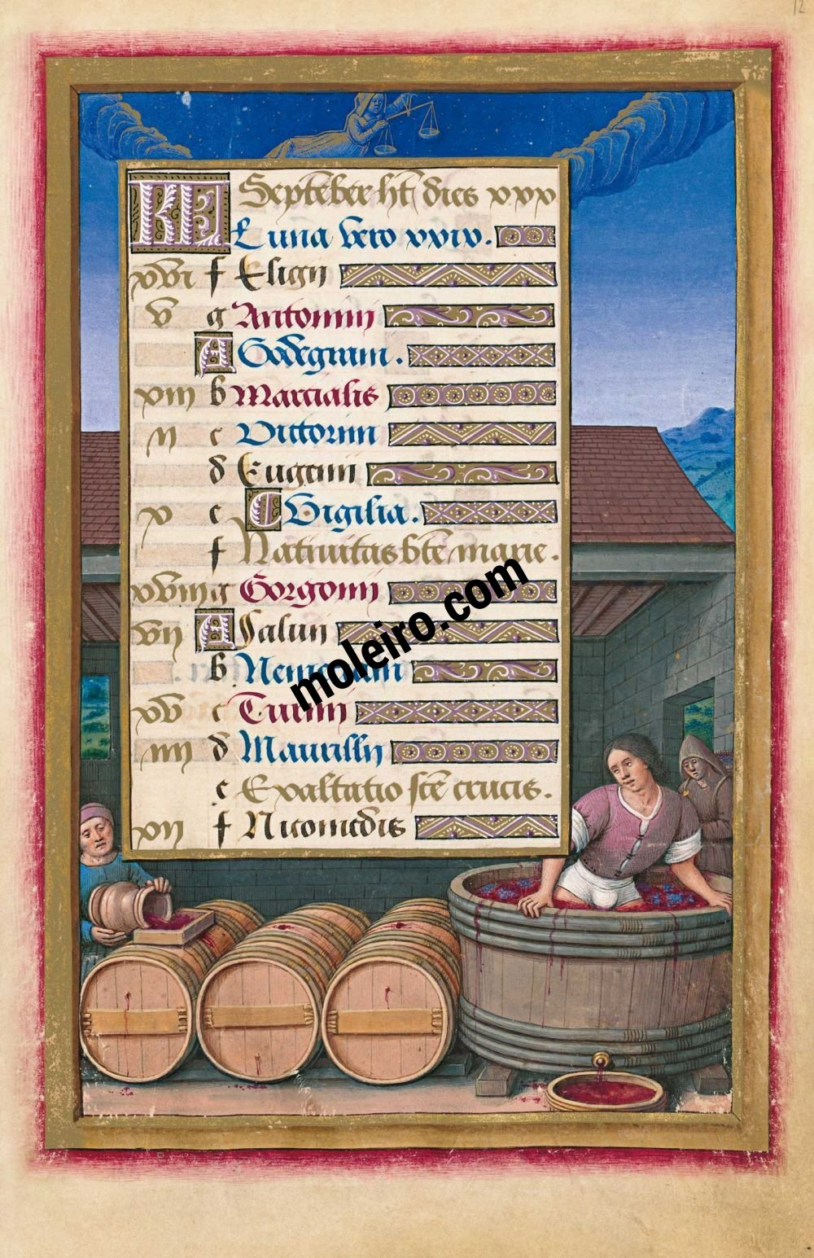
[Figure 1] Paris, Bibliothèque Nationale de France, Lat. 9474 (September - The Great Hours of Anne of Brittany).

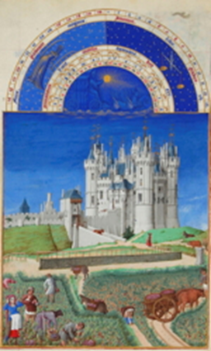
[Figure 2] Chantilly, Musée Condé, MS 65 (September - Très Riches Heures de Duc de Berry).

Bibliography

Archival Sources

Chantilly, Musée Condé, MS 65 (Très Riches Heures du Duc de Berry). Available online at: https://oll.libertyfund.org/pages/the-tres-riches-heures-du-duc-de-berry-1416 [accessed 23 November 2020].
Paris, Bibliothèque Nationale de France, Lat. 9474 (Great Hours of Anne of Brittany). Available online at: https://www.moleiro.com/en/books-of-hours/great-hours-of-anne-of-brittany/miniatura/829 [accessed 23 November 2020].
Philadelphia, The Free Library of Philadelphia, Lewis E. M. II 19-22v (The Hours of Louis XII). Available online at: http://www.vam.ac.uk/content/articles/t/the-book-of-hours-louis-xii/ [accessed 17 November 2020].

Secondary Sources

Backhouse, J. ‘Bourdichon’s ‘Hours of Henry VII’, The British Museum Quarterly, 37(3) (1973), pp. 95-102.
The British Library (2020) Detailed record for Royal 2 D XL. Available online at: http://www.bl.uk/catalogues/illuminatedmanuscripts/record.asp?MSID=8407 [accessed 6 December 2020].
The British Library (2020) Medieval calendars. Available online at: https://www.bl.uk/medieval-english-french-manuscripts/articles/medieval-calendars [accessed 15 December 2020].
Carrol, S. ‘Louis XII: Les Dereglements de l’Image Royale – by Nicole Hochner and Lettres de Henri III: Tome VI (4 Janvier 1583-20 Mars 1585) – edited by Jacqueline Boucher’, Renaissance studies, 22(4) (2008), p. 596.
Herman, N. ‘A newly discovered portrait of Louis XII by Jean Bourdichon’, The Burlington Magazine, 156(1337) (2014), pp. 507-509.
Kren, T., and McKendrick, S., The Renaissance: The Triumph of Flemish Manuscript Painting in Europe. (Los Angeles: Paul Getty Trust, 2003).
Lloyd-Jones, H. ‘Louis XII: Medieval king or renaissance monarch?’, History Today, 42(2) (1992).
Sherman, M. ‘Pomp and circumstances: pagentry, politics and propaganda in France during the reign of Louis XII, 1498-1515’, The Sixteenth Century Journal, 9(4) (1978), p. 13 - 32.
Spangenburg, L. L., Labors of September. 2020, https://www.digitalmedievalist.com/things/manuscripts/books-of-hours/labors-of-the-months/labors-of-september/ [accessed 30 November 2020].
The Victoria and Albert Museum, The Book of Hours of Louis XII. 2016, http://www.vam.ac.uk/content/articles/t/the-book-of-hours-louis-xii/ [accessed 4 November 2020].

The Victoria and Albert Museum, The Book of Hours of Louis XII. 2016, http://www.vam.ac.uk/content/articles/t/the-book-of-hours-louis-xii/ [accessed 4 November 2020].
Their names are not always clearly discernible due to the gold ink which makes reading quite difficult.
L. L. Spangenburg, Labors of September. 2020, https://www.digitalmedievalist.com/things/manuscripts/books-of-hours/labors-of-the-months/labors-of-september/ [accessed 30 November 2020].
One notable exception is the Tres Riches Heures de Duc de Berry, another fifteenth century French Book of Hours [see Figure 2].
H. Lloyd-Jones, ‘Louis XII: Medieval king or renaissance monarch?’, History Today, 42(2) (1992).
Ibid.
The British Library (2020) Medieval calendars. Available online at: https://www.bl.uk/medieval-english-french-manuscripts/articles/medieval-calendars [accessed 15 December 2020].
J. Backhouse, J. ‘Bourdichon’s ‘Hours of Henry VII’, p. 99.
Ibid., p. 98.
N. Herman, ‘A newly discovered portrait of Louis XII by Jean Bourdichon’, The Burlington Magazine, 156(1337) (2014), p. 507.
Ibid., p. 509.
The Victoria and Albert Museum, 2016.
S. Carrol, ‘Louis XII: Les Dereglements de l’Image Royale – by Nicole Hochner and Lettres de Henri III: Tome VI (4 Janvier 1583-20 Mars 1585) – edited by Jacqueline Boucher’, Renaissance studies, 22(4) (2008), p. 596.
Ibid., p. 596.
Including the Victoria and Albert Museum, the National Library of Scotland and the Paul Getty Museum, amongst others.
J. Backhouse, J. ‘Bourdichon’s ‘Hours of Henry VII’, p. 95.
The Victoria and Albert Museum, 2016.
J. Backhouse, J. ‘Bourdichon’s ‘Hours of Henry VII’, pp. 95 – 96.
H. Lloyd-Jones, ‘Louis XII: Medieval king or renaissance monarch?’.

