
An analysis and critical review of Tesco home grocery service.
Leading and Implementing Workplace Change

March 26, 2021
Christopher Davis
1712446

Executive Summary

Contents
Executive Summary 1
1.0 Introduction 3
2.1 Background Information 4
2.2 Change Models 5
2.3 Leadership 7
2.4 Change Agents 7
2.5 Culture Model 9
3.0 Conclusion 9
4.0 Recommendations 9
5.0 Appendices 10
6.0 References 13

1.0 Introduction
On January 29th, 2021 Mr Ken Murphy, the newly appointed CEO of Tesco requested a report on the changes implemented in the Home Grocery Services due to the current Global Pandemic Covid 19. The report along with its recommendation’s is due by March 26th.
Covid 19 has challenged organisations around the world and has seemingly caught even the most prepared and well-planned organisations off guard. This pandemic has a mind of its own and is bringing about change whether an organisation is ready or not.
(Frahm,2017) defines change as the process of constantly renewing an organisations capability to ensure the changing needs of internal and external customers are met.
The Report is going to focus on the changes that have been planned implemented within Tesco Home Grocery Service due to Covid and will report on the success and failures of these changes. These changes have been necessary to ensure that Tesco can still meet the demands of their customers whilst adhering to the guidelines and recommendations set out by the local governments.
To help them manage these changes the researcher will be highlighting the various elements of Tesco SWOT (appendix A) and PESTLE (appendix B) analysis that have helped or hindered the process. These tools will also highlight why they are needing to change.
The reports list of references will include citations from a range of sources including books, journals, and websites and will include a list of recommendations.

2.1 Background Information
“From market stall to the UK’s biggest supermarket.”

Tesco was founded in 1919 as a market stall in the East end of London and today is recognised as one of the largest retailers in the world. Tesco have stores operating across 12 countries and employ over 500,000 employees to serve over a million online and instore customers on a weekly basis. Tesco headquarters are in Chestnut United Kingdom and recently in October 2020 employed a new CEO Ken Murphy who has taken over from Dave Lewis. The U.K operations are the largest in the group with 3300+ stores and an employee base of 300,000 employees. (Tesco,2021)
Over the years Tesco has continued to grow and develop by taking over many successful retail chains around the globe including Hilliards and the Williamlow chain, in 1997 Tesco also purchased the retail arm of Association of British Foods.
Since the early days of selling on a Market stall Tesco has diversified into the retail sector selling Groceries, Books, Clothing, Electronics, Furniture and Software’s. They also have hundreds of Petrol Forecourts and have further developed and progressed into Financial Services, Internet, and Mobile services by introducing Tesco Credit Card/Bank and more recently Tesco Mobile.
Tesco boasts many firsts in the world of Retail and maybe their most recognised and profitable one to date is the launch of their Home Grocery Service in 1997. Not only did this set them apart from their competitors but in today’s market it is seen as the largest and most profitable online grocery retailer on the market. (Tesco Story - Profile, History, Founder, Founded, CEO | Retail Stores | Success Story, 2021)
After a turbulent few year and a mountain of debt Tesco has sold its Asian business for a jaw dropping 10 billion pound which has seen the supermarket pay off debts and return millions to its shareholders across the board. (Bloomberg - Are you a robot? 2021)
Considering the current pandemic and growing concerns over Brexit the last 12 months have been massively successful and has seen Tesco return to profitability levels not seen in recent years. (Tesco shares: Should I buy for my portfolio today? - The Motley Fool UK, 2021)
Tesco currently sits on the Stock Exchange as TSCO with shares selling at an impressive £229.60 which is up 0.39%. (Tesco - Search | London Stock Exchange, 2021)

2.2 Change Models
Over the last 2 years Tesco have been preparing and planning for the changes that Brexit would bring with it however in March 2020 all that changed the first national lockdown due to the global pandemic Covid 19.
Market Business News (2021) defines organisational change as a process that looks at the process a company uses to change its operational methods as well as what effects these changes have on it. This change will not only allow Tesco to remain ahead of their rivals it will also stop them from falling behind.
It is all about reviewing and modifying structures – specifically management structures – and business processes. Change is important for Tesco to ensure they keep their competitive edge and remain loyal to their customers.
Covid 19 has highlighted and forced Tesco customers to change the way they shop in a society where peoples lifestyle and leisure times were already changing.
Due to Covid 19 Tesco needed to move its business online fast as the demand for home delivery soared to cope with the demand, they would need to employ 47,000 temporary staff during the lockdown and approximately£840 million was spent to adjust to Covid- secure shopping. In the first 3 months of the quarter Tesco Home Grocery Services saw their sales increase by 48.5% and by the end of May the demand grew by 100%. One of the changes needed to meet this demand was the need to double its online capacity with the help of their technical departments. They have also increased their delivery slots from 600,000 to 1.3 million and have created a priority list of 590,000 vulnerable customers. As well as having to more than double the staff intake of drivers, packers, home shoppers Tesco have also had to increase the availability of Click and Collect orders as the demand was so overwhelming for Home Deliveries.
All these changes have put a great deal on all employees in the Home Grocery Services department. The previous CEO Dave Lewis said how proud he was of the staff who had gone above and beyond for the business. ‘Their selfless efforts, combined with our embedded strategic advantages online have ensured that everyone can get the food they need in a safe environment.’ (Tesco shows how it adapted as shoppers moved online fast during the Covid-19 lockdown – and counts the costs of change, 2021)
It is important all members involved in the change process understand why the change needs to occur. This organisational change will allow its employees to accept and recognise the changes within their department. Tesco will need to transform and implement these changes quickly if they are to succeed. (Burns, 2000).
For the change to take place it is important that all managers and team leaders utilise the various tools available to them. The team will need to refer to their SWOT Analysis (appendix A) to identify the internal factors which are their Strengths and Weaknesses as well as understanding the Opportunities and Threats they could face whilst implementing their change. The SWOT analysis is a useful tool as it highlights the Strengths and Weaknesses and introduces the Opportunities that could help combat these Weaknesses. The Threats could also be useful in identifying the factors that could prevent the change being a success. Tesco have been lucky with their strengths as they were already well-established in the Home Grocery Service and Click and collect so all the changes being introduced would help improve their weaknesses by taking the opportunities onboard and implementing and improving on their systems. Their biggest threat is going to be all the different lockdown and restriction measurements as they do not have time to plan these but need to ensure they can adapt to the measures being put into place as quickly and efficiently as possible.
Another useful tool for the team to use is the PESTLE Analysis (appendix B) as this will help them overcome the micro and macro environmental factors challenging them. The PESTLE highlights everything that is going against them in the environment, the manager needs to be aware of all these factors as they will affect and determine any changes being implemented. The biggest impact for the Home Grocery Service will come from the Political, Technological, and environmental factors. These factors will affect them as the majority of their changes are due to the recommended guidelines and precautions implemented to ensure a safe working environment and experience for customers.
To help the team make the changes they used Kurt Lewin’s (1947) Change Model (appendix C). Lewins Model is a 3-step process which is made up of the following 3 important steps:
- Unfreeze- ready to change.
- Change- implementation.
- Freeze-making it stick.
These 3 steps will give the Home Grocery Services manager the guidance on how to get the changes implemented and the staff to embrace these changes.
Due to the nature and urgency of Covid 19 the management did not have much time to pre plan the change but instead had to act fast and ensure all staff understood the nature of the change to ensure a smooth transition through an already difficult time.
During step 1 the manager needed to ‘unfreeze’ he needed to ensure that all staff worked more effectively and meticulously due to the PPE changes and the greater demand on their time. The manager needs to set the wheels in motion explaining how things are going to be needed to be done differently for the changes to be a success. Whilst ‘change’ is happening this allows the manager to oversee the effectiveness of these changes and implement them into their daily routines. The manager will need to be prepared for a certain amount of chaos as these changes are happening so fast. Finally, in the ‘freeze’ stage Tesco will now be operating more effectively and these changes will form part of the new norm.
‘At present Tesco is making on average 120 deliveries a minute’. (Every little help - how Tesco has adjusted its online retail strategy to cope with Coronavirus and life after lockdown, 2021)
These statistics are impressive for the Supermarket giant and would not have been possible without the necessary changes being made and the support and involvement of all staff.

2.3 Leadership
“Effective leaders have the ability to communicate well, motivate their team, handle and delegate responsibilities, listen to feedback, and have the flexibility to solve problems in an ever-changing workplace.” (Important Leadership Skills for Workplace Success, 2021)

Even when change is clearly designed to improve organisational functions, a business will need someone spearheading the transition, a leader charged with understanding the change, establishing just how it will affect the team, and communicating that information to everyone, to ensure they are all happy to go on the journey together. (6 Traits of a Successful Change Agent | Knowledge, 2021)
It is important that throughout the change process that Tesco leaders are involved in the planning and implementation of the necessary changes. Due to the nature of the problems and the Home Grocery Services needing to change swiftly to adapt to the demand and restrictions Covid 19 has presented.
There were many complex areas of the changes that needed the involvement of the leaders. It was identified that the HR, Finance, Health & Safety, and the Information services would all need to be involved as these complex areas cannot be decided upon or implemented by the lower-level members of staff but instead need to be decided upon by these Senior Level Managers and Departmental Officers.
To deliver the changes HR would need to be involved as the recruitment of staff would be increased and due to Government Legislation, the working conditions and contract would need to change. There is also the introduction of Furlough, and any vulnerable staff would need to identify who currently work within the Home Grocery department.
Health and Safety is at the forefront of many of these changes and Covid risk Assessments and PPE are going to need to be approved and implemented.
Information Services will be feeling the heat during these changes as the majority of Tesco Home Grocery Service relies on technology and databases to get the job done. As they have been increasing delivery slots, online products, restricting multiple items they are going to be at the forefront of many of these changes so that they can keep up with the online demand.
Dave Lewis (ex-CEO of Tesco) has admitted that all leaders within the industry are going to need to be very adaptable and believes that the impact of all these changes particularly in Payroll and PPE are set to cost Tesco as much as £925 million.
“Covid has shown how critical the food supply chain is to the UK.” (Lewis, 2021).
Throughout the changes it is important that the necessary Leaders are communicating effectively with the different stakeholders to keep everyone up to date.

2.4 Change Agents
The success of any change effort depends heavily on the quality and workability of the relationship between the change agent and the key decision makers within the organization. (Lunenburg, 2021).

A Change Agent is who first introduces the planned change. They will be responsible for initiating the change in Tesco Home Grocery Service to increase the departments effectiveness. The planned change could be in the employees, the structure or technology used to compliment the department. The Change Agent will also be responsible for motivating the employees to accept the changes and to overcome any resistance or negativity. (Change Agent: Meaning and Role | Organisation, 2021)
The Change Agent will take on the role of a Facilitator, Consultant and Counsellor as throughout the process they will be responsible for developing and raising awareness of the change, sets in motions the plans. They will also be responsible for supporting and motivating the team throughout the process.
To be an effective Change Agent they will need to possess excellent Cognitive, Communication and Action Skills to facilitate the change process. (What is a Change Agent? definition, types, and skills - Business Jargons, 2021)
There are two types of Change Agents.
- Internal Agents- An internal agent works within the organisation and is involved in all aspects of the change process. They are normally the managers and Department Leads who are normally trained by the External Change Agents to implement the changes. They will introduce the changes to the different Managers, Supervisors and Team workers.
- External Agents- These are usually consultants or specialists in their field who are employed by the organisation to identify and devise its change strategy.

Change is an inevitable part and truth of life, and there is no running away from it. If change is well planned and formulated, it can produce positive results but even with planning, change is hard to incorporate, accept and appreciate’. (Understanding the Kubler-Ross Change Curve, 2021)

“Change is an upsetting time for people as it can introduce a variety of uncertainty,” (Lock, D)
By understanding The Kubler Ross Change Curve (appendix D) the Change Agent will have a better understanding of where his team fit within the 5 Stages Of Change. There are many different types of people and they will all coast through the curve at various times throughout the process. These different steps include Denial, Anger, Bargaining, Depression and Acceptance/Integration. (The Kubler Ross Change Curve: Understanding The 5 Stages Of Change, 2021)
Since the first lockdown and over the last year the staff of the Home Grocery Service have not had much time to dwell on the changes as the majority of them were implemented instantly however that does not eliminate them from experiencing different emotions and feelings throughout the last year. When the changes first started there was a lot of shock and denial as not only were the staff dealing with the greater demands of the job but also with the changes covid was bringing to their family and personal lives. With the increasing demands came a lot of disappointments as customers couldn’t get delivery slots, or products were unavailable making their jobs more difficult and this manifested into the staff becoming critical of themselves and their peers causing some animosity and friction across departments. At this stage it is vital that the Change Agent steps in and motivates the staff or all their hard work will have been for nothing as the changes would have been unsuccessful. This is also where staff will be at their most stressed stage. Moving onto the Bargaining stage the staff although initially were showing signs of confusion and doubt will be starting to feel comfortable with the changes and there will be more signs of acceptance. They will also start showing interest in the changes and begin asking positive questions. We are now at the Depression stage and the staff are starting to realise just how much things have changed around them. This is even worse for the staff as they are also facing all these challenges in their personal lives as well as their professional roles. Finally, Lockdown is to be lifted and the staff are now used to the new ways of doing their jobs and no longer see the changes as a hindrance but a re more likely to be ready to accept them and start to realise that things are now working better than they were before the changes were implemented. They are now showing signs of acceptance and are beginning to understand this is a new era and the beginning os a new norm. (Coaching people through the Change Curve, 2021)
Within the Home Grocery Services dept the Change Agent will need to understand the various staff personalities and traits. The Change Agent will come across a variety of personalities including Apathetic, Incubators and Advocates. Whilst the Apathetic will feel totally unaffected by the change the Incubators will be doing the complete opposite and thinking how the change will affect them. These feelings can be encouraged and improved by the Advocates as they have been through change before and are overly enthusiastic. This attitude will help the Change Agent get all staff together as the Advocates enthusiasm will move the Apathetic into Incubators and the Incubators will start to become Advocates as their enthusiasm grows. Throughout the process and with the help of the Advocates the changes will become a success.
During the changes the Change Agent will also cross paths with Resistors these individuals will cause delays and concerns as their resistance will affect their commitment, productivity quality and interaction with peers. It is important on all levels that this is not a result of poor communication from the Change Agent regarding the change. (What Is Resistance to Change? 2021)
The motivation and leadership skills of the Change Agent are what will make the changes successful as a well-motivated team will strive harder to embrace the changes. Drucker (1963) is quoted as saying “You’re first and foremost job as a leader is to take charge of your own energy and then help to orchestrate the energy of those around you.”

2.5 Culture Model
“Culture is the environment that surrounds us all the time. A workplace culture is the shared values, belief systems, attitudes, and the set of assumptions that people in a workplace share. This is shaped by individual upbringing, social and cultural context. In a workplace, however, the leadership and the strategic organizational directions and management influence the workplace culture to a huge extent. A positive workplace culture improves teamwork, raises the morale, increases productivity and efficiency, and enhances retention of the workforce. Job satisfaction, collaboration, and work performance are all enhanced. And, most importantly, a positive workplace environment reduces stress in employees.” (Agarwal, 2021)
Handy Model of Organisational Culture (appendix E) puts forward the idea that there 4 types of culture:
- Power- Without a Power culture an organisation will fail, these are a select few individuals who are at the centre of the organisation and hold all the power and authority. Change and decisions are driven by these individuals.
- Task- This culture is very flexible and due to the interlinked relationships; they are more dynamic to change. This organisation is without a superior power and all employees are treated equally. There are minimum policies and procedures unless they are communicating effectively, they will not bode well with change.
- Role-This Cultures management are the main decision makers with all the power to make changes. The management will be supported by the different department managers to help support the managers by giving their expertise. This culture is very bureaucratic and structured with little room for innovation and creativity.
- Person- The power in these organisations are spread throughout the organisation (Charles Handy's Model of Organisational Culture, 2021)

Tesco core purpose:
“Serving shoppers, a little better every day.
Our business was built with a simple mission – to be the champion for customers, helping them to enjoy a better quality of life and an easier way of living. This hasn't changed. Customers want great products at great value which they can buy easily and it's our job to deliver this in the right way for them.
That is why 'Serving shoppers a little better every day' is our core purpose. As a business, serving customers is at the heart of everything we do – from colleagues in our stores to those of us in supporting roles.” (Tesco, 2021).
Tesco is committed to this mission and with their values and beliefs they are ensuring that Every Little Helps makes a big difference, they believe that no one tries harder for their customers and that they treat people how they want to be treated.
Tesco has a hierarchical structure and is operating a Role Culture. This culture is evident as there are various Supervisors and Managers all reporting to their managers in a chain of command process. This culture sits well within large organisations however is not always the best culture to operate when trying to facilitate change as there are too many layers and information could be lost before it gets to the level it needs to be at. Where the culture will work well is that all employees know their roles and are working together to achieve the end goal.
When going through the change process it is important to understand the culture of the customers and the staff to understand how they can make it a smoother process for all.
During the changes brought on by Covid the culture going to be changing as employees’ roles are changing which will result in them needing further training throughout.
Communication is the key to success and if the changes are not communicated effectively then the message will be lost in translation leading to failures and unhappy staff.

3.0 Conclusion

4.0 Recommendations
The report has shown that Tesco changed as fast as it could due to the pandemic however as the report shows there were clearly room for improvements which could have been avoided if they had had more time to plan. moving forward the following recommendations could help them greatly.

- Improve on the current changes implemented.
- Introduce permanent ‘PPE,’ safety measures and good practices to ensure staff and customers always feel safe and protected.
- Be more aware of the different Leadership Styles and understand which styles and traits as going to complement your workforce and be instrumental in the Strategic Planning.
- Coronavirus ‘survival’ plan.
- Ensure the Culture of the Organisation fits well with all stakeholders.

5.0 Appendices

Appendix A
Swot Analysis
Strengths  Online Shopping-already established in this market.  Locations- operational sites for warehousing and stores across UK  Click and Collect- already established and operational.  Automated Pick Tower. | Weaknesses  Keeping up with online demand- this was an issue pre-covid.  Constant changes- new CEO, changing customer’s needs, cultures, and expectations.
Opportunities  Improve KM systems- as they are experiencing a lot more online shoppers, so the data collected is invaluable to them.  Online catalogue to help promote more of their products& services. | Threats  Government restrictions due to local and national restrictions  Competitors- M&S partnered with Ocado.  Aldi’s started click& collect.  Morisons started doorstep deliveries.  Covid  Brexit and supply

Appendix B
PESTLE
Political  Brexit  Government guidelines  National/regional local guidelines  Lockdown tiers in different areas | Economic  Furlough  Employing more people
Social  Scaremongering  Bulk shopping/hoarders  Spend per person.  People want more healthier and value for money options.  Providing opportunities for unemployed | Technological  Greater demand and impact on their current systems
Environmental  PPE  Carbon footprint  Reducing packaging waste etc  Delivering in trays not bags  Customers/staff/ suppliers more aware of the environment | Legal  Various guidelines  Vat

Appendix C
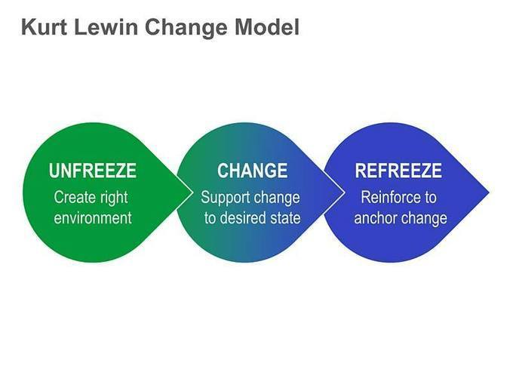Image 1: Kurt Lewin (1947) Change Model (kurt lewin change model - Bing, 2021)
Appendix D
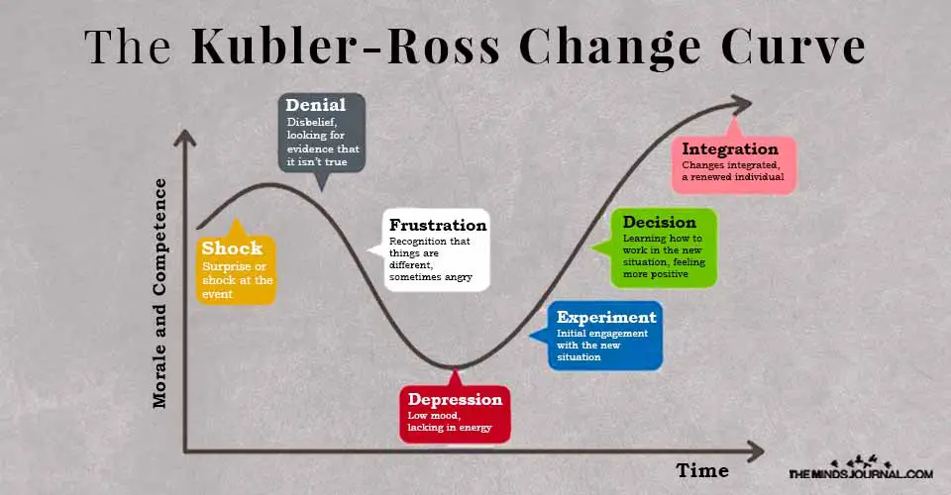
(The Kubler Ross Change Curve: Understanding The 5 Stages Of Change, 2021)

Appendix E
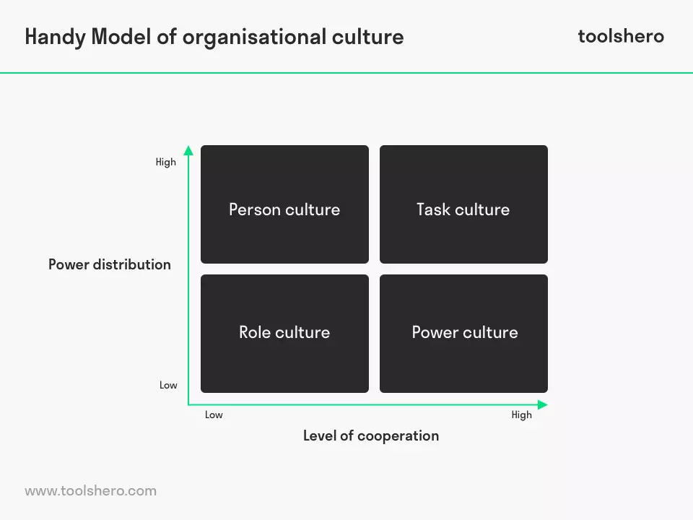
(What is Charles Handy Model of Organisational Culture? toolshero, 2021)

6.0 References
Successstory.com. 2021. Tesco Story - Profile, History, Founder, Founded, CEO | Retail Stores | Success Story. [online] Available at: <https://successstory.com/companies/tesco-plc> [Accessed 22 March 2021].
The Motley Fool UK. 2021. Tesco shares: Should I buy for my portfolio today? - The Motley Fool UK. [online] Available at: <https://www.fool.co.uk/investing/2021/02/27/should-i-buy-tesco-shares-for-my-portfolio-today/> [Accessed 22 March 2021].
Tesco.com. 2021. [online] Available at: <https://www.tescoplc.com/> [Accessed 22 March 2021].
Market Business News. 2021. What is organizational change? Definition and examples. [online] Available at: <https://marketbusinessnews.com/financial-glossary/organizational-change-definition-meaning/> [Accessed 23 March 2021]
Bloomberg.com. 2021. Bloomberg - Are you a robot? [online] Available at: <https://www.bloomberg.com/news/articles/2020-03-09/tesco-sells-asian-unit-for-10-6-billion-plans-special-dividend#:~:text=Tesco%20Plc%20agreed%20to%20sell%20its%20Asian%20businesses,outbreak%20damps%20enthusiasm%20for%20mergers%20and%20acquisitions%20worldwide.> [Accessed 22 March 2021].
Londonstockexchange.com. 2021. Tesco - Search | London Stock Exchange. [online] Available at: <https://www.londonstockexchange.com/search?searchtype=all&q=tesco> [Accessed 22 March 2021].
2021. MarketLineIC_OnlineFoodDeliveryBusinesshasbeenboostedbyconditionsandisgrowing_230321.pdf.
InternetRetailing. 2021. Tesco shows how it adapted as shoppers moved online fast during the Covid-19 lockdown – and counts the costs of change. [online] Available at: <https://internetretailing.net/covid-19/covid-19/tesco-shows-how-it-adapted-as-shoppers-moved-online-fast-during-the-covid-19-lockdown--and-counts-the-costs-of-change-21616> [Accessed 23 March 2021].
diginomica. 2021. Every little helps - how Tesco has adjusted its online retail strategy to cope with Coronavirus and life after lockdown. [online] Available at: <https://diginomica.com/every-little-helps-how-tesco-has-adjusted-its-online-retail-strategy-cope-coronavirus-and-life> [Accessed 23 March 2021].
Frahm, J. (2017) A guide to implementing workplace change. First edition. Melbourne
Bing.com. 2021. Kurt Lewin change model - Bing. [online] Available at: <https://www.bing.com/images/search?view=detailV2&ccid=kd4WR1hP&id=0201A4709FBF9336B25EFC59809963D1F7F2F953&thid=OIP.kd4WR1hPzRrsrYOYv9PqnQHaFj&mediaurl=https%3a%2f%2fimg.scoop.it%2fB3Pwnf5_XH5Hsc2AP3mceoXXXL4j3HpexhjNOf_P3YmryPKwJ94QGRtDb3Sbc6KY&exph=510&expw=680&q=kurt+lewin+change+model&simid=608019863454353375&ck=85ED4D91EC0D92754F0CE52852403BF1&selectedIndex=7&FORM=IRPRST&ajaxhist=0> [Accessed 23 March 2021].
Lunenburg, Fred. (2021). Managing Change: The Role of the Change Agent.
Essays, Research Papers and Articles on Business Management. 2021. Change Agent: Meaning and Role | Organisation. [online] Available at: <https://www.businessmanagementideas.com/notes/management-notes/organisational-change/change-agent-meaning-and-role-organisation/5299> [Accessed 24 March 2021].
Insights.com. 2021. Coaching people through the Change Curve. [online] Available at: <https://www.insights.com/resources/coaching-people-through-the-change-curve/> [Accessed 24 March 2021].
Mind Journal. 2021. The Kubler Ross Change Curve: Understanding The 5 Stages Of Change. [online] Available at: <https://themindsjournal.com/kubler-ross-change-curve/> [Accessed 24 March 2021].
Business Jargons. 2021. What is a Change Agent? definition, types and skills - Business Jargons. [online] Available at: <https://businessjargons.com/change-agent.html> [Accessed 24 March 2021].
Insights.com. 2021. Coaching people through the Change Curve. [online] Available at: <https://www.insights.com/resources/coaching-people-through-the-change-curve/> [Accessed 24 March 2021].
The Balance Careers. 2021. What Is Resistance to Change? [online] Available at: <https://www.thebalancecareers.com/what-is-resistance-to-change-1918240> [Accessed 24 March 2021].
Drucker, P.F., 1963.Managing for business effectiveness. Harvard Business Review.
CIPD. 2021. Change Management | Factsheets | CIPD. [online] Available at: <https://www.cipd.co.uk/knowledge/strategy/change/management-factsheet#8092> [Accessed 25 March 2021].
toolshero. 2021. What is Charles Handy Model of Organisational Culture? toolshero. [online] Available at: <https://www.toolshero.com/management/handy-model/#:~:text=Handy%20Model%20of%20Organisational%20Culture,%20developed%20by%20Charles,model%20which%20sets%20out%20four%20basic%20organisational%20types.> [Accessed 25 March 2021].
Tesco.com. 2021. Our latest response to covid 19. [online] Available at: <https://www.tescoplc.com/news/2020/our-latest-response-to-covid-19-a-message-to-customers-from-dave-lewis-tesco-ceo/> [Accessed 25 March 2021].
Investors in People. 2021. 6 Traits of a Successful Change Agent | Knowledge. [online] Available at: <https://www.investorsinpeople.com/knowledge/successful-change-agent/> [Accessed 25 March 2021].
Agarwal, D., 2021. How To Create A Positive Workplace Culture. [online] Forbes. Available at: <https://www.forbes.com/sites/pragyaagarwaleurope/2018/08/29/how-to-create-a-positive-work-place-culture/?sh=73e84ca42727> [Accessed 25 March 2021].
Ogbonna, E. (1992). Managing organisational culture: fantasy or reality?. Human Resource Management Journal, 3(2), 42-54.
Mulder, P. (2018). Handy Model of Organisational Culture. Retrieved [25 March 2021] from ToolsHero: https://www.toolshero.com/management/handy-model/
Managers Information. 2021. Charles Handy's Model of Organisational Culture. [online] Available at: <https://www.managersinformation.com/2020/10/charles-handys-cultural-categories.html> [Accessed 25 March 2021].
The Balance Careers. 2021. Important Leadership Skills for Workplace Success. [online] Available at: <https://www.thebalancecareers.com/top-leadership-skills-2063782> [Accessed 26 March 2021].

