Rhys Whatty
academic and employability skills (computational thinking element)
ACCA4016

Contents
Use Case Diagram: 2
Use Case Documentation: 3
Business Process Modelling Diagrams: 4
Diagram for rectangle: 4
Diagram for Right-Angle Triangle: 5
Circle within square Diagram: 6
Joint symbol Diagram: 7
Robot Images: 8
Screenshot of Code: 8
Images taken during testing: 8

Use Case Diagram:
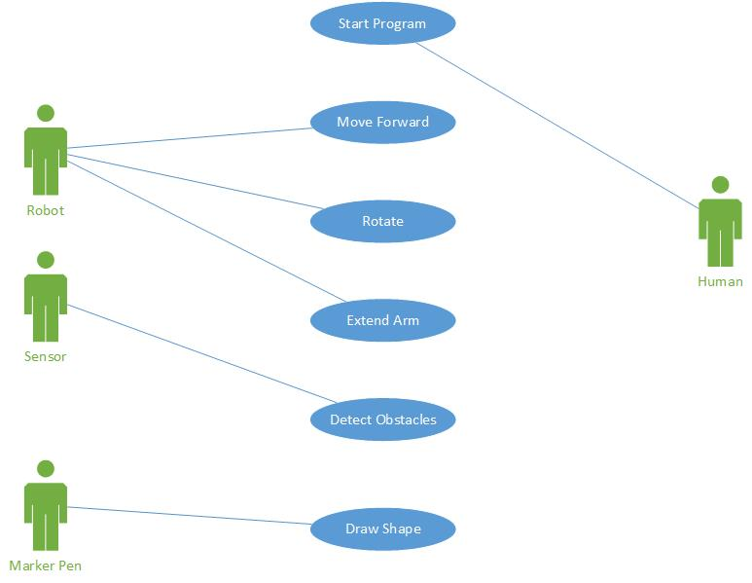
This is a use case diagram that shows that each member of team will do during the development of the robot and its code.

Use Case Documentation:

General Characteristics
Intent | Draw 4 pre-defined shapes 3 times each, with each time the measurements of side lengths increasing by 10cm, and while looking out for obstacles and reacting if it comes across one
Author | Rhys Whatty
Primary Actor | Robot (controls movement, rotation and extending an arm to move moveable obstacles)
Secondary Actor | Sensor, Marker Pen, Human
Assumptions | Course will contain moveable and non-moveable obstacles that will block the robot’s way  Robot won’t need unexpected attention during program execution (replacing pen due to lack of ink for example)
Trigger | Start Program, Robot begins drawing shape
Success Post Condition | Robot completes all 3 sizes of shapes
Failed Post Condition | Robot encounters immovable object, robot fails to successfully complete shape
Overview | Robot will begin drawing the first shape. During the drawing, it will be using a sensor to scan for obstacles indicated by red and blue tape (moveable and immovable objects) The robot should raise alarm and act accordingly should it encounter one of these obstacles. Upon completion the first shape, it will display the total area of the shape it has drawn. This procedure is repeated 2 more times with the predefined larger sized shapes. The robot will then be able to move onto the next shape, and repeat the process until all 4 shapes are completed.  If the robot encounters a blue immovable obstacle, then the program will terminate.

Main Success Scenario
Step | Action
Start | User triggers program on Robot
1 | The Use Case begins when the robot begins drawing the first shape
2 | Robot completes the 1st drawing and displays the area of the shape
3 | Robot begins drawing the 2nd, middle sized, shape
4 | Robot completes the 2nd drawing and displays the area of the shape
5 | Robot begins drawing the 3rd final shape
6 | The Use Case ends when the robot completes the 3rd drawing and displays the area of the shape.

Business Process Modelling Diagrams:

Diagram for rectangle:
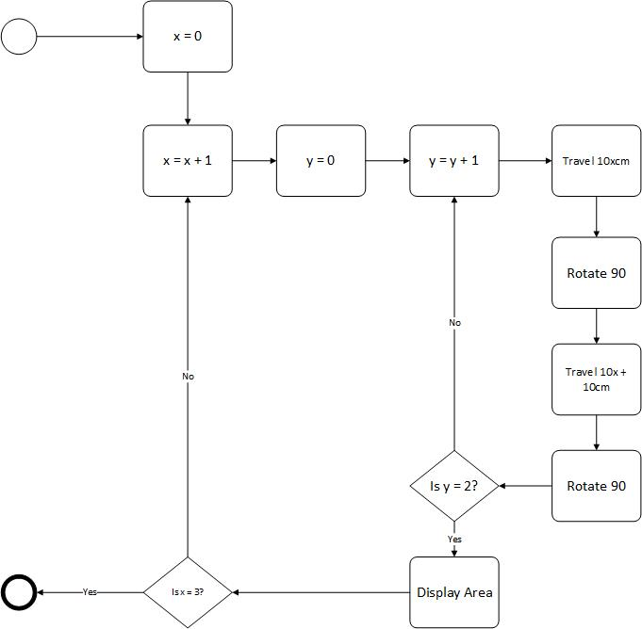

Diagram for Right-Angle Triangle:
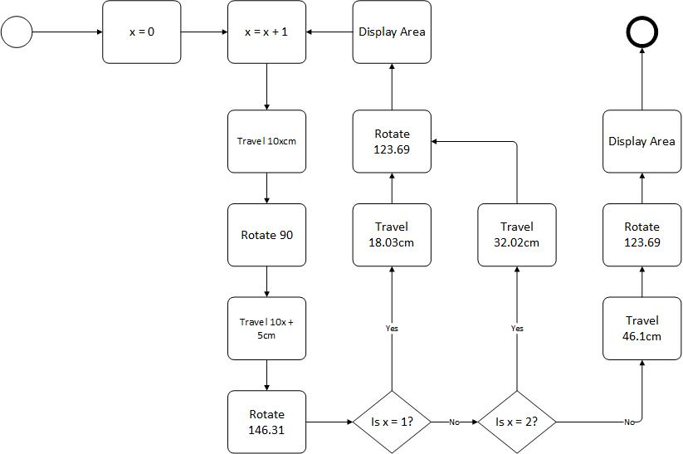

Circle within square Diagram:
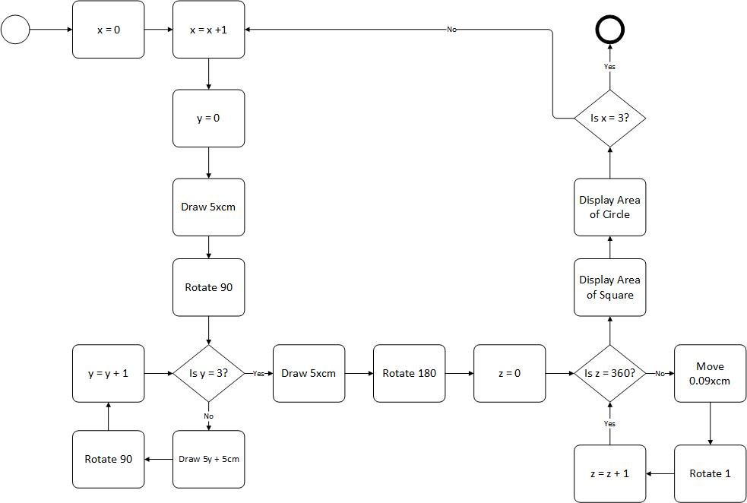

Join symbol Diagram:
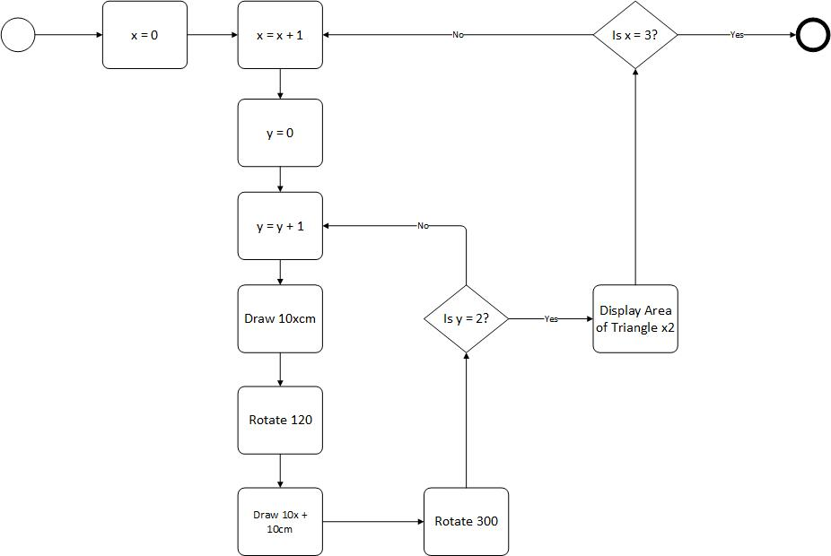

Hazard Detection Diagram:
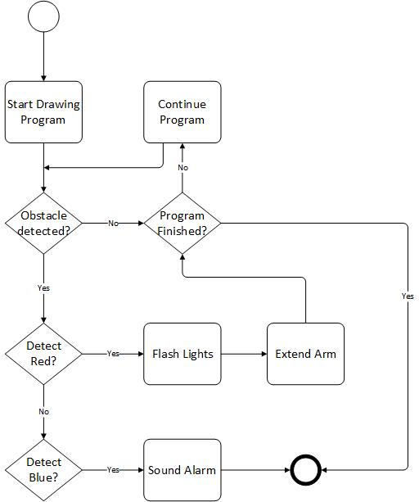
I did the diagram for Hazard Detection separate to the diagrams for each of the shapes as it would be the same system for all the shapes and also it kept the other diagrams tidier.

Robot Images:
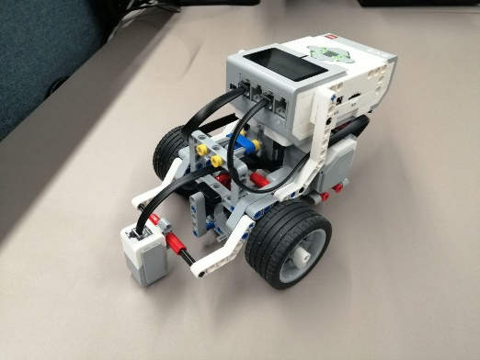
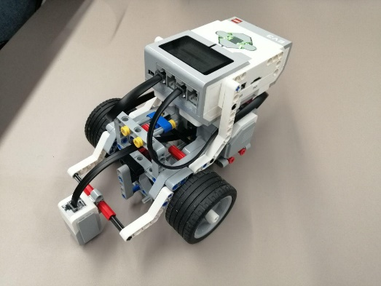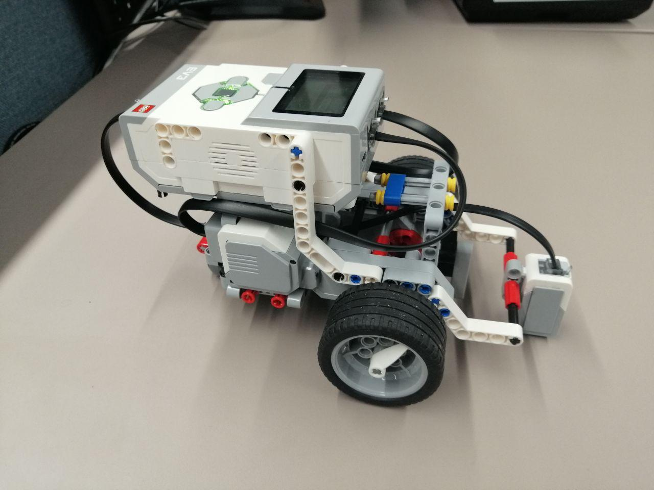

Screenshot of Code:

Joint symbol:
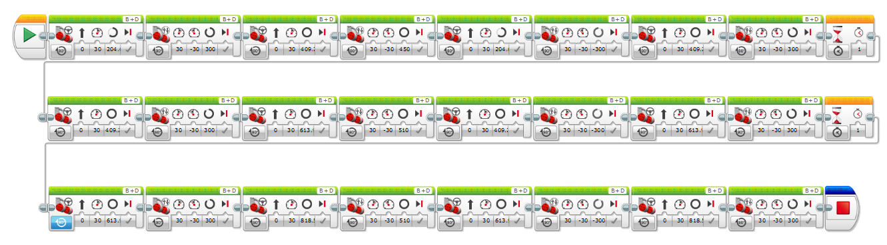

Rectangle:
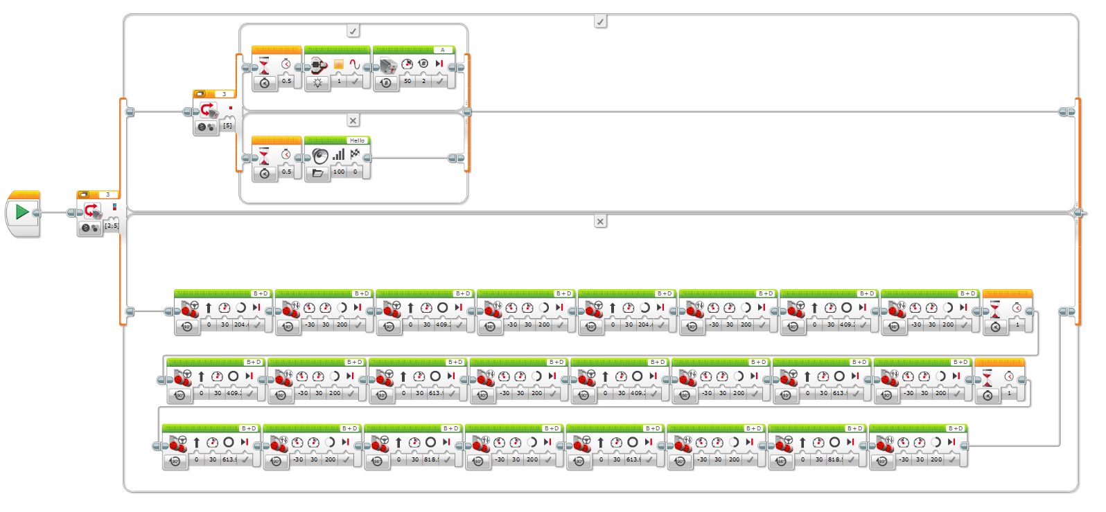

Right Angle Triangle:
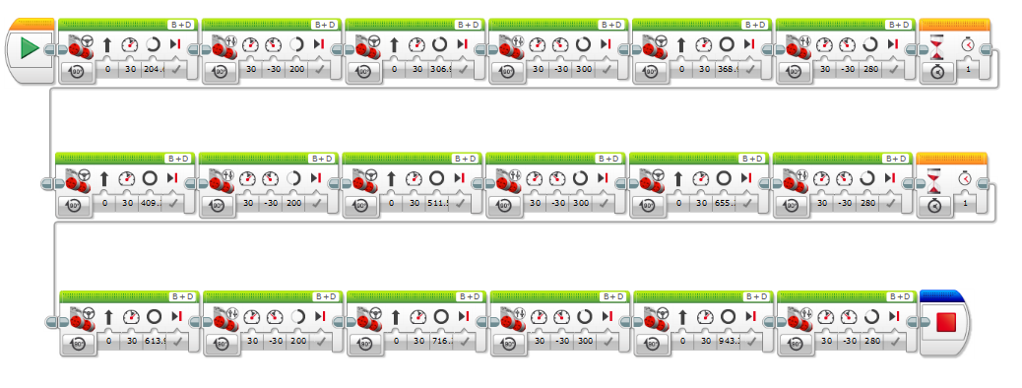

Circle within Square:
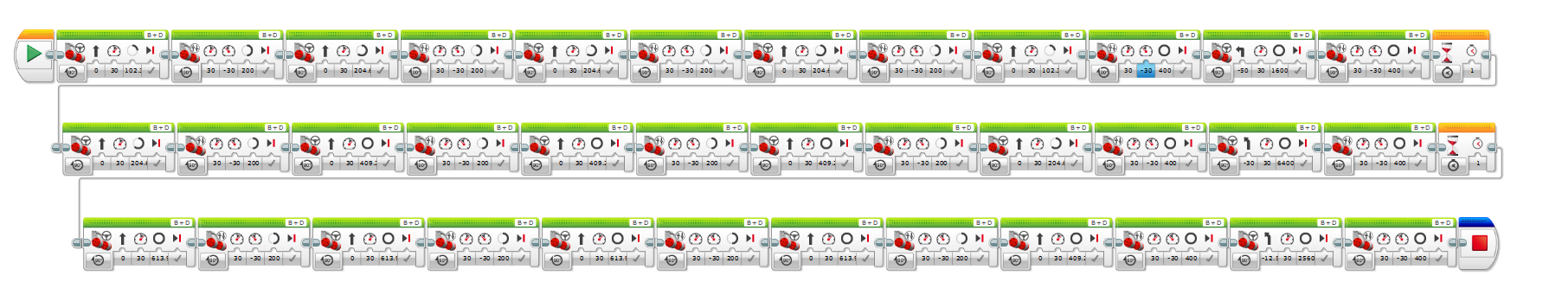

Images taken during testing:



