Introduction
The ‘cost of living Crisis' what does this mean, what are the government, local councils and communities doing to help the situation. Is what they are doing enough to helping communities?
The ‘cost of living Crisis' refers to the fall in ‘real’ incomes that the United Kingdom (UK) has and is experiencing since the latter end of 2021. (Hourston, 2022). Wage growth is not sufficient to keep up the pace with inflation.
The fall in disposable income is predominantly being caused by soaring inflation which is not in line with benefit and wage increase and has been made increasing worse by the tax increases.
Since 2021 the costs of living have been rising, this has been since many countries have opened their economies from the Coronavirus Pandemic. Gas price increase is also a major issue this has been from several factors, a depletion in gas storage supplies in Europe, and the war between Ukraine and Russia are but a few.
According to Darren Dodd who writes for the Financial Times the war between Russian and Ukraine has also had a devastating impact on the world’s economy, as well as the Ukrainians people, as is well documented across the FT website. (Dodd, 2023)
Gas prices have increased drastically with over 80% of households in England and Wales are heated by mains gas, and a third of electricity is gas power stations. The rise in fuel costs has also had a considerable effect on transport across the UK with many families unable to afford fuel for their vehicles. (Energy Efficiency of Housing, England and Wales, Country, and Region - Office for National Statistics, 2022)
An article in the Guardian by Jack Monroe states that the poor are being ‘priced out of food ‘within the UK, In December 2022 it was reported that the consumer price index inflation rose to 5.4% this is the highest level in nearly 30 years. (Monroe, 2022)

1.1 Purpose of research
The purpose of this research is to look at the ‘Warm spaces,’ that many local councils across the UK have funded from a government initiative, focusing on Carmarthen Council. Carmarthen Council have 57 Warm Spaces currently advertised on their webpage.
The Question is, are designated warm spaces being utilised and at what cost to the local councils, would local residents like to see something else in its place and if so what, and do communities know about the Warm Space innovative, are they being used?
A warm space is designed to allow anybody from your local community whether they are unemployed, working, young or old to have a warm and welcoming space a couple of times a week over the winter months during this crisis. Assigned warm places have been set up in Ammanford, Carmarthen, and Llanelli libraries along with many other village community centres, places of worship and cafes. Newspapers, books, computers, and iPads have all been made available to attendees along with comfortable seating and warm refreshments all at no cost to those who choose to attend. (Warm Places and Warm Welcome Spaces, n.d.)

1.2 Objectives
The objectives of this dissertation are to critically analyse literature and data collected, to understand warm spaces, if they are commonly known about within the community and are they being used. Whilst looking at the data, recommendations will also be made to support the initiative and working collaboratively with the community and the local councils to make any improvements for any further initiatives such as warm spaces.

1.3 Research questions
1. Are residence aware of the warm space initiative, and is there one local to them? If not why, is it lack available space, cost, or even lack of volunteers.
2. Are the warm spaces being used in the numbers as predicted by spaces holders?
3.Who is using the warm spaces?
4. Do residence think the warm spaces are a good idea or not.
5. Do the residents think that the available money has been spent wisely or would they have spent it on other possible initiatives?
To answer the questions each will be investigated and answered by gathering evidence from a literature review, and a questionnaire which will be given to 102 participants, whilst also interviewing three volunteers from local warm space initiatives, using Quantitative and qualitative data to gather the information.

1.4 Dissertation structure
Firstly, a literature review will be undertaken to understand the fundamental nature of the research subject, this will include primarily looking at warm spaces in Carmarthenshire Council (CCC) area, CCC will be use for the purpose of this investigation to abbreviate Carmarthen County Council, analysing the usage and community perspective of the initiative, examining the advantages and disadvantages of the initiative, all of which whilst looking at community views. This will be achieved by liaising closely with the community, gathering evidence via feedback platforms such a survey on social media and interviewing three volunteers for warm spaces asking open ended questions aiming to have a flowing conversation, this will enable the interviewer to gain the information required for the research without directing the interviewee to their answers. The data collected will then be analysed to conclude the research questions.

2 Literature Review
Reviewing the available information on ‘Warm Places ‘or similar initiatives will not only provide a background knowledge of their purpose and design, but baseline how effective they are against intent. The review will consider journals, newspaper articles, Press release and government reports (national and local) to assess the impact warm places are having withing communities . This review will look at elements of Warm Hubs/ warm spaces/war, places, across the united kingdom and in Wales.
According to the website’ Warm Spaces ‘there are over 4320 registered organisations across the united kingdom that have opened in the winter of 22/23. Welcoming the general public to a warm welcoming, and safe space. (Find a Warm Welcome Space Today, 2022). From homework clubs in church and community halls to libraries and clubs with organised events.

2.1 Warm Spaces – A Quiet Revolution
A blog by David Barclay on March 3rd, 2023, looks at the warm spaces and the effects they have had on local communities. David calls the initiative a ‘quintessentially British kind of movement’ Barclay (2023) this movement is powered by an army of volunteers, providing countless hot drinks and conversation.
Several religious leaders and the former prime minister Gordon Brown met in the summer of last year to discuss the growing ‘Cost of living crises and the increasing bleak future for low income households, which lead to the launch of the Warm Welcome Campaign also know as the Warm Hub or Warm spaces.
According to David Barclay Barclay (2023) Gordon brown remarked that he had heard of a proposal for “heated areas designed to resemble train stations waiting rooms” this area would be for people who were unable to pay their energy bills, this was said to be a throw away remark. As the effect of that mental image set in, the room became silent and everyone who attended left the meeting with the conviction that better needed to be made.
Over the next few weeks a ‘Warm Space ‘made an appearance it was an initiative that would be free, safe, warm and welcoming.
The government decided to trust local council and groups to set these initiatives up, local people would know more what their community need. Centres, Groups and libraries arranged a variety of events from a warm space with a hot drink, papers to read and computers to use to homework’s clubs and film nights.
One lady intervened by the BBC said “before she found her local warm hub she would stay in bed all day to keep warm”, David states in his blog. Warm spaces are describe by many as a life line, a way to keep going in this cost of living crisis.

2.2 Warm Hubs and The Welsh Assembly
On 20th September 2022, the Welsh assembly’s Jane Hutt MS for social justice announced the Welsh assembly were releasing £1 million pounds to support warm Hubs Hutt (2022). Stating that many people would be struggling to keep their homes at a healthy temperature this winter. The Welsh assembly wanted organisations like community councils, faith groups, sport and community clubs would set up Warm Hubs within local communities a safe warm place for the public, by using these hubs it is hope that peoples heating cost would reduce in their own homes and to help those facing extreme fuel poverty. Hutt (2022)
It was suggested that Warm hubs would possibly include:
-Refreshments and snacks (as a minimum) but could extend to more substantial meals where needed and if possible.
-Advice and support would be available to those who attend, these could include health and wellbeing and financial matters.
-Make available the internet and devices attendees could use to source any information or apply for various grants or help online.
-Activities such as light exercise, arts and crafts and cultural activities could be made available, (Hutt, 2022)
Funding would be distributed via local authorities within Wales,

2.3 Carmarthenshire County Council

Collaborating with the local Community.
October 17th, 2022, CC announced the ‘warm Place’ initiative available to residents within CC, with the story being released on Carmarthenshire news online. Announcing libraries at Llanelli, Ammanford and Carmarthen where opening public warm spaces. Explaining that with the cost-of-living crisis and specifically the rise of energy costs people poverty is very real.
Carmarthen County council describe warm places as a ‘Warm and welcoming space where residence can spend time to keep warm over the winter months’ (Warm Places and Warm Welcome Spaces, 2022).
Initiatives that are pre-existing such as food banks and community luncheons and sports groups could also apply for the new funding that had become available along with cafes, public houses, and such like other businesses. A total of £180.000 became available via the CC Poverty Fund which has been funded by the Welsh government. Discretionary fund and other Welsh funding government schemes. (Evans, 2022)
Business within the CC area were sent out a newsletter emails on the 28th of October asking if they would like to be part of the initiative and apply for funding, funding applications could be made up until November 18th 2022 and used by March 2023. Email attached in appendix.
The funding was allowing groups or businesses that would be interested in setting up a warm space the sum of up to £10,000, however there was a clause that funding was to be claimed back after the money had been spent, unfortunately many business could not do this, after investigating this further there was an option of claiming back the money that was spent every 6 weeks, however this still was not feasible for some that wanted to help.
Many libraries in Carmarthenshire have also enrolled in the warm space initiative, Ammanford, Carmarthen and Llanelli libraries all have a generic welcoming statement, offering a warm friendly space and a welcoming environment. With hot drinks and a biscuit daily, the use of their computers and internet or just to sit with a hot drink and read a book, paper, or magazine. The libraries also offer advice on the cost of living and how to access potential support of needed.
Deputy Leader and Cabinet lead Cllr. Linda Evans quoted in the south Wales guardian’ We all know that heating our homes will be considerably, more expensive this winter, which is a worry that plays on everybody’s mind’ she later goes on to say in the article that the council would be opening libraries as warm spaces to help with the ongoing crisis, stating that CC need to try and provide warm spaces in other towns and rural areas of CC.
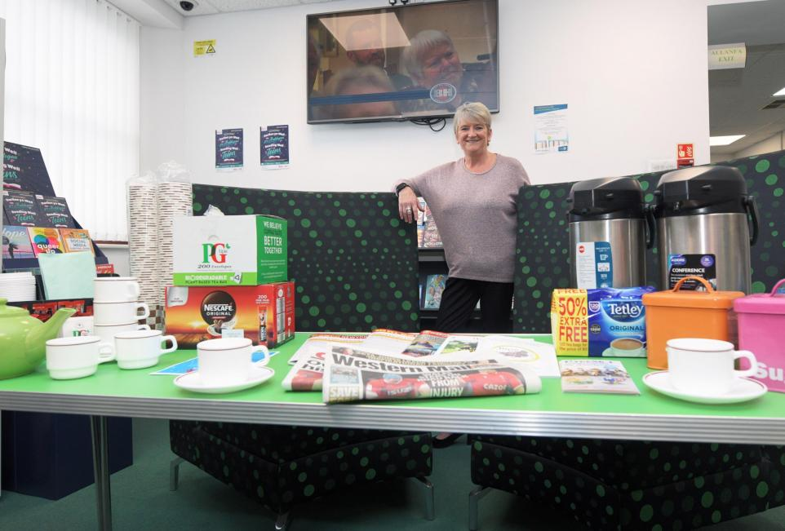 (Riley, 2022)
Figure 1
Cllr Lind Evans at one of the first warm spaces to open in Ammanford library.

How to find Warm spaces within the CC area
According to towns and counties postcodes in Carmarthenshire there are 321 Towns and villages, out of these only 57 have set up registered, recognised established council warm spaces on the Carmarthen Council website.
The CC website describes the warm spaces as areas people can go and read paper, magazines and books, use iPad’s and computers and some also have televisions to watch, whilst being able to have a warm drink available free of charge.CC also encourage to think creatively about the type of events that they could hold within the warm spaces that suits their communities needs, from setting up money advice to pointing people in the right direction for help and advice on most subjects.
As well as a description of their warm spaces CC also have an area on their website where you can add your warm space to their official directory and find your nearest warm space, by typing in your postcode it will bring up the closest spaces to you. With the use of all spaces shown on an ordnance survey map on the CC website.
This is an example off the CC website displaying where warm spaces are within CC area.
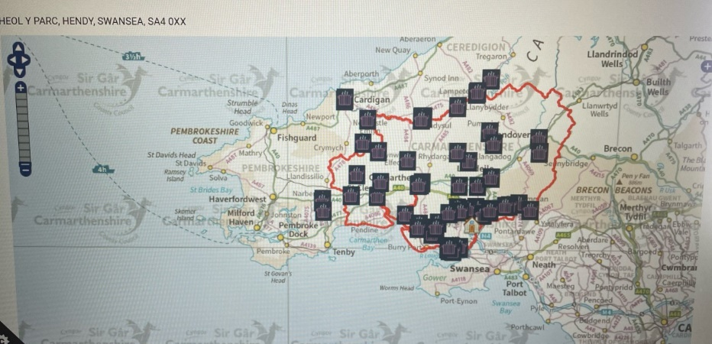(In My Area, 2022)
Figure 2

2.4 Examples of Warm space initiatives in CCC
Trallwn Area Community Hall- Coffi, Clecs a Croeso Cynnes which translates to Warm welcome, coffee, and tales(chats). Trallwn community hall is the closest nearest warm space to Hendy at 5 miles away. Offering a warm space with a hot drink and a snack daily between 9.30am-4pm although their advert does state these times could change. Whilst offering computer use, game sessions and other events.

Y Cwtch Tymbl which is another one of my nearest Warm spaces is 7 miles away, they have a bold statement attached to their space’ No child should go hungry, no parent should go hungry to feed their child, and no one person should be struggling or left out in the cold this winter’ (Y Cwtsh, Tymbl, 2022). Cwtch state they are at the heart of the community and a welcoming safe place for all, they have incorporated a ‘social supermarket’ withing their warm space.

Offering free Coffee, Tea, and a warm bowl of soup to all between 12-1pm, in return the volunteers will ask you to fill in a membership form and pay a donation of £1 this enables all members of your household to become a member for a year, most warm spaces only run from November 2022 – March 31st, 2023. Whilst using the space your household will have the opportunity to take up to 12 items of food, personal hygiene items and household essentials for a donation of £3 although this is not a compulsory donation.

3 Methodology

3.1 Introduction
The methodological chapter defines and provides an overview of processes used within this paper to gain the required information needed for the primary research, whilst explaining the methods that were used to collate the data.

3.2 Research Aim
The aim of this paper is to research ‘Warm Spaces’ within the community, are the warm places widely known about and are they being used, do the communities know who can use the spaces, and is there a stigma attached to such places? Various sources and approaches where used to gain the relevant information. The methodological chapter will explain what methods and approaches where used to collate the information for this research.

3.3 Research Approach
In order to comprehend the who, what and why of a study issue and desired outcome, a variety of research methodologies can be used. In order to comprehend the phenomenon being seen by way of acquiring insight based on humanistic and interpretive behaviours, this research will be undertaken using a qualitative and quantitative technique.
To provide a more thorough examination of the study, strategy and approach the Saunders research onion has been looked at, The metaphor of the onion made famous in the research field by Saunders and others like Shrek. Onions contain layers and in order to grasp the phenomenon that is being investigated, the researcher must peel the study onion back to its core. Sinha, Clarke, S., & Farquharson, L. (2018)

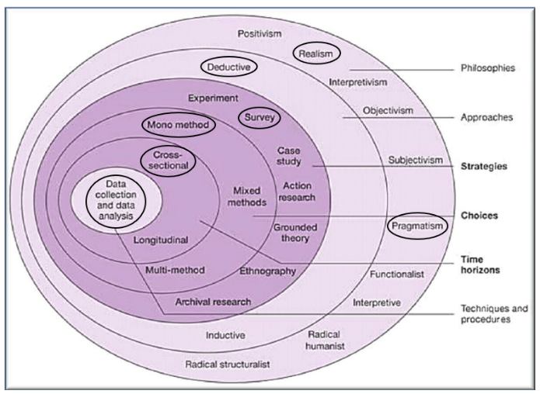

Figore 3 Saunders Research Onion (Saunders,2012)

3.4 Methods Used.
Firstly, Preparation of an effective questionnaire is undertaken, designed on Google Forms, the software Google Forms offers several different formats of questions, which include multiple choice and text (Google,2021) and shared to social media platforms. Social media platforms are used daily by most people according to The Digital 2022 April Global Statshot Report there were 4.65 billion social media users globally, this equates to 58.7% of the world’s population, many of whom use social media as a primary source of information. (Walsh (2022). Facebook and WhatsApp have been the choose platforms for this study due to the fact that they both fall in the top three rated social media platforms, Facebook has over 2.9 billion active users monthly, and WhatsApp have 2 billion,
Setting a target number and a time limit, in this case the target number would be 100. Secondly write the questions that are needed for the three interviews, ensuring the questions support the expressed objective and show no bias.
The goal of methodology Is to include a variety or research methods within a piece of work, helping to establish a stronger research strategy for conducting, analysing, and making conclusion and to provide a clear structure to data collection. (Igwenagu, 2016). In the course of writing the literature review it has revealed the factors of the study, this section will show how all the data was gathered and why. There will be no financial reward or incentive for participants.
In order to gather information for this report, both qualitative and quantitative methods will be used. The qualitative method will use semi-structured interviews to gather information about people's experiences rather than just their opinions. At the beginning, qualitative research was intended to reveal patterns and themes in social and cultural phenomena (Ernst, a2003).
With the help of predefined questions in the form of a questionnaire, 102 participants were interviewed using quantitative research, which assists in looking for trends and patterns in the data by using close ended questions. A quantitative study collects numerical information like age and opinion, as well as the possibility of collecting subjective information through surveying using a scale marking method. (Grbich, 2007)
With the intensive gathering and analysis of narrative data, qualitative research is thought to be a type of study that gives participants' opinions greater weight and attention while also gaining clarity and insight into phenomena (Ahmad & Sumaiya,2019).
Interviewing three participants with open ended questions, allowing a free flowing conversation, rather than answering from a list of answers.
There are benefits to using both qualitative and quantitative methods. While quantitative methods allow the researcher to ask many participants with just one specially designed questionnaire, qualitative methods allow the researcher to collect more descriptive data to analyse the subject with a small group of participants.
The questionnaires’ will seek to gain the understanding that the general public have on the research subject, the questions will be phrased with as much neutrality as possible.

3.5 Data Protection Procedure and ethics
In compliance with Trinity St David’s data protection policy, the dissertations academic supervisor will be briefed on the assignment and methods planning to be used to collect data, drafting an ethics form is the first part of the of the research before surveys and interviews can be conducted, secondly finalising the ethics form ready to be signed off by the dissertation supervisor. Gaining consent form all Qualitative participants, whilst also making the quantitative participants aware that the information they provide is being used for research and analysis. (Uwtsd, n.d.) Minimising the risk of harm and stress, by obtaining informed consent prior to the interview or questionnaire this would either be by form or writing a brief section at the start of the questionnaires.
Another compliance that is needed to be met for data protection is the using of Pseudonyms (nick names) this is to protect the identity of that Qualitative participants, also arranging a private venue for their face-to-face interviews, assuring the participants that their identity will not be revealed. Interviews will be recorded to allow a more accurate collection of information, then transcribed to allow data collection.

3.6 Data analysis and Presentation.
After collecting the responses, it is time to condense the results, analyse the specifics and look for any recurring trends and lay the format of new theories. Create categories for the data encryption and divide the date into manageable parts.
Virginia Braun and Victoria Clarke created the thematic process initially for psychological study. Thematic analysis is a versatile tool, nevertheless, and can be used to a wide range of research types. (Braun & Clarke 2006 - Using Thematic Analysis, n.d.)
Following the completion of the interview’s transcription will take place, further allowing relevant information to be extracted from the dialogue In accordance with the dissertation. Allowing the identification of any patterns and themes within the information. Using Thematic analysis allowing a way of seeing information as well as processing data.
A theme is a ‘patterned response or meaning’ derived from the data that informs the research question (King & Varpio, 2020)
(Braun and Clarke.2012)
The process of thematic analysis can be approached in a variety of ways, the most popular comprises of six steps: familiarisation, coding, generating themes, reviewing themes, defining, and labelling themes and writing. By using this process, you can prevent boas from creeping into your analysis. (Jones,2022)
The quantitative research findings will then be exported to excel and loaded into SPSS(Statistical Program for the Social Sciences), this is used for research analysis. The SPSS application offers a wide range of fundamental features that will be employed for this research, including cross tabulation and bivariate statistics.(Jordan,2021)

3.7 Limitations of study
Bias according to Merriam Websters inline directory is the deviation of the expected value of a statistical estimate or encouraging one answer or outcome over others. (“Definition of Bias,” 2023c). Consideration needs to be taken that bias does not affect the data collection process when doing the face-to-face interviews.
There are strengths and weakness for both surveys and questionnaires, strengths could be questionnaires are cheap or free to conduct, quantitative data collection compared to qualitative data collection methods like interviews is simpler and easier to gather data from a bigger audience such as social media platforms.
Weakness could be, the number of responses to a questionnaire can be too low to yield quantifiable information, and the use of open-ended questions in an interview type survey could leave questions unanswered or answered incorrectly if the interviewee goes of on to a different subject.
Questionnaires will be made available on Facebook, Instagram, and WhatsApp for participants to complete, this is a random sampling method, sharing on social media could potentially attract people who will just answer for fun and not for the desired reason. One of the most common and straight forward data collection technique in the study domain is random sampling, this consists of probability, statistics and mathematics. Enabling the collection of objective data, which then enables studies to draw objective conclusions. (Taylor, 2023)
The face-to-face questionnaire will be asked to three warm spaces leaders, however sourcing these could become problematic since most people have busy lives and cannot simply find the time to take part.

3.8 Time Horizon and Budget
Without the correct planning and preparation, you will not receive the quality of work that is needed for a dissertation, this takes time a four-week allowance has been given for this. This includes investigating whether there is a gap in the existing or recent research if there is any research available on the subject, does the question merit investigation?. Will statistical analysation take place and if so what kind of analysis? Will there be any computers or tools used to assist with the research and reduce the time scale.
The cost of books that can not be obtained from the library or online will be kept to minimum, there will be a small cost in fuel travelling to interview the three qualitative participants. Participation will be voluntary, but since this may discourage the participants from taking part interview limits will be set at 30 minutes each, this is not to use up to much of other people’s valuable time.
Additionally important is to consider a note pad, pens and highlighters as not all the information will be recorded directly onto a laptop.
For research and data management, creating questionnaires and posting onto social media a laptop or a form of computer will be needed, however if the research does have one the university can loan one or allow the use of one on campus, to record the interviews a mobile phone will be used.

4 Findings
The key research findings are presented in the section that follows, presenting the primary research from the findings. A total of 123 reposes were collected from the questionnaire distribution on social media platforms which provide the information for data analysis, the three semi structured interviews provided in depth information that could be analysed using humanistic and interpretivist behaviours in terms of experiences that the participants were familiar with in regard to the research issue as all three participants ran their own warm hub.

  - Questions

Question 1 What is your Gender?
Out of the 102 participants figure 1 shows 89 which is 86% were women, 13% where men and 1% preferred not to say their gender.

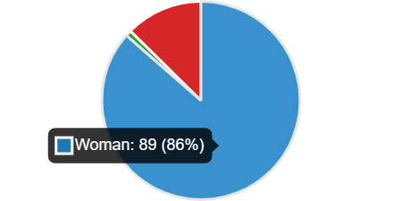
Figure 4

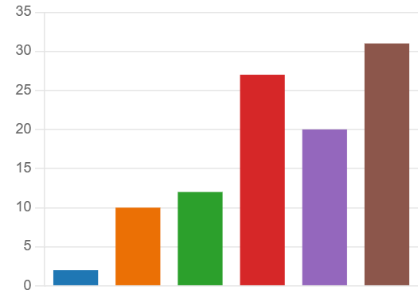
Figure 5

Question 2 What is your age?

Figure 2 determines that the age group with highest number of participants was 55+ this is 31.62% of the participants.
Under 18 | 2
18-24 | 10
25-34 | 12
35-44 | 27
45-54 | 20
55+ | 31


Figure 6

Question 3 What council Area do you live?

In figure three it shows that the blue area is 58% of participants live in Carmarthenshire, the orange area 31% live in Swansea and green area 12 % live in neither.

Question 4 Have you heard of warm spaces?

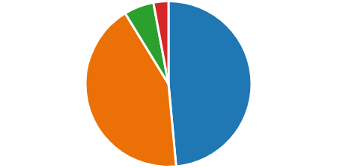
Figure 7

Figure four shows in the blue quadrant that 49% of participants had heard of a warm space where a high rate of 44% had not. Figure four has been cross tabulated with age to see if this had a bearing on the results as you can see in figure five from the age of 25-44 is the highest rate of participants not knowing what a warm space i
What is your age? * Have you heard of 'Warm Spaces' Crosstabulation
Count
 |  | Have you heard of 'Warm Spaces' |  |  |  | Total
 |  | No | Not sure | On the news, social media etc | Yes | Total
What is your age? |  | 1 | 0 | 0 | 0 | 1
What is your age? | 18-24 | 7 | 1 | 0 | 2 | 10
What is your age? | 25-34 | 11 | 1 | 0 | 0 | 12
What is your age? | 35-44 | 11 | 1 | 2 | 12 | 26
What is your age? | 45-54 | 7 | 1 | 0 | 12 | 20
What is your age? | 55 + | 5 | 1 | 1 | 24 | 31
What is your age? | Under 18 | 2 | 0 | 0 | 0 | 2
Total |  | 44 | 5 | 3 | 50 | 102
Figure 8

Question 5

Who do you think can use a warm space?
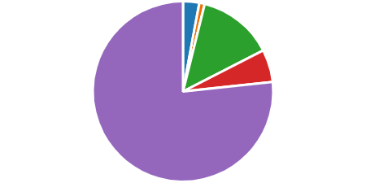
Figure 6

In figure six it shows that 79% of participants knew that a warm space is open to anybody to use, this is a very strange answer as according to the survey data 44% of participants did not know what a warm space was.

Question 6 Do you think there is a stigma attached to initiatives such as warm space?

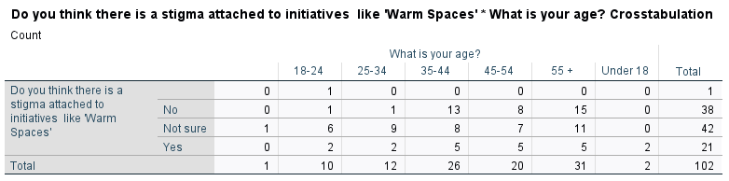
Figure 9

The question, Do you think a stigma is attached to initiatives such as warm spaces was asked, 21 said yes, 39 said no and 42 participants said they were unsure. Figure 7 shows that the higher age categories that has said yes, they do think there is a stigma attached.

Question 7 Is there a warm space in your area?

Yes | 33 | 32%
No | 6 | 6%
Unsure | 64 | 64%
Figure 10

Figure 8 shows that 64% of participants did not know if there was a warm space in their area, where 33% knew there was and only 6% said no there was not one in their area.

. 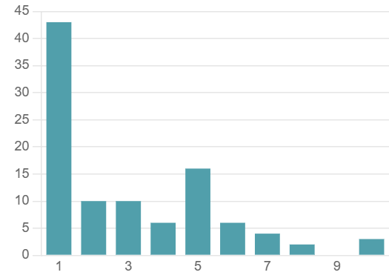
Figure 11

Question 8 How likely are you to use a warm space?

An average rating of only 3.07 % of participants are likely to use a warm space, this question was analysed with the age of the participant to see if there was a pattern. Figure 10 shows that the older the participants were the more likely they would use the initiative.

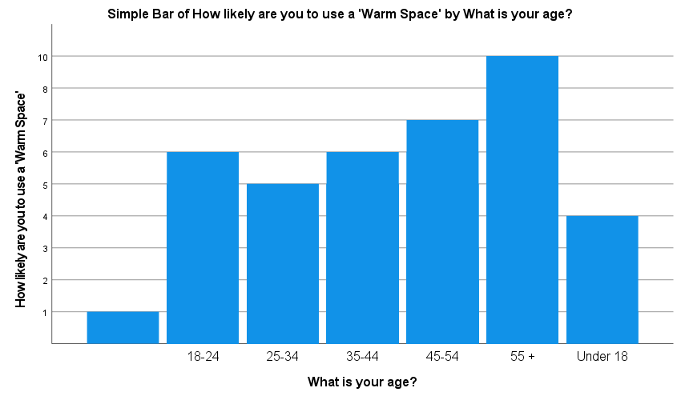
Figure 12

Question 9 Do you think Warm Space money could be spent on other things in the community? If yes what.

The data from this question showed that thirty-seven people answered this question, yes, they think the money could be spent better elsewhere. Below are some of the replies that were found.
-Helping others who are on low income who work, not just people on benefits who receive more help than those who are on a low working income. This can be done by helping local houses draught proof homes etc.
-Pavements that are unfinished, filling potholes in roads.
-Unsure what it is so can’t comment on what the service provides.
-I am not sure what a warm space is although assuming it is for homeless people then I would recommend money being spent elsewhere due to there not being many homeless people in the Carmarthenshire area
-The other answers were generic in the fact that people answered they were unsure what a warm space was so couldn’t comment.

Question 10 Do you know anybody that has used a Warm Space?

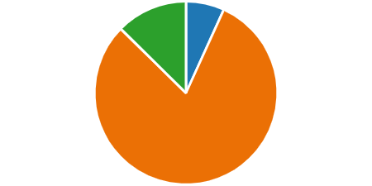
Figure 13

There is a very high percentage of 81% people that do not know anybody that has used a warm space, with only seven people 7% saying yes, they do know somebody that has used a space. Is this because there is not one local to them or they are unaware of warm spaces?

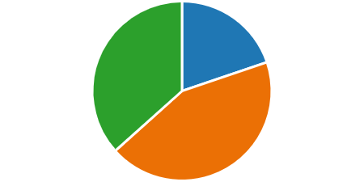
Figure 14

Question 11 Do you know anybody that would benefit from a Warm Space?

The orange quadrant shows that 44% of people are of the opinion they do not know anybody that would benefit from a warm hub, with 37% as a maybe with only 20% showing that they do not know anybody that would benefit.

  - Quantitative Findings overview

After analysing the data from the 102 questionnaires, it was found
-87.25% of women participated with just 12.74% of men, and 76.47% where of the older three brackets 35-55 years old.
-58.82% lived in Carmarthenshire, which is the focus of this ‘Warm spaces’ research. 49.01% had heard of the warm space initiative with 43.13% that said -they had not.
-80.58% of participants said that anybody can use a warm space with 14.28% though it was a homeless initiative.33.35% answered that there was a warm space in their area with 62% that didn’t know.
-20.58% said there was a stigma attached to warm spaces, 38.23 said there was not and 41.17% were usure.
- 32.35% participants said there was a warm space in their area, while only 5.8% said no however 62.74% said they were unsure.
- 3.07%participants said they would use a warm space.
- 36.27% responded to the question do you think the warm space money can be used elsewhere, some of the comments are in the findings.
- 19.60% said they do know somebody that could benefit from a warm space, 43.13 said they do not know anybody with 36.27 unsure.

5 Quantitative Data

Three participants took part in the qualitative section of this research, they are each fundamental to running the warm space initiatives in their communities.
Semi structured questions were asked in order to gain the information required for this research. The participants will be given the pseudo name of participants A,B and C for the purpose of this assignment. In this section are the selected sections of the interviews relevant to the research.

Question 1 Are the levels of attendees to your warm space as you expected, if no why have you had to implement anything to improve your attendance figures.?
Participant A – At the start the numbers were quite low, but they increased as word spread about what we were doing.
Participant B- We were unsure what to expect to be honest, we hoped we would have around 20-30 as we are a small village, however after introducing a homework club and a mother and baby coffee morning, we now see around 100 participants a week.
Participant C – When we applied for the funding, we approximately said we would hope to help100 plus people a week, at the start we only had four or five a day this was worrying. We decided to do a leaflet drop and asked the local school to send out a text message to all parents to explain about the warm space and a list of times days etc as the school holiday were coming up (this was October half term) we decided to open more in the day. The school half term was busy and this then continued right up to now, we asked the community what times they think we should open rather than us choosing the times.
Result 1 - As the responses show all three warm spaces are successful, maybe with a slow start that have increased to helping substantial numbers from their communities.
Questions 2 How many roughly attend your warm initiative every week
Participant A – we get around 60 individual a week these include of families as well, during the school holidays and over Christmas we had a lot more.
Participant B- Currently we get around 100 plus per week, we are hoping we can continue to help these numbers after this is supposed to finish on the 31st march.
Participant C- To be honest it depends on things like the weather and what we have on, and also the time of day. In the morning sessions we get a lot of mother and baby’s as we have started a session for them and also some elderly, whilst the tea time section we see more children and young families.
I asked Participant C do you know rough numbers for a week, they said it was hard to judge but around 120 on a busy week and maybe only 40-50 on a quiet one.
Result 2 – attendance varies on all three participants, this could be down to the size of their community or lack of knowledge from the communities about the initiative.
Question 3 – How many days a week do you run the warm spaces?
Participant A – Our space runs 5 days a week at different times to suit different people, we try to make sure that there is a time to suit all types of people.
Participant B – At the moment we open 3 days a week 1 morning and 2 teatime / evening sessions, this is due to the lack of volunteers as two of our initial volunteers are unable to commit anymore due to their own ill health.
Participant C – We open on a Monday morning 9-11 and teatime 4-7 and a Wednesday the same a Saturday we open 10 am -2pm. This seems to work for the people that come here.
Results 3 – The amount of time the space are run vary between the three however two are very similar four and five days a week, the third struggles with volunteers so could possibly open more if this was not the case.
Question4 – What percentage of attendees would you say are over 55 years old?
Participant A – ok that’s a good question is this in general over the week?
Interviewer - yes just in general not to each session.
Participant A – We have a high number of elderly that attend but I would say they are over 65 not 55, we do get some in that age bracket, if we talking the older age I’d say at least 60% of the people come are that age.
Participant B – Over 55 in the morning session, we get mainly the older generation but we do have a mother and baby and that is attended by about 10 mothers.
Interviewer – Do the older generation sit in the same room as the mother and baby,?
Participant B – no we have a separate room for that, the older ones like to sit and chat quietly not with baby’s running about if you know what I mean.
Results 4 – There is definitely a pattern in question four, all space are used Widley by the elderly, however due to the fact that the three of them run a mother and baby group and homework club means that they all have a good amount of the younger generation as well.
Question 5 - do you have organised events for your warm space?
Participant A – yes we have all kinds of stuff going on bingo, quiz, afterschool clubs and book and board game swopping.
Interviewer- book and game swopping how does that work.?
Participant A – people can bring their old books, board games and jigsaws along to the centre as long as they are not damage or bits missing. They can then swop to another one this is good with young families we recently had a large donation of children’s books In to add to the swapping station.
Participant B – We have a mother and baby session and a mature person hot drink and chat sessions we did try quiz sessions etc but due to lack of volunteer we are struggling to stay open as much as we would like to.
Interviewer – have you advertised for more help?
Participant B – yes we put it on social media and asked people we know, people are buys doing their own thing unfortunately a lot wont help for nothing.
Participant C- We stick to our rota and do mother and baby, homework club and a Saturday morning open one. We do get the elderly in but they just like to sit and chat or read.
Results 5 – All three spaces have organised events.
Question 6 – Is there a donation or a fee requested for your warm space?
Participant A – No we don’t charge the money comes from Carmarthen Council, we are thinking of working with our local food bank to help people more as well.
Participant B – What do you mean a fee ?
Interviewer- A charge to be able to attend your warm space sessions, like a membership.
Participant B- gosh no the whole point of this is that people can save money by coming here have a hot drink and keep warm, save on their bills. Why would we charge them?
interviewer – some warm spaces charge a membership fee although they say it is a donation fee and not compulsory.
Participant B – that is wrong they should not be allowed to charge.
Participant C- We ask for a £1 a week donation but this allows the people to also have something to eat not just a warm drink and a biscuit, we also only charge a further £1 if people want to take an extra meal home with them.
Interviewer what type on food do you supply for £1
Participant C unfortunate due to being short of volunteers its basic but warm and filling, stews, soups and a roll and sometimes something like cottage pie. We get donations from our local shop and community to help with this its great. Last week they had a pasta bake as we were given a load of pasta and tuna for free from somebody that was moving house so cleaned out their cupboards.
Interviewer -Are you able to accept food off just anybody?
Participant C -yes as long as it is in date and has not been opened we will accept it, we do not accept food from a fridge or a freezer thou just in case.
Results 6 – Only one third of the participants charge or ask for a donation, this is not for attending the space this is payment towards a free meal they can receive if required.
Question 7- What benefits do you think warm spaces have on people?
Participant A -Isn’t that obvious? Not having to put their heating on and keeping warm, being safe.
Interview – At this point I quickly moved on to the last question as I could sense that Participant A was getting bored of the questions, which was surprising as was enthusiastic all the way through.
Participant B-It was set up to be a warm place for people that, so they did not have to sit in a freezing house possibly on their own, having company a lot that attend live on their own and have nobody to talk to.
Participant C- I started to come to the warm space for company as I live on my own and retired, I think having a warm cuppa and a natter means so much to so many people, having social interaction keeps a lot of people sane sitting on your own all the time is not good for mental health. After a few weeks I decided to volunteer to help others like me. I do hope we can continue as I will be lost as well without coming here to help.
Results 7 -All three participants stated that the benefits were a warm place and a hot drink rather than sit in a cold house, one participant stated that it also helps with mental health being able to chat to people and not be on their own at home.
Question 8 - Lastly would you consider keeping your warm space running after the funding stops on the 31^{st of} March this year?
Participant A - We have already looked into this and have enquired with the local councillor to see if there is any funding available otherwise it will be hard to cover the cost of it all.
Participant B -Yes as I said earlier we would like to carry on, it depends on the money though as horrible as that sounds we do it for nothing but we need to pay the bills and the cost of products we supply like tea coffee and biscuits.
Participants C- Possibly but I can’t carry on after end of march as I am starting a new job so I need to find volunteers to take over which unfortunately are few and far between at the moment. I know my friend and her mother are still happy to carry on but we need more than two people to help.
Results 8 -All there warm spaces would consider staying open.
The interviews were concluded after 30 minutes, the participants were thanked for their time and help.

5.1 findings
It is clear from the dialogue above that warm spaces are working and helping many people, relying solely on volunteers which can sometimes be problematic. There is a clear pattern from all three regards to what sessions they run, mother and baby and homework sessions are the main core of all three groups. There is a mixed option about asking for a donation however if participant C was interview before the other two it could have ben mentioned what the other spaces charge a donation for, and that its not just for attending the space the attendees get a warm meal in return for a donation.
All three participants would like to carry on with the initiative; however, this is dependant across the board on funding, how would they fund the space to allow it to continue, and volunteers as the spaces cannot run without them.
The three participants mentioned that the warm spaces were for people to be able to keep warm and not sit in a cold house, however only one mentioned the spaces are good for peoples mental health not to be sat at home on their own with nobody to talk to and being cold.

6 Conclusion

The Mental Heath Foundation states that “ Our basic human needs of staying warm, safe and having enough to eat is being challenged” (Cost-of-living and Mental Health, 2023). Find the time to care of oneself might be challenging especially when added daily concerns like worrying about bills, food an keeping warm. Even with so much going on its crucial to make time to look after your physical and emotional health.
Nearly everyone in the UK is impacted by the cost-of-living challenges, The price of heating our homes, running water to wash the dishes have a was or do the laundry, and the price of food. Most households plan every meal to a budget which hasn’t been done in such a scale in this country in years. With all the stress of the increase of bills, and of course the stress from our everyday lives like health, family, friend and work, it can make you feel you lack the mental capacity to handle anymore.
Warm spaces have been a haven to many people that we just do not know about and possibly saved lives, maybe after competition on this winter’s hubs on the 31st of march there will be data released on hubs, and on how they have actually helped the communities. The total cost of the hubs across the UK and especially in Carmarthenshire where the focus of this research was based on is currently unknown, this leaves plenty of scope for future research on the warm spaces.

6.1 Recommendations
Whilst the threes warm spaces appear to be working according to this research study, there are a few areas that lack clarity. 44.13% of participants in the study had not hear of a warm space, maybe schools could send notifications to families informing them of the warm space in their village and what they are all about, explain that they are not just for low income families and that are welcome.
Secondly with over 321 towns and villages within Carmarthenshire and only 57 registered warm spaces, do the council need to approach communities to participate in the initiative, possibly give a subsidy to those groups, business or volunteers that take part. This in turn could and will help more people.

6.2 Further study Recommendations

As there was no other research found regarding the dissertation subject ‘Warm Spaces’, apart from newspaper articles and government press release on warm spaces, the following recommendations would benefit from additional study after the end date of the ‘Warm Spaces ‘which is 31st March 2023.After this date there should be information available from all the participating council, that would derive from the warm spaces them selves.
Recommendation one
How much has ‘the Warm spaces’ initiative cost the government, and could the money be spent to help the more vulnerable in a more cost affecting and positive way?
Recommendation Two
How many people has the initiative helped over the 6 month its has been running for and, is the number of people using the spaces what the government and councils were expecting.
Recommendation Three
What age groups has the initiative helped and could the homework clubs and hot drink be held within the schools to allow the spaces to make more room for adults and families in an evening?
Recommendation Four
Is there funding available to carry on with the initiative past the end date? And would this benefit the communities.

