University of Wales Trinity Saint David

Wales Institute of Science & Art



Energy in a Flywheel
Further Science for Engineers (ACHA4007)

Efren Sabastian
2400744
23/03/2025

Contents
1. Introduction 1
1.1 Experiment Procedure 2
2. Results 3
3. Analysis 5
4. Conclusion 7
5. Evaluation 8
5.1 Strengths of the experiment 8
5.2 Limitations and sources of error 8
5.3 Improvements to minimize errors 8
6. Further Work 9
6.1 Improvements to the current experiment 9
6.2 Additional experiments 9
7. References 10

Figure 1- Image of experiment setup 1
Figure 2- Image to show 500grams of weight on hanger 2
Figure 3- image to show 200grams of weight on hanger 2
Figure 4- Graph to show relation between mass, PE and KE 4
Figure 5- Graph to show torque vs angular acceleration 6

Table 1- Data gathered from experiment 3
Table 2 - Energy Losses 4

Introduction

The change of potential energy (PE) to kinetic energy (KE) is important in understanding how mechanical systems work. This experiment aims to investigate the energy in a flywheel system, utilizing a weight hanger to measure how effectively PE can be converted to KE and the overall efficiency of this process. Flywheels are used in all different types of applications from simple mechanical devices to energy storage systems (Tie and Tan, 2013)

Figure 1- Image of experiment setup

The basis of this experiment relies on the laws of conservation of energy, which say that energy cannot be created or destroyed but can change forms. This experiment observes how gravitational potential energy (GPE) is changed into KE as the weights are released and fall. By measuring energy before and after the fall we can calculate the loss of energy from friction and other factors, thus increasing our understanding of energy in a flywheel system.

Experiment Procedure
The experiment was structured to ensure accurate measurements and reliable results. The following steps show the methodology used:
The weight hanger was made secure and attached to the flywheel, the flywheel and pulley block was fixed to a work backing to prevent any external disturbances, the flywheel was aligned properly to ensure it rotated freely, a magnetic ruler was added to help with data recording and making sure the start position for each drop was correct.
Incremental weights were added to the weight hanger, the weight increased throughout the experiment from 100g to 500g in weight. Every weight had 3 turns each so an average could be worked out. Having a range of weights helps with the understanding of PE and to observe how they affected the flywheels performance.
Starting off at 100g the flywheel was rewound to lift the weight hanger to its start position at 280mm on the ruler. The timer on a mobile device was used to record the fall. The timer recorded how many seconds it had taken for the weight hanger to fall from 280mm to 0mm and back up to its maximum height.



Figure 2- Image to show 500grams of weight on hanger
Figure 3- image to show 200grams of weight on hanger

Results
All data was then logged into a table, this included the mass of the weights, the distance fallen, the time taken, and the calculations of PE and KE.
The PE of each weight was calculated using the formula: PE=mgh
m = the mass of the weight (kg)
g = acceleration due to gravity (approximately 9.81m/s²)
h = height fallen (meters)
KE after the weight fell and the flywheel began to rotate. KE was measured using the formula: KE= ½ Iω²
I = moment of inertia of the flywheel
ω = angular velocity (radians per second)

Table 1- Data gathered from experiment
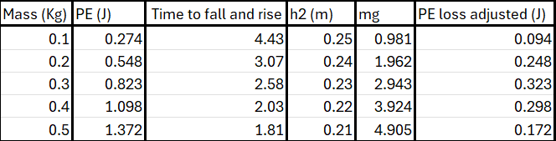

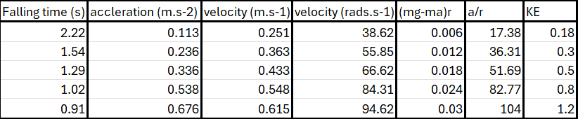

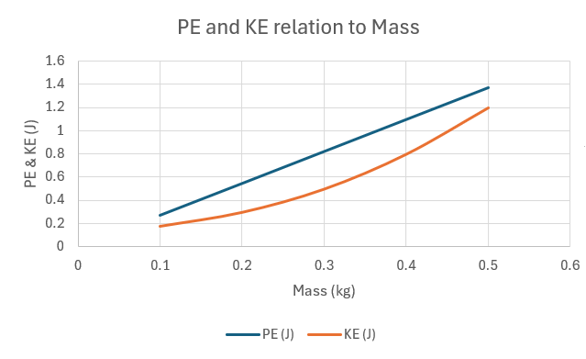

Figure 4- Graph to show relation between mass, PE and KE

From the table and graph, we can deduce the following trends. Every increase in mass yields a corresponding increase in PE, for example, the PE for 0.1kg is 0.274J, while for 0.5kg, it is 1.373J. KE also increases as mass increases, with 0.5kg having a KE of 1.200J, significantly higher than the 0.1kg KE of 0.180J.

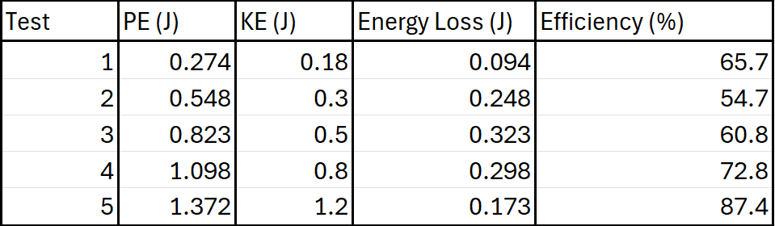
Table 2 - Energy Losses

Efficiency calculated using: Efficiency = KE/PE x 100%

Analysis
The analysis of the data shows several important trends and insights related to the efficiency of energy conversion in the flywheel system. The increasing PE energy in the data shows a direct relationship between mass and PE, as mass increases, PE also increases, which therefore shows us why PE = mgh.
For m= 0.1kg
PE=mgh
=0.1 x 9.81 x 0.28= 0.274J
KE= 0.18J

PEloss= PE – KE= 0.274 – 0.18 = 0.094J

For m= 0.5kg
PE= 0.5 x 9.81 x 0.28= 1.372
KE= 1.2J

PEloss= 1.372- 1.2 = 0.172J

The PE loss increases with mass, indicating that energy is being lost to friction and other resistive forces. This is consistent with the theoretical expectation that heavier masses result in larger energy losses due to increased frictional forces
KE measurements also reflect an increase in mass; however, the increase is not proportional. KE energy for 0.5kg mass is 1.200J, which is less than the PE of 1.373 J. This difference shows us that there are energy losses during the conversion process.
The efficiency values differ across the test, with the lowest efficiency recorded at 0.2kg at 54.7%. The highest efficiency levels were at 87.4 percent with the 0.5kg mass. This can suggest that heavier weights can lead to better energy conversion under certain conditions.
Energy losses showed variability across different weights, for example, the energy loss for 0.5kg mass is relatively low at (0.137J) while the loss for the 0.2kg weight is higher (0.248J). This trend suggests that the system performs better with heavier loads, it could be due to the increased inertia helping to overcome resistive forces.

A chart of (mg-ma)r against a/r was created as seen in figure 5 below. The results formed a reasonably straight line with little scatter. The gradient of this line represents the moment of inertia of the flywheel.
The gradient of the line is 0.0003, which represents the moment of inertia (I) of the flywheel. Thus: I = 0.0003kgm²
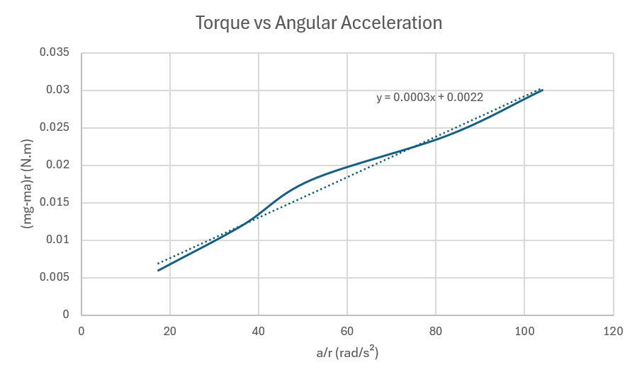

Figure 5- Graph to show torque vs angular acceleration

Friction plays a significant role in the experiment, as it causes energy losses and affects the accuracy of the results. The frictional torque can be estimated by analyzing the intercept of (mg-ma)r vs a/r graph. If the intercept is non zero, it indicates the presence of a frictional force.
The y intercept of the line is 0.0022 N.m, which indicates the presence of frictional torque in the system. This torque is responsible for the energy losses during the experiment.

Conclusion
This experiment successfully demonstrated the conversion of PE to KE using a flywheel mechanism. The results confirmed the theoretical relationship that as the mass increased, the PE energy also increased. However, the KE did not increase proportionally, indicating significant energy losses and could be the result of friction. The efficiency of energy conversion varied throughout the tests, with heavier weights achieving higher efficiencies, suggesting that the system performed better under more load.
The experiment also successfully showed the relationship between torque and angular acceleration in a flywheel system. The calculated moment of inertia was found to be 0.0003kg.m² , which is close to the nominal value of 3.862 x 10^-4 kgm². The y intercept of the trendline indicated the presence of frictional torque, which contributed to energy losses during the experiment. Despite these losses, the results provided a clear understanding of how torque and angular acceleration are related in a flywheel system.
Overall the experiment highlighted the importance of careful measurement and control of external factors. The results demonstrated the behavior of the flywheel system.

Evaluation

5.1 Strengths of the experiment
There was a clear relationship between torque and angular acceleration, which was demonstrated clearly, with little scatter in the data points.
Consistent data throughout the experiment ensured reliable data and reduced random errors. The repeated measurements for each mass also increased the credibility of the experiment and overall accuracy.
The results aligned with theoretical expectations, demonstrating the effectiveness of the experiment.

5.2 Limitations and sources of error
Friction in the flywheel bearings and pulley system caused energy losses, leading to gaps in the relationship between torque and angular acceleration. This was shown in the y intercept on the trend line (0.0022Nm), which represents frictional torque.
Human error in timing and alignment could have introduced inaccuracies, slight misalignments of the hanger or inconsistencies of starting and stopping the timer may of affected the results.

5.3 Improvements to minimize errors
Reducing friction by using low friction bearings and lubricating the flywheel shaft to minimize energy losses. This would improve accuracy of the torque and angular acceleration.
Improving measurement accuracy by using digital sensors for timing and alignment to reduce human error, for example using a photogate to measure the time of the fall.
Ensuring all equipment is calibrated properly before conducting the experiment, this would help reduce systematic errors and improve reliability.

Further Work
Given unlimited time and resources, several improvements and extensions could be made to enhance the experiment and explore additional aspects.

6.1 Improvements to the current experiment
Replace the stopwatch with digital sensors, such as photogates or laser timers, to measure time and velocity more accurately. This would reduce human error and improve the precision of the results. (Walker, Resnick and Halliday, 2014)
A low friction set up using advanced materials such as ceramic bearings, and lubricants to minimize friction in the flywheel and pulley system. This would help reduce energy losses and provide more accurate measurements of torque and angular acceleration. (Serway, 2018)
Conduct the experiment in a vacuum to eliminate air resistance. This would allow for a more accurate analysis of the relationship between torque and angular acceleration without the interference of external factors. (Young and Freedman, 2015)

6.2 Additional experiments
Test flywheels of different masses, shapes, and materials to study their energy storage capabilities. For example, comparing steel and carbon fiber flywheels could provide insights into how material properties affect performance and efficiency. (Genta, 2014)
investigate the effect of cord length on the energy transfer and rotational dynamics of the flywheel. This could help optimize the setup for different experimental conditions and improve the accuracy of the results. (Ferdinand Pierre Beer, Elwood Russell Johnston and DeWolf, 2006)

References
Ferdinand Pierre Beer, Elwood Russell Johnston and DeWolf, J.T. (2006). Mechanics of Materials. McGraw-Hill.

Genta, G. (2014). Kinetic Energy Storage. Butterworth-Heinemann.

Serway, R.A. (2018). Physics for scientists and engineers. Pacific Grove: Brooks Cole.

Tie, S.F. and Tan, C.W. (2013). A review of energy sources and energy management system in electric vehicles. Renewable and Sustainable Energy Reviews, 20, pp.82–102. doi:https://doi.org/10.1016/j.rser.2012.11.077.

Walker, J., Resnick, R. and Halliday, D. (2014). Halliday & Resnick fundamentals of physics. Hoboken, Nj: John Wiley & Sons, Inc.

Young, H.D. and Freedman, R.A. (2015). University Physics with Modern Physics. Pearson.

