Slide 2

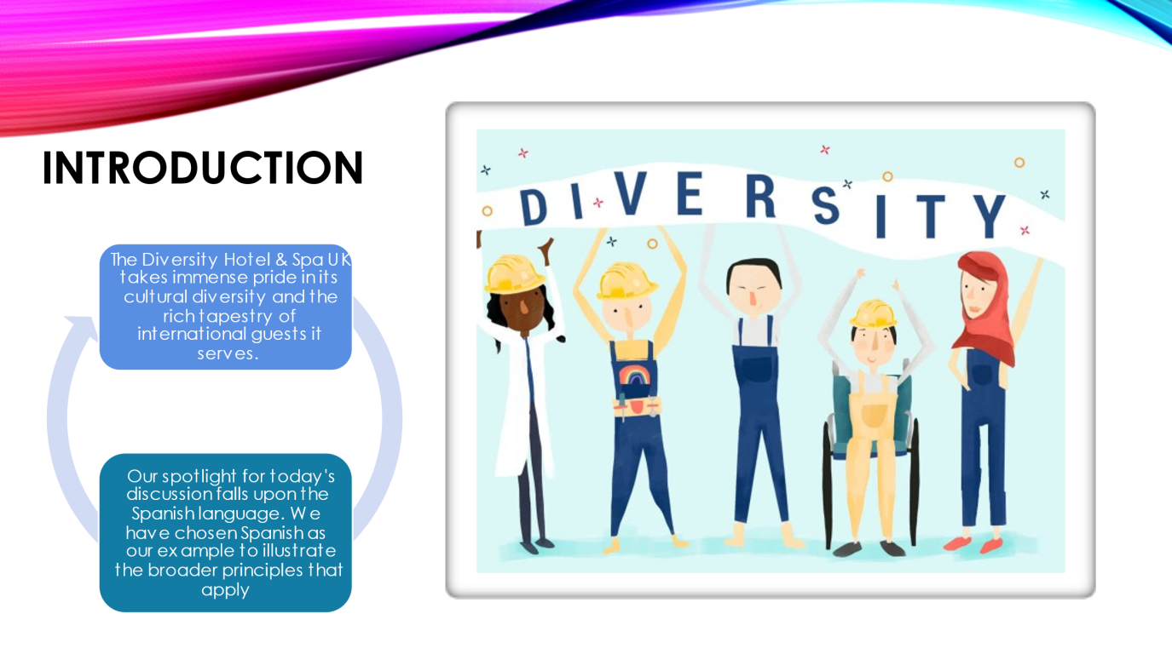

The London-based Diversity Hotel & Spa is quite proud of the noteworthy number of visitors from different countries. Thus, learning a new language is essential if we want to reach a wider audience worldwide. Therefore, the Slide focus will be on Spanish.

Slide 3

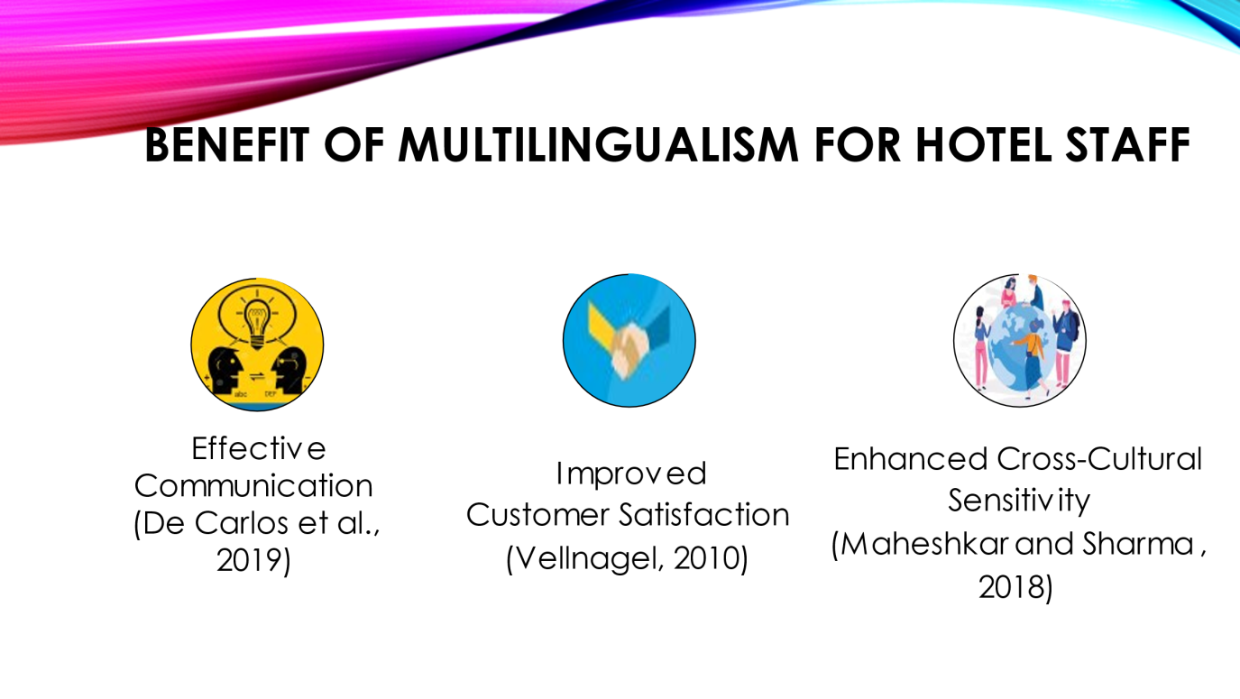

We should learn multilingualism for many reasons. To begin, customers in the hospitality industry speak a lot of different languages. A staff member who speaks multiple languages may be able to better serve visitors by speaking in their preferred language. Speaking multiple languages may also increase business opportunities. Hotels with multilingual staff are better at attracting international customers and catering to their cultural preferences. The hotel will get more reservations, work with other businesses, and get good reviews, which may boost its global reputation and earnings. Thirdly, cultural values shape language. Hotel staff who speak multiple languages are more likely to be sensitive and helpful to international guests. This is crucial to making all hotel guests, regardless of culture, feel welcome and at home.

Slide 4

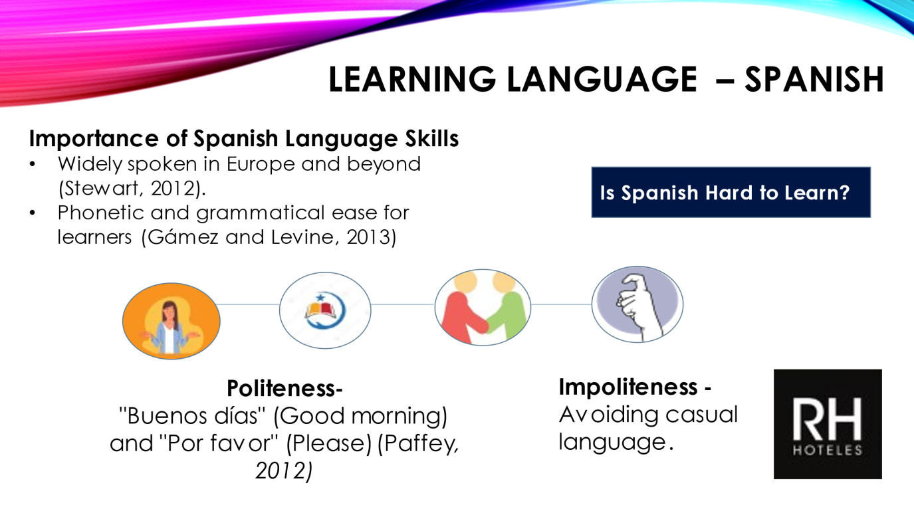

The significance of the Spanish language stems from the fact that it is spoken globally. Spanish is an official language in twenty countries, making it one of the most widely spoken languages in the world. After English, Spanish ranks as the second most advantageous language in the hospitality and tourism sector.
The phonetic and grammatical simplicity of Spanish renders it a language that learners from diverse backgrounds easily understand. The expressions "Buenos das" (Good morning) and "Por favour" (Please) are examples of Spanish courtesy. It is appropriate to address guests by their proper titles and last names.
On the contrary, Slang and other informal forms of speech that may offend customers or employees should be avoided. It is essential to use proper titles and greetings when interacting with others in order to avoid making a negative impression.
As an illustration, the Hotel RH Princesa & Spa has achieved remarkable success by employing personnel who are proficient in multiple languages, including Spanish.
Link: Video 10-26 at 12.53.webm

