BMIH6007
International Meetings Management for the Hotel Industry
DOBRA LUCIANA MARIA
Student number 2019290@student.uwtsd.ac.uk
Module code BMIH6007
Module teacher Kathryn Flynn

Slide 1: Introduction
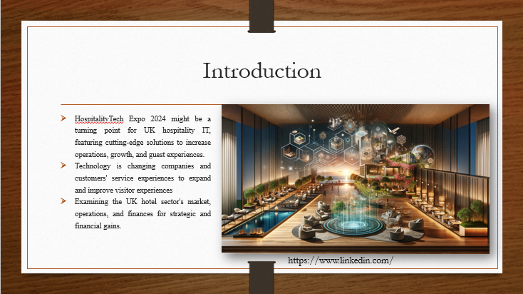
Speaker note
Hello, everybody. It gives me great pleasure to introduce HospitalityTech Expo 2024, a unique occasion that will revolutionise hospitality technology in the UK.
Our aim for HospitalityTech Expo 2024 is to showcase the newest technologies in the hospitality sector. To keep ahead, hospitality must welcome these developments. Technology is quickly transforming consumer service experiences, business growth, and operational efficiency (Sukach et al., 2021).
This presentation evaluates HospitalityTech Expo 2024. Event feasibility and success depend on various factors. we will evaluates market statistics, operational challenges, and financial feasibility to determine if HospitalityTech Expo 2024 will benefit the UK hotel industry financially and strategically.

Slide 2: Event Concept and Rationale
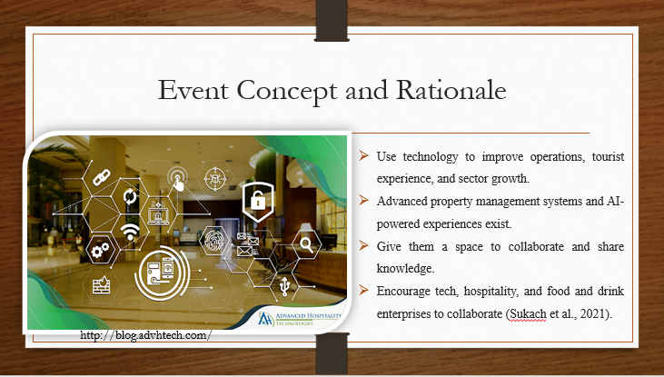
Speaker note
Innovative solutions that improve tourist experiences, operations, and industry growth are featured at this event. It combines hospitality with technology. At the Expo, you may see several hotel industry-changing technologies. These include advanced property management systems and AI-powered visitor experiences.
HospitalityTech Expo 2024 was chosen because the UK hospitality business needs acknowledge and use technology's revolutionary potential. Due to rapid technology change, hospitality companies must stay ahead to succeed in today's competitive landscape. Our event is a sensible response to industry stakeholders' demand for a centralised platform that highlights the newest innovations and stimulates collaboration and knowledge sharing. The Expo aims to boost the UK hospitality sector by providing a space for technology vendors, hoteliers, restaurateurs, and industry experts to interact, discuss, and innovate (Sukach et al., 2021).

Slide 3: Target Market
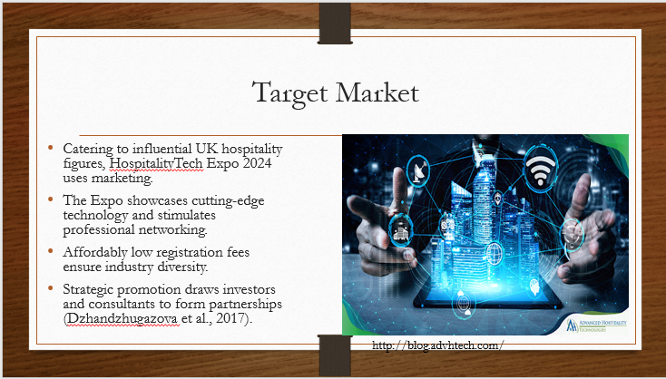
Speaker note
Following marketing theory, notably the "4Ps" structure (Product, Price, Place, and Promotion), HospitalityTech Expo 2024 will target key UK hospitality leaders.
- Product: The Expo showcases property management systems, AI-powered experiences, and cutting-edge hospitality technologies.
- Price: HospitalityTech Expo invites all hospitality professionals and has low registration prices, making it accessible to large chain managers and local inn owners.
- Place: The Expo, which takes place in the vibrant heart of the UK, brings professionals in the area together and encourages networking and information sharing from all across the nation.
- Promotion: Expo organisers advertise the event's worth to investors, consultants, analysts, and academics to attract hospitality sector partners (Dzhandzhugazova et al., 2017).

Slide 4: Demand landscape
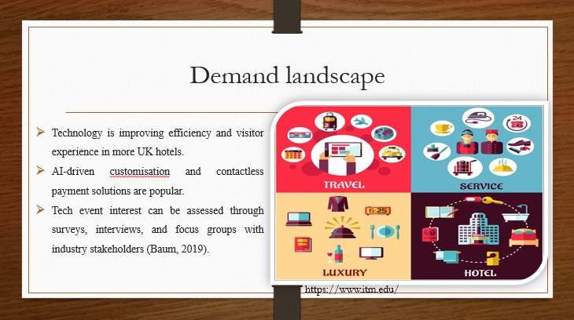
Speaker note
Industry trends, technology improvements, and stakeholder interests have to be analysed to evaluate UK hospitality demand for HospitalityTech Expo 2024. The UK hotel industry is using technology to improve operations and guest experiences. Hosting a tech-centric event now is a good idea because AI-driven personalisation, contactless payment systems, and smart room technologies are growing popular. Investors, tech businesses, restaurant owners, and other industry insiders should be surveyed, interviewed, or focus-grouped about future tech events. HospitalityTech Expo 2024 examined UK hospitality sector events to better understand the market and how to stand out. Business papers and media also provide information on emerging trends and technology-focused events. Synthesising these sources can help HospitalityTech Expo 2024 strategic planning and decision-making by providing a complete demand landscape (Baum, 2019).

Slide 5: Competitive landscape
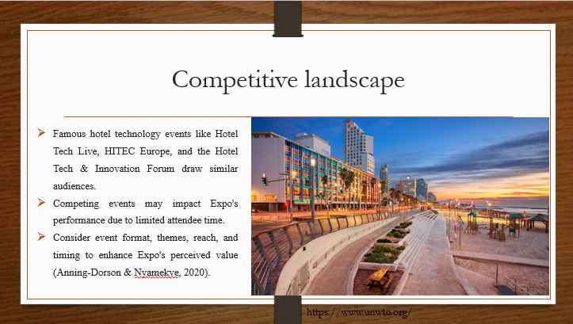
Speaker note
SWOT analysis helps understand the hospitality technology industry's competitive landscape. This will help to find competition' strengths, weaknesses, threats, and opportunities. HospitalityTech Expo 2024 can use this framework to seize opportunities, avoid threats, and stand out from the competition to give exceptional value to all parties.
- Strengths: HITEC Europe, Hotel Tech Live, and the Hotel Tech & Innovation Forum are acknowledged in the hotel technology industry. They offer large spaces for showcasing cutting-edge tech and connecting experts.
- Weaknesses: Despite their potency, rival events have difficulties like a small geographic reach or outdated event forms. If they can't keep up with the times or satisfy everyone, some events may lose their appeal.
- Opportunities: HospitalityTech Expo 2024 could investigate its competitors' weaknesses and market gaps to improve its value proposition. This might involve partnering with industry leaders to create unique experiences, using new event forms, or incorporating interactive elements.
- Threats: Well-established competitors threaten HospitalityTech Expo 2024's success. If rival events attract comparable audiences, attendees may be cannibalised and market penetration low. New industry disruptions or market issues could increase competitiveness and threaten the Expo's viability (Anning-Dorson & Nyamekye, 2020).

Slide 6: Venue Selection
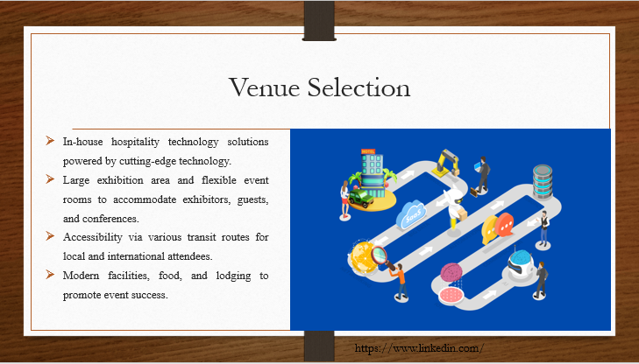
Speaker note
When determining the place for HospitalityTech Expo 2024, many factors were examined to ensure success. A technology-focused exposition and conference required thorough venue selection for technical infrastructure, capacity, accessibility, facilities, and acceptance.
HospitalityTech Expo 2024 taking place at ExCeL London for several reasons. First, ExCeL has in-house hospitality technology solutions powered by cutting-edge technology. Its large exhibition area and flexible event rooms accommodate exhibitors, guests, and conferences. Additionally, ExCeL's London location makes it accessible by many transit routes for local and international attendees. The venue's modern facilities, food, and lodging promote the event's success (Buhalis & Leung, 2018).

Slide 7: Skills and Expertise Required for Event Staff
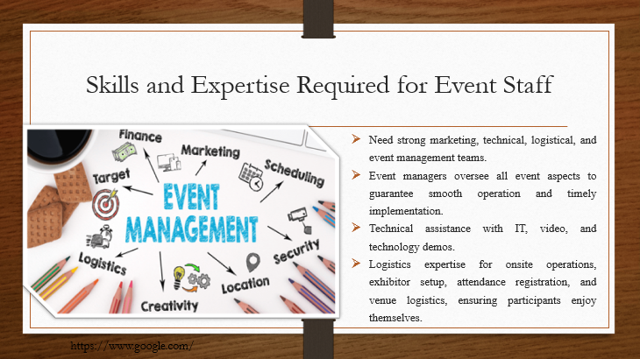
Speaker note
HospitalityTech Expo 2024 organisers require a strong team to succeed. Marketing, technical assistance, logistics, and event management are essential skills. Event managers will monitor everything to ensure it runs well and on time. Manage IT infrastructure, audiovisual equipment, and technological demonstrations with technical support. Advertising professionals will create multi-media campaigns to attract sponsors, exhibitors, and attendees to boost participation. Logistics expertise will also handle onsite operations, exhibitor setup, attendance registration, and venue logistics, ensuring a pleasant experience for all (A. Quinn & A. Buzzetto-Hollywood, 2019).

Slide 8: Resources Required
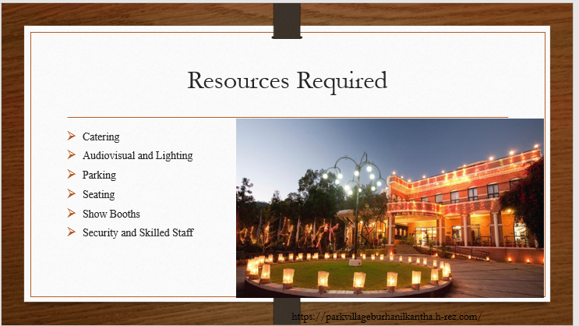
Speaker note
HospitalityTech Expo 2024 requires many resources to run smoothly. Catering provides food and drink for exhibitors, attendees, and event staff. High-quality audiovisual and lighting are needed for captivating presentations and immersive experiences. Parking must be sufficient for all participants. Guests can network and learn more while sitting comfortably. Displaying cutting-edge technology requires show booths. Registration and badge printing simplify check-in. Security and skilled event staff keep everyone safe and running smoothly. Collaboration and networking spaces encourage productive conversation and networking. Carefully structuring and distributing these assets can make HospitalityTech Expo 2024 an immersive and powerful event and foster innovation in UK hospitality (Buhalis et al., 2019).

Slide 9: Financial Feasibility Analysis
Expense Category | Cost (GBP)
Venue Rental | £50,000
Staffing | £20,000
Technology Equipment | £30,000
Marketing | £15,000
Catering | £10,000
Logistics | £8,000
Insurance | £5,000
Miscellaneous | £7,000
Total Expenses: | £145,000

Revenue Source | Amount (GBP)
Registration Fees | £100,000
Sponsorships | £50,000
Exhibitor Fees | £40,000
Advertising Sales | £10,000
Partnerships | £15,000
Total Revenue: | £215,000
Funding Sources:
- Sponsorships: £50,000
- Grants: Find grants from numerous sources.
- Ticket Sales: £100,000
- Partnerships: Sponsorship or in-kind donations.

Slide 10: Conclusion
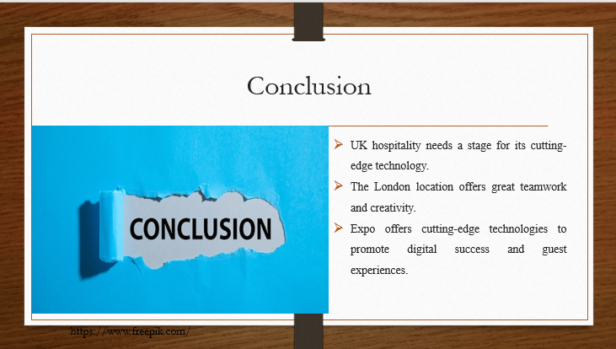
Speaker note
HospitalityTech Expo 2024's feasibility report shows the UK hospitality industry needs a cutting-edge technology exhibition. The event can foster technical innovation and collaboration due to its London location and unique selling factors. The HospitalityTech Expo 2024 will give guests a once-in-a-lifetime chance to learn about and use cutting-edge technology to improve guest experiences, streamline operations, and develop businesses in a rapidly changing digital landscape.

Slide 11: Reference
A. Quinn, K. and A. Buzzetto-Hollywood, N. (2019) ‘Faculty and student perceptions of the importance of management skills in the hospitality industry’, Interdisciplinary Journal of e-Skills and Lifelong Learning, 15, pp. 021–041. doi:10.28945/4198.
Anning-Dorson, T. and Nyamekye, M.B. (2020) ‘Be flexible: Turning innovativeness into competitive advantage in hospitality firms’, International Journal of Contemporary Hospitality Management, 32(2), pp. 605–624. doi:10.1108/ijchm-12-2018-1014.
Baum, T. (2019) ‘Does the hospitality industry need or deserve talent?’, International Journal of Contemporary Hospitality Management, 31(10), pp. 3823–3837. doi:10.1108/ijchm-10-2018-0805.
Buhalis, D. and Leung, R. (2018) ‘Smart hospitality—interconnectivity and interoperability towards an ecosystem’, International Journal of Hospitality Management, 71, pp. 41–50. doi:10.1016/j.ijhm.2017.11.011.
Buhalis, D. et al. (2019) ‘Technological disruptions in services: Lessons from tourism and hospitality’, Journal of Service Management, 30(4), pp. 484–506. doi:10.1108/josm-12-2018-0398.
Dzhandzhugazova, E.A. et al. (2017) ‘Intellectual Resources used in developing tourism and Hospitality Industry’, Eurasian Journal of Analytical Chemistry, 12(5b), pp. 705–722. doi:10.12973/ejac.2017.00204a.
Kansakar, P., Munir, A. and Shabani, N. (2019) ‘Technology in the hospitality industry: Prospects and challenges’, IEEE Consumer Electronics Magazine, 8(3), pp. 60–65. doi:10.1109/mce.2019.2892245.
Kazandzhieva, V. and Filipova, H. (2019) ‘Customer attitudes toward robots in travel, tourism, and Hospitality: A conceptual framework’, Robots, Artificial Intelligence, and Service Automation in Travel, Tourism and Hospitality, pp. 79–92. doi:10.1108/978-1-78756-687-320191004.
Nikopoulou, M. et al. (2023) ‘Determinants of digital transformation in the hospitality industry: Technological, organizational, and environmental drivers’, Sustainability, 15(3), p. 2736. doi:10.3390/su15032736.
Sukach, O., Kozlovska, S. and Sushko, N. (2021) ‘Modern Management Technologies in the hospitality industry’, Baltic Journal of Economic Studies, 7(3), pp. 168–176. doi:10.30525/2256-0742/2021-7-3-168-176.

