[Name: Theo Tiencken
[Student Number: Theo Tiencken
[WORKSHEET 2 -- TESTING (Parking Fee Calculator)]
[Copy and paste your original code from Moodle into this box. Do not change it.]
vehicle = input("please enter vehicle (car, bike, van or plane)")

if vehicle =="car":
rate = 2.50
maxrate = 15.00
elif vehicle == "bike":
rate = 1.00
maxrate = 6.00
elif vehicle == "van":
rate = 4.00
maxrate = 25.00
elif vehicle == "plane":
rate = 100.00
maxrate = 10000.00

else:
print("vehicle invalid please type again")
exit()
#part b
typeofday = input("is it weekend or weekday: ")

if typeofday == "weekend":
rate = rate * 1.2
elif typeofday != "weekday":
print("invalid day type")
exit()
#end of part b

hours = float(input("please input hours parked: "))
if hours <= 0:
print("ERROR hours MUST be greater than 0")
exit()

#part c validation

if hours < 1 or hours > 72:
print("Strange hours detected")

confirmation = input("Is this correct? (yes or no): ")

if confirmation == "no":
hours = float(input("Please re-enter hours: "))
elif confirmation != "yes":
print("Invalid response")
exit()
cost = hours * rate
if cost >= maxrate:
cost = maxrate

print(f"total parking cost: £{cost:.2f}")

[Code Testing]
For each test below, run your code and enter the values provided. Provide a screenshot of what happened when the programme ran. Did the programme behave correctly or did it do something unexpected? Fill in a box for each test below. You should present 12 separate boxes, 1 for each test. (Note: the first box is provided as a template)
Test the following values for your calculator:
i) 2 hours parking with a car on weekday
ii) 0.5 hours parking with a motorcycle on weekday
iii) 8 hours parking with a van on weekend
iv) 0.25 hours parking with a car (short stay outlier)
v) 100 hours parking with a motorcycle (long stay outlier)
vi) 24 hours parking with a van on weekday
vii) 72 hours parking with a car on weekend
viii) -2 hours parking with any vehicle
ix) Enter an outlier value, click "n", then enter another outlier value
x) Suitable "normal" parking duration for your chosen 4th vehicle
xi) Suitable out of range parking duration for your chosen 4th vehicle
xii) Test your menu -- what happens if you enter "5" for vehicle type?

For each test provide screenshots(s) of output: and answer the following questions
- Result: Did the program behave as expected ie syntactically and logically correct? YES/NO
If NO, what problems were encountered and why? Suggest how things could be improved.

- 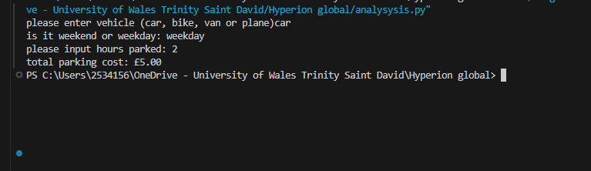

Yes the program worked at intended.
- 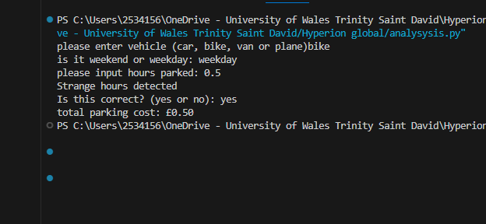
Yes and No. the program worked as intended to a point. However I should have specified what happenes when the hours were less than 1 for pricing.

- 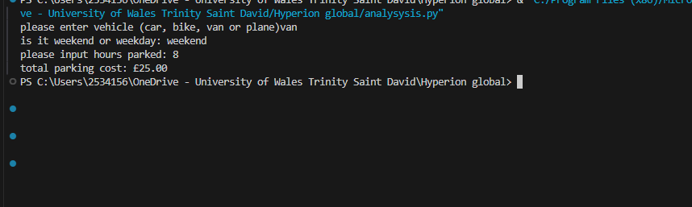
Yes it worked correctly as after applying the 20% premium the total amount would have come to more than £25 so the programme capped it.

- 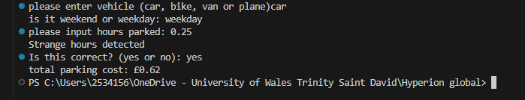
Same as 2 however I suspect if I said no then it would work as intended all the way through.

5)
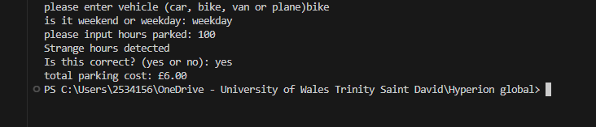
Yes this worked as intended. Which is strange considering the low outliers do not
6)
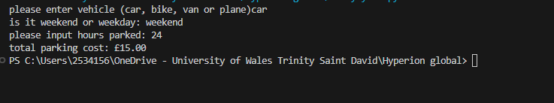
Yes worked at intended

8) 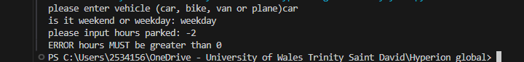
Yes it caught the negative value.

