
PORTFOLIO OF EVIDENCE


June 10, 2020
eLIZABETH lANGSHAW

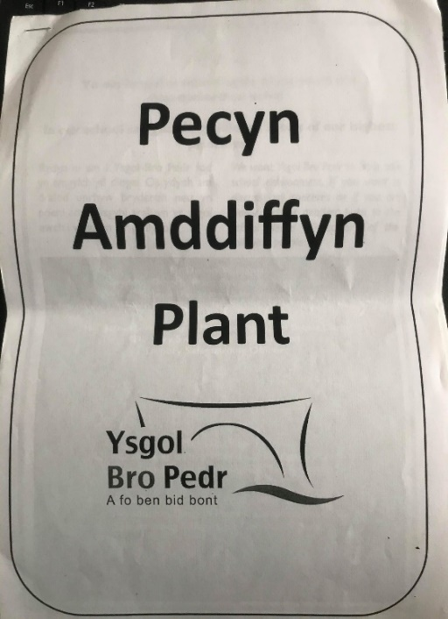
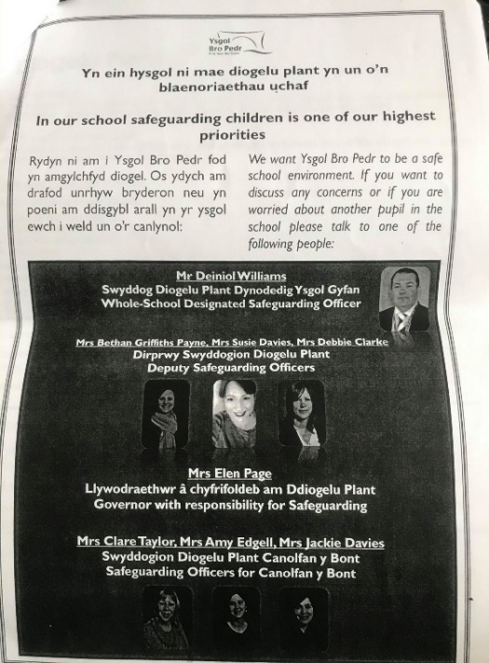
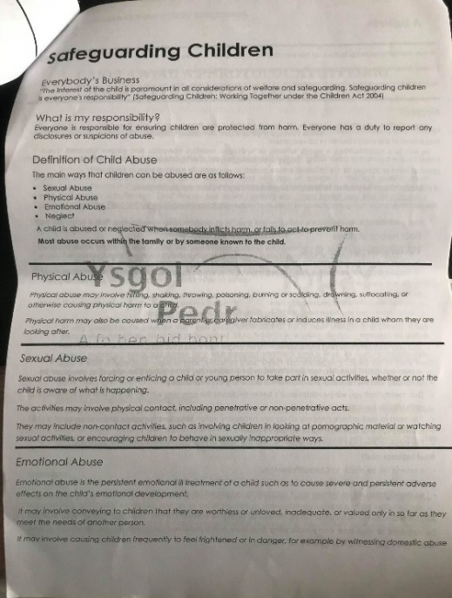
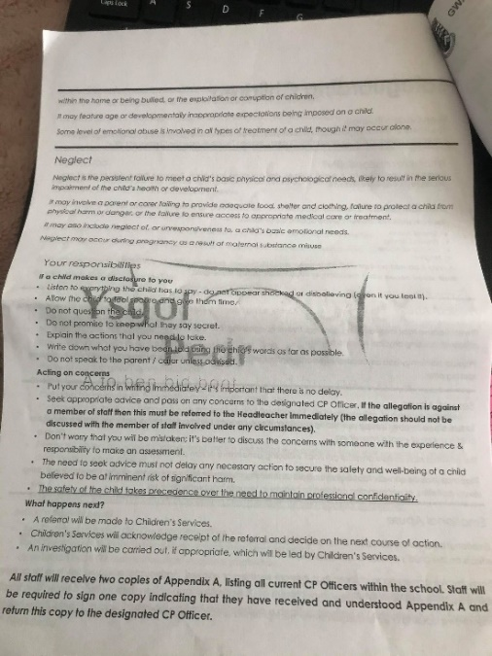
Safeguarding
https://gov.wales/safeguarding-children
https://gov.wales/sites/default/files/publications/2018-11/keeping-learners-safe-the-role-of-local-authorities-governing-bodies-and-proprietors-of-independent-schools-under-the-education-act-2002.pdf
https://gov.wales/sites/default/files/publications/2018-11/safeguarding-children-in-education-handling-allegations-of-abuse-against-teachers-and-other-staff.pdf
Ysgol Bro Pedr, provided important information on the first day of placement on safeguarding and child protection. Included was the schools child protection officers, Safe guarding information and staff/visitor responsibilities, child protection guidance and referral protocol, information of the prevent strategy to reduce the threat of terrorism in the UK and finally a form to record concerns about a pupils welfare.

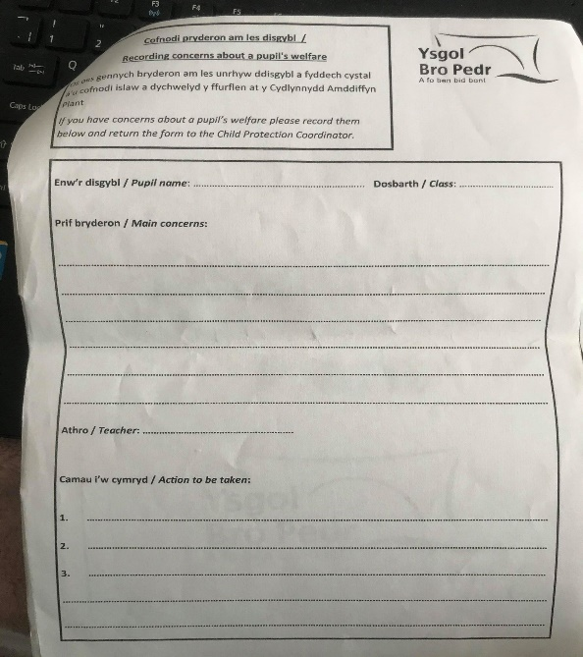
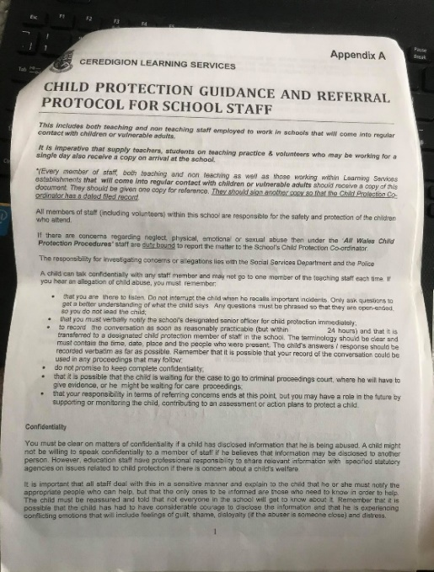
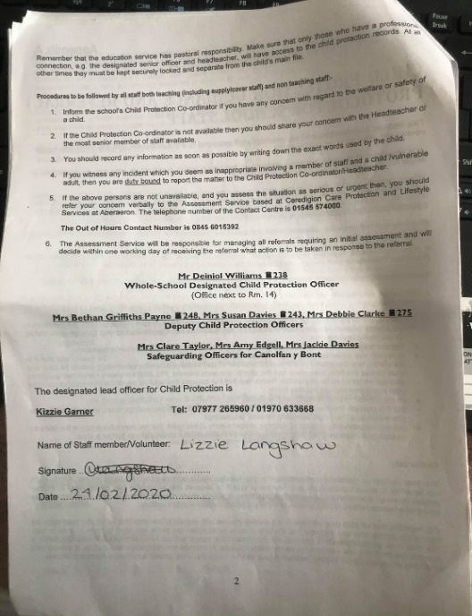
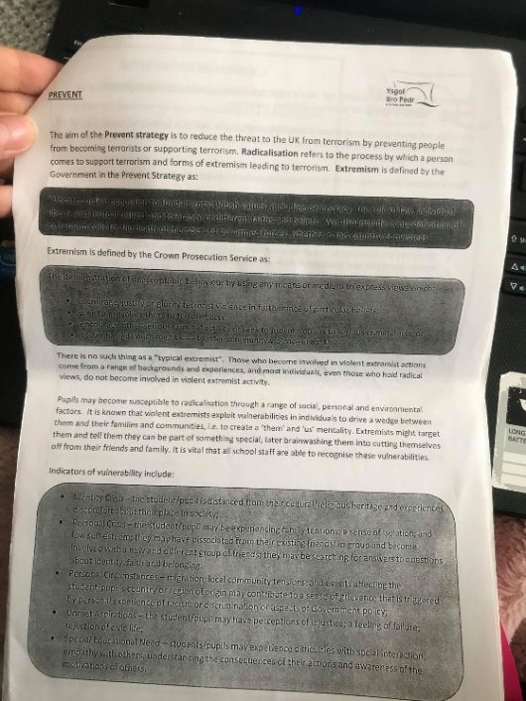
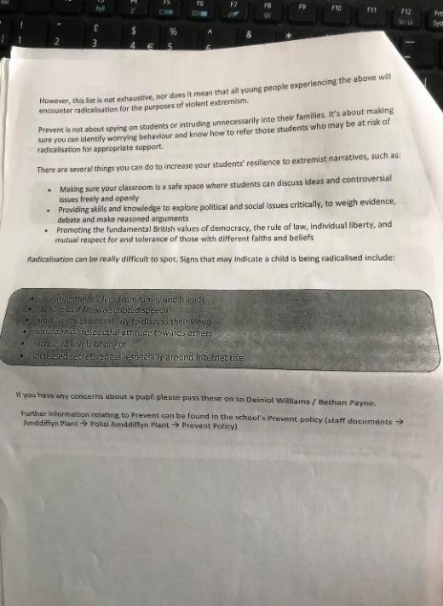
Child Protection
https://gov.wales/child-protection
https://gov.wales/sites/default/files/publications/2018-11/keeping-learners-safe-easy-read-version.pdf
http://www.legislation.gov.uk/ukpga/1999/14/contents
https://learning.nspcc.org.uk/child-protection-system/wales
http://bropedr.ceredigion.sch.uk/wp-content/uploads/2017/01/Child-Protection-Policy-ERW-Bro-Pedr-May-2016.pdf

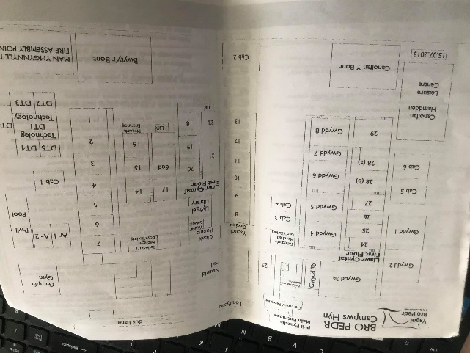
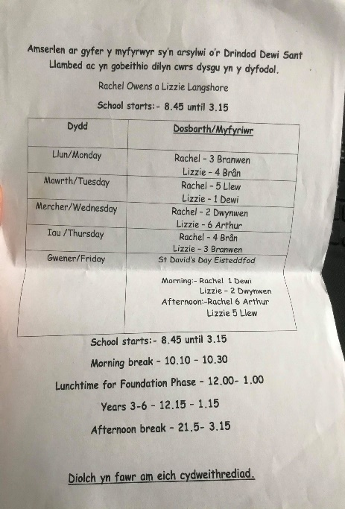
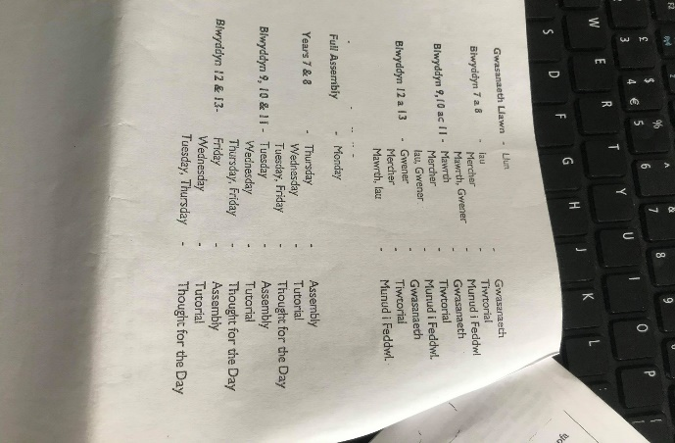
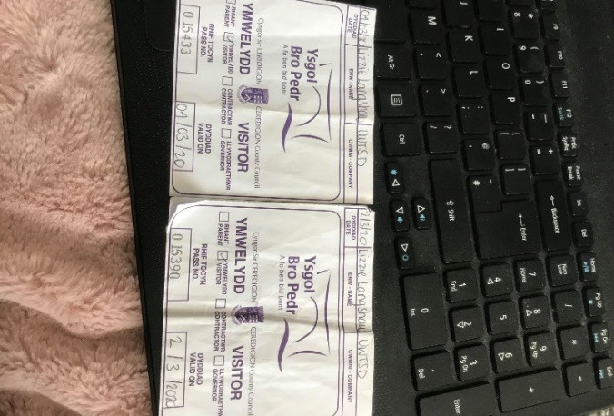
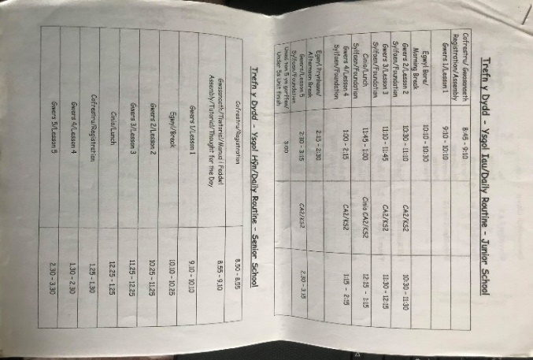
Timetable, Visitor ID example and Map

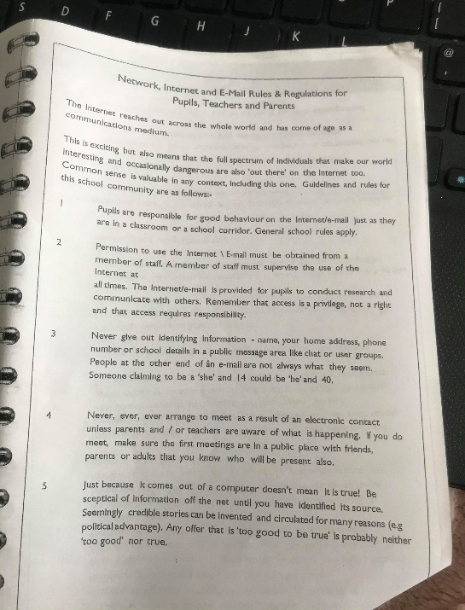
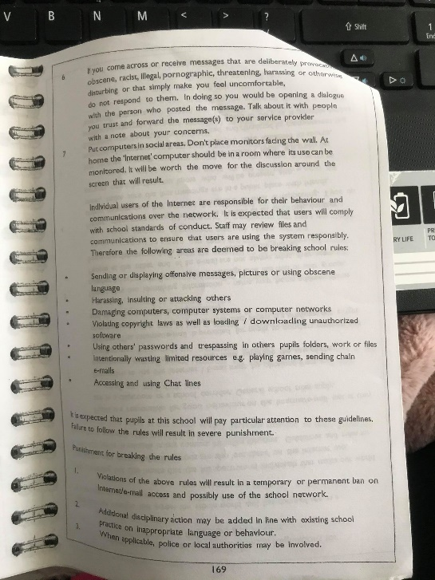
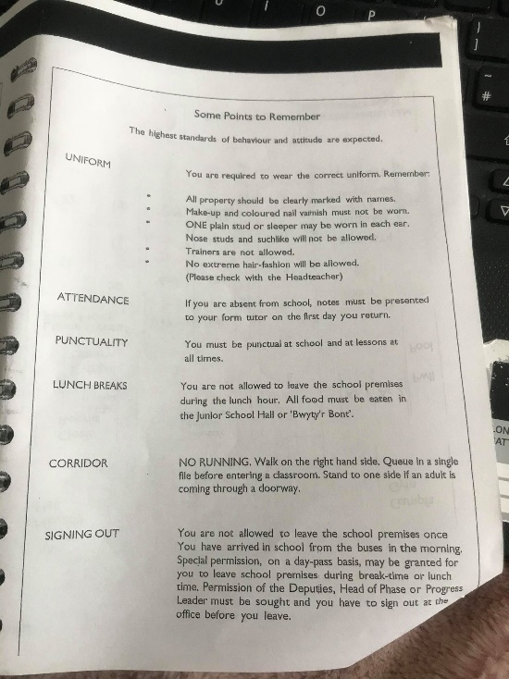
Points to Remember (Pupils) and Network, Internet and E-Mail Rules and Regulations for Pupils, Teachers and Parents
https://gov.wales/sites/default/files/publications/2018-07/online-safety-action-plan-for-children-and-young-people-in-wales.pdf

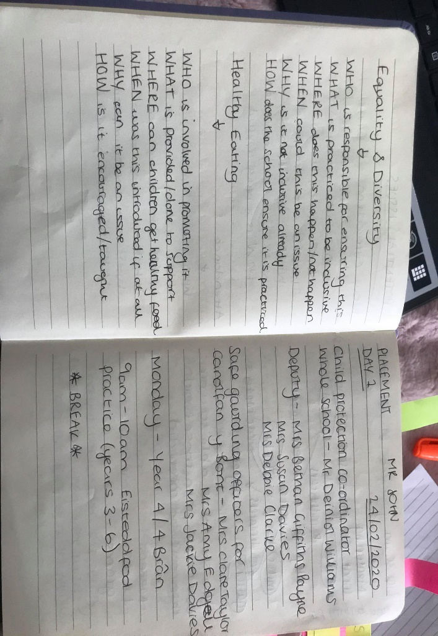
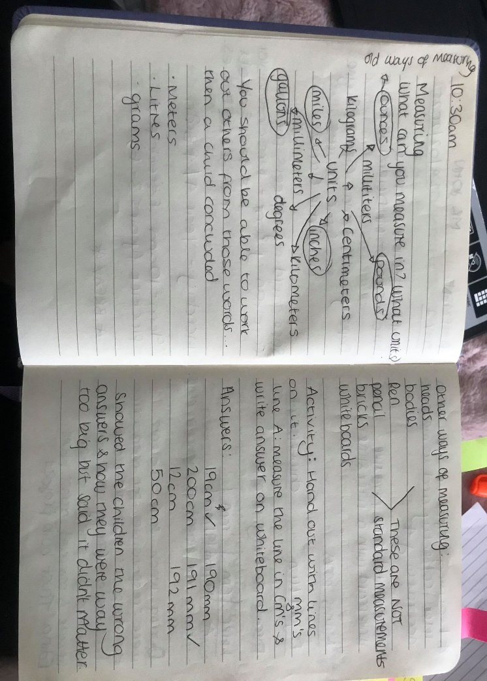
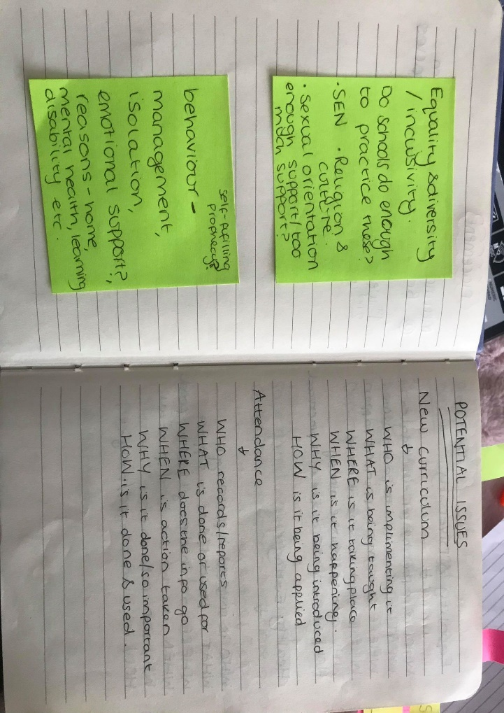
Journal
https://senedd.wales/en/abthome/about_us commission_assembly_administration/Documents/Final%20DI%20Strategy-e.pdf
https://gov.wales/sites/default/files/publications/2018-12/practical-approaches-to-behaviour-management-in-the-classroom-a-handbook-for-classroom-teachers-in-primary-schools.pdf
https://gov.wales/curriculum-wales-overview#:~:text=Curriculum%20for%20Wales%3A%20overview,used%20throughout%20Wales%20from%202022.
https://gov.wales/sites/default/files/publications/2018-03/all-wales-attendance-framework.pdf
https://gov.wales/food-drink-schools

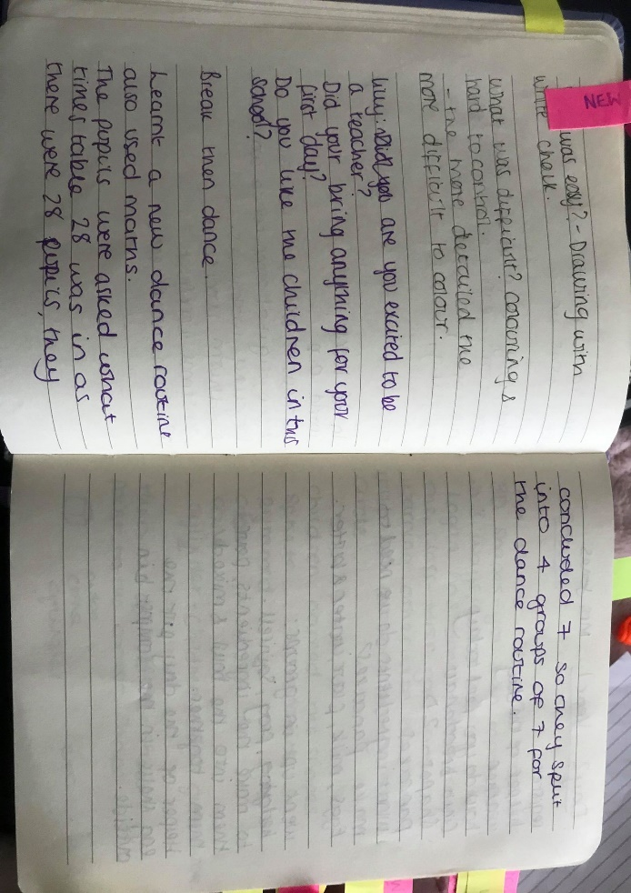
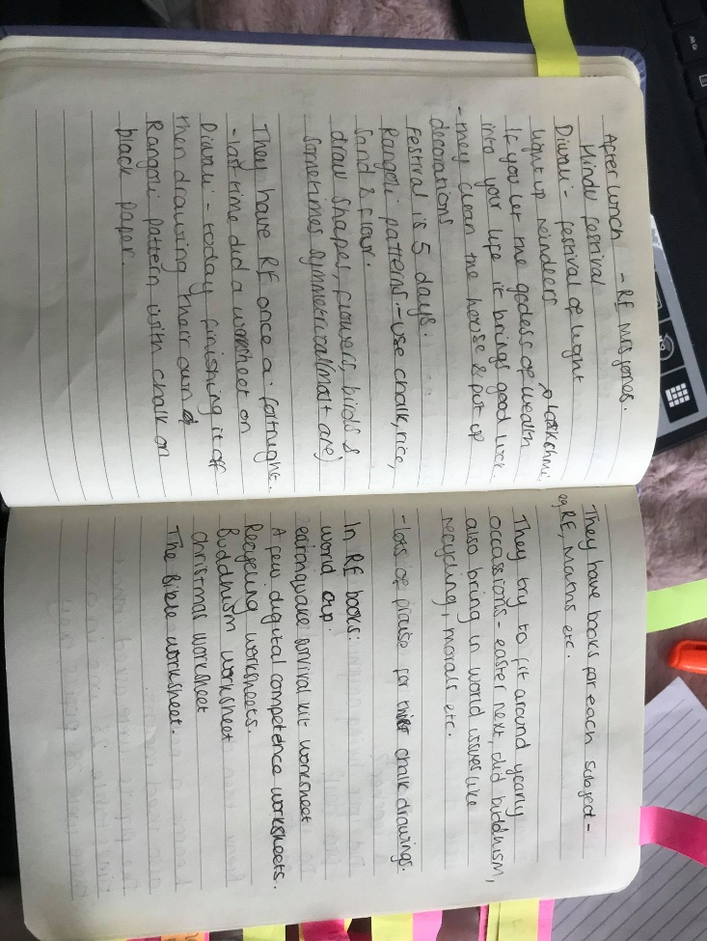
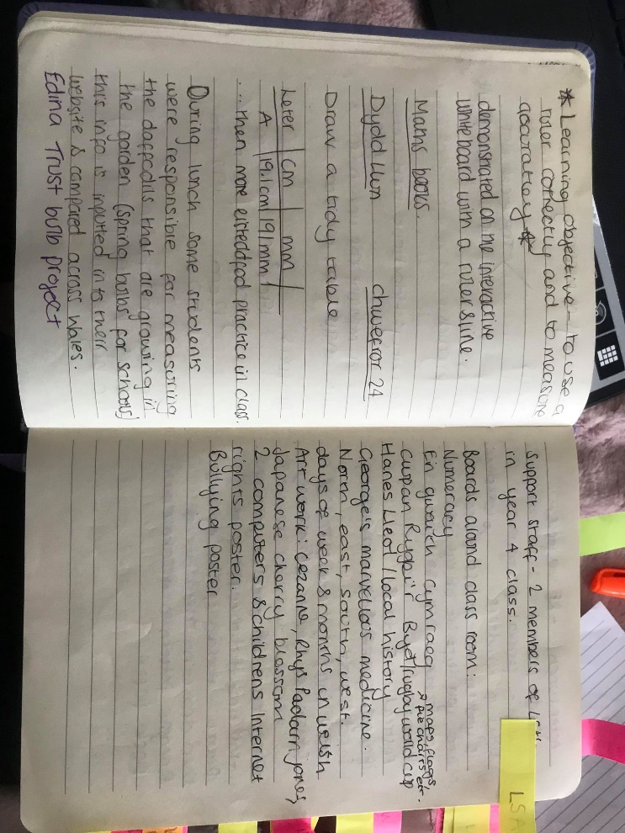
Edina Trust Bulb Project, RE and Dance
https://www.edinatrust.org.uk/the-bulb-project
https://hwb.gov.wales/storage/fcb8539c-9be7-4883-8542-35d7b54b56f2/foundation-phase-outdoor-learning-handbook.pdf
https://www.estyn.gov.wales/thematic-reports/religious-education-key-stage-2-and-key-stage-3
https://hwb.gov.wales/storage/3da78371-3567-4804-9539-88b1b7ad8d1a/physical-education-guidance-key-stages-2-and-3.pdf
https://hwb.gov.wales/curriculum-for-wales/designing-your-curriculum/developing-a-vision-for-curriculum-design/
- The dance session took a cross-curricular approach, in line with the new curriculum guidance by involving numeracy skills in the dance routine.
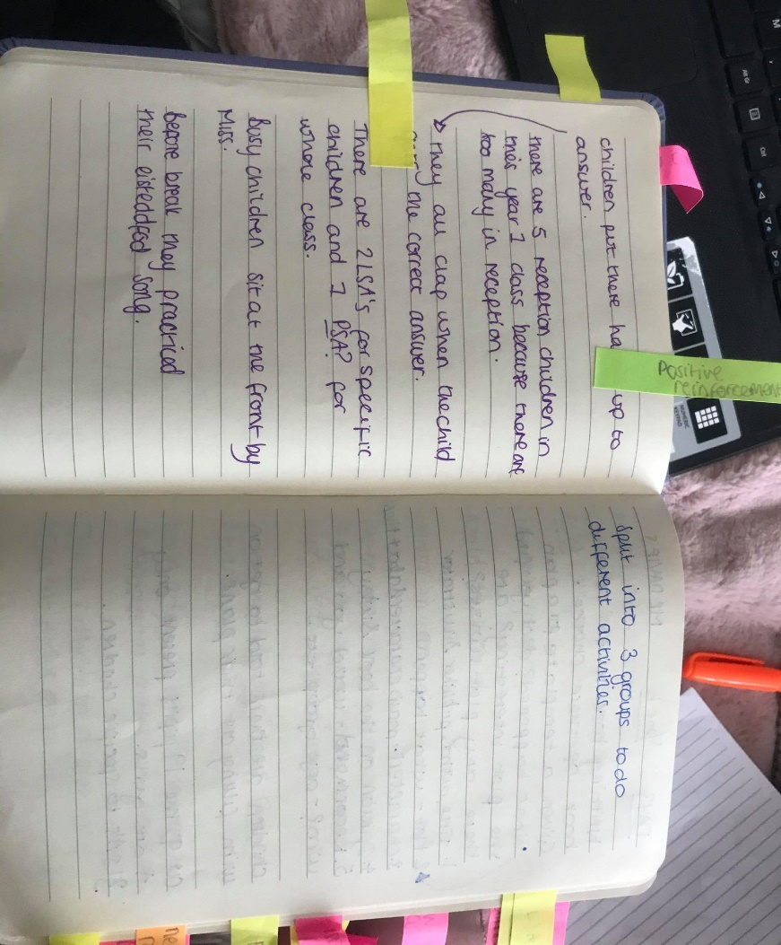
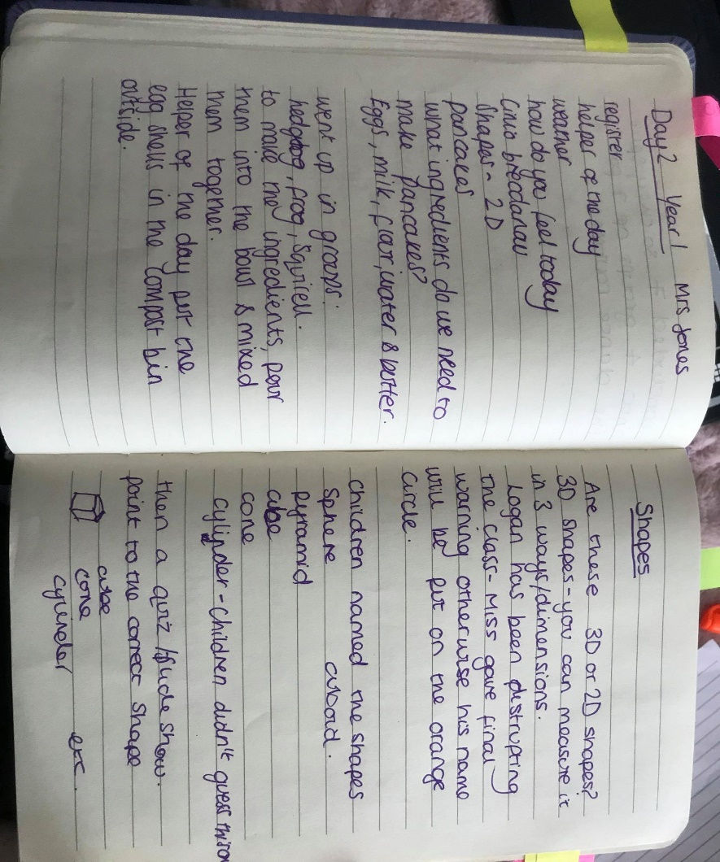
Class size and Support Staff
https://gov.wales/sites/default/files/publications/2020-01/reducing-infant-class-sizes-progress-report-2017-to-2019.pdf
https://gov.wales/sites/default/files/statistics-and-research/2019-07/research-into-the-deployment-of-primary-school-support-staff_0.pdf
http://bropedr.ceredigion.sch.uk/wp-content/uploads/2018/11/Polisi-ADY-a-Chynhwysiant-Ysgol-Bro-Pedr-2017-2019.pdf

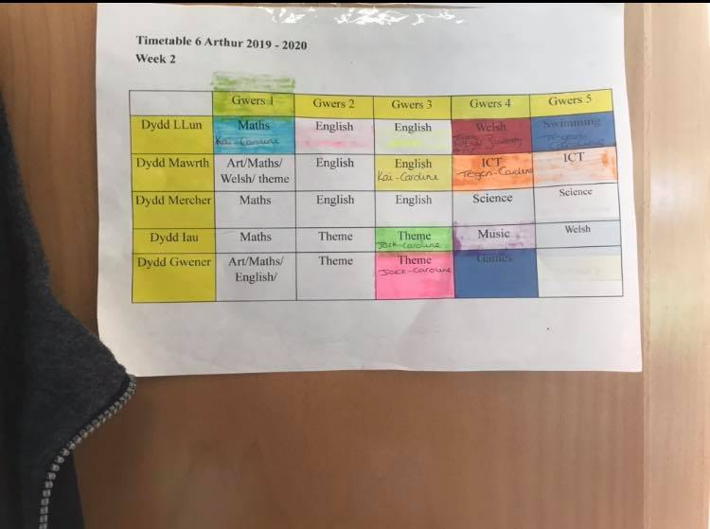
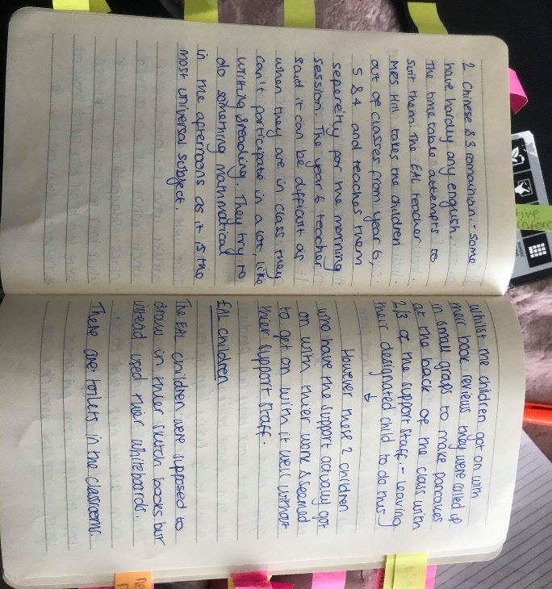
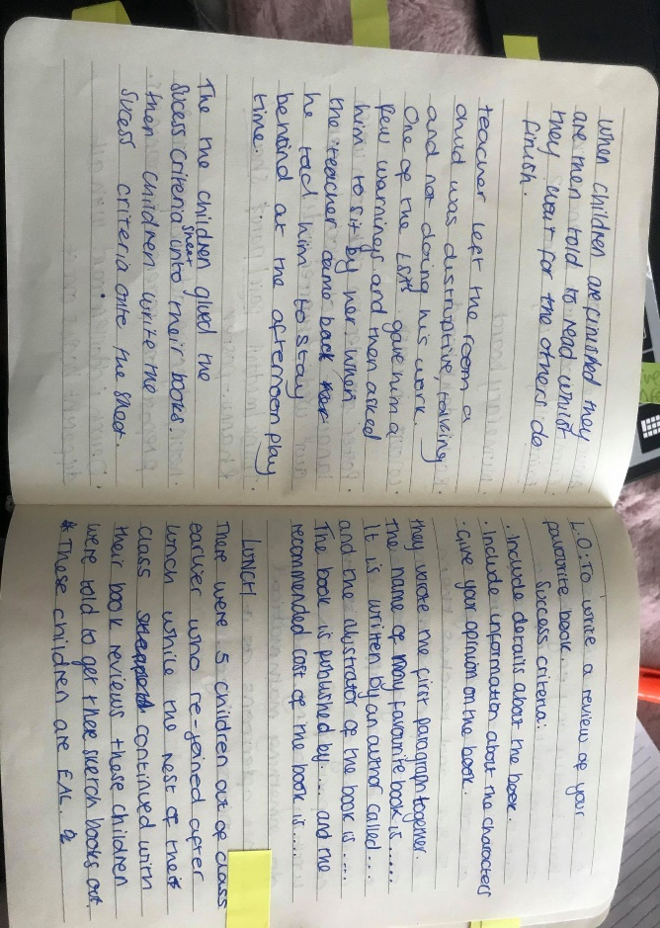
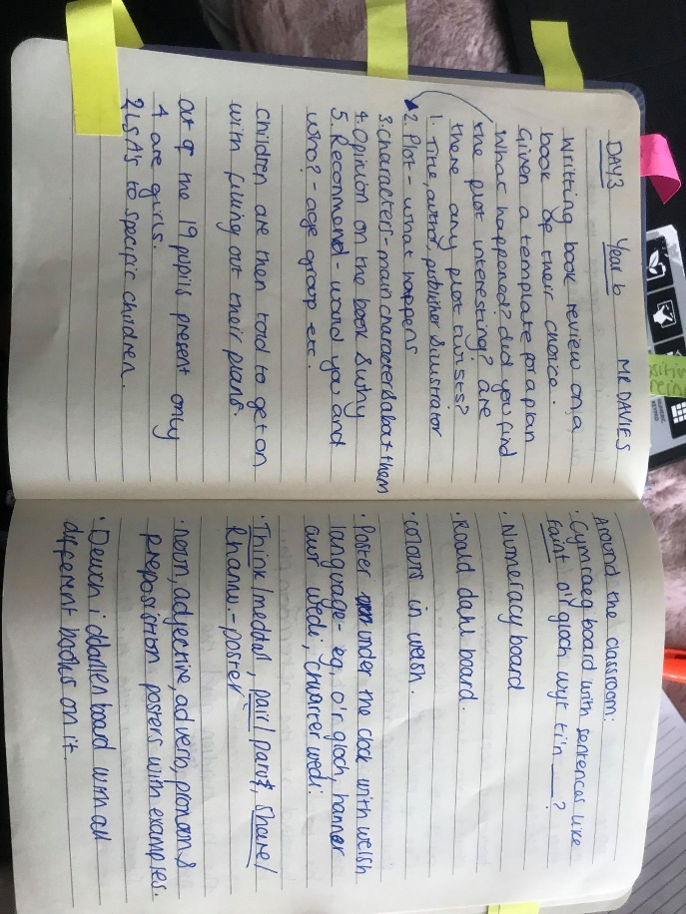
Gender, Second-language Welsh and EAL children
https://statswales.gov.wales/Catalogue/Education-and-Skills/Schools-and-Teachers/Schools-Census/Pupil-Level-Annual-School-Census/Pupils/pupils-by-yeargroup-sex
https://gov.wales/sites/default/files/publications/2018-02/welsh-in-education-action-plan-2017%E2%80%9321.pdf
https://gov.wales/sites/default/files/publications/2018-11/evaluation-report-on-capacity-building-approaches-to-support-the-delivery-of-english-as-an-additional-language-in-wales.pdf

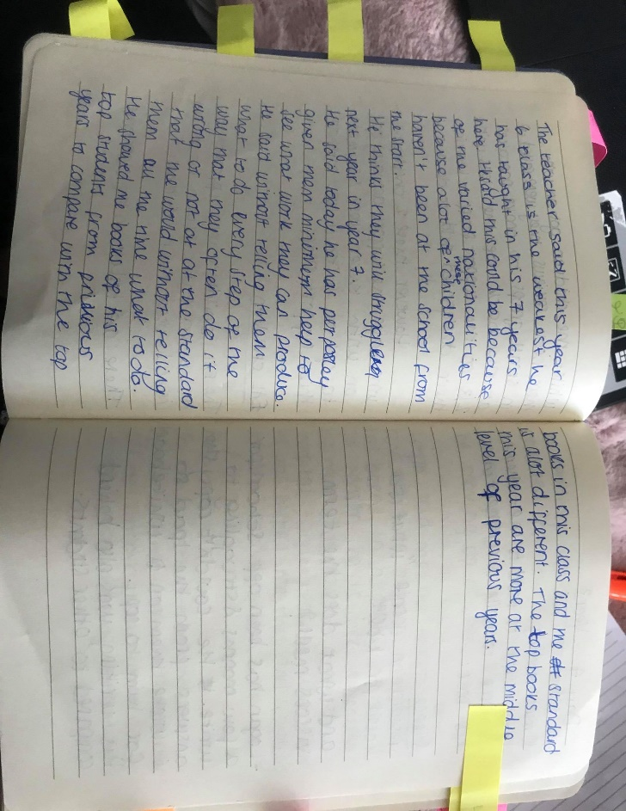
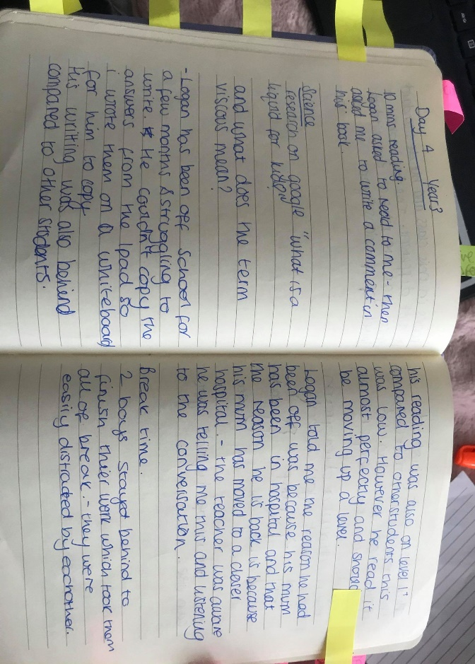
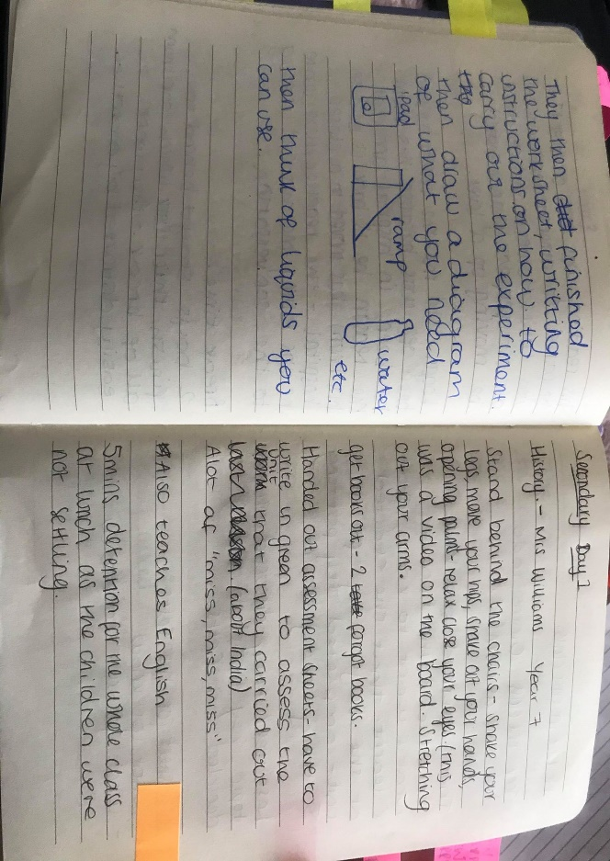
Absence, Science in Primary School
https://gov.wales/sites/default/files/publications/2018-03/guidance-on-school-attendance-codes.pdf
http://bropedr.ceredigion.sch.uk/wp-content/uploads/2018/09/Polisi-Presenoldeb.pdf
https://senedd.wales/NAfW%20Documents/report-2.pdf%20-%2019082013/report-2-English.pdf
https://gov.wales/sites/default/files/publications/2018-02/science-technology-engineering-and-mathematics-stem-guidance-for-schools-and-colleges-in-wales.pdf

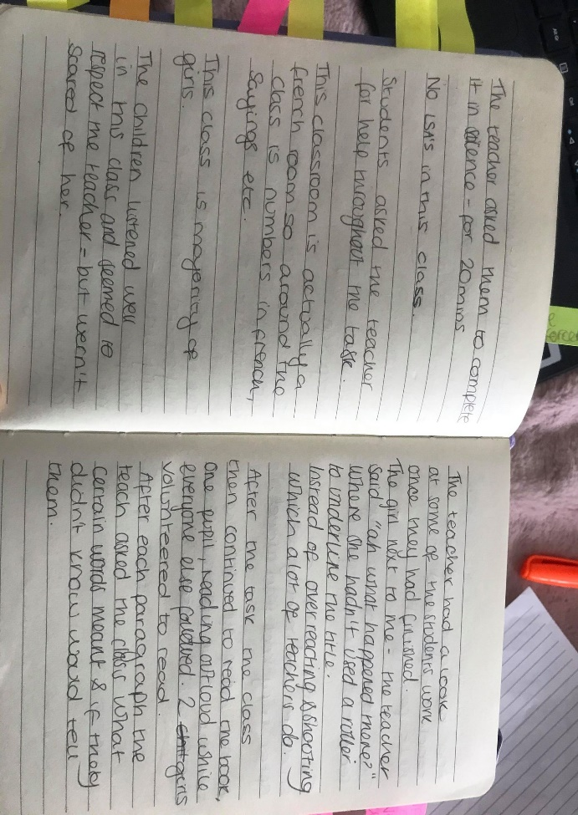
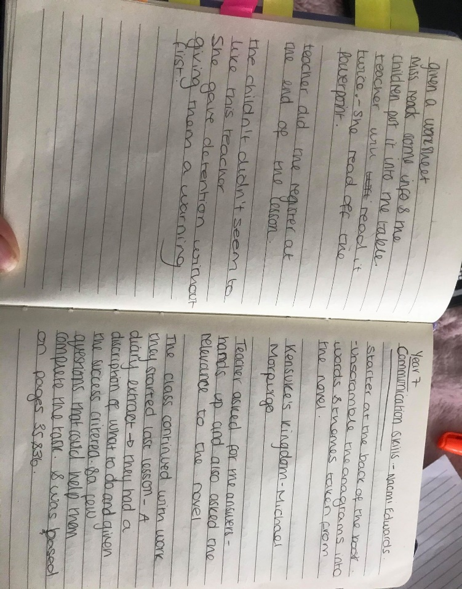
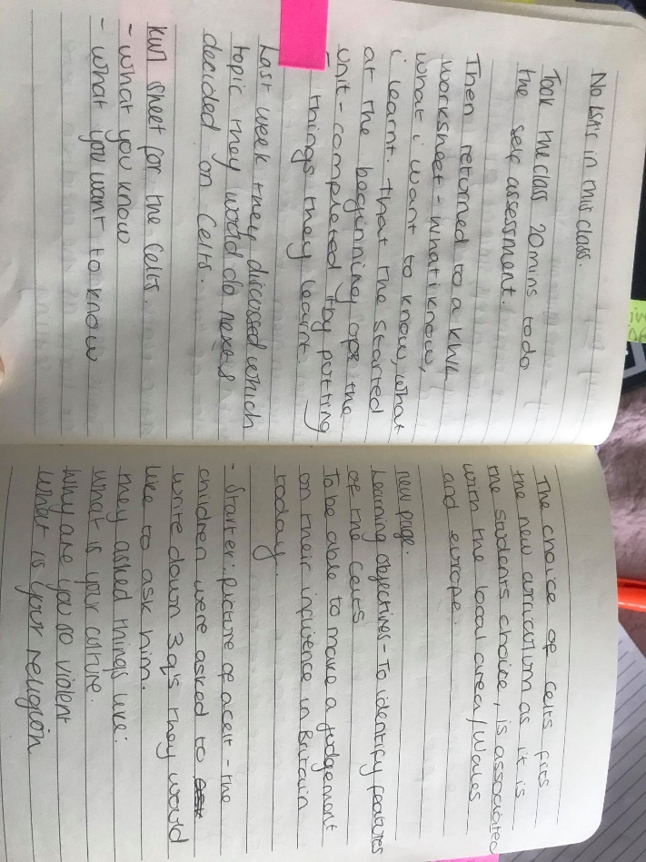
New Curriculum, choice in learning
https://hwb.gov.wales/curriculum-for-wales/designing-your-curriculum/principles-for-designing-your-curriculum/#statements-of-what-matters
https://hwb.gov.wales/curriculum-for-wales/designing-your-curriculum/developing-a-vision-for-curriculum-design/#curriculum-design-and-the-four-purposes

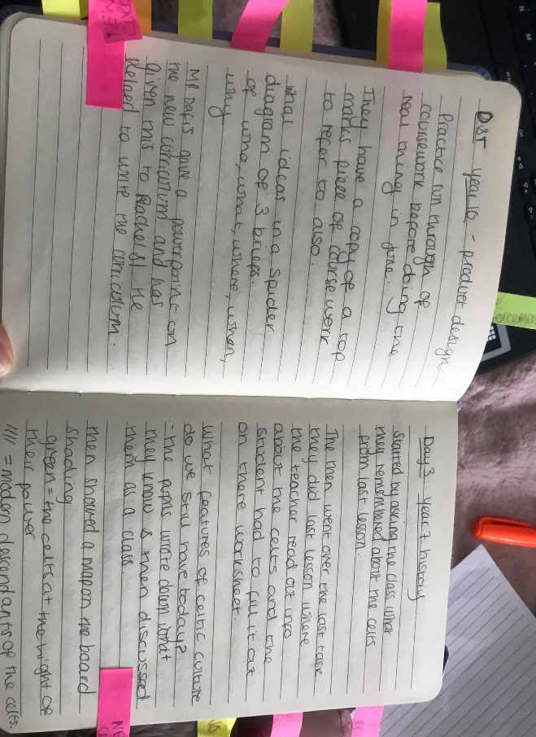
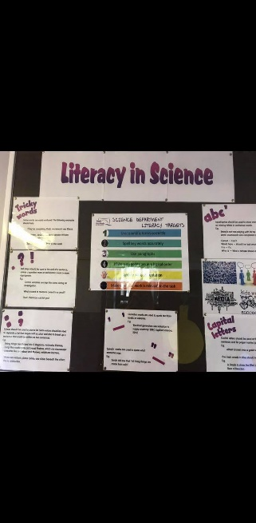
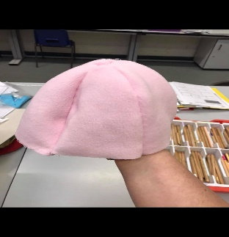
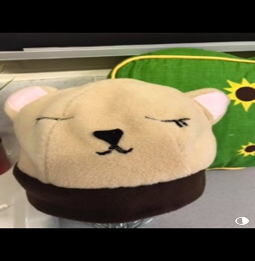
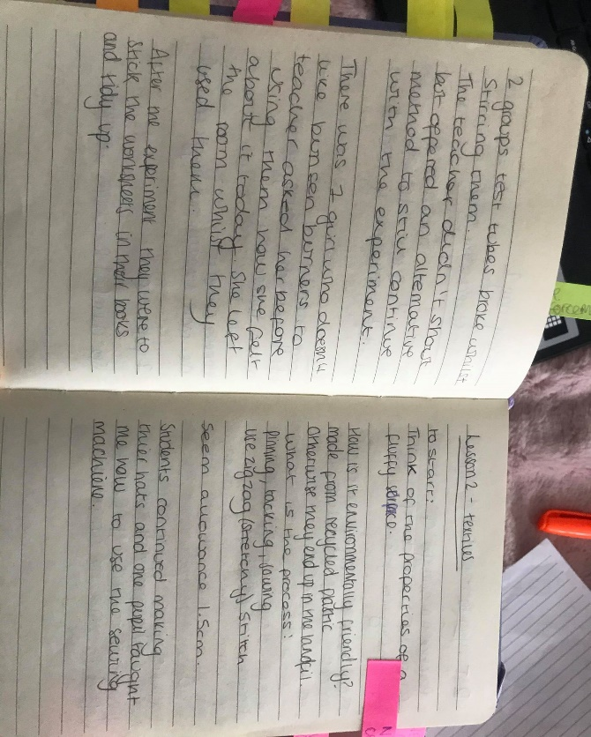
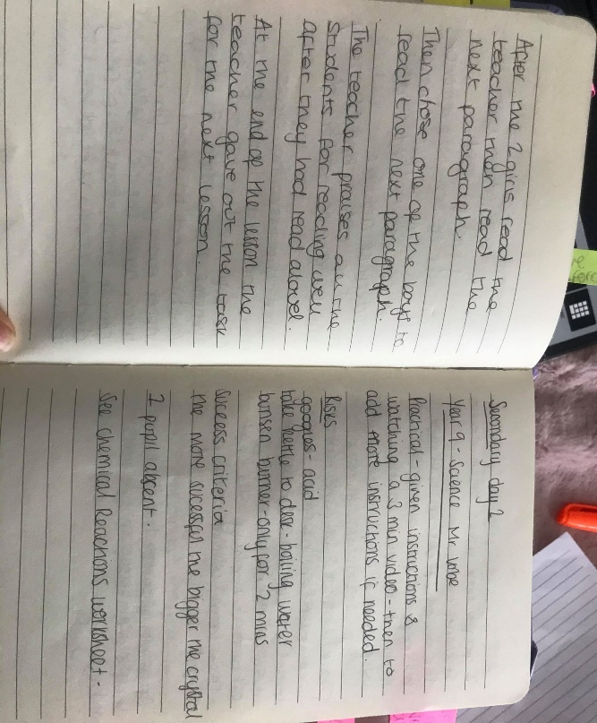
Science and D&T in Secondary School
https://hwb.gov.wales/zones/national-network-for-excellence-in-science-and-technology/about-us
https://hwb.gov.wales/api/storage/119a7383-b164-40dd-8b0e-d26317fa2884/design-and-technology-in-the-national-curriculum.pdf

Resource suggested by Mr Dafis-
https://hwb.gov.wales/storage/b44ad45b-ff78-430a-9423-36feb86aaf7e/curriculum-for-wales-guidance.pdf

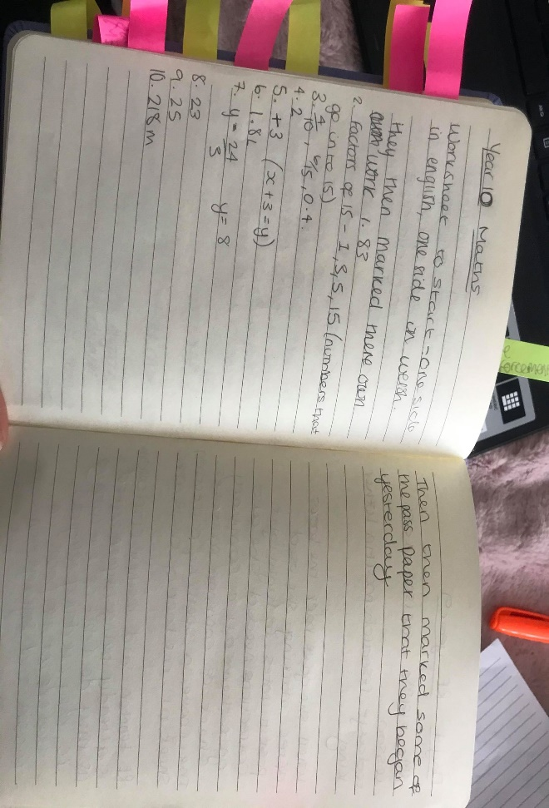
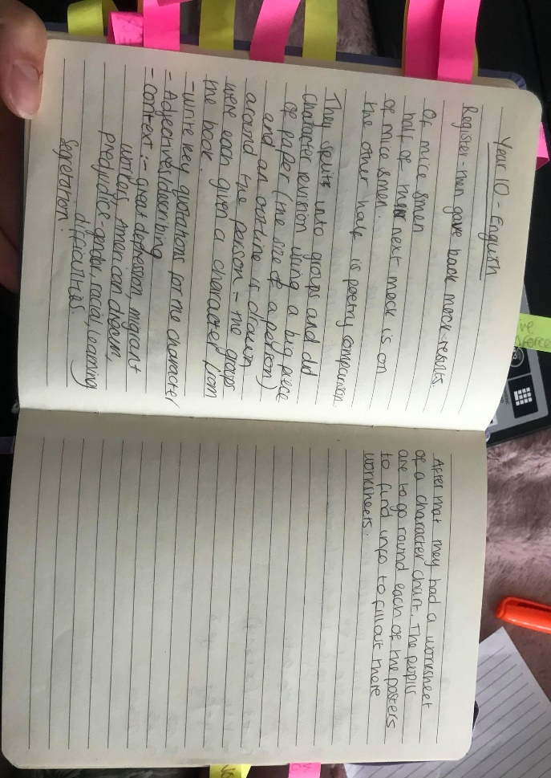
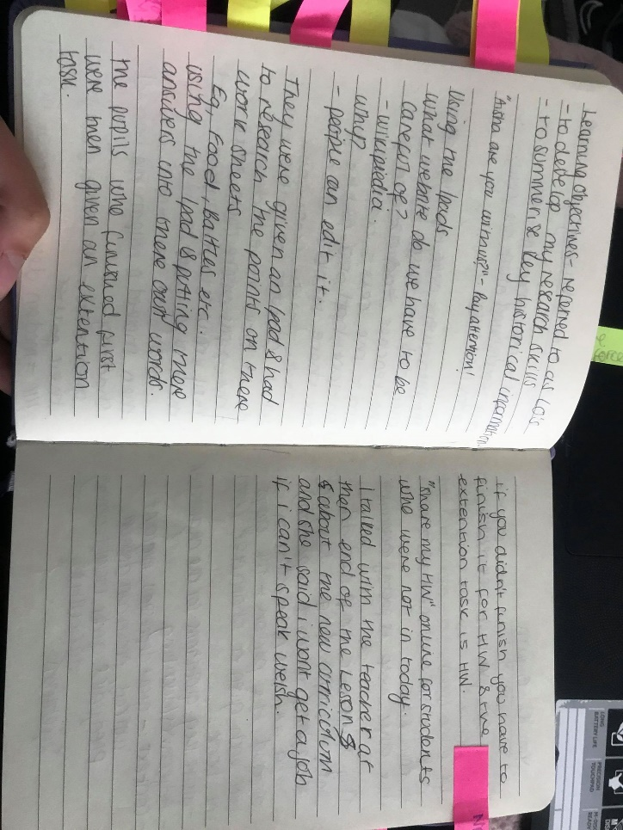
Digital Competence
https://www.estyn.gov.wales/blog/digital-competence-improving-pupils-digital-skills
https://hwb.gov.wales/curriculum-for-wales/science-and-technology/
http://bropedr.ceredigion.sch.uk/digital-competence-framework/

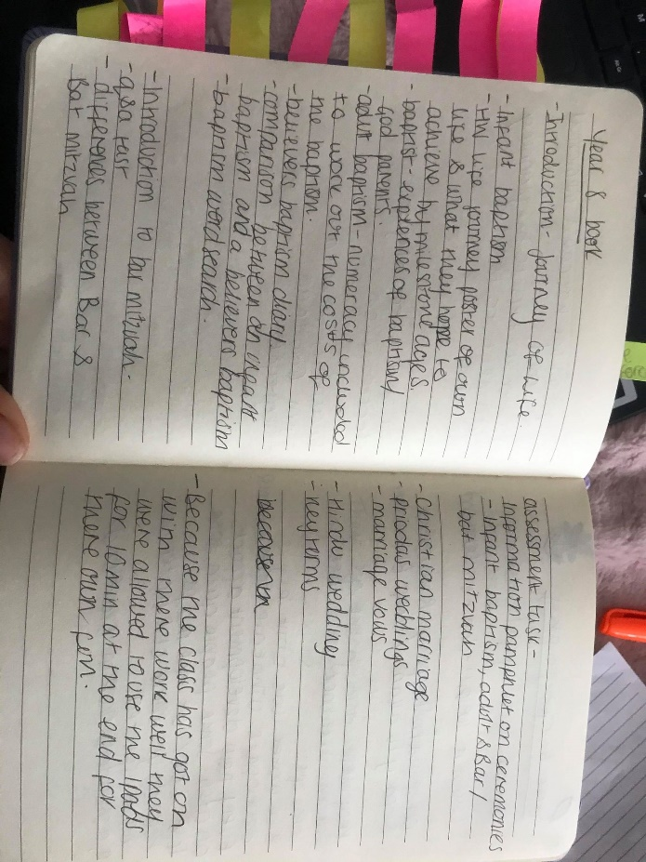
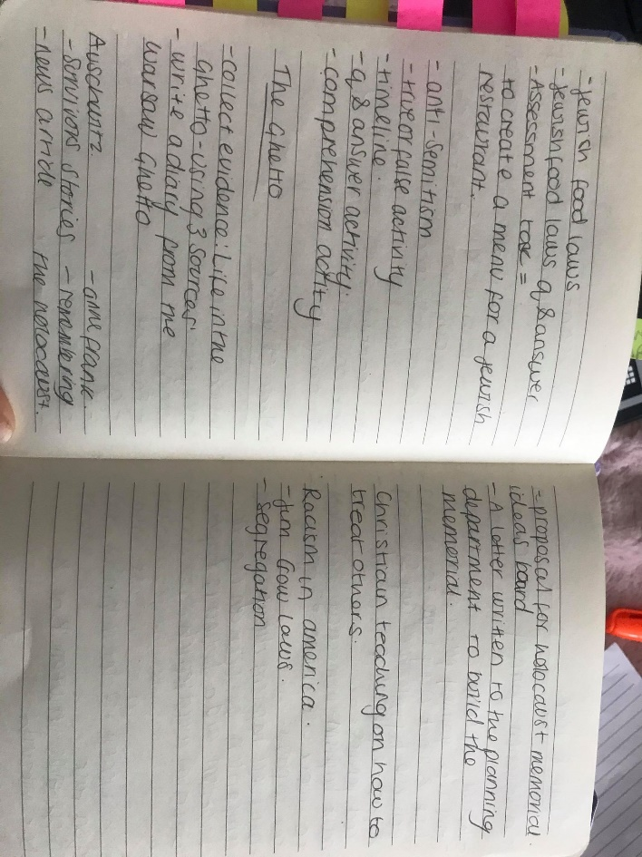
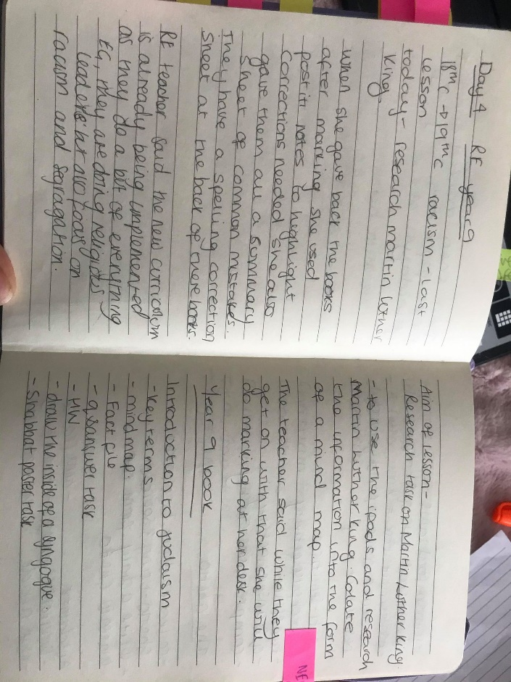
RE in Secondary School
https://hwb.gov.wales/curriculum-for-wales/humanities/
https://www.estyn.gov.wales/sites/www.estyn.gov.wales/files/documents/Religious%20education%20in%20secondary%20schools%20-%20June%202013.pdf

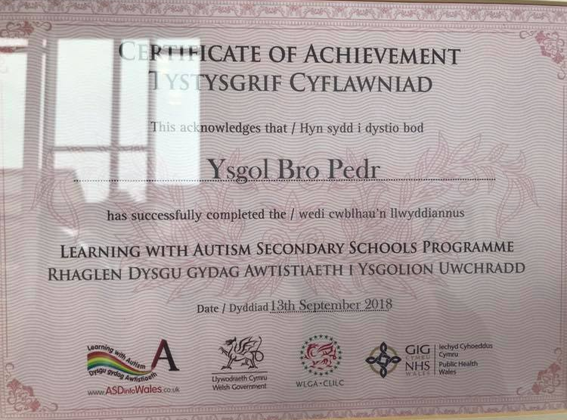
Learning with Autism
http://bropedr.ceredigion.sch.uk/learning-with-autism/
http://bropedr.ceredigion.sch.uk/west-wales-integrated-autism-service/
http://bropedr.ceredigion.sch.uk/parents/support-for-parents/

