ssage by receiver but some factors influence the effective communication by interrupting the message such as contents from beginning to end of the message, verbal or non-verbal elements of
Name: Ramila Ramji
Student ID: 2020127
Module code:BMSW4002
Lecture Name: Eijro Esohwode

Effective Team Work and Communication

Contents
Introduction 3
Strategies for effective team working. 3
Clearance of mission statements and goals- 3
Maintaining team bonds for a long time 3
Relaxation in idea implementation 4
Formal and informal communication with the teammates 4
Encouragement 4
The Shannon weaver Model of Communication 4
Practical examples of Shannon weaver model of mathematical communication 5
Berlo’s SMCR model of communication 6
Solution to the case study 6
The challenges and barriers Barry faces 6
The solutions that Barry might consider in addressing each of these challenges and barriers 7
Some ways of effective communication that Barry might use as a motivator for the employees for following the safe food handling practices 7
Idea generation and creativity 7
Improves productivity 7
Maintaining team bonds for a long time 8
Clearance of mission statements and goals 8
Conflict management 8
Creativity 8
Conclusion 9

Introduction
Effective teamwork and communication is essential in an organization to make successful completion of group tasks and workflow from seniors to juniors. Within the organization from start to end employees, managers and people from outside and inside the organization need to communicate with each other and share information, receiving direction and motivation, delivering the products and receiving raw materials, records keeping and giving direction to the employees. These are all the kinds of tasks required for good communication skills and effective team work skills of employees and managers. In this report, we will be working on the demonstration of our understanding of communication and communication skills by referring to the case studies done to properly understand the matter. With some examples of poor communication skills and their ways to improve it will be discussed at the final part.

Strategies for effective team working.
Individual’s skills, efforts, knowledge and ability cannot achieve goals and objectives within the limited time but effective team working can do the best and mind blowing achievement of the goals. The team consists of several individuals with having or possessing skills, knowledge, ability and different levels of intelligence. Different employees from different departments have capabilities and expertise in doing different tasks. Some effective team working strategies are as follows to understand it effectively-
Clearance of mission statements and goals-
Teams must follow the instructions and directions of the management and the mission statement is the written direction to form the team and their targets are explained. The defined goals and objectives are achieved by the team within the time frame (Butchibabu, and Shah, 2016). Thus elaboration of the task and detailed goals of the team enable team mates to achieve it and understand the ways to achieve properly. They make combined tactics for those goals and if there is any necessary amendments to make they can make it.
Maintaining team bonds for a long time- The achievement of consistent results at the finished point of each project, team mates need to have a team bond for a long time. When the team member changes a particular task it will decrease the team bond and hamper the team success. Thus organizations need to focus on building good team and maintain their bond for a long time to achieve consistent success.
Relaxation in idea implementation- Team members have a mind-set and unique brain to think about the problems. Thus team leaders need to provide some freedom to think out of the box to the team members. By these rights they will be able to share their views and opinions to their assigned task and innovative ideas to solve the problems (Leonard, and Bonacum, 2004). Management needs to generate ideas and take risks to implement those ideas and encourage them for future leadership.
Formal and informal communication with the teammates- Business owner’s need to communicate with all the employees and managers to give them instructions and get their expected results from them. People can interact with each other both in a formal and informal way. Based on the situation, team members need to communicate in an effective way.
Encouragement- Managers or team leaders need to boost the results and reputation of the organization in the market by making their employees encouraged to take decisions and make greater development for the company (Weller, Boyd, and Cumin, 2014). When employees get recognition of their tasks and contribution they will be very glad to be a team leader and work for the company at their level best.

The Shannon weaver Model of Communication
In 1948, an American mathematician, electronic engineer and weaver wrote an article in Bell technical system journal called the mathematical theory of communication that is also called the Shannon- weaver model of communication.
This model was designed to develop the effective communication between the receiver and sender and they find out some factors that affect the communication process such as noise.
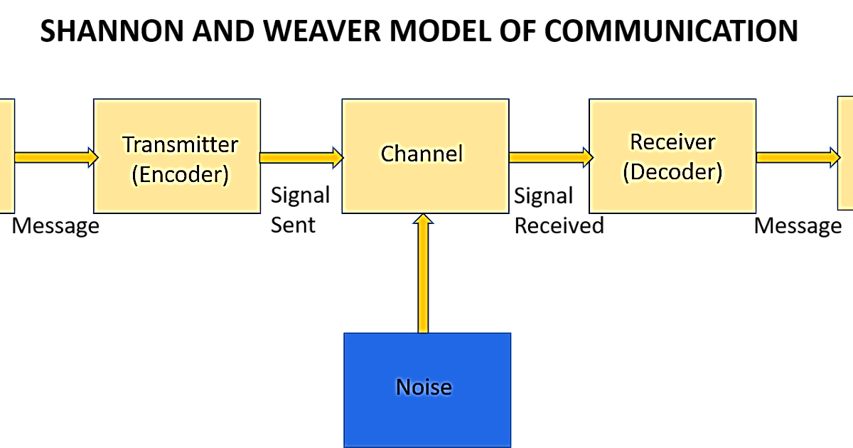
Figure 1 Shannon weaver model of communication, Sources- (Al-Fedaghi, 2012)
This model deals with different concepts such as sources of information, transmitter, Noise channel, message receiver information destination, encode and decode.
Sender- The people who originate the message or the source of information who select the desired message for the receivers.
Encoder- the transmitter that transfers the message to signals. The sender’s message needs to be converted into binary or waves to transfer from one place to another by using cables or satellites.
Decoder- the reception place that transfers the signals into readable messages. It is the reverse process of encoding. Receivers mainly convert those binary signals or waves into a message that is readable with very comfort and understandable. If they do not understand effectively that may hamper the effective communication between them.
Receiver- the people who receive the message and the sender sends the message for them. After receiving the decoded message receiver gives feedback to the senders for ensuring that they get the message with greetings (Oyadonghan, and Island, 2010). Sometimes the message is distracted by noise and it mainly affects by communication flow between the sender and receiver.
The model definitely deals with the external noises and these will affect the message or signals from different external sources. Such as problems occurring in the network that directly affects the communication such as mobile communication is distracted by the internet problems.
Practical examples of Shannon weaver model of mathematical communication-
My colleague Thomas called his assistant to come there because he wanted to see him. During the call, Noise appeared such as transmission errors occurred and his assistant received that I wanted a note more than he did not hear. Again the assistant of Thomson asked him what he wanted.
Here is the application of the model- Senders is Thomson, encoders is telephone of Thomson, channel is cable line, Noises is voice distractions such as transmission errors, Reception telephone Assistant’s. Finally, due to the transmission errors, the assistant did not get the proper message from Thomson and again he asked his boss to clearly understand what he wanted from his assistant (Sapienza, and Veenstra, 2015).

Berlo’s SMCR model of communication
David Berlo’s SMCR model represents effective communication in simplest form and the acronym stands for sender, message channel and receiver. The model from 1960 describes a different component of the communication model that is the formation of basic processes of communication. It emphasises the coding and decoding of the message in an efficient way and people can use it for making more efficient communication.
Components of Berlo’s SMCR model of communication- This model has four major components in the communication process. After these components this model is influenced by various factors. The components are as follows-
Sender- it is the source of the message who creates and sends to the receiver and it is the start of the communication process and people who send messages are the encoder. The factors that influence the sender are his communication skills such as reading, listening and speaking skills of the sender (Saud, Usman, and Saleh, 2013). Another one is the attitude of the sender and receiver. Knowledge is another one, the familiarity with the subject of the message creates effective communication.
Message- it is the package of information or main meaning of the senders and it can be in various forms such as speech, text, audio and video.
Channel- it is the main use of communication process. It must be able to pick up the message and its sensory system of the destination and they involve vision, smell, sound and taste. These are the senses hearing, touching, seeing and smelling.
Receiver- the receiver is the person who receives the message and decodes the message to make it readable and easily understandable (Muyanga, and Phiri, 2020). In linear communication receivers are in the end location.
To make successful, effective and smooth communication as much as possible the Berlo’s communication model assumes that the receiver’s pattern of thinking must be related to the sender’s one. The same factors mentioned in the sender part also influenced the receiver’s end.

Solution to the case study
The challenges and barriers Barry faces- Barry faces cultural diversity and different ethnicity of the employees and it makes problems in communicating effective by them. Employee’s age range is from 16-55 years. It also creates problems for effective communication that people come from different ages (Butchibabu, and Shah, 2016). Employees of Barry’s restaurant do not have their primary language is English. Within the organization the employee turnover is high, which is another challenge for Barry to provide training and language skills to them.
The solutions that Barry might consider in addressing each of these challenges and barriers- Barry can introduce them to different ways to communicate effectively by providing training and other facilities. Barry can offer a language course after completing the duties of the employees. Barry can create teams based on the age range of the employees that will help them to cooperate and perform their jobs effectively (Fraser, and Hvolby, 2010). Barry noticed that employees are not conscious about the food safety and food standard. He makes a sign and puts it over the kitchen that indicates employees need to keep hot foods into a hot place and cold food into a cold area. And they need to wash their hands very so often. Employees got direction properly and did their jobs properly. This is an effective way for a large number of people to become successful.
Some ways of effective communication that Barry might use as a motivator for the employees for following the safe food handling practices-
As a motivator, Barry can use different ways of effective communication creating an effective environment in one of them. Barry can create an environment where the communication is open to employees and managers that leads to reduction of misunderstandings and generates transparency among the employees (Scholl, 2018). Research shows that Employee engagement increases the productivity of the business by 51% and absenteeism is reduced 4 days.

Benefits of team working:
Benefit of team working are as follows-
Idea generation and creativity- team working helps organizations and generate new and innovative ideas and facilitates creativity of the employees by giving them chances to show their talents in the team.
Improves productivity- Team working brings some effective and better business success by improving the team members productivity.
Boost employee’s Morale and their motivation- Team working increases the employees motivation and boosts their morals effectively. Team working relieves stress and gives learning opportunities faster.

Successful team development:
Maintaining team bonds for a long time- When the team member changes at a particular task it will decrease the team bond and hamper the team success. Thus management needs to continue the consistent success by focusing on maintaining team bonds for the long run.
Clearance of mission statements and goals- When good collaboration happens to them it will help them to achieve their extraordinary goals and objectives. Team working can solve various problems with less effort.
Creativity- employees are creative in nature and they have been given the opportunity to explore their ideas and creativity. Management should encourage them for new idea generations and making new things for the organization.

Conclusion
Business communication and team working is a vital part of a business organization to achieve its success. Management needs to regularly communicate to employees, management, executives and stakeholders. Individual skills with team collaboration meet the success of an organization effectively. Some strategies help organizations to make effective team development strategies for the success and consistently they achieve their long term as well as short term success.
References
Al-Fedaghi, (2012). A conceptual foundation for the Shannon-Weaver model of communication. International Journal of Soft Computing, 7(1), pp.12-19.
Bojeun, (2019). Program management leadership: Creating successful team dynamics. Auerbach Publications.
Butchibabu, and Shah, (2016). Implicit coordination strategies for effective team communication. Human factors, 58(4), pp.595-610.
Butchibabu, and Shah, (2016). Implicit coordination strategies for effective team communication. Human factors, 58(4), pp.595-610.
Fraser, and Hvolby, (2010). Effective teamworking: can functional flexibility act as an enhancing factor? An Australian case study. Team Performance Management: An International Journal.
Leonard, and Bonacum, (2004). The human factor: the critical importance of effective teamwork and communication in providing safe care. BMJ Quality & Safety, 13(suppl 1), pp.i85-i90.
Muyanga, and Phiri, (2020). Assessment of Effective Communication in International Schools in Developing Countries Based on the Berlo’s SMCR Model. Open Journal of Business and Management, 9(1), pp.448-459.
Nielsen, and Randall, (2012). The importance of employee participation and perceptions of changes in procedures in a teamworking intervention. Work & Stress, 26(2), pp.91-111.
Oyadonghan, and Island, (2010). Information flow patterns in organizations: The library in focus. Library Philosophy and Practice, 504, pp.1-4.
Sapienza, and Veenstra, (2015). Reading Lasswell's model of communication backward: Three scholarly misconceptions. Mass Communication and Society, 18(5), pp.599-622.
Saud, Usman, and Saleh, (2013). The effectiveness of Communication Model in Teaching Wortshatz SCMR Berlo. Indonesian Journal of Educational Studies, 14(1).
Scholl, (2018). Effective teamwork—A theoretical model and a test in the field. In Understanding group behavior (pp. 127-146). Psychology Press.
Super, (2020). Building innovative teams: Leadership strategies across the various stages of team development. Business Horizons, 63(4), pp.553-563.
Weller, Boyd, and Cumin, (2014). Teams, tribes and patient safety: overcoming barriers to effective teamwork in healthcare. Postgraduate medical journal, 90(1061), pp.149-154.

