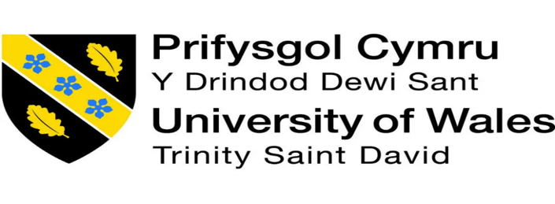

EXPLORING THE RELATIONSHIP BETWEEN MANAGEMENT COMMUNICATION STYLE AND EMPLOYEE PERFORMANCE

Submitted by:
Student name: Anca-Daniela Cruceru
Student ID: 2316314
Module code: LCBB6014
Faculty: BACHELOR OF ARTS BUSINESS MANAGEMENT University/Institution: UNIVERSITY OF WALES TRINITY SAINT DAVID LONDON

Supervisor’s name: Dr. Dudley Ofori

Date:
August 2026

Declaration

I declare that the text of this dissertation "Exploring the Relationship Between Management Communication Style and Employee Performance" is my own work and has been prepared in this instance for the fulfilment of the academic requirements of the programme of study in my institution. The work has not been submitted, either wholly or partly, for any other degree or qualification at this or any other institution. The sources of information, ideas and materials that have been utilised in this dissertation have been referenced and acknowledged in accordance with the academic guidelines as required.

Acknowledgement

I would like to thank my supervisor for his constant guidance and useful advice and helpful feedback during the work on this dissertation. I also would like to thank my lecturers for their knowledge, encouragement and academic support throughout my studies. I would like to express my sincere gratitude to my family and friends for their continuous encouragement, patience and motivation during this research. Last but not least, I am grateful to all authors and researchers who have published their research and work in the successful completion of this study.

Abstract

Research background has highlighted that globalisation has increased the importance of management communication, as it influenced workplace practices and employee motivation. In this regard, the research aims to explore the relationship between management communication styles and employee performance.
This literature review chapter provides a review concerning management communication style and employee performance, which involves key concepts, past studies and the correlation between management communication style and employee performance. It offers how communication is managed and how it impacts employee performance and determines the gap in research that the study is investigating. Communication Accommodation Theory and the Expectancy Theory covered the impact management communication has on employee behaviour and performance. It also gives the conceptual and theoretical grounding to study the relationship between management communication style and employee performance.
The methodology section intends to explore and illustrate the core methods and processes that have been adopted in this research. It also reflects the critical limitations that adversely affected the methodological implications in this research. Lastly, the ethical measures of this research are also highlighted in this section.
The chapter 4 discussed the findings and provided the analysis of the collected 16 articles for thematic analysis. The chapter has provided the discussion of thematic analysis to meet the objectives of the dissertation. The dissertation has also discussed the findings by relating to the literature and objectives on understanding the impact of the findings in competing the dissertation efficiently.
Chapter 5 focuses on the strategy to explore a better relationship between communication and employee performance management. Determination of an adequate measure is associated with diversification of guidelines associated with performance management.
The conclusion chapter has summarised that the research has effectively addressed each objective while key barriers involve poor communication stemming from toxic leadership and lack of transparency.

Table of Contents
CHAPTER 1. Introduction 9
1.1 Background 9
1.2 Research Aim and Objectives 10
1.3 Research Questions 10
1.4 Research Rationale 11
1.5 Research Significance 11
1.6 Chapter Summary 12
CHAPTER 2. Literature Review 13
2.1 Chapter Introduction 13
2.2 Relationship Between Management Communication Style and Employee Performance 13
2.3 Identification of Management Communication Practices that Impact Employee Performance 14
2.4 Determination of the Level of Employee Performance that Management Communication Style Influences 15
2.5 Factors Affecting the Relationship between Management Communication Style and Employee Performance 16
2.6 Theoretical Framework 17
2.6.1 Communication Accommodation Theory 17
2.6.2 Expectancy Theory 19
2.7 Literature Gap 19
2.8 Conceptual Framework 20
2.9 Summary 21
CHAPTER 3. Research methodology 22
3.1 Introduction 22
3.2 Research Onion 22
3.3 Philosophy 23
3.4 Approach 23
3.5 Design 23
3.6 Research Strategy 24
3.7 Data Collection 24
3.8 Sampling 24
3.9 Data Analysis 25
3.10 Limitations 25
3.11 Ethical Considerations 25
3.12 Summary 26
CHAPTER 4. Result and analysis 27
4.1 Introduction 27
4.2 Results 27
4.3 Analysis 42
4.4 Chapter summary 45
CHAPTER 5. Conclusion 46
5.1 Summary of key findings 46
5.2 Linking with Objectives 46
5.3 Recommendations 47
5.4 Limitations and future scope 47
5.5 Chapter Summary 48
References 49

List of Figure
Figure 1.1: Different management communication styles 10
Figure 2.1: Impact of effective communication 16
Figure 2.2: Concept of Communication Accommodation Theory 19
Figure 2.3: Concept of Expectancy Theory 20
Figure 2.4: Conceptual Framework 22
Figure 3.1: Representing the Research Onion 23

List of tables
Table 1: Thematic analysis 29

CHAPTER 1. Introduction

1.1 Background
Communication is a key aspect within organisational management as it plays a critical role in shaping employee behaviour, performance, and attitudes. According to Triyawanich and Singharach (2025), management communication involves translating strategies into actionable tasks, while aligning company’s goals with individual objectives. In this aspect, managers’ responsibility transcends beyond providing simple direction and coordinating tasks, as it involves offering guided instructions along with feedback. Management communication styles range from passive, direct, secretive, and passive aggressive, while the differences in styles impact employee performance through motivation-building and engagement. As discussed by Abed et al. (2023), interpersonal communication is common across workplaces, while factors shaping interaction include workplace culture. The study has dissected that a work environment displaying egalitarian and controlling traits often focuses on aggressive communication approaches, while open workplace culture focuses on two-way communication. Considering this insight, adopting a balanced approach across communication is necessary to address potential barriers such as miscommunication and misunderstanding.
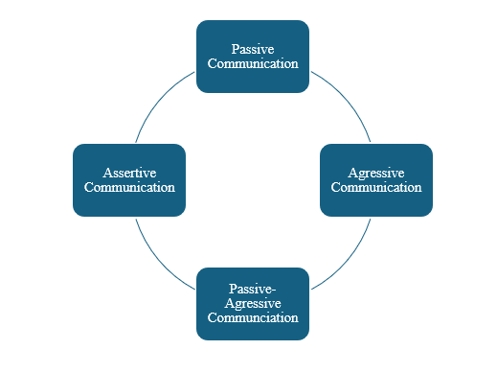

Figure 1.1: Different management communication styles
(Source: Self-Developed)
Referring to the above figure, the styles of communication offer different outcomes, while it further influences employee behaviour at the workplace. As found by Abolnasser et al. (2023), cultural values have a major influence on shaping communication styles, as cultures with high traditional values prefer formal communication over direct approaches. The passive approach leads to avoidance of conflict, whereas cultures with high value of individualism prefer conveying information with a direct approach. However, Balakrishnan et al. (2024) have noted that assertive communication, a hybrid between passive and aggressive styles, provides a balanced approach by utilising an open approach. Analysing the assertive approach, it offers both equality and power, while enabling active listening to form appropriate responses in the process of conveying information. Communication style’s impact on employee performance stems from factors such as psychological empowerment, clear direction and trust, as employees receiving clear information have higher ability to enhance productivity. As a result, the research intends to focus on the ways distinct management communication styles influence employee performance, while extending beyond current research of leadership and communication.

1.2 Research Aim and Objectives
Aim
The research aims to analyse the ways different management communication influences employee performance at the workplace along with the relationship between the two components.
Objectives
- To identity the relationship of management communication styles such as passive, aggressive, assertive, and passive-aggressive with employee productivity
- To evaluate the ways management communication affects employee motivation and job satisfaction levels
- To determine the impact of barriers such as poor management communication on increasing misunderstanding and inadequate performance at the workplace
- To recommend strategies for improving management communication and enhancing employee performance

1.3 Research Questions
- What is the interaction between different management communication styles and employee productivity?
- What is the impact of management communication styles on employee motivation and job satisfaction levels?
- How communication barriers, especially poor management communication, contribute to misunderstandings and inadequate employee performance in the workplace?
- What are the strategies supporting improvement of management communication and enhancing employee performance?

1.4 Research Rationale
Effective communication at the workplace supports employee productivity and contributes towards overall success of the organisation. However, despite advancements, proper communication has been a constant challenge across modern organisations. As found by Bahrain et al. (2023), effective communication is hindered by barriers such as misunderstanding, cultural differences, conflicts and use of digital channels. Although digital channels have increased continuity in communication, it has affected streamlining of messages due to use of different platforms such as instant messaging or emails. In this regard, the challenge has mainly emerged due to a lack of training on adopting effective communication styles along with emphasis on cultural awareness leading to misinterpretation. Based on Sumaiya et al. (2022), managers often lack the ability of active listening leading to a one-way communication that further increases employee dissatisfaction at the workplace. Analysing the challenge, communication barriers such as unclear instructions, inadequate feedback along with poor listening practices distorts the process of two-way communication.
The relationship between management communication and employee performance has increased the significance of adopting a positive communication style to boost motivation. However, across modern organisations technological advancements and cultural diversity have further reinforced communication barriers. As mentioned by Taylan and Weber (2023), managing cultural difference and whole interactions within a globalised environment lower threat of misinterpretation and distortion of messages. In this context, due to low managerial training in cultural awareness along with handling interpersonal communication with a diverse workforce has caused issues in further maintaining cross-cultural diversity at the workplace. Furthermore, global expansions of organisations have strengthened expectations of employees regarding greater transparency, participation, recognition, and constructive feedback from management. Thus, the research seeks to address gaps related to the ways different management styles influence employee performance outcomes.

1.5 Research Significance
The research’s significance lies in examining the relationship between management communication styles and employee performance, an area that enables maintaining competitive advantage in modern businesses. In this regard, the research presents a theoretical framework on management communication and utilises secondary information to identify interrelation between the two variables. Effective communication is essential for ensuring that employees understand organisational goals that further supports task achievement along with work motivation. Utilising a practical perspective, the research offers valuable insights for managers, supervisors, and organisational leaders especially in terms of adopting suitable communication styles driving motivation.

1.6 Chapter Summary
Summarising the chapter, the research aim involved examining the interrelations between management communication styles with employee performance. Reviewing the background, management’s ways of communication impact employee productivity and motivation, while poor communication also causes challenges such as miscommunication. Overall, the chapter provided the foundation for the research by defining the study's purpose and offers a clear discussion to build a theoretical foundation for literature review.

CHAPTER 2. Literature Review

2.1 Chapter Introduction
This chapter, Literature review, evaluates the linkage between the management communication style and employee performance. It includes an overview of concepts, previous research, communication practices, relevant theories, and gaps in research. This chapter also establishes the conceptual matrix, which can help in conducting this research and achieving the research objectives.

2.2 Relationship Between Management Communication Style and Employee Performance
Management communication style highlights managers' communication, informing, guiding and interacting process with workers to accomplish tasks. Employee performance is an indicator of completing the task efficiently, meeting the expectations and contributing to the overall productivity of organisations. According to Mpuangnan et al. (2024), an open participative management communication style has a positive effect on employee performance, as it increases trust, motivation and job satisfaction. Staff are more likely to work well when managers communicate with them and give feedback at regular intervals and involve them in decision-making. Promoting such communication enhances employee engagement and boosts productivity by fostering a positive workplace culture. On the other hand, Rahman et al. (2023) argued that communication style is not the only variable which influences employee performance. Organisational structure, job design, and managerial role are more important in determining the outcomes of performance than is the communication strategy used by managers.
Communication is a means to support performance, rather than a means to get the task done. In contradiction, Liaquat et al. (2024) suggested that the motivation of employees to perform is more important than reward expectations. These motivations and expectancies are largely influenced by the communication style itself as getting benefits can motivate them to work harder, improving employee performance. Thus, communication only enhances performance when it is precise and clear about goals, expectations, and reward systems. Similarly, Imran et al. (2025) opined that although communication can enhance employee satisfaction, providing other intrinsic motivators such as achievement, recognition, responsibility, and opportunity for personal growth can enhance employee performance. The workplace must provide meaningful and motivating experiences for employees, or any efforts for high performance through effective communication. Therefore, management communication style is a significant factor to employee performance, however other organisational and motivational factors are needed to enhance it.

2.3 Identification of Management Communication Practices that Impact Employee Performance
Effective management communications have a positive impact on the performance of employees, as they can create clarity, coordination, trust, and motivation among employees in the workplace. Sulaiman et al. (2023) stated that the best management communication towards enhancing work performance is open communication, frequent feedback, and employee involvement. Improved two-way communication and timely information, as encouraged by managers, leads employees to know more about the aims of the organisation, feel appreciated and motivated to perform at a high level. These practices also help to minimise miscommunication and improve team collaboration. On the contrary, Bukar et al. (2025) argued that communication alone was not likely to significantly impact employee performance unless complemented by appropriate management systems and objectives. This view suggests that managers should pay more attention to establishing measurable objectives and holding people accountable for them than on communicating often.
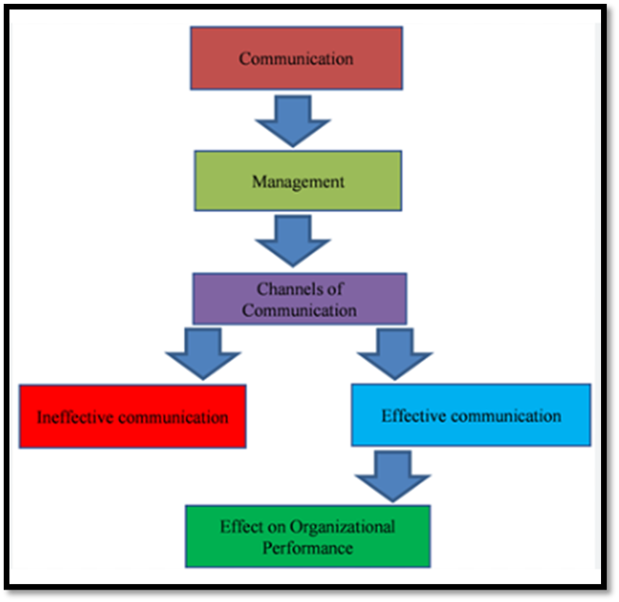

Figure 2.1: Impact of effective communication
(Source: Influenced by Bukar et al. 2025)
Clarity of roles and expectations is seen as having a greater impact than communication practices. Similarly, Meirinhos et al. (2023) stated that communication fails to influence the employees’ work due to the lack of motivation to work, implying the lack of motivators. Practices such as feedback meetings and open discussion meetings fail to create lasting improvements absent of recognising employees, giving them responsibility, and providing them opportunities to grow. From this perspective, motivation has a greater influence on employee performance than communication. On the other hand, from the perspective of Denner et al. (2025), informal communication, spontaneous interaction and the everyday coordination of management may be more effective than formal communication. Information sharing during normal work routines, rather than formal communication programs, has an impact on workplace performance. Managers need to be able to ensure flexible and responsive communication and not just rely on formal communication. Therefore, it can be stated that implying single communication practice is less effective regarding the employee performance, highlighting the significance of following different management communication practices.

2.4 Determination of the Level of Employee Performance that Management Communication Style Influences
Management communication style is one of the key factors contributing to employee performance; however, the extent of this influence differs depending on the existing scenario. Mpuangnan et al. (2024) found that participative and open communication plays a major role in enhancing employee performance by fostering trust, collaboration and job satisfaction. For instance, staff who are given regular feedback and engaged in decision-making are more likely to show commitment to the organisation's aims. Additionally, communication improves the understanding of the expectations that employees place on the work they do, which leads to higher productivity and better quality of work. On the other hand, Rantala (2025) argued that communication style plays a direct role in task and contextual performance as a means to establish a supportive work environment. Management communication style can only indirectly influence the performance of its employees. Shahriar et al. (2024) revealed that the role of organisational culture and job satisfaction factors on employee outcomes is stronger than the role of communication factors. Even managers who communicate effectively can have poor relations with subordinates if their subordinates have too much work, unclear organisational structure or limited career prospects. Thus, communication should not be considered as the main element of a system of performance, but as one aspect of a larger organisational system.
Similarly, Balakrishnan et al. (2024) revealed that assertive communication has a positive impact on employees' performance because it boosts employees' commitment, trust and organisational engagement. It can be stated that the relationship between communication and job performance is mediated by the leadership style, and it is suggesting that communication is more effective when facilitated by the right leadership behaviours. On the other hand, Rantala (2025) contradicted that communication cannot be expected to enhance employee performance, unless there is no psychological empowerment experienced by the employees. Moreover, empowerment is an intervening factor that mediates the relationship between managerial communication and employee attitudes and behaviour. Employees follow the path of seeing more autonomy and responsibility in their role, they react more positively to the managerial communication than if they do not see such autonomy and responsibility. Moreover, Paredes-Saavedra et al. (2024) presented the idea that modern communication technologies and AI-assisted communication systems have enhanced managerial communication, decreased information delay, and increased the quality of the feedback. However, it can be recognised that technology can help to accelerate the way of communicating. Thus, interpersonal communication skills are required for employee trust and motivation, and these skills are still vital, even in the age of technology.

2.5 Factors Affecting the Relationship between Management Communication Style and Employee Performance
Management communication style is such a factor which can affect employee performance; however, there are several factors in the organisation and the individual that affect the strength of the relationship. Motivation among employees is one of the most important. Öngel et al. (2023) claimed in this aspect that motivated employees are more receptive towards managerial communication as they interpret clear communication of objectives, rewards and expectations as motivation for them to increase their efforts. Communication can help improve employee performance only when it helps to raise employees' expectations that an increased effort can lead to a meaningful reward. However, Andreas (2022) contradicted that there is a lack of a direct relationship between motivation and employee performance. Additionally, it can be stated that intrinsic elements, such as being recognised, achieving, being responsible for the process, and opportunities for professional development, exert a greater influence on performance than do communication elements. Managers who talk about performance improvement but are not aware of the employee contribution are unlikely to work towards sustainable performance improvements. This implies that communication is effective if it is supported by human resource practice. Apart from that, Tahir and Hajjad (2023) stated that openness, transparency and employee participation promoted by the organisation fosters work culture that positively impacts employee engagement and productivity. For instance, in a supportive organisational culture, employees can become more likely to share information, ask for input and team with peers. However, Öngel et al. (2023) disagreed with this stating that communication devoid of an effective performance management framework doesn't add much to the effectiveness of any organisation. While communication frequency is important to employee performance, measurable objectives, accountability mechanisms, and strategic planning also have an impact. Thus, communication cannot be a substitute for structured management practices.
Another important aspect is the informal communication, as informal communication has a significant impact on employee performance through spontaneous knowledge sharing, relationship building and daily coordination (Chi et al. 2023). Informal communication can help employees solve issues promptly and enhance work relationships, unlike formal meetings and official communication channels. However, Andreas (2022) disagreed and argued that without the support of good leadership, recognition and reward systems, neither formal nor informal communication can create long-term performance improvements among employees. Thus, organisations need to incorporate effective communication into the overall managerial and motivational strategies to harness the potential of employees to their fullest.

2.6 Theoretical Framework

2.6.1 Communication Accommodation Theory
The Communication Accommodation Theory is used to explain the process of people modifying their communication style to better suit understanding and social relationships when communicating with others. It assumes that people can adjust their language, tone, behaviour or style of communication in ways of convergence, divergence or maintenance according to the context and the interlocutors with whom they communicate (Barlow et al. 2024). The theory within an organisational context can be described as how managers who modify their communication style when it is relevant to meet the needs, capacities and backgrounds of their employees can enhance the relationships they have with them.
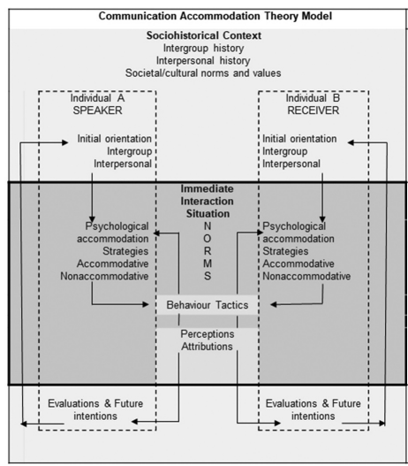

Figure 2.2: Concept of Communication Accommodation Theory
(Source: Barlow et al. 2024)
As per the above figure, clear, active listening and feedback from managers contribute to employee understanding of roles & expectations. This kind of communication helps to avoid misunderstandings, builds trust and helps the employees get involved in the activities of the organisation (Santos et al. 2023). Respect and support of employees lead to increased motivation, commitment, job satisfaction, and performance. Hence, Communication Accommodation Theory is effective to describe the adaptiveness of communication styles in management to enhance effective interaction, cooperation and understanding among employees in an organisation.

2.6.2 Expectancy Theory
As per the notions of the Expectancy theory, employees feel that good performance can lead to good performance, and it will lead to rewards, and those rewards are of value.
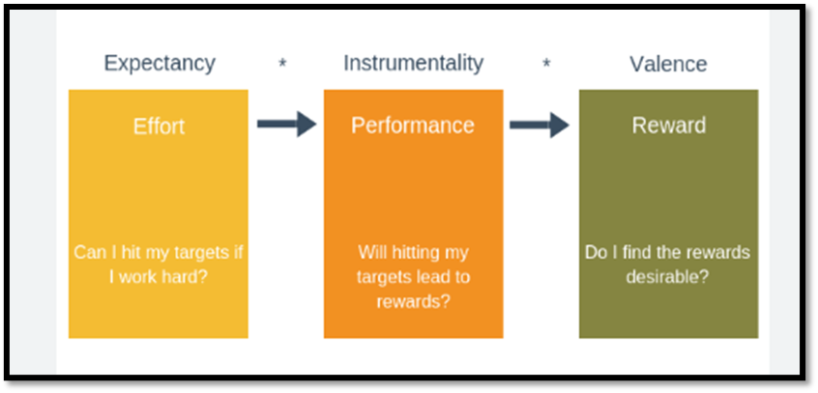

Figure 2.3: Concept of Expectancy Theory
(Source: Influenced by Ogundare and Omotosho, 2022))
As per the above figure, Expectancy, instrumentality and valence are the three components of the Expectancy Theory. Management communication style has an important role in this study, which is to form the expectations of employees, by communicating the job responsibilities, the standards of performance and the reward systems clearly (Ogundare and Omotosho, 2022). Additionally, communicating improves employees' confidence in meeting organisational objectives, improves motivation and boosts employee performance. Thus, Expectancy theory delivers a suitable theoretical foundation for explaining how management communication style influences employee performance.

2.7 Literature Gap
There is some research that has already been done that has determined that management communication is a factor that influences employee performance, however there is no clear agreement on what the most effective communication practice is. Concentration on leadership or organisation communication in general, not management communication styles can fail to assess the direct impact on employee performance (Florea and Croitoru, 2025). Moreover, this connection has only been studied in the context of a few organisations. Therefore, the purpose of this study is to fill these gaps by examining the influence of the management communication style on employee performance and determining which communication practices have the greatest impact on employee performance.

2.8 Conceptual Framework
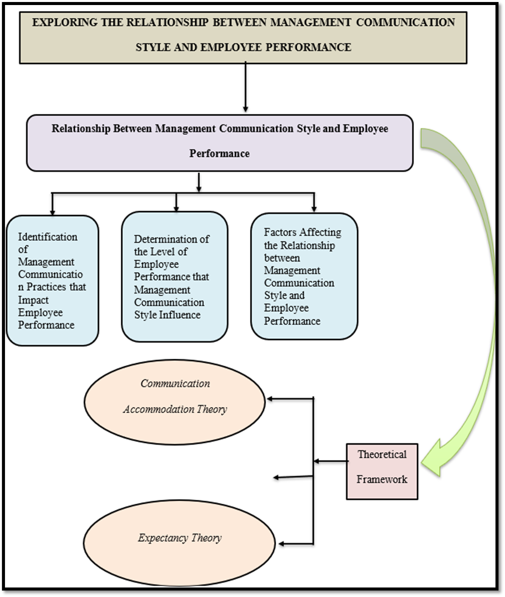

Figure 2.4: Conceptual Framework
(Source: Self-developed)
The conceptual framework illustrates the link between the organisational management communication practices and employee performance. Further, it also shows that in the case of brief discussion, the Communication Accommodation Theory and Expectancy Theory play crucial roles to highlight the relationship.

2.9 Summary
Thus, the literature review chapter explored previous theoretical concepts and the literature review of management communication style and employee performance, covering concepts, communication practices, theoretical perspectives, and previous empirical studies. It also covers the research gap and formulates the conceptual framework of the study. Thus, from the literary analysis, it can be stated that with high-quality management communication and organisational and motivational conditions, the performance of employees can be significantly improved.

CHAPTER 3. Research methodology

3.1 Introduction
The methodology section intends to explore and illustrate the core methods and processes that have been adopted in terms of assessing the relationship between the management communication style and employee performance. On the other hand, the integration of the Research Onion has been significant in visualising the methods suited for addressing the core objectives of this research in an effective manner. Apart from this, the critical limitation of this methodological implication has also been determined and recognised in this section in a significant process. Lastly, the key dimensions and protocols that have been advantageous in the context of driving the ethical standard and value of this research are also pointed out and evaluated significantly in this section.

3.2 Research Onion
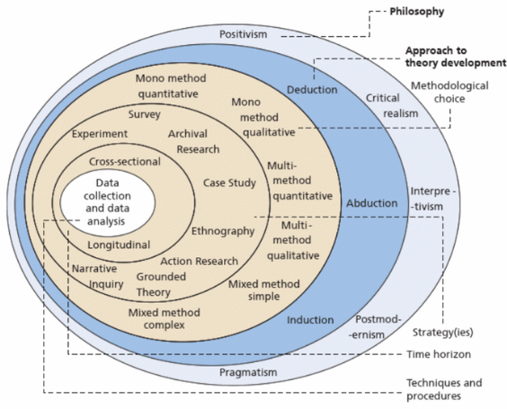

Figure 3.1: Representing the Research Onion
(Source: Saunders et al. 2015)
Applying the Research Onion has been valuable in terms of illustrating an in-depth overview of the core methods that are applicable to addressing the key objectives in this research. In accordance with the depiction of Selepe and Makinde (2024), the Research Onion presents a six-layered diagram in order to highlight the key dimensions of effective methods and patterns. In this regard, implementing the Research Onion has been valuable in visualising the suitability and implications of the methods in relevance to this research’s objectives and questions. Therefore, the Research Onion has been valuable in addressing any sort of bias in successfully choosing and implementing suitable methods in this research.

3.3 Philosophy
The interpretivism philosophy is proactively chosen and applied in this research to address the relationship between management communication style and employee performance. In accordance with the statement of Alborough and Hansen (2023), applying the interpretivism philosophy is significant in the context of developing and comprehending the meaning of social realities. Consequently, applying the interpretivism philosophy proved valuable in relevance to addressing the core objectives of this research by understanding the relationship between management communication style and employee performance. On the contrary, the positivism philosophy is discarded as it emphasises explaining complex human behaviour, which might cause bias in this research’s data interpretation process. Henceforth, the interpretivism philosophy turned out to be accurate in positively answering the specific questions of this research.

3.4 Approach
This research has predominantly emphasised the integration of the deductive approach in terms of assessing the relationship between management communication style and employee performance through theoretical support. The statement by Kumar and Ujire (2024) depicts that the deductive approach is valuable in the procedure of testing and integrating existing theories in research studies. In this regard, the core arguments in this research have been significantly validated by integrating adjacent theories through the application of the deductive approach. On the other hand, the inductive approach is significantly avoided as it specifically focuses on the creation of new theoretical concepts in research, which might have interrupted the accuracy of this research’s outcomes. Thus, the application of the deductive approach is perceived to be beneficial in relevance to linking the key objectives and questions in this research.

3.5 Design
This research focused on the descriptive design in relevance to evaluating the impact that the style of management communication has on the individual performance of staff members. Based on the opinion of Devi et al. (2022), adopting the descriptive design in research assists individual researchers to assess and explain the link and relationships between the multiple variables in research. Accordingly, the descriptive design is proactively selected and applied to highlight the relationship between the variables of this research in an effective manner. In essence, the independent variable of this research is the management communication style, and the dependent variable is perceived to be employee performance. In this context, the descriptive design is appropriate to accurately explore and comprehend the relationship between management communication style and employee performance.

3.6 Research Strategy
The qualitative strategy is chosen and implemented in this research to accumulate the required data to explore the impact that the style of management communication has on the individual performance of staff members. In accordance with the observation of Ayre and McCaffery (2022), the qualitative tactic emphasises the gathering and interpretation of non-numeric data in terms of generating accurate outcomes and research deliverables. Accordingly, applying the qualitative strategy has been valuable in addressing the specific objectives in this research by using non-numeric data. On the contrary, the quantitative strategy is avoided as it intends to incorporate the utilisation of numeric data in research. Therefore, choosing the qualitative strategy proved appropriate in positively answering the research questions in a significant way.

3.7 Data Collection
This research has focused on gathering and using secondary data in terms of exploring the relationship between management communication style and employee performance effectively. As per the comment of Rahayu et al. (2024), books, websites, articles and journals are perceived to be the remarkable sources in relevance to obtaining secondary data. In this context, the secondary data emerged to be valuable in observing the works of other researchers and integrating accurate data in terms of addressing the specific objectives of this research. However, the primary data collection process is avoided as it significantly emphasises the proactive participation of human respondents, which might have created bias in this research. Hence, the secondary data collection process turned out to be suitable in positively addressing the core questions of this research.

3.8 Sampling
The purposive sampling is proactively chosen and applied in this research to source relevant data sources based on the relationship that the style of management communication has with the individual performance of staff members. In accordance with the view of Ahmad and Wilkins (2025), the purposive sampling procedure enables an individual researcher to choose and engage participants accurately to meet the actual criteria and purpose of research. In essence, the purposive sampling tactic is used to choose 16 peer-reviewed journals based on the objectives in this research. For example, the 16 papers are presented on a table in section “Article name and reference”. Henceforth, the purposive sampling tactic emerged to be appropriate in successfully choosing relevant journals to acquire the required secondary data.

3.9 Data Analysis
The thematic analysis process is implemented to interpret the acquired secondary data in an effective manner to explore the relationship that management communication styles have with staff performance. Based on the idea of Braun and Clarke (2024), thematic analysis is remarkable in the context of developing themes from a large set of qualitative data. In this regard, four themes are framed and created based on the core objectives of this research to analyse the gathered secondary data accurately. On the contrary, the statistical analysis process is neglected as it emphasises the interpretation of numeric data. Thus, the thematic analysis tactic turned out to be the most suitable in terms of accurately analysing secondary qualitative data in this research.

3.10 Limitations
This research has put stress on integrating the collection and interpretation of secondary data to explore the relationship and link between management communication styles and staff performance effectively. However, the inclusion of primary data has been completely avoided in this research, which eventually turned out to be a critical limitation of this research. Apart from this, qualitative data has only been utilised in this research by avoiding the integration of quantitative data. Therefore, the avoidance of quantitative data emerged as another severe limitation in this research. Henceforth, the use of primary quantitative is likely to be valuable in terms of positively overcoming the limitations in an effective manner.

3.11 Ethical Considerations
The guidelines provided by the university based on anti-plagiarism are strictly evaluated and followed throughout this research to prevent any sort of academic bias. Apart from this, the protection of the gathered data has been secured through the implications of the Data Protection Act of 2018. Accordingly, the Data Protection Act of 2018 provides administrative norms to secure the processing of personal information in an effective manner (Gov, 2026). In addition, the gathered data is stored safely in electronic devices to prevent the unauthorised intervention of third parties in a significant way. Lastly, proper credibility is provided to the authors in terms of preventing bias in this research in a significant way.

3.12 Summary
The methodology section has predominantly summarised and explained the specific methods and processes that have been adopted in terms of evaluating the link between management communication style and employee performance. The implementation of the philosophy and approach, along with the design, has been proactively explained and illustrated in this chapter. The use of the Research Onion has also been effective in highlighting the methods suited for addressing the core objectives of this research in an appropriate manner. Apart from this, the critical limitation of this methodological implication has also been determined and recognised in this section effectively. Lastly, the key dimensions and protocols that have been advantageous in the context of driving the ethical standard and value of this research are also pointed out and evaluated significantly in this section. Thus, this section serves as a key backbone to this research effectively.

CHAPTER 4. Result and analysis

4.1 Introduction
Application of effective style of communication helps in increasing coordination of team and consequences are observed in reaching the desired performance improvement. Communication helps in sharing ideas among team members, and structured coordination creates an opportunity for adequate performance management. The aim of the chapter is to analyse the diverse perspectives of scholars regarding employee performance management and reach the desired vision. An evaluation has been made of the poor communication and its consequences for employee performance management. The role of practical implementation of strategies to ensure success in communication management turns out to be easier.

4.2 Results

Article name and reference | Intext | Aim and objective | Methodology in the paper | Findings | Themes
Eresanara, A. and Frank, O., (2024). Communication styles and employee job performance: A review of literature. The Uniben Journal of Human Resource Management, 3(1), pp.2024-07 | Eresanara and Frank (2024) | The study aimed to examine the different management communication styles influencing the performance of the employees to focus on productivity, quality of work, employee commitment, and overall effectiveness of organisations. | The study adopted a secondary qualitative analysis method using empirical studies and different theoretical frameworks | The findings of the study described the significant relationship between management communication styles and performance of employees. The research showed that assertive communication is the most effective communication style to understand the expectations of the organisations, productivity and the performance. Eresanara and Frank (2024) Also mentioned that managers allowing employees to understand the preferences and expectations of the organisations help in improving the quality of work. | Theme 1: Different communication styles of management including supportive communication increase productivity of employees
Balakrishnan, K., Angusamy, A., Patil, R.G. and Razak, M.N.F., (2024). Enhancing work performance: the role of communication and leadership styles. Jurnal Komunikasi: Malaysian Journal of Communication, 40(1), pp.376-394. | Balakrishnan et al. (2024) | The research aimed at investigating the role of different leaderships and communication styles in improving the organisational performance | The study adopted a qualitative survey method using the purposive sampling strategy for the dissertation. | An inclusion of assertive communication style has been identified from the research that positively effects collaboration and engagement. Employees working with leaders that communicate effectively, respect the ideas of employees and listeners carefully perform better than other teams. Therefore, it implies that effective communication and leadership roles are important in enhancing job performance of employees.
Mallillin, L.L.D., Caday, M.A.T. and Canda, E.G., (2024). Management Style and Productivity of Employee Toward Organizational Outcome. European Journal of Alternative Education Studies, 9(2). | Mallillin et al. (2024) | The aim and objective of the study is to understand the way management styles impact on the productivity of the employees and organisational outcomes. | The research adopted a mixed-method design using 125 participants and literature review | The findings of the study by Mallillin et al. (2024) disclosed that transformational, persuasive and authoritative management styles influence the productivity of employees in a positive way. Use of effective communication, recognition of employees, motivation and supportive workplace among employees can help in enhancing performance. The researchers mentioned that clear communication and leadership behaviours can help in improving the performance of employees and bring success to organisations.
Naji, G.M.A., Isha, A.S.N., Alazzani, A., Saleem, M.S. and Alzoraiki, M., (2022). Assessing the mediating role of safety communication between safety culture and employee’s safety performance. Frontiers in public health, 10, p.840281. | Naji et al. (2022) | The research aimed to examine whether safety communication influences the relationship between safety culture and actions for employee safety by evaluating the role of communication in promising a safer working environment. | A primary quantitative study is adopted by the research by analysing 320 employees. | The findings by Naji et al. (2022) states that effective communication positively influences the relationship between culture of organisational safety and employee safety actions. Inclusion of supportive leadership, proper environment and clear communication can help in providing transparent communication practices to enhance employee trust.
Santos, T., Santos, E., Sousa, M. and Oliveira, M., (2024). The mediating effect of motivation between internal communication and job satisfaction. Administrative Sciences, 14(4), p.69. | Santos et al. (2024) | The study aimed to investigate the way international communication impacts on the satisfaction of employees and investigate the role of motivation and increase effectiveness. | The research adopted a quantitative study design through collecting data from 426 employees | The findings by Santos et al. (2024) showed that effective internal communication can help in influencing the motivation of employees and job satisfaction. The motivation for employees significantly enhanced the organisational outcome and increased the efficiency of the employees. | Theme 2: Management communication in impact motivation and enhance the job satisfaction
Aryawan, I.W., Agung, A.A.G., Sulindawati, N.L.G.E. and Werang, B.R., (2024). Exploring the effect of interpersonal communication, conflict management, Asta Brata leadership style and motivation on job satisfaction of teachers. Pegem Journal of Education and Instruction, 14(2), pp.331-339. | Aryawan et al. (2024) | The study has aimed in devaluating the effect of interpersonal communication, conflict management system and motivation on the job satisfaction of teachers | The research adopted a quantitative study design using simple random sampling from 234 teachers and investigating the relationship between SEM-PLS | The findings by Aryawan et al. (2024) showed that the effect of conflict management and clear communication positively impact on the job satisfaction of a teacher. Inclusion of effective communication system can help in strengthening trust, collaboration and employee engagement wrestling into improved job satisfaction for teachers.
Ramirez-Lozano, J., Peñaflor-Guerra, R. and Sanagustín-Fons, V., (2023). Leadership, communication, and job satisfaction for employee engagement and sustainability of family businesses in Latin America. Administrative Sciences, 13(6), p.137. | Ramirez-Lozano et al. (2023) | The research aims at analysing the factors influencing the employee engagement in examining the authentic leadership, use effective communication and achieve job satisfaction. | The study has used a mixed-method approach through interviews and surveys along with literature review | The findings by Ramirez-Lozano et al. (2023) implies that proper leadership, effective communication and job satisfaction of employees enhances the engagement of the employees. Employees can experience extensive support through effective communication leading to positive outcomes for organisations.
Wicaksono, A.S., Hendri, M.I., Daud, I. and Rosnani, T., (2024). The effect of communication, work discipline and work life balance on employee performance. Jurnal Ilmiah Manajemen Kesatuan, 12(4), pp.1219-1226. | Wicaksono et al. (2024) | The study aimed at investigating the impact of communication, discipline in work, work-life balance motivating the employee performance of the staff | The study adopted quantitative design using questionnaire and PLS-SEM using SmartPLS | The findings by Wicaksono et al. (2024) showed that communication impacts positively in enhancing motivation by conveying proper instructions to the team. The inclusion of effective communication can help in improving employee understanding
Wolor, C.W., Ardiansyah, A., Rofaida, R., Nurkhin, A. and Rababah, M.A., (2022). Impact of toxic leadership on employee performance. Health psychology research, 10(4), p.57551. | Wolor et al. (2023) | The research aims at understanding the impact of topic leadership on job satisfaction and employee performance within the employees in private sector | The research follows primary quantitative questionnaire-based method using 400 employees. | The findings by Wolor et al. (2023) shows that toxic leadership affects job satisfaction and minimises the productivity mindset among employees. It also shows that abusive and ineffective communication can lead to performance decline. | Theme 3: Improper management communication on performance of employees results into poor communication minimising performance
Huu, P.T., (2023). Impact of employee digital competence on the relationship between digital autonomy and innovative work behavior: a systematic review. Artificial Intelligence Review, p.1. | Huu (2023) | The research aimed at investigating the employee digital competence, innovative behaviour of employees and digital autonomy in improving efficiency | The research has adopted a qualitative method using PTISMA guidelines | The findings by Huu (2023) showed that digital compete in working environment increased the autonomy, adaptability and work behaviour during the digital transformation leading to positive organisational outcome.
Anakpo, G., Nqwayibana, Z. and Mishi, S., (2023). The impact of work-from-home on employee performance and productivity: a systematic review. Sustainability, 15(5), p.4529. | Anakpo et al. (2023) | The study aimed at investigating the impact of the working from home on the productivity of employees, job satisfaction and performance if employees | The research has adopted a mixed method or its study | The findings by Anakpo et al. (2023) highlights that working from home provides higher satisfaction, organisational commitment and motivation and on the contrary, it shows stress, minimise collaboration and decreased communication.
Al-Tit, A.A., Al-Ayed, S., Alhammadi, A., Hunitie, M., Alsarayreh, A. and Albassam, W., (2022). The impact of employee development practices on human capital and social capital: the mediating contribution of knowledge management. Journal of Open Innovation: Technology, Market, and Complexity, 8(4), p.218. | Al-Tit et al. (2022) | The research has the aim and objective to understand employee development practices and knowledge management including the role of knowledge management increasing intellectual capital. | The study has adopted a primary quantitative method through questionnaire survey of 464 ICT employees | The findings by Al-Tit et al. (2022) highlights that employee development actions significantly influence knowledge management, human capital and improve productivity.
Masruddin, N.P.D., Saharuddin, S. and Hasbi, A.R., (2026). The Effect of Work Discipline and Workload on Employee Performance. Golden Ratio of Human Resource Management, 6(1), pp.59-72. | Masruddin et al. (2026) | The research has aimed to investigate the impact of the work discipline and workload on performance of employees and understand the way factors achieve organisational goals | The study adopted a quantitative ensign with questionnaire with 30 employees | The findings by Masruddin et al. (2026) showed that work discipline positively influences the performance of the employees in the workplace and excessive workload minimises the responsibility by putting stress on employees. | Theme 4: Strategies such as feedback and transparency can be used for improving management communication leading to enhancing performances of employees
Abdellatif, H. and Alabay, G.G., (2026). The New Management Imperatives: Culture, Connectedness, Performance, Leadership Sensemaking, Organizational Trust, And Employee Voice: A Qualitative Study. Cultura: International Journal of Philosophy of Culture and Axiology, 23(1), pp.84-98. | Abdellatif and Alabay (2026) | The research focuses on understanding the relationships between organisational culture, sensemaking in leadership, connectedness and employee voice | The study adopted primary qualitative method for the discussion | The findings by Abdellatif and Alabay (2026) highlights that employees can experience transparent communication, support from leaders and psychological safety through stronger engagement of the employees.
Fang, T., Gunderson, M., Hartley, J., King, G. and Ming, H., (2026). Determinants and Effects of Remote Work Arrangements: Evidence from an Employer Survey. Asia Pacific Journal of Human Resources, 64(1), p.e70053. | Fang et al. (2026) | The research aimed at investigating determinants of enhancing remote work and understand the effect on performance of employees | The study has adopted primary quantitative method for the research | The finding by Fang et al. (2026) has mentioned that remote work expansion has been influenced by the rapid digitisation and organisational non-rigidness.
Al Nahyan, M.T., Al Ahbabi, J.M., Alabdulrahman, M.A., Alhosani, I., Jabeen, F. and Farouk, S., (2026). Employee job security and job performance: the mediating role of well-being and the moderating role of perceived organizational support and psychological capital. European Journal of Management and Business Economics, 35(2), pp.244-265. | Al Nahyan et al. (2026) | The study has aimed to investigate the role of job security, employee well-being and job performance maintaining productivity using COVID-19 social distancing protocol. | The study has adopted a primary quantitative method from 279 frontline public employees | The study by Al Nahyan et al. (2026) highlights that on security of an organisation enhance the well-being of the employees that leads to improvement in the job performance.

Table 1: Thematic analysis
(Created by author)

4.3 Analysis
Utilisation of different communication styles helps in enhancing employee productivity in the organisation.
Employee performance management is linked with the identification of the complete potential of the team. Communication style is instrumental in achieving success in performance management and achieving adequate results in fulfilling the objectives (Eresanara and Frank, 2024). It can be analysed from the findings that communication ideas among team members can provide guidelines to reach the objectives. Enhancement of performance coordination helps in fulfilling the vision and achieving success in decision-making (Balakrishnan et al., 2024). Ensuring adequate output in the strategy of decision-making is necessary to gain success in ensuring employee productivity.
Optimisation of organisational productivity is associated with the strategy of performance planning and increased coordination in the strategy of training. Diverse management styles are instrumental in determining success in decision-making, and fulfilling goals becomes easier (Mallillin et al. 2024). Referring to the findings, it can be stated that optimisation of organisational productivity is associated with the identification of skill gaps. Management of administrative coordination is associated with the process of dealing with the skill gap and achieving desired results (Naji et al. 2022). Thus, communication helps in the strategy to gain success in performance management in an organisation.
Management communication fulfils the needs of employee motivation and satisfaction levels.
Communication helps in the management of motivation in the team, and achieving strategic measures of workplace satisfaction turns out to be easier. Ensuring adequate motivation among team members helps in the determination of better performance outcomes (Santos et al. 2024). It can be analysed referring to the findings that optimisation of organisational performance requires identification of skill gaps. A proactive strategy of conflict management helps in determining active outcomes, and developing better performance resilience becomes possible (Aryawan et al. 2024). Accomplishment of success in decision-making provides an opportunity to gain desired results in fulfilling the vision.
Development of an inclusive team structure is linked with determination of proactive results and optimising the scope of ensuring organisational satisfaction. Adequate leadership strategy intervention is an integral part to address management gaps and achieve success in gaining adequate output (Ramirez-Lozano et al. 2023). Ensuring the psychological well-being of team members is necessary to ensure success of employee satisfaction in the organisation. Management of administrative discipline is associated with measures to achieve adequate results and organisational success (Wicaksono et al. 2024). Thus, it is important to adopt a strategy of effective communication in the team and fulfil the concerned objective associated with workplace satisfaction.
Inefficiency of management communication leads to a lack of understanding and poor management of performance
Diversity of language is a notable factor responsible for the communication gap and lack of understanding regarding the administrative measures that are responsible for performance management. Leadership challenge is a crucial factor responsible for the communication gap observed in organisations and achieving administrative success (Wolor et al. 2022). Additionally, time constraints are one of the notable challenges observed in the case of large-scale organisation and it can take the form of misunderstanding. Performance optimisation at the workplace requires an understanding of diverse perspectives and achieving success in reaching organisational vision (Huu, 2023). Thus, lack of coordination can create notable obstacles in fulfilling administrative issues.
In some cases, the existing administrative structure creates complexity in optimising better performance outcomes and reaching the targeted goal. Workplace satisfaction creates an opportunity to ensure adequate performance measures, and the accomplishment of progress in reaching the goal becomes easier (Anakpo et al. 2023). Referring to the findings, it can be analysed that conflict in the team can create difficulty in managing adequate administrative coordination. Optimisation of performance measures is linked with the implementation of measures and reaching the concerned objectives (Al-Tit et al. 2022). Therefore, it is necessary to ensure success in performance management and determine the opportunity for success.
Strategic implementation helps in increasing employee performance with the help of effective communication
It is suggested to focus on ensuring transparency of communication and achieving success in reaching the goal. Organisational effectiveness helps in improving coordination and gaining desired results (Masruddin et al. 2026). It is recommended to increase transparency of communication and increase the scope of decision-making. Identification of performance gaps helps in reaching the desired vision, and accomplishment of success in fulfilling the goal becomes possible (Abdellatif and Alabay, 2026). Therefore, it is important to address the existing challenges and determine opportunities for performance management.
It is recommended to optimise organisational performance and gain success in terms of effective decision-making. Determination of structured collaboration in the organisation creates an opportunity to deal with the obstacles and achieve proactive results (Fang et al. 2026). It is suggested to gain insights into the process of coordination and fulfilling the vision appears to be possible. The strategy of performance evaluation is linked with the implementation of proactive measures and gaining authentic output (Al Nahyan et al. 2026). The need is to address the existing challenges and implement necessary measures to fulfil the concerned measures of performance.

4.4 Chapter summary
It can be summarised from the above evaluation that the need is to determine insights regarding the strategy of coordination. The need is to achieve adequate output in terms of desired performance planning and reach the targeted goal. Communication helps in ensuring success in performance management and implementing measures to reach desired output in terms of decision-making. Henceforth, the need is to develop insights regarding the long-term vision and achieve success in terms of success.

CHAPTER 5. Conclusion

5.1 Summary of key findings
The research explored the interconnection and relationship between management communication styles followed by employee performance through a thematic analysis of secondary literature. In this regard, the findings have revealed that management communication plays a significant role in influencing employee productivity, while motivating the workforce to achieve organisational objectives. Comparing literature with core findings, management communication styles have varying effects on employee productivity, as assertive style often tends to provide positive influence at the workplace. On the other hand, demonstration of passive or aggressive communication approach combined with toxic leadership hinders effective communication in organisations. Overall, the study concludes that management communication is necessary to avoid barriers related to employee motivation and performance, while strategies such as transparency and training widely influence communication approaches.

5.2 Linking with Objectives
Linking with Objective 1
The thematic finding has addressed the first objective of the study related to the relationship between management communication styles. In this regard, Theme 1 has specified that assertive and supportive communication styles encourage collaboration, whereas a passive approach reduces employee engagement at the workplace.
Linking with Objective 2
The research has met objective 2 within the findings of theme 2, which focused on understanding the ways communication influences motivation and satisfaction levels at the workplace. The key findings highlighted that effective communication promotes employee motivation by offering clear support and clarifying job responsibilities.
Linking with Objective 3
Theme 3 by emphasising on influencing management practices has discussed core barriers of communication and simulate addressed objective 3 of the study. The barriers such as unclear instructions, poor leadership communication, language diversity and inadequate feedback create misunderstanding at the workplace and lowers overall employee engagement.
Linking with Objective 4
The theme 4 based on strategic implementation has focused on the fourth objective surrounding improvement of employee performance through effective management communication. The findings have discussed that transparent communication, structured feedback systems and employee participation in decision-making are core strategies that influence employee performance. Hence, offering effective strategies the theme has met objective 4 and provided ways of implementation such as ensuring structured communication at the workplace.

5.3 Recommendations
Recommendation 1: Promotion of assertive and supportive communication at the workplace
Adopting assertive and supportive communication styles during employee interaction provided benefits such as elimination of misinterpretation and gaining employee trust at the workplace. In this aspect, adoption of an assertive communication approach relies on extensive training to avoid use of personal habits in professional instances. As per Meinlschmidt et al. (2025), communication training focuses on building awareness on cultural factors and providing knowledge on different communication styles. As a result, training programmes focusing on communication skills can boost managers’ competencies on assertive communication and demonstrating support.
Recommendation 2: Establishing Regular Feedback and Two-Way Communication Mechanisms
A challenge identified at the workplace involves use of one-way communication and lack of employee participation within decision-making, which threatens engagement. Addressing the issue, a recommendation offered includes regular communication through two-way systems such as feedback loop and platforms for mutual discussion. Based on Niks et al. (2022), feedback loops effectively provide opportunities for employees to raise concerns while focusing on individual improvements following the feedback. Two-way communication promotes transparency, strengthens trust, and enables managers to identify issues before they negatively affect performance. Thus, use of regular feedback can help employers and managers understand key challenges at workplace culture reducing engagement along with productivity.

5.4 Limitations and future scope
A key limitation of the study consists of a lack of incorporation of real-time sights or primary information to understand barriers threatening global organisations’ communication approaches. Due to reliance on secondary inflammation, the study has failed to incorporate insights from employees facing practical challenges within multinational corporations. Additionally, the focus on management communication has limited its analysing on the ways leadership styles are further interlinked with management approaches. As a result, future scope of the study includes addressing these limitations by conducting primary research involving employees and managers from different organizations and industries.

5.5 Chapter Summary
Concluding the chapter, it has been revealed that management communication styles have a major impact on workforce’s performance. Linking objectives with findings, the research has addressed each question by highlighting the interrelations, impact, key barriers and strategic implementation of recommendations. Lastly, focusing on limitations such as a lack of primary insights, the future scope has been presented to include real-time data gathered from employees of specific industries to increase applicability of the research.

References
Chapter 1
Abed, L.G., Abed, M.G. and Shackelford, T.K., (2023). Interpersonal communication style and personal and professional growth among Saudi Arabian employees. International Journal of Environmental Research and Public Health, 20(2), p.910.
Abolnasser, M.S.A., Abdou, A.H., Hassan, T.H. and Salem, A.E., (2023). Transformational leadership, employee engagement, job satisfaction, and psychological well-being among hotel employees after the height of the COVID-19 pandemic: a serial mediation model. International journal of environmental research and public health, 20(4), p.3609.
Bahrain, N.K., Sakrani, S.R. and Maidin, A., (2023). Communication barriers in work environment: understanding impact and challenges. International Journal of Academic Research in Business and Social Sciences, 13(11), pp.1489-1503.
Balakrishnan, K., Angusamy, A., Patil, R.G. and Razak, M.N.F., (2024). Enhancing work performance: the role of communication and leadership styles. Jurnal Komunikasi: Malaysian Journal of Communication, 40(1), pp.376-394.
Sumaiya, B., Srivastava, S., Jain, V. and Prakash, V., (2022). The role of effective communication skills in professional life. World Journal of English Language, 12(3), pp.134-140.
Taylan, C. and Weber, L.T., (2023). “Don’t let me be misunderstood”: communication with patients from a different cultural background. Pediatric Nephrology, 38(3), pp.643-649.
Triyawanich, T. and Singharach, S., (2025). Directions to improve modern organizational communication management systems. ACTUAL ECONOMY: Afro-Asian solutions to global challenges-2025, pp.170-176.

Chapter 2
Andreas, D., (2022). Employee performance: The effect of motivation and job satisfaction. PRODUKTIF: Jurnal Kepegawaian dan Organisasi, 1(1), pp.28-35.
Balakrishnan, K., Angusamy, A., Patil, R.G. and Razak, M.N.F., (2024). Enhancing work performance: the role of communication and leadership styles. Jurnal Komunikasi: Malaysian Journal of Communication, 40(1), pp.376-394.
Barlow, M., Watson, B., Jones, E., Morse, C. and Maccallum, F., (2024). The application of communication accommodation theory to understand receiver reactions in healthcare speaking up interactions. Journal of Interprofessional Care, 38(1), pp.42-51.
Bukar, K., Usman, M. and Ngubdo, U.M., (2025). Effect of Communication Strategies on Organisational Performance. Solo International Collaboration and Publication of Social Sciences and Humanities, 3(02), pp.225-236.
Chi, H., Vu, T.V., Nguyen, H.V. and Truong, T.H., (2023). How financial and non–financial rewards moderate the relationships between transformational leadership, job satisfaction, and job performance. Cogent Business & Management, 10(1), p.2173850.
Denner, N., Koch, T., Viererbl, B. and Ernst, A., (2025). Feeling connected and informed through informal communication: a quantitative survey on the perceived functions of informal communication in organizations. Journal of Communication Management, 29(1), pp.71-93.
Florea, N.V. and Croitoru, G., (2025). The impact of artificial intelligence on communication dynamics and performance in organizational leadership. Administrative Sciences, 15(2), p.33.
Imran, U.D., Ghazwan, M.F. and Firmansyah, F., (2025). The effect of recognition and appreciation on employee motivation and performance. Economics and Digital Business Review, 6(1), pp.1-18.
Liaquat, M., Ahmed, G., Ismail, H., Ain, Q.U., Irshad, S., Izhar, S.S. and Mughal, M.T., (2024). Impact of motivational factors and green behaviors on employee environmental performance. Research in Globalization, 8, p.100180.
Meirinhos, G., Cardoso, A., Neves, M., Silva, R. and Rêgo, R., (2023). Leadership styles, motivation, communication and reward systems in business performance. Journal of Risk and Financial Management, 16(2), p.70.
Mpuangnan, K.N., Govender, S., Mhlongo, H.R. and Osei, F.S., (2024). Impact of motivation and participative leadership style on employee performance: Mediating the role of job satisfaction. International Journal of Innovative Research and Scientific Studies, 7(3), pp.1088-1098.
Ogundare, P. and Omotosho, B.J., (2022). The relevance of expectancy theory in explaining employee performance and productivity. Available at SSRN 4553246.
Öngel, V., Günsel, A., Gençer Çelik, G., Altındağ, E. and Tatlı, H.S., (2023). Digital leadership’s influence on individual creativity and employee performance: a view through the generational lens. Behavioral Sciences, 14(1), p.3.
Paredes-Saavedra, M., Vallejos, M., Huancahuire-Vega, S., Morales-García, W.C. and Geraldo-Campos, L.A., (2024). Work team effectiveness: Importance of organizational culture, work climate, leadership, creative synergy, and emotional intelligence in university employees. Administrative Sciences, 14(11), p.280.
Rahman, M.S., Sulistyani, S. and Widayati, T., (2023). The effect of assertive communication style and organizational culture on employee performance with job satisfaction as an intervening factor. In Proceeding of The International Conference on Business and Economics (Vol. 1, No. 1, pp. 41-53).
Rantala, J., (2025). Cultural Context in Action: Exploring the Role of Communication Styles in International Workplaces.
Santos, S., Augusto, L., Ferreira, S., Espírito Santo, P. and Vasconcelos, M., (2023). Recommendations for internal communication to strengthen the employer brand: A systematic literature review. Administrative sciences, 13(10), p.223.
Shahriar, H., Makhdum, L.N. and Hossen, B.E., (2024). Organizational culture and its influence on employee job satisfaction. International Journal of Engineering Applied Sciences and Technology, 9(04), pp.52-61.
Sulaiman, N.S., Abdullah, Z. and Man, N.I., (2023). The effects of employee communication and engagement on organisational performance: A conceptual study. International Journal of Accounting, Finance and Business, 8(46), pp.233-251.
Tahir, M. and Hajjad, M.F.N., (2023). Employee performance and the impact of workplace facilities and discipline. Jurnal Manajemen Bisnis, 10(2), pp.417-425.
Chapter 3
Ahmad, M. and Wilkins, S., (2025). Purposive sampling in qualitative research: A framework for the entire journey. Quality & Quantity, 59(2), pp.1461-1479.
Alborough, L. and Hansen, R.K., (2023). Reframing fundraising research: The challenges and opportunities of interpretivist research practices and practitioner researchers in fundraising studies. Journal of Philanthropy and Marketing, 28(1), p.e1775.
Ayre, J. and McCaffery, K.J., (2022). Research Note: Thematic analysis in qualitative research. Journal of Physiotherapy, 68(1), pp.76-79.
Braun, V. and Clarke, V., (2024). Supporting best practice in reflexive thematic analysis reporting in Palliative Medicine: A review of published research and introduction to the Reflexive Thematic Analysis Reporting Guidelines (RTARG). Palliative medicine, 38(6), pp.608-616.
Devi, B., Lepcha, N. and Basnet, S., (2022). Application of correlational research design in nursing and medical research. Journal of Xi'an Shiyou University, Natural Sciences Edition, 65(11), pp.60-69.
Gov, (2026). The UK's data protection legislation. Available at: https://www.gov.uk/data-protection [Accessed 16 June 2026]
Kumar, S. and Ujire, D.K., (2024). Inductive and deductive approaches to qualitative research. International Journal of Multidisciplinary Educational Research, 13(1), pp.58-63.
Rahayu, N.I., Muktiarni, M. and Hidayat, Y., (2024). An application of statistical testing: A guide to basic parametric statistics in educational research using SPSS. ASEAN Journal of Science and Engineering, 4(3), pp.569-582.
Saunders, M.N., Lewis, P., Thornhill, A. and Bristow, A., (2015). Understanding research philosophy and approaches to theory development.
Selepe, R.L. and Makinde, O.A., (2024). Analysis of factors and solutions to poor supply chain quality in a manufacturing organisation. Journal of Transport and Supply Chain Management, 18, p.989.
Chapter 4
Abdellatif, H. and Alabay, G.G., (2026). The New Management Imperatives: Culture, Connectedness, Performance, Leadership Sensemaking, Organizational Trust, And Employee Voice: A Qualitative Study. Cultura: International Journal of Philosophy of Culture and Axiology, 23(1), pp.84-98.
Al Nahyan, M.T., Al Ahbabi, J.M., Alabdulrahman, M.A., Alhosani, I., Jabeen, F. and Farouk, S., (2026). Employee job security and job performance: the mediating role of well-being and the moderating role of perceived organizational support and psychological capital. European Journal of Management and Business Economics, 35(2), pp.244-265.
Al-Tit, A.A., Al-Ayed, S., Alhammadi, A., Hunitie, M., Alsarayreh, A. and Albassam, W., (2022). The impact of employee development practices on human capital and social capital: the mediating contribution of knowledge management. Journal of Open Innovation: Technology, Market, and Complexity, 8(4), p.218.
Anakpo, G., Nqwayibana, Z. and Mishi, S., (2023). The impact of work-from-home on employee performance and productivity: a systematic review. Sustainability, 15(5), p.4529.
Aryawan, I.W., Agung, A.A.G., Sulindawati, N.L.G.E. and Werang, B.R., (2024). Exploring the effect of interpersonal communication, conflict management, Asta Brata leadership style and motivation on job satisfaction of teachers. Pegem Journal of Education and Instruction, 14(2), pp.331-339.
Balakrishnan, K., Angusamy, A., Patil, R.G. and Razak, M.N.F., (2024). Enhancing work performance: the role of communication and leadership styles. Jurnal Komunikasi: Malaysian Journal of Communication, 40(1), pp.376-394.
Eresanara, A. and Frank, O., (2024). Communication styles and employee job performance: A review of literature. The Uniben Journal of Human Resource Management, 3(1), pp.2024-07.
Fang, T., Gunderson, M., Hartley, J., King, G. and Ming, H., (2026). Determinants and Effects of Remote Work Arrangements: Evidence from an Employer Survey. Asia Pacific Journal of Human Resources, 64(1), p.e70053.
Huu, P.T., (2023). Impact of employee digital competence on the relationship between digital autonomy and innovative work behavior: a systematic review. Artificial Intelligence Review, p.1.
Mallillin, L.L.D., Caday, M.A.T. and Canda, E.G., (2024). Management Style and Productivity of Employee Toward Organizational Outcome. European Journal of Alternative Education Studies, 9(2).
Masruddin, N.P.D., Saharuddin, S. and Hasbi, A.R., (2026). The Effect of Work Discipline and Workload on Employee Performance. Golden Ratio of Human Resource Management, 6(1), pp.59-72.
Naji, G.M.A., Isha, A.S.N., Alazzani, A., Saleem, M.S. and Alzoraiki, M., (2022). Assessing the mediating role of safety communication between safety culture and employees safety performance. Frontiers in public health, 10, p.840281.
Ramirez-Lozano, J., Peñaflor-Guerra, R. and Sanagustín-Fons, V., (2023). Leadership, communication, and job satisfaction for employee engagement and sustainability of family businesses in Latin America. Administrative Sciences, 13(6), p.137
Santos, T., Santos, E., Sousa, M. and Oliveira, M., (2024). The mediating effect of motivation between internal communication and job satisfaction. Administrative Sciences, 14(4), p.69.
Wicaksono, A.S., Hendri, M.I., Daud, I. and Rosnani, T., (2024). The effect of communication, work discipline and work life balance on employee performance. Jurnal Ilmiah Manajemen Kesatuan, 12(4), pp.1219-1226.
Wolor, C.W., Ardiansyah, A., Rofaida, R., Nurkhin, A. and Rababah, M.A., (2022). Impact of toxic leadership on employee performance. Health psychology research, 10(4), p.57551.

Chapter 5
Meinlschmidt, G., Koc, S., Boerner, E., Tegethoff, M., Simacek, T., Schirmer, L. and Schneider, M., (2025). Enhancing professional communication training in higher education through artificial intelligence (AI)-integrated exercises: study protocol for a randomised controlled trial. BMC Medical Education, 25(1), p.804.
Niks, I.M., Veldhuis, G.A., van Zwieten, M.H., Sluijs, T., Wiezer, N.M. and Wortelboer, H.M., (2022). Individual workplace well-being captured into a literature-and stakeholders-based causal loop diagram. International Journal of Environmental Research and Public Health, 19(15), p.8925.

