

LOCATION: Swansea | LLEOLIAD: abertawe
LEVEL 6 | LEFEL 6
EXAMINATION PERIOD | CYFNOD ARHOLIADAU
January 2026 | IONAWR 2026
MODULE CODE: ACDA 6008
SCIENTIFIC PRINCIPLES OF OME DESIGN
TIME: 2 HOURS

answer all of section A

answer 2 out of 3 QUESTIONS in section B

Equipment or materials required. Please select from the following:
Adnoddau neu ddefnyddiau sydd eu hangen.

Cyfrifiannell/Calculator
Llyfr Agored/Open Book.
Arall/Other Nodwch/Please Note ……………………….

BEGIN EXAM QUESTIONS HERE!

SECTION A

ANSWER ALL 6 QUESTIONS IN THIS SECTION

- Describe the differences between an ideal and non-ideal detonation
[5 marks]

- a) Using the diagram below, explain the significance of the point highlighted on the lethality curve for a 70 kg male in the free field

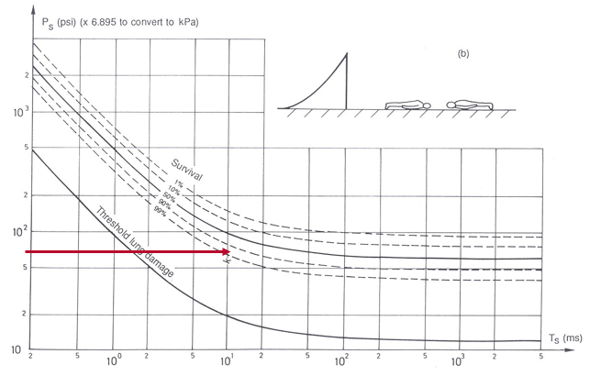
[3 marks].

b) If the individual were standing next to a reflecting surface, would you expect survivability to be better or worse, and why?

[2 marks]

- Describe 5 different shock waves that a submarine may experience from an underwater explosion. Assume the detonation is of sufficient strength to generate reflection from the sea floor and water surface.

[5 marks]

- a) An explosive comprises 50% TNT, 40% Ammonium Nitrate and 10% aluminium. Given the parameters described in the table below, and the equation provided, what is the theoretical detonation velocity of the mixture in km s⁻¹?

D_{i} TNT | 6.970 km s⁻¹
Di Al | 6.850 km s⁻¹
Di AN | 3.143 km s⁻¹
V_{i} | The volume fraction of component

$$D_{mix}=\sum{D_{i}V_{i}}$$

[3 marks]

b) If the theoretical density (ρ) of the composition is 1.65 g cm⁻¹, calculate the detonation pressure (P_{cj}) in GPa

$P_{cj}≅$ $\frac{ρD_{mix}^{2}}{4}$

[2 marks]

- Describe 5 factors that would influence the penetration of a shaped charge in a semi-infinite armoured plate of RHA.

[5 marks]

- a) Describe the mechanical properties required of a cased munition and its explosive to produce blast as the primary lethal mechanism.

[3 marks]

b) What type of fragmentation may a designer choose for a hand grenade, where each fragment provides similar lethality at close range?

[2 marks]

SECTION B
ANSWER 2 OUT OF 3 QUESTONS IN THIS SECTION

- a) From the diagram and data below, calculate the initial fragmentation velocity (V_{o}) and beam angle for a static cylindrical warhead detonated from the centre.

$ρ=\frac{m}{v}$ Relationship between density, mass and volume

$πr^{2}l$ Equation to describe the volume of a cylinder
$V_{o}=\sqrt{2E}{\left(\frac{M}{C}+0.5\right)}^{-0.5}$Gurney Equation for a Cylinder

$θ=\sin^{-1}\left\{\left(V_{o}\cos{∝}\right)/2D\right\}$ Equation to determine Taylor Angle

Case material density (steel) | 7850 kg m⁻³
Explosive density | 1890 kg m⁻³
Gurney Constant $\sqrt{2E}$ | 2860 ms⁻¹
Initial fragment velocity V_{o} | What you must calculate in ms⁻¹
Mass of case material M | What you must calculate in kg
Mass of explosive material C | What you must calculate in kg
Velocity of detonation of explosive D | 6840 ms⁻¹

[25 marks]

b). If we assume that the warhead has detonated at sea level (density of air 1.225 kg m⁻³) and each steel fragment is a cube of dimensions (10 x 10 x 10 mm) with a drag coefficient of 1.6, will a fragment defeat a target with a kinetic energy density of 100 J mm⁻² at 30 metres? You should use the following equation as a start point, where:
Vs = slant range [m]
Cd = drag coefficient
ρ_{air} = density of air at given altitude [kg m⁻³]
A = cross-sectional area of fragment [m²]
S = slant range [m]
m = mass of fragment [kg]

$$V_{s}=V_{0}e^{\left(\frac{-C_{d}ρ_{air}AS}{2m}\right)}$$

Note: you are expected to know the equation for kinetic energy density at Level 6.

- a) In relation to a kinetic energy projectile (such as a bullet or a long rod penetrator), describe the following velocity regimes that would apply to their use. Your answer should include the primary mode of penetration in both case

- Sub-hydrodynamic
- Hydrodynamic

[6 marks]

b) Draw a graphical representation of Penetration vs Velocity for these regimes, explaining why velocities between 800 ms⁻¹ and 1200 ms⁻¹ should be avoided by the designer for a long rod penetrator.

[6 marks]

c) Explain the optimum criteria that should apply in the design of a long rod penetrator. Your answer should demonstrate an understanding of the role of purpose of the discarding sabot, target material properties, penetrator material properties, adiabatic shear, strain rate, angle of attack, the effects of yaw, the shape of the penetrator’s nose and types of material would afford the best design.

[20 marks]

d) For an armoured platform, what could the designer consider in terms of countermeasures against a long rod penetrator?

[3 marks]

- a) Discuss the most suitable types of propellant you would design for the following applications, including their composition and method of ignition. Justify your choices in terms of calorimetric value, highlighting any additives that may be required to support performance and prolong barrel life:

- To defeat a main battle tank using a long rod penetrator
[15 marks]

- To propel a 7.62 mm sniper’s bullet with increased accuracy and range
[5 marks]

- To propel 4.5” naval ammunition over long ranges, whilst keeping muzzle flash to a minimum.
[10 marks]

(b) Describe the principal differences of regressive, neutral and progressive burning, providing an example of the shape of a propellant grain to support your argument:

[5 marks]

Diwedd/End

