

Task 1 – Reading Task Template
Upload your photo of your A3 in-class notes here:
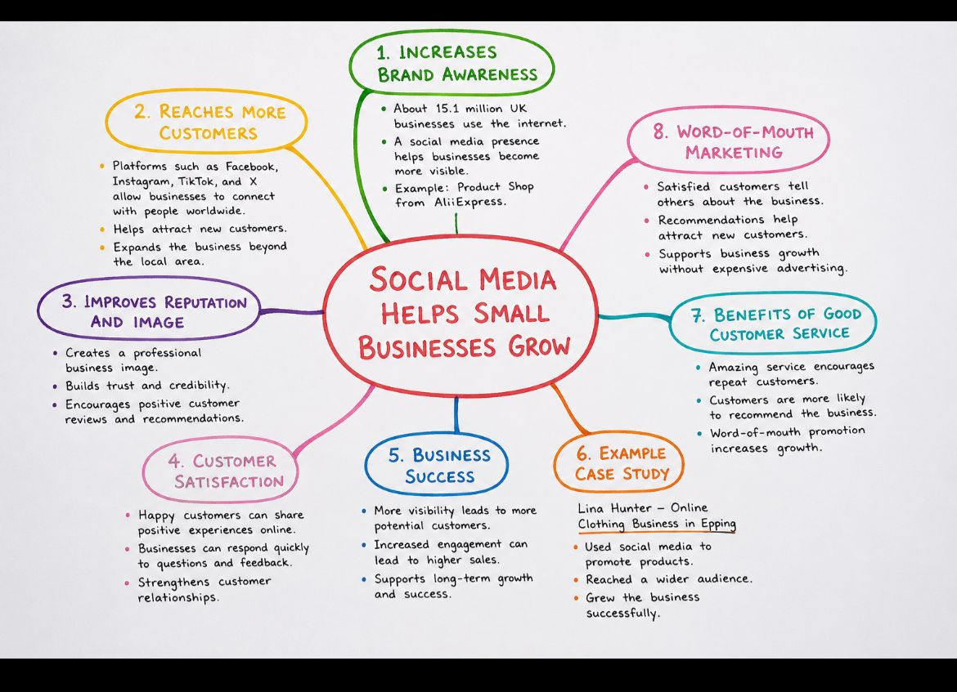

1. Answer these questions using the sentence starters below
a. What is the main idea of the text?
The main idea is that social media social media helps small businesses grow by increasing awareness, attracting customers, and improving customer relationships.
b. What are two key points?
One key point is that social media helps businesses reach more customers through platforms such as , facebook, instragram and tiktok.
Another key point is that social media improves a bussiness’s reputation and image by building trust and encouraging positive reviews.
c. What part of the text did you find most important? Why?
The most important part is reaching more customers because attracting new customers helps a business grow and increase sales.
d. Was anything unclear or difficult to understand?
I was not sure about the statistic showing how man tuk businesses use the internet and where it came from.
e. How did your group help you understand the text better?
My group helped me by discussing the key ideas and explaining how social media benefits small businesses.
3. One sentence reflection
Question: What did you find challenging about this task?
The hardest part was choosing the most important information from the mind map and putting it int complete sentences.

