Boycho Nikolov
Student ID: 2115531

Data Analysis & Visualisation (ACCB4002_LON)
Assessment 1 Database Analysis and Design
Module code: ACCB4002
Boycho Nikolov
2115531@student.uwtsd.ac.uk

Table of Contents
Introduction: 2
Task 1: 3
1: Identifying the message: 5
2: Assess the way colour is used 5
3: Assess the way text is used 5
4: Assess the suitability of the graph 5
5: Assess the way graphics are incorporated 6
6: Cognition (is it suitable for the user) 6
7: Improving the infographic 6
Conclusion: 7
Bibliography 8

Introduction:

In this report will be explain how the skills was improved during to the course.
The report Will show how is develop the knowledge and skills required to perform basic statistical analysis.
It will be reported few techniques and how to use and display different types of data effectively, data presentations for static and interactive displays.
Infographics is a way to learn and demonstrate an ability to represent data, to extract information from it.

Task 1:
A poster was given to analyse, is include any particularly good features, any problems that was identified and ideas for improving the design.
In next report the following aspects of visualisation design will be discussed to describe what we learn during the course.

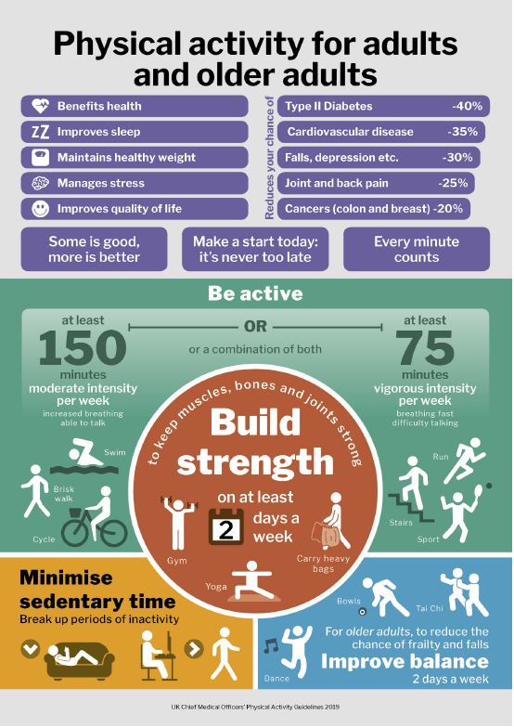

1: Identifying the message:
The main purpose of Information graphics also called infographics, are to take visual information, data, or knowledge. These types of graphics represent complex information in quick way and clearly.
Infographics are popular because they can illustrate a huge amount of information successfully, with visual elements that could make attention, easy to understand. [1]
In this poster the information is given in good order ad we could understand the main message and data in proper and easy to assimilate way.
It’s about the Physical activity for adults and activities to prevent from disease.

2: Assess the way colour is used

The colours used in every presentation or visual tools, such as Infographic is power way to impact to the authority.
Colour has an important role in graphic design, i.e., to emphasize the purpose of the message, to make differences of the messages each other, and also such as decorative part of the infographic. However, the use of colour is recognized as an important component of creating an infographic. [2]
In this poster was used soft and warm colours associated with health.

3: Assess the way text is used
The text used to display information in this poster at the header is useful and very well oriented, however at the bottom it’s little bit too much information in one place.
At the bottom in Blue of the poster are suited too much information with small size of the text, is not the best way to target the audience.
However, in the Orange is simple and easy to understand.

4: Assess the suitability of the graph
The graph is well presented with big size of the numbers, but the main information of this Infographics is lost somewhere into the poster.
It’s supposed to be the main information and accent of this poster.
It could be used some pictures and specific sport.

5: Assess the way graphics are incorporated

Using the lines and shapes in Infographics is a way to touch more target.
In this poster the line and shapes are very good suited, with able lines and nicely to еyes.
However, the white colour for lines between different parts of the poster it’s not the suitable.
For health more suitable is green colour or red.

The position of passage is verry well designed with pleasure shapes.

6: Cognition (is it suitable for the user)
Statistical Cognition (SC) is the study of how people understand or, quite often, misunderstand statistics or presentations.
The question answered below Is what way is better to report results, with numbers, or graphs? [3]
In this poster is not the best represented with the gaffs, the numbers are more likely to make harder to take information from this poster.

7: Improving the infographic

In my opinion, in this poster could be simple and accent to be into healthy activities,
In combination with happy faces from real persons.
It could be aimed specific target group of people by ages foe example.

More smile and happy faces are always nice idea and useful.
important part of the Infographics is to be clear for whom is targeted. Visuals that are created for educated audience can make the research much more understandable for the audience.
Providing context and removing technical words, could ensure that information is easy to get and understand. [4]

Conclusion:
In conclusion, the main target is aimed, the data was extracted a displayed in the proper way.
The combination of text, images, and visual techniques strongly make this a proper way to Target a huge number of peoples. [5]

Infographics are a useful and modern way of communication with great future for making information more accessible to the general public.

Bibliography

[1] | “https://msktc.org/,” Department of Education, [Online]. Available: https://msktc.org/lib/docs/KT_Toolkit/MSKTC_KT_Tool_Infographics_508.pdf.
[2] | A. D. &. W. Swasty, “semanticscholar.org,” School of Creative Industries, Telkom University, 2019. [Online]. Available: https://pdfs.semanticscholar.org/cdd2/efafbb108978de7dc6fd2a7803c7b830a25c.pdf.
[3] | F. F. G. C. Ruth Beyth-Marom, “https://www.semanticscholar.org/,” 2008. [Online]. Available: https://www.semanticscholar.org/paper/Statistical-Cognition%3A-Towards-Evidence-Based-in-Beyth-Marom-Fidler/dab3f6246beb6e42e29dab81a0428e2b058d905d?p2df.
[4] | A. D. M. S. J. W. C. W. O. A. W. M. A. H. R. W. S. I. R. Murray, “boneandjoint.org.uk,” 7 november 2017. [Online]. Available: https://doi.org/10.1302/2046-3758.611.BJR-2017-0313.
[5] | U. M. J, “https://www.ncbi.nlm.nih.gov/,” May 2016. [Online]. Available: https://www.ncbi.nlm.nih.gov/pmc/articles/PMC4920488/.

