University of Wales Trinity Saint David
Application Development (ACCA5012) – Kemi Ademoye
Assignment 2- Games report
Jack Partridge - 1702918
April 16st, 2019
Contents
Introduction 1
Application Development Concepts 1
Requirements section 1
Design 2
Implementation 2
Evaluation 2
References 2

Introduction
Within this report I shall be going over different various software design patterns used within Application development and how each one has diverse advantages & disadvantages. I shall be demonstrating my chosen application software I had built and instructions on how to play the game along with the goal/challenges the user may face in order to progress through levels and achieve a reward. Within the reports evaluation section I will talk about future improvements and the tests done to see if the features worked or needed fixing.

Application Development Concepts

Security vulnerabilities
The importance of security vulnerabilities associated with Games Development is essential as it helps keeping the user’s private information and payment details in tacked. Since the video game industry is so large with constant increment of players rising daily it’s so important for technology to keep a secure wall around the players that play these games and especially with online gaming.
At wepc.com/ you can find a lot of useful stats to help show how large the game industry really is and how much of an impact it has on the world.
With software, hardware and more consistently advancing so will the security problems along with technology. What user’s need to avoid within games development is important and here is a list of some problems that users may face with my application software or other software application.
Ransomware: A form of malware that will essentially disable the user from editing or accessing files until the attacker receives ransom such as payment. This problem is less known within gaming due to user’s data being saved via the cloud but if the data is locally then a fix would be a decryption key or tool to recover files.
Password stealers/keyloggers: User(s) passwords can get stolen here is using spyware (harmful code) to track keyboard presses in order to steal credentials and gain access to accounts with private information. This is the most common form of attack for victims and can be done via a social chatroom with a fake link from the attacker pretending to be friendly by getting you to download the spyware. Prevention for this is that you should not click or download anything remotely suspicious from random users.
Phishing: The most common way for data to get stolen is by simulating a website’s homepage or domain name and changing 1 or two letters to trick the victim into inputting details that the attacker then holds in a database to access at any point. If Game applications have websites and attacks will replicate to gain account access and in order to stop this the user must be ensured that they are on the correct corresponding website. A useful tip is ensuring the website has https:// to know it’s secure! [1]

Design patterns
For software engineering, a template or brief description for how a problem can be solved is repeated and this is called a design pattern. Upon implementation it can speed up the process of application development and is a very effective means for software design.
Many different types of design patterns are out there to help aid in time and solutions. [2]
Abstract factory design pattern is one I like that will allow an interface without specifying their concrete classes. With in my application development I could use the pattern to allow for a model change such as the colour or player model for my desired application platform. The advantages are that the new operator is harmful, no need to specify concrete classes and a hierarchy that encapsulates. Disadvantage will be that for the application to be portable it will need to encapsulate platform dependencies such as database or operating systems. [3]

Requirements section

How to play!
A game designed for younger ages (5-13) with a Low Poly art style playable on platforms Android, PC & MAC.
RabbitRun, you play as Ronnie the rabbit with a singular goal of essentially dodging fences that are obstacles in order to escape the mean hungry Fred the fox that chases you through gardens whilst collecting crunchy carrots to feed yourself. Using the key ‘A’ & ‘D’ keys to navigate left & right Ronnie must dodge the fences to avoid being caught by Fred. You can use ‘spacebar’ in order to jump over a fence, but this can mean missing out on collecting the carrots. The more carrots collected the higher the score will become. In order to get to the next “garden” Ronnie must reach the end without falling off the side or feeding Fred by getting caught on a fence.
As Ronnie progresses through the day(s) the gardens get more difficult with weather impacting the environment in which Ronnie can see the fences and carrots. The carrots too will begin to move meaning less carrots will be collected as Ronnie advances.
Carrots are a means of payment that can be used in a shop to customise your rabbits view in the future. These features will involve colour of Ronnie along with accessories such as hats that the player can buy.
A hidden key feature is that if Ronnie falls off, I will add it so that you can spend carrots to rewind and continue the chase where you left off.

Design
A pattern of levels such as the gardens that increment difficulty over time with the player repeatedly doing the same thing throughout the gardens. Finding a balance for the player to feel accomplished even though all carrots might not be gathered in that set level.
The movement is there to feel simple with just limited controls for the player to focus on just simple gameplay over confusing controls that may take time to learn.
For graphic, i’ve scaled the models to fit that of a real looking garden to get the user to feel as if when Ronnie is being played, he is small and must run from a rather large Fred the Fox all in a lowpoly art style to account for low end devices.

Implementation
Back-and-forth-Used for carrots or object to move left and right direction (X axis).
Button Manager-Script used to manage the main menu and pause menu buttons throughout scenes.
Carrot Pickup-Simple script to count the carrots picked up throughout the gardens.
Fade-in-Used for the splash screen upon starting the game.
Follow Player-Used on the camera to get a modular change for view along with the fox’s position from the rabbit.
Game Manager-The main script that is accountable for a lot of the game’s features.
Player Collision-To manage Ronnie’s collision events that occur in the game.
Player Movement-Navigation controls for Ronnie to avoid obstacles.
Rotate Object-A script to rotate object to add more movement in the game.
Time Body-Manage Ronnie’s transform for if he falls off and would like to essentially rewind time.
Up-and-Down-The same as Back-and-Forth but to move on the Y axis.

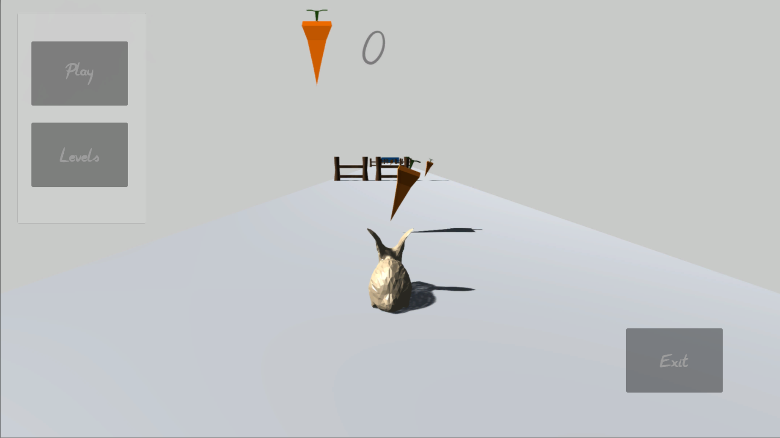

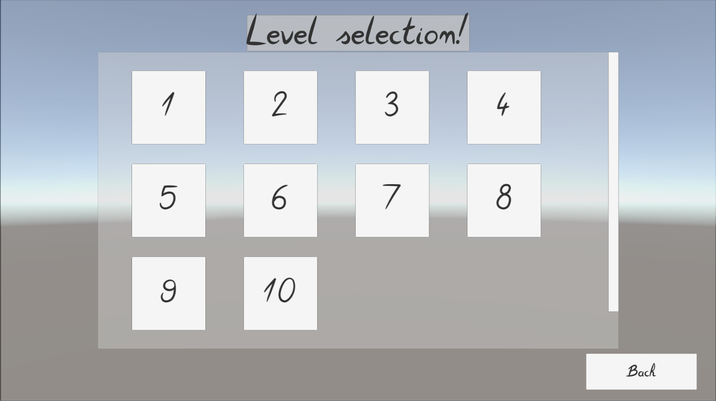

Evaluation
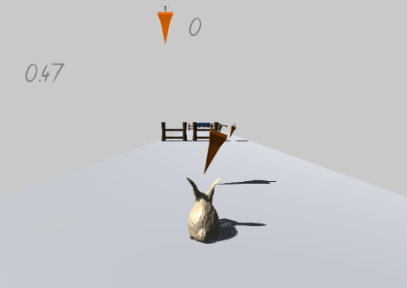
To ensure the software verification and validation I shall be conducting test to for go if the software development features or requirements work.
Test 1. Play testing it on a SamsungA3 6 to see if the game will be able to run and at a playable state. Installing of .apk was easy and with the screen resolution of 720x1280 pixels the main menu picture and button text had turned white, but the game ran and was at a playable state.
Test 2. Rewinding using the TimeBody script it worked but the timer for the game would continue along with the fact the user can go right back to the start if wanted to.
Test 3. Level progression along with the game features and playability on the platform PC. When testing levels, carrot collecting, barriers and more they all worked along with button navigation and the core gameplay features. The game is that at a playable state but has some work to get it near finish and where it is expected to go to.

Conclude
To conclude my application is designed what was intended, kid friendly using a simple art style, limited material colours and a design of that for low end and cost-efficient devices. The look is basic and is intended to be simple for young minds. The player’s experience should be quick and easy to get rewarded when playing and the game is intended to pick up and play quickly. Limited content as far as game’s detail goes with only a short storyline and slight player customisation to the player model.

Future development
With more time to spend on the development I can crack the game down into a fun, enjoyable and playable stage that will allow the user to change Ronnie’s colour, clothes and even more! Along side this I can add a carrot economy when the user can collect carrots throughout the game’s gardens to purchase said items/character options.
I’d also like to include harder levels and refine the small details such as a more thought-out colour scheme, models, game features and more bug free environment for the player.

References

[1] | Support, “Pickaweb,” 28 June 2018. [Online]. Available: https://www.pickaweb.co.uk/kb/what-is-https/. [Accessed 6 April 2019].
[2] | A. shvets, “Dive into design patterns,” in Dive into design patterns demo version, 2019, pp. 1-45.
[3] | “sourcemaking,” [Online]. Available: https://sourcemaking.com/design_patterns/abstract_factory.

Asset Refferences
Low Poly Rabbit Model
https://www.turbosquid.com/FullPreview/Index.cfm/ID/1235028
Royalty free game music
https://www.dl-sounds.com/royalty-free/off-limits/
Low Poly fox Model
https://www.turbosquid.com/3d-models/3d-model-fox-rigged-1382014
Apple bite sound effect
http://soundbible.com/1968-Apple-Bite.html
The fences & carrots were modelled using 3ds Max by myself.

