

BA Business Management
Data Handling and Business Intelligence
Assignment 2

Lecturer : Dr Sadeque Shaikh
Module code: LCBB5000
Student: Emanuel-Georgian Puiu
Student ID: 2130778
Table of Contents
Introduction 3
Section One 4
Part A 4
Part B 5
Part C 7
Section Two 14
Advantages of Excel 14
Disadvantages of Excel 14
Meaning of Data Mining Cycle 15
Importance of the process 15
Conclusion 17
References 18

Introduction
The following report would present the use of Excel and SPSS to explore the information and analyse it effectively. The report will cover the core aspect associated with the utilisation of Excel along with various formulas available. The data set ‘USA Housing’ would be used for the report to analyse the information. The core formulas for statistical analysis would be provided in the report. Moreover, the report will also use the pivot chart to showcase the information more effectively along with the process of using the pivot chart. Furthermore, the correlation and scatter plot would be prepared to showcase the core statistical functions in Excel. Moreover, advantages and disadvantages of excel along with importance of data mining cycle would also be showcased in the report.

Section One

Part A
The data set provided ‘USA Housing’ could be analysed using the Excel and various functions available in Excel. Certain basic formulas could be used to showcase the statistical aspects of the information (Remenyi et al., 2022). Various different functions and formulas could be used to meet all the requirements of the task. In the first part, key statistical components of the data would be computed using formulas.
Mean value for price | 553062.9
Median value for price | 460000
Mode value for price | 0
Standard deviation for number of bedrooms | 0.90383

Mean of the Price: The mean could be computed in Excel using the =AVERAGE formula and selecting the cells of the data set which is of the pricing information.
Median of the Price: The median could be computed in Excel using the =MEDIAN formula and selecting the cells of the data set with is of the price of the house (Salkind and Frey, 2021).
Mode the Price: The mode could be computed in Excel using the =MODE.SNGL formula and selecting the cells of the data set containing price.
Standard Deviation for Number of Bedrooms: The standard deviation could be computed in Excel using the =STDEV.P formula and selecting the cells of the data set based on the number of bedrooms.
Computing the Variance of the Variables
Variables | Variance
Price | 340607582293.28
Bedrooms | 0.82
Bathrooms | 0.62
Sqft_living | 916549.61
Sqft_lot | 1286836608.51
Floors | 0.29
Sqft_above | 741801.36
Sqft_basement | 215568.12

Computing the Standard Deviation of Variables
Variables | Standard Deviation
Price | 583615.95
Bedrooms | 0.90
Bathrooms | 0.78
Sqft_living | 957.37
Sqft_lot | 35872.50
Floors | 0.53
Sqft_above | 861.28
Sqft_basement | 464.29

Interpretation of the Computation
The computation of the variance and standard deviation is showcased to gain insight into the fluctuations in the information and data in the population. Different variable were considered based on the data provided in the ‘USA Housing’. Various different metrics for the property was provided which could be used for analysed from a statistical standpoint (Anderson et al., 2020). Based on the computation, the highest variance and standard deviations were revealed in the computation. In order to compute variance, =VAR.P formula was used for each variable that could analysed. Similarly, the =STDEV.P was used to showcase the standard deviation for each variable present in the data set. In the data presented, in both regards price had the highest value due to such high fluctuation in the data. This implies there were major gaps in the data with higher fluctuations from other populations. Variables such as floors and bedrooms had lower values which implies the diversions were also low (Quirk, 2020). On the other hand, the price and measurements were much higher, but the measurement values were not even close to the price which resulted in the price having a higher variance and standard deviation.

Part B
The data showcased could be presented in a more comprehendible manner using certain functions in Excel. The user would be able to make the information more interactive and sort various values more effectively. Among those functions, Pivot Charts is a very reliable function which helps make the information more accessible in a large data set (Lindquist and Sulewski, 2020). The Pivot Chart could be used to make the information more linear and easier to sort. With sorting capabilities, the chart help visualise the information along with various interactive functions.

Pivot Charts
Step One
The first step requires the entire data set to be selected using Ctrl+Shift+Arrow Down followed by Ctrl+Shift+Arrow Right.
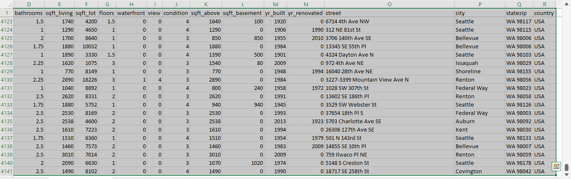
Step Two
After the data was selected, the Pivot Chart Function needs to be used which is located in the Insert Tab (Lindquist and Sulewski, 2024).
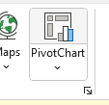
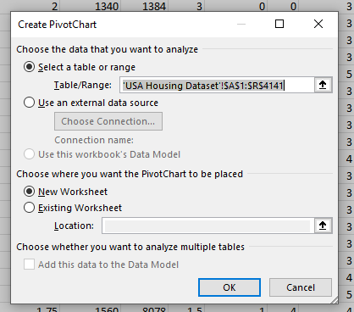

Step Three
After the options were provided, selecting the location of the chart and preferences would be required followed by pressing of OK.
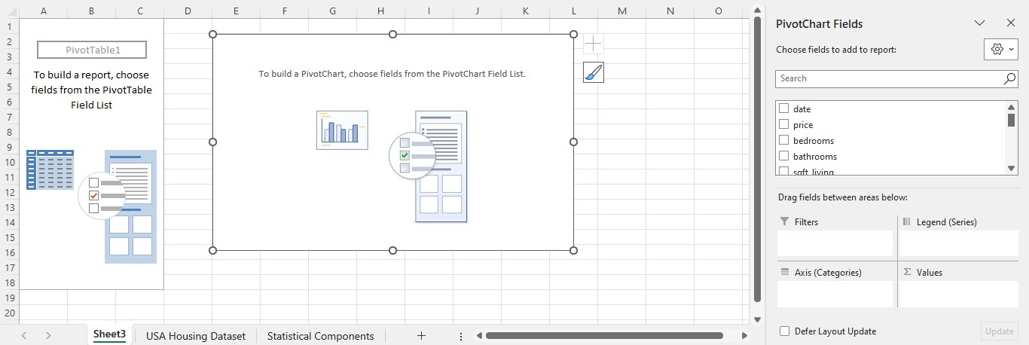
Step Four
As per the preference selected, the framework of the pivot chart would be prepared with all the variables in the data set in a new spreadsheet (Parlier and Lee, 2021). A filter would need to be selected with appropriate metrics.
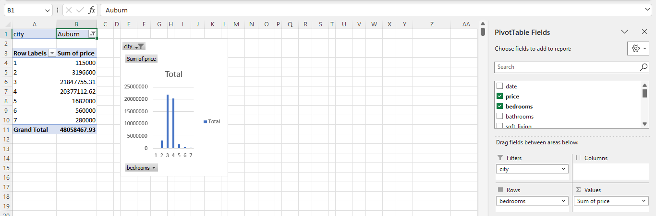

Part C
Explanation of the correlation coefficient
The process of correlation indicates the relationship between the two variables that are given. It is used to summarise the relationship into a single statistic which can range from -1 to +1. Clearly, this coefficient can be positive, negative or even 0, indicating the direction of this specific relationship (Taylor, 2024). A positive coefficient can imply that the variables tend to move together in the same direction whereas a negative number showcases that the variables move in opposite directions together. Additionally, a 0 coefficient shows that no relationship indicates among the given quantities, indicating that these are independent measures.

Significance of the coefficient
This element actually measures the strength and direction of the relationship between the given quantities (Corporatefinanceinstitute, 2024). However, it is different from causation as a strong correlation does not automatically imply that one of these variables causes the change in another one. Often, an underlying variable may be present that can act as the cause of both the quantities moving together.
Calculation of the correlation coefficient between price and number of bedrooms
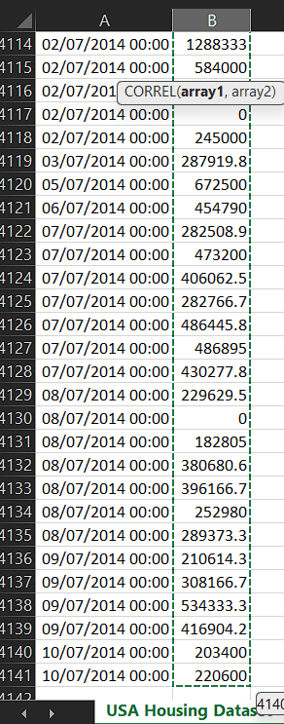

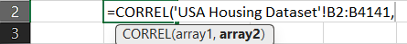
Step One
The Excel formula of CORREL () has been utilised here for this purpose that takes the two variables as inputs. In order to perform the computation, the worksheet of USA Housing Dataset has been selected from which all the values of the house prices have been selected as the first array.
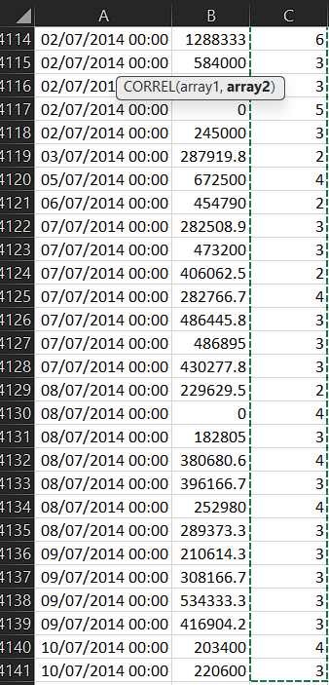
Step Two
In the place of the second array, all the values under the number of bedrooms have been entered as the input.
Correlation between house price and number of bedrooms | 0.188765142

Step Three
These two inputs together have determined the correlation coefficient using the formula of CORREL () that can be seen as 0.1887.
Interpretation of the coefficient value
The two elements that need to be considered in case of the coefficient value are the magnitude and the sign. It can be observed that the sign in this case is positive meaning that the price of the houses in the USA and the bedroom numbers tend to move together in the same direction. The house prices usually increase with the bedroom quantities as well as decrease in the same manner as evidenced by the positive coefficient (Yau, 2024). Still, the strength of the relation appears to be low at 0.18 which is far from 1, meaning that the association between those variables are not strong. This correlation therefore is very weak and no significant association between prices and bedrooms exist. This likely means that other independent variables such as view, square foot area and condition also need to be taken into account as these can have an effect on the price of the building.

Scatter plot of house prices and bedroom numbers
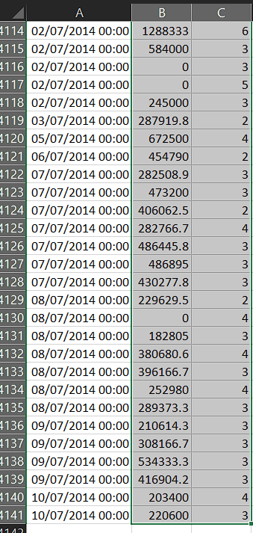
Step One
This process has been performed by selecting all the data of the price and bedrooms from the datasheet of USA Housing Prices.
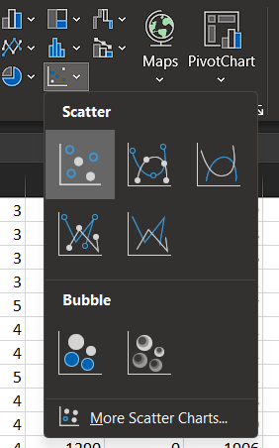
Step Two
A scatter diagram has been inserted in the MS Excel based on the above selected data.
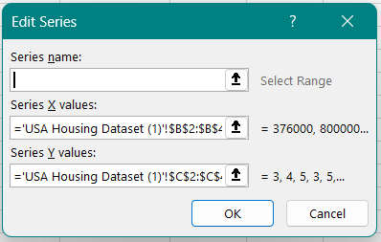
Step Three
In the scatter diagram showcased above, the price has been taken in the horizontal or the x axis whereas the bedrooms have been taken in the vertical axis or the y axis.
Step Four

After the axes are determined, all the price, bedroom pairs have been plotted on the graph as seen here. Further, the axis titles have been added to the newly formed chart to properly showcase the variables concerned.
Interpretation of the chart
The maximum amount of data is situated within the price range of $0 to $5,000,000 for the number of bedrooms ranging from 0 to 8. The buildings with just one-bedroom ranges comparatively lower in terms of prices which increases gradually for 2-, 3- and 4-bedroom scenarios (Corporatefinanceinstitute, 2024). Surprisingly, the houses with 5 to 8 bedrooms have a lower price band than the 4 rooms scenario, indicating that some other variables are at play here contributing to the same. It can also be seen that no clear trend is visible in this chart as a straight line, resulting in very little correlation between the concerned variables as evidenced by the coefficient value of 0.18.

Section Two

Advantages of Excel
There are numerous advantages of using excel that are described on the points below:
Visual representation of data- With the help of Excel, it becomes easier to create different types of charts and graphs which aids in the presentation of the data in an enhanced manner (Giraud, 2021). For example, with the help of presenting their data related to targeted demographics or conversion rates, a marketing team can highlight information more efficiently by presenting them in a bar or column graph.
Data management and organisation- When there is an availability of huge number of data, and each need to be recorded in a set, excel plays a crucial role. Small and medium sized business enterprise can keep the record of their employees or customers using an Excel spreadsheet where the information such as name and contact details are mentioned (Natter, 2024). This would aid the company to easily track the records and keep the information safe and get easy accessibility to check the past records.
Advanced data analysis- Another major advantage of Excel is that it can be used to analyse the data that are already presented in a set which are further utilised to predict and forecast planning. For an instance, a financial analyst can make use of excel to enter the trends of sales of the company and apply necessary formula to evaluate the change on the basis of which further predictions will be made.
Efficiency and automation- There are many automatic techniques available in Excel which streamlines the process of recording and calculating the data (Microsoft, 2024). With the help of this automation, the accountant can efficiently function the repetitive tasks and generate reports on a monthly or yearly basis. With this automatic method, it requires less effort to be implemented on these activities, and major focus can be provided to core functions.

Disadvantages of Excel
Issues in cooperation- One of the biggest drawbacks of Excel is that it lacks proper team cooperation and collaboration which can reduce the efficiency (Taylor, 2024). The problem rises even more when there are certain activities that need to be done together simultaneously and due to a lack of cooperative nature, the productivity efficiency declines.
Restricted visualisation of data- Although Excel can provide basic data visualisation opportunities, it still lacks in offering standard and better options of visual data presentation (Natter, 2024). This led to the utilisation of the same available charts and graphs every time which restricts the quality of presentation of look even better. There is certain analytics that require enhanced data visualisation, which cannot be done by using Excel which results in the interpretation of data being less attractive.
Restriction in expansion- Another significant disadvantage of excel is that it does not provide unlimited entries of data, but rather has certain limitations in it. For example, considering the fact that a multinational company needs to input millions of data in an Excel sheet, then it will not able to present the observations in a data set, leading to dissatisfaction of the user.
High chances of error- Considering the fact that excel is used by humans and all the data are input in the excel spreadsheet manually, there are high chances that errors could occur in some stages of the preparation (Microsoft, 2024). For an instance, if a wrong formula is applied for any calculation, then the overall result will be incorrect, depicting unrealistic evaluation of the viability of the information.

Meaning of Data Mining Cycle
The technological process that is used to identify the movements, algorithms and alterations from a huge set of data is known as data mining cycle. There are several components including in it with each having its own crucial significance and a few of them are data selection, pre-processing and transformation (Rotondo and Quilligan, 2020). The initial stage of data mining cycle includes data selection, where the required data are figured out from the sets and then collected. The stage where the collected data are analysed and altered for improving the results is the data pre-processing stage while data transformation stage could be elaborated as that stage where the observations are arranged for further evaluation.

Importance of the process
Helps in decision-making process- The major importance of data mining cycle is that it contributes efficiently in the decision-making process and improves it within a business organisation (IBM, 2024). With its feature where it efficiently aids in analysing the data set, data mining cycle provides opportunity to organisation to discover essential information required to make strategic decisions. One of the most important use of data mining cycle is that it aids business company to access the current trends and shift in the taste and preferences of the customers, on the basis of which they take necessary alteration decisions.
Enhances the quality of data- Considering the fact that the data mining cycle puts a strong emphasis on pre-processing of data, it ensures that the quality of the observations improves. This phase is important in data mining cycle as it determines that the inaccuracies, error or any inconsistencies are identified and cleared out which helps in providing accurate results without any mistake (Rotondo and Quilligan, 2020). In addition to this, the data mining cycle also ensures through this process that all the data are formatted in an efficient manner and complying to the necessary analytical techniques. With the better and improved quality of data, the business organisation can trust the results on the basis of which better and efficient strategies could be implemented.
Flexible and modifies to shifts- Another significant importance of data mining cycle is that it is flexible and nature provides opportunity to the business organisation to shift according to the change and modification in the marketplace. It is the feature of data mining cycle to analyse the alteration in the market condition whenever any latest data gets available and gets adaptable to new assessments (IBM, 2024). For being competitive in the highly dynamic marketplace it is essential for business organisation to be flexible and apply data mining cycle through which they can get information related to latest trend in the choice of the customers and other clients.

Conclusion
This specific study has showcased various data analysis methods to be applied on the given dataset of USA Housing Prices. It has calculated the central tendency measures for the prices of the houses as well as the dispersion measures of the given variables. This information has been properly analysed and the outcomes have been interpreted here. Moreover, the given data has been presented using the pivot charts function in the MS- Excel. The correlation between the price and bedrooms has been calculated here along with a scatterplot showcasing the relationship between the same. In the end, a theoretical discussion of the advantages and disadvantages of MS- Excel has been elaborated along with the meaning and significance of the Data Mining Cycle.

References
Anderson, D.R., Sweeney, D.J. and Williams, T.A., (2020). Essentials of modern business statistics with Microsoft Excel. Cengage Learning.
Corporatefinanceinstitute, (2024). R-Squared. [Online] Available at: https://corporatefinanceinstitute.com/resources/data-science/r-squared/ [Accessed 13 November 2024].
Giraud, C., (2021). Introduction to high-dimensional statistics. Chapman and Hall/CRC.
IBM, (2024). Data preparation in the mining process. [Online] Available at: https://www.ibm.com/docs/en/db2/11.1?topic=studio-data-preparation-in-mining-process [Accessed 13 November 2024].
Lindquist, J.M. and Sulewski, C.A., (2020). Microsoft Excel: The Universal Tool of Analysis. In Handbook of Military and Defense Operations Research (pp. 19-54). Chapman and Hall/CRC.
Lindquist, J.M. and Sulewski, C.A., (2024). Microsoft Excel. Handbook of Military and Defense Operations Research, p.21.
Microsoft, (2024). Using Access or Excel to manage your data. [Online] Available at: https://support.microsoft.com/en-us/office/using-access-or-excel-to-manage-your-data-09576147-47d1-4c6f-9312-e825227fcaea#:~:text=Excel%20is%20generally%20better%20for,the%20benefits%20of%20both%20programs. [Accessed 13 November 2024].
Natter, E., (2024). The Advantages & Disadvantages of Spreadsheets. [Online] Available at: https://smallbusiness.chron.com/advantages-disadvantages-spreadsheets-26551.html [Accessed 13 November 2024].
Parlier, J. and Lee, L., (2023). Inventory analytics: A teaching case using excel and Alteryx. Journal of Accounting Education, 63, p.100848.
Quirk, T.J., (2020). Excel 2019 for Educational and Psychological Statistics. Springer International Publishing.
Remenyi, D., Onofrei, G. and English, J., (2022). An introduction to statistics using Microsoft Excel. UJ Press.
Rotondo, A. and Quilligan, F., (2020). Evolution paths for knowledge discovery and data mining process models. SN Computer Science, 1(2), p.109.
Salkind, N.J. and Frey, B.B., (2021). Statistics for people who (think they) hate statistics: Using Microsoft Excel. Sage publications.
Taylor, S., (2024). Correlation. [Online] Available at: https://corporatefinanceinstitute.com/resources/data-science/correlation/ [Accessed 13 November 2024].
Yau, N., (2024). Visualize this: the FlowingData guide to design, visualization, and statistics. John Wiley & Sons.

