

BSc (Hons) Professional Police Practice

LEVEL 6 - 40 Credits

Workbook title: Competency Based Workbook 3 (PCDA)
8000 Words

(SOUTH WALES POLICE, GWENT POLICE AND UWTSD)

Learner name: _Matthew Hibbert_____________________________

Learner’s University Registration Number:
_2134291______________________________

FACULTY OF BUSINESS AND MANAGEMENT
PUBLIC SERVICE PROGRAMME

Module title: Professional Police Practice 3 (PCDA) BMPP6000D

Workbook Guidance

Please read these notes carefully; they provide essential information.

What is the workbook for?

The purpose of this workbook is to enable learners to demonstrate and provide evidence of how they meet the learning outcomes set by the College of Policing, for the BSc programme. Essentially, you are being asked to outline your experiential learning based upon your theoretical understanding in a range of operational situations.

- Understanding the Police Officer role
- Modern Professional Police Officer
- Strategic Role of the College of Policing
- Communication Skills
- Social Media
- Leadership and Team Working
- Leadership style
- Flexibility and Leadership Strategy
- Coaching
- Mentoring
- Professional and Organisational goals
- Assessment

You may wish to use the same incidents as you’ve outlined in the Occupational Competence Portfolio.

How should the workbook be presented?

Blank electronic copies can be found on Moodle of this workbook. You must submit this document electronically therefore it is important that you save your work regularly and upload the final typed version through Turnitin on Moodle.

Word count policy can be found in chapter 7 of the Academic Quality under section 7.7 (this applies to presenting work above and under the specified word count).

(https://www.uwtsd.ac.uk/media/uwtsd-website/content-assets/documents/academic-office/aqh-chapters/chapters---en/Chapter_07_Assessment_Taught_Programmes_Pages_72-79-UPDATED-05-11-2019.pdf)

Reflective practice is a core aspect for your workbooks and although there is a variety of useful resources on Moodle, there is one particular book, that is specifically based on reflective practice in policing, here is a link to one chapter from Selina Copley’s Reflective Practice for Policing Students:

https://moodle.uwtsd.ac.uk/pluginfile.php/298870/mod_resource/content/1/Reflective%20Practice%20for%20Policing%20Students%20-%20Selina%20Copley%20Chapter5.pdf

How is the workbook assessed?

Advice and support about the completion of this workbook was provided by university staff as part of your initial training day and further help and advice is available on Moodle.

Your tutor constable and in-force training staff will not be involved in assessing or marking your workbook after it has been submitted.

Dates of workbook submission will be made available and posted on Moodle.

Once submitted your workbook will be assessed and marked independently.

Confidentiality

It is important that no individual can be identified either directly or indirectly from the information in the workbook. Therefore, you must:

- adhere to guidance in the Student Handbook about unfair practice and plagiarism.
- not identify individuals including witnesses, victims or offenders by name.
- not write information that enables any individual to be identified indirectly through the description you provide. This includes references to names, colleagues, places (including hospitals, schools, town, villages, streets) specific incidents which were high profile and could be identified due to past publicity, other professionals or any other personal information including medical or other conditions;
- take personal responsibility for adhering to confidentiality rules.
- not include any dates of any incidents or anything that specifically identifies an actual incident.

Please be aware that any content that is deemed to be inappropriate, disrespectful, or abusive will not be tolerated. Following review of any content of this nature the information will be shared with the employer of the student responsible.

Should any health and wellbeing concerns be raised because of disclosures made by the student within this workbook, the employer of the student will be informed.

NOTE

Your workbook will be submitted electronically via Turnitin on Moodle. Guidance on this is in the Student Handbook.

Remember that the workbook is YOUR responsibility you must not rely on the assessor or anyone else to pick up any confidentiality breaches as this is your work and you must accept full responsibility for confidentiality. Meeting all the confidentiality requirements is very important.

Dyslexia and other special circumstances

If you have any condition that you feel may affect your ability to deal with any part of the programme, please see the Student Handbook for further guidance. The University has a Student Services Unit that may be able to help but it is the learner’s individual responsibility to contact them.

Guidance:

- Your workbook must contain the items specified in the table below (clearly identified and in the order given).
- You should use this document (electronically on Moodle) - insert your text / answer within each section of this workbook.
- You should upload your completed document as a saved pdf file of this workbook; if this is not possible then a Word Doc file is acceptable. Do not send a scanned file from a photocopier, an apple.dot file, or a Microsoft publisher file as Turnitin will not be able to assess them despite you being able to upload them.

Contents

Workbook | Area of Professional Practice | Word count
Task 1 | Understanding the Police Officer Role | 2000
Task 2 | Communication Skills – social media | 2000
Task 3 | Leadership and Team Working | 2000
Task 4 | Coaching, Mentoring, Assessment | 2000
 | Bibliography
 | Total | 8000

Task 1

Relevant areas of the National Policing Curriculum:
Understanding the Police Officer Role.

You must choose a policing incident in which you played a significant role with an offender/service user/victim and reflect on what happened.

Critically evaluate the strategic role of the College of Police in professionalising policing in the U.K.

Evidence how you are working to fulfil the role of a modern professional police officer now that you are in your final year of probation.

Critically reflect upon how your final year of probation has seen your role as a police officer change.

Consider the strategic Policing requirement, Policing Vision 2025, the Workforce Transformation 2018 and the College of Policing’s 5 Year Strategy.

2000 words (+/- 10%: include your actual word count at the end of each section)

ANSWER:

Introduction.
I am now on my third and final year of probation as a police officer. Having been a response police officer for the last 2 and a half years I have noticed myself developing and learning to be a competent and reliable police officer. During my 3 years of probation, I have learned a lot of new things regarding the role, whether this be from other colleagues, members of the public, the College of Policing or university work. Within this essay I will be evaluating the strategic role that the College of Policing has in the U.K within professional policing. I will also evidence what I am doing to fulfil the role of a modern-day professional police officer and will also reflect on how I feel my role as a police officer has changed now that I am on my final year of probation.

What is a modern professional police officer?
Modern day policing is as challenging as ever. A Police Federation for England and Wales survey in 2024 that was completed by 2,654 police leavers between 2017 and 2024 suggests that 73% of the leavers retired after reaching pension age, which is expected, however more than a quarter of the 2,654 participants resigned prior to pension age. The more common reasons as to why these officers resigned were due to factors such as low morale, poor job satisfaction, personal life impacts such as the toll that the job has on family life and staff shortages (Police federation England and Wales, 2024). A modern-day professional police officer has to adapt to challenges they are faced with, some of the challenges such as staff shortages and the personal life impacts that come with the job are often unavoidable, but some of the factors can be addressed and fixed such as having low morale. This can be dependent on various circumstances such as the team a person is on, a person’s perspective of the job and the department that the person is currently working in. A modern-day professional police officer can continue doing their job and make a positive impact in their communities whilst having these factors to deal with. There are plans and strategies in place to assist police officers with their day-to-day job, such as Policing Vision 2025 and The College of Policing Corporate Strategy 2022-2026.

The College of Policing.
The College of Policing is there to ensure police officers in England and Wales are professional and competent in their jobs. The College of Policing connects everyone working in the police to understand their challenges, it helps police officers by educating them on policing with standards, skills and capabilities. The College of Policing uses evidence-based knowledge in everything that they develop. (College of Policing, no date). The College of Policing is essential as it ensures all police officers in England and Wales are adequately trained in their profession to ensure that the communities they serve are provided with the best possible service. The College of Policing corporate strategy 2022-2026 describes a big part of the strategic role of the College of Policing.

The College of Policing Corporate Strategy 2022 – 2026.
In 2022 the College of Policing set out a corporate strategy that would span until 2026. This strategy describes the five strategic ambitions that the College of Policing has set for police forces to achieve. The first strategy being building trust and a promoting a fair culture, the second is transforming police leadership, the third is supporting career-long professional development and wellbeing, the fourth is boosting core skills and the fifth is strengthening innovation and implementing what works. These ambitions come hand in hand with the College of Policing’s three core functions which are to set standards, share knowledge and to share good practice as well as being able to support professional development (College of Policing, 2024).

The Strategic Policing Requirement.
In February 2023 the Strategic Policing Requirement was released and numerous topics were highlighted. These topics include violence against women and girls, terrorism, serious and organised crime, child sexual abuse, public disorder and civil emergencies. The Strategic Policing Requirement sets out the Home Secretary's view of what the current national threats are, and the national policing capabilities that are needed to counter those threats. (UK GOV, 2023). By ensuring I am up to date with competencies and learning packages, I will be able to attend calls with confidence gained from the learning opportunities that I have been given which will allow me to provide the best possible service for victims and the wider community. This is important as it will maintain the public’s faith in the police and will encourage the public to use the police when they are required and shows an insight that the police are professional in what they do.

Policing Vision 2025.
The Policing Vision 2025 is a plan for policing in the U.K for the next ten years, this vision began in November 2016. The Policing Vision 2025 considers that the communities that the police serve are increasingly diverse and complex which requires a more practical response to any challenges that are faced no matter how complex they may be. Ultimately, the goal for the Policing Vision 2025 is to make a transformative change across the whole of policing and to improve policing for the public. The Policing Vision 2025 will make changes through numerous different aims such as encouraging proactive, preventative policing rather than reactive policing. (NPCC, no date).

Reflection of an incident.
I will reflect upon an incident that I attended in my first few weeks in this job and my look on the incident now I am almost 3 years into this job. The incident occurred in the first few weeks of my probationary period where I was fresh out of initial training. It was during a school holiday period on a very warm day. Due to the weather and there being beach on my patch which attracts thousands of people each year, it was very busy. There were a lot of teenagers in the area, some of whom were causing anti-social behaviour. A grade one emergency response call came out over the police radio to this effect where a large group of teenagers were causing issues to local businesses near the beach. My tutor at the time and I arrived at the location and saw over 30 teenagers who instantly saw the blue lights of our police vehicle and immediately began to approach us in a relatively hostile manner. Due to me being new to the job, my tutor encouraged me to take the lead in dealing with this situation. Looking back, I can see that this helped me develop as it helped boost my core skills and supported career long professional development. I had never been in a situation like this, and I initially felt overwhelmed as I had numerous teenagers approaching me, asking me questions, shouting abuse and surrounding me. A business owner later approached me and stated that a teenager had threatened him with a brick. Due to the numbers of teenagers present, my tutor asked for further police officers to attend and assist. When the further police officers arrived at the scene, the crowd of teenagers got even more hostile towards police, however, due to the number of police officers present, they were easily manageable. As my colleagues assisted in the crowd control, I spoke to my tutor and my sergeant and outlined what the business owner had told me and came to the realisation that the offence of Affray under section 3 of the Public Order Act 1986 was identified as this teenager had threatened unlawful violence against the business owner which caused the business owner to fear for his own personal safety. I then obtained the best description of the suspect teenager and located him. I subsequently arrested him for Affray whilst the other police officers present assisted in dispersing the crowd. Although I knew what the offence was, I didn’t immediately recognise this, I believe this was due to my lack of experience and me being overwhelmed by the situation that I had been put in.
National decision-making model.
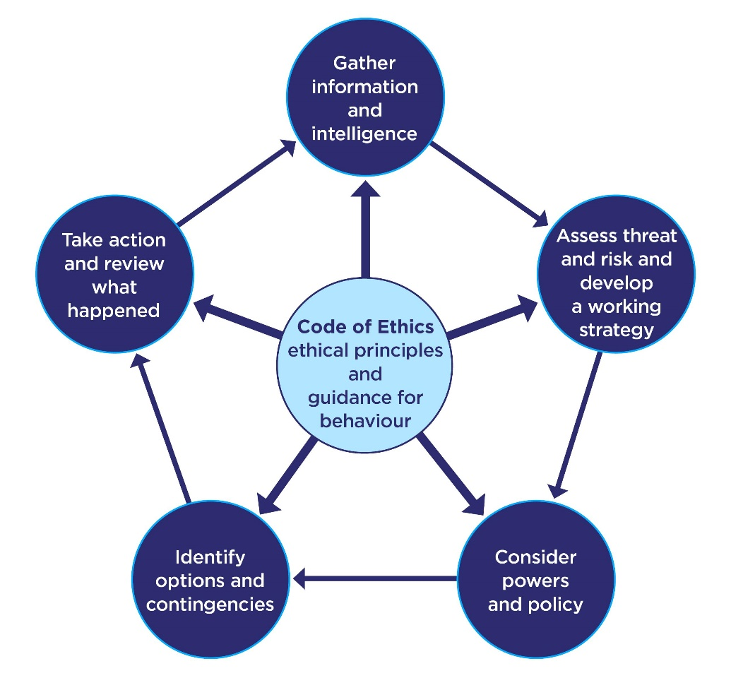
If I was put in that situation again, I would utilise the College of Policing National Decision-Making model (NDM). The National Decision-making model helps police officers at any call they attend. The NDM has six key elements, the code of ethics, gathering information and intelligence, assessing any threat and risk and developing working a working strategy, considering powers and policy available, identifying options and contingencies then acting and reviewing what happened. Each element provides the user with an area for focus and consideration. The element that binds the model together is the Code of Ethics at the centre. (College of Policing, 2013).

(College of Policing, 2013).

Reflection.
Upon reflection, if I were to attend that call now, after ‘spinning’ the national decision-making model wheel and noticing the large amount of people, I would immediately ask for additional officers to attend to assist with the crowd, as to me they were deemed to be a threat and a potential risk to themselves, other members of the public and even attending police officers. This was due to their demeanour and hostility when seeing police arrive at the scene. I would consider what powers and policy are available to use such as potentially arresting individuals committing offences or seeking other alternatives such as an out of court disposal such as restorative justice or an anti-social behaviour order. The options and contingencies that were available were to intervene straight away, which I did, however this could make the situation more hostile which it did. I would now wait for further units to arrive whilst monitoring the crowd from a distance, if an offence was being committed, I would intervene. When further units arrive, I would discuss with the other officers a plan. I would phone the reporting person and gather further information off them and speak to the potential victims before identifying the suspects. The crowd would be dispersed using tactical communications, if this didn’t work then a notice under section 35 of the Anti-Social behaviour act can be served instructing a person to leave the area for up to 48 hours otherwise, they could be arrested. The suspect(s) would be detained prior to them leaving the area. A review of the situation would be conducted before the national decision-making model is spun again.

Conclusion.
To conclude this essay, I believe over the past three years, I have developed significantly from an inexperienced police officer with low confidence to a more experienced police officer with a lot more confidence which I use to ensure that best possible outcome is obtained at every call that I attend. The strategic aims in place from the College of Policing and the U.K Government are efficiently working to train police officers to be competent and reliable for the communities that they serve. Police officers are highly trained with a high skill set and are capable with dealing any type of call that they are deployed too. The College of Policing ensures that the training standard is where it needs to be to support the Strategic Policing requirement, the College of Policing Corporate Strategy and any other strategies set by the Government or the College of Policing itself. Now that I am in my final role of my probationary period, I can see my role has changed, in particular with new police officers on my team. I have noticed that I am becoming one of the more experienced police officers on the team. I am often asked on how to do things and for advice in general. I have learned that policing is a job where you learn new things about the job near enough every day and there is always something new to learn. I am constantly working to fulfil the role of a modern professional police officer now that I am in my final year of probation. I try and book myself on to any course that can assist me in being a better and more efficient police officer and make sure to stay in date with my competencies including learning packages from the College of Policing.

2033 words.

Relevant areas of the National Policing Curriculum:
Communication Skills, social media, Communication Strategy

You must choose a policing incident in which you played a significant role with an offender/service user/victim and reflect on what happened.

Critically evaluate your experience of the use of social media as a means of informing and engaging with the community and promoting policy initiatives.

Consider the force policy on using social media for professional information and engagement purposes.
What social media platforms are used by policing?
What are the benefits and risks of using social media?

2000 words (+/- 10%: include your actual word count at the end of each section)

ANSWER:

Introduction.
Three billion people, roughly 40% of the world’s population, use online social media. People spend an average of two hours every day sharing, liking, tweeting and updating on these platforms. That breaks down to around half a million tweets and Snapchat photos shared every minute (Jessica Brown, 2018). Social media has a huge impact on modern day policing. Social media can be a great tool to assist police forces for numerous different reasons, however it can also be dangerous for police forces due to spread of misinformation. Within this essay I will evaluate my experiences with the use of social media within policing, I will consider the force policies on using social media for information and engagement purposes and will also look at the benefits and risks of social media.
What is social media?
The definition of social media as described by the dictionary of Cambridge is “websites and computer programs that allow people to communicate and share information, opinions, pictures, videos, etc. on the internet, especially social networking websites” (Cambridge Dictionary, no date).
Social media in policing.
Social media helps police constabularies across the U.K regularly to help find missing persons, locate/identify suspects, make travellers aware of any road closures that may disrupt travel time and share information messages that can be of use to people within the community. Platforms such as X (Twitter), Facebook, Instagram and even TikTok are used to engage with local communities. As these platforms are used by people of all ages, it ensures that there is a consistent target audience of all ages across all of the social media platforms. It is vital that all posts shared on social media by police forces are factual and have a purpose. Information being shared by police accounts on social media should be factual as this will build trust within the local and wider communities. If a wanted person has been arrested since the post was made, then it is very important that the post is deleted once the person is arrested. This is to prevent any spread of misinformation. This is also the same when it comes to missing persons and road closures. If a person see’s information shared by the police online through social media that is in fact not true, there is a chance that this could affect the persons trust in the police and could have an impact further down the line if the person needs to use or be in contact with the police. An effective use of social media for a policing purpose is to create posts alerting local residents of crimes that are taking place in the local area. For example, a post can be created to tell the residents to be vigilant as there have been a number of burglaries in the area recently, advice can also be passed to residents to ensure they lock their doors and close their windows as a preventative measure to combat to burglaries. A similar post was created in the area I police where cars parked on the street were subject to arson attacks by local youths. Numerous social media posts were made on several social media platforms asking residents to be vigilant and the suspect was located after a resident heard a noise outside her house in the early hours of the morning and remembered the social media posts from the police which prompted her to take a look at the window where the suspect was seen with equipment that would be used to start a fire.
Authorised Professional Practice – Engagement and communication.
In 2013 The College of Policing first published engagement and communication guidance, within this guidance is a media relations chapter which was published more recently and was last updated in 2022. The guidance is not directly linked to social media, however many of the points and headings in the guidance are very relevant to police forces using social media. The guidance is an authorised professional practice (APP). An APP outlines the actions everyone in policing need to take to ensure a consistent level of service is provided to the public (College of Policing, 2024). Within the media relations section of the engagement and community APP is direct guidance on how to deal with media as a whole, this APP is used by each force that uses social media as a guide on what can and what can’t be posted on social media. The first headline after the introduction to the guidance is the code of ethics and these ethics can be used when utilising social media. One of the code of ethics headings is confidentiality, where it says to access or disclose information only in the proper course of duties. For example, this could be justified when looking for a high-risk missing person, a post can be released on social media asking the public if there have been any sightings. There is a chance that the missing person may not want their photo being posted on social media, but it can be justified as the concern for them outweighs them not wanting a photograph on social media.
Leicestershire police released their social media guidance and policy that has been reviewed against the APP. Within their guidance it states that Leicestershire police’s main social media accounts are followed by over 300,000 people and the goal for their use of social media is to improve trust confidence and satisfaction within their communities, to achieve objectives and to make a positive change. Leicestershire police also state that their aims are to ensure the reputation of the force is not compromised by its staff on social media and that members of the force are not affected by the use of social media. (Leicestershire police, 2022).
How social media has helped me in policing.
There are several different incidents I have attended where social media has assisted me in carrying out my duties. Due to a social media requests, I have had a next of kin identified for sudden deaths I have attended where the deceased has had no family members or friends present, social media has also assisted me in locating missing people. The most notable use of social media within policing that has assisted me was it leading to a high priority suspect being found after a member of the public has phoned in sighting the suspect. The suspect had been wanted for 2-3 months for numerous domestic violence and drug related offences. He was actively evading the police and would continuously obtain new cars and stay in different addresses each night which deemed it extremely hard to locate him. I requested for a social media post to be created stating that the male was wanted and encouraged members of the public to get in contact should they sight the male. Due to the offences that the suspect was wanted for, it drew media attention causing the local news outlets to also create an appeal where they subsequently posted it on their respective social media platforms. A phone call was received into the police control room stating that the male had just checked into a hotel that the caller worked at. This immediately initiated officers to be deployed. The suspect was on high alert, and it transpired that the male was sat in another vehicle not known to the police, in the car park of the hotel. When police officers arrived at the hotel, the male started the car and evaded officers. A further social media appeal was made almost immediately after this incident asking for any dash cam footage from members of the public or any sightings of the vehicle involved. Another call was made into the police control room by a member of public stating that the vehicle was outside their house, seeming to be abandoned. Police officers attended this location and seized the vehicle and located crucial evidence within the car which gave officers the location of the suspect where he was then arrested and remanded into custody.
Negatives of social media within policing.
Although social media can be very useful for police officers for numerous reasons. It can also be very disruptive. Going back to the previous example, although the suspect was located, the suspect himself saw the social media posts and in anticipation of being arrested, had deleted everything to do with the offences he was wanted for off his electronic devices which put a lot of strain on the investigation as there was a substantial amount of evidence now lost. This is likely to happen with other suspects who have seen they are wanted online through social media. In this case, the positives outweighed the negatives as the suspect was very dangerous to police officers, the public and himself.
Misinformation and disinformation.
Another risk presented to police from social media is the spread of misinformation and even disinformation. Misinformation is fake news that is created and spread by a mistake – by someone who doesn’t realise that it’s false. On the other hand, disinformation is fake news that is created and spread deliberately – by someone who knows full well that it’s false. (BBC, no date). I have seen myself on social media platforms such as TikTok and Instagram videos of police officers being cropped or edited to make the police look malicious. This can have a huge knock-on effect to the viewers of the videos who do not know that they are viewing videos of misinformation or disinformation, as it perceives the polices reputation to be negative. An example of this was the Southport riots. Three young girls were tragically killed which resulted in a lot of misinformation and disinformation being spread online via social media and news outlets. This caused protests and in some place’s riots across the UK. Historic videos of riots in London were spread across social media which were actually from previous protests it was believed they were shared to mislead of to fuel tensions (BBC, 2024).
Crime in social media.
Since the introduction of social media, some offences have become more common. Blackmail (Section 21 of the Theft Act 1968) has a relatively new variant of the offence called ‘Sextortion’. ‘Sextortion' is a type of online blackmail. It's when criminals threaten to share sexual pictures, videos, or information about you unless you pay money or do something else you don’t want to (Metropolitan Police, no date). All of my experiences in dealing with victims of sextortion have been where the victim has been extorted through social media platforms such as Instagram or Snapchat by people who disguise themselves to be someone else. Other offences such as Stalking (Section 2a or 4a of the Protection from Harassment Act 1997) are also possible for criminals to commit via social media. Depending on a person’s security settings, they could be messaged by a completely unknown stranger through social media, or the person could be known to them and could be committing offences, such as stalking. It is important as a police officer to relay relevant safeguarding advice to victims of these offences, instructing victims to update their privacy settings and block certain accounts.
Conclusion.
In conclusion to this essay. Social media is a powerful tool that should be utilised by police officers and police constabularies across the U.K to help locate missing persons, find suspects, give useful information to local residents and be used as a reliable source of information. Officers should be wary of misinformation and disinformation being spread across social media which has potential to give police a bad name. It is important for police officers to educate the people who they engage with regarding social media, highlighting the dangers that can come with social media and also show the positives of it. Social media often shows or portrays police officers in a negative way it is very important that police officers engage with the public in a positive manner as this will impact a person’s outlook on the police rather than how police officers are perceived to be online. Police forces across the U.K must adhere to the relevant APP when it comes to social media as it is ever growing and becoming more and more popular each day.

2028 words.

Task 3

Relevant areas of the National Policing Curriculum:
Leadership and Teamworking

You must choose a policing incident in which you played a significant role with an offender/service user/victim and reflect on what happened.

Critically evaluate and evidence your flexibility in leadership style.

Critically analyse leadership strategies that you have developed to manage a range of different operational situations.

Consider leadership models commonly used in policing.
How were you able to apply a change in leadership style/strategy to reflect changing circumstances?

2000 words (+/- 10%: include your actual word count at the end of each section)

ANSWER:

Introduction.
Within this essay I will evaluate and evidence my flexibility in my leadership style, I will analyse leadership styles I have developed to manage a different range of operational situations, I will consider a leadership model commonly used in policing, and I will give an example where I was able to apply a change in leadership style to reflect changing circumstances.
Police officers should be able to show leadership within their role and it is important that police officers are in charge of the calls they are attending. This shows a positive look for the officers especially when it comes to public perception. If a police officer was attending a call in a busy city centre where someone was being aggressive, the public would rather see the police officers being in charge of the aggressive person rather than the aggressive person overruling the police officers.
National decision-making model.
When it comes to policing, I believe I show leadership. I take ownership and take the lead at calls I attend when it is required, if my colleague is taking the lead then I will take a step back and allow them to do so. I believe my situational awareness is very good and I understand people’s needs when attending calls. I know the difference on when to show empathy and when to show authority. A model that can be used as a leadership model is the National decision-making model (NDM). A police officer should always cycle through the national decision-making model to make appropriate decisions when attending calls. The college of policing’s code of ethics is at the centre of the national decision-making model and it is followed by a continuous cycle of gathering information and intelligence, assessing threat and risk and developing a working strategy, considering powers and policy, identifying options and contingencies and taking actions and reviewing what happened (College of Policing, 2013). I believe the national decision-making model is a good structure in leadership as it is an efficient and effective way to make justified and proportionate decisions.
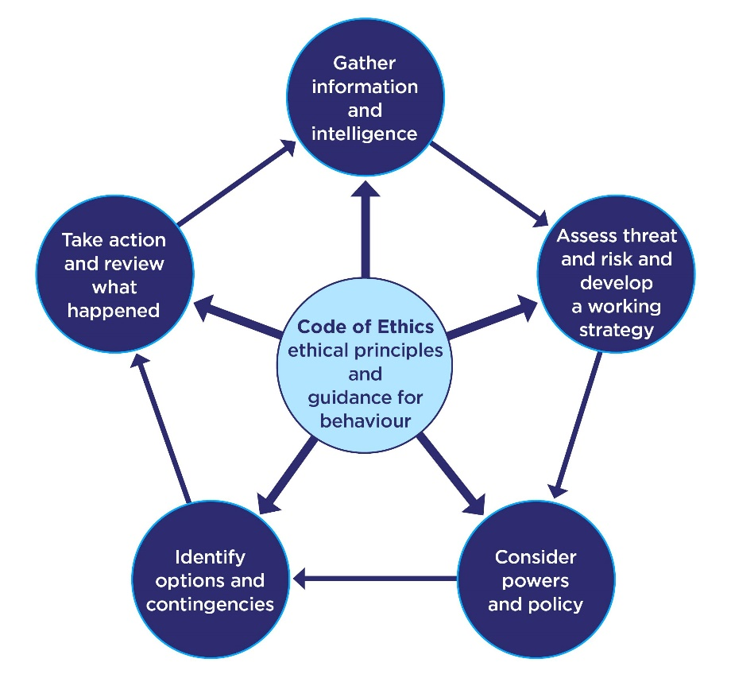
(College of policing, 2013).
Leadership styles.
There are numerous different leadership styles, and it generally is dependent on the type of person on what their leadership style is. All different leadership styles have positives and negatives. A police officer should have a wide variety of leadership styles and should be able to be flexible between each leadership style when it is appropriate to do so.
Transformational Leadership.
Transformational leadership can be very effective when working within policing as it can encourage people to make a positive change. “Transformational leadership is a leadership style that empowers people to accomplish positive change through big vision, inspiration, and a call to action. Leaders enable change by emotionally connecting with their audience and inspiring them to achieve something greater than themselves. By communicating a positive vision of the future, they motivate and encourage their followers to keep pushing forward. The end result is collective action that leads to innovation, massive transformation, and the betterment of society.” (C, Baker, 2023). This type of leadership style could benefit police officers greatly as it could encourage members of the public to do the right thing and could even prevent offenders from re-offending. Transformational leadership is one of the better leadership styles to use whilst someone is in a crisis. As a police officer, it is a regular occurrence to see someone in a crisis or with heightened emotions. A police officer who uses the transformational leadership style will motivate others which includes the members of public that they serve and will also fulfil their needs, this leadership style ensures that all reach their full potential.
Authoritative leadership.
“Authoritative leadership is strictly rules-based with a preference for order and a sometimes military-like approach” (Erik Fritsvold, no date). There are plenty of occasions in policing when people do not listen and leadership styles such as transformational leadership simply does not work, it could be due to numerous reasons such as a person being intoxicated or a person not liking police. Sometimes the military-like authoritative leadership style is required to pass information to people, for example the leadership style has to be more authoritative at a high-risk football game than it does at a missing person call.
Example of leadership within policing.
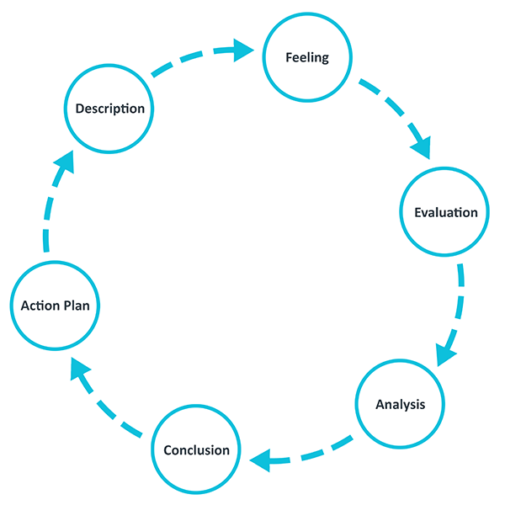
I will use the Gibbs model of reflection to analyse a call that I attended where I showed flexibility in leadership styles and how I was able to apply changes to my leadership styles. The Gibbs model of reflection assists in looking back on an incident, it was created by Graham Gibbs in 1988 to give a structure to learning from experiences.
(University of Edinburgh, 2024).
Description -
Using the Gibbs model of reflection to describe the experience, a call I recently attended involved a male who had taken his parents car without consent and had crashed it, leaving the car written off. At the time this information wasn’t known, and the call was just to conduct a welfare check on the registered owner of the vehicle as no one was present with the vehicle when it was found. The registered owner lived in a relatively rural area, however at the time there was no threat to officers presented and it was simply just a welfare check. Upon attendance to the address, the registered owner answered the door and invited us in. The owner stated that his son had taken class a drugs and had taken the car in what the son described to him to be an attempt to harm himself. I immediately showed empathy towards the father due to the circumstances. The father stated that he wanted his son arrested as the son had done this type of thing previously and is causing a lot of stress for his family so needed to be taught a lesson. I asked the father details about his son and was told he can be very aggressive, and he hates the police. The son was upstairs in the house sleeping, there was still concerns for the son as he had just been involved in a road traffic collision. I asked for further units to start making their way to the area as a precautionary measure just in case the son became aggressive. I asked the subjects mother what she believed the best way to get her son to come into custody peacefully was. She replied stating that she believes she could potentially calm him down and get him to come into the police vehicle compliantly. At this stage I was showing transformational leadership towards the parents as I was being positive about the situation, ensuring them that it will be dealt with in the most effective way possible and stated that this could be a turning point in their son’s life which makes him realise the strain he is putting his parents through. This gave the parents a different outlook on the situation and made them feel a lot more positive. I went upstairs with the mother and let her speak to her son whilst I stood out of the way. The son was clearly still intoxicated. Everything the mother was saying to the son would just result in the son hurling abuse back to her. I gave the son a few chances with his mother to come into police custody compliantly. The son would not come compliantly so after my colleague arrested him, we immediately had to use force to prevent any injuries to any parties involved. Tactical communications were utilised, and it was clearly stated that he was under arrest however he still continued resisting. My leadership style changed towards an authoritative leadership style. I told the son what was happening and there were no other options, however he continued resisting, I was stern and strict with him as he was not trustworthy, I told him what was going to happen and how it was going to happen. Once the male was in the van, a realisation had struck him with what was happening. I went back towards a transformational leadership style and offered to take his leg restraints off if he continued to stay calm, I showed empathy with him and stated that this may be a low point in his life, but it could go on to help him. Despite being assaulted by this male, a rapport was built with him due to talking about other subjects such as his job and hobbies. The male then compliantly went into custody without further disorder or incidents.
Feelings –
Whilst on my way to the call, I thought nothing of it. I thought the call would be a simple one and certainly did not expect what happened. Throughout the call, I felt safe as I was with my colleagues however my adrenaline was high. I still showed different types of leaderships despite being put under pressure and having a lot of adrenaline.
Evaluation –
To evaluate the incident, I believe although the call took a turn which could have been very dangerous it was always in control, this was due to many factors, including the flexibility of leadership styles. I was also constantly using the national decision-making model throughout the duration of the incident and was constantly cycling through each stage of it. Due to the subject being unpredictable, I was constantly re-evaluating the situation by keeping a close eye on him. I discussed with my colleagues the best working strategy and the powers, policies, options and contingencies available. One of the options available was to use legs restraints to prevent him from harming officers and family members present, this was justified by cycling through the national decision-making model and the leg restraints were put on him.
Analysis –
The leadership styles presented to the subject were effective, I do not believe a change in the style would affect the subject’s behaviour. I do believe that I have developed different leadership styles such as transformational and authoritative for different situations that are presented to me. Due to the different traits that I have developed whilst being a police officer, I am learning what situations are best to use certain leadership styles.
Conclusion –
From the situation, I learned that leadership styles make a difference when attending calls, no matter how simple I think they will be. By using traits such as emotional intelligence, it allows me to adapt to whatever leadership style is necessary.
Action plan –
If I were to deal with the incident again, I would do things very similar, however would show the directive leadership approach sooner and would not let the subjects mother go to him first. There were several risks to this, such as the son becoming aggressive to his mother as he was very unpredictable.
The College of Policing.
The College of Policing has a leadership standard programme where it has a commitment to change the future of police leadership. Within the commitment the college is supporting leaders to build trust, improve performance and protect the public. The expectation will be set for all police officers to uphold the code of ethics, which is also a part of the National Decision-making model, contribute to an inclusive workplace culture and challenge any unprofessional actions. The College of policing’s CEO, Chief constable Andy Marsh states that all ranks within the police are leaders and that leaders must expect to manage wellbeing and support, continue professional development and apply problem-solving approaches in the workplace, the standards set will cover, problem solving, effective communication, decision-making skills, leading high performing teams, team wellbeing, resilience and to challenge unacceptable behaviour (College of Policing, 2023). This programme is crucial to allow for police officers to develop different leadership styles.
Conclusion.
To conclude this essay, as stated by the College of Policing. All police officers must display leadership in particular the styles that are listed in the College of Policing leadership standard. This is to ensure calls attended by police officers are done in a safe manner where the national decision-making model can be utilised to make effective decisions that will have a positive impact on communities served by police officers. All police officers must be aware of leadership styles and should be able to adapt to whatever leadership style is required for the situation they are put in.

2047 words.

Task 4

Relevant areas of the National Policing Curriculum:
Coaching, Mentoring, Assessment

Critically reflect upon your three-year probation:

How have you benefited from mentoring and coaching?
How has it helped you to meet personal, professional and organisational goals?
How has it aided you to learn, develop and perform in the workplace?

Consider relevant coaching and mentoring definitions along with current coaching and mentoring theories used in policing.

How do you provide and receive feedback?

2000 words (+/- 10%: include your actual word count at the end of each section)

ANSWER:

Introduction.
Over the past 3 years of me being a police officer I believe I have developed at a steady and healthy pace. I joined the job not knowing anything about policing and had no background with policing. None of my family members are police officers and I did not know any police officers, I entered the job not knowing what to expect. In the first few months of me being a police officer in my probation, I struggled for numerous reasons, I didn’t have a healthy relationship with my tutor due to us have two completely different personalities and not being able to relate with each other. I initially failed my tutorship and thought that being a police officer was not for me. I then however had a new tutor who changed my perspective of policing completely. The tutor coached me into becoming an independent police officer, he understood who I was and the best methods to teach me the job. I learned that my original tutor didn’t enjoy the job role within the police that he was doing, which had a huge negative effect on me. My new tutor was motivated and was willing to commit time to help me learn and I matched this energy which made me feel like I was in a completely new job. Since passing my tutorship and becoming an independent police officer, I have seen the role of being a police officer in a new light and have matured into the role. I am constantly being mentored and coached by more experienced members on my team, my supervisors and even newer in-service officers who are knowledgeable with specific topics. It is important to be open to learn from anyone who is willing to help as that promotes a healthy team culture which makes the workplace a nicer place to be.
The difference between coaching and mentoring.
Coaching and mentoring are very similar to each other, but both have distinct differences. Coaching is regularly used to focus on certain goals that are set by an individual. Guidance and feedback are then given by a coach to improve how an individual performs. Coaching can be seen as a more short-term method of improving a person’s performance. Mentoring on the other hand is more of a long-term solution. A mentor shares knowledge and experience to guide their mentee which will develop personal and professional growth (Matt Mundey, 2023).
Below is a Venn diagram that shows the similarities and differences between mentoring and coaching.
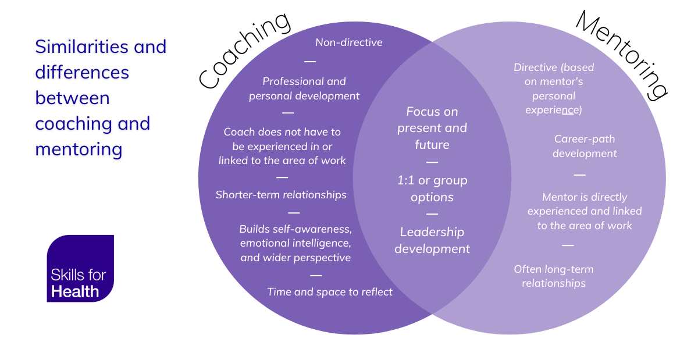
(Skills for health, 2023).

Example of being mentored in policing.
A positive constructive relationship with a supervisor would count as mentoring. For example, I found working as a police officer to be job where a great amount of knowledge is required in different subjects, some parts of the job I thrive in and other parts I struggle with. I get along with my sergeant very well and am more than happy to approach them for guidance when required. I recently struggled with a complex case file so approached my sergeant for help. My sergeant helped and gave me positive carer-path development and directive, where I needed to be told what to do and how to do it. Supervisors are experienced in the job and are able to offer long term relationships to assist their staff with development.
Example of coaching in policing.
The initial 3-month tutorship that every police officer has to do would count as being coached. A tutor is not always as experienced as what a supervisor would be and due to the tutorship only lasting 3 months, the relationship is more often than not, shorter than what a relationship with a supervisor is. Coaching still provides development to a person but is non-directive. A tutor will often let their student make the decisions at calls as this will build the student's confidence and cause personal growth. The initial 3-month long tutorship is an opportunity for the student officer to thrive whilst being coached by their tutor, although the length of tutorship is set as being 3 months long, it can vary between different people as some people may need to be coached for longer, while others may be ready well before the tutorship is complete. However, once tutorship is complete and an officer becomes independent, there are still learning and developmental opportunities but at this stage this may be seen as being mentoring rather than coaching.
How coaching and mentoring have helped me develop.
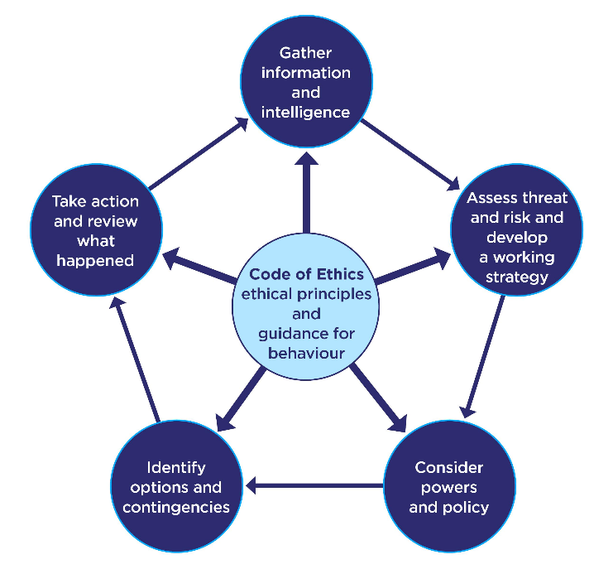
As both coaching and mentoring focus on both the present and future they both have helped me and continue to help me to be the best police officer I can be. I have gone from not knowing anything about policing to putting myself forward to be in a coaching role myself to assist newer police officers who have joined the job. Although coaching and mentoring is guaranteed to be given to people who join the job, it is important that competent and responsible people are put in these positions as they are there to develop a person’s career and are there to reassure their students/staff with any queries they may have. From the second phase of my tutorship, to the continued mentoring I receive from my sergeant it has all has aided me in becoming a better police officer. Every time I learn something new; it increases my performance within the job, which ultimately gives the community I serve a better service. I have been taught that the national decision-making model is at heart of policing which has developed my decision-making and critical thinking skills. My sergeant who is my mentor told me early on in my policing career to always refer to the national decision-making model whenever attending any call. This has stuck with me which is as a result of good mentoring. The national decision-making model is a model that has is approved by the College of Policing, it is to be referred to by police officers when making any decision within their job.
(College of Policing, 2013).
What is feedback?
Feedback is provided to a person about the performance in a certain subject or topic. Feedback should aim and be capable of providing an improvement in a person’s learning and performance. (EEF, 2025)
Feedback in policing
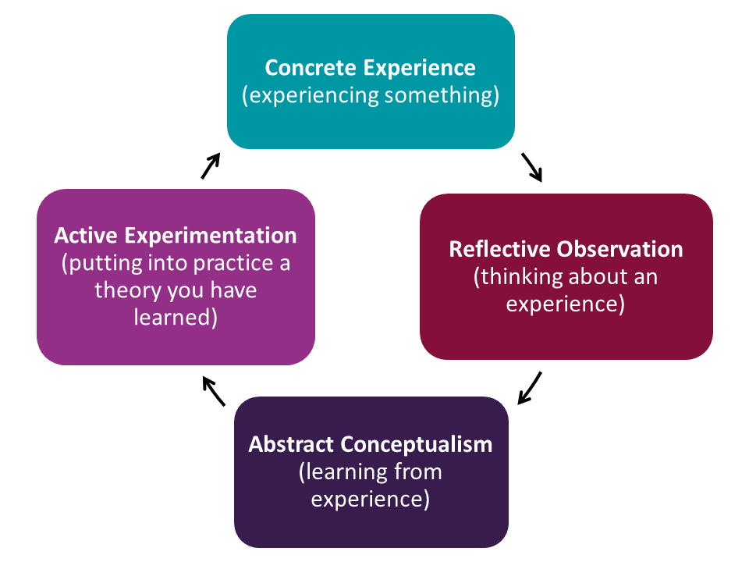
Feedback is very important within policing due to the type of job it is. There are always developmental opportunities, and feedback will help a person thrive in the job. For example, if a student and a tutor attend a sudden death and the tutor acts as a coach and is non-directive, giving the student the opportunity to take the lead and the student goes to the address and talks to the family without showing compassion. The tutor can coach the student and give developmental points for the next time the go to a sudden death which they will hopefully show improvement. If this fails then the sergeant who is the mentor can get involved and show further guidance to assist the student with their carer-path development and take necessary steps even if it includes taking a directive stance to the matter, this could be by putting them on a formal action plan for example. I will use the Kolb cycle of reflective practice to demonstrate how feedback can assist within policing. Kolb’s cycle of reflective practice is designed to encourage learning and it a good way to structure thinking through reflection. (Hull University, 2024).
(Hull University, 2024).
The first part of Kolb’s reflective cycle is concrete experience which is experiencing something. This would be an incident that a constable would attend, usually with a coach or mentor who can provide feedback. The second part of Kolb’s reflective cycle is reflective observation which is thinking about an experience. This would be done after the incident is dealt with where the constable thinks and reflects on the incident alongside their coach or mentor. The third part of Kolb’s reflective cycle is abstract conceptualism which is any learning that is gained from the experience. This part of the cycle can also be discussed with a coach or mentor where feedback can again be provided to show any learning and development opportunities, the final part of Kolb’s reflective cycle is active experimentation which is putting into practice any feedback that has been delivered. This part of the cycle can be done at the next incident that a constable attends. They can take on the feedback provided to them by their coach and mentor and put it into effect at the next incident that they attend. I am now starting to provide feedback to younger-in-service colleagues when it is required. I can see that I reflect knowledge to my colleagues when it is required and if someone is unsure on a process, I am happy to assist if I know how that process works and am confident to do so. Feedback doesn’t necessarily have to highlight something that someone could’ve done better. Feedback can also be used to highlight something positive that was done. If a constable that is being coached or mentored attended a call and was speaking to a victim of crime who was scared of the police and was shaken up due to the situation they were in, then the victim is likely to not want to talk to the police. However, if the attending officers showed compassion and understanding with the person which allowed them to talk to the police, then their mentor or coach could praise the constable and tell them that what they did was good and to keep up the good work. This could be implemented by using Kolb’s reflective cycle.

Conclusion
Reflecting on my three-year probation, I can see that mentoring and coaching have helped me develop into a competent police constable. Mentoring and coaching has provided me with many different feedback opportunities which has helped my professional growth. I have gained a lot more confidence in the job than what I had when I first started, and I believe that the main reason for this is due to coaching and mentoring. I believe that coaching and mentoring is invaluable to policing and is it can be used to continually develop constables, even if a constable has a long amount of service. Due to the nature of the job and not knowing what call could come next, there are always development opportunities. I am now confident to provide feedback to colleagues of mine who are younger-in-service when it is required and am also confident to give feedback to other colleagues even if they have been in the job longer than me. As I have been given good feedback from colleagues and supervisors who have been mentoring and tutoring me, I can now identify room for improvement for myself when I reflect on incidents that I have attended. I have also developed my decision-making skills when attending calls as I have been taught the national decision-making model numerous times from my supervisor since I first began the job.
1835 words.

Bibliography
The bibliography should only include sources referenced within the workbook using the Harvard referencing system. Information about referencing in written assignments and how to avoid plagiarism can be found on Moodle. It is important that you are aware of the importance of ensuring that the work submitted is your original work.

- BBC, no date, Misinformation v disinformation: What’s the difference? Available at https://www.bbc.co.uk/bitesize/articles/z3hhvj6m Accessed 3rd March 2025.
- BBC, August 2024, Timeline of how online misinformation fuelled UK riots. Available at https://www.bbc.co.uk/bitesize/articles/zshjs82 Accessed 3rd March 2025.
- Cambridge dictionary, no date, Social Media, Available at
- https://dictionary.cambridge.org/dictionary/english/social-media Accessed 3rd March 2025.
- Colin Baker, 5 January 2023, What is transformational leadership? Available at https://leaders.com/articles/leadership/transformational-leadership/ Accessed 9th March 2025.
- College of Policing, no date, Mentoring, Available at https://www.college.police.uk/career-learning/support-for-career-development/mentoring Accessed 20th March 2025.
- College of Policing, no date, About us, Available https://www.college.police.uk/about Accessed 1 March 2025.
- College of Policing, 14 March 2024, Corporate strategy 2022 to 2026, Available at https://www.college.police.uk/about/corporate-strategy Accessed 1 March 2025.
- College of Policing, 21 June 2023, New leadership standards for officers, staff and volunteers, Available at https://www.college.police.uk/article/leadership-standards Accessed 9th March 2025.
- College of Policing, 23 October 2013, NDM, Available at https://www.college.police.uk/app/national-decision-model/national-decision-model Accessed 1 March 2025.
- College of Policing, 21 August 2024, Using APP and guidelines, Available at https://www.college.police.uk/app/using-app Accessed 16 April 2025.
- Education Endowment Foundation, 16 April 2025, Feedback, Available at https://educationendowmentfoundation.org.uk/education-evidence/teaching-learning-toolkit/feedback accessed 17 April 2025.
- Hull University, 19 January 2024, Reflective writing: Kolb, Available at https://libguides.hull.ac.uk/reflectivewriting/kolb Accessed 23 April 2025.
- Jessica Brown, 5th January 2018, What the science suggests so far about the impact of platforms such as Facebook, Twitter or Instagram on your mental well-being. Available at https://www.bbc.co.uk/future/article/20180104-is-social-media-bad-for-you-the-evidence-and-the-unknowns Accessed 3rd March 2025.
- Leicestershire Police, October 2022, Social Media Policy & Procedure, Available at https://leics.pcc.police.uk/DOCUMENT-LIBRARY/Transparency/Meetings/Ethics-and-Transparency-Panel/2023/28th-March-2023/Item-10-Social-Media-Policy-and-Procedure.pdf Accessed 16 April 2025.
- Matt Mundey, Mentoring vs coach: the key differences and benefits. Available at https://www.think-learning.com/employee-engagement/mentoring-vs-coaching/ Accessed 17 April 2025.
- Metropolitan Police, no date, Sextortion, Available at https://www.met.police.uk/advice/advice-and-information/online-safety/online-safety/sextortion/ Accessed 3rd March 2025.
- Natasha Koifman, 5th July 2023, The importance of mentorship, available at https://www.forbes.com/councils/forbesbusinesscouncil/2023/07/05/the-importance-of-mentorship/ Accessed 20th March 2025.
- NPCC, No date, Policing Vision 2025, Available at https://www.npcc.police.uk/SysSiteAssets/media/downloads/publications/policing-vision/policing-vision-2025.pdf Accessed 15TH March 2025.
- Online Degrees, No date, What Style of Police Leadership is Most Effective? Available at https://onlinedegrees.sandiego.edu/what-style-police-leadership-most-effective/ Accessed 17 April 2025.
- Police federation England and Wales. 23 October 2024, Why police officers are leaving and why retention is crucial. Available at https://www.polfed.org/news/latest-news/2024/why-police-officers-are-leaving-and-why-retention-is-crucial/ Accessed 15TH April 2025.
- Police1, 07 October 2020, what leadership style works best during a crisis? Available at https://www.police1.com/leadership/articles/what-leadership-style-works-best-during-a-crisis-OwPozvGzewG41fHy/ Accessed 17 April 2025.
- Skills for health, 17 July 2023, Coaching v mentoring: What is the difference? Available athttps://www.skillsforhealth.org.uk/article/coaching-v-mentoring-what-is-the-difference/ Accessed 17 April 2025.
- UK Government, 20 February 2023, Strategic policing requirement 2023, Available at https://www.gov.uk/government/publications/strategic-policing-requirement-2023 Accessed 1 March 2025.
- University of Edinburgh, 15 October 2024, Gibbs Reflective Cycle, Available at https://reflection.ed.ac.uk/reflectors-toolkit/reflecting-on-experience/gibbs-reflective-cycle Accessed 17 April 2024.

CONFIDENTIALITY and PLAGIARISM

This is automatically checked via Turnitin submission of your workbook.

Please sign below to confirm that the work submitted is your own.

Sign M Hibbert

Date 26/04/2025

