
Programme: BA Business and Management
Module: Learning and Collaboration for Global Citizenship
Module code: BMSP4015
NAME: Paris Denisa
Student number: 2520283

Presentation link : https://docs.google.com/presentation/d/1cjOasYBpsBB_X9wAhw6u8sDVARnv05XJ/edit?usp=drive_link&ouid=114911395410477866174&rtpof=true&sd=true

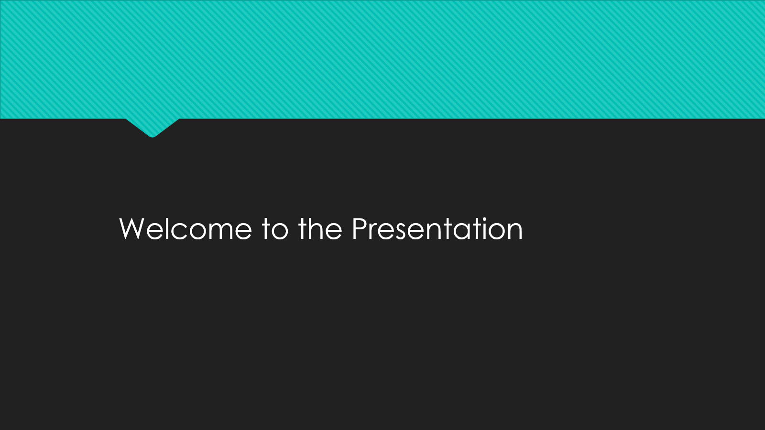
Hello everyone. Welcome to my presentation. Today I am going to discuss the advantages of collaborative learning, in particular, in global business. The component of collaborative learning plays a vital role in this module and it is one of the most significant skills in the future profession. This presentation will describe the meaning of collaborative learning, its significance, the way it helps in professional practise, and the challenges associated with it. I will also elaborate on the importance of it to global citizenship. I wish that this presentation will make you realise how collaborative learning is an effective tool among students and workers.
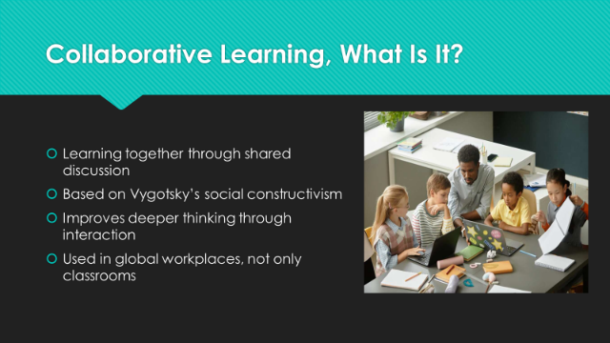
Collaborative learning is just a matter of learning collectively with others. It occurs when a group of individuals’ exchanges thoughts, poses questions, resolves issues, and supports other people in comprehending information. Collaborative learning enables us to learn together and through team work instead of learning individually. Learning theories such as social constructivism by Vygotskys explain that people are likely to learn more in case they engage with others (Ouyang & Zhang, 2024). The reason is that speaking, listening and explaining makes us think more profoundly. Team learning is not classified as classroom only. It also finds application at work places of which it is applied particularly in international companies where workers of various nationalities co-work. This renders senior learning highly significant to the contemporary profession.
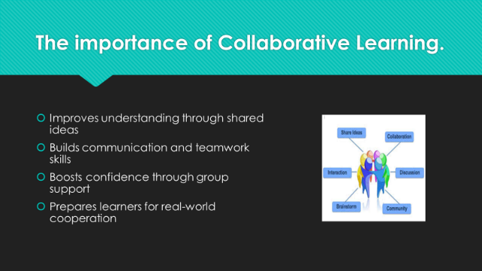
The importance of collaborative learning is that we get to comprehend topics in a more detailed and understandable manner. We learn together, and we listen to new arguments, various views, and methods of solving the issues. This assists us to develop better thinking abilities. It also contributes to the building of soft skills, such as communication, teamwork, confidence and leadership. Such competencies are necessary in multinational organisations nowadays (Ouyang & Zhang, 2024). Studying alongside people also gives one encouragement. When we have support, we like to learn. We are not shy to ask questions and exchange ideas. Lastly, collaborative learning also equips us with the actual world where team work, cooperation and problem solving are the norm in most of the jobs.
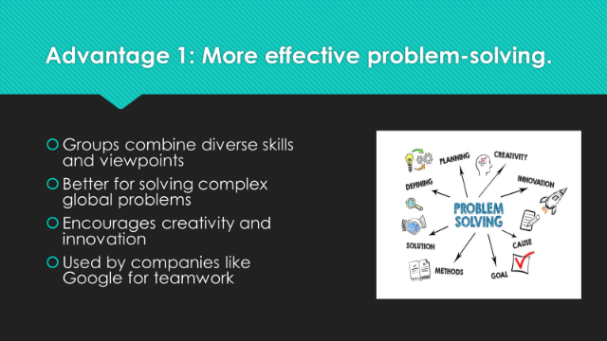
Among the benefits of collaborative learning, effective problem-solving can be assumed. This is because when individuals present their ideas, they integrate their strengths and experience. This results in improved solutions. Studies indicate that groups tend to handle complicated issues more effectively than individuals due to the ability to view the issue in various perspectives. The companies operating in the global business are exposed to complex challenges, including cross-cultural working, entering new markets, or new technology (Yang, 2023). Team learning enables employees to be innovative and collaborate in order to create solutions. In fact, world businesses such as Google are promoting collaboration among teams since they are likely to become innovative. This type of teamwork is supported by collaborative learning.
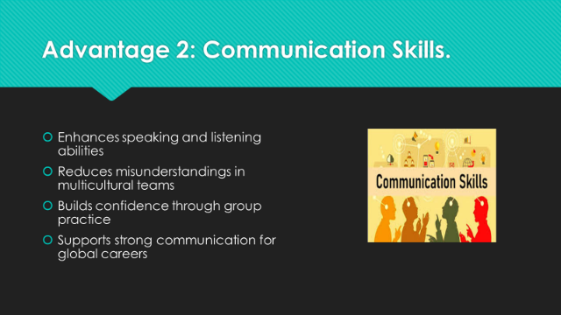
The other significant advantage of collaborative learning is the fact that it develops effective communication skills. When we study with people, we have to talk loudly, listen attentively and describe our concepts. These are communication skills that can be valued in any work place but mostly in international companies where individuals possess different nationalities and origins. Effective communication prevents misunderstandings and errors in the teams (Jafari, Kavousi-Fard, Dabbaghjamanesh, & Karimi, 2022). Team learning is also useful in gaining confidence when speaking. Most students are shy and when they participate in small groups practicing helps them in being more comfortable. In general, group studies contribute to the development of communicative skills that are beneficial to a successful career.
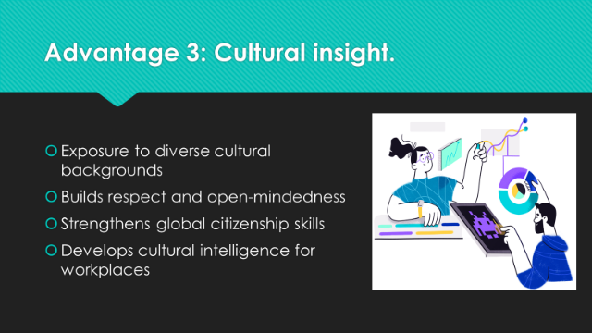
Team learning can be particularly useful in international business since it facilitates cultural knowledge. In most workplaces, teams are composed of individuals of varying countries, cultures as well as languages. Dealing with various individuals makes us know new horizons and learn to respect diversity in cultures. This helps to eliminate conflict and establish trust. This is also a component of being a global citizen, which is one of the central themes of this module (Jovanović & Milosavljević, 2022). Global citizenship refers to an individual being open-minded, respectful, and capable of working with people that are unlike us. Team learning assists in building cultural intelligence - the skill to communicate and cooperate with individuals of other cultures. This is one of the main international career skills.
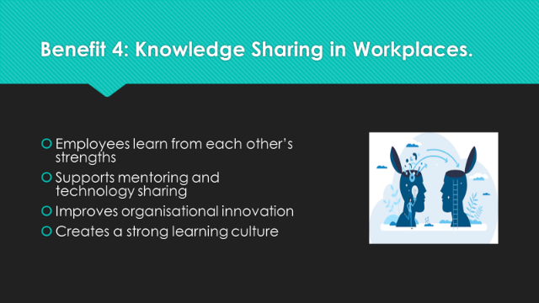
Knowledge sharing is also facilitated by collaborative learning. On the work places, workers possess varying expertise and experiences. When they collaborate they are able to learn with each other. Indicatively, experienced employees can mentor the new employees and the new employees can exchange new technology skills. Sharing of knowledge assists firms to remain creative and relevant. Numerous multinational organisations promote learning in groups since it produces improved performance. Knowledge sharing also creates a good culture of learning in the organization (Liu, Fan, Chen, Xu, & Yang, 2021). The exchange of ideas among people makes the entire company even smarter and stronger.
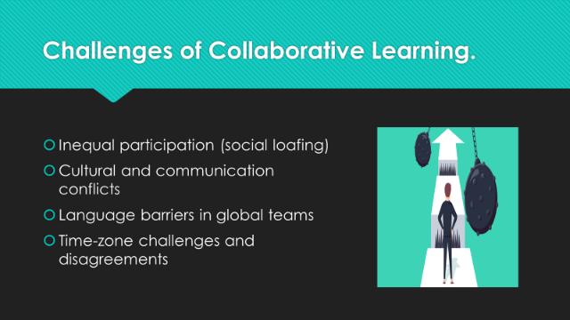
Despite all the advantages of collaborative learning, there are certain limitations associated with it. Inequal participation is one of the problems. In other cases, there are situations where one or two individuals do the majority of the work as others remain silent. This is referred to as social loafing. The other is the issue of culture. Individuals might possess conflicting communication patterns, and this might cause misunderstanding. Group work can also be challenging to language barriers particularly in international based teams (Kocaarslan & Eryaman, 2024). The international businesses face challenges in online collaboration due to time-zone differences. Another possible conflict that can occur in the group is disagreement. These obstacles demonstrate that to become effective, collaborative learning requires proper planning, good leadership, and effective communication.
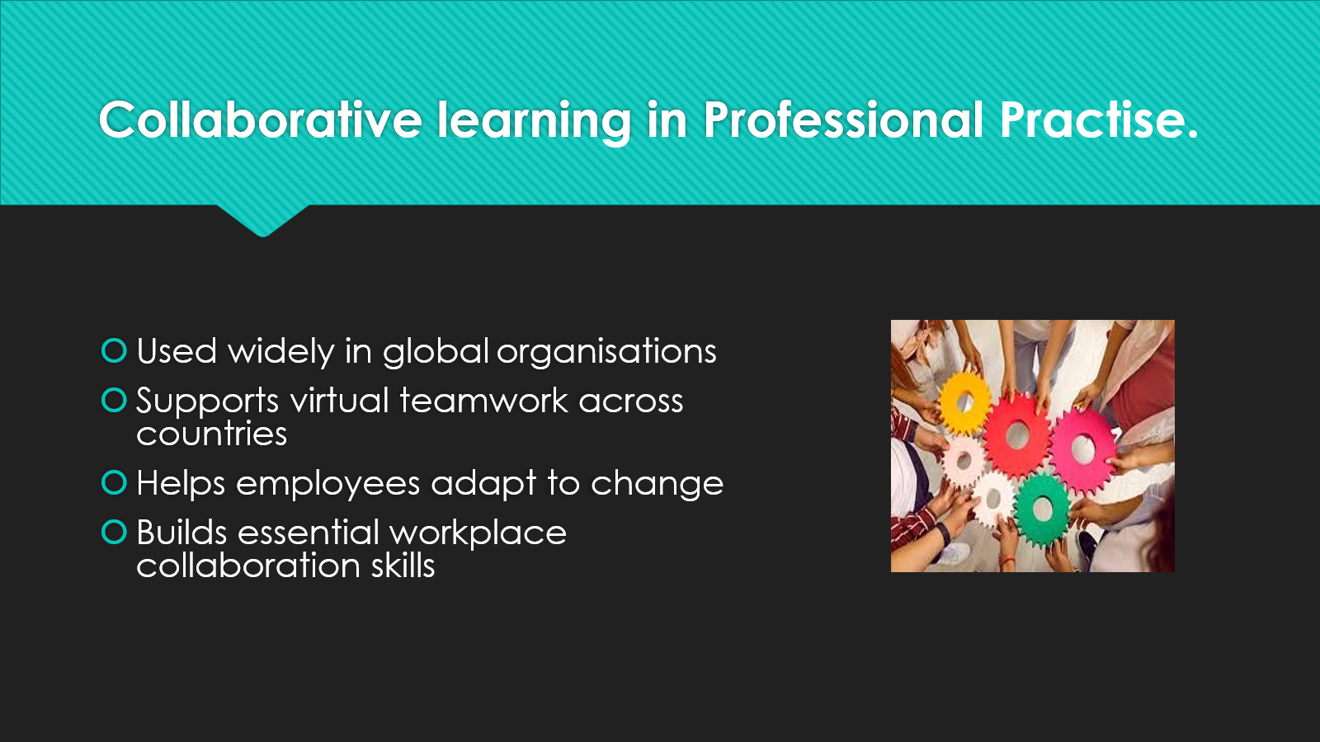
Teamwork in learning does not just exist in college. It is applied in the professional practice extensively. The global organisations such as Google, Microsoft, Amazon, and Unilever are collaborative teams that tackle problems and innovate. They have a belief that working in teams is a way to make decisions and achieve faster development. Virtual teams are in a lot of use by many companies where people collaborate online across nations (Supena, Darmuki, & Hariyadi, 2021). To effectively operate these teams, employees have to employ such collaborative learning skills as communication, respect, and problem-solving. Team learning also assists the employees to adjust to change. The rapid changes in technology and international markets have become a reality in modern businesses and hence the necessity of learning and working together.
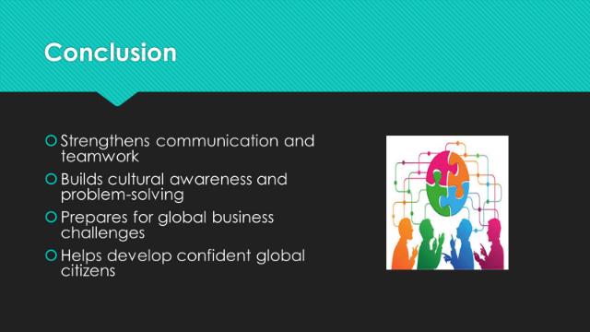
In summary, team learning is an effective and significant approach to learning, particularly in international business. It assists the students and workers to develop teamwork skills, communication skills, and problem solving skills and understanding of cultures. It helps us to develop professionally and get ready to face business real-life issues. Despite these challenges that occur including unequal participation and the cultural differences, they can be controlled through effective communication and leadership (Alzubi, Nazim, & Ahamad, 2024). In general, collaborative learning serves in making us better learners, better team players and better global citizens. Thank you for listening.


